PROJECT REPORT

DATABASE MANAGEMENT

CSE 303

GROUP 03

Section 04

|  |  |
| --- | --- |
| NAME | ID |
| Jaima Jahan Khan | 2030183 |

Contents

Ch-1 Introduction: 3

Background of the organization: 3

Background of the project: 4

Objectives of the project: 5

Scope of the project 6

Ch-2: Requirement Analysis 6

Existing Business System (with rich picture) 6

Processes along with Six System Element Analysis 7

Existing Problems & Analysis of the problem 53

Proposed Business System (with rich picture) 54

Proposed Processes along with Six System Element Analysis 55

Ch-3 Logical System Design 80

Business Rules 80

Entity Relationship Diagram (ERD) 83

ERD to Relations 84

Normalization 85

Data Dictionary 89

Ch-4 Physical System Design 98

Input Forms 98

Output Query & Reports 99

Ch-5 Conclusion 100

Problem & Solution 100

Additional Feature & Future Development 100

Conclusion & Recommendations 101

# Ch-1 Introduction:

## Background of the organization:

Established in 1993, the Independent University, Bangladesh (IUB) is the leading private university in Bangladesh with a specific focus on research and global partnership. The institution has robust and versatile schools, including.

● Business & Entrepreneurship

● Engineering, Technology & Sciences

● Environment and Life Sciences

● Liberal Arts & Social Sciences

● Pharmacy and Public Health.

IUB has produced competent and knowledgeable scholars who have made contributions both domestically and internationally.

To achieve this, IUB has received support from various institutions for each of the schools. Regular curriculum updates, the implementation of a system to track student set by UGC and the Bangladesh government, and ongoing student performance monitoring have also been instrumental mental in helping IUB achieve its goals.

The objectives of IUB are to produce graduates of international standards in the local environment who have the knowledge and necessary skills to provide leadership in business, public service, and welfare. The university also aims to encourage and support useful research, to create knowledge, and to offer opportunities for adults to continue their education.

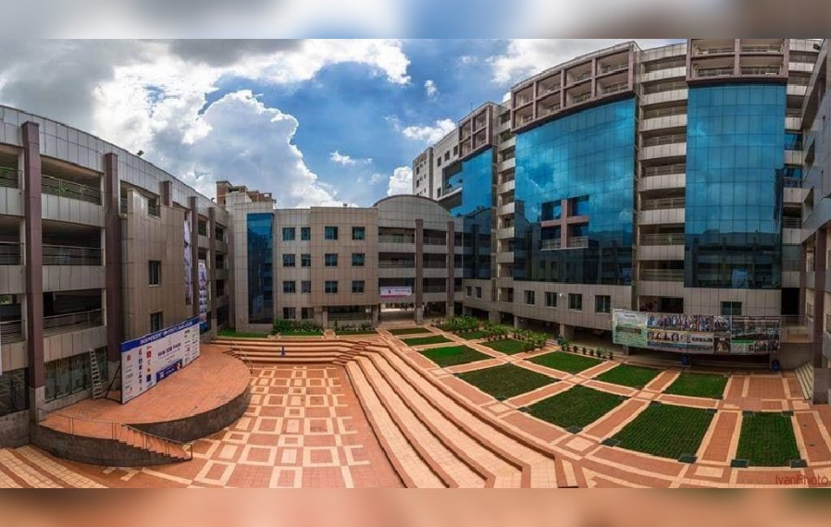

Figure : Independent University, Bangladesh

## Background of the project:

The new system will allow the Faculty User to add questions to that exam. The questions will be needed to assign to a CO. The user will be able to add multiple questions under a single exam. And must assign CO with all the questions separately. The user will be given a text box to type the question. After the Faculty User adds the question, the applications will create an option to view the question. In the question view interface, the user will be able to see the domain of learning along with its level.

The faculty user will also be able to assign marks to each of the questions separately, from which the percentage of CO’s and POs achieved can be calculated. All the users will be able to see a spider chart of the CO’s and POs achieved by the students.

OBE based course outline of a single course will be added by the faculty user and will be available to all users. User will be able to download course outline of a course in a program separately and the user will also be able to download all the course outline of all the courses in a program in a single PDF file.

Our project's goal is to create, develop, and distribute software that, in our opinion, will assist universities worldwide in promoting a more fruitful and efficient method of student evaluation. As the central concept of our project, we've introduced the notion of Course Outcomes (COs) and Program Learning Outcomes (PLOs), where each CO is mapped to a PLO, and each PLO represents a particular valuable skill that students are expected to acquire or improve at the conclusion of that course, such as problem analysis, design, implementation of a skill and spider chart.

The details will all be present in the course outline for the students to have easy access and have all the necessary details regarding a course. The project will determine whether each student has successfully completed the PLOs that are linked to the COs requirements in order to evaluate them effectively through tools such as spider charts. IEB input is accepted by the system when establishing PLO criteria. For the system to map the COs to PLO appropriately, the faculties then input the COs for each of their students. It was discovered via the execution of this project that the efficiency not only reduced time but also increased quality. The PLOs are carefully and deliberately selected to guarantee that each student gets the most skills out of a course.

We also have the feature where faculties can input the questions in the question bank which can be accessed by the students which will help them gain knowledge on their desired topics and will provide them with a vast field to practice.

Students can monitor their progress in each area and identify their areas for growth and improvement. Our program also aims to help the institutional bodies, including faculty, administrative, and departmental bodies, track student development, departmental performance, and better distribute and allocate resources.

## Objectives of the project:

Our project seeks to create a user-friendly and interactive software application that will act as a platform for university staff, faculty, and other participants to enhance the quality of instruction and transform the integration of technology in education. We believe that the information we have collected, evaluated, and structured will enable substantial advancements in both the education sector and computer science field. To expand the project’s impact across the departments, S are confident that the information we have gathered, assessed, and organized will open doors for significant improvements in the educational sector as well as the field of computer science. In this situation, SPMS will broaden its scope.

## Scope of the project

approach entails building a Web application called SPMS 4.0 that makes use of a Relational Database Management System (RDMS) to enhance an existing web application for student registration and course management by adding new features that allow for the calculation of course outcomes based on student performance data. This will involve adding new data fields to capture student ID, educational year, educational semester, enrolled course, enrolled section and obtained grade. The system will then use this data to calculate course outcomes, which will include data points such as the number and percentage of students who passed or failed a course, the average grade for each course, and the distribution of grades across different sections and semesters. The new feature is to implement with the existing functionality, including school-wise and department-wise student enrollment and performance trends, PLO and CO achievement stats, question bank management and course outline creation and the project also involve developing a user interface for inputting and viewing the new data and generating reports and visualizations to help faculty and administrators monitor and analyze student performance data.

# Ch-2: Requirement Analysis

## Existing Business System (with rich picture)

The new system will allow the Faculty User to add questions to that exam. The questions will be needed to be assigned to a CO. The user will be able to add multiple questions under a single exam. And must assign CO with all the questions separately. The user will be given a text box to type the question. After the Faculty User adds the question, the applications will create an option to view the question. In the question view interface, the user will be able to see the domain of learning along with its level.

The faculty user will also be able to assign marks to each of the questions separately, from which the percentage of COs and POs achieved can be calculated. All the users will be able to see a spider chart of the COs and POs achieved by the students.

OBE-based course outline of a single course will be added by the faculty user and will be available to all users. The user will be able to download the course outline of a course in a program separately and the user will also be able to download all the course outlines of all the courses in a program in a single PDF file.

Figure : Rich Picture of Existing System

## Processes along with Six System Element Analysis

The Six Elements Analysis gives a thorough explanation of each element's function in each process. The table below makes it very evident that human entities predominate all important system operations, particularly the two most important ones—mapping course outcomes and examining documents associated with them. The existing approach, for instance, relies significantly on manually handled and processed hardcopy databases. As a result, there is a considerable amount of waiting involved in the interdependent processes before the Human components may perform their obligations.

|  |  |  |  |  |  |  |
| --- | --- | --- | --- | --- | --- | --- |
| Process | System Roles | | | | | |
| Human | Non-Computing Hardware | Computing Hardware | Software | Database | Network and Communication |
| Student Enrollment | Student:  a) Search for the website  b) Goes to the website.  c) Clicks  on the  form  option.  c) Fill up the  form with  required  Information.  Admin:  a) Admin  logs into  the system  using  SPMS  User-ID and  password.  b)  Receives  the student  enrollment information in the  attached  files.  c) Admin  updates the  student  enrollment information in  Database.  d) Inputs  the desired  time  period for  number of  students  enrolled. | Paper and Stationery:  a) Used to collect information about students through enrollment forms. | Computer/  Laptop  a) SPMS admin will use Computers to access and update data.   b) Users will use the  computer to view the data.  Database  Server  a) Used by  SPMS  Developers to collect data and maintain the software.  Networking Devices  (Router,  Switch,  Bridge, Hub):  a) Used to  access SPMS | Operating  Software  a) Utilized by  Registrar  Office and  SPMS.  Student  a) Uses to fill  up the form  from the  website.  SPMS  a) The software for which the administrator will set up user accounts. | Register  Office  Database  a) Used by the registrar's office to compile student data into an excel file for sending to SPMS.  SPMS  a) For any upgrades or new user accounts, information is kept in the database.  Excel  a) Data from student accounts may be kept in an excel file and used later in SPMS. | Internet  a) To access and store data to SPMS it is used.  b) It is used to collect the student form from the student to registrar office.  c)The Registrar office sends all the student information to SPM admin by using it. |
| Student Performance Based on CGPA | Student:  a) Logs into  the System  using  Student-ID  and  password.  b) Inputs the desired time - period to  view self  CGPA  Progress.  Registrar's Office:  a) Logs into  the System  using User-ID  and  password.  b) Inputs the  desired time  period and  School,  Department or program to view  Statistically and analyzed  CGPA trend  of students.  Department Head:  a) Logs into  the System  using User-ID  and  password.  b) Inputs the  desired time-  period and  school,  Department or program.  c) View  statistically analyzed  CGPA trend  of students or  any  individual student.  Faculty:  a) Logs into the system  using  Faculty-ID  and  password.  b) Inputs the  desired time  -period and  program to view  statistically and  analyzed  CGPA trend  of students or any  individual student those  who attended  the faculty’s  Section.  Higher Authority:  a) Logs into the system  using their  User-ID  and  password.  b) Inputs the  desired time-  period,  School and  Department  c) View  statistically analyzed  CGPA trend of students. |  | Computer/  Laptop  a) User will need a computer to access SPMS  Printer  a) Used to print out the report if need be.  Networking Devices  (Router,  Switch,  Bridge, Hub):  a) Used to  access the  Internet. | Operating  Software  a) The user uses it to execute SPMS  SPMS  a) A performance trend will be generated by the software. | SPMS  Database  a) Obtain performance using the database. | Internet  a) To login into and access the SPMS it is used. |
| Course-wise student performance based on CGPA | Student:  a) Logs into the system  using  Student-ID  and  password.  b) Inputs the  course  c) View self  GPA for the  course. Department Head:  a) Logs into the System  using User-ID and  password.  b) Inputs the desired time-  period  Course-ID  c) View statistically analyzed  GPA trend of  Students.  Registrar’s office:  a) Logs into the System  using  Admin-ID and  password.  b) Inputs the  desired time  -period and  coursed  c) view  statistically analyzed  GPA trend of  students.  Faculty:  a) Logs into the System  using  Faculty-ID  and  password.  b) Inputs the  desired time  -  period  Course-ID  under the  faculty  c)view  statistically analyzed  GPA trend of  students who faculty’s  section.  Higher Authority:  a) Logs into  the system  using their  User-ID  and  password.  b) Inputs the  desired time-  period and  Course-ID  c)View  statistically analyzed  GPA trend of  students for that specific  course. |  | Computer/  Laptop  a) User will need a computer to access SPMS  Printer  a) Used to print out the report if need be.  Networking Devices  (Router,  Switch,  Bridge, Hub):  a) Used to  access the  Internet. | SPMS  a) A performance trend based on GPA will be generated by the software. | SPMS  Database  a) Here, the performance will be stored and updated. | Internet  a) To login into and access the SPMS it is used. |
| Selective Number of Instructor-wise student performance based on the GPA | Department Head:  a) Logs into the system  using User-ID and  password.  b) Inputs the  desired time-  period  Course-ID  c)View  statistically  analyzed  GPA trend of  students for a  selective  number of  Instructors.  Registrar’s office:  a) Logs into the system  using  Admin-ID and  password.  b) Inputs the  desired time-  period  Course-ID  c) View  statistically  analyzed  GPA trend of  students for a  selective  number of  Instructors  Faculty:  a) Logs into the system  using  Faculty-ID  and  password.  b) Inputs the  desired time -  period &  Course-ID  c)View  statistically  analyzed  GPA trend of  students for a  selective  number of  Instructors.  Higher Authority:  a) Logs into  the System  using User-ID  and  password.  b) Inputs the  desired time-  period  Course-ID  c) View  statistically  analyzed  GPA trend of  students for a  selective  number of  Instructors. |  | Computer/  Laptop  a) User will need a computer to access SPMS  Printer  a) Used to print out the report if need be.  Networking Devices  (Router,  Switch,  Bridge, Hub):  a) Used to  access the  Internet. | SPMS  a) a) The software will produce a performance trend for a specified instructor. | SPMS  Database  a) Here, the performance will be stored and updated. | Internet  a) To login into and access the SPMS it is used. |
| VC-wise, dean-wise, or department head-wise student performance | Department Head:  a) Logs into the system  using User-ID  and  password.  b) Select  Input from  from  VC/Dean/Department  Head  c) View the  student  performance  trend as per  choice.  Registrar’s office:  a) Logs into the system using User-ID  and  password.  b) Select  Input from  from  VC/Dean/Department  Head  c) View the  student  performance  trend as per  choice.  Dean or VC  a) Logs into  the system  using User-ID  and  password.  b) Select  Input from  from  VC/Dean/Department  Head  c) View the  student  performance  trend as per  choice. |  | Computer/  Laptop  a) User will need a computer to access SPMS  Printer  a) Used to print out the report if need be.  Networking Devices  (Router,  Switch,  Bridge, Hub):  a) Used to  access the  Internet. | SPMS  a) The software will produce a performance trend | SPMS  Database  a) Here, the performance will be stored. | Internet  a) To login into and access the SPMS it is used. |
| Instructor-wise student performance based on the GPA of the students | Department Head:  a) Logs into the system  using  Department-I  D and  Password. b) Inputs a  particular  instructor  Name/ID  c)View the  student  performance  trend of  selected  Instructor.  Registrar’s office:  a) Logs into the system  using User-ID  and  password.  b) Inputs a  particular  instructor  c) View the  student  performance  trend of  selected  Instructor.  Faculty:  a) Logs into the system  using User-ID and  password.  b) Input their  Name/ID.  c) View the  student  performance  trend.  Dean  a) Logs into  the system  using User-ID  and  password.  b) Inputs a  particular  instructor  c)View the  student  performance  trend of  selected  instructor  VC  a) Logs into  the system  using User-ID  and  password.  b) Inputs a  particular  instructor  c)View the  student  performance  trend of  selected  instructor. |  | Computer/  Laptop  a) User will need a computer to access SPMS  Printer  a) Used to print out the report if need be.  Networking Devices  (Router,  Switch,  Bridge, Hub):  a) Used to  access the  Internet. | SPMS  a) The software will produce a performance trend | SPMS  Database  a) The  performance  will be stored  and updated  in the  database. | Internet  a) To login into and access the SPMS it is used. |
| Total PLO percentage achieved and attempted by the student along with the departmental average | Student:  a) Logs into the system  using Student-ID and  Password  b) Inputs the  time- period  c)Views their  comparison  of attempted  vs achieved PLO  percentage  along with  the  departmental  Average.  Department Head:  a) Logs into the system  using User-ID and  Password  b) Inputs the time- period  c) Views the comparison of students  attempted  PLO vs  achieved  PLO  percentage  along with  the  departmental  average.  Registrar’s office:  a) Logs into the system  using User-ID and  Password  b) Inputs the time- period  c) Views the  comparison  of students  Attempted PLO vs  achieved  PLO  percentage  along with  the  departmental  average.  Faculty:  a) Logs into the system  using User-ID and  Password.  b) Inputs the  time period.  c) Views the  comparison of students  attempted  PLO vs  achieved  PLO  percentage  along with  the  departmental  Average.  Dean  a) Logs into  the system  using User  ID and  Password  b) Inputs the time period  c) Views the  comparison of students  Attempted PLO vs  achieved  PLO  percentage  along with  the  departmental  average.  VC  a) Logs into the system  using User-ID and  Password.  b) Inputs the time- period.  c) Views the  comparison of students  attempted  PLO vs  achieved  PLO  percentage  along with  the  departmental  average. |  | Computer/  Laptop  a) User will need a computer to access SPMS  Printer  a) Used to print out the report if need be.  Networking Devices  (Router,  Switch,  Bridge, Hub):  a) Used to  access the  Internet. | Operating  system  a) Used by  the  SPMS  SPMS  a) A comparison of the attempted vs. achieved PLO as well as the departmental average will be produced by the software. | SPMS  Database  a) Here, the performance will be stored. | Internet  a) To login into and access the SPM it is used. |
| PLO achievement | Student:  a) Logs into the system  using  Student-ID  and  password. b) Selects  PLO  achievement  c) View PLO  Achievement.  Department Head:  a) Logs into the System  using user-ID  and  password.  b) Selects  PLO  achievement  c) View PLO  Achievement.  Registrar’s office:  a) Logs into the system  using user-ID and  password.  b) Selects  PLO  achievement.  c) View PLO  Achievement.  Faculty:  a) Logs into  the System  using  Faculty-ID and  password.  b) Selects  PLO  Achievement.  c) View PLO  Achievement.  Dean  a) Logs into  the System  using user-ID and  password.  b) Selects  PLO  achievement.  c) View PLO  Achievement.  VC  a) Logs into the system  using user-ID  and  password.  b) Selects  PLO  achievement.  c) View PLO  achievement |  | Computer/  Laptop  a) User will need a computer to access SPMS  Printer  a) Used to print out the report if need be.  Networking Devices  (Router,  Switch,  Bridge, Hub):  a) Used to  access the  Internet. | SPMS  a) A PLO achievement will be generated by the software. | SPMS  Database  a) Here, the performance will be stored and updated. | Internet  a) To login into and access the SPM it is used. |
| Expected PLO-achievement versus actual score (for course's, student’s,  Department’s, program’s or school’s) | Student:  a) Logs into the system  using  Student-ID  and  password.  b) Selects  PLO  achievement  comparison  c) View PLO  achievement  Comparison.  Department Head:  a) Logs into the system  using user-ID  and  password.  b) Selects  PLO  achievement  comparison  c) View PLO  achievement  Comparison.  Registrar’s office:  a) Logs into  the system  using user-ID and  password.  b) Selects  PLO  achievement  comparison.  c) View PLO  achievement  comparison.  Faculty:  a) Logs into the System  using  Faculty-ID and  password.  b) Selects  PLO  achievement  comparison.  c) view PLO  Achievement comparison.  Dean  a) Logs into the system  using user-ID  and  password.  b) Selects  PLO  achievement  comparison.  c) View PLO  achievement  Comparison.  VC  a) Logs into the system  using user-ID  and  password.  b) Selects  PLO  achievement  comparison  c) View PLO  achievement  Comparison. |  | Computer/  Laptop  a) User will need a computer to access SPMS  Printer  a) Used to print out the report if need be.  Networking Devices  (Router,  Switch,  Bridge, Hub):  a) Used to  access the  Internet. | SPMS  a) A) The software will calculate the expected vs. achieved PLO. | SPMS  Database  a) The  performance  will be stored  and updated  in the  database. | Internet  a) To login into and access the SPMS it is used. |
| CO-PLO achievement summary | Student:  a) Logs into the system  using  Student-ID  and  password.  b) Selects  CO -PLO  achievement  summary.  c) View CO- PLO achievement summary.  Department Head:  a) Logs into the system  using user-ID  and  password.  b) Selects  CO -PLO  achievement  summary.  c) View CO  - PLO  achievement  Summary.  Registrar’s office:  a) Logs into the system  using user-ID  and  password.  b) Selects  CO -PLO  achievement  summary.  c) View CO  -PLO  achievement  Summary.  Faculty:  a) Logs into the system  using  Faculty-ID and  password.  b) Selects CO  -PLO  achievement  summary.  c) View CO  - PLO  achievement  Summary.  Dean  a) Logs into the system  using user-ID  and  password.  b) Selects  CO -PLO  achievement  summary.  c) View CO  - PLO  achievement  Summary.  VC  a) Logs into the system  using user-ID  and  password.  b) Selects  CO  -PLO  achievement  summary  .  c) view CO  - PLO  achievement  summary. |  | Computer/  Laptop  a) User will need a computer to access SPMS  Printer  a) Used to print out the report if need be**.**  Networking Devices  (Router,  Switch,  Bridge, Hub):  a) Used to  access the  Internet. | SPMS  a) The software will produce a summary of CO-PLO accomplishments. | SPMS  Database  a) The  Summary  will be stored  and updated  in the  database. | Internet  a) To login into and access the SPMS it is used. |

## Existing Problems & Analysis of the problem

|  |  |  |  |  |
| --- | --- | --- | --- | --- |
| **Process Name** | **Stakeholders** | **Concerns (Problems)** | **Analysis (Reason of the Problem)** | **Proposed Solution** |
| **CO-PLO Achievement** | 1. Student  2. Department Head  3. Registrar’s Office  4. Faculty  5. Dean  6. VC | 1. Generated reports may not be clear or enough to make assessment. | 1. Despite generating several reports, another form of report may prove to be useful to give a clear view of COs and POs achieved. | 1. Generating Spider Charts for percentages achieved of both COs and Pos. |
| **Question Bank** | 1. Faculty/Instructor | 1. There is no interface for faculties to add assessment materials. | 1. Faculty will need an option to add all the assessment materials to the system.  2. The system currently has no unified for storage for past and present assessment materials. | 1. Faculty will have option to add quiz/mid-term/ final-term and assign marks.  2. All assessment materials can be found in one place.  3.The assigned marks will be used to calculate percentage of COs and POs achieved.  4. Difficulty level of question will be mapped from the questions according to the verbs list provided. |
| **Course Outline** | 1. Faculty/Instructor | 1. A feature is needed to generate course outline. | 1. A feature is needed to generate course outline after providing some of the key details of course.  2. Some of the key details include course code, grading chart, CO matrix, Bloom’s Learning Level, etc. | 1. Provide the feature to generate course outline.  2. Provide option to download the generated course outline in a PDF file for all stakeholders involved. |

## Proposed Business System (with rich picture)

We need to enhance the existing web application to add new features that allow the calculation of course outcomes based on student performance data. As we know we need to add new data fields to the existing web application to capture student ID, educational year, educational semester, enrolled course, enrolled section, and obtained grade. And the user must be able to input the data, and the application must store it in the database.

Once the data is inputted, we must develop a module that can calculate course outcomes based on the student performance data. The course outcomes can be measured based on various parameters such as course completion rate, pass rate, average grade and so on. The module should also be able to generate reports and visualizations to help users understand the performance of students in different courses.The objective of this project also needs to update the user interface to include the new features and data fields. The updated user interface intuitive and user-friendly to make it easier for users to input and access data.

Overall, the goal of this project is to provide a comprehensive tool for managing student registration, course selection, and academic records while also enabling the calculation of course outcomes based on student performance data.

## Proposed Processes along with Six System Element Analysis

The six elements analysis of the proposed system is a continuation of an analysis process where each analysis is based on the one that comes before it. Based on the rich picture, the role of each element in the new system is further understood in the table below.

|  |  |  |  |  |  |  |
| --- | --- | --- | --- | --- | --- | --- |
| Process | System Roles | | | | | |
| Human | Non-Computing Hardware | Computing Hardware | Software | Database | Network and Communication |
| Student Enrollment | Student:  a) Search for the website  b) Goes to the website.  c) Clicks  on the  form  option.  c) Fill up the  form with  required  Information.  Admin:  a) Admin  logs into  the system  using  SPMS  User-ID and  password.  b)  Receives  the student  enrollment information in the  attached  files.  c) Admin  updates the  student  enrollment information in  Database.  d) Inputs  the desired  time  period for  number of  students  enrolled. | Paper and Stationery:  a) Used to collect information about students through enrollment forms. | Computer/  Laptop  a) SPMS admin will use Computers to access and update data.   b) Users will use the  computer to view the data.  Database  Server  a) Used by  SPMS  Developers to collect data and maintain the software.  Networking Devices  (Router,  Switch,  Bridge, Hub):  a) Used to  access SPMS | Operating  Software  a) Utilized by  Registrar  Office and  SPMS  Student  a) Uses to fill  up the form  from the  website.  SPMS  a) The software for which the administrator will set up user accounts. | Register  Office  Database  a) Used by the registrar's office to compile student data into an excel file for sending to SPMS.  SPMS  a) For any upgrades or new user accounts, information is kept in the database.  Excel  a) Data from student accounts may be kept in an excel file and used later in SPMS. | Internet  a) To access and store data to SPMS it is used.  b) It is used to collect the student form from the student to registrar office.  c)The Registrar office sends all the student information to SPMS admin by using it. |
| Student Performance Based on CGPA | Student:  a) Logs into  the System  using  Student-ID  and  password.  b) Inputs the desired time - period to  view self  CGPA  Progress.  Admin:  a) Logs into  the System  using User-ID  and  password.  b) Inputs the  desired time  period and  School,  Department or program to view  Statistically and analyzed  CGPA trend  of students.  Faculty:  a) Logs into the system  using  Faculty-ID  and  password.  b) Inputs the  desired time  -period and  program to view  statistically and  analyzed  CGPA trend  of students or any  individuals student those  who attended  the faculty’s  Section. |  | Computer/  Laptop  a)User will need a computer to access SPMS  Printer  a)Used to print out the report if need be.  Networking Devices  (Router,  Switch,  Bridge, Hub):  a)Used to  access the  Internet. | Operating  Software  a) The user uses it to execute SPMS 2.0  SPMS  a) A performance trend will be generated by the software. | SPMS  Database  a) Obtain performance using the database. | Internet  a) To login into and access the SPMS it is used. |
| Course-wise student performance based on CGPA | Student:  a) Logs into the system  using  Student-ID  and  password.  b) Inputs the  course  c) View self  GPA for the  course. **Admin:**  a) Logs into the System  using User-ID and  password.  b) Inputs the desired time-  period  Course-ID  c) View statistically analyzed  GPA trend of  Students.  Faculty:  a) Logs into the System  using  Faculty-ID  and  password.  b) Inputs the  desired time  -  period  Course-ID  under the  faculty  c)view  statistically analyzed  GPA trend of  students who faculty’s  section. |  | Computer/  Laptop  a)User will need a computer to access SPMS  Printer  a)Used to print out the report if need be.  Networking Devices  (Router,  Switch,  Bridge, Hub):  a)Used to  access the  Internet. | SPMS  a) A performance trend based on GPA will be generated by the software. | SPMS  Database  a) Here, the performance will be stored and updated. | Internet  a) To login into and access the SPMS it is used. |
| Selective Number of Instructor-wise student performance based on the GPA | Admin:  a) Logs into the system  using User-ID and  password.  b) Inputs the  desired time-  period  Course-ID  c)View  statistically  analyzed  GPA trend of  students for a  selective  number of  Instructors.  Faculty:  a) Logs into the system  using  Faculty-ID  and  password.  b) Inputs the  desired time -  period &  Course-ID  c)View  statistically  analyzed  GPA trend of  students for a  selective  number of  Instructors.  GPA trend of  students for a  selective  number of  Instructors. |  | Computer/  Laptop  a)User will need a computer to access SPMS  Printer  a)Used to print out the report if need be.  Networking Devices  (Router,  Switch,  Bridge, Hub):  a)Used to  access the  Internet. | SPMS  a) a) The software will produce a performance trend for a specified instructor. | SPMS  Database  a) Here, the performance will be stored and updated. | Internet  a) To login into and access the SPMS it is used. |
| Admin wise student performance | Admin:  a) Logs into the system  using User-ID  and  password.  b) Select  Input from  from  VC/Dean/Department  Head  c) View the  student  performance  trend as per  choice. |  | Computer/  Laptop  a)User will need a computer to access SPMS  Printer  a)Used to print out the report if need be.  Networking Devices  (Router,  Switch,  Bridge, Hub):  a)Used to  access the  Internet. | SPMS  a) The software will produce a performance trend | SPMS  Database  a) Here, the performance will be stored. | Internet  a) To login into and access the SPM it is used. |
| Instructor-wise student performance based on the GPA of the students | Admin:  a) Logs into the system  using  Department-I  D and  Password. b) Inputs a  particular  instructor  Name/ID  c)View the  student  performance  trend of  selected  Instructor.  Faculty:  a) Logs into the system  using User-ID and  password.  b) Input their  Name/ID.  c) View the  student  performance  trend. |  | Computer/  Laptop  a)User will need a computer to access SPMS  Printer  a)Used to print out the report if need be.  Networking Devices  (Router,  Switch,  Bridge, Hub):  a)Used to  access the  Internet. | SPMS  a) The software will produce a performance trend | SPMS  Database  a) The  performance  will be stored  and updated  in the  database. | Internet  a) To login into and access the SPM it is used. |
| Total PLO percentage achieved and attempted by the student along with the departmental average | Student:  a) Logs into the system  using Student-ID and  Password  b) Inputs the  time- period  c)Views their  comparison  of attempted  vs achieved PLO  percentage  along with  the  departmental  Average.  Admin:  a) Logs into the system  using User-ID and  Password  b) Inputs the time- period  c) Views the comparison of students  attempted  PLO vs  achieved  PLO  percentage  along with  the  departmental  average.  Faculty:  a) Logs into the system  using User-ID and  Password.  b) Inputs the  time period.  c) Views the  comparison of students  attempted  PLO vs  achieved  PLO  percentage  along with  the  departmental  Average. |  | Computer/  Laptop  a)User will need a computer to access SPMS  Printer  a)Used to print out the report if need be.  Networking Devices  (Router,  Switch,  Bridge, Hub):  a)Used to  access the  Internet. | Operating  system  a) Used by  the  SPMS  SPMS  a)A comparison of the attempted vs. achieved PLO as well as the departmental average will be produced by the software. | SPMS  Database  a) Here, the performance will be stored. | Internet  a) To login into and access the SPM it is used. |
| PLO achievement | Student:  a) Logs into the system  using  Student-ID  and  password. b) Selects  PLO  achievement  c) View PLO  Achievement.  Admin:  a) Logs into the System  using user-ID  and  password.  b) Selects  PLO  achievement  c) View PLO  Achievement.  Faculty:  a) Logs into  the System  using  Faculty-ID and  password.  b) Selects  PLO  Achievement.  c) View PLO  Achievement. |  | Computer/  Laptop  a)User will need a computer to access SPMS  Printer  a)Used to print out the report if need be.  Networking Devices  (Router,  Switch,  Bridge, Hub):  a)Used to  access the  Internet. | SPMS  a) A PLO achievement will be generated by the software. | SPMS  Database  a) Here, the performance will be stored and updated. | Internet  a) To login into and access the SPMS it is used. |
| Expected PLO-achievement versus actual score (for course's, student’s,  Department’s, program’s or school’s) | Student:  a) Logs into the system  using  Student-ID  and  password.  b) Selects  PLO  achievement  comparison  c) View PLO  achievement  Comparison.  Admin:  a) Logs into the system  using user-ID  and  password.  b) Selects  PLO  achievement  comparison  c) View PLO  achievement  Comparison.  Faculty:  a) Logs into the System  using  Faculty-ID and  password.  b) Selects  PLO  achievement  comparison.  c) view PLO  Achievement comparison. |  | Computer/  Laptop  a)User will need a computer to access SPMS  Printer  a)Used to print out the report if need be.  Networking Devices  (Router,  Switch,  Bridge, Hub):  a)Used to  access the  Internet. | SPMS  a) A) The software will calculate the expected vs. achieved PLO. | SPMS  Database  a) The  performance  will be stored  and updated  in the  database. | Internet  a) To login into and access the SPMS it is used. |
| CO-PLO achievement summary | Student:  a) Logs into the system  using  Student-ID  and  password.  b) Selects  CO -PLO  achievement  summary.  c) View CO- PLO achievement summary.  Admin:  a) Logs into the system  using user-ID  and  password.  b) Selects  CO -PLO  achievement  summary.  c) View CO  - PLO  achievement  Summary.  Faculty:  a) Logs into the system  using  Faculty-ID and  password.  b) Selects CO  -PLO  achievement  summary.  c) View CO  - PLO  achievement  Summary. |  | Computer/  Laptop  a)User will need a computer to access SPMS  Printer  a)Used to print out the report if need be**.**  Networking Devices  (Router,  Switch,  Bridge, Hub):  a)Used to  access the  Internet. | SPMS  a)The software will produce a summary of CO-PLO accomplishments. | SPMS  Database  a) The  Summary  will be stored  and updated  in the  database. | Internet  a) To login into and access the SPMS it is used. |
| Question Bank | Student:  a) Logs into the system  using  Student-ID  and  password.  b) Selects  Question Bank  c) Views form  d)Selects course, section and semester and assessment type.  d)Downloads questions  Faculty:  a) Logs into  the System  using  Faculty-ID and  password.  b) Selects  question bank  c) Views form  d)Selects course, section and semester and assessment type.  e) Uploads questions |  | Computer/  Laptop  a) User will need a computer to access SPMS  Printer  a)Used to print out the report if need be.  Networking Devices  (Router,  Switch,  Bridge, Hub):  a)Used to  access the  Internet | SPMS  a)The software will produce Question Bank | SPMS  Database  a) The  Question Bank  will be stored  and updated  in the  database | Internet  a) To login into and access the SPMS it is used. |
| Course Outline | Student:  a) Logs into the system  using  Student-ID  and  password.  b) Selects  Couse Outline  c) Views form  d)Selects course, section and semester.  d)Downloads course outline.    Faculty:  a) Logs into  the System  using  Faculty-ID and  password.  b) Selects  Course Outline  c) Views form  d)Selects course, section and semester.  e)Uploads course outline |  | Computer/  Laptop  a)User will need a computer to access SPMS  Printer  a)Used to print out the report if need be.  Networking Devices  (Router,  Switch,  Bridge, Hub):  a)Used to  access the  Internet | SPMS  a)The software will generate course Outline | SPMS  Database  a) The  Couse Outline will be stored  and updated  in the  database | Internet  a) To login into and access the SPMS it is used. |

# Ch-3 Logical System Design

## Business Rules

Business rules describe the operations, definitions and constraints that govern the data model. As opposed to the ERD, they are made using regular English sentences so that a non-technical stakeholder can decipher information about the data model without notation knowledge.

The business rules that govern our data model are as follows:

1. A student must have one department. A STUDENT has StudentID, FirstName, LastName,DateofBirth, Gender, Email, Phone, Address, EnrollmentDate. A department must have many students.

2. Student may perform many registrations. A REGISTRATION includes RegistrationID,

Semester, Year, Section Id, StutendID. A registration must be performed by at least one student.

3. A section mandatorily have many registrations. A registration has at least one section. A section includes SectionID, SectionNum, CourseId, FacultyID, Semester, Year.

4. A registration may belong to many EVALUATIONS. An evaluation mandatorily belongs to one registration. An evaluation contains EvaluationID, ObtainedMarks, AssessmentID,RegistrationID.

5. An evaluation must have one question. A question must have many evaluations.

Question contains QuestionID, AssessmentName, TotalMarks. An

question will have one section. A section contains one or many question.

6. Question must map with one CO’s. A CO maps with one or many question. A

CO’s includes COID, CourseID, PLOID. A CO must contain one Course. A Course contain one or many CO’s. A course may have many prerequisites. A course must affiliate one mark distribution. A mark distribution may affiliate many courses. A Mark Distribution includes DistID, A, A-, B+, B, B-, C+, C, C-, D+, D, ThresoldMarks.

7. A CO’s must map with one PLO’s. A PLO’s must map with one or many CO’s. PLO includes PLOID, PLONum, Details, ProgramID.

8. A PLO must contain one program. A program contains one or many PLO’s. A program has ProgramID, ProgramName, DepartmentID. A program must contain one or many courses. A Course must contain one course.

9. A program must belong to one department. A department must belong to one or many

programs. A department contain DepartmentID, DepartmentName, SchoolID.

10. A department must contain one school. A School must contain one or many departments. A school includes SchoolID, SchoolName.

11. An employee has two sub-type (Admin and Faculty). An employee

includes EmployeeID, FirstName, LastName, DateofBirth, Gender, Email, Phone, Address,

EmployeeType.An admin has EmployeeID,Rank,Join_Date , End_Date, Admin_Type.

12. A school must be run by one admin (Admin Type-Dean). A dean must run one school. A school has SchoolID,StartDate, EndDate.

13. A Department must manage one or many admin (Admin Type- Department head). A department head must manage one department.

14. A Faculty must have one Department. A department must have one or many Faculties. A

Faculty includes DepartmentID, Rank, JoinDate. A faculty may teach many sections. A section

must be taught by one faculty.

15.One or many sections must have a course outline.A course outline contains CouseOutlneID,Section_Num, Course_Description,multiple course objectives which includes Domain_and_level and PLOs.It has multiple PLOs which includes PLO_number,PLO_description.It also contains  Grade_Conversion_Scheme, Required_Textbook, Course_Policy, University_Regulation_And_Code_Of_Conduct and multiple values of Class_and_Schedule,Topics_and_Reading.

## Entity Relationship Diagram (ERD)

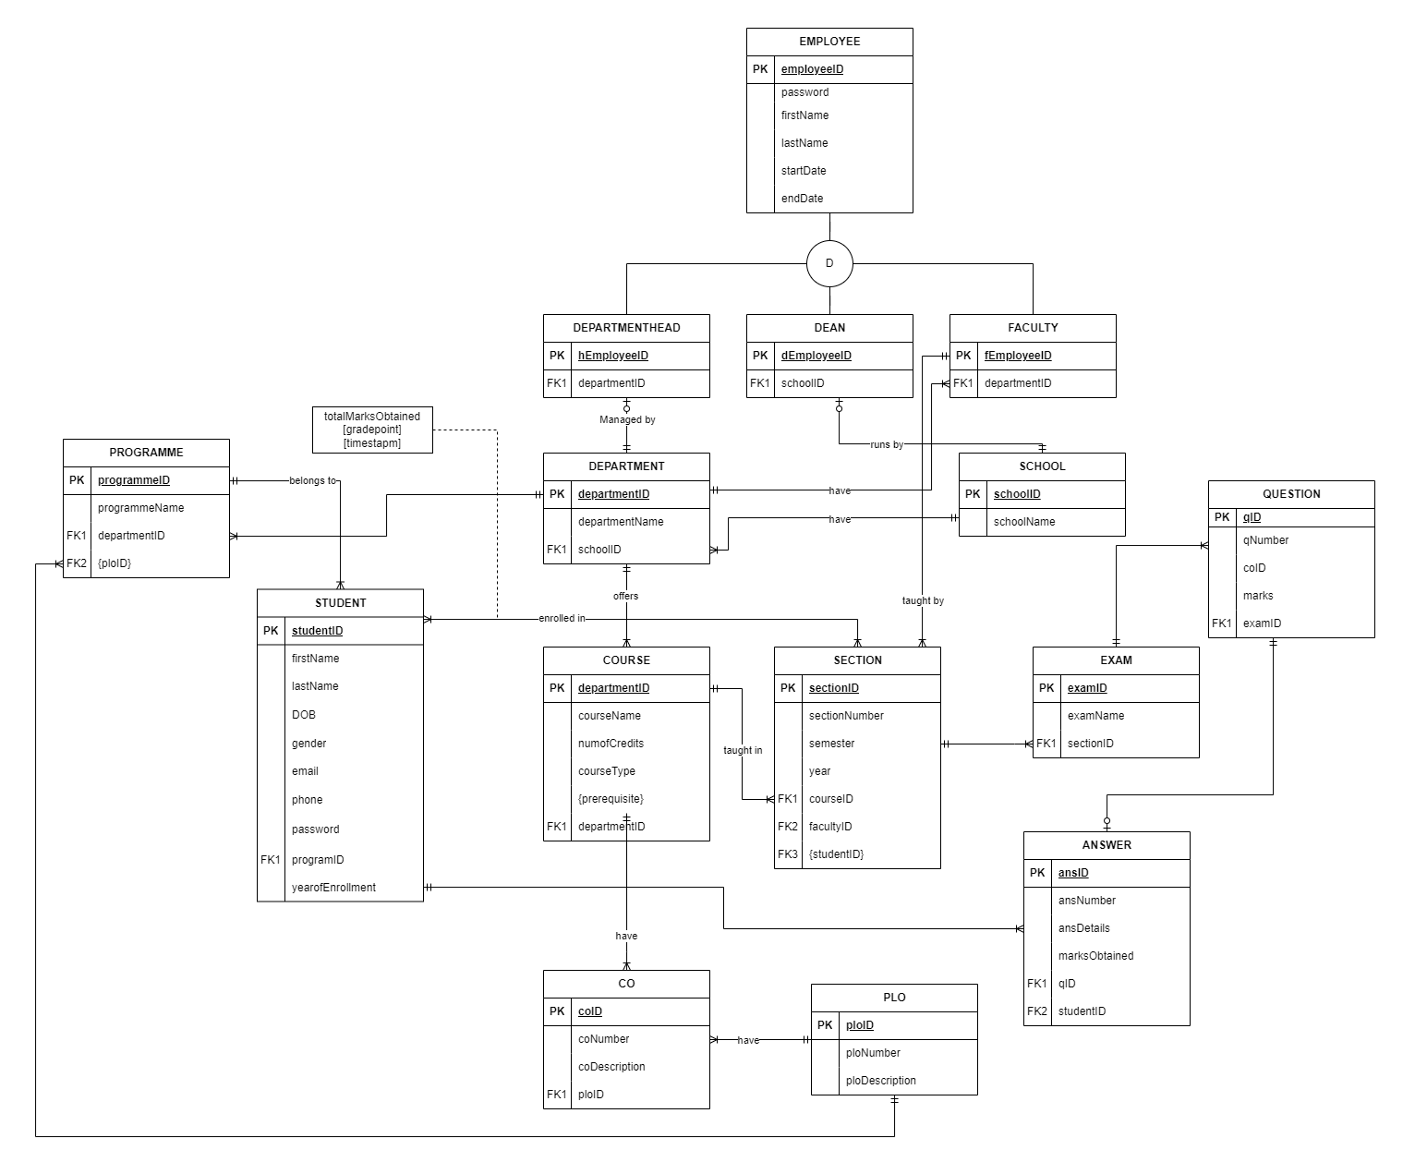

## ERD to Relations

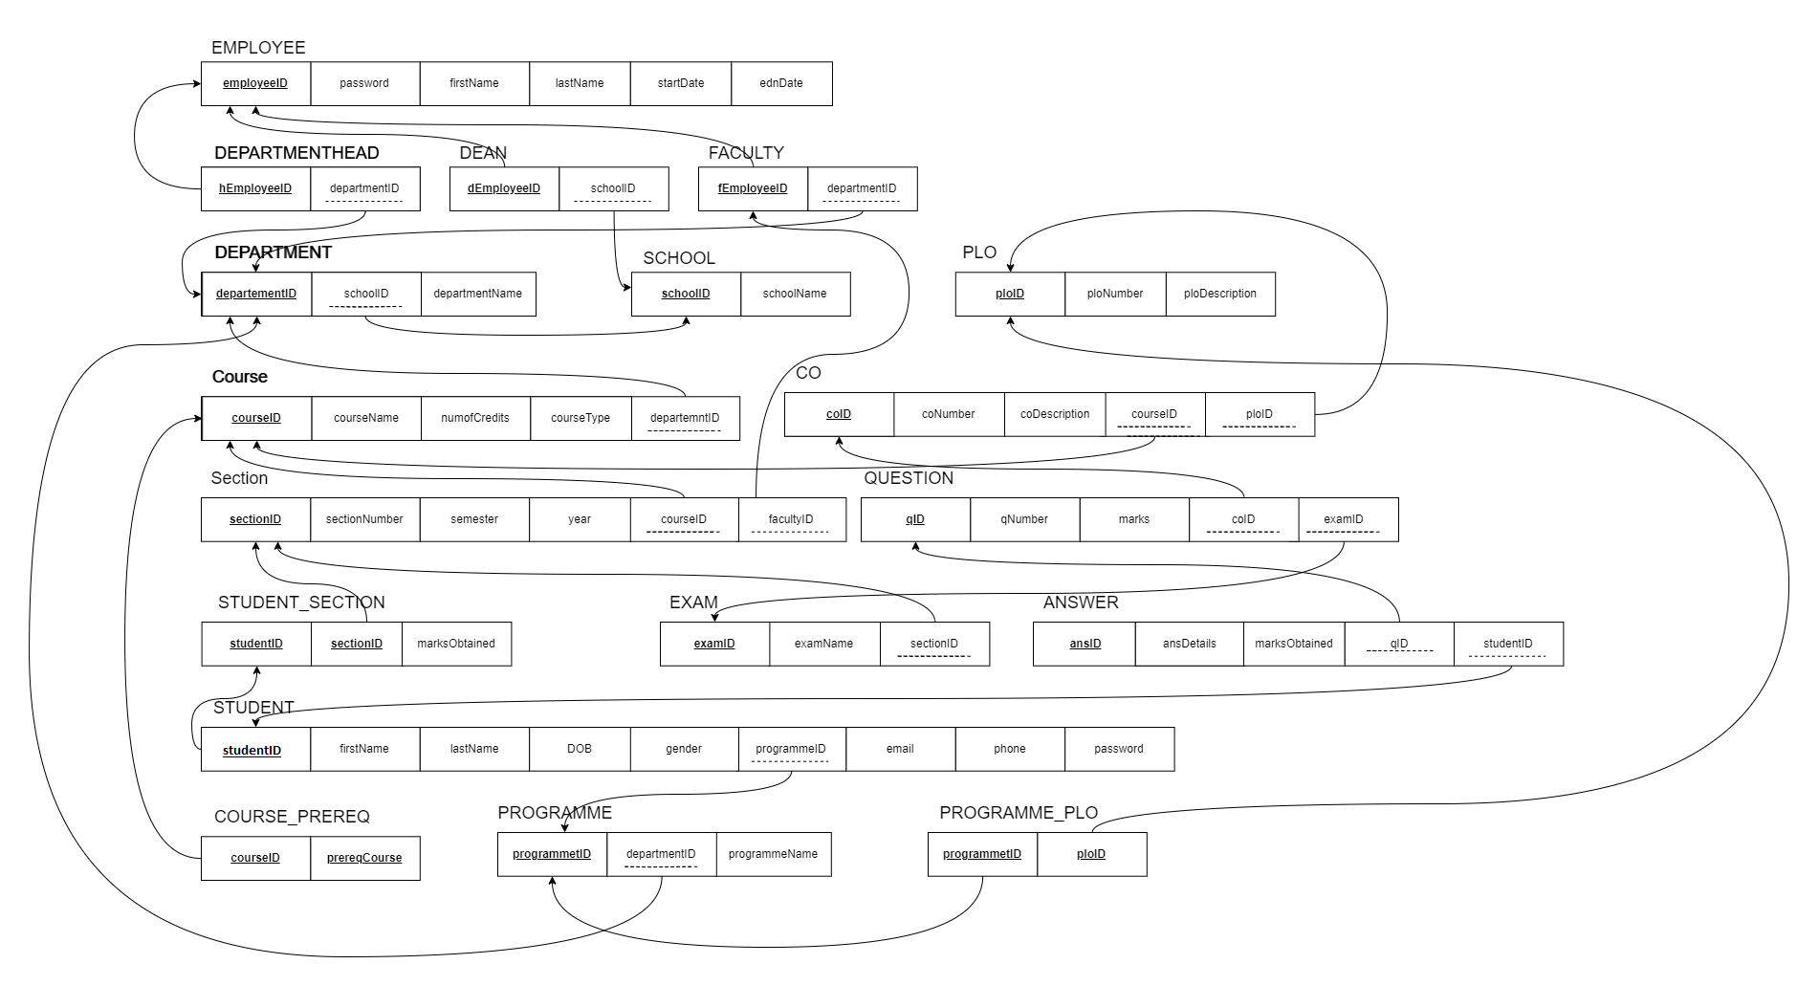

## Normalization

|  |  |  |
| --- | --- | --- |
| Employee (a) | EmployeeID | a1 |
| FirstName | a2 |
| LastName | a3 |
| StartDate | a4 |
| EndDate | a5 |
| password | a6 |
| Faculty (b) | FacultyID | b1 |
| DepartmentID | f1 |
| Dean (c) | dEmployeeID | c1 |
| SchoolID | e1 |
| Department Head(d) | departmentID | d1 |
| SchoolID | e2 |
| School (e) | SchoolID | e1 |
| SchoolName | e2 |
| Department (f) | DepartmentID | f1 |
| SchoolID | e1 |
| DepartmentName | f2 |
| PLO(g) | ploID | g1 |
| ploNumber | g2 |
| ploDescription | g3 |
| Course(h) | CourseID | h1 |
| CourseName | h2 |
| Numofcredits | h3 |
| Coursetype | h4 |
| DepartmentID | h5 |
| CO(i) | coID | i1 |
| coNumber | i2 |
| coDescription | i3 |
| CourseID | h1 |
| ploID | g1 |
| Section (j) | SectionID | j1 |
| SectionNumber | j2 |
| Semester | j3 |
| Year | j4 |
| CourseID | h1 |
| FacultyID | b1 |
| Question(k) | qID | k1 |
| qNumber | k2 |
| Marks | k3 |
| coID | i1 |
| examID | m1 |
| Student Section (l) | StudentID | o1 |
| SectionId | j1 |
| Marks obtained | l1 |
| Exam (m) | ExamID | m1 |
| ExamName | m2 |
| SectionID | j1 |
| Answer (n) | AnswerID | n1 |
| AnswerDetails | n2 |
| MarksObtained | n3 |
| qId | k1 |
| StudentID | o1 |
| Student(o) | StudentID | o1 |
| FirstName | o2 |
| LastName | o3 |
| DOB | o4 |
| Gender | o5 |
| ProgrammeID | q1 |
| Email | o6 |
| Phone | o7 |
| Password | o8 |
| Course Preq (p) | CourseID | h1 |
| PrereqCourse | p2 |
| Programme (q) | ProgrammeID | q1 |
| DepartmentID | f1 |
| Programme Name | q3 |
| Programme PLO (r) | ProgrameID | q1 |
| PloID | g1 |

After Normalization:

a1 → a2, a3, a4, a5, a6

b1 → f1

c1 → e1

d1 → e2

e1 → e2

f1 → e1, f2

g1 → g2, g3

h1 → h2, h3, h4, h5

i1 → i2, i3, h1, g1

j1 → j2, j3, j4, h1, b1

k1 → k2, k3, i1, m1

l1 → o1, j1, l2

m1 → m2, j1

n1 → n2, n3, k1, o1

o1 → o2, o3, o4, o5, q1, o6, o7, o8

p1 → p2, h1

q1 → f1, q3

r1 → q1, g1

## Data Dictionary

School_T

|  |  |  |  |
| --- | --- | --- | --- |
| Name | Data Type | Size | Remarks |
| cSchoolID | VARCHAR | 5 | This is the primary key of School.  E.g.: “SETS” |
| cSchoolName | VARCHAR | 50 | This is the name of the school.  E.g.: “School of Engineering, Technology & Science”. |

Program_T

|  |  |  |  |
| --- | --- | --- | --- |
| Name | Data Type | Size | Remarks |
| ansID | INTEGER |  | This is the primary key for a program. E.g.: “1” |
| ansDetails | VARCHAR | 50 | This is the name of the program.  E.g.: “Bachelor of Science” |
| marksObtained | INTEGER | 3 |  |

Answer_T

|  |  |  |  |
| --- | --- | --- | --- |
| Name | Data Type | Size | Remarks |
| ansID | INTEGER |  | This is the primary key for a program. E.g.: “1” |
| ansDetails |  |  | These are the details from the provided question. |
| marksObtained | INTEGER | 3 |  |
| cqID | INTEGER |  | This is the foreign key from the Question table.  E.g.: “CSE” |
| cstudentID | INTEGER |  | This is the foreign key from the Student table.  E.g.: “CSE” |

Department_T

|  |  |  |  |
| --- | --- | --- | --- |
| Name | Data Type | Size | Remarks |
| cDepartmentID | VARCHAR | 3 | This is the primary key for the  Department table.  E.g.: “CSE” |
| cDepartmentName | VARCHAR | 50 | This is the name of the department.  E.g.: “Computer Science and Engineering”. |
| cSchoolID | VARCHAR | 5 | This is a foreign key from the school table.  E.g.: “SETS”. |

CO_T

|  |  |  |  |
| --- | --- | --- | --- |
| Name | Data Type | Size | Remarks |
| nCOID | INTEGER |  | This is the primary key for the CO table.  E.g.: “1”. |
| cCONum | TEXT |  | E.g.: “CLO1”. |
| coDescription | Integer |  | This is the details for Course Outcome. |
| cPLOID | INT |  | This is the foreign key from the Program Learning Outcome table.  E.g.: “PLO1” |
| cCourseID | VARCHAR | 6 | This is the Foreign Key from the Course table.  E.g.: “CSE203” |

PLO_T

|  |  |  |  |
| --- | --- | --- | --- |
| Name | Datatype | Size | Remarks |
| cPLOID | VARCHAR | 5 | This is the primary key for Program Learning Outcome.  E.g.: “PLO1” |
| nPLONum | INTEGER |  | This is the PLO number. E.g.: “1” |
| cploDescription | VARCHAR | 50 | These is the details for Program Learning Outcome. E.g.: “An ability to select and apply the knowledge, technique, skills and modern tools of the computer science and engineering discipline” |

Student_T

|  |  |  |  |
| --- | --- | --- | --- |
| Name | Data Type | Size | Remarks |
| nStudentID | INTEGER |  | This is the primary key for the student table.  E.g.: “1921834”. |
| cFirstName | VARCHAR | 30 | This is the first name of the student.  E.g.: “Rakibul”. |
| cLastName | VARCHAR | 30 | This is the last name of the student.  E.g.: “Hasan”. |
| dDateOfBirth | DATE | DD  MM  YYYY | This is the birth date of the student.  E.g.: “21-12-1996”. |
| cGender | VARCHAR | 6 | This is the gender of the student.  E.g.: “Female”. |
| cEmail | VARCHAR | 30 | This is the email of the student.  E.g.: “1921834@iub.edu.bd” |
| nPhone | NUMERIC | 11 | This is the phone of the student.  E.g.: “01XXXXXXXXX”. |
| dEnrollmentDate | DATE | DD  MM  YYYY | This is enrollment date of the student.  E.g.: “1-1-2019” |
| cProgramID | INTEGER |  | This is the foreign key from the program table.  E.g.: “1” |

Employee_T

|  |  |  |  |
| --- | --- | --- | --- |
| Name | Datatype | Size | Remarks |
| nEmployeeID | INTEGER |  | This is the primary key for Employee table.  E.g.: “1801” |
| Password | STRING | 20 | This is the password of the employee. |
| cFirstName | VARCHAR | 30 | This is the first name of the faculty.  E.g.: “Sadita” |
| cLastName | VARCHAR | 30 | This is the last name of the faculty.  E.g.: “Ahmed” |
| JoinDate | DATE | dd-mm-yyyy | This is starting date.  E.g.: “01-02-2019” |
| EndDate | DATE | dd-mm-yyyy | This is the date retires from his post.  E.g.: “01-04-2025” |

 Course_T

|  |  |  |  |
| --- | --- | --- | --- |
| Name | Datatype | Size | Remarks |
| cCourseID | VARCHAR | 6 | This is the Primary Key for the Course.  E.g.: “CSE203” |
| cCourseName | VARCHAR | 40 | This is the name of the Course.  E.g.: “Discreet Mathematics” |
| nNumOfCredits | INTEGER |  | This is the number of credits for the Course.  E.g.: “3” |
| cCourseType | VARCHAR | 10 | This is the type of the Course. E.g.: “Core” |
| CdepartmentID | INTEGER |  | This is the foreign key from the Department table.  E.g.: “PLO1” |

Section_T

|  |  |  |  |
| --- | --- | --- | --- |
| Name | Datatype | Size | Remarks |
| nSectionID | INTEGER |  | This is the Primary Key for Section.  E.g.: “1” |
| nSectionNum | INTEGER |  | This is the section number.  E.g.: “1” |
| cCourseID | VARCHAR | 6 | This is the foreign key from the Course table.  E.g.: “CSE101” |
| cSemester | VARCHAR | 6 | This is the semester of the section.  E.g.: “Summer” |
| cFacultyID | NUMERIC | 4 | This is the foreign key from Faculty table.  E.g.: “1801” |
| dYear | YEAR | yyyy | This is the year of registration.  E.g.: “2019” |

Question_T

|  |  |  |  |
| --- | --- | --- | --- |
| Name | Datatype | Size | Remarks |
| nQuestionID | INTEGER |  | This is the Primary Key for  Assessment. |
| cCoID | INTEGER | 30 | This is the Foreign Key from the CO table. |
| cMarks | NUMBER |  | Each question marks the assessment.  E.g.: “30” |
| nQuestionNum | INTEGER |  | This is the question number.  E.g.: “1,2,3….” |
| ExamID | INTEGER |  | This is the Foreign Key from the Exam table. |

Faculty_T

|  |  |  |  |
| --- | --- | --- | --- |
| Name | Datatype | Size | Remarks |
| nFacultyID | INTEGER |  | This is the primary key for the faculty table.  E.g.: “4250” |
| cDepartmentID | VARCHAR | 3 | This is the foreign key from the Department table.  E.g.: “CSE” |

Dean_T

|  |  |  |  |
| --- | --- | --- | --- |
| Name | Datatype | Size | Remarks |
| nDeanID | INTEGER |  | This is the primary key for the admin table.  E.g.: “4250” |
| cSchoolID | VARCHAR | 5 | This is a foreign key from the school table.  E.g.: “SETS”. |

Department_Head_T

|  |  |  |  |
| --- | --- | --- | --- |
| Name | Datatype | Size | Remarks |
| hemployeeID | INTEGER |  | This is the Primary Key for The Department Head table. |
| ndepartmentID | INTEGER |  | This is the Foreign Key from Department table. |

# Ch-4 Physical System Design

## Input Forms

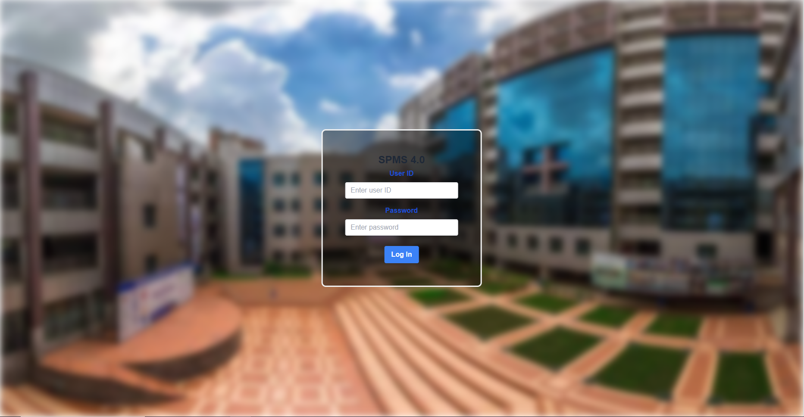

## Output Query & Reports

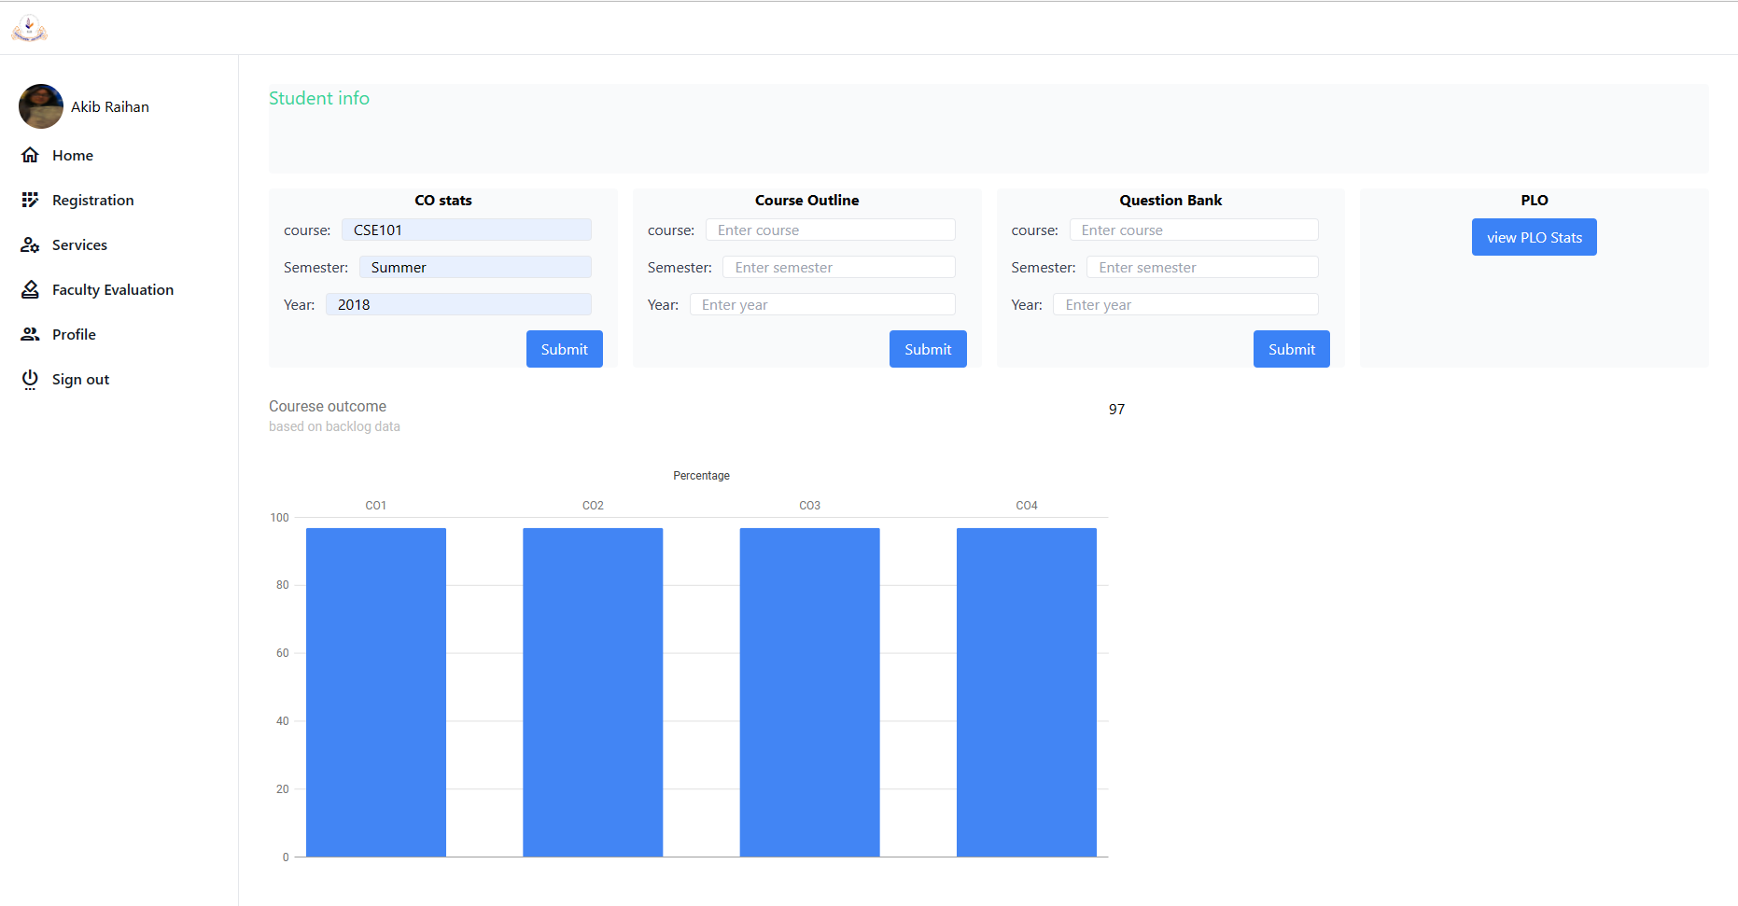

# Ch-5 Conclusion

## Problem & Solution

1. Our ability to utilize this program to its full potential has been hampered by the limited period of the semester and evil teammates. We intend to make enhancements with greater analysis when given more time, but we believe we have produced the best program we could given the time and resources available.
2. We might think that we could have produced far more trustworthy and accurate outcomes, representations, and predictions if given more tools and information to work with.

## Additional Feature & Future Development

Future Development Scope:

1. The number of users will be increased to include advisers, who will receive pertinent data on the students they are advising for better and more advantageous interactions between students and advisors.
2. Project goals include adding a component that predicts a candidate's marks based on prior previous grades and performances.

## Conclusion & Recommendations

We think the idea we had for our SPM software has been created, built, and implemented in the greatest way possible. With the appropriate application of this software, we intend to significantly raise the standard of education offered by institutions. This program can be used by students who want to become better and more capable scholars, by faculties to keep better track of their students and adjust their teaching strategies accordingly, and by institution members to more effectively manage their resources.