**Helm repositories:**

We know that we can add the helm stable repository with the helm repo add command.

$ Helm repo add stable <https://charts.helm.sh/stable>

But keep in mind that this repository is no longer maintained, and its charts are deprecated. So you can find the latest helm charts in Helm repository hub.

The helm repository hub can be accessed at one of the following addresses.

<https://hub.helm.sh/>

<https://artifacthub.io/>

**Using existing charts:**

There are 2 ways to use existing charts. The first way, is to define an export property in the child chart.

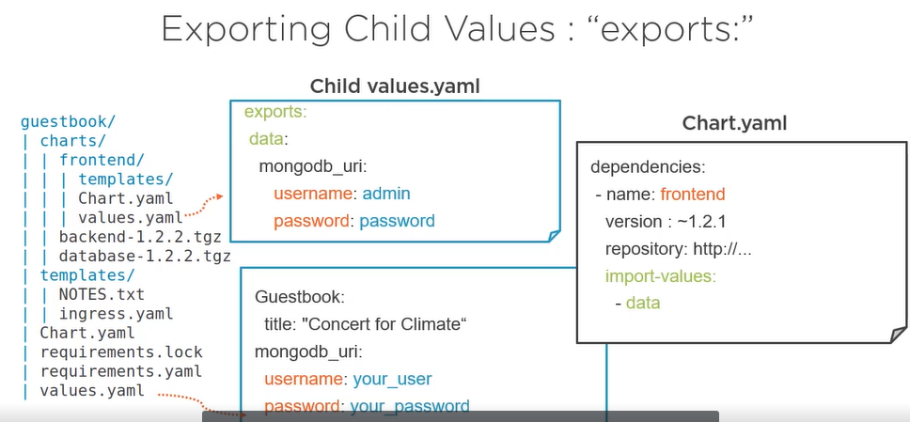

To make that export property available in the parent chart, you can add import-values property in the dependency section of the chart.yaml file in the block corresponding to the child chart.

Note that the data property is used to embed the exported property.

The other technique is to use the a child parent mapping.