**How to get Jenkins file from git SCM:**

* Create a new job or use existing job(type : pipeline)

Then select the option of ‘pipeline script from SCM’ in configure for the job as shown below

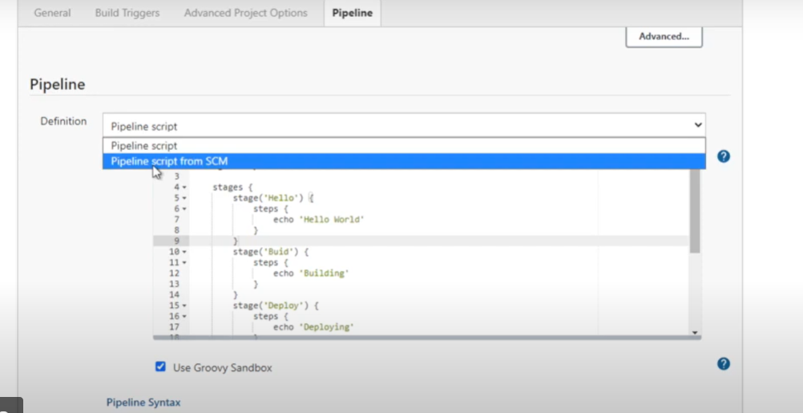

* Create a repository or github.
* Then add Jenkinsfile in the repository.
* Under Jenkins job >pipeline section >select definition pipeline script from SCM.
* Add repo and jenkinsfile location in the job under pipeline section.
* Save and run.

**How to clone GIT repo using Jenkinsfile:**

To add the GIT repo we can generate the corresponding declarative syntax from the pipeline syntax option in pipeline and then add it to the code as shown below:

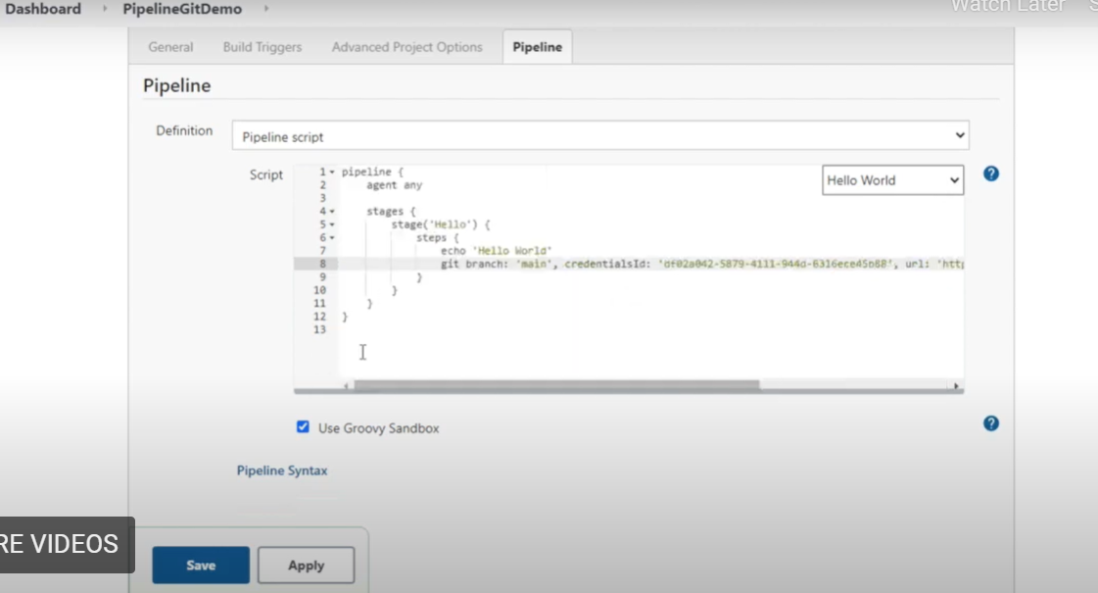

Apply and save the changes and trigger the build.