System Requirements Statement (SRS) –

Jungle Safari Management System

1. Introduction 3

2. Functional Requirements 4

2.1 User Module 5

2.2 Park Management Module 7

2.3 Admin Module 11

2.4 Message Acknowledgement module 17

2.5 Use Case Diagram.............................................................................................................................21

THIS DOCUMENT CONTAINS 23 NUMBERED PAGES

# Introduction

This document explains the system requirements and scope for developing Jungle Safari Management System.

Jungle Safari Management System could divide the Four main parts, User part, Park Management Team,Admin part and Message acknowledgement part.

This document describes the system requirement of the Account part.

# Functional Requirements

The Account part of Jungle Safari Management System has three modules which are divided 13 processes described as below.

|  |  |  |
| --- | --- | --- |
| **No** | **BRS requirement ID** | **Description** |
| **2.1** | **User Module** | |
| **2.1.1** | **F1** | **Account Creation Process** |
| **2.1.2** | **F2** | **Login Process** |
| **2.1.3** | **F3** | **Forgot Password Process** |
| **2.1.4** | **F4** | **Change Password Process** |
| **2.1.5** | **F5** | **Update Account Process** |
| **2.1.6** | **F6** | **Select Booking Date** |
| **2.1.7** | **F7** | **Select Number Of Persons** |
| **2.1.8** | **F8** | **Select Additional Services** |
| **2.1.9** | **F9** | **Confirm Booking** |
| **2.1.10** | **F10** | **Cancel Ticket** |
| **2.2** | **Park Management Module** | |
| **2.2.1** | **F11** | **Registration Process** |
| **2.2.2** | **F12** | **Login Process** |
| **2.2.3** | **F13** | **Forgot Password Process** |
| **2.2.4** | **F14** | **Change Password Process** |
| **2.2.5** | **F15** | **Create Safari** |
| **2.2.6** | **F16** | **Update Safari** |
| **2.2.7** | **F17** | **Delete safari** |
| **2.2.8** | **F18** | **Update Guide Information** |
| **2.3 Admin Module** | | |
| **2.3.1** | **F19** | **Login Process** |
| **2.3.2** | **F20** | **Forgot Password Process** |
| **2.3.3** | **F21** | **Change Password Process** |
| **2.3.4** | **F22** | **Update Account Process** |
| **2.3.5** | **F23** | **Generate Report** |
| **2.3.6** | **F24** | **Account Management** |
| **2.4 Message Acknowledgement Module** | | |
| **2.4.1** | **F25** | **Sends Messages of Acknowledgement** |

## User Module

* User can register and login.
* Jungle safari management system provides the function which allows user to book tickets online.
* Individuals are able to browse the website features and information about the park.
* The user could find what are pricing and timings to visit the park.

### Account Creation Process

Jungle Safari Management System compels to create the account before using it. So, Jungle Safari Management System should provide the function which makes user creates new account.

* When user creates new account, the function demands four information described as below.

1. Login information
2. Contact Details

* The Login information

The Login information consists of some items described as below.

1. User ID/mob number
2. Password
3. First Name
4. Last Name
5. E-mail address
6. Select Gender
   * All items are compulsory demanded.
   * User ID

* The User ID should be unique. If the User ID correspond with not case-sensitive to other which is previously registered, the User ID should not be registered as an account. User can also use his own mobile number

for Login

* + Password
* The Password has constrains which makes the Password consists of more than or equal 8 and less than or equal 16 characteristics including characters described as below.

1. Numeric figure (at least one)
2. Capital alphabet (A-Z)(at least one)
3. Small alphabet (a-z)(at least one)
4. Special character (#, $, %, &, etc.) (at least one)

* The Password is masked by dummy characters. The re-entering Password is demanded.
* The Password must be encrypted in Jungle Safari Management System.
  + User Type

The User Type falls into three categories described as below.

1. Visitor User
2. Management team
3. Admin

* The User Type defines also three types of user; "Visitor user", "Management user", and "Admin user”.
* In an Account Creation Process, the user can select either Visitor User or Management Team.
* No one could select The Admin, because Admin is implemented to Jungle Safari Management System in advance.
* Contact Details
* The Contact Detail consists of some items described as below.

1. Permanent Address.
2. Contact Phone No.
   * All items are compulsory demanded.
   * Permanent Address

* Permanent Address should be filled.
* But only the state should be selected from options.
* The Security Question information

The Security Question information is needed when User lost their Password. This information consists of two items described as below.

1. Selected Question
2. Answer
   * All items are compulsory demanded.
   * Some questions which are difficult to answer for anyone else are prepared in advance.

E.g. which color do you like most?

* + A question should be selected from options by the User, and the Answer is registered by the User.
* Login information should be entered on one screen, and then User information and Security Question information should be entered on another screen.

### Login Process

* Jungle Safari Management System always compels user authentication before using itself except when a new account is successfully created.
* The user authentication demands User ID and Password. The User ID and the Password should be checked in three ways.
  + First, The UserID and the Password should be existed and correct.
* If The UserID and the Password are not equal to what the user has registered, the user authentication cannot be provided.
  + Second, the User Type linked to the UserID should be "User".
* When the User Type is " Visitor User", then user can be placed on “ Home Page”.
  + Finally, UserID should be available.
* The Admin can decide whether the UserID is available or suspended – Refer to the SRS of the Admin part.
* If User is rejected, user authentication is not provided for system user.
* The User account should alive for so long as the duration decided by Admin.
* Only when the three checks are successfully completed, User can be placed on respected page.
* The “Home Page” provides the some items described as below.

1. A trigger to login
2. A trigger to Forgot Password

*************Add more use cases**************

### Forgot Password Process

* When system user lost their Password, the recovery method should be provided by Jungle Safari Management System.

The recovery method is described as below.

* + First, system user enters their UserID or Phone number for Jungle Safari Management System .
  + Next Jungle Safari Management System demands the Answer which has been registered since when the Account was created.
  + Only when the Answer is correct, User get the new password by E-mail or Phone which also has been registered since when the Account was created.
* The new password is automatically generated by Jungle Safari Management System .
* Of course, the new password should consist of more than or equal 8 and less than or equal 16 characteristics including at least a numeric figure, a capital alphabet, a small alphabet, and a special character.
* As a consequence, The User could get the User authentication using the new password.
  + Then, the User had better change the new password manually.
* If the Answer is not correct, otherwise, the correct Answer is demanded for user again.
  + In that case, Of course, User couldn’t get the new password.

### Change Password Process

* When User wants to change their Password, the measure should be provided by Jungle Safari Management System.
* Therefore Jungle Safari Management System should provide the function which is available after getting the User authentication.
* The function demands the current password and the new password.
  + Of course, the new password should consist of more than or equal 8 and less than or equal 16 characteristics including at least a numeric figure, a capital alphabet, a small alphabet, and a special character.
  + The current password and the new password are masked by using dummy characters.
  + The new password is demanded to enter twice to avoid a typing error.
* Only when the current password is correct, User could change their Password.
* When the current password is changed into new password, Jungle Safari Management System compels user authentication again.

### Update Account Process

* Jungle Safari Management System should provide the function which makes the account updated for User.
* The information User could update is described below.

1. Login information
2. User information
3. Security Question Information

* The Login information

The updatable items as described below.

1. First Name
2. Last Name
3. E-mail address
   * All items are compulsory demanded, but updating is optional.

* The User information

The updatable items as described below.

1. User Name
2. User Phone No
3. E-mail address
4. Permanent address
   * All items are compulsory demanded, but updating is optional.
   * All items are compulsory demanded but updating is optional.

### Select Booking Date

* Check available Date.

### Select Number Of Adults and Children

* Search conditions are described as below.

1. Below 18(Children)
2. Above 18(Adults)

### 2.1.8 Select Additional Services

* User can Select Additional Services.

1. Gypsy
2. Museum
3. Guide

### 2.1.9Confirm Ticket

* User will see the selected Services charges.
* User will get redirected to particular transaction page.

### 2.1.10Cancel Ticket

* User can able to cancel the order with valid reason.

#### 2.2Park Management Module

### Registration process

* Jungle Safari Management System compels to create the account before using it. So, Jungle Safari Management System should provide the function which makes user creates new account.
* When user creates new account, the function demands four information described as below.

1.Login information

2.Contact Details

3.Security Question Information

4.Mode of Payment.

* The Login information

The Login information consists of some items described as below.

5.UserID/mob number

6.Password

7.First Name

8.Last Name

9.E-mail address

10.User Type

* + All items are compulsory demanded.
  + UserID
* The UserID should be unique. If the UserID correspond with not case-sensitive to other which is previously registered, the UserID should not be registered as an account.
  + Password
* The Password has constrains which makes the Password consists of more than or equal 8 and less than or equal 16 characteristics including characters described as below.

1.Numeric figure (at least one)

2.Capital alphabet (A-Z)(at least one)

3.Small alphabet (a-z)(at least one)

4.Special character (#, $, %, &, etc.) (at least one)

* The Password is masked by dummy characters. The re-entering Password is demanded.
* The Password must be encrypted in Jungle Safari Management System.
  + User Type

The User Type falls into three categories described as below.

1.User

2.Park Management Team

3.Administrator

* The User Type defines also three types of user; " Vistor user", "Park Management user", and "Admin user”.
* In an Account Creation Process, the user can select Park management Team.
* No one could select The Admin, because Only Admin have Access to Jungle Safari Management System in advance.
* Contact Details
* The Contact Detail consists of some items described as below.

1.Permanent Address

2.Contact Phone No

* + All items are compulsory demanded.
  + Permanent Address
* Permanent Address should be filled.
* But only the state should be selected from options.
* Login information should be entered on one screen, and then Park Management User information and Security Question information should be entered on another screen.

### Login Process

* Jungle Safari Management System always compels Park Management authentication before using itself except when a new account is successfully created.
* The user authentication demands UserID and Password. The UserID and the Password should be checked in three ways.
  + First, The UserID and the Password should be existed and correct.
* If The UserID and the Password are not equal to what the user has registered, the user authentication cannot be provided.
  + Second,
* When the User Type is Park Management , user can be placed on “Park Management Home”.
  + Finally, UserID should be available.
* The Admin can decide whether the UserID is available or suspended – Refer to the SRS of the Admin part.
* If user is rejected, user authentication is not provided for Park Management.
* The Park Management account should alive for so long as the duration decided by Admin.
* Only when the three checks are successfully completed, Park Management can be placed on respected page.
* The “Park Management Home” provides some items described as below.

1. A trigger to login
2. A trigger to update Account
3. A trigger to Change Password
4. A trigger to Select Category
5. A trigger to Publish Product for Rent
6. A trigger to Update Product Information
7. A trigger to Delete Product
8. A trigger to Accept Order
9. A trigger to Cancel Order

### Forgot Password Process

* When Park Management lost their Password, the recovery method should be provided by Jungle Safari Management System.

The recovery method is described as below.

* + First, Park Management enters their UserID/mob number Jungle Safari Management System.
  + Next, Jungle Safari Management System demands the Answer which has been registered since when the Account was created.
  + Only when the Answer is correct, Park Management get the new password On E-mail as well as on mob number
  + which also has been registered since when the Account was created.
* The new password is automatically generated by Jungle Safari Management System .
* Of course, the new password should consist of more than or equal 8 and less than or equal 16 characteristics including at least a numeric figure, a capital alphabet, a small alphabet, and a special character.
* As a consequence, The Park Management could get the user authentication using the new password.
  + Then, the Park Management had better change the new password manually.
* If the Answer is not correct, otherwise, the correct Answer is demanded for Park Management again.
  + In that case, Of course, Park Management couldn’t get the new password.

### Change Password Process

* When Park Management wants to change their Password, the measure should be provided by Jungle Safari Management System.
* Therefore, Jungle Safari Management System should provide the function which is available after getting the Park Management authentication.
* The function demands the current password and the new password.
  + Of course, the new password should consist of more than or equal 8 and less than or equal 16 characteristics including at least a numeric figure, a capital alphabet, a small alphabet, and a special character.
  + The current password and the new password are masked by using dummy characters.
  + The new password is demanded to enter twice to avoid a typing error.
* Only when the current password is correct, Park Management could change their Password.
* When the current password is changed into new password, Jungle Safari Management System compels Park Management authentication again.

### Create Safari

### Update Safari

### Delete Safari

### Update Guide Information

#### Admin Module

**•** Adminshould be responsible for following activities**,**

### Login Process

* Jungle Safari Management System always compels user authentication before using itself except when a new account is successfully created.
* The user authentication demands UserID and Password. The UserID and the Password should be checked in three ways.
  + First, The UserID and the Password should be existed and correct.
* If The UserID and the Password are not equal to what the admin has registered, the Admin authentication cannot be provided.
  + Second, the User Type linked to the UserID should be "Admin".
* When the User Type is "Admin", user can be placed on “Admin Home”.
  + Finally, UserID should be available.
* The Administrator can decide whether the UserID is available or suspended – Refer to t
* .0he SRS of the Admin part.
* If user is rejected, user authentication is not provided for system user.
* The Admin account should alive for so long as the duration decided by Admin.
* Only when the three checks are successfully completed, Admin can be placed on respected page.
* The “Admin Home” provides the some items described as below.

1. A trigger to logout
2. A trigger to update Account
3. A trigger to Change Password

### Forgot Password Process

* When Admin lost their Password, the recovery method should be provided by Jungle Safari Management System.

The recovery method is described as below.

* + First, Admin enters their UserID for Jungle Safari Management System.
  + He will enter the E-mail id since when the Account was created.
  + Only when the E-mail Id is correct, Admin get the new password by E-mail which also has been registered since when the Account was created.
* The new password is automatically generated by Jungle Safari Management System .
* Of course, the new password should consist of more than or equal 8 and less than or equal 16 characteristics including at least a numeric figure, a capital alphabet, a small alphabet, and a special character.
* As a consequence, The Admin could get the Admin authentication using the new password.
  + Then, the Admin had better change the new password manually.

### Change Password Process

* When Admin wants to change his Password, the measure should be provided Jungle Safari Management System.
* Therefore, Jungle Safari Management System should provide the function which is available after getting the Admin authentication.
* The function demands the current password and the new password.
  + Of course, the new password should consist of more than or equal 8 and less than or equal 16 characteristics including at least a numeric figure, a capital alphabet, a small alphabet, and a special character.
  + The current password and the new password are masked by using dummy characters.
  + The new password is demanded to enter twice to avoid a typing error.
* Only when the current password is correct, Admin could change his Password.
* When the current password is changed into new password, Jungle Safari Management System compels user authentication again.

### Update Account Process

* Jungle Safari Management System should provide the function which makes the account updated for Admin.
* The information Admin could update is described below.

1. Login information
2. User information
3. Security Question Information

* The Login information

The updatable items as described below.

1. First Name
2. Last Name
3. E-mail address
   * All items are compulsory demanded, but updating is optional.

* The User information

The updatable items as described below.

1. User Name
2. User Phone No
3. E-mail address
4. Permanent address
   * All items are compulsory demanded, but updating is optional.

* The Security Question information

The updatable items as described below.

1. Selected Question
2. Answer
   * All items are compulsory demanded, but updating is optional.

#### Record Generation

• Admin should able to see all the records from any users.

• Daily report of enrolment to admin.

Add subpoints

• Monthly report of enrolment as per the states to admin.

#### Accounts Management

• Admin should able to manage all the accounts with following activities,

1. Enable accounts

2. Disable accounts

#### Message Acknowledgement Module

• In following conditions acknowledgement to be send

1. After completion of successful registration.
2. After every successful transaction (search,book).
3. Now the messages are being sent by using email but in future we can have mobile sms.

#### 2.5 Use Case Diagram

**User:**

1. User can handle following use cases:
2. Register
3. Login
4. Book ticket
5. Select Number Of persons
6. Select Additional Services
7. Confirm Ticket
8. Cancel Ticket

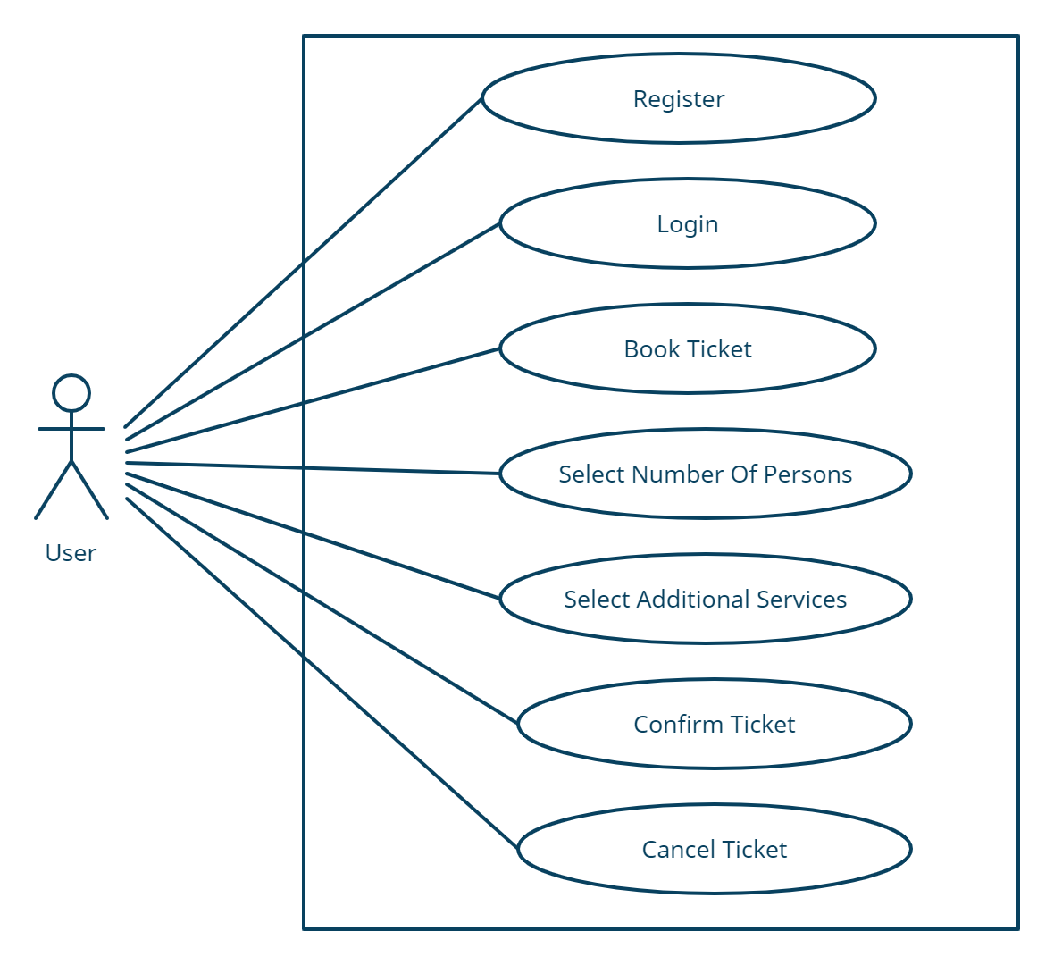

*Fig. Use case diagram for User*

**Park Management Team:**

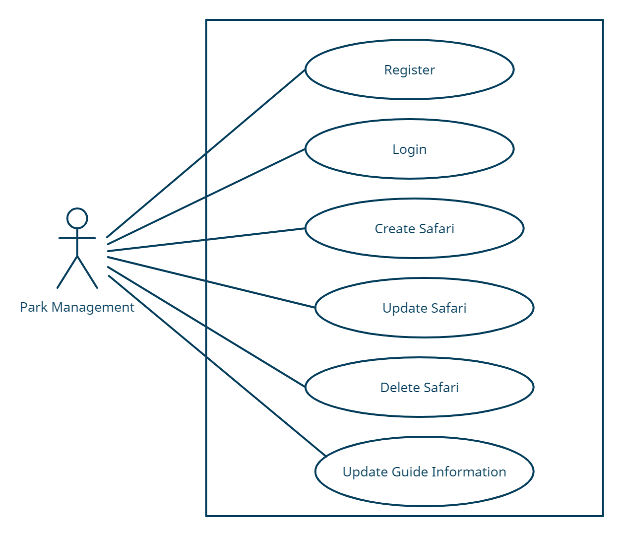

*Fig. Use case diagram for Park Management*

1. In use case diagram Park Management is the Actor**.**
2. Park Management can handle following use cases:
3. Register
4. Login
5. Create Safari
6. Update safari
7. Delete Safari
8. Update Guide Information

**Admin:**

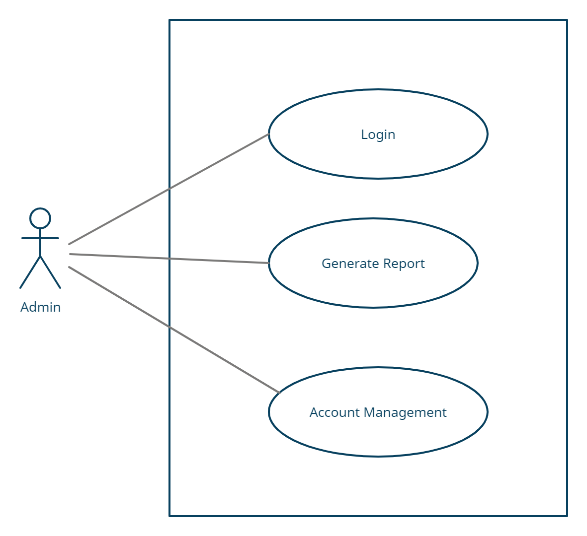

*Fig. Use case diagram for admin*

1. In Admin use case diagram Admin is the Actor.
2. Admin can handle following use cases:
3. Login
4. Generate Report
5. Controls account