Review
Write here the review of the End of Bachelor Degree Project/Master Thesis, the extension of which can not be higher than this page (page number 2 will be then left all in white).
It must be as informative as the nature of the document allows, so that possible readers can decide whether it is worth for them or not to read the complete document; it must define the objective, the methods, the results and the conclusions presented in the body of the document, in this order or initially standing out the results and the conclusions; It must be a complete text so its understandable without having to refer to the memory; it must contain the basic information and the original character of the document. As in all documents, the correction of the style must be ensured, a normalised terminology must be used, or define the non familiar terms, the abbreviations and the symbols that appear for the first time in the review. It is the page number 1 of the document.

NOTES
This template tries to help the realization of the documentation of the End of the Bachelor Degree Project/Master’s Thesis, as aside of incorporating a possible model of the design, automates and facilitates a number of tasks as the elaboration of the summary, the structuring of units and sections, the bibliographic references, the references to equations, figures, tables, sections, bibliography...

Its utilization does not count with the technical support of the School and is therefore exclusive responsibility of the students.

Summary
The following summary is automatically generated and actualised with the option “actualise fields” which appears when the right button of the mouse is pressed on it.

ReVIEW 1
SumMarY 2
1. GlossarY 3
2. Preface 5
2.1. Origin of the project 5
2.2. Motivation 5
2.3. Previous requirements 5
3. Introduction 7
3.1. Objectives of the project 7
3.2. Scope of the project 7
4. Text of the chapter 4 [Ctrl + Shift + 1] 9
4.1. Text of the section 1 of the chapter 4 [Ctrl + Shift + 2] 9
4.1.1. Text of the sub section 1 of the chapter 4 [Ctrl + Shift + 3] 9
Conclusions 11
Thanks 13
Bibliography 15
Bibliographic references 15
Complementary bibliography 16

Glossary
Optional chapter. When a document contains signs, symbols, abbreviations, acronyms or terms which could not be easily and quickly understood by the possible readers, they should be defined in one or various lists. The existence of these lists does not justify the omission of an explanation about these elements when they appear for the first time in the text.

Preface
Optional chapter. A preface can be considered as a presentation note to define the object study of the project, outlining an aspect in particular, showing its relation with related works or drawing the historic circumstances which have motivated the project. Some of the sections can be:

Origin of the project

Motivation

Previous requirements

Introduction
The introduction must briefly establish the scope and the objectives of the project described in the document, its relation with other projects and the methodology used. The review must not be repeated or paraphrased, nor giving details of the theory, the experimentation, the method or the results, or anticipating the conclusions or the recommendations. It can include the information of the preface, if this is not presented separately. Some sections can be:

Objectives of the project

Scope of the project

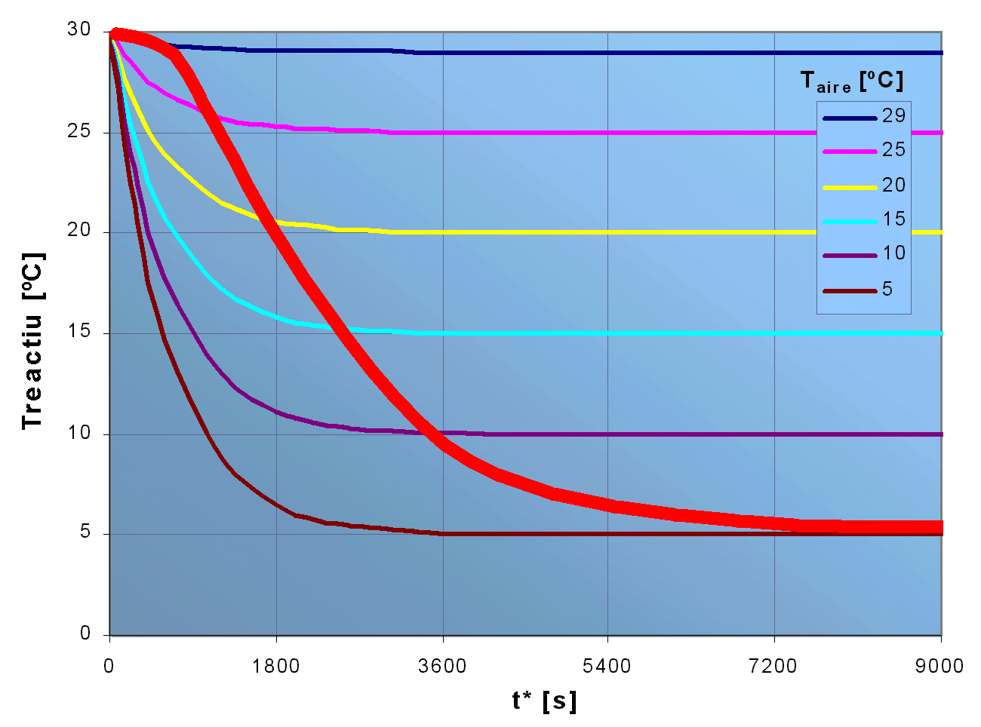
Text of the chapter 4 [Ctrl + Shift + 1]
Tmostra [ºC]
To convert a normal text into a chapter, the following combination must be pressed [Ctrl+Shift+1]
Examples of figure and equations numbering. An option when new figures and equations must be included is to copy the previous example and substitute the content, the numbering will be automatically actualised later.
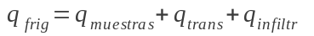 (Ec. 4.1)
Fig. 4.1. Estimation of the real curve of the group of temperatures

The origin and author of all the figures used by the bibliographic references must be respected and commented.

Text of the section 1 of the chapter 4 [Ctrl + Shift + 2]
To convert a normal text into a section level 2, the combination [Ctrl+Shift+2] must be pressed

Text of the subsection 1 of the section 1 of the chapter number 4 [Ctrl + Shift + 3]
To convert a normal text into a section of level 3, the combination [Ctrl+Shift+3] must be pressed
If a reference to an existing equation or figure wants to be done, and we want it to automatically actualise if this varies its position or numbering, a “crossed reference” must be used; you will find it in the menu “Insert” submenu “reference”, and select the desired type (Ec., Fig., Table, indicator, footnote, etc.) with reference to “only mark and number”. If it is find convenient, the “number of page” can also be referenced.
For example: ... as deduced in de la pàgina16...
... as observed in the ...
If a quote to a bibliographic reference of the bibliographic chapter wants to be done, and that this is automatically modified if we later add more references, a “crossed reference” is also used and the type must be “numbering element” regarding to the “number of paragraph” (the number of paragraphs in the bibliographic references must be numbered).
For example: ... characteristics of the climate systems [1], ...

This way we would make reference to the following work which figures at the head:
[1] ASHRAE, American Society of Heating, Refrigerating and Air-Conditioning Engineers, Fundamentals Volume (S.I. edition.). Atlanta: 2001, p. 104-121

Conclusions
The conclusions must be a clear and organized reflect of the conclusions made as a consequence of the work described along the nucleus of the document. Quantitative data can be included but no details of any argument or result should be given.
The recommendations are concise manifestations of a future action seeming necessary, as a direct result of the conclusions or some experience done in the project’s object work course. They are not necessary, although they are completely justified by the described work.
These and the following chapters do not make part of the nucleus of the document and do not need the chapter to be numbered.

Thanks
Thanks related to adjustments in the realization of the work and the preparation of the document can be included. It is not usual to thank the contributions as a routine control, a small help or general type recommendations.
The recognition of other works used must be carried out in reference ways. The thanks making reference to a quoted text and to the use of tables and illustrations may require the recognition of the author rights.

Bibliography
By the end of the document body, a list of all the sources in which the document is based must be included; a reference to this list must be done in the suitable places within the text. Optionally, the supplementary documentation which is not quoted in the text, but which is considered of interest by the reader of the project, must be included as an independent bibliographic list in a section (complementary bibliography) of this same chapter.

Bibliographic references
Only those bibliographic references quoted along the End of Bachelor Degree Project/Master’s Thesis must figure, the rest will be noted in the section of other bibliographic references. It is a recommendable practise to be drafting the bibliography at the same time the documentation of the End of Bachelor Degree Project/Master’s Thesis is carried out, and quotes to these references are written down.
The entrances or elements of the list of references must be given according to the general diagram: Author/Title/Data of the publication (respecting the cursive writing of the title). To facilitate the quotes along the text, a possibility is to number the paragraphs as done in the following examples:
Examples of books, articles, catalogues, computing material and material obtained in the network:
- ASHRAE, American Society of Heating, Refrigerating and Air-Conditioning Engineers, Fundamentals Volume (S.I. edition.). Atlanta: 2001, p. 104-121
- BOSSER, J. Vademécum de mecánica de fluidos y maquinas hidráulicas, Barcelona: ETSEIB - CPDA . 1985.
- CARRIER AIR CONDITIONING CO.: Manual de Aire Acondicionado. Barcelona: Marcombo, 1974, p. 57-64
- GUTOWSKI, T,G., DYM, C.L. Propagation of ground vibration: a review. Journal of Sound and Vibration. Vol. 49(2)*, 1976, p. 179-193. *Revista Volum (Número).
- UNIVERSITAT POLITÈCNICA DE CATALUNYA. SERVEI DE LLENGÜES I TERMINOLOGIA *. Guia lingüística pràctica 2. Barcelona, Servei de Publicacions de la UPC , 1996. *Institució. Departament(s).
- UNIVERSITAT POLITÈCNICA DE CATALUNYA. SERVEI DE LLENGÜES I TERMINOLOGIA. Guia lingüística pràctica 2. Barcelona, 1998.
[http://www.upc.es/slt/cat/publicacions/gl2/gl2.htm, 21 de setembre de 2000]*. *[URL, data de consulta].
- FUNDACIÓ SERVEIS DE CULTURA POPULAR. Introducció a la geometria descriptiva, II: la perspectiva cònica. Barcelona, 1993. [Vídeo]*. *[Suport, tipus de material].

Complementary bibliography
If this section is needed, it must be presented the same way as the list of the previous references, but with the difference that the consulted bibliographic references or relative to the object topic of the End of Bachelor Degree Project/ Master’s Thesis and which have not been quoted along the same can figure. The criteria in which the documents have been selected should be indicated.

