Project Lifecycles
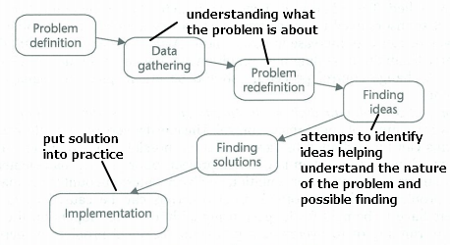
Subdividing problems into more tasks: easier to manage, there can be many ways but the core activities (understanding the problem, choosing and designing, and building the solution).

Software development project = focused solely on producing a software system that satisfies the user requirements
System development project = wider cope, may not even include software.

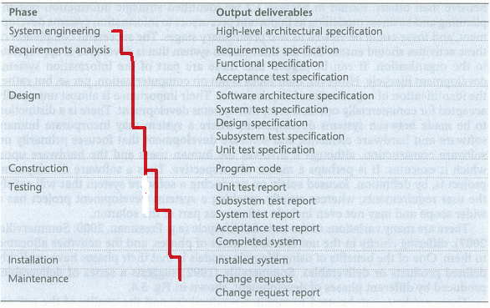
Waterfall lifecycle = systematic approach,
good when requirements are not likely to change during the development process and nothing has to be delivered during the dev. proc.:
+ the phases have explicitly defined products or deliverables which can be manages individually.
- Real project rarely are that simply structured
- Task have to be repeated
- requirements may change (when lot of time between start and end)
- difficult to change, inflexible (f.ex when new technologies comes up)

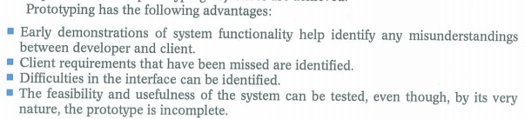
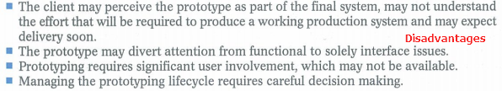
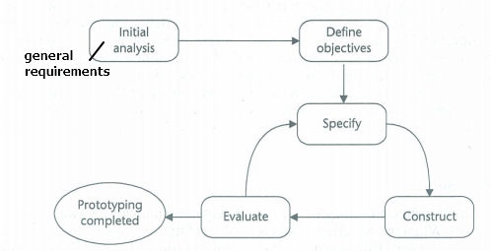
Prototype:
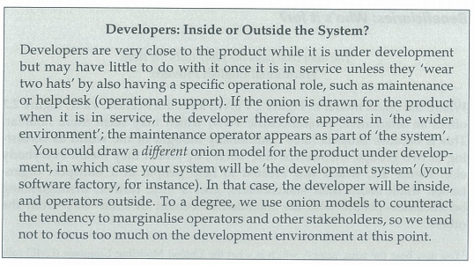
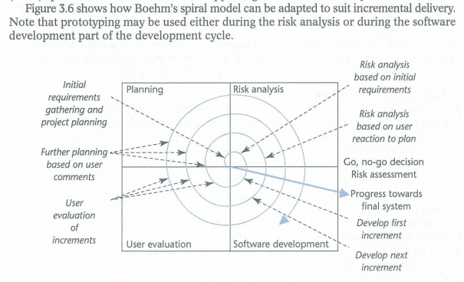
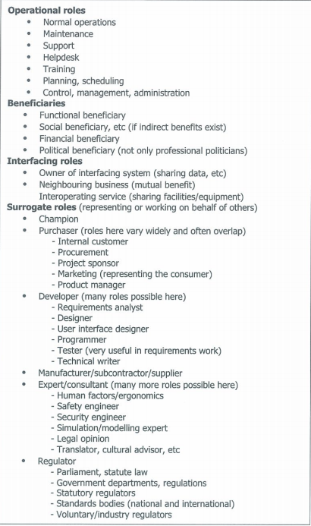
Prototype

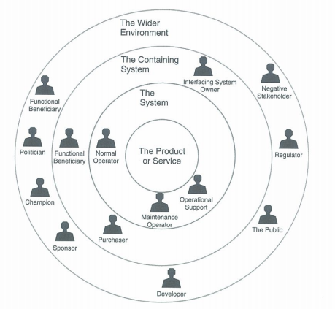

System: people that deliver results to the world outside.
Beneficiary: who intend to benefit in some way (financial, political, functional, social)
Regulator: according to law, standards
Interfacing Roles: Responsible project / operation of systems that our service or project has to cooperate with
Negative Stakeholders: peaceful opposition to active hostilitiy, can threaten or harm project; f.ex. Competitors, security threats
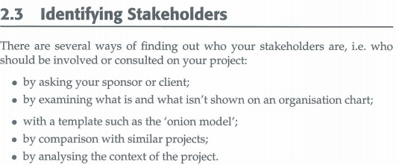
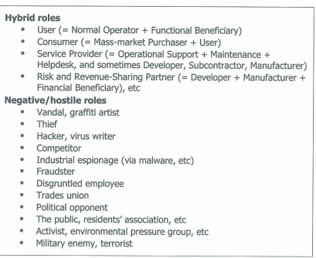
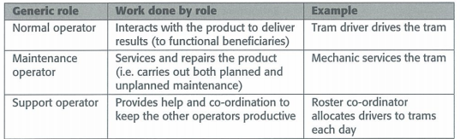
Champion: really wants the project to work out, provides “political” support (Can be the same as sponsor but normally not)

