ECE4179/5179 — Assignment Report Template
Due: XX/10/2026, 11:55 PM
Student name | Shang Chen
Student ID | 30586267
Student email | sche0151@student.monash.edu

This is a report template for the ECE4179/5179/6179 Assignment. Fill in every placeholder marked << like this >> and delete it once you have entered your answer. Keep all headings so that any table of contents resolves correctly. Submit this document as a PDF (not .docx); include your name and student ID in the filename.
Submission checklist
☐ Submit as a single ZIP file containing: the PDF of this report, all .ipynb notebooks, and any other required deliverables.
☐ Include your name and student ID in the filename of the ZIP, PDF, and notebooks.
☐ Do NOT submit .doc or .docx files — convert to PDF before submitting.
☐ All results, plots, tables, code screenshots, and discussion must appear in this report.
☐ Declare any use of GenAI in the relevant section of each task.

Questions Attempted
Update the "Attempted?" column as you complete each question.
Question | Topic | Marks | Marking | Attempted? (Y/N)
Q1-1 | MLP forward pass & SGD update | 10 | Report | Y
Q1-2 | Stacked activation function analysis | 5 | Report | Y
Q2-3 | Iterative weighted linear regression | 10 | Report | Y
Q3-4 | Face landmark detection – linear probing | 15 | Report | Y
Q3-5 | Face landmark detection – model improvement | 10 | Report | Y
Q4-6 | CNN for traffic sign classification | 15 | Report | Y
Q4-7 | Occlusion sensitivity analysis | 10 | Report | Y
Q5-8 | Speech command recognition | 25 | Report | Y
Total |  |  | 100 | All from report

Question 1 — MLP Analysis (No GenAI)
Note on Generative AI: For Q1-1 and Q1-2 you must work independently. You may not use GenAI tools at all, including for verifying your solutions.

Q1-1. MLP Forward Pass & SGD (10 marks)
Show your working clearly. Unsupported answers may lose marks.
(a) (2 pts) Compute the output of the network for x = (2, -1)ᵀ.

<< Working and final answer for part (a) >>

(b) (1 pt) With label y = 0, compute the binary cross-entropy (BCE) loss for (x, y).

<< Working and final answer for part (b) >>

(c) (1 pt) With label y = 1, compute the BCE loss for (x, y). State whether it is larger or smaller than part (b) and why.

<< Working and final answer for part (c) >>

(d) (2 pts) Let lr = 0.1. For x = (2, -1)ᵀ and y = 0, update w₃,₆ with one SGD step.

<< Working and final answer for part (d) >>

(e) (3 pts) Under the same settings, update w_{1,5}

<< Working and final answer for part (e) >>

(f) (1 pts) Under the same settings, update w_{2,4}

<< Working and final answer for part (e) >>

Q1-2. Stacked Activation Function Analysis (5 marks)
Discuss the behaviour of z₁₀₀₀(x) for x ∈ ℝ, where z₁₀₀₀ is the given activation function composed 1000 times. Support your discussion with clear mathematical reasoning.

(a) (2 pts) Find all fixed points of z, that is, all x ∈ R satisfying z(x) = x. You may argue from Figure 2.

<< Working and final answer for part (a) >>

(b) (3 pts) Determine the response of z1000 to x ∈ R. Justify your answer.

<< Working and final answer for part (b) >>

Question 2 — Iterative Weighted Linear Regression

Q2-3. Iterative Weighted Linear Regression (10 marks)
Report your implementation results below. Include all required plots and numerical results. Your discussion should reflect on the behaviour of the algorithm and the effect of the hyperparameter σ.
Numerical results
Hyperparameter σ used | 55
Final training MSE | 0.12454046876928337
Final validation MSE | 0.0004196998501118245
Number of iterations to converge | 5

Training and validation error curves with clear axis labels:
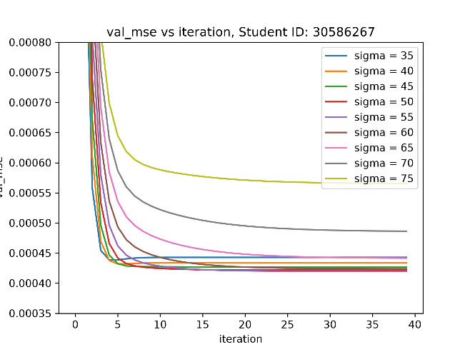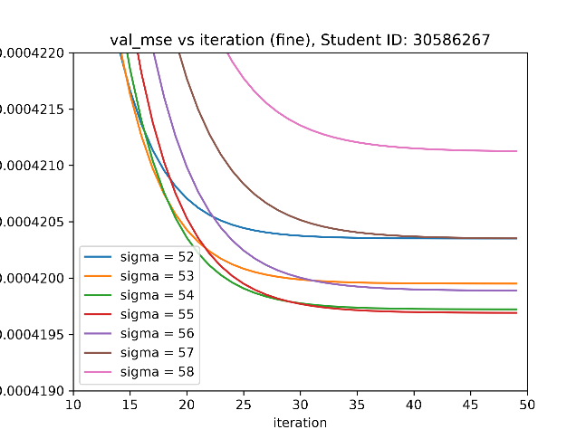
Figure 1: Graph of validation loss across iterations in a sigma sweep
Discussion
A polynomial fit of degree 9 is chosen as it produces the lowest loss following a degree sweep.
Hyperparameter sigma is the tuneable weight that modifies the strength of the alpha weighting matrix used to supress outliers. The relevant equations are:

alpha = np.exp(-sigma*(y_trn-y_trn_pred)**2)
A = np.diag(alpha)
w = np.linalg.inv(X.T @ A @ X) @ X.T @ A @ y

Where alpha, y_trn and y_trn_pred are lists, and alpha has values between 0 and 1.
A higher sigma value means alpha decays to 0 faster as squared loss (y_trn-y_trn_pred)**2 in the equation increases:
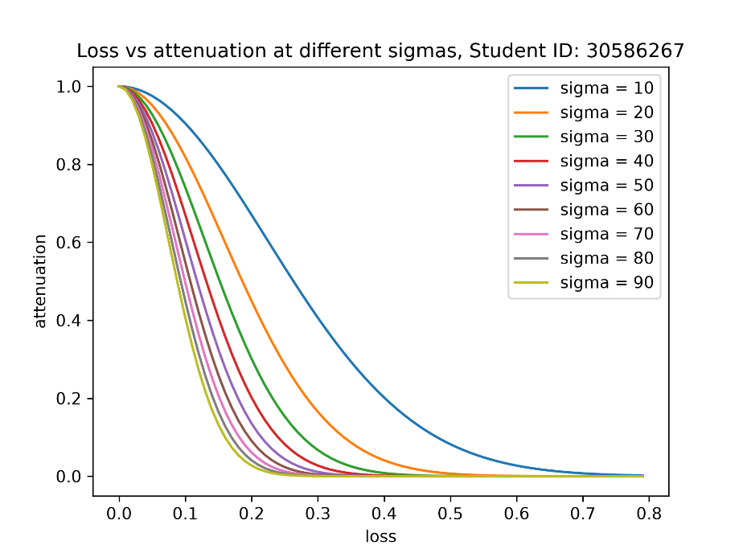
Figure 2: Graph of loss vs attenuation at different sigmas
An appropriate sigma value must be chosen to ensure that genuine outliers are heavily attenuated but samples with acceptable levels of deviation from the ground truth and are still suitable for use in training do not get too heavily attenuated.
A trial-and-error approach as illustrated by figure 1 reveals that the sigma value that produces the smallest validation loss after converging is sigma=55.
The learned alpha list has the below weights after convergence:
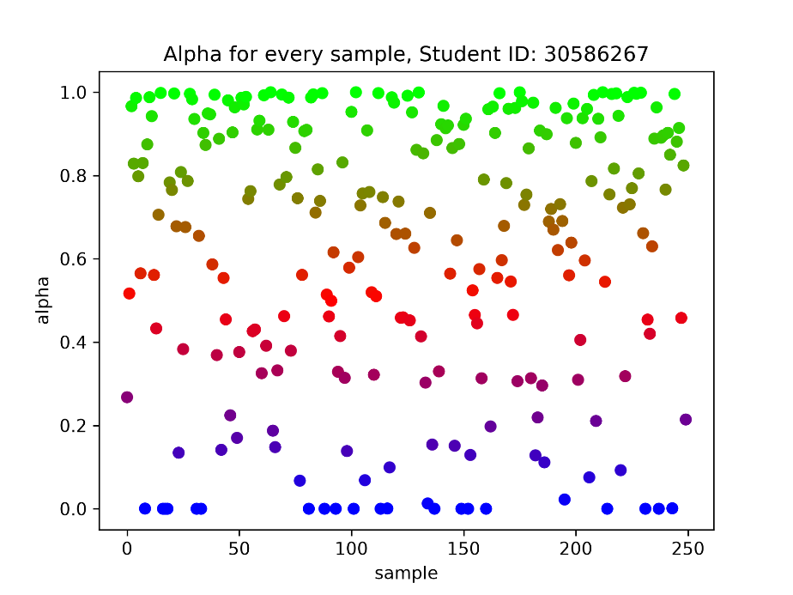
Figure 3: Graph of alpha value by sample
Overlaying these alpha values onto the original x_trn vs y_trn graph yields the following graph which clearly illustrates that alpha at sigma=55 is attenuating genuine outliers:
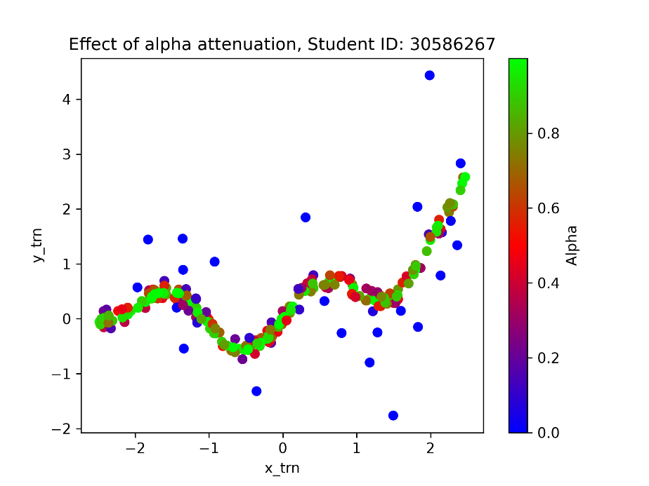
Figure 4: Graph illustrating alpha attenuation on the training dataset
At polynomial degree 9, the weighted prediction achieves an validation less that is 10 times smaller than the unweighted predictions:

unweighted | weighted
train_mse: 0.1209212446251193  val_mse: 0.004277185261129884 | train_mse: 0.12454046876928337  val_mse: 0.0004196998501118245
Figure 5: Table of training and validation losses
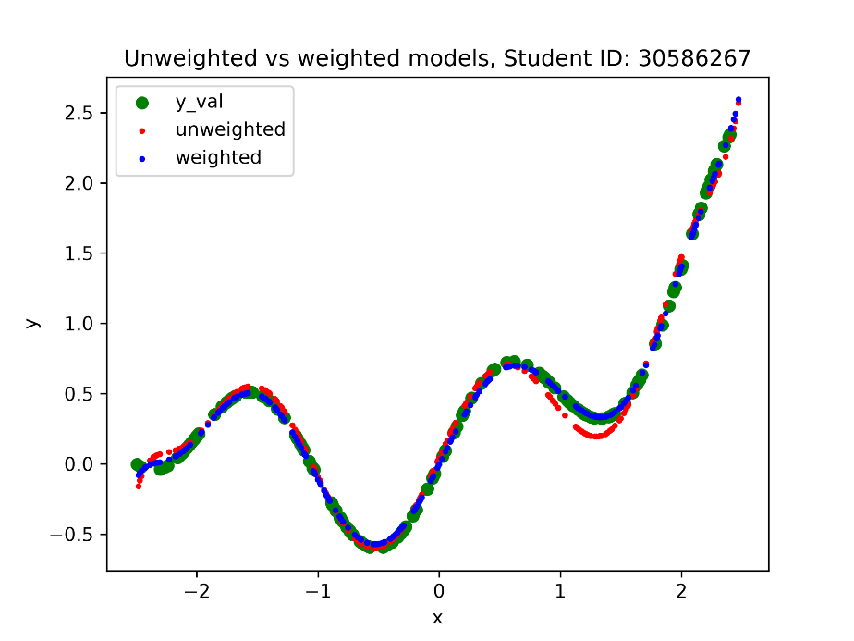
Figure 6: Graph of weighted and unweighted predictions

GenAI Declaration
Did you use any GenAI tools for this question? Yes

If yes, state: (i) what you asked, (ii) which suggestions you tried, and (iii) what worked or was discarded.
List of prompts:
- why does X.T@X become badly conditioned if I do not normalise it?
- after normalising, do I need to bring each feature back to the original domain?
- I want to change the colour of the markers based on a list of alpha values, sort of like a heatmap. Where the highest alpha value is blue and lowest is red. How can I achieve this
- Several “what does this error mean” questions

Which suggestions I tried:
- Colourmap
- Bug fixes

What worked / what was discarded:
- Colourmap
- Need to normalise but do not need to bring features back to original domain
- Virtually all bug explanations were on point and solved the issue

Question 3 — Face Landmark Detection

Q3-4. Baseline: Linear Probing (15 marks)
Report the results of your linear probing experiment below. A well-trained linear probe should achieve a validation RMSE of approximately 12 pixels.
RMSE results
Validation RMSE (pixels) | 14.5388
Test RMSE (pixels) | 9.9886

Training and validation loss curves with clear axis labels:
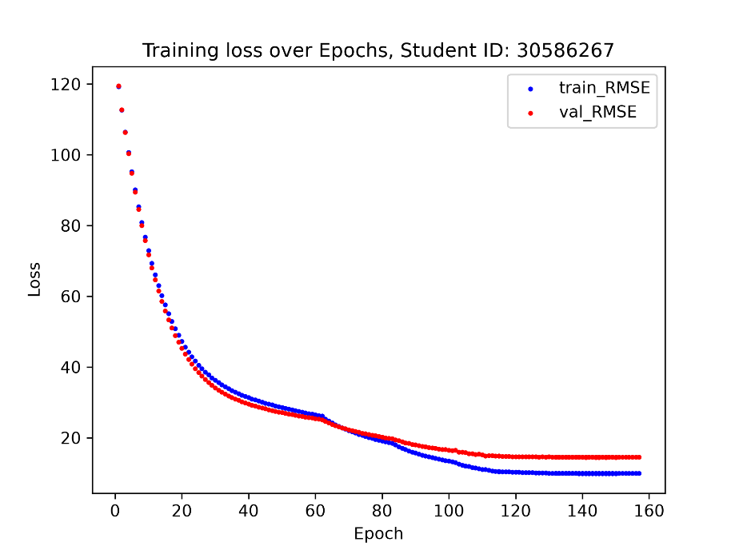
Figure 7: Graph of training loss vs validation loss over epochs (best_checkpoint15.pth)
5 Example Predictions on Validation and 5 on Test Images:
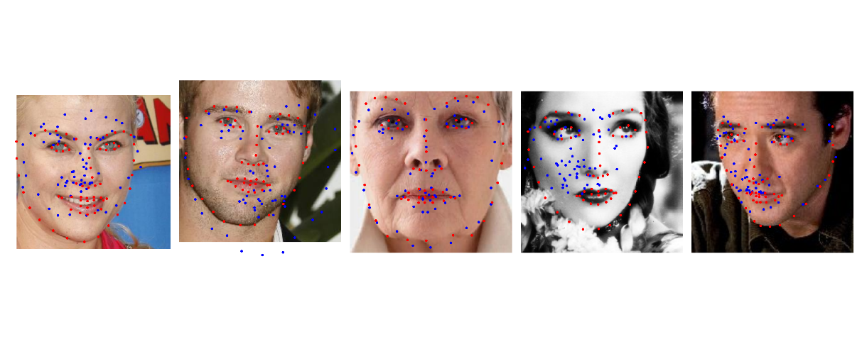
Figure 8: Landmark predictions on test set using only a trained classifier
Discussion
The classifier head is implemented on top of an efficientnet_b0 model backbone using default weights. The classifier connects 1280 neurons to 136 outputs or 68 landmark co-ordinate pairs.
The input images are normalised using the ImageNet mean/std normalisation matrix to make sure the model converges with a typical learning rate as per the assignment’s instructions. Landmarks co-ordinates are divided by 224 to match the transformation.
The training code uses the AdamW optimiser with various combinations of lr(learning rate) and weight_decay. A total of 15 classifier-only models were trained using different weight_decay values that ranges from 1e-5 to 1e1. See Figure 9: Loss curves for different decay settings.
A higher weight_decay is warranted during training given the extremely small number of training images compared to the number of neurons seen by the classifier head. This means overfitting is a risk in this situation as highlighted by assignment instructions.

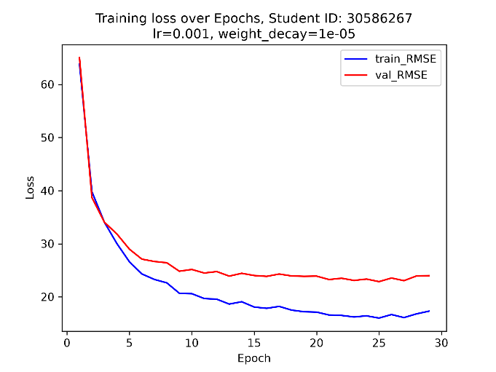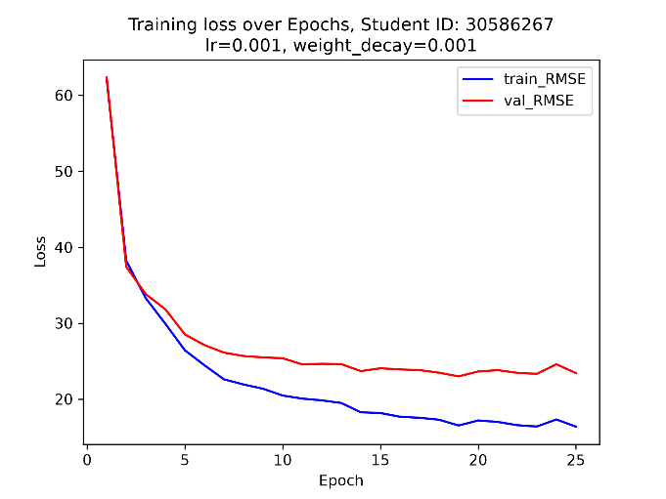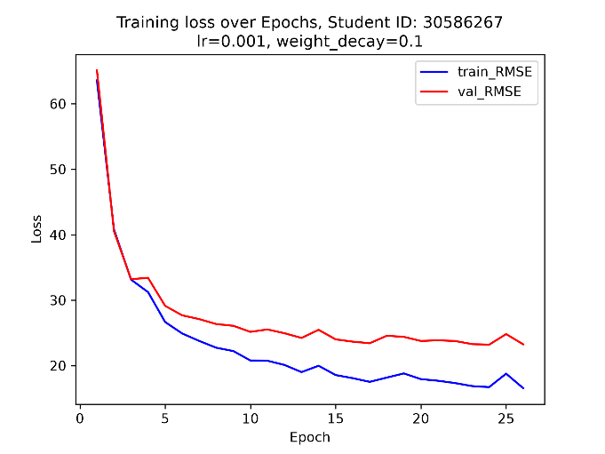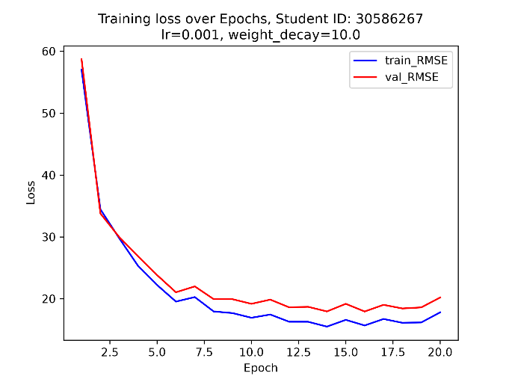

Figure 9: Loss curves for different decay settings.
Increasing the decay effectively decreases the severity of overfitting. The gap between train_RMSE and val_RMSE is the lowest out of all 4 graphs:

weight_decay = 1e-5 | weight_decay = 1e-3 | weight_decay = 1e-1 | weight_decay = 1e1
Epoch: 30  trn_RMSE: 16.3471  val_RMSE: 22.2895 | Epoch: 26  trn_RMSE: 16.8134  val_RMSE: 22.8692 | Epoch: 27  trn_RMSE: 17.1393  val_RMSE: 22.6530 | Epoch: 21  trn_RMSE: 15.2145  val_RMSE: 17.4166
Figure 10: Table of best checkpoints produced by different weight settings
The AdamW update equation is the following:

W = (1 - lr*weight_decay) * W_prev – [AdamW update value]

The weight_decay and lr parameters control how heavily the previous weights influence the upcoming weights update. The overfitting risk justifies using a weight_decay value that is large. Notably, the influence of weight_decay is counterbalanced by lr, which gets decreased subject to scheduling as val_RMSE converges. This is consistent with the idea that the quality of trained weights improves throughout training. Once the quality of the baseline weights reaches a point where the model is no longer at high risk of overfitting, then more influence should be given to the baseline weights rather than discarding them with a high weight_decay setting.
That was the approach taken during training & manual scheduling. During the training processes, the lr was subject to manual scheduling and early-stopping several times when the rate of decrease of val_RMSE slowed or began oscillating. This is visible as sharp gradient changes in Figure 7: Graph of training loss vs validation loss over epochs.
The training dataset was also subject to augmentation during training. The dataset’s __getitem__ method randomly flips images to effectively double the size of the original dataset. This increase the difficulty of training in the beginning as seen with the higher val_RMSE for training runs where flipping is enabled. However, the gap between trn_RMSE and val_RMSE increase as a result. Ultimately a model with the smaller val_RMSE was chosen as the best model to conform to the requirements of the assignment. If the requirement did not exist, the model with less loss gap will also be a sensible baseline to refine. Notably, horizontal flipping was reintroduced in Q3-5 to refine the baseline model.
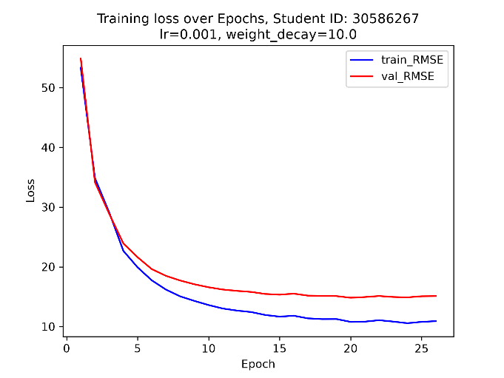
Figure 11: Graph of training loss for models using an augmented dataset (left) and non-augmented dataset (right)

augmentation = True | augmentation = False
Epoch: 21  trn_RMSE: 15.2145  val_RMSE: 17.4166 | Epoch: 27  trn_RMSE: 10.1064  val_RMSE: 14.7444
Figure 12: Loss of models trained on augmented vs non-augmented datasets
The dataset is also loaded in shuffled batches to increase the number of optimiser steps per epoch. Using batches also potentially assists prediction for images that may otherwise be harmed by overgeneralisation from calculating optimiser steps from the entire dataset.
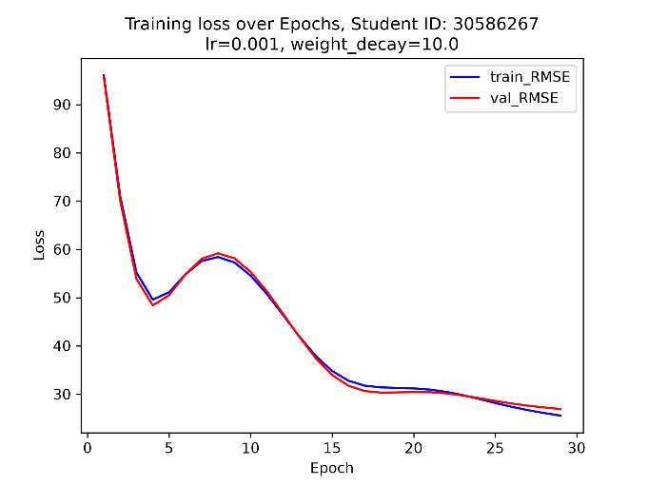
Figure 13: Graph of training loss for models using batch size of 680 (left) and 85 (right)
batch_size = 680 | batch_size = 85
Epoch: 30  trn_RMSE: 25.1311  val_RMSE: 26.5620 | Epoch: 21  trn_RMSE: 15.2145  val_RMSE: 17.4166

The final model best_checkpoint15.pth with val_RMSE = 14.5388 produces predictions that are poor in quality. There are significant shifts in prediction location. Occasionally the model fails to detect which region is the face.

GenAI Declaration
Did you use any GenAI tools for this question? Yes

If yes, state: (i) what you asked, (ii) which suggestions you tried, and (iii) what worked or was discarded.
What I asked:
- I need to horizontally flip my dataset to use for training.
- so the index mapping is the same for every image?
- how do I use the getitem function
- is the index flipping logic correct? I think including flipped images has increased loss
- should I start from my previous best checkpoint or start from scratch
- numerous debug questions

Which suggestions I tried:
- The flipmap
- Augmentation (horizontal flipping)
- Using the model with lower loss as baseline
- All debugging suggestions

What worked / did not work:
- Most debugging suggestions worked
- AI’s lr and weight_decay suggestions were unsuitable for the task
- The flipmap worked

Q3-5. Model Improvement (10 marks)
Document the improvements you made to the baseline model. Boss performance target: ~7 pixels RMSE on the validation set.
RMSE results
Validation RMSE (pixels) | 4.5956
Test RMSE (pixels) | 4.7452

Training and validation loss curves with clear axis labels:
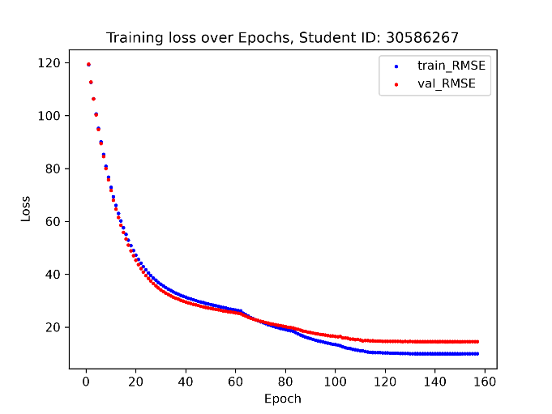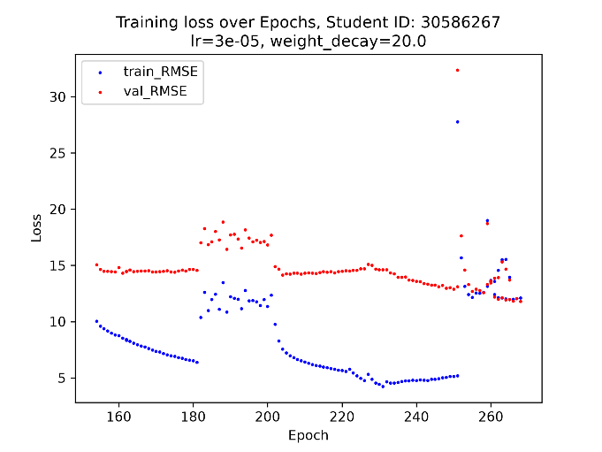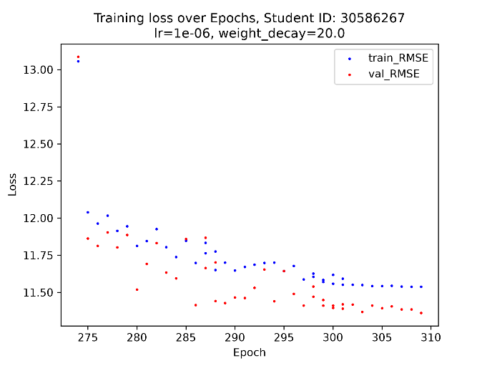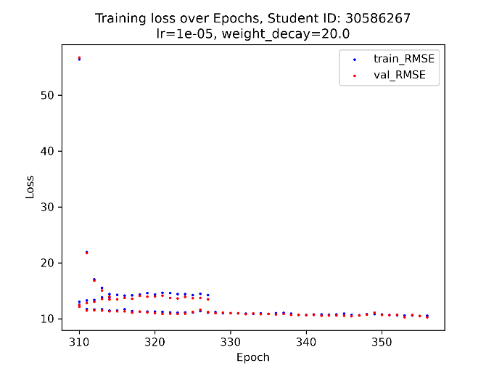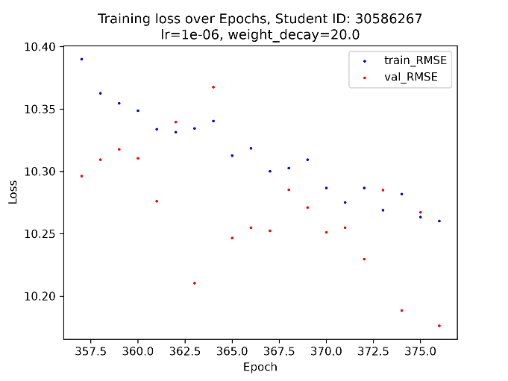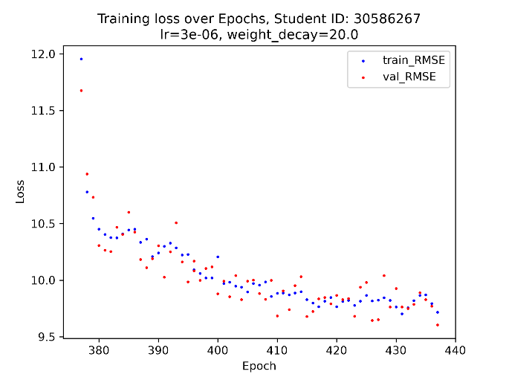
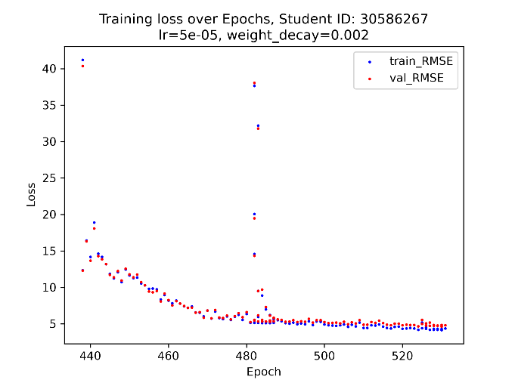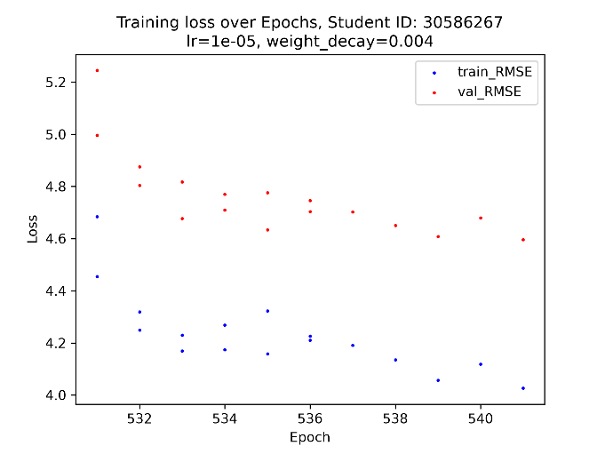
Figure 14: List of graphs documenting loss over epochs as training settings change
5 Example predictions on test images:
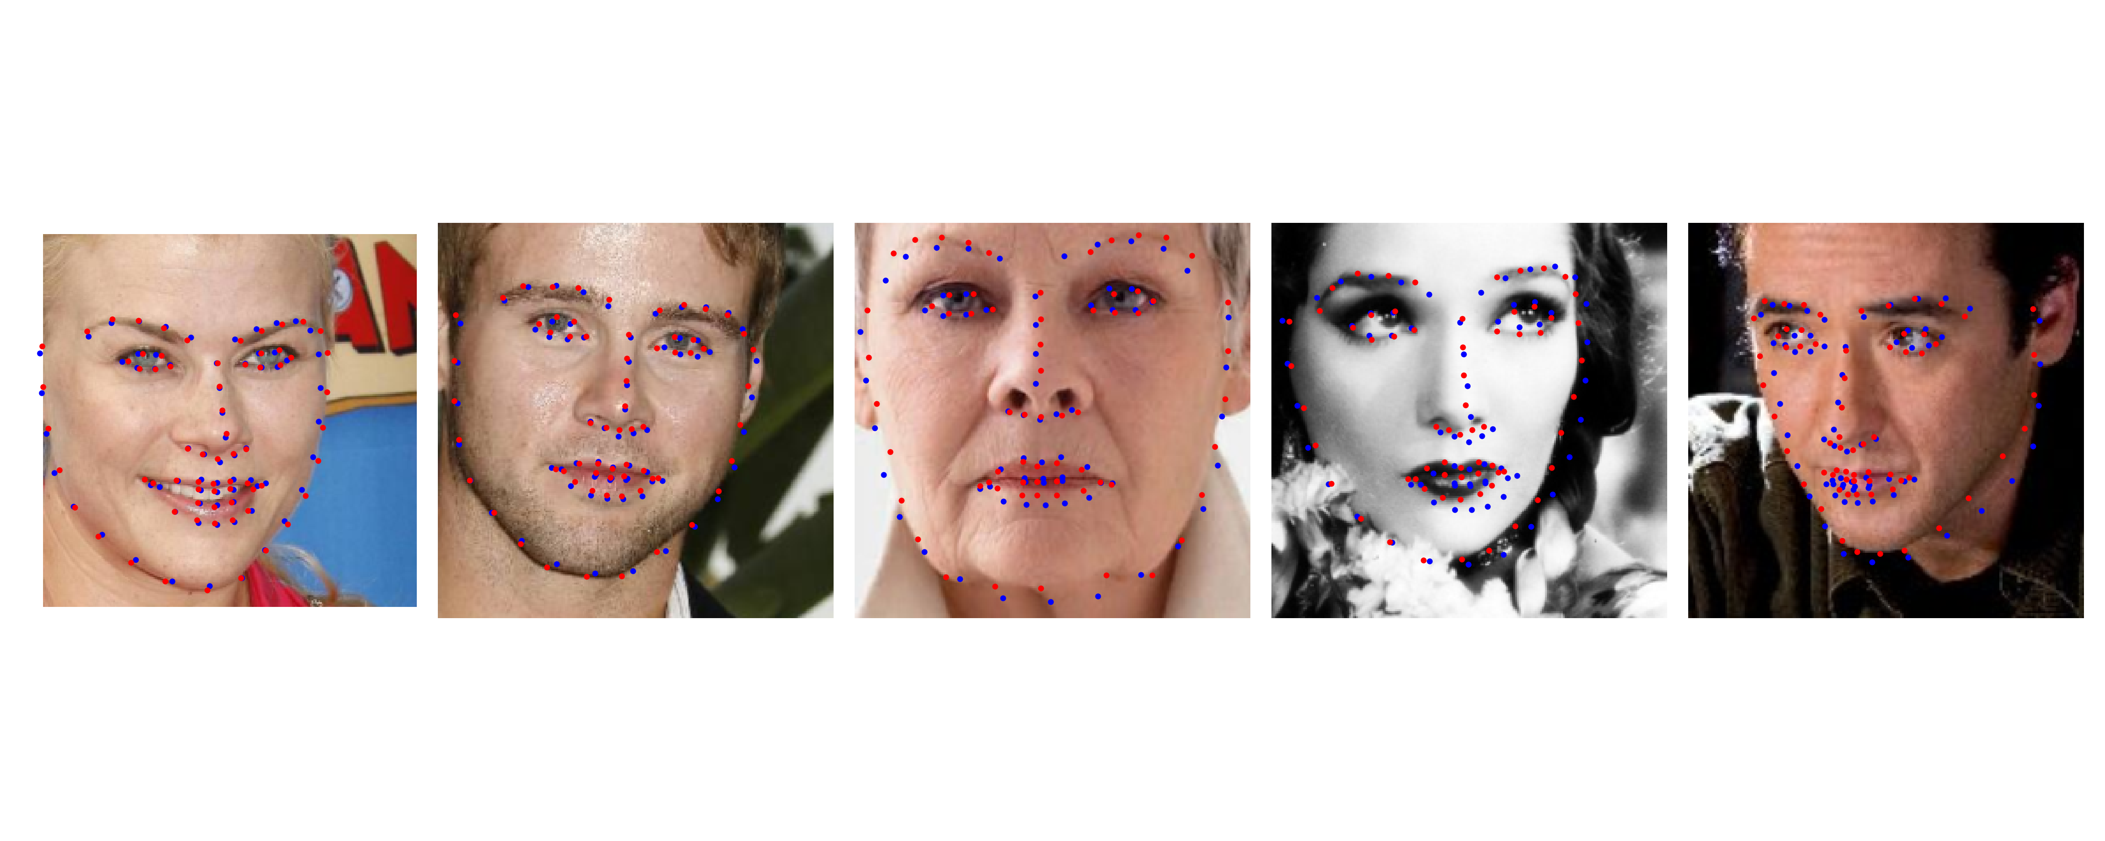
Figure 15: Prediction of final model
Reflection: modifications made and their effect
Only being able to train the classification head limits the number of parameters that can be changed to suit the task. Unfreezing later layers in the model allow the features to better adapt to the geometry in the current dataset and improve performance.
Performance generally improved as more layers are unfrozen:
Unfrozen | Training outcome
7, 8  best_checkpoint15-4.pth  best_checkpoint15-4-1.pth | Epoch: 309  calculated train loss: 11.5381  calculated val loss: 11.3614
6  best_checkpoint15-4-2.pth  best_checkpoint15-4-2-1.pth | Epoch: 376  calculated train loss: 10.2602  calculated val loss: 10.1762
5  best_checkpoint15-4-3.pth | Epoch: 437  calculated train loss: 9.7168  calculated val loss: 9.6044
5  best_checkpoint15-4-4.pth | Epoch: 481  calculated train loss: 5.1275  calculated val loss: 5.2428
5  best_checkpoint15-4-5.pth | Epoch: 524  calculated train loss: 4.1606  calculated val loss: 4.6549
5  best_checkpoint15-4-6.pth | Epoch: 530  calculated train loss: 4.1308  calculated val loss: 4.6244
4  best_checkpoint15-4-7.pth | Epoch: 541  calculated train loss: 4.0265  calculated val loss: 4.5956
Figure 16: Final loss values as layers are unfrozen
The lr for the feature was set to a value 10 times smaller than the lr of the head. For a pre-trained model it is unnecessary to use a large learning rate, only fine tuning is required. A range of different lr and weight_decay values were used during training as seen in Figure 14: List of graphs documenting loss over epochs as training settings change.
A significant reduction in loss occurred between best_checkpoint15-4-3.pth and best_checkpoint15-4-4.pth from a reduction in weight_decay from 20 to 2e-3. At that point the weights are well-trained enough such that it is no longer sensible to supress it to prevent overfitting. Subsequent adjustments produced smaller improvements. The fluctuations and sharp changes in the graphs are results of manually adjusted settings following early-stopped and resumed training runs. Most models here were not trained under constant conditions.
As mentioned above, horizontal flipping was reintroduced to improve generalisation of the weights.
The checkpoint at epoch 541 achieved a val_RMSE of 4.5956, as opposed to the baseline of 14.5388. This is a reduction of approximately 68.4%.
The final results on test data are fairly high quality. Most predictions on the test set overlap with the ground truth:
Test dataset loss: | 4.7452

GenAI Declaration
Did you use any GenAI tools for this question? Yes

If yes, state: (i) what you asked, (ii) which suggestions you tried, and (iii) what worked or was discarded.
What I asked:
- What optimisation methods should I be trying to reduce loss
- Numerous debugging questions

Which suggestions I tried
- Increase fine-tuning learning rates.
- Gradually unfreeze more backbone blocks.
- Revisit weight decay.
- Restore verified augmentation

What worked:
- All suggestions were effective. Suggestions overlapped with what I planned to do anyway.

Question 4 — Classifying Traffic Signs with CNNs

Q4-6. CNN Training (15 marks)
Train a CNN on GTSRB from scratch (no pretrained models). Your model must achieve at least 90% test accuracy to be considered competent.
Architecture summary
<< Describe your CNN architecture (number of conv blocks, kernel sizes, pooling, FC layers, etc.) >>

Training details
Optimiser | AdamW
Learning rate | Head: 2e-4 Backbone: 1e-4
Batch size | 128
Number of epochs | 22
Data augmentation, i.e. transformations | Rescaled input images to 64 by 64

Accuracy results
Validation accuracy (%) | Overall accuracy: 99.80%  Balanced accuracy: 99.79%
Test accuracy (%) | Overall accuracy: 96.86%  Balanced accuracy: 94.19%

Training and validation accuracy / loss curves with clear axis labels:
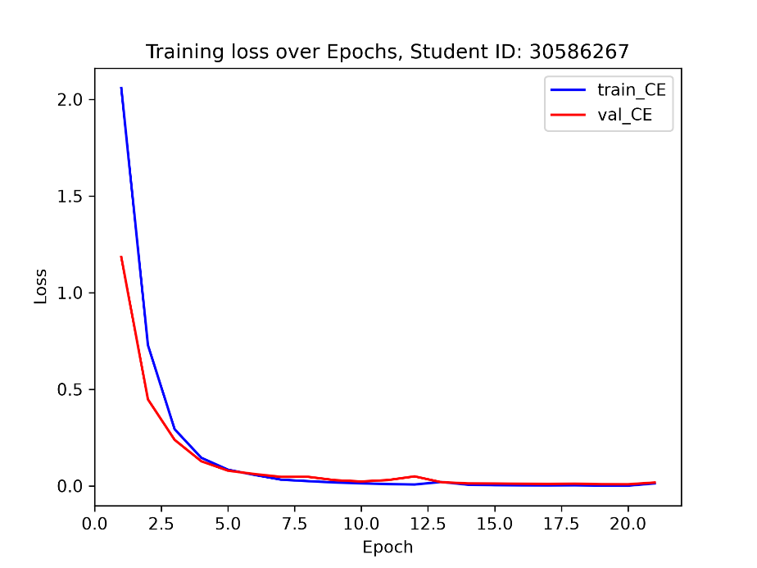
Figure 17: Graph of training and validation loss over epochs

Discussion
The custom model consists of 5 convolution blocks as referred to by the assignment. Each block contains a conv block, a batchnorm layer, a ReLU activation layer and a maxpool layer.

self.block1 = nn.Sequential(
nn.Conv2d(3, 32, kernel_size=3, padding=1, bias=False),
nn.BatchNorm2d(32),
nn.ReLU(),
nn.MaxPool2d(2),
)

The conv layer has 3 by 3 kernels that create feature maps from the input when they are convolved with the image channels. This is the feature extraction method. The bias of the conv layers are set to false because the batchnorm layers immediately after includes a learnable bias term that is also updated using backpropagation. The batchnorm layer also normalises and scales the feature map outputs by giving it roughly unit variance and 0 mean this ensures the model can be trained more easily using a standard learning rate across all blocks. The final conv layer has 256 channels to allow for detection of a wider range of complex features combinations.
The maxpool layer was added to reduce computational load. The block reduces the output of the ReLU layer by a factor of 2 in both dimensions by taking the maximum response in non-overlapping 2 by 2 areas. This may negatively impact accuracy but the significant reduction in computation means this layer is commonly used. Note that the input images are deliberately scaled to 64 x 64 so that 5 maxpool functions can be applied to reach a channel size of 2x2 on which a global pool function can be applied in the classifier.
The classifier layer contains a global pool function as referred to by the assignment. It averages the activation channel by channel and then passes the output into a linear 256 feature to 43 class head.
Cross entropy loss was used as the loss function because it is suitable for classification tasks.
Minimal architectural changes were made to the model during training. The training and validation losses decreased very quickly during training. Training LCE fell from 2.0585 in the first epoch to 0.0839 by epoch 5. Validation LCE decreased from 1.1837 to 0.0788. Refer to Figure 17: Graph of training and validation loss over epochs. The final validation loss was
Running the final model checkpoint_V3.pth on the test dataset resulted in a LCE of 0.0075. Prediction on the test set resulted in 0.1060. This is substantially lower than the validation loss. However, the model still manages to achieve an overall test accuracy of 96.86%, and a balanced test accuracy of 94.19%. This surpasses the assignment’s 90% requirement.
The confusion matrix demonstrates that most classes are correctly predicted. Refer to Figure 18: Confusion matrix below. However, classes 21, 27, and 39 are more prone to misclassifications. For example, class 27 (pedestrians) occasionally gets predicted as class 25 (road works). This is because the signs are visually similar with triangular warning signs and a person in the middle. See Figure 19: Example class 27 (pedestrian) and class 25 (road works) below.
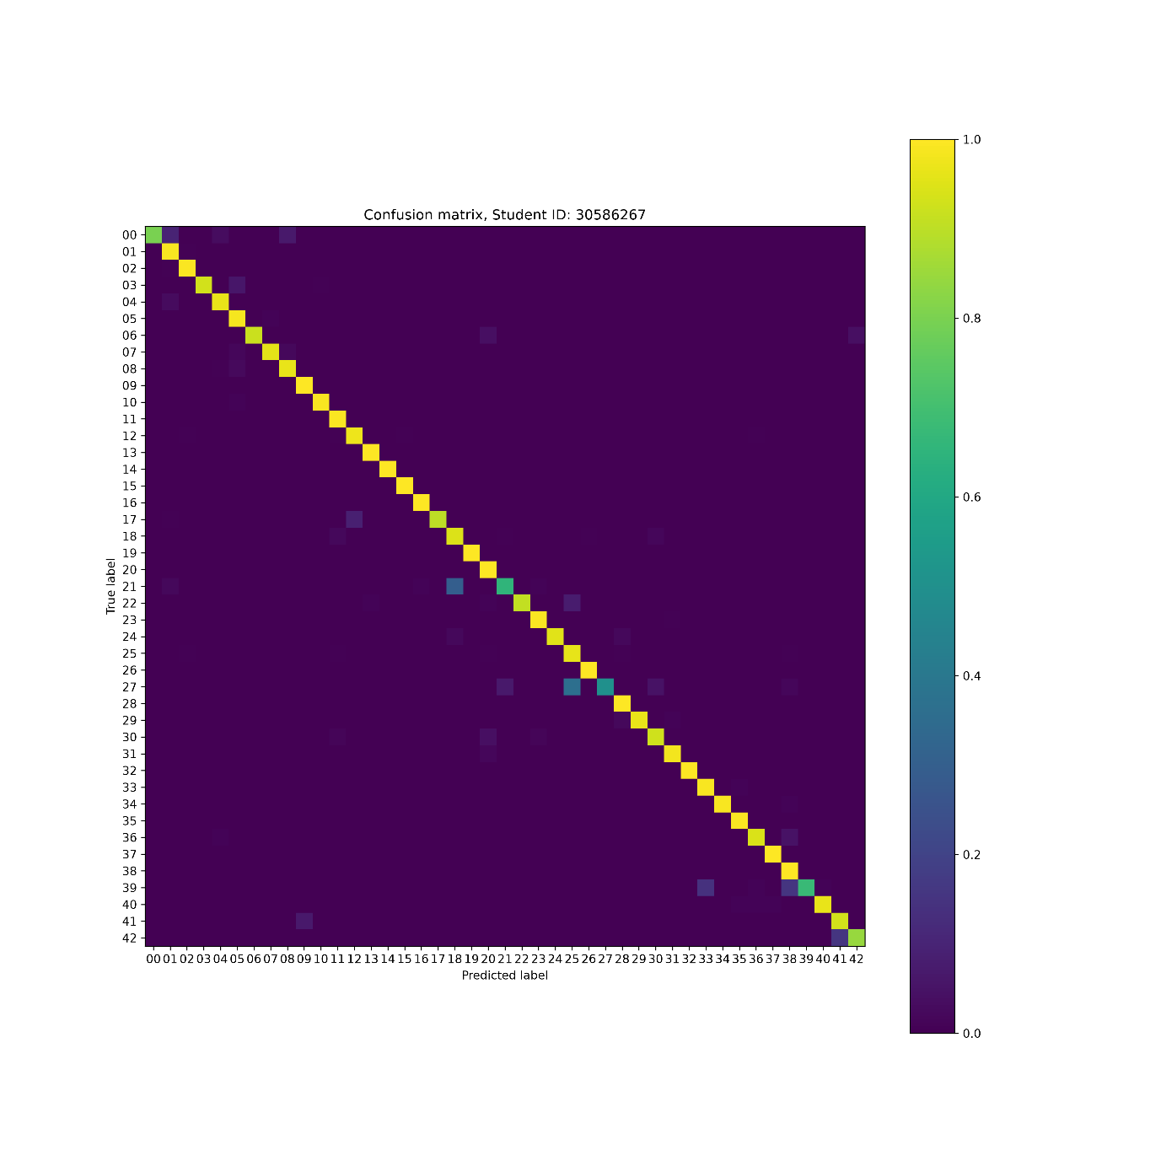
Figure 18: Confusion matrix

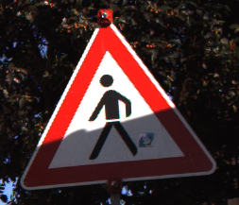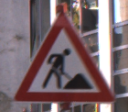

Figure 19: Example class 27 (pedestrian) and class 25 (road works)

GenAI Declaration
Did you use any GenAI tools for this question? Yes

If yes, state: (i) what you asked, (ii) which suggestions you tried, and (iii) what worked or was discarded.
What I asked:
- The dataset I found on kaggle for GTSRB is structured differently from what Q4 suggested. Why is that
- The training dataset contains images of different sizes. Can I train a model on that set without resizing? Does the assignment want me to pad the smaller images or simple scale them?
- I am confused about what the assignment's instructions are.
- Does the assigment say which optimiser I should use?
- should I explicitly move my model to my cuda device before training
- what methods are useful to know about the imagefolder class
- My validation loss from training is very low but the test loss is significantly higher. Why is that

What I tried:
- Looking for the dataset on moodle
- The suggested resize to 64 x 64
- Miscellaneous debug tips

What worked / didn’t
- Basically all debug tips worked.
- Resize suggestion worked.
- Explicitly moving the model to CUDA before training (I was already doing that before without knowing)

Q4-7. Occlusion Sensitivity Analysis (10 marks)
Generate occlusion heatmaps for three correctly classified and three misclassified test images. Discuss what the model appears to focus on.
3 Heatmaps with original images — correctly classified images
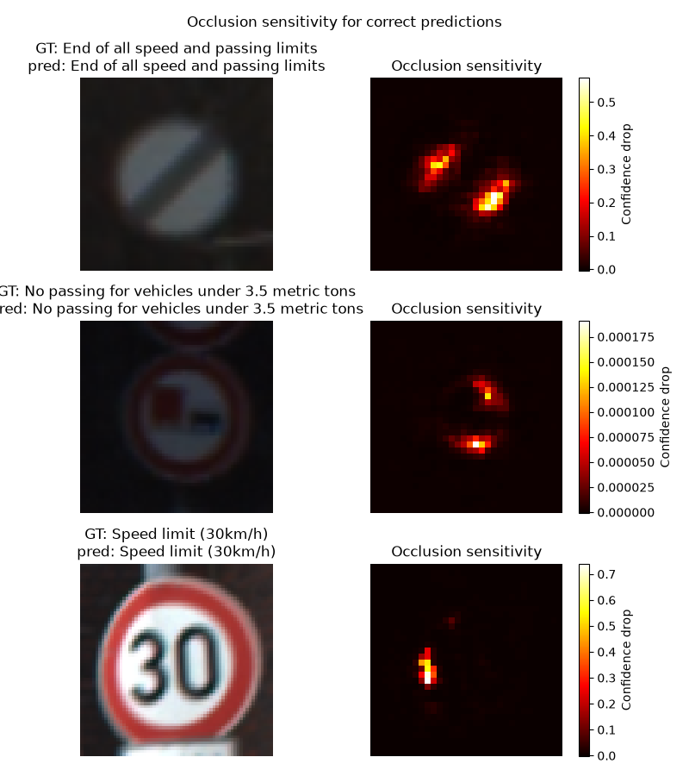
Figure 20: Occlusion sensitivity on correctly classified images

3 Heatmaps with original images — misclassified images
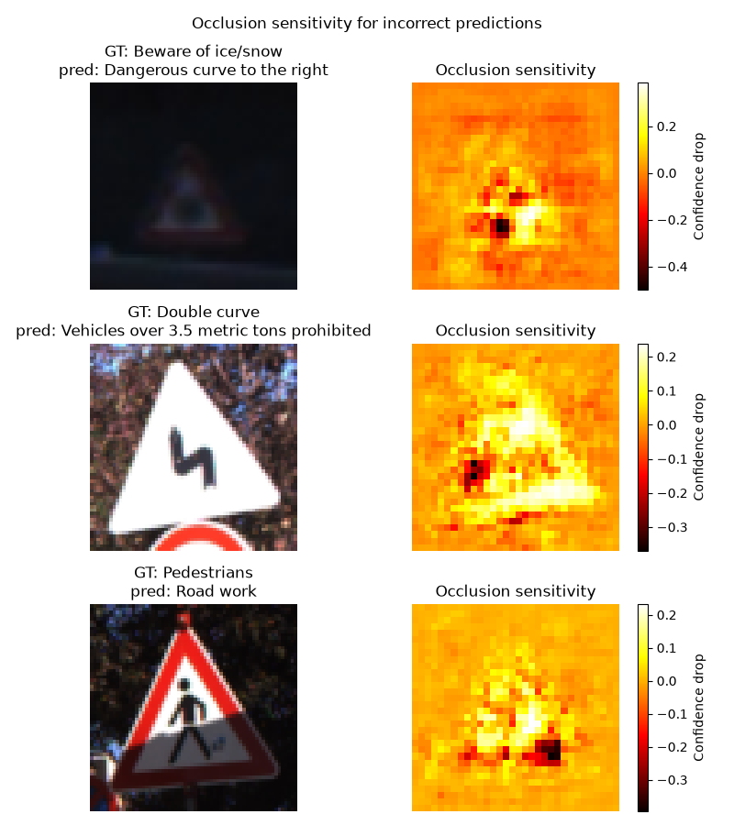
Figure 21: Occlusion sensitivity on incorrectly classified images

Discussion
Occlusion sensitivity was done on three correctly classified and three incorrectly classified images from the test dataset as per the assignment’s instructions. Please see Figure 20: Occlusion sensitivity on correctly classified images and Figure 21: Occlusion sensitivity on incorrectly classified images.
An occlusion sensitivity dataset was created on the randomly selected 6 images which are 64 by 64. A 2 by 2 patch in the image is set to completely black and the black patch is gradually moved over the image. The occluded images are fed through the model and the drop in prediction confidence or the softmax probability is taken as the value of the occlusion sensitivity heatmap of 32 by 32. A large drop in confidence means the model is most sensitive to occlusions in that area of the selected images.

For end of all speed and passing limits, the model is sensitive to the white patches being occluded.

For the no passing sign, occlusion almost had no effect on model confidence. This may be due to the distinct red box design that is not seen on other signages.

For the speed limit sign. The model heavily relies on the centre point of the digit 3. This suggests that the classification here depends on unambiguity of the text on the sign.
The beware of ice/snow sign is very blurry. Some patches support the incorrect prediction, but others support otherwise. This is a shared feature of all misclassified images. But here the poor visibility of the internal symbol is a likely cause of misclassification.

For the double-curve sign and the pedestrian sign, extreme lighting conditions and shadow potentially erased feature that the model relies on. For the pedestrian sign specifically, the reduced visibility of the distinguishing detail between the two classes (the pile of dirt) may be the cause of the misclassification. Refer to Figure 19: Example class 27 (pedestrian) and class 25 (road works). This is supported by the bright spot on the bottom left of the heat map.

GenAI Declaration
Did you use any GenAI tools for this question? Yes

If yes, state: (i) what you asked, (ii) which suggestions you tried, and (iii) what worked or was discarded.
What I asked
- Should I do occluded = img.cpu().numpy().copy(), edit the img, then cast back into tensor?
- what is a good way to pre-populate a 3 dimensional list for unedited images
- is there a function that lets me produce a heatmap based on a list of confidence loss and occlusion position

What I tried
- Directly editing the tensor
- Using .repeat method
- Using matplotlib to build a heatmap

What worked:
- All suggestions worked

Question 5 — Speech Command Recognition

Q5-8. Speech Command Recognition (25 marks)
Build a model to classify ten spoken commands. Submit your final test predictions to the Kaggle competition (linked on Moodle) and report your Kaggle username.
Approach Discussion (Detailed Discussion of the Model Architecture and Improvements Made):
I used the architecture suggested by the assignment. That is a Wav2Vec2 feature extraction model and a custom classifier head with MLP structure.
This is basically the same as the transfer learning approach in Q2 of the assignment. I trained the classification head first before gradually unfreezing more layers in the pretrained feature extractor.
This approach also allowed me to cache the output of the feature extractor and pass that into the custom head which sped up training significantly. This effectively reduced repeated computations that would produce the same results every epoch anyway. Eliminating that resulted in every epoch only taking several seconds to complete.
Notably, every time a layer is unfrozen, the cached intermediate outputs would need to be recomputed.
Unfreezing the transformer layers also drastically increased training time. Even though the caching code was modified to include only up to transformer feature layer 9, the training time still increased to approximate 1 minute per epoch with 2 unfrozen transformer layers.
For pre-processing, most recordings appeared to be approximately 1 second long. To make sure length is consistent, all data was either padded or trimmed to fit. All audio was loaded as mono channel at 16kHz sampling rate as instructed and processed using the Wav2Vec2 processor using the same pretrained weights.
Pooling after the feature extractor backbone as suggested by the assignment provides a vector of length 768 which means the classifier simply has to connect these 768 features to 10 class predictions. This is very similar to tasks done in the previous sections.
The initial implementation had a simple linear layer connecting the features directly to the classes:
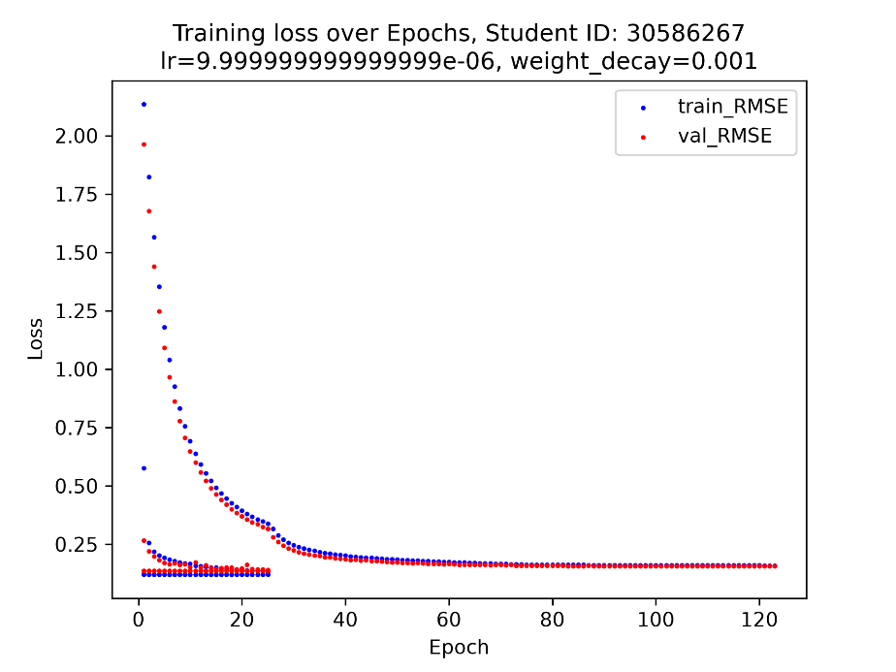
Figure 22: Graph of training and validation loss over epochs
The graph contains loss data that is out of place due to epoch count being accidentally reset during training. The head achieved a best validation loss of 0.1566.

I then chose to use a MLP structure as suggested by the assignment and reduced loss to 0.1285.
The MLP has the following simple structure:
self.classifier = nn.Sequential(
nn.Linear(768, 256),
nn.ReLU(),
nn.Dropout(0.20),
nn.Linear(256, 10),
)
Instead of directly mapping to classes, the MLP structure essentially adds capability for the model to learn and detect weighted combinations of the 768 features. Also, the random dataset augmentation with the dropout layer. This theoretically helps the model generalise to unseen data better.
The best checkpoints were selected using validation LCE and is reported alongside classification accuracy for performance monitoring. The final model achieved a validation accuracy of 96.93%.

Training details
Feature extractor model | Wav2Vec2 pretrained facebook/wav2vec2-base-960h
Frozen / fine-tuned layers | Only transformer layer 10 and 11 are unfrozen, and custom head
Classifier architecture | MLP
Optimiser & learning rate | AdamW  Feature lr = 1e-4, Head lr = 2e-3, weight_decay=1e-2
Epochs / early stopping | 66

Results
Validation accuracy (%) | 96.93%
Kaggle username | Shang Chen (shangchen0151)
Kaggle test accuracy (%) | 97.031%

Training curves with clear axis labels:
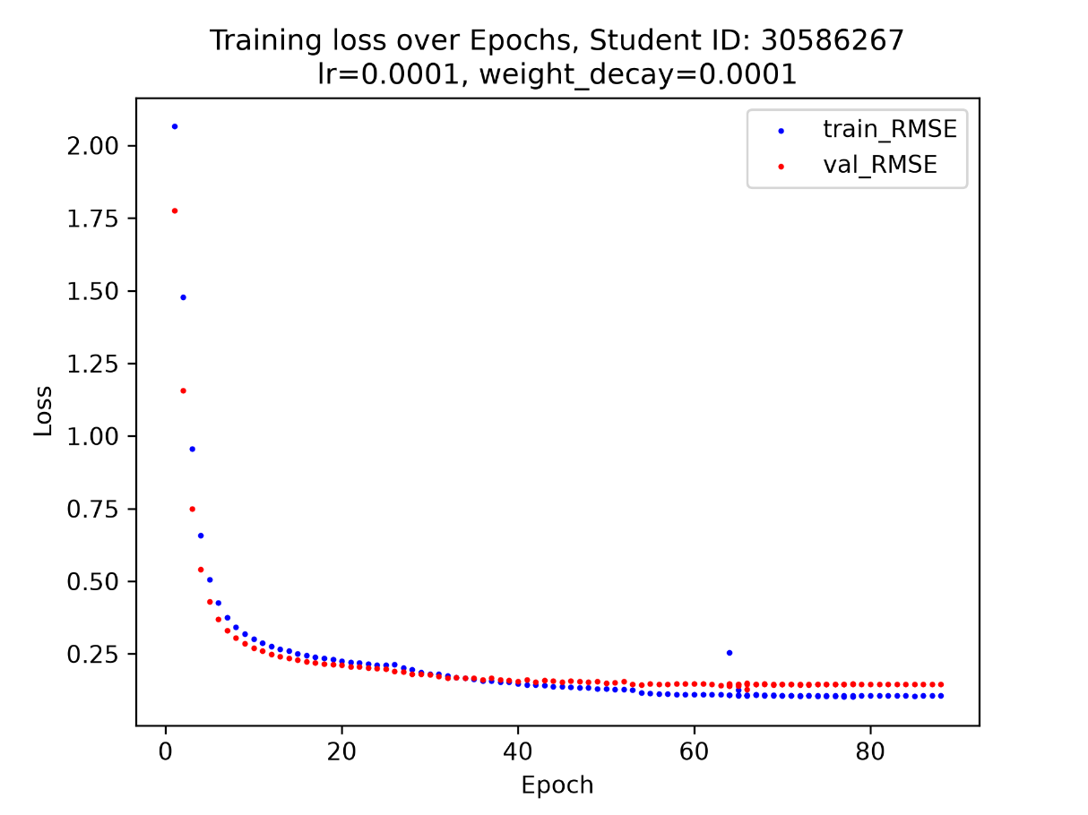

Figure 23: Graph of training loss and validation loss vs epoch
Unfortunately, the final few attempts at training the best model:
checkpoint_audio_v3_unfreeze.pth
caused significant overfitting to occur.
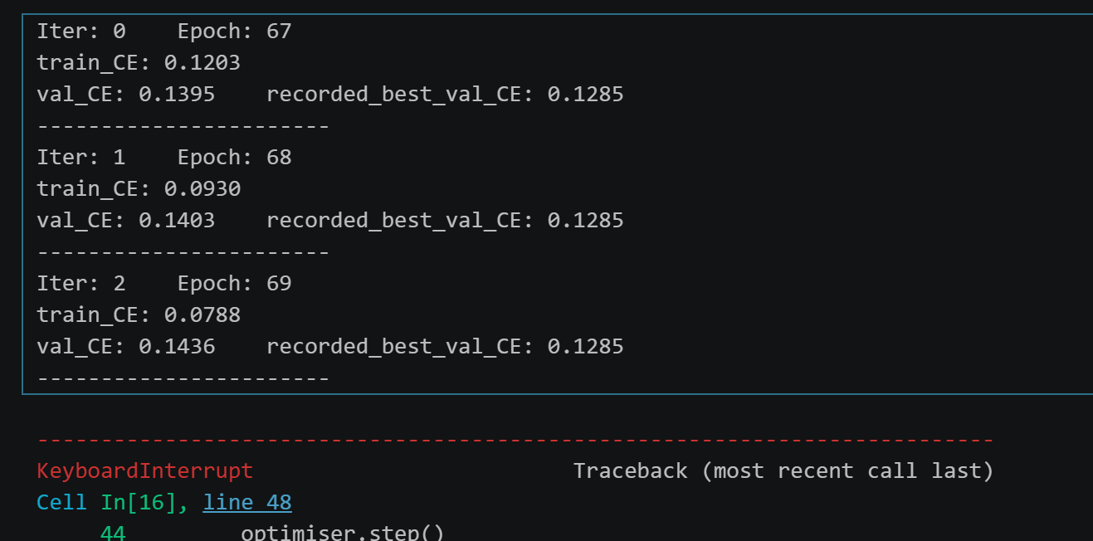
Figure 24: Screenshot of overfitting behaviour
GenAI Declaration
Did you use any GenAI tools for this question? Yes

If yes, state: (i) what you asked, (ii) which suggestions you tried, and (iii) what worked or was discarded.
- What is the difference between Wav2Vec2Model and Wav2Vec2Processor
- I need to prepare all wav files by loading it with librosa and passing it into wav2vec2Processor. Do I need a for loop or is there a more efficient way
- What is the structure of wav2vec2
- How do I create a wrapper model for the linear head
- Is it possible to cache pooled features
- the notebook cell has run for 40 minutes and still not complete
- The model is beginning to overfit. Which layers should I try unfreezing next
- Do I need to regenerate the cached dataset with every training run?
- I don't think unfreezing is improving training outcomes. What other methods should I try

What suggestions I tried:
- Stuck to using a for loop for loading data
- Custom wrapper model that contains custom head and Wav2Vec2
- Caching of pooled feature output
- Using MLP to replace the simple linear head

What worked:
- MLP
- Wrapper model
- Caching
- Data loading (into ram)

Acknowledgements (optional)
<< List any people or resources you found particularly helpful (not required) >>

