ECE4179/5179 — Assignment Report Template
Due: XX/10/2026, 11:55 PM
Student name | Shang Chen
Student ID | 30586267
Student email | sche0151@student.monash.edu

This is a report template for the ECE4179/5179/6179 Assignment. Fill in every placeholder marked << like this >> and delete it once you have entered your answer. Keep all headings so that any table of contents resolves correctly. Submit this document as a PDF (not .docx); include your name and student ID in the filename.
Submission checklist
☐ Submit as a single ZIP file containing: the PDF of this report, all .ipynb notebooks, and any other required deliverables.
☐ Include your name and student ID in the filename of the ZIP, PDF, and notebooks.
☐ Do NOT submit .doc or .docx files — convert to PDF before submitting.
☐ All results, plots, tables, code screenshots, and discussion must appear in this report.
☐ Declare any use of GenAI in the relevant section of each task.

Questions Attempted
Update the "Attempted?" column as you complete each question.
Question | Topic | Marks | Marking | Attempted? (Y/N)
Q1-1 | MLP forward pass & SGD update | 10 | Report | Y
Q1-2 | Stacked activation function analysis | 5 | Report | Y
Q2-3 | Iterative weighted linear regression | 10 | Report | Y
Q3-4 | Face landmark detection – linear probing | 15 | Report | Y
Q3-5 | Face landmark detection – model improvement | 10 | Report | Y
Q4-6 | CNN for traffic sign classification | 15 | Report | Y
Q4-7 | Occlusion sensitivity analysis | 10 | Report | Y
Q5-8 | Speech command recognition | 25 | Report | Y
Total |  |  | 100 | All from report

Question 1 — MLP Analysis (No GenAI)
Note on Generative AI: For Q1-1 and Q1-2 you must work independently. You may not use GenAI tools at all, including for verifying your solutions.

Q1-1. MLP Forward Pass & SGD (10 marks)
Show your working clearly. Unsupported answers may lose marks.
(a) (2 pts) Compute the output of the network for x = (2, -1)ᵀ.

<< Working and final answer for part (a) >>

(b) (1 pt) With label y = 0, compute the binary cross-entropy (BCE) loss for (x, y).

<< Working and final answer for part (b) >>

(c) (1 pt) With label y = 1, compute the BCE loss for (x, y). State whether it is larger or smaller than part (b) and why.

<< Working and final answer for part (c) >>

(d) (2 pts) Let lr = 0.1. For x = (2, -1)ᵀ and y = 0, update w₃,₆ with one SGD step.

<< Working and final answer for part (d) >>

(e) (3 pts) Under the same settings, update w_{1,5}

<< Working and final answer for part (e) >>

(f) (1 pts) Under the same settings, update w_{2,4}

<< Working and final answer for part (e) >>

Q1-2. Stacked Activation Function Analysis (5 marks)
Discuss the behaviour of z₁₀₀₀(x) for x ∈ ℝ, where z₁₀₀₀ is the given activation function composed 1000 times. Support your discussion with clear mathematical reasoning.

(a) (2 pts) Find all fixed points of z, that is, all x ∈ R satisfying z(x) = x. You may argue from Figure 2.

<< Working and final answer for part (a) >>

(b) (3 pts) Determine the response of z1000 to x ∈ R. Justify your answer.

<< Working and final answer for part (b) >>

Question 2 — Iterative Weighted Linear Regression

Q2-3. Iterative Weighted Linear Regression (10 marks)
Report your implementation results below. Include all required plots and numerical results. Your discussion should reflect on the behaviour of the algorithm and the effect of the hyperparameter σ.
Numerical results
Hyperparameter σ used | 55
Final training MSE | 0.12454046876928337
Final validation MSE | 0.0004196998501118245
Number of iterations to converge | 5

Training and validation error curves with clear axis labels:
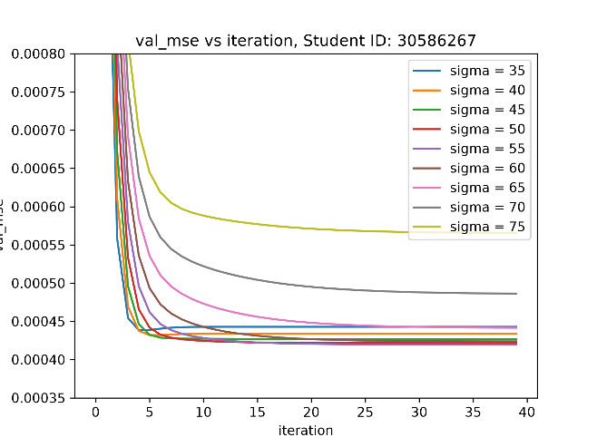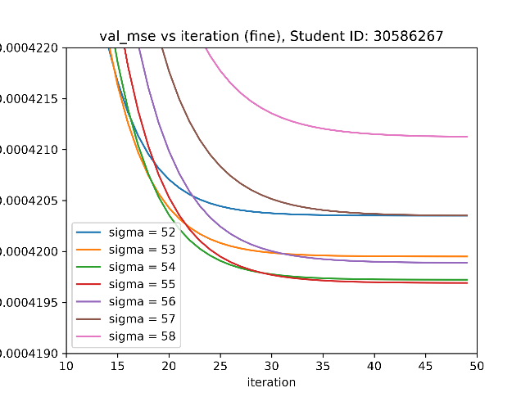
Figure 1: Graph of evaluation loss across iterations in a sigma sweep
Discussion
A polynomial fit of degree 9 is chosen as it produces the lowest loss following a degree sweep.
Hyperparameter sigma is the tuneable weight that modifies the strength of the alpha weighting matrix used to supress outliers. The relevant equations are:

alpha = np.exp(-sigma*(y_trn-y_trn_pred)**2)
A = np.diag(alpha)
w = np.linalg.inv(X.T @ A @ X) @ X.T @ A @ y

Where alpha, y_trn and y_trn_pred are lists, and alpha has values between 0 and 1.
A higher sigma value means alpha decays to 0 faster as squared loss (y_trn-y_trn_pred)**2 in the equation increases:
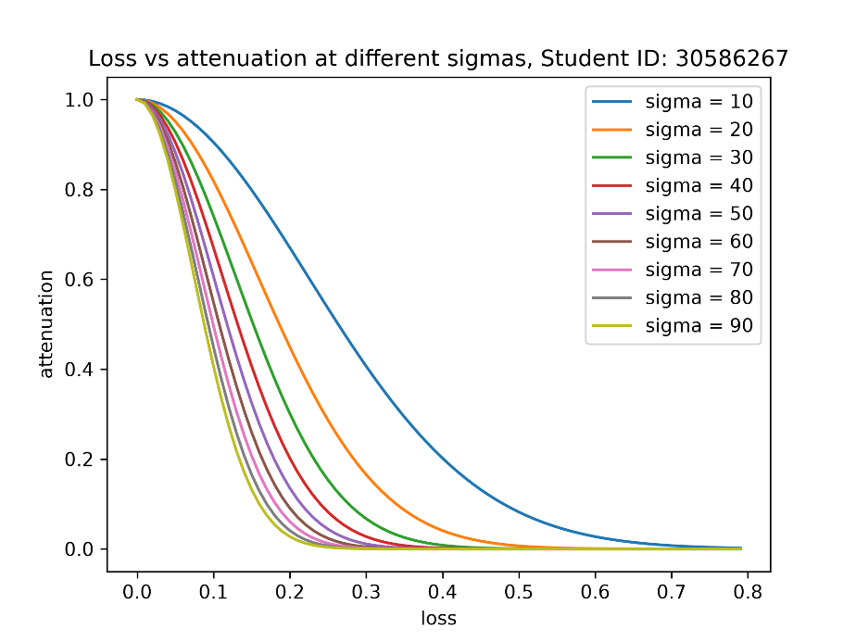
Figure 2: Graph of loss vs attenuation at different sigmas
An appropriate sigma value must be chosen to ensure that genuine outliers are heavily attenuated but samples with acceptable levels of deviation from the ground truth and are still suitable for use in training do not get too heavily attenuated.
A trial-and-error approach as illustrated by figure 1 reveals that the sigma value that produces the smallest evaluation loss after converging is sigma=55.
The learned alpha list has the below weights after convergence:
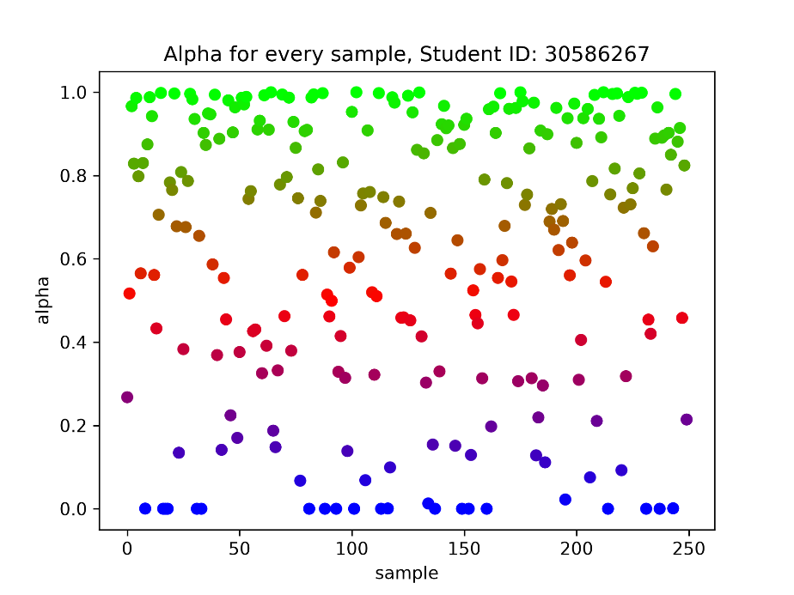
Figure 3: Graph of alpha value by sample
Overlaying these alpha values onto the original x_trn vs y_trn graph yields the following graph which clearly illustrates that alpha at sigma=55 is attenuating genuine outliers:
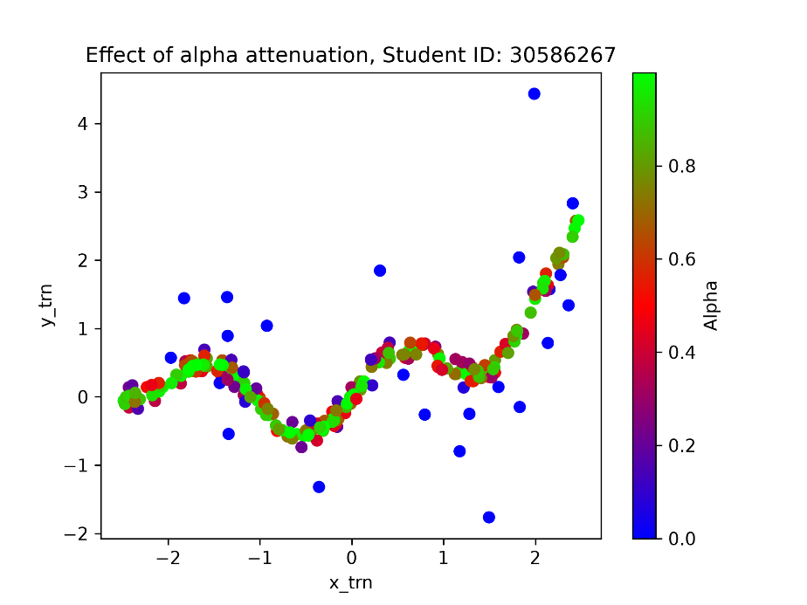
Figure 4: Graph illustrating alpha attenuation on the training dataset
At polynomial degree 9, the weighted prediction achieves an evaluation less that is 10 times smaller than the unweighted predictions:

unweighted | weighted
train_mse: 0.1209212446251193  val_mse: 0.004277185261129884 | train_mse: 0.12454046876928337  val_mse: 0.0004196998501118245
Figure 5: Table of training and evaluation losses
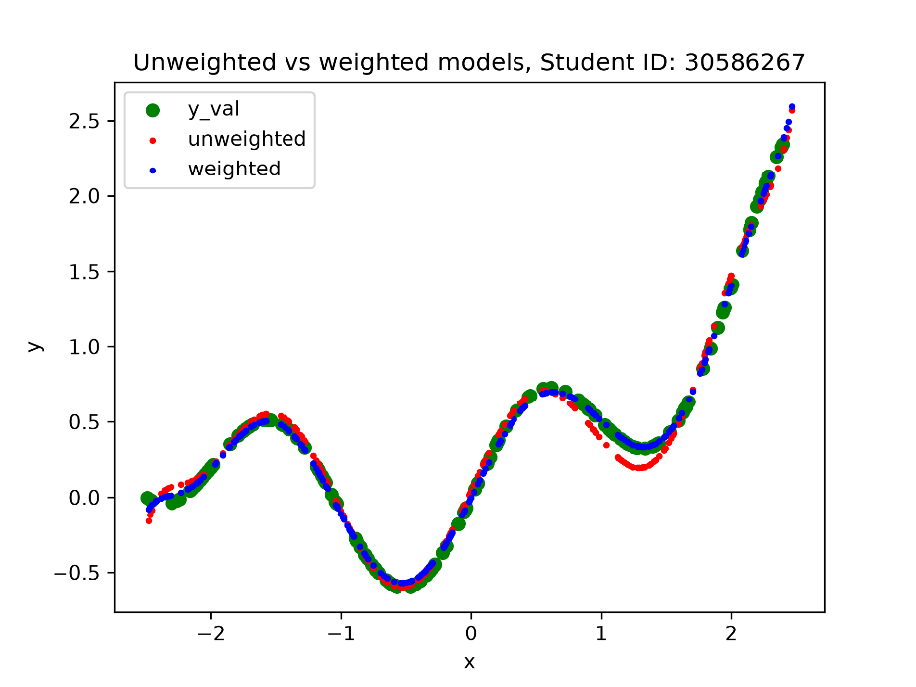
Figure 6: Graph of weighted and unweighted predictions

GenAI Declaration
Did you use any GenAI tools for this question? Yes

If yes, state: (i) what you asked, (ii) which suggestions you tried, and (iii) what worked or was discarded.
List of prompts:
- why does X.T@X become badly conditioned if I do not normalise it?
- after normalising, do I need to bring each feature back to the original domain?
- I want to change the colour of the markers based on a list of alpha values, sort of like a heatmap. Where the highest alpha value is blue and lowest is red. How can I achieve this
- Several “what does this error mean” questions

Which suggestions I tried:
- Colourmap
- Bug fixes

What worked / what was discarded:
- Colourmap
- Need to normalise but do not need to bring features back to original domain
- Virtually all bug explanations were on point and solved the issue

Question 3 — Face Landmark Detection

Q3-4. Baseline: Linear Probing (15 marks)
Report the results of your linear probing experiment below. A well-trained linear probe should achieve a validation RMSE of approximately 12 pixels.
RMSE results
Validation RMSE (pixels) | 14.5388
Test RMSE (pixels) | 9.9886

Training and validation loss curves with clear axis labels:
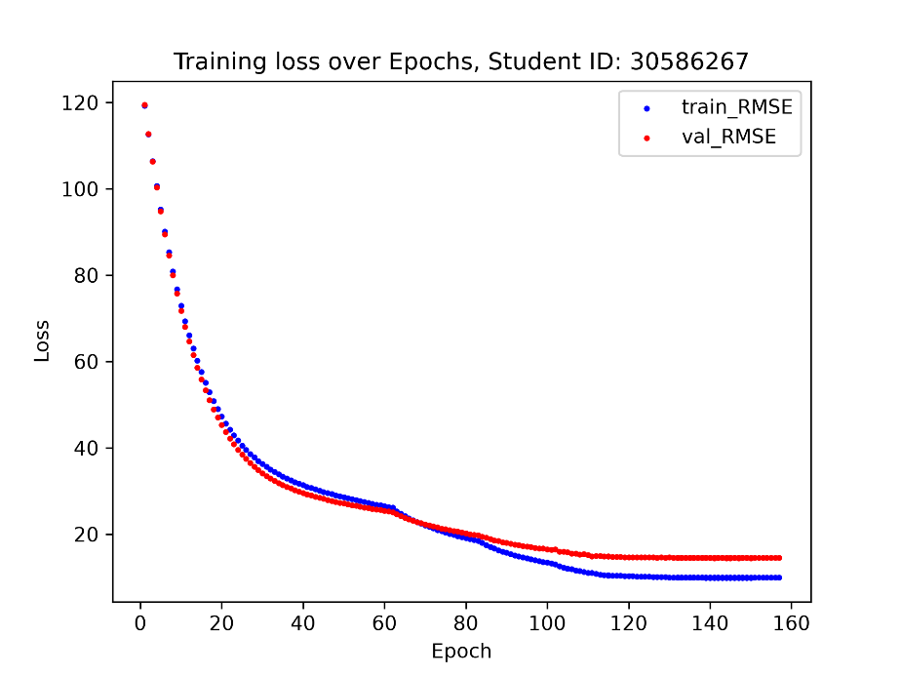
Figure 7: Graph of training loss vs evaluation loss over epochs (best_checkpoint15.pth)
5 Example Predictions on Validation and 5 on Test Images:
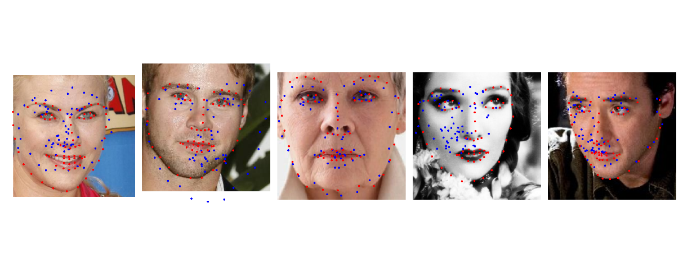
Figure 8: Landmark predictions on test set using only a trained classifier
Discussion
The classifier head is implemented on top of an efficientnet_b0 model backbone using default weights. The classifier connects 1280 neurons to 136 outputs or 68 landmark co-ordinate pairs.
The input images are normalised using the ImageNet mean/std normalisation matrix to make sure the model converges with a typical learning rate as per the assignment’s instructions. Landmarks co-ordinates are divided by 224 to match the transformation.
The training code uses the AdamW optimiser with various combinations of lr(learning rate) and weight_decay. A total of 15 classifier-only models were trained using different weight_decay values that ranges from 1e-5 to 1e1. See Figure 9: Loss curves for different decay settings.
A higher weight_decay is warranted during training given the extremely small number of training images compared to the number of neurons seen by the classifier head. This means overfitting is a risk in this situation as highlighted by assignment instructions.

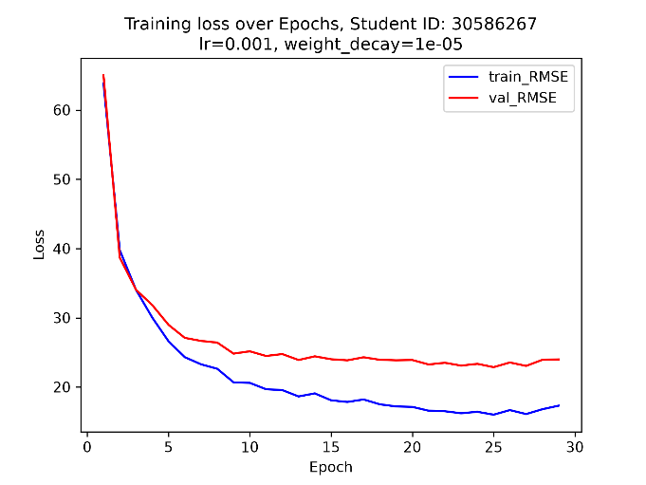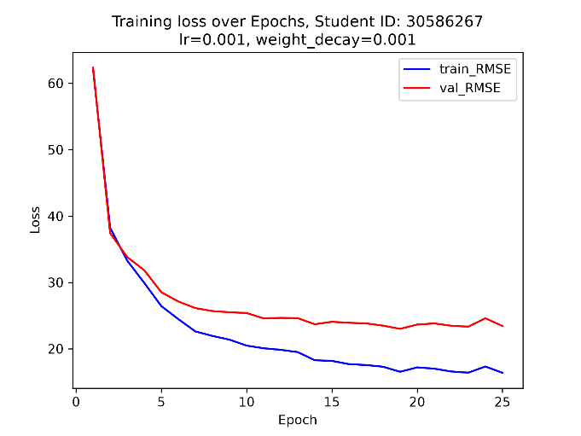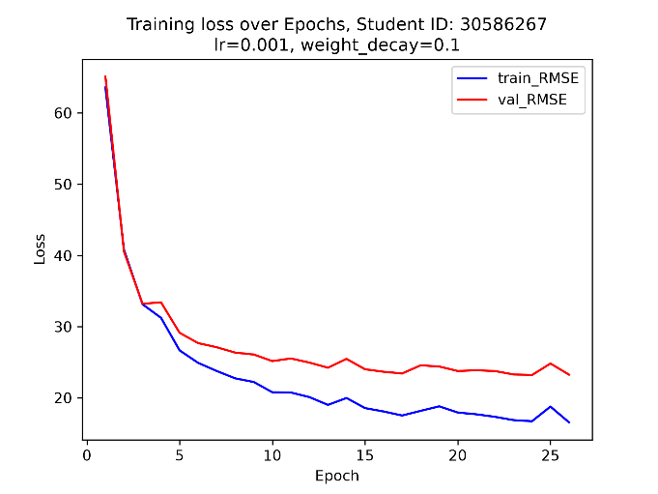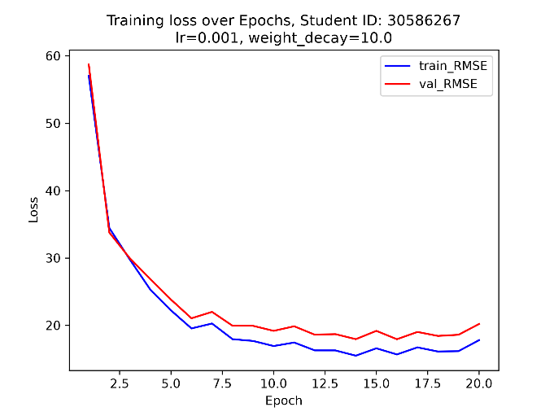

Figure 9: Loss curves for different decay settings.
The intersection between the training and evaluation loss is the point at which overfitting begins to occur. While decreasing the decay does not seem to delay when overfitting occurs, it does effectively decrease the severity of overfitting. The gap between train_RMSE and val_RMSE is the lowest out of all 4 graphs:

weight_decay = 1e-5 | weight_decay = 1e-3 | weight_decay = 1e-1 | weight_decay = 1e1
Epoch: 30  trn_RMSE: 16.3471  val_RMSE: 22.2895 | Epoch: 26  trn_RMSE: 16.8134  val_RMSE: 22.8692 | Epoch: 27  trn_RMSE: 17.1393  val_RMSE: 22.6530 | Epoch: 21  trn_RMSE: 15.2145  val_RMSE: 17.4166
Figure 10: Table of best checkpoints produced by different weight settings
The AdamW update equation is the following:

W = (1 - lr*weight_decay) * W_prev – [AdamW update value]

The weight_decay and lr parameters control how heavily the previous weights influence the upcoming weights update. The overfitting risk justifies using a weight_decay value that is large. Notably, the influence of weight_decay is counterbalanced by lr, which gets decreased subject to scheduling as val_RMSE converges. This is consistent with the idea that the quality of trained weights improves throughout training. Once the quality of the baseline weights reaches a point where the model is no longer at high risk of overfitting, then more influence should be given to the baseline weights rather than discarding them with a high weight_decay setting.
That was the approach taken during training & manual scheduling. During the training processes, the lr was subject to manual scheduling and early-stopping several times when the rate of decrease of val_RMSE slowed or began oscillating. This is visible as sharp gradient changes in Figure 7: Graph of training loss vs evaluation loss over epochs.
The training dataset was also subject to augmentation during training. The dataset’s __getitem__ method randomly flips images to effectively double the size of the original dataset. This increase the difficulty of training in the beginning as seen with the higher val_RMSE for training runs where flipping is enabled. However, the gap between trn_RMSE and val_RMSE increase as a result. Ultimately a model with the smaller val_RMSE was chosen as the best model to conform to the requirements of the assignment. If the requirement did not exist, the model with less loss gap will also be a sensible baseline to refine. Notably, horizontal flipping was reintroduced in Q3-5 to refine the baseline model.
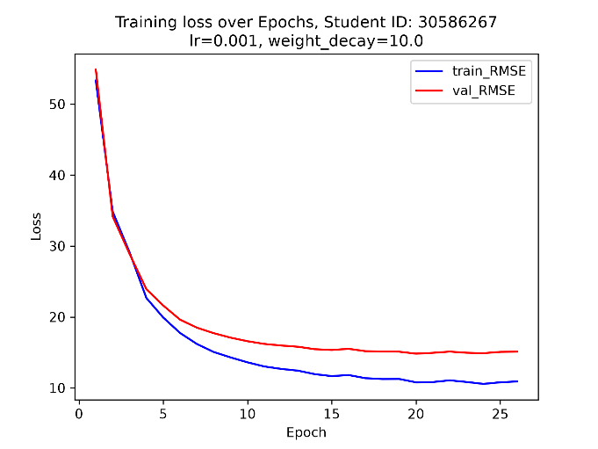
Figure 11: Graph of training loss for models using an augmented dataset (left) and non-augmented dataset (right)

augmentation = True | augmentation = False
Epoch: 21  trn_RMSE: 15.2145  val_RMSE: 17.4166 | Epoch: 27  trn_RMSE: 10.1064  val_RMSE: 14.7444
Figure 12: Loss of models trained on augmented vs non-augmented datasets
The dataset is also loaded in shuffled batches to increase the number of optimiser steps per epoch. Using batches also potentially assists prediction for images that may otherwise be harmed by overgeneralisation from calculating optimiser steps from the entire dataset.
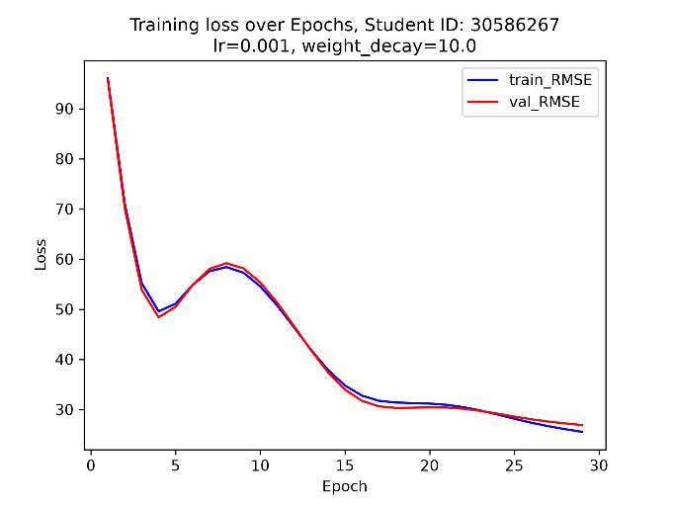
Figure 13: Graph of training loss for models using batch size of 680 (left) and 85 (right)
batch_size = 680 | batch_size = 85
Epoch: 30  trn_RMSE: 25.1311  val_RMSE: 26.5620 | Epoch: 21  trn_RMSE: 15.2145  val_RMSE: 17.4166

The final model best_checkpoint15.pth with val_RMSE = 14.5388 produces predictions that are poor in quality. There are significant shifts in prediction location. Occasionally the model fails to detect which region is the face.

GenAI Declaration
Did you use any GenAI tools for this question? Yes

If yes, state: (i) what you asked, (ii) which suggestions you tried, and (iii) what worked or was discarded.
What I asked:
- I need to horizontally flip my dataset to use for training.
- so the index mapping is the same for every image?
- how do I use the getitem function
- is the index flipping logic correct? I think including flipped images has increased loss
- should I start from my previous best checkpoint or start from scratch
- numerous debug questions

Which suggestions I tried:
- The flipmap
- Augmentation (horizontal flipping)
- Using the model with lower loss as baseline
- All debugging suggestions

What worked / did not work:
- Most debugging suggestions worked
- AI’s lr and weight_decay suggestions were unsuitable for the task
- The flipmap worked

Q3-5. Model Improvement (10 marks)
Document the improvements you made to the baseline model. Boss performance target: ~7 pixels RMSE on the validation set.
RMSE results
Validation RMSE (pixels) | 4.5956
Test RMSE (pixels) | 4.7452

Training and validation loss curves with clear axis labels:
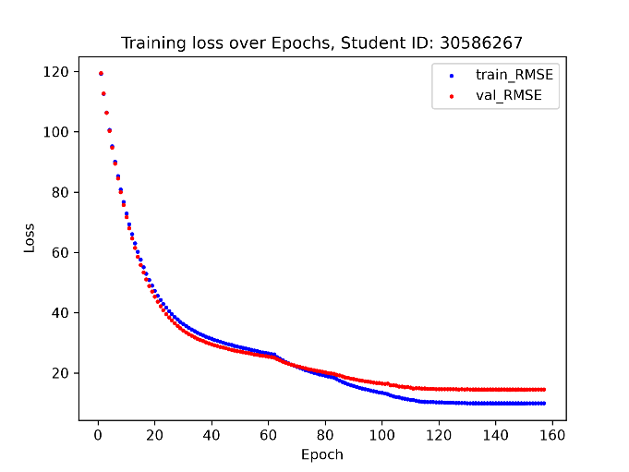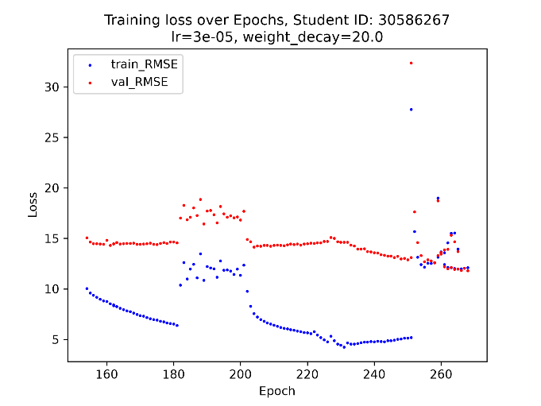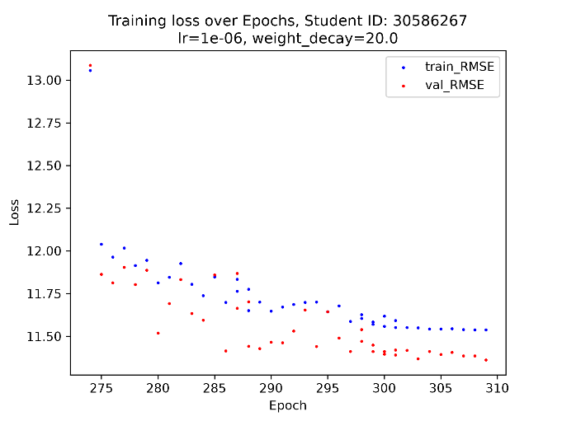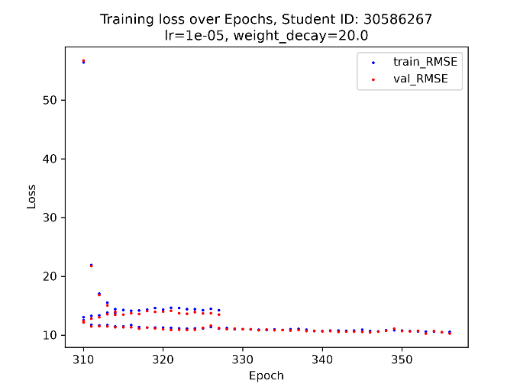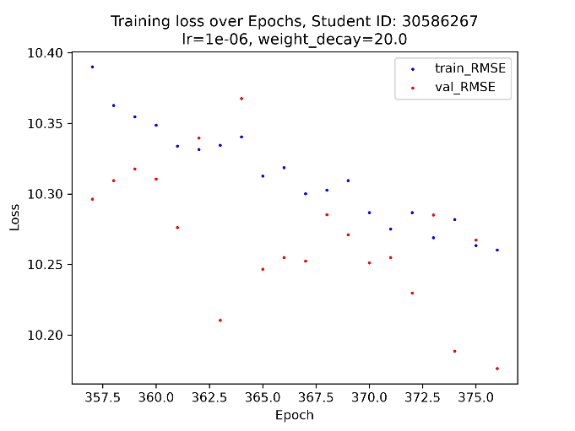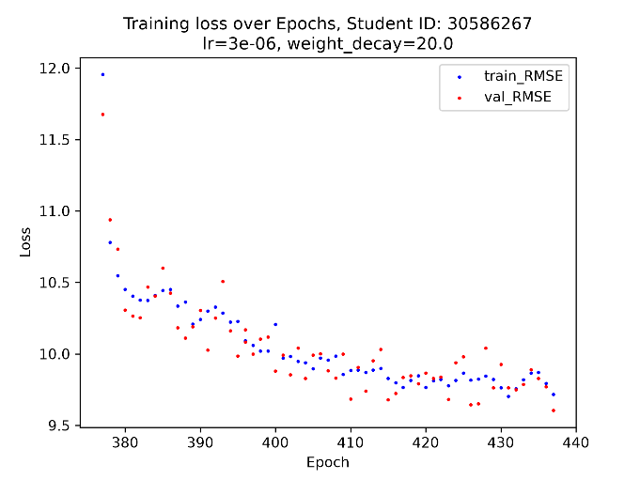
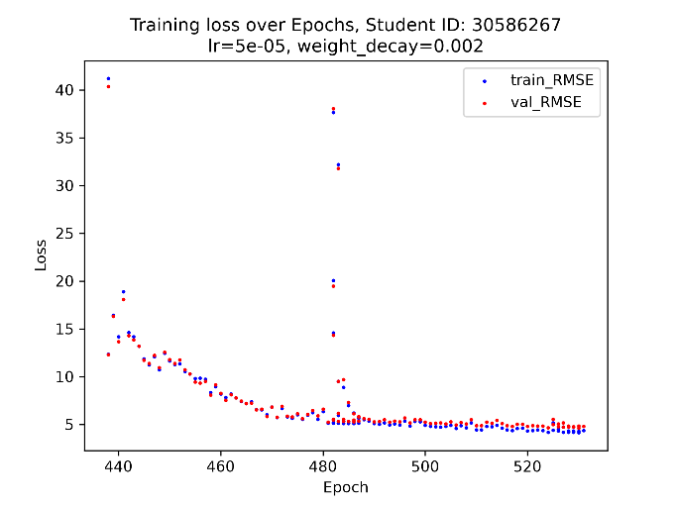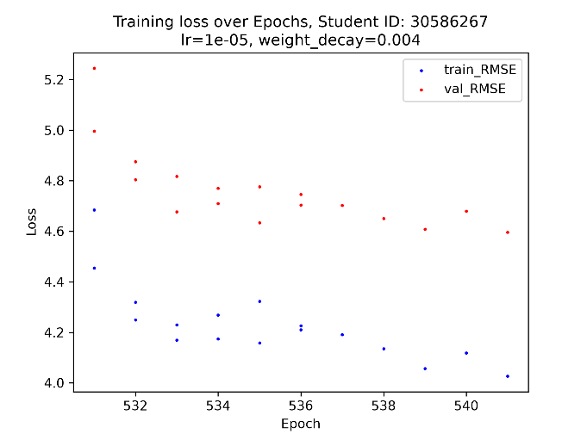
Figure 14: List of graphs documenting loss over epochs as training settings change
5 Example predictions on test images:
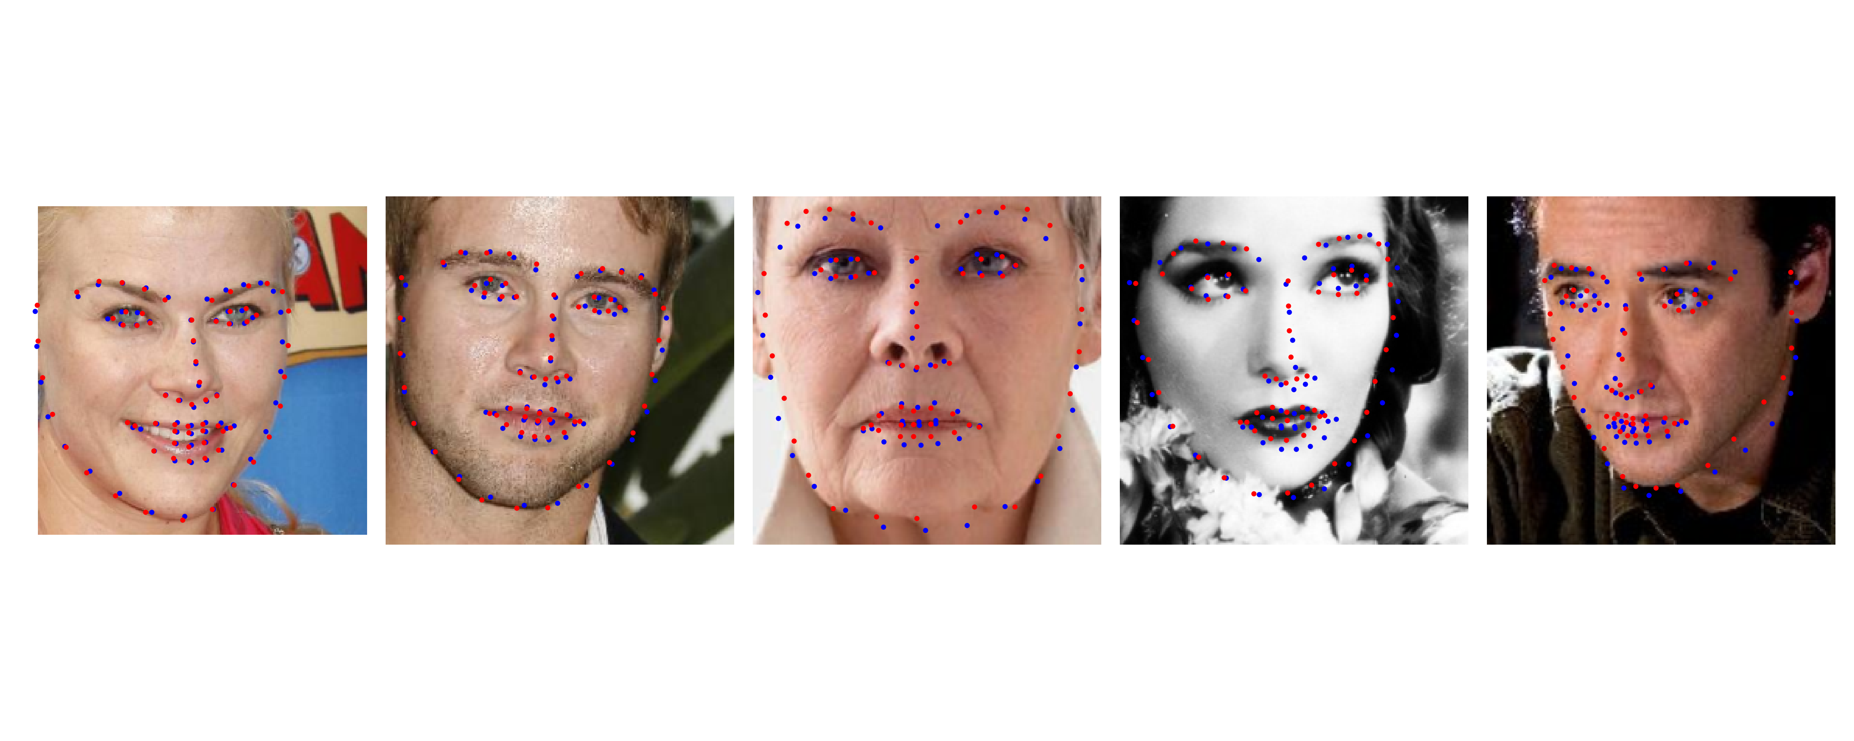
Figure 15: Prediction of final model
Reflection: modifications made and their effect
<< Describe what you changed, why, and the performance impact >>

GenAI Declaration
Did you use any GenAI tools for this question? << Yes / No >>

If yes, state: (i) what you asked, (ii) which suggestions you tried, and (iii) what worked or was discarded.

<< GenAI usage description, or "N/A" >>

Question 4 — Classifying Traffic Signs with CNNs

Q4-6. CNN Training (15 marks)
Train a CNN on GTSRB from scratch (no pretrained models). Your model must achieve at least 90% test accuracy to be considered competent.
Architecture summary
<< Describe your CNN architecture (number of conv blocks, kernel sizes, pooling, FC layers, etc.) >>

Training details
Optimiser | << value >>
Learning rate | << value >>
Batch size | << value >>
Number of epochs | << value >>
Data augmentation, i.e. transformations | << value >>

Accuracy results
Validation accuracy (%) | << value >>
Test accuracy (%) | << value >>

Training and validation accuracy / loss curves with clear axis labels:
[ Paste your training curves here ]

Discussion
<< Discuss your design choices, challenges, and results >>

GenAI Declaration
Did you use any GenAI tools for this question? << Yes / No >>

If yes, state: (i) what you asked, (ii) which suggestions you tried, and (iii) what worked or was discarded.

<< GenAI usage description, or "N/A" >>

Q4-7. Occlusion Sensitivity Analysis (10 marks)
Generate occlusion heatmaps for three correctly classified and three misclassified test images. Discuss what the model appears to focus on.
3 Heatmaps with original images — correctly classified images
[ Paste occlusion heatmaps for 3 correctly classified images here ]

3 Heatmaps with original images — misclassified images
[ Paste occlusion heatmaps for 3 misclassified images here ]

Discussion
<< Discuss what the heatmaps reveal about the model's focus and any patterns in misclassifications >>

GenAI Declaration
Did you use any GenAI tools for this question? << Yes / No >>

If yes, state: (i) what you asked, (ii) which suggestions you tried, and (iii) what worked or was discarded.

<< GenAI usage description, or "N/A" >>

Question 5 — Speech Command Recognition

Q5-8. Speech Command Recognition (25 marks)
Build a model to classify ten spoken commands. Submit your final test predictions to the Kaggle competition (linked on Moodle) and report your Kaggle username.
Approach Discussion (Detailed Discussion of the Model Architecture and Improvements Made):<< Describe your feature extraction approach (e.g. Wav2Vec2, Whisper) and classifier >>

Training details
Feature extractor model | << value >>
Frozen / fine-tuned layers | << value >>
Classifier architecture | << value >>
Optimiser & learning rate | << value >>
Epochs / early stopping | << value >>

Results
Validation accuracy (%) | << value >>
Kaggle username | << value >>
Kaggle test accuracy (%) | << value >>

Training curves with clear axis labels:
[ Paste your training and validation accuracy / loss curves here ]

GenAI Declaration
Did you use any GenAI tools for this question? << Yes / No >>

If yes, state: (i) what you asked, (ii) which suggestions you tried, and (iii) what worked or was discarded.

<< GenAI usage description, or "N/A" >>

Acknowledgements (optional)
<< List any people or resources you found particularly helpful (not required) >>

