The Effect of Content Embeddings on Hybrid Recommender Systems for Short Videos
A study on the VK-LSVD dataset
Abtini Aisha Ismailevna
Third year Student of Group БПАД#246
Higher School of Economics
July 2026

Abstract
Hybrid recommenders combine collaborative filtering with content features, but it is often unclear when the content side actually pays off. This report measures that on VK-LSVD, an industrial short-video dataset with a single multimodal content embedding per item whose components are ordered, so a prefix of length d is a usable lower-dimensional signal. I train and compare six model families, from a popularity baseline to a two-tower network, and evaluate them under a global temporal split with cold, warm, and popular item slices. The result is consistent across three ways of adding the embedding: content signal barely moves quality on popular items and carries almost all of its value on cold items with little training history. Any pure collaborative model scores exactly zero on the cold slice; a hybrid that reserves a fixed quota of content-selected candidates lifts cold NDCG@10 from 0 to 0.0023 on the test week while keeping overall metrics on par with iALS. Quality as a function of d saturates past d=32, and the multimodal embedding contributes far more than tabular metadata (+22% vs. +2% NDCG@10 in the two-tower model).

1. Introduction
Recommender systems for short-video feeds have to rank a catalog that changes by the hour. Collaborative filtering (CF) learns from interaction history and does this well for items people have already watched, but it has nothing to say about a video uploaded an hour ago. Content features are the usual answer: if two videos look and sound similar, a model can transfer preference from one to the other before either has much history. The open question this report addresses is narrower and more practical than whether content features help. It is when they help, and by how much, relative to the cost of adding them.
VK-LSVD [1] gives an unusually clean setting for that question. It ships one multimodal content embedding per video, trained only on content (frame, description, audio) with no collaborative signal mixed in. The embedding has a property most datasets lack: its 64 components are ordered so that the dot product of the first n components approximates the cosine similarity of the full production embedding. That turns the question of how much content signal you need into a single knob, the prefix length d, and lets me trace a clean quality-versus-width curve instead of guessing at a fixed size.

2. Problem Statement
The task defined for this project is to implement several collaborative filtering algorithms on an open dataset, add content embeddings of different kinds, and report how each addition changes recommendation accuracy, robustness, and ranking quality. VK-LSVD provides a single multimodal embedding rather than separate text, image, and audio vectors, so the different-kinds-of-embedding axis is reframed. Instead of comparing modalities, I study how informative the multimodal signal is as a function of two things I can control: its width (the prefix length d) and the way it enters the model (a pure content model, a fallback hybrid, or a learned feature inside a neural retriever). The central claim I set out to test is that content embeddings pay off mainly on cold items and add little on popular ones. That claim, if it holds, is the direct answer to the in-different-scenarios part of the task.

3. Objectives
- Build a reproducible pipeline over a VK-LSVD subsample: interaction loading, an implicit-feedback target, a global temporal split, and ranking metrics with cold/warm/popular slices.
- Implement and compare six model families spanning the CF-to-hybrid spectrum: Popularity, content k-NN, iALS, BPR, EASE, and a two-tower network.
- Trace quality against embedding width d in {4, 8, 16, 32, 64} for every model that consumes the embedding.
- Separate the contribution of the content embedding from that of tabular metadata (duration, demographics).
- Confirm the findings transfer to a second, much denser subsample and to the held-out test week.
I frame three hypotheses and test each in Section 6:
- H1. Content signal drives the gain on cold items and barely affects popular ones.
- H2. Quality rises with d and then saturates; the first components hold most of the information.
- H3. Tabular metadata alone contributes much less than the content embedding.

4. Dataset and Exploratory Analysis
VK-LSVD is the largest open industrial short-video dataset: 40 billion interactions, 10 million users, 20 million videos, over six consecutive months. I work on the official ur0.01_ir0.01 subsample (a random 1% of users by 1% of items): 3.72M interactions, 89,371 users, 120,415 videos. To check that the conclusions are not an artifact of one sampling regime, I also use the dense up0.001_ip0.001 subsample (10,000 users, 19,628 videos, 47M interactions, 24% density against 0.036% for the main one).
Each interaction records watch time, explicit reactions (like, dislike, share, bookmark, click-on-author, open-comments) and context. There are no repeated exposures of the same pair. Item metadata gives duration and author; user metadata gives age, gender, and region.
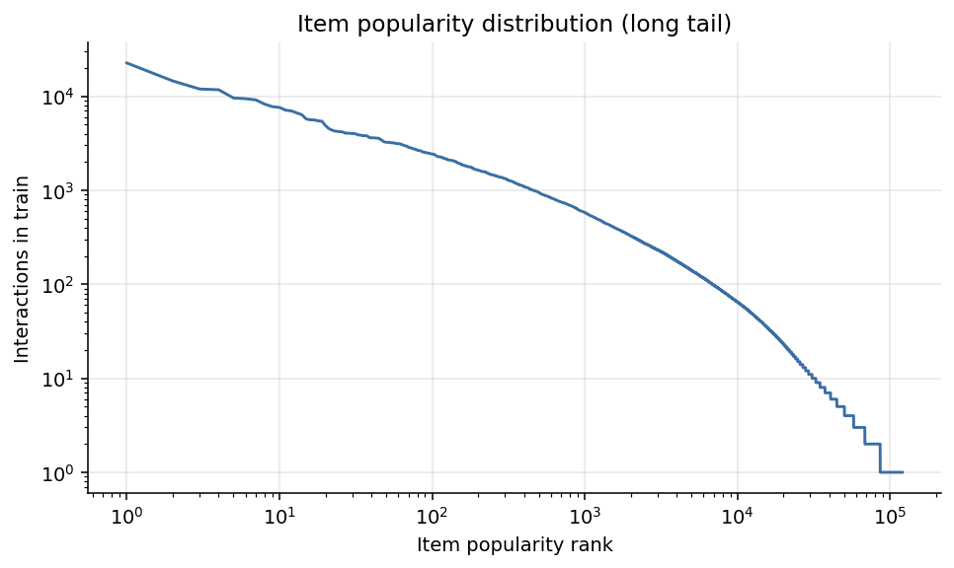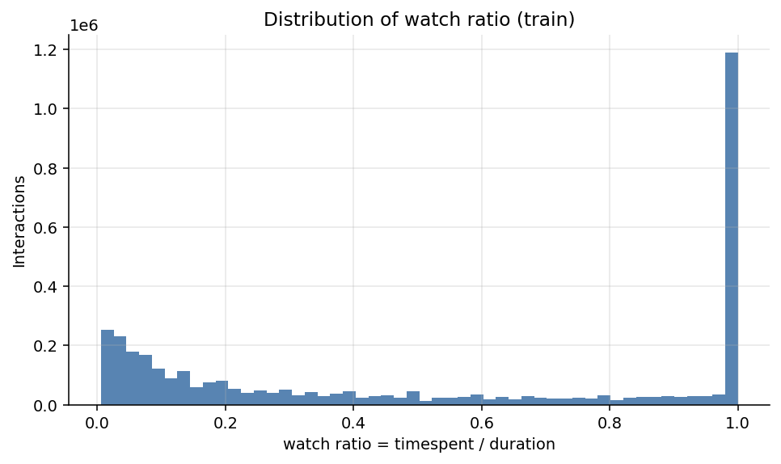
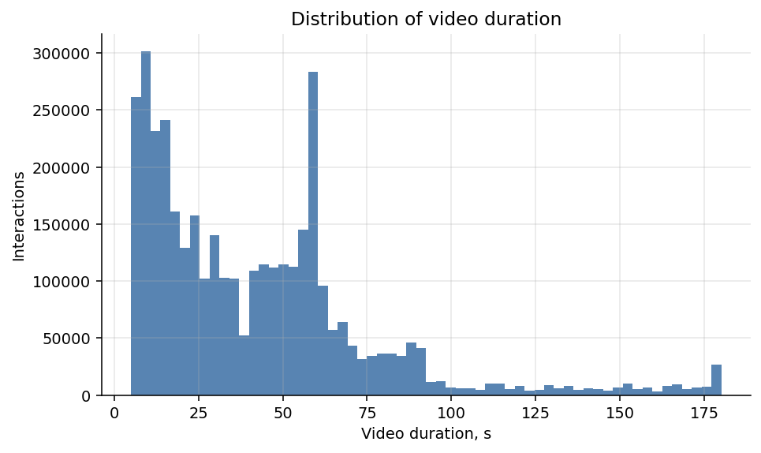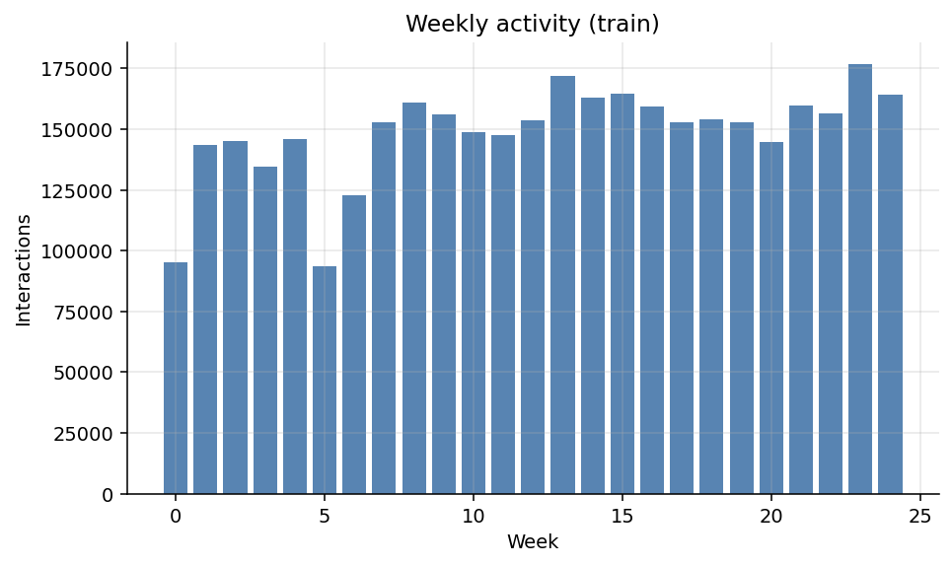
Figure 1. Exploratory views of the main subsample (train weeks 0-24): item popularity, watch ratio, duration, weekly activity.
Two properties of the data shaped the design. Explicit reactions cover only 3.4% of interactions, so a target built on likes alone would be extremely sparse. And 31% of views have timespent at least equal to duration: these are looped replays, a short-video quirk, for which the watch ratio is clipped to 1.

5. Methodology

5.1. Implicit-feedback target
A positive interaction is defined as like OR share OR bookmark OR watch-ratio ≥ 0.8 (the combined target). Two alternatives are tested in Section 6.4: explicit reactions only, and watch-ratio ≥ 0.5. The watch ratio is timespent/duration, clipped to [0, 1].

5.2. Global temporal split
I use the split shipped with the dataset: train is weeks 0-24, validation is week 25, test is week 26. The model learns from the past and is scored on the future. Random and leave-one-out splits are avoided because they leak future information and inflate metrics. Users and items that first appear in the evaluation weeks are kept, not dropped; they form the cold slices. Hyperparameters were tuned on validation only. The test week was touched once, with the final models.

5.3. Models
- Popularity: top-N by number of train positives; the lower bound.
- Content k-NN: a pure content model. The user profile is the mean of the embeddings of their train positives; items are scored by cosine similarity.
- iALS [2]: CF with confidence weighting 1 + alpha(watch_ratio + 3 like), alpha = 20, 128 factors.
- BPR-MF [3]: matrix factorization with a pairwise ranking loss.
- EASE [4]: a closed-form linear item-item model. The dense item-by-item matrix needs about 62 GB on the full catalog, so EASE is trained on the dense subsample (19,628 items, about 1.5 GB) instead.
- iALS + content fallback: a hybrid. Warm items are ranked by iALS; cold candidates are selected by content similarity to the user profile and given a fixed 10% quota of output positions (the exploration-slot pattern used in production feeds).
- Two-tower [5]: a neural retriever. The item tower is concat(id_emb, frozen content_emb to a learned projection, duration bucket) to an MLP; the user tower is id_emb plus demographics to an MLP. Training uses InfoNCE [6] with in-batch negatives plus popularity-sampled hard negatives, L2-normalized outputs, temperature 0.07.

5.4. Evaluation protocol
Ranking is done over the full catalog, without sampled negatives. Accuracy metrics are Recall@10/50, NDCG@10/50, and MAP@10. Beyond-accuracy metrics are catalog Coverage@50 and Novelty@10 (the mean negative log2 popularity share of recommended items). Robustness slices split evaluation items into cold (fewer than 5 train interactions), warm, and popular (top 1%), and split users into cold (no train history, served the popularity fallback) and active. Evaluation runs in the original id space: items with no train history are legitimately unreachable for a pure CF model, and that is exactly the effect being measured.

6. Experiments and Results

6.1. Model comparison
Table 1. Model comparison on validation (week 25). R = Recall, N = NDCG; cold/warm are NDCG@10 on item slices.
Model | R@10 | N@10 | R@50 | N@50 | N@10 cold | N@10 warm | Cov@50 | Nov@10
Popularity | 0.0002 | 0.0001 | 0.0127 | 0.0030 | 0.0000 | 0.0000 | 0.001 | 8.7
Content k-NN (d=64) | 0.0028 | 0.0017 | 0.0111 | 0.0038 | 0.0016 | 0.0017 | 0.614 | 18.0
BPR-MF | 0.0212 | 0.0123 | 0.0676 | 0.0242 | 0.0000 | 0.0179 | 0.488 | 14.7
iALS | 0.0312 | 0.0170 | 0.1107 | 0.0373 | 0.0000 | 0.0084 | 0.098 | 11.2
iALS + fallback | 0.0299 | 0.0164 | 0.1097 | 0.0369 | 0.0036 | 0.0074 | 0.114 | 12.1
Two-tower: id-only | 0.0051 | 0.0029 | 0.0248 | 0.0078 | 0.0004 | 0.0047 | 0.991 | 18.4
Two-tower: + metadata | 0.0054 | 0.0029 | 0.0250 | 0.0078 | 0.0005 | 0.0047 | 0.993 | 18.5
Two-tower: + embedding | 0.0060 | 0.0032 | 0.0270 | 0.0085 | 0.0010 | 0.0049 | 0.992 | 18.6
Two-tower: full hybrid | 0.0067 | 0.0035 | 0.0291 | 0.0090 | 0.0015 | 0.0050 | 0.993 | 18.4

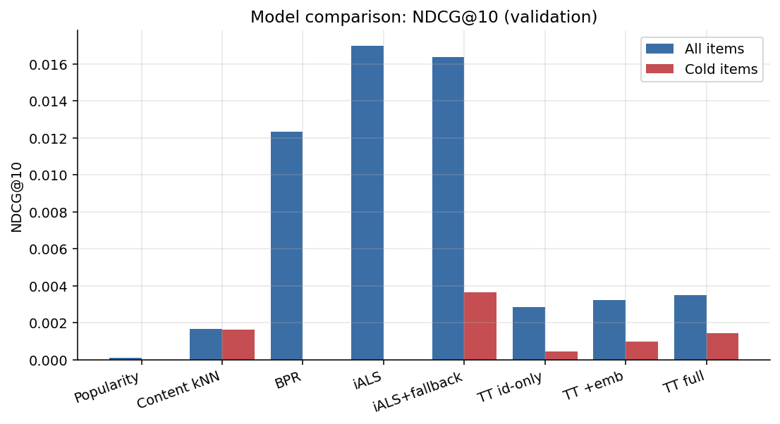
Figure 2. Overall and cold-slice NDCG@10 on validation. Every pure CF model scores zero on the cold slice.
Table 1 and Figure 2 tell one story. Pure CF (iALS, NDCG@10 = 0.0170) wins the overall ranking by a wide margin, but on cold items it scores exactly zero, because those items are absent from the training matrix. The content k-NN model is an order of magnitude weaker overall, yet it is the only baseline that reaches cold items at all (cold NDCG@10 = 0.0016). The fallback hybrid gets both: its cold NDCG@10 of 0.0036 is the best of any model, and it costs only a 3% drop in overall quality against iALS. This is the first evidence for H1.

6.2. Width of the content signal
Table 2. NDCG@10 as a function of embedding width d (validation), for three ways of using the embedding.
d | k-NN overall | k-NN cold | Hybrid overall | Hybrid cold | TT overall | TT cold
4 | 0.0001 | 0.0001 | 0.0154 | 0.0008 | 0.0024 | 0.0004
8 | 0.0006 | 0.0010 | 0.0157 | 0.0018 | 0.0028 | 0.0007
16 | 0.0010 | 0.0009 | 0.0160 | 0.0022 | 0.0034 | 0.0012
32 | 0.0016 | 0.0017 | 0.0164 | 0.0036 | 0.0035 | 0.0012
64 | 0.0017 | 0.0016 | 0.0164 | 0.0036 | 0.0032 | 0.0010

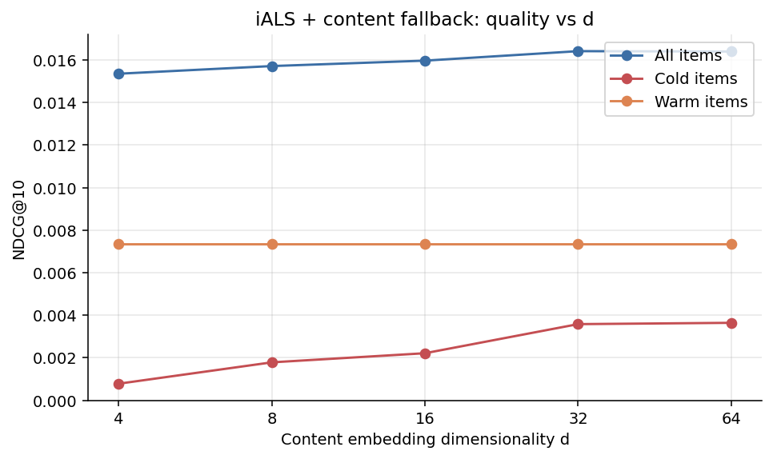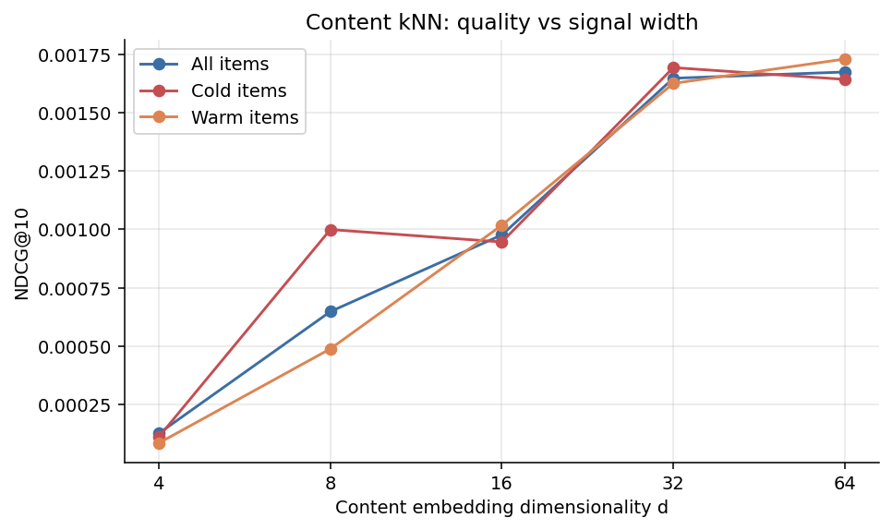
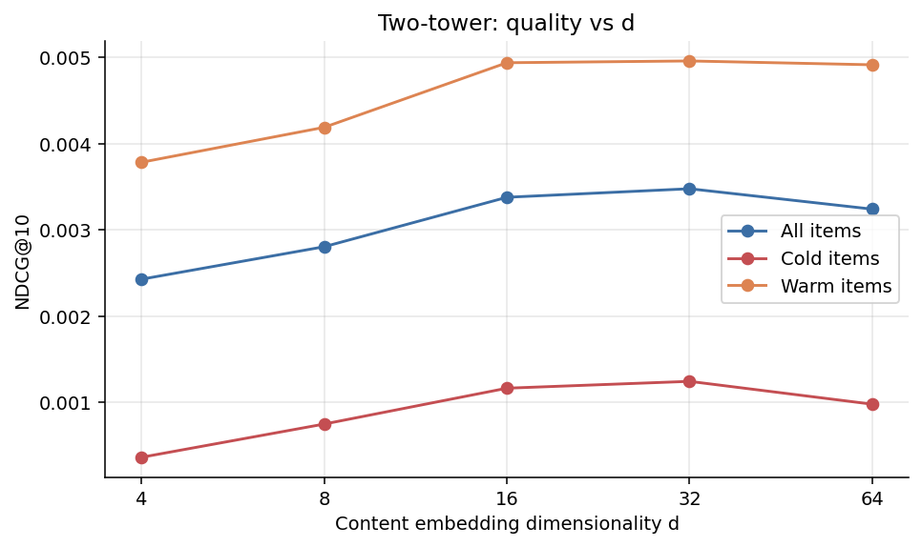
Figure 3. Quality against embedding width d. The warm line is flat; the cold line climbs and then levels off past d=32.
The three integration methods trace the same shape: a fast climb up to d=16-32, then a plateau at d=64. For the hybrid, cold NDCG@10 rises from 0.0008 at d=4 to 0.0036 at d=32 and stops moving after that. The first components carry most of the information, which confirms H2 and has a direct practical reading: d=32 is enough in production, halving the memory and compute of the content path for no measurable loss.

6.3. Embedding vs. metadata
Under a fixed training budget (8 epochs, CPU), adding the content embedding raises the two-tower NDCG@10 by 22% over id-only (0.0035 vs. 0.0029), while tabular metadata alone adds 2% (0.0029, statistically flat). On the cold slice the full hybrid reaches 3.4 times the id-only model. That is H3: the multimodal embedding is the content signal that matters, and metadata is a weak add-on.

6.4. Target ablation
Table 3. iALS metrics under three positive-interaction definitions (validation).
Positive definition | Positives share | R@10 | N@10 | R@50 | N@50
explicit (like/share/bookmark) | 3.4% | 0.0289 | 0.0147 | 0.0795 | 0.0268
watch (ratio ≥ 0.5) | 48.8% | 0.0311 | 0.0172 | 0.1114 | 0.0383
combined (main) | 39.8% | 0.0312 | 0.0170 | 0.1107 | 0.0373

A target built only on explicit reactions loses 28% of Recall@50 against the combined target: the implicit watch signal is needed. The gap between watch and combined is small, but combined also captures explicit intent, so I keep it as the fuller definition.

6.5. Beyond accuracy
Content sharply widens catalog coverage. Coverage@50 is 9.8% for iALS, 11.4% for the hybrid, 61% for content k-NN, and 99% for the two-tower with the embedding. Novelty rises monotonically as content is added (11.2 for iALS, 12.1 for the hybrid, 18.6 for the two-tower). Content is a lever against the popularity feedback loop, a separate benefit from accuracy.

6.6. Final evaluation on test
Table 4. Final evaluation on test (week 26). Stochastic models report mean ± std over 3 seeds.
Model | R@10 | N@10 | R@50 | N@10 cold
Popularity | 0.0000 | 0.0000 | 0.0115 | 0.0000
Content k-NN (d=64) | 0.0022 | 0.0013 | 0.0087 | 0.0010
EASE (dense subsample) | 0.0011 | 0.0009 | 0.0067 | 0.0000
BPR-MF (3 seeds) | 0.0164 ± 0.0004 | 0.0092 ± 0.0002 | 0.0539 ± 0.0004 | 0.0000 ± 0.0000
iALS (3 seeds) | 0.0218 ± 0.0002 | 0.0118 ± 0.0000 | 0.0840 ± 0.0001 | 0.0000 ± 0.0000
iALS + fallback (3 seeds) | 0.0213 ± 0.0003 | 0.0116 ± 0.0001 | 0.0849 ± 0.0006 | 0.0023 ± 0.0000

The validation ordering holds on the test week. iALS is still the strongest overall; the hybrid keeps parity on the general metrics (its Recall@50 is actually higher) and is the only model with a non-zero cold slice. Seed variance is negligible (std at most 0.0004). EASE on the dense subsample trails iALS: in a very high density regime, a linear item-item model is not enough.

7. Conclusions
- H1 holds. Content embeddings barely change quality on popular items, but they move the cold slice from a hard zero (every pure CF model) to measurable quality. The best mechanism is the hybrid with a content candidate quota: cold NDCG@10 = 0.0036 at a 3% overall cost.
- H2 holds. The quality-versus-d curve saturates past d=32 in all three integration methods; half of the embedding is enough.
- H3 holds. Metadata adds 2% against 22% for the embedding (two-tower, NDCG@10); the multimodal embedding is the content signal that counts.
- Practical reading. When the catalog is stable and items live long, plain iALS is enough. When the catalog turns over fast, which is the short-video case, a content fallback is not optional: without it, new items are systematically never recommended. The cold-candidate quota is a transparent dial on the accuracy-versus-exploration trade-off.
- Content also improves coverage and novelty in every configuration, a benefit beyond top-k accuracy.

8. Limitations
- One multimodal embedding rather than separate text, image, and audio vectors, so the modality comparison is replaced by the width axis d.
- Subsamples rather than the full 452 GB dataset. Transfer was checked on a second subsample with very different density.
- The two-tower model was trained under a small CPU budget (8 epochs) and does not reach iALS in absolute terms; its relative effects (embedding contribution, shape of the d curve) agree with the other models. LightFM was dropped because it does not build under Python 3.12.
- The two-tower test-week run was not completed for compute reasons; its numbers are reported on validation.
- Offline metrics are not the same as online effect; the cold-slice finding should be confirmed with an A/B test.

References
- deepvk. VK-LSVD: Large Short-Video Dataset. 2026. https://huggingface.co/datasets/deepvk/VK-LSVD (accepted at WWW '26).
- Y. Hu, Y. Koren, C. Volinsky. Collaborative Filtering for Implicit Feedback Datasets. ICDM, 2008.
- S. Rendle et al. BPR: Bayesian Personalized Ranking from Implicit Feedback. UAI, 2009.
- H. Steck. Embarrassingly Shallow Autoencoders for Sparse Data. WWW, 2019.
- P. Covington, J. Adams, E. Sargin. Deep Neural Networks for YouTube Recommendations. RecSys, 2016.
- A. van den Oord, Y. Li, O. Vinyals. Representation Learning with Contrastive Predictive Coding. arXiv:1807.03748, 2018.

