1. The before value of the fourth point (4.0, 2.1) is nonzero because the weights of six of its indices have been updated when the second point (4.0,2.0) was being learned. The before value of point four is the sum of the six weights of the tile indices that are shared by points two and four. These indices are:
[39, 160, 281, 403, 777, 898]

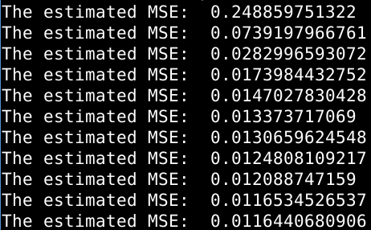
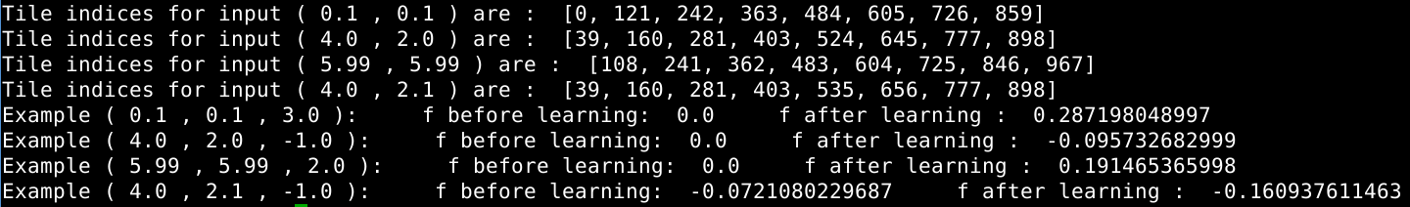
2. Since the target is non-stationary, the training function cannot account for the variability in the target caused by the addition of a random variable taken from a distribution with mean zero and standard deviation 0.1. The mean error will equal the variability, 0.1, and the MSE=(0.1)^2=0.01, and therefore the MSE will always be about 0.01 off.

