**DSCI D532 : HOMEWORK 1 (**[**schekka@iu.edu**](mailto:schekka@iu.edu)**)**

CREATE DATABASE adt_hw1;

-- Creating the hospitals table by following all the constraints properly

CREATE TABLE IF NOT EXISTS hospitals (

hospital_id INT AUTO_INCREMENT PRIMARY KEY,

hospital_name VARCHAR(255) NOT NULL,

state CHAR(2) NOT NULL,

city VARCHAR(100) NOT NULL,

doctor VARCHAR(255) NOT NULL

);

-- Creating the doctors table by following all the constraints properly

CREATE TABLE IF NOT EXISTS doctors (

doctor_id INT AUTO_INCREMENT PRIMARY KEY,

name VARCHAR(255) NOT NULL,

gender CHAR(7) CHECK (gender IN ('Male', 'Female', 'O')),

insurance CHAR(3) CHECK (insurance IN ('Yes', 'No')),

new_patients CHAR(3) CHECK (new_patients IN ('Yes', 'No')),

speciality_one VARCHAR(100),

speciality_two VARCHAR(100),

speciality_three VARCHAR(100),

license CHAR(3) CHECK (license IN ('MFT', 'PhD', 'MD')),

phone CHAR(10)

);

INSERT INTO

doctors(name, gender, insurance, new_patients, speciality_one,

speciality_two, speciality_three, license, phone)

VALUES

('Flora Martinez', 'Female', 'Yes', 'Yes', 'Diabetes', 'Cholesterol', 'immunology', 'MD', '8495776489'),

('Andy James', 'Male', 'Yes', 'No', 'Hypertension', 'Diabetes', 'PTSD', 'PhD', '2340894766'),

('Hannah Myers', 'Female', 'No', 'Yes', 'Diabetes', 'Hypertension', 'immunology', 'MD', '9907846574'),

('Jane Huang', 'Female', 'Yes', 'Yes', 'Dermatology', 'Hypertension', 'immunology', 'MD', '4507856797'),

('April Adams', 'Female', 'No', 'Yes', 'OCD', 'Hypertension', 'PTSD', 'MFT', '4507856797'),

('Jon Schaffer', 'Male', 'Yes', 'No', 'BPD', 'immunology', 'Dermatology', 'PhD', '9907846574'),

('Shauna West','Female', 'Yes', 'Yes', 'ADHD', 'immunology', 'OCD', 'MD', '8495776480'),

('Juan Angelo', 'Male', 'No', 'Yes', 'Diabetes', 'immunology', 'Dermatology', 'MD', '4507856797'),

('Christie Yang', 'Female', 'Yes', 'Yes', 'Autism', 'ADHD', 'OCD', 'PhD', '4507856796'),

('Annika Neusler', 'Female', 'Yes', 'No', 'Addiction', 'Dermatology', 'PTSD', 'MFT', '9907846575'),

('Simone Anderson', 'Female', 'No', 'No', 'Hypertension', 'Dermatology', 'PTSD', 'MD', '8304498765'),

('Ted Nyguen', 'Male', 'Yes', 'Yes', 'ADHD', 'Hypertension', 'Allergy', 'PhD', '4301239990'),

('Valentino Rossi', 'Male', 'Yes', 'Yes', 'Autism', 'Hypertension', 'Dermatology', 'MD', '8304498765'),

('Jessica Armer', 'Female', 'No', 'Yes', 'PTSD', 'immunology', 'Dermatology', 'MD', '3330456612'),

('Sid Michaels', 'Female', 'Yes', 'Yes', 'OCD', 'Allergy', 'Hypertension', 'MFT', '4301239997'),

('Yen Waters', 'Male', 'Yes', 'Yes', 'Hypertension', 'Dermatology', 'ADHD', 'PhD', '4507856796'),

('Ru Izaelia', 'Female', 'No', 'Yes', 'immunology', 'BPD', 'Allergy', 'MD', '4301239990'),

('Vishal Rao', 'Male', 'Yes', 'Yes', 'Dermatology', 'Diabetes', 'Hypertension', 'MD', '7305557894'),

('Lana John', 'Female', 'Yes', 'Yes', 'Hypertension', 'Allergy', 'OCD', 'MFT', '7305557894'),

('Izzie Geralt', 'Female', 'Yes', 'Yes', 'Dermatology', 'Addiction', 'Hypertension', 'MD', '4301239990');

INSERT INTO

hospitals(hospital_name, state, city, doctor)

VALUES

('Van Holsen Community Hospital', 'CA', 'San Francisco', 'Flora Martinez'),

('Clear Water Services', 'CA', 'San Diego', 'Andy James'),

('Imagery Health', 'CA', 'Sacramento', 'Hannah Myers'),

('Blue Cross Clinic', 'CA', 'Los Angeles', 'Jane Huang'),

('Blue Cross Clinic', 'CA', 'Los Angeles', 'April Adams'),

('Imagery Health', 'CA', 'Sacramento', 'Jon Schaffer'),

('Van Holsen Community Hospital', 'CA', 'Long Beach', 'Shauna West'),

('Blue Cross Clinic', 'CA', 'Santa Barbara', 'Juan Angelo'),

('Blue Cross Clinic', 'CA', 'San Francisco', 'Christie Yang'),

('Imagery Health', 'CA', 'Auburn', 'Annika Neusler'),

('Holistic Health Services', 'CA', 'Santa Barbara', 'Simone Anderson'),

('Open Clinic', 'CA', 'San Jose', 'Ted Nyguen'),

('Holistic Health Services', 'CA', 'Santa Barbara', 'Valentino Rossi'),

('Clark Jamison Hospitals', 'CA', 'Fresno', 'Jessica Armer'),

('Open Clinic', 'CA', 'Oakland', 'Sid Michaels'),

('Blue Cross Clinic', 'CA', 'San Francisco', 'Yen Waters'),

('Open Clinic', 'CA', 'San Jose', 'Ru Izaelia'),

('Clear Minds Community', 'CA', 'Sacramento', 'Vishal Rao'),

('Clear Minds Community', 'CA', 'Sacramento', 'Lana John'),

('Open Clinic', 'CA', 'San Jose', 'Izzie Geralt');

SELECT * FROM doctors;

SELECT * FROM hospitals;

-- Alter the hospitals table to add the doctor_id column

ALTER TABLE hospitals

ADD COLUMN doctor_id INT NOT NULL;

UPDATE hospitals

INNER JOIN doctors

ON hospitals.doctor = doctors.name

SET hospitals.doctor_id = doctors.doctor_id;

CREATE TABLE IF NOT EXISTS specialties(

specialties_key serial PRIMARY KEY,

speciality_one VARCHAR(100),

speciality_two VARCHAR(100),

speciality_three VARCHAR(100),

doctor_id INTEGER,

CONSTRAINT fk_doctor

FOREIGN KEY(doctor_id)

REFERENCES doctors(doctor_id));

INSERT INTO specialties(doctor_id, speciality_one, speciality_two, speciality_three)

SELECT doctor_id, speciality_one, speciality_two, speciality_three

FROM doctors;

ALTER TABLE doctors

DROP COLUMN speciality_one,

DROP COLUMN speciality_two,

DROP COLUMN speciality_three;

-- Exploration

-- 1. How many doctors are currently accepting new patients?

SELECT COUNT(*) AS doctors_accepting_new_patients

FROM doctors

WHERE new_patients = 'Yes';

-- 2. What is the distribution of doctors across different cities in California?

SELECT city, COUNT(doctor_id) AS number_of_doctors

FROM hospitals

GROUP BY city;

-- 3. How many male and female doctors have each type of license?

SELECT

license,

SUM(CASE WHEN gender = 'Male' THEN 1 ELSE 0 END) AS male_doctors,

SUM(CASE WHEN gender = 'Female' THEN 1 ELSE 0 END) AS female_doctors,

SUM(CASE WHEN gender = 'O' THEN 1 ELSE 0 END) AS other_gender_doctors

FROM doctors

GROUP BY license;

-- 4. How many doctors have a license in 'MD' and are treating 'Diabetes'?

SELECT COUNT(*) AS md_diabetes_doctors

FROM doctors

WHERE license = 'MD' AND doctor_id IN (

SELECT doctor_id

FROM specialties

WHERE speciality_one = 'Diabetes' OR speciality_two = 'Diabetes' OR speciality_three = 'Diabetes'

);

-- 5. What is the average number of doctors per hospital in the database?

SELECT AVG(doctor_count) as average_doctors_per_hospital

FROM (

SELECT hospital_id, COUNT(doctor_id) as doctor_count

FROM hospitals

GROUP BY hospital_id

) AS doctor_counts;

-- Visualization

-- Visualization 1: Distribution of Doctors by Specialty

SELECT speciality_one, COUNT(*) AS number_of_doctors

FROM specialties

GROUP BY speciality_one

ORDER BY number_of_doctors DESC;

-- Visualization 2: Acceptance of New Patients by Gender

SELECT gender, new_patients, COUNT(*) AS number_of_doctors

FROM doctors

GROUP BY gender, new_patients;

**Schema of the normalized database(EER Diagram):**

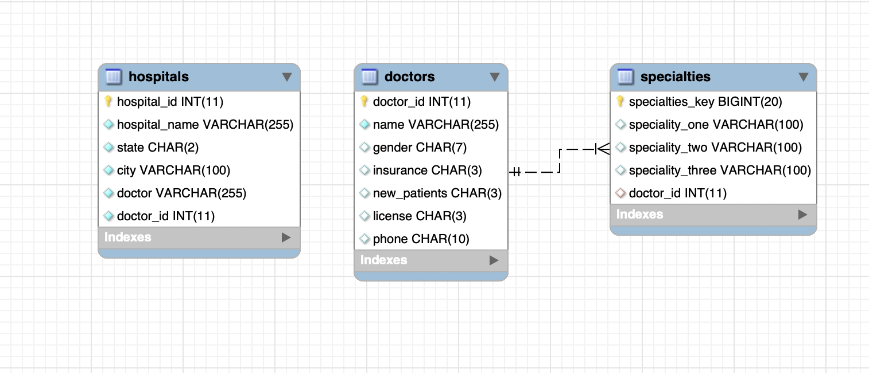

**Python notebook: Exploration**

**config = {**

**'user': 'root',**

**'password': 'root',**

**'host': '127.0.0.1',**

**'port': 8889,**

**'database': 'adt_hw1',**

**'raise_on_warnings': True**

**}**

**pip install mysql-connector-python**

**# create a MySQL server connection object**

**import mysql.connector**

**mydb = mysql.connector.connect(**config)**

**# cursor object**

**my_cursor = mydb.cursor(dictionary=True)**

**import mysql.connector**

**import pandas as pd**

**# Function to run a single query and return the results as a pandas DataFrame**

**def run_query(query):**

**my_cursor.execute(query)**

**rows = my_cursor.fetchall()**

**return pd.DataFrame(rows)**

**Query 1:**

**SELECT COUNT(*) AS doctors_accepting_new_patients**

**FROM doctors**

**WHERE new_patients = 'Yes';**

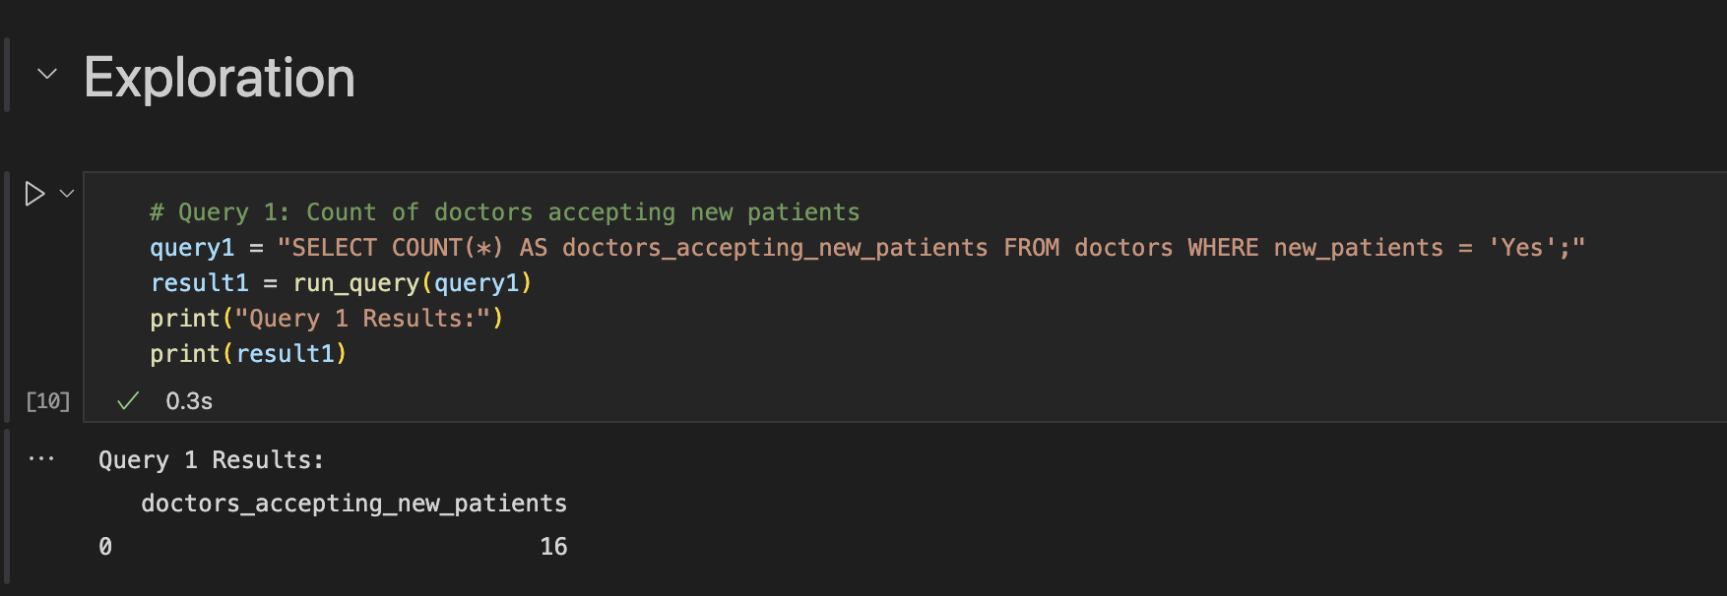

**Query 2**

**SELECT city, COUNT(doctor_id) AS number_of_doctors**

**FROM hospitals**

**GROUP BY city;**

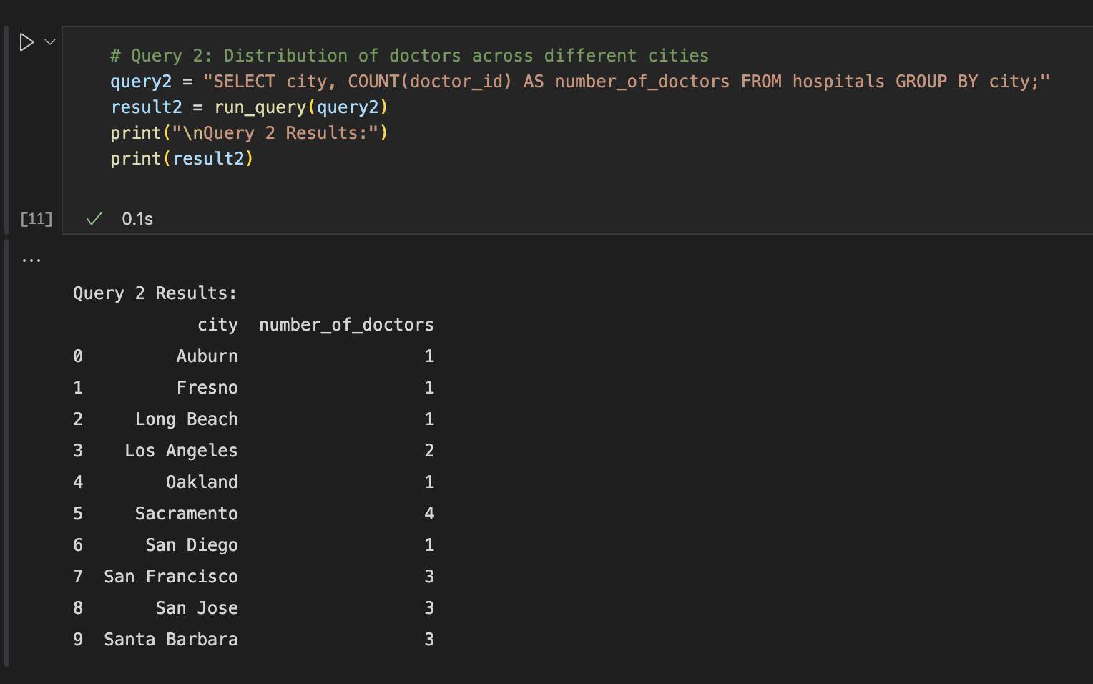

**Query 3:**

**SELECT**

**license,**

**SUM(CASE WHEN gender = 'Male' THEN 1 ELSE 0 END) AS male_doctors,**

**SUM(CASE WHEN gender = 'Female' THEN 1 ELSE 0 END) AS female_doctors,**

**SUM(CASE WHEN gender = 'O' THEN 1 ELSE 0 END) AS other_gender_doctors**

**FROM doctors**

**GROUP BY license;**

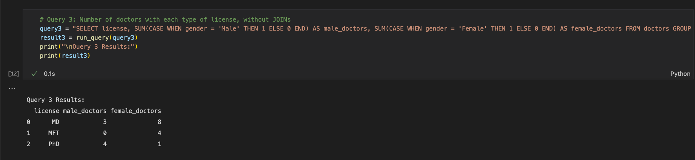

**Query 4 :**

**SELECT COUNT(*) AS md_diabetes_doctors**

**FROM doctors**

**WHERE license = 'MD' AND doctor_id IN (**

**SELECT doctor_id**

**FROM specialties**

**WHERE speciality_one = 'Diabetes' OR speciality_two = 'Diabetes' OR speciality_three = 'Diabetes'**

**);**

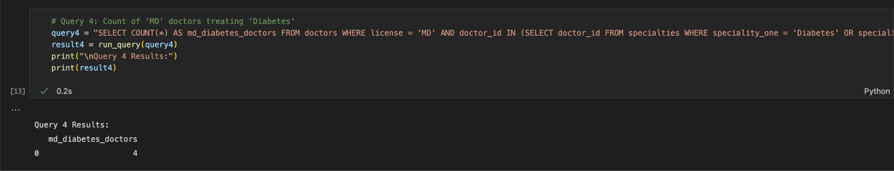

**Query 5**

**SELECT AVG(doctor_count) as average_doctors_per_hospital**

**FROM (**

**SELECT hospital_id, COUNT(doctor_id) as doctor_count**

**FROM hospitals**

**GROUP BY hospital_id**

**) AS doctor_counts;**

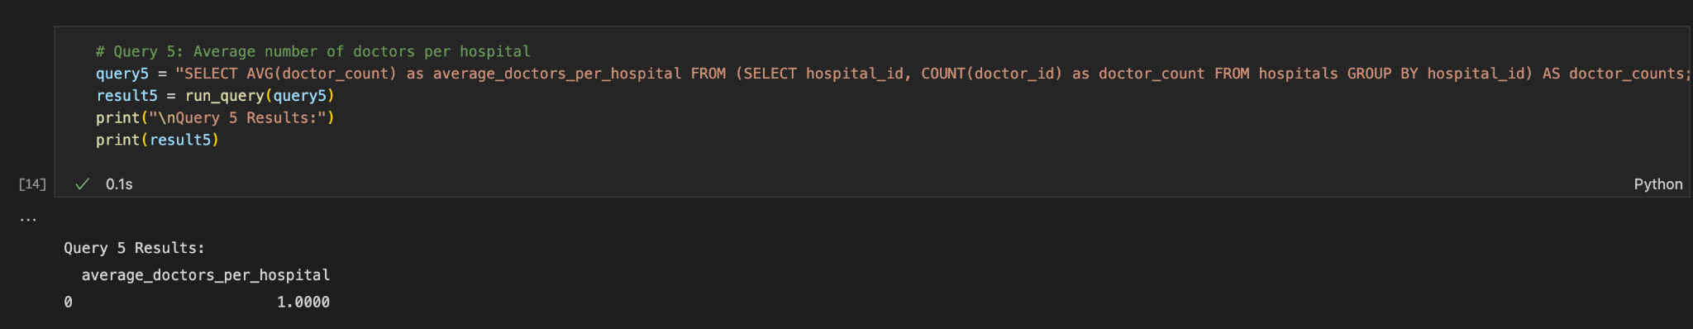

**Visualization 1 : Distribution of Doctors by Specialty**

**# Executing the query to get data**

**query_specialty_distribution = """**

**SELECT speciality_one, COUNT(*) AS number_of_doctors**

**FROM specialties**

**GROUP BY speciality_one**

**ORDER BY number_of_doctors DESC;**

**"""**

**specialty_distribution = run_query(query_specialty_distribution)**

**# Visualization with matplotlib**

**import matplotlib.pyplot as plt**

**plt.figure(figsize=(12, 8))**

**plt.barh(specialty_distribution['speciality_one'], specialty_distribution['number_of_doctors'])**

**plt.xlabel('Number of Doctors')**

**plt.ylabel('Specialty')**

**plt.title('Distribution of Doctors by Specialty')**

**plt.gca().invert_yaxis() # To display the highest count at the top**

**plt.show()**

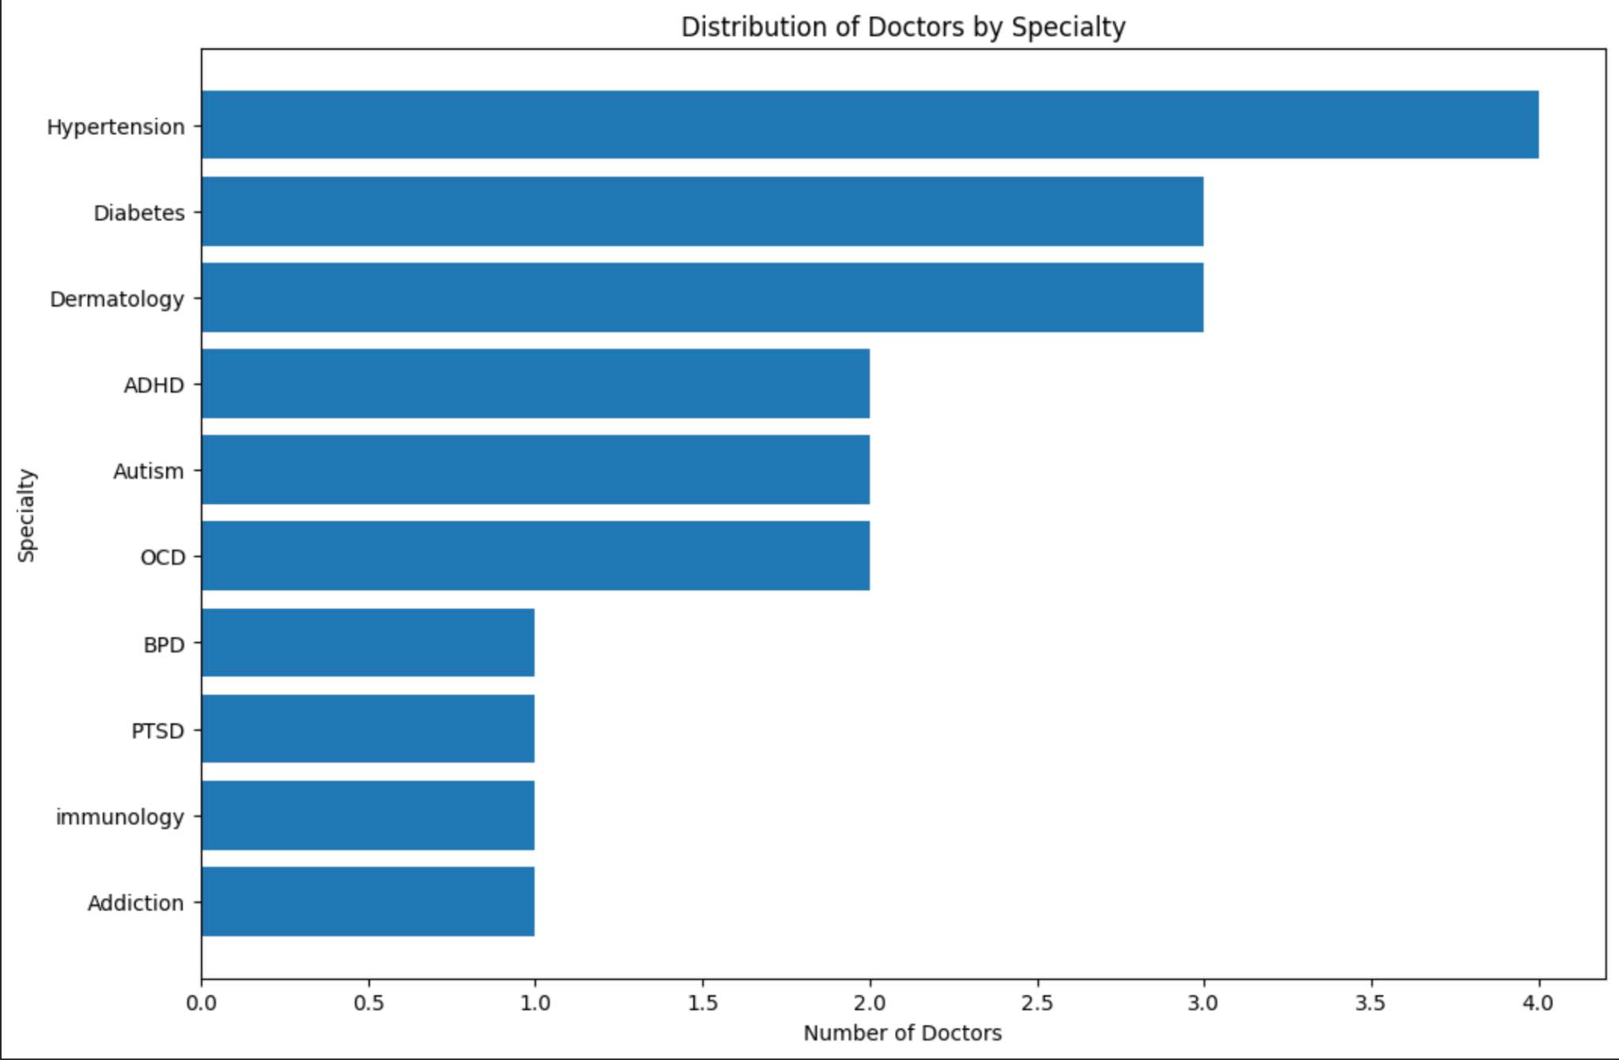

**Visualization 2 : Acceptance of New Patients by Gender**

**# Executing the query to get data**

**query_new_patients_by_gender = """**

**SELECT gender, new_patients, COUNT(*) AS number_of_doctors**

**FROM doctors**

**GROUP BY gender, new_patients;**

**"""**

**new_patients_by_gender = run_query(query_new_patients_by_gender)**

**# Visualization with seaborn**

**import seaborn as sns**

**plt.figure(figsize=(10, 6))**

**sns.barplot(x='gender', y='number_of_doctors', hue='new_patients', data=new_patients_by_gender)**

**plt.xlabel('Gender')**

**plt.ylabel('Number of Doctors')**

**plt.title('Acceptance of New Patients by Gender')**

**plt.legend(title='New Patients')**

**plt.show()**

