|  |  |  |  |  |  |
| --- | --- | --- | --- | --- | --- |
| **Fiche** | | **Parameter** | | **Weergave** | |
| S-FC-N-025 | Korrelgrootefractie  (in drooggewicht) | | > 63 μm in % | | Niet opgenomen  dataset niet compleet |
| < 2 μm in % | | | | | |
| < 63 μm in % | | | | | |
| Organisch koolstof (%) | | | | | |
| < 16 μm in % | | | | | |
| Metalen  (in drooggewicht) | Arseen mg/kg | | As | | Gemeten waarden |
| Cadmium mg/kg | | | Cd | | |
| Chroom mg/kg | | | Cr | | |
| Koper mg/kg | | | Cu | | |
| Kwik mg/kg | | | Hg | | |
| Lood mg/kg | | | Pb | | |
| Zink mg/kg | | | Zn | | |
| S-FC-N-026 | Organische microverontreinigingen  (in drooggewicht) | | PCB’s | | 2,2’,3,4,4’,5,5’-heptachloorbifenyl (μg/kg) / PCB180 |
| 2,2’,3,4,4’,5’-hexachloorbifenyl (μg/kg) / PCB138 | | | | | |
| 2,2’,4,4’,5,5’-hexachloorbifenyl (μg/kg) / PCB153 | | | | | |
| 2,2’,4,5,5’-pentachloorbifenyl (μg/kg) / PCB101 | | | | | |
| 2,2’,5,5’-tetrachloorbifenyl (μg/kg) / PCB52 | | | | | |
| 2,3’,4,4’,5-pentachloorbifenyl (μg/kg) / PCB118 | | | | | |
| 2,4,4’-trichloorbifenyl (μg/kg) / PCB128 | | | | | |
|  | | |  | | |
|  | | | | | |
|  | | | | | |
|  | | | | | |
|  | | | | | |
|  | | | | | |
|  | | | | | |

*Eerstelijnsrapportage Westerschelde 2013*

|  |  |  |  |
| --- | --- | --- | --- |
|  | | | |
|  | | | |
|  |  | |  |
|  | |  | |
|  | |  | |
|  | |  | |
|  | |  | |
|  | |  | |
|  | |  | |
|  | |  | |
|  | |  | |
|  | |  | |

|  |  |  |  |  |  |
| --- | --- | --- | --- | --- | --- |
| **Fiche** | **Parameter** | | | | **Weergave** |
| S-FC-N-025 | Korrelgroottefractie  (in drooggewicht) | > 63 μm in % | |  | Niet opgenomen  (dataset niet compleet) |
| < 2 μm in % | |  |
| < 63 μm in % | |  |
| Organisch koolstof (%) | |  |
| < 16 μm in % | |  |
| Metalen  (in drooggewicht) | Arseen mg/kg | | As | Gemeten waarden |
| Cadmium mg/kg | | Cd |
| Chroom mg/kg | | Cr |
| Koper mg/kg | | Cu |
| Kwik mg/kg | | Hg |
| Lood mg/kg | | Pb |
| Zink mg/kg | | Zn |
| S-FC-N-026 | Organische microverontreinigingen  (in drooggewicht) | PCB’s | 2,2’,3,4,4’,5’-hexachloorbifenyl (μg/kg) / PCB138 | |
| 2,2’,4,4’,5,5’-hexachloorbifenyl (μg/kg) / PCB153 | |
| 2,2’,4,5,5’-pentachloorbifenyl (μg/kg) / PCB101 | |
| 2,2’,5,5’-tetrachloorbifenyl (μg/kg) / PCB52 | |
| 2,3’,4,4’,5-pentachloorbifenyl (μg/kg) / PCB118 | |
| 2,4,4’-trichloorbifenyl (μg/kg) / PCB128 | |
| PAK’s | antraceen (mg/kg) / Ant | |
| benzo(a)antraceen (mg/kg) / B(a)A | |
| benzo(a)pyreen (mg/kg) / B(a)P | |
| benzo(g,h,i)peryleen (mg/kg) / B(ghi)Pe | |
| benzo(k)fluorantheen (mg/kg) / B(k)Flu | |
| chryseen (mg/kg) / Chr | |
| fenanthreen (mg/kg) / Fen | |
| A-3 fluorantheen (mg/kg) / Flu | |
| indeno(1,2,3-c,d)pyreen (mg/kg) / IP | |
| PCB’s | 2,2',3,4,4',5,5'-heptachloorbifenyl | PCB180 |
| 2,2',3,4,4',5'-hexachloorbifenyl | PCB138 |
| 2,2',4,4',5,5'-hexachloorbifenyl | PCB153 |
| 2,2',4,5,5'-pentachloorbifenyl | PCB101 |
| 2,2',5,5'-tetrachloorbifenyl | PCB52 |
| 2,3',4,4',5-pentachloorbifenyl | PCB118 |
| 2,4,4'-trichloorbifenyl | PCB28 |
| Overige stoffen | tributyltin (μg/kg) / TBT | |

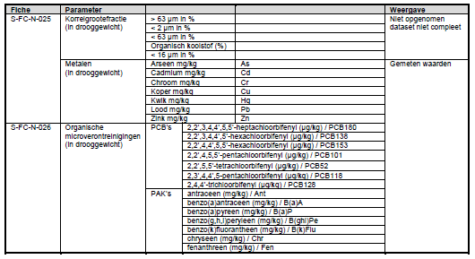

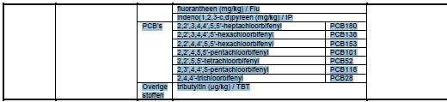

|  |  |  |  |  |
| --- | --- | --- | --- | --- |
| **Fiche** | **Parameter** | | | **Weergave** |
| S-HD-N-001 | Waterstand | Hoog- en laagwaterstand | | Jaargemiddeld |
| Getijslag | |
| M2-getijcomponent | |
| S-HD-N-006 | Golven | Golfhoogte | Golfhoogte H1/3 | Maandgemiddeld |
| Golfhoogte Hm0 |
| Golfperiode | Golfperiode TH1/3 |
| Spectrale golfperiode Tm02 |