Repeat Until Practice

For each of the following, keep track of the value of the variable *x* in the provided chart:

|  |  |
| --- | --- |
| **iterations** | **value of x** |
|  |  |
|  |  |
|  |  |
|  |  |
|  |  |
|  |  |
|  |  |
|  |  |
|  |  |

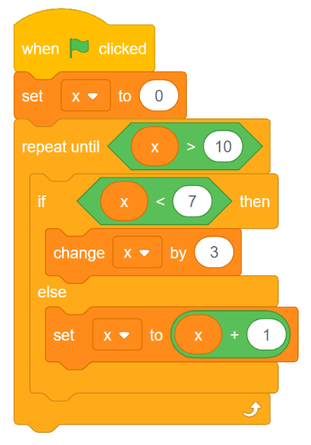**Question 1:**

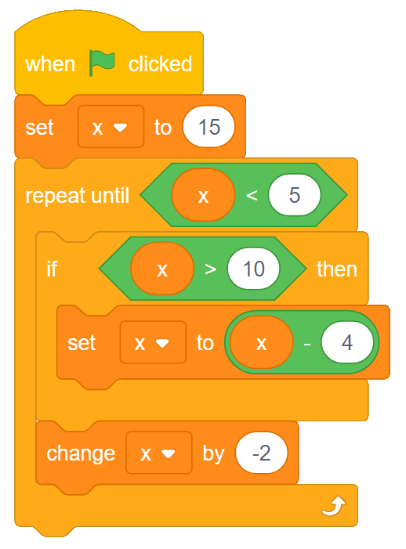**Question 2:**

|  |  |
| --- | --- |
| **iterations** | **value of x** |
|  |  |
|  |  |
|  |  |
|  |  |
|  |  |
|  |  |
|  |  |
|  |  |
|  |  |

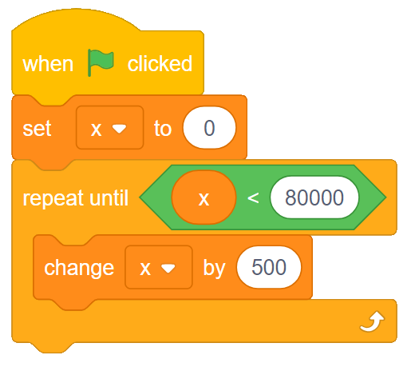**Question 3:**

|  |  |
| --- | --- |
| **iterations** | **value of x** |
|  |  |
|  |  |
|  |  |
|  |  |