1. Clone the project from the below git link.

<https://github.com/schellur/shoppingCart>

1. Run the application main class(ShoppingCartAppliation) as RunAsApplication.
2. Please find the attached file for the Json collection which includes all the request for the Shopping cart application. Please import the json file into postman to access all the requests.



1. Add Apparel products in to the Database.

POST : <http://localhost:8080/addApparelProducts>

Request body :

[

{

"productName" : "Shirt",

"productPrice" : 2000.9,

"type" : "Cotton",

"brand" : "Siyarams",

"design" : "Printed"

},

{

"productName" : "Trousers",

"productPrice" : 1200.4,

"type" : "Jeans",

"brand" : "Lee",

"design" : "Torn"

},

{

"productName" : "T-Shirt",

"productPrice" : 3200.4,

"type" : "Sports",

"brand" : "Jockey",

"design" : "Sports"

}

]

Screenshot from Database

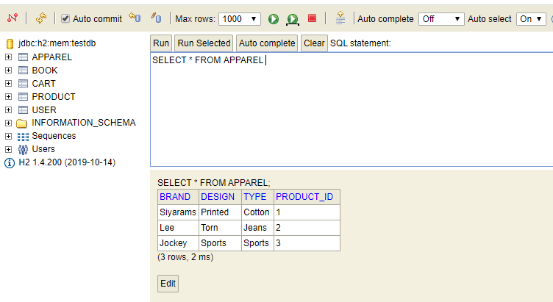

1. Add Book products in to the Database.

POST : <http://localhost:8080/addBookProducts>

Request body:

[

{

"productName" : "Think and Grow Rich",

"productPrice" : 99,

"genre" : "Motivational",

"author" : "Napolean Hill",

"publications" : "Amazing Reads"

},

{

"productName" : "Life is What You Make It",

"productPrice" : 119,

"genre" : "Motivational",

"author" : "Preeti Shenoy",

"publications" : "Srishti Publishers"

},

{

"productName" : "Thoughts to Inspire: Swami Vivekanand",

"productPrice" : 115.4,

"genre" : "Motivaional",

"author" : "Swami vivekanand",

"publications" : "Amazing Reads"

}

]

ScreenShot from Database

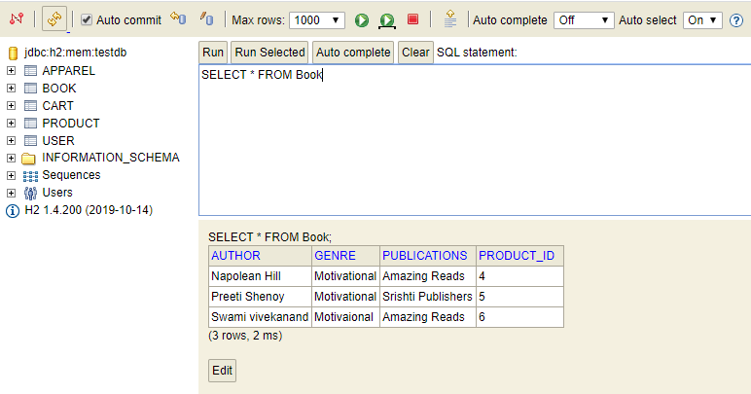

1. Search Product by Id

GET : <http://localhost:8080/product/2>

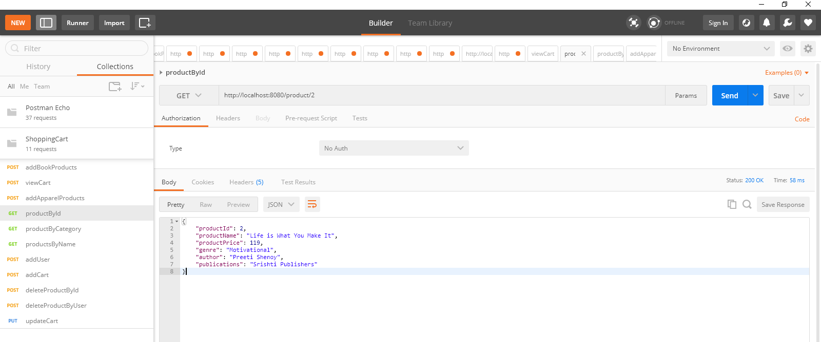

1. Search Product By Product Category

GET : <http://localhost:8080/products/Apparel>

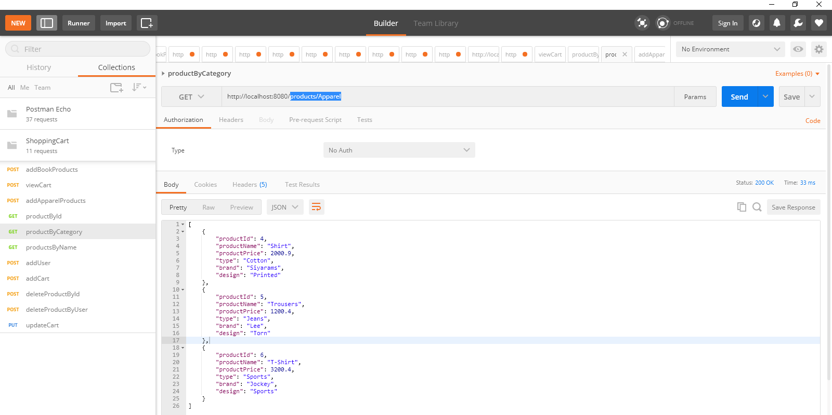

1. Search Product By Product Name

GET : <http://localhost:8080/products?name=Shirt>

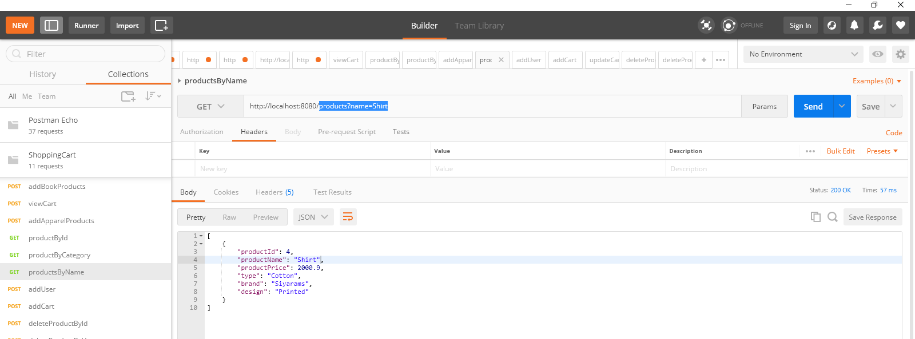

1. Create User

POST : <http://localhost:8080/addUser>

{

"userId" : "John",

"userName" : "John"

}

Screen shot from the Database

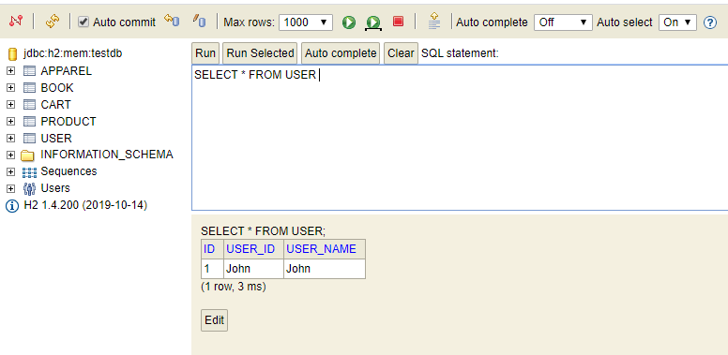

1. Add product to cart

POST: <http://localhost:8080/addCart>

Request body :

{

"userId": "John",

"productId": 2

}

Screen shot from the database

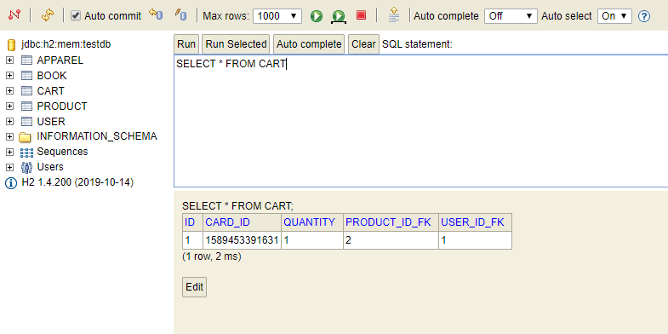

1. Add the same product to the cart once again.

POST: <http://localhost:8080/addCart>

Request body :

{

"userId": "John",

"productId": 2

}

Screen shot from the data base

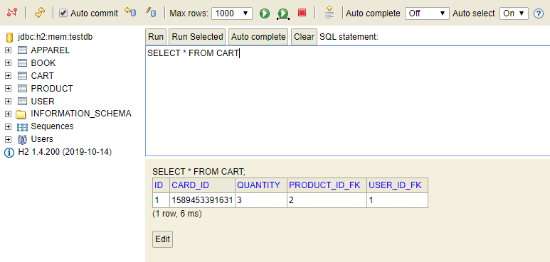

1. Update Quantity with 10 for the product Id 2

POST : <http://localhost:8080/updateCart>

Request body :

{

"userId": "John",

"productId": 2,

"quantity" :10

}

Screen shot from the database

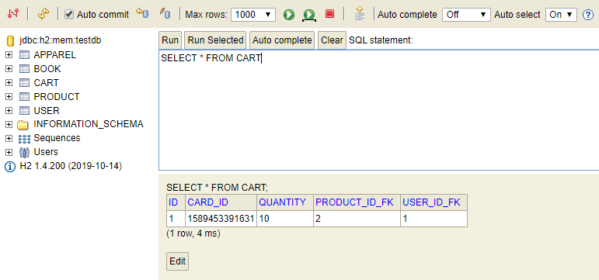

1. Update Quantity with -1 for the product Id 2

POST : <http://localhost:8080/updateCart>

Request body :

{

"userId": "John",

"productId": 2,

"quantity" :-1

}

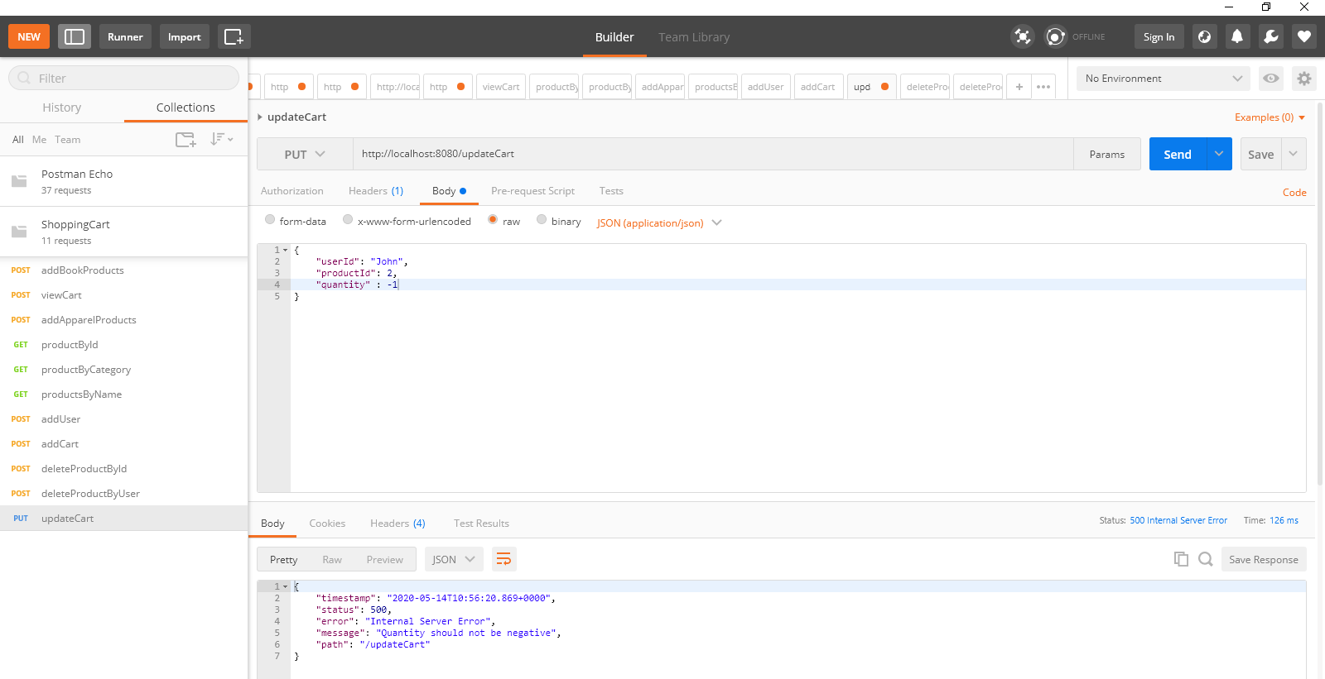

1. Update Quantity with 0 for the product Id 2

POST : <http://localhost:8080/updateCart>

Request body :

{

"userId": "John",

"productId": 2,

"quantity" :0

}

Screen shot from the database

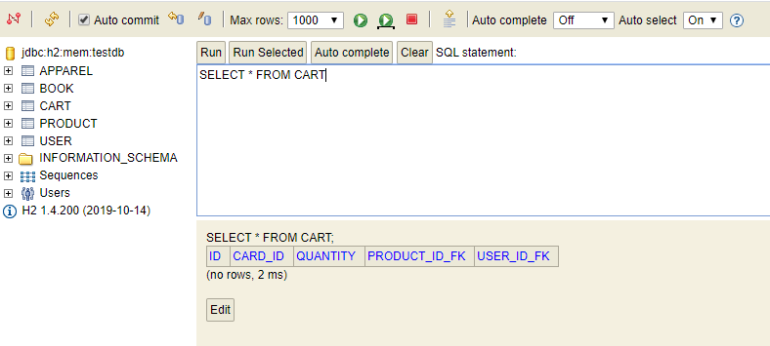

1. View cart : To display the Total price, total quantity and the products in the cart

POST : <http://localhost:8080/viewCart>

Request body :

{

"userId": "John"

}

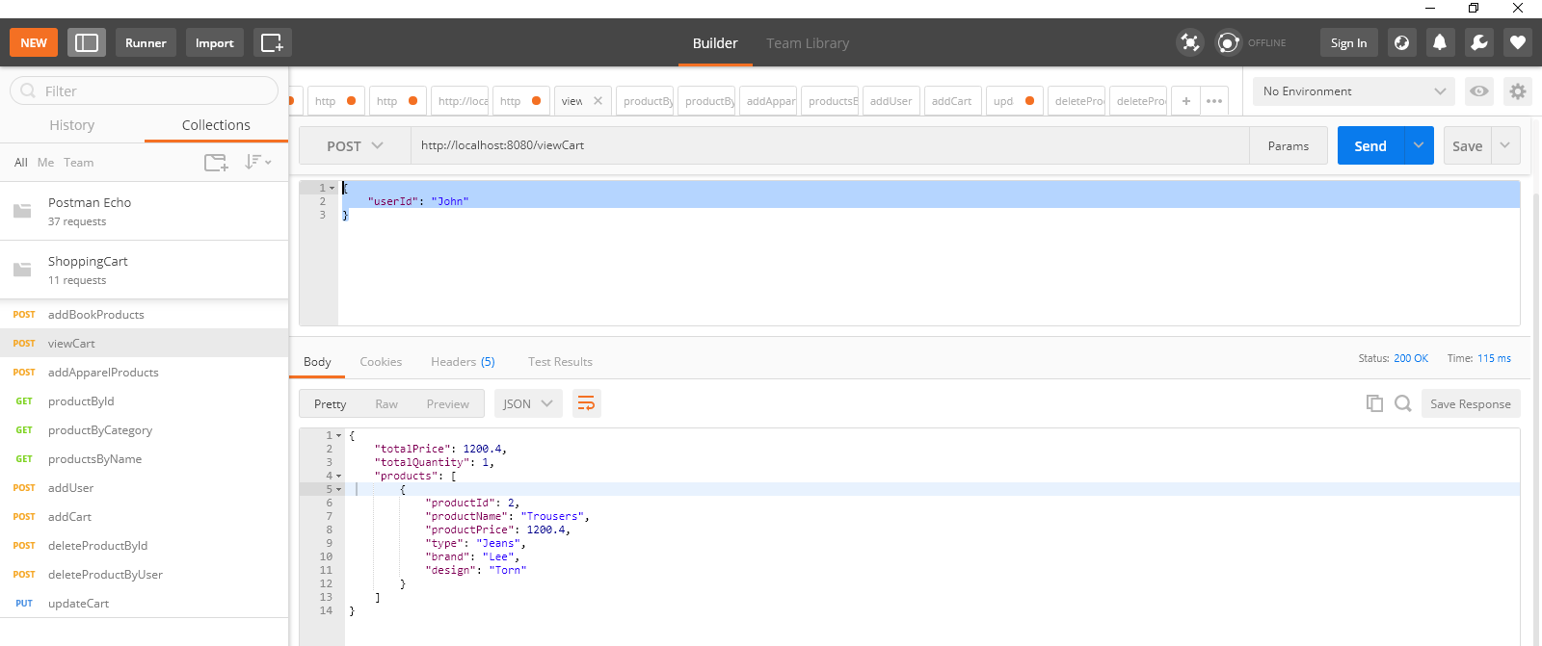

1. Delete the product by id 2 from the cart

POST : <http://localhost:8080/deleteProductById>

Request body :

{

"userId": "John",

"productId" : 2

}

Screen shot from database

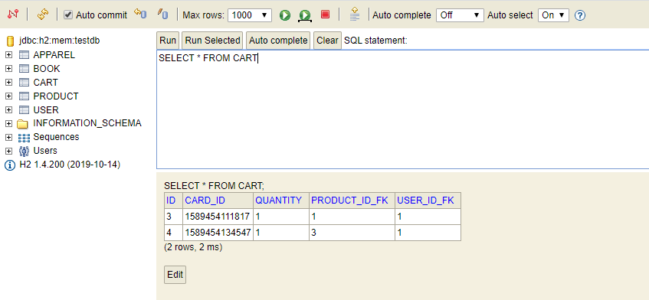

1. Delete the products by user from the cart

POST : <http://localhost:8080/deleteProductByUser>

Request body :

{

"userId": "John"

}

Screen shot from datbase.

