# start service from maven project

1. Unzip the “**BP_Transactions.zip**” file where you want to extract project

OR

checkout project from github <https://github.com/schelva82/BPTransactions.git>

1. Set JAVA_HOME if it is not set already – as per below screen shot.
2. Go to **BPTransactions** project folder and run the below maven command to start the service.

**mvn clean install tomcat7:run –** as per below screen shot.

**Note: Make sure you have Apache maven installed in your system.**

1. Service will be up and running using embedded tomcat server (using default port 8080). We can start calling services using REST API end-points.
2. Follow “section 2” for REST API details.

Screen shot:

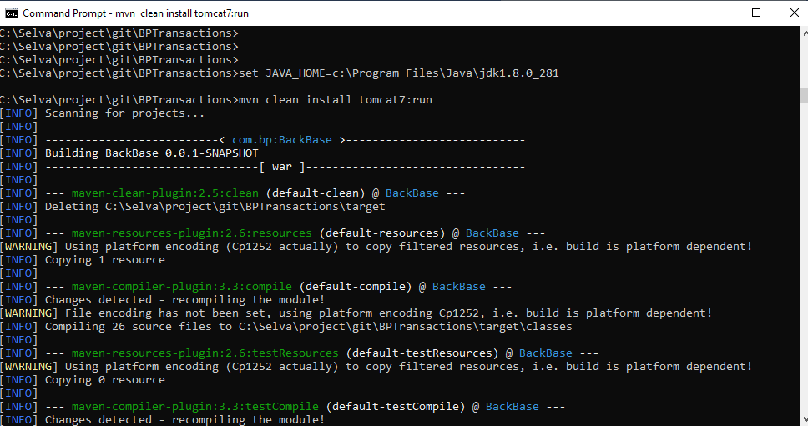

# Transactions API:

## Transactions list API

|  |  |
| --- | --- |
| Description | Transactions objects are retrieved from openbank sandbox (test API) and transformed in to backbase specific transactions objects. |
| Request Type | GET |
| REST URL | <http://localhost:8080/backbase/transactions/list> |
| Users | **User**: testuser  **Password**: testuser123 |
| Curl command | curl <http://localhost:8080/backbase/transactions/list> -u testuser:testuser123 |
| Response | {  "status": "Success",  "statusCode": "000",  "transactions": [{  "id": "58aeed54-7042-456d-af86-f517bff5b7af",  "accountId": "savings-kids-john",  "counterpartyAccount": "savings-kids-john",  "counterpartyName": "ALIAS_03C57D",  "counterpartyLogoPath": null,  "instructedAmount": 8.6,  "instructedCurrency": "GBP",  "transactionAmount": 8.6,  "transactionCurrency": "GBP",  "transactionType": "SEPA",  "description": "This is a SEPA Transaction Request"  }, {  "id": "e22b7066-d02f-41fa-a84f-5dbfcc39e307",  "accountId": "savings-kids-john",  "counterpartyAccount": "savings-kids-john",  "counterpartyName": "ALIAS_03C57D",  "counterpartyLogoPath": null,  "instructedAmount": 8.6,  "instructedCurrency": "GBP",  "transactionAmount": 8.6,  "transactionCurrency": "GBP",  "transactionType": "SEPA",  "description": "This is a SEPA Transaction Request"  }, {  "id": "e69c0f86-86c8-423b-8fcb-071cbd957997",  "accountId": "savings-kids-john",  "counterpartyAccount": "savings-kids-john",  "counterpartyName": "ALIAS_03C57D",  "counterpartyLogoPath": null,  "instructedAmount": 8.6,  "instructedCurrency": "GBP",  "transactionAmount": 8.6,  "transactionCurrency": "GBP",  "transactionType": "SEPA",  "description": "This is a SEPA Transaction Request"  }]  } |
| Screen shot |  |

## Transactions list filter API:

|  |  |
| --- | --- |
| Description | Transactions objects are retrieved from openbank sandbox (test API) and transformed in to backbase specific transactions objects and transactions are filtered based on account type |
| Request Type | GET |
| REST URL | [http://localhost:8080/backbase/transactions/list/{type}](http://localhost:8080/backbase/transactions/list/%7btype%7d)  input parameter:  type: Transaction type |
| Users | **User**: testuser  **Password**: testuser123 |
| Curl command | curl <http://localhost:8080/backbase/transactions/list>/SEPA -u testuser:testuser123  Filtering transactions using transactionType: SEPA |
| Response | {  "status": "Success",  "statusCode": "000",  "transactions": [{  "id": "58aeed54-7042-456d-af86-f517bff5b7af",  "accountId": "savings-kids-john",  "counterpartyAccount": "savings-kids-john",  "counterpartyName": "ALIAS_03C57D",  "counterpartyLogoPath": null,  "instructedAmount": 8.6,  "instructedCurrency": "GBP",  "transactionAmount": 8.6,  "transactionCurrency": "GBP",  "transactionType": "SEPA",  "description": "This is a SEPA Transaction Request"  }} |
| Screen shot |  |

## Transactions total amount API:

|  |  |
| --- | --- |
| Description | Returns transactions total amount based on account type |
| Request Type | GET |
| REST URL | [http://localhost:8080/backbase/transactions/list/{type}](http://localhost:8080/backbase/transactions/list/%7btype%7d)  input parameter:  type: Transaction type |
| Users | **User**: testuser  **Password**: testuser123 |
| Curl command | curl <http://localhost:8080/backbase/transactions/list>/SEPA -u testuser:testuser123  Getting total amount for transactionType: SEPA |
| Response | {  "status": "Success",  "statusCode": "000",  "amount": {  "transactionType": "SEPA",  "totalAmount": 25.799999999999997  }  } |
| Screen shot |  |