Troubleshooting port 22 error message
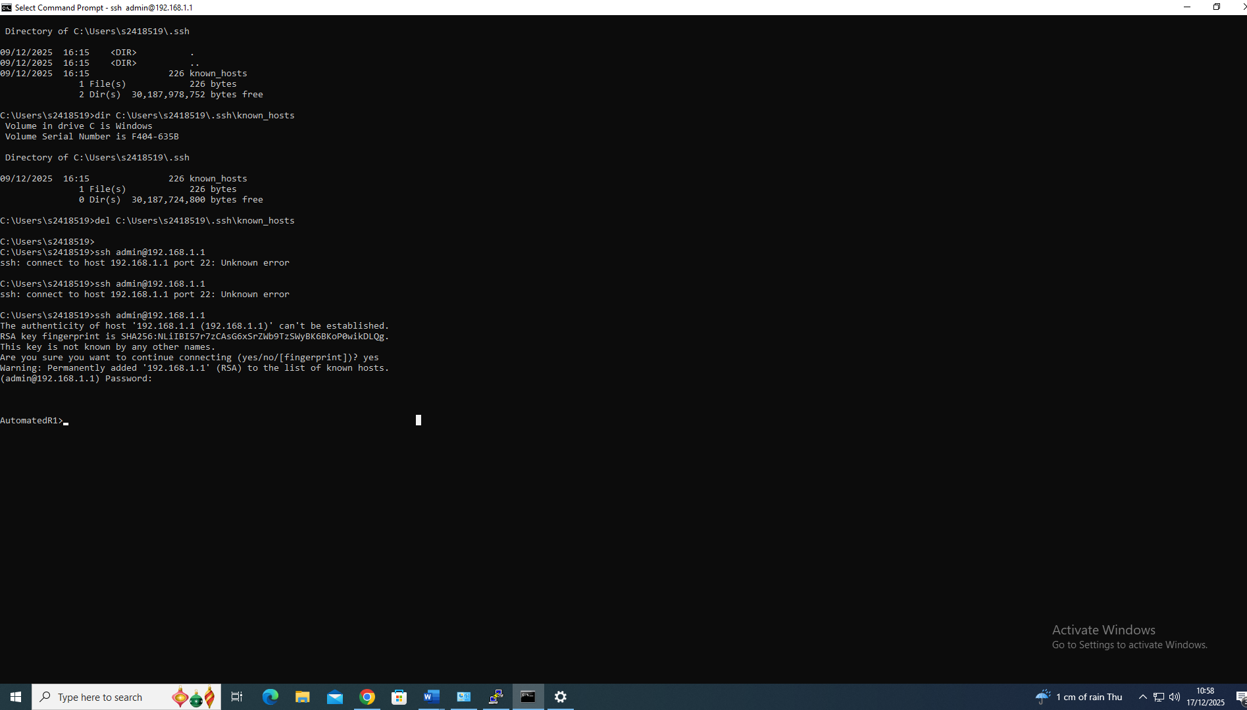

Man in the middle error troubleshooting
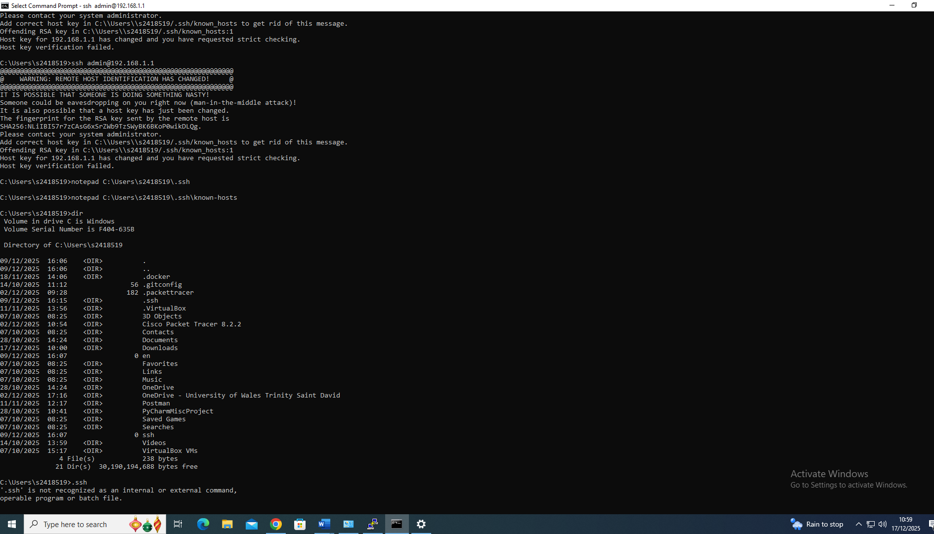

Double checking the routing configuration
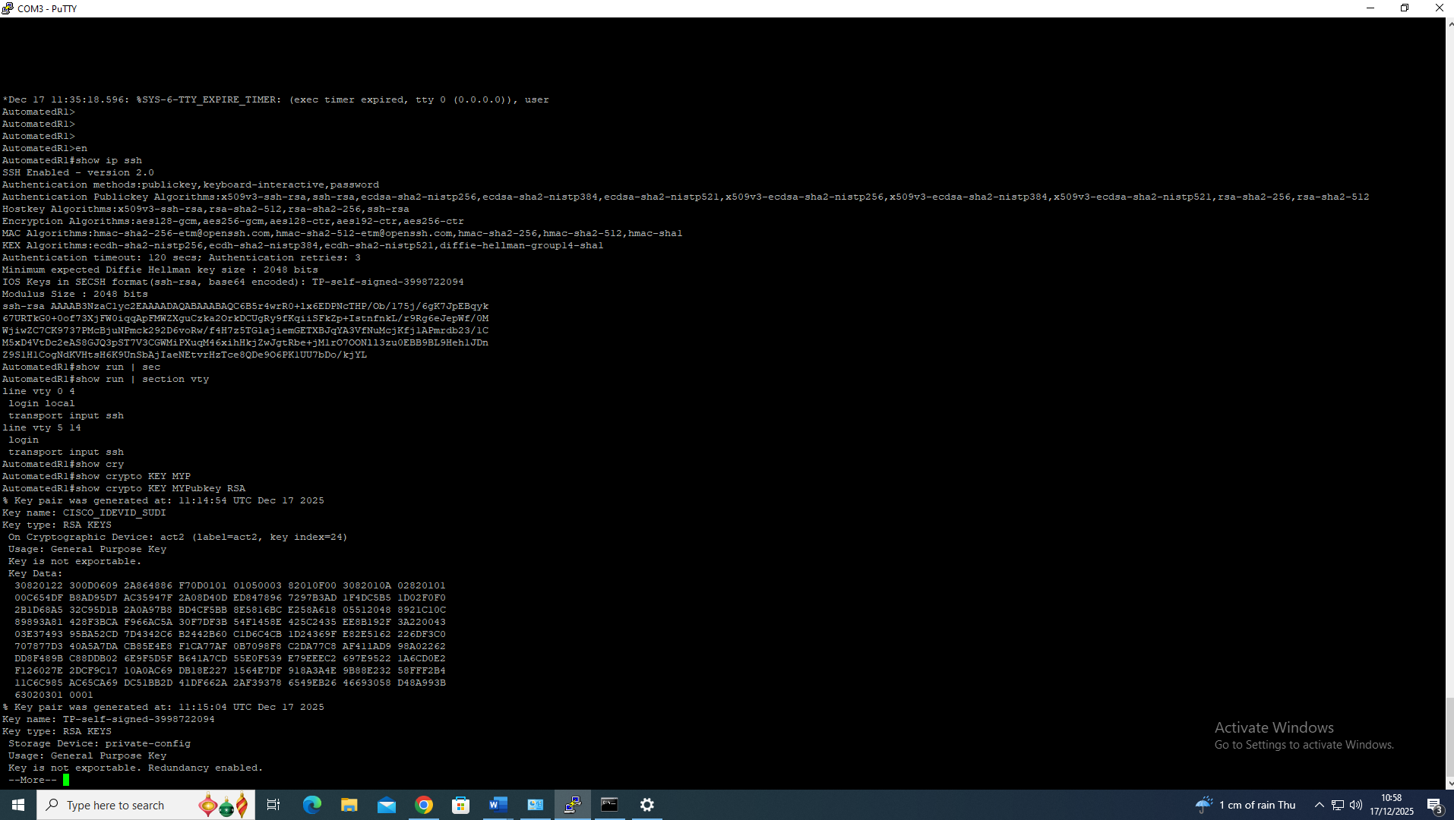

Installing ansible in WSL
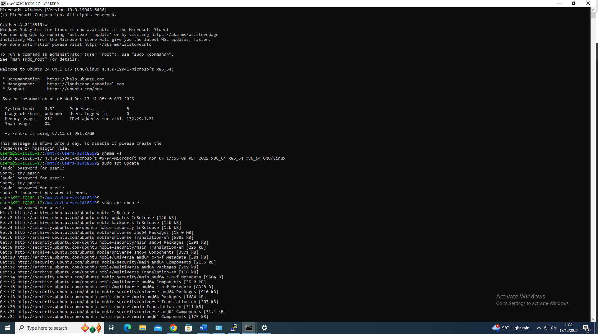
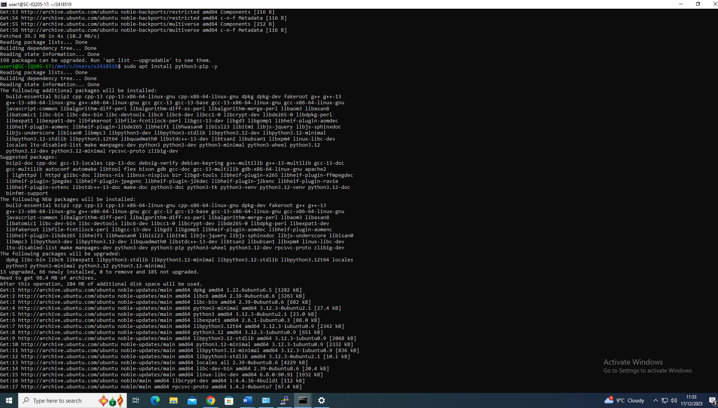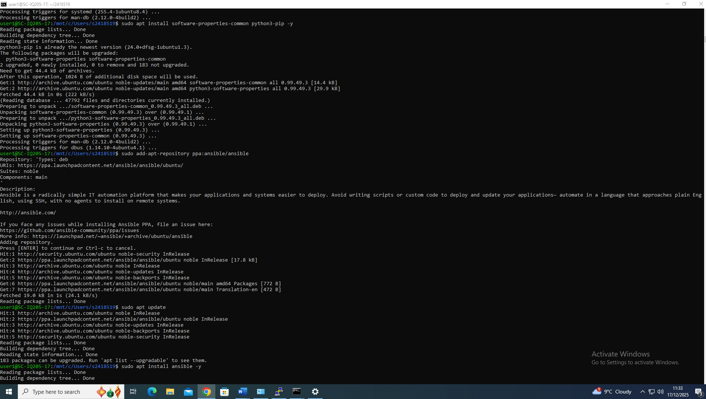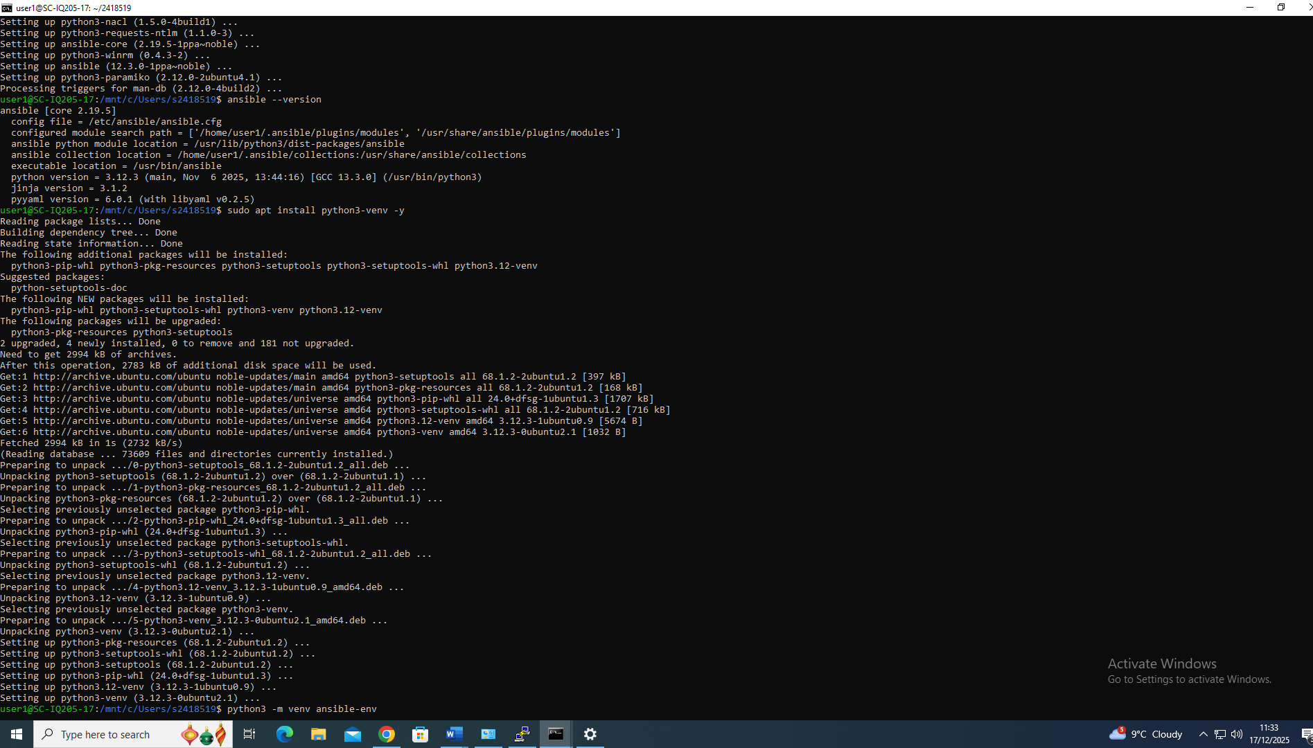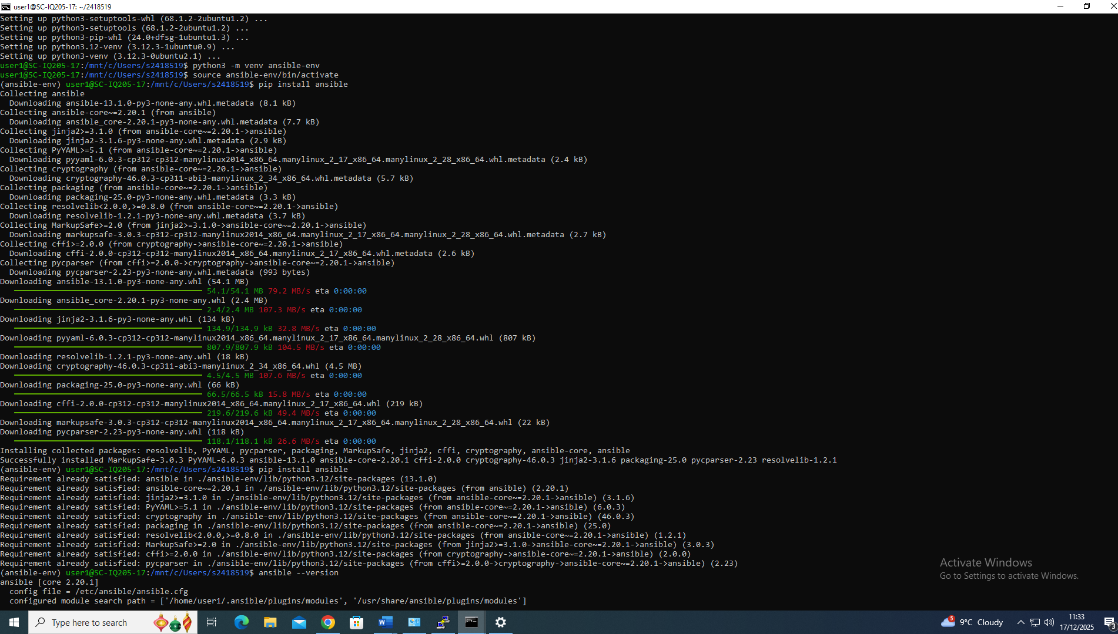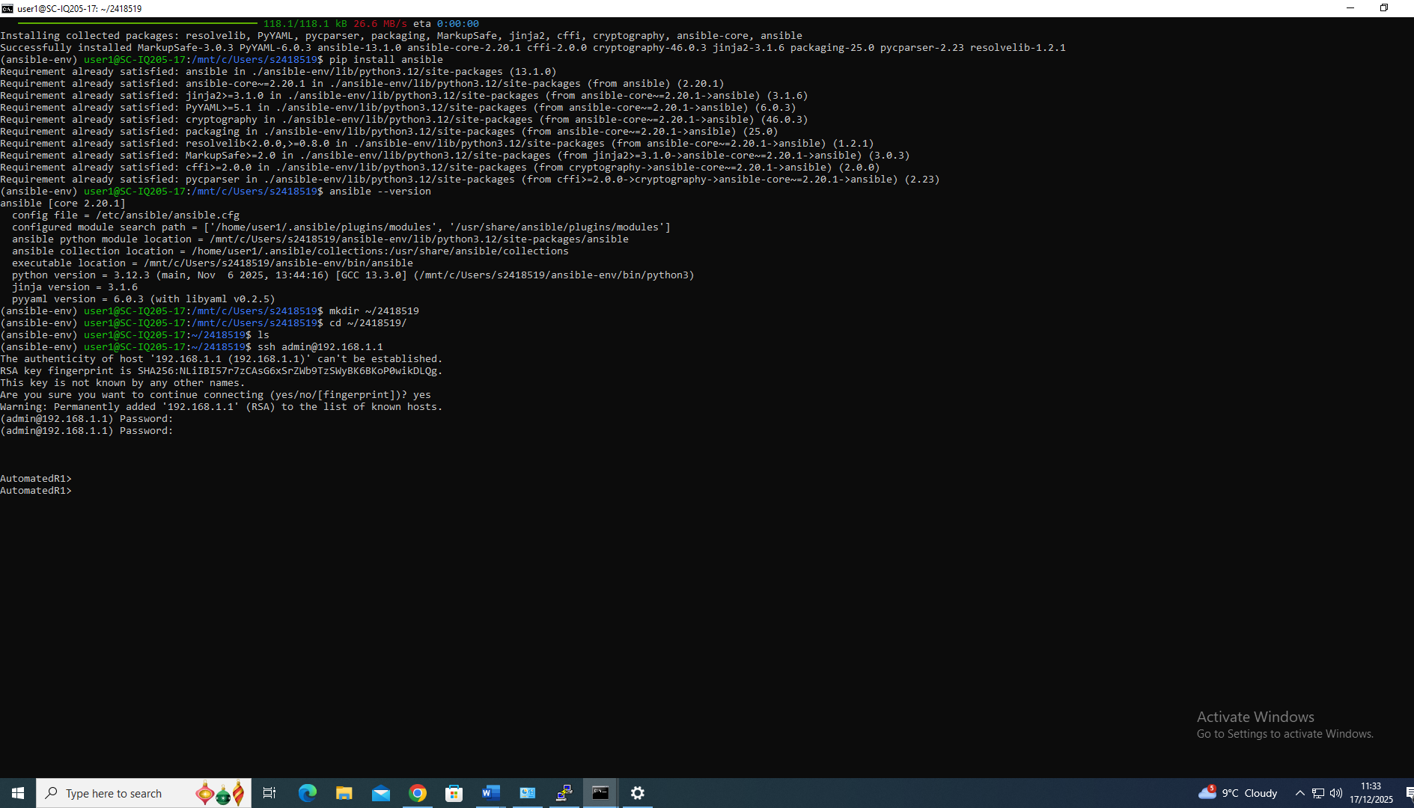

Ping test with multiple routers and switches
