**Versa64Cart v1.6**

**Testing**

# Test Description

The electrical test was executed with a Versa64Cart v1.2 (the differences to v1.3 to v1.6 are not functional), a C64G (Mainboard ASSY 250469) and an EPROM type ST micro M27C512 10F1. The programming of the EPROM was done with a TL866II Plus programmer.

The following binaries were loaded into the program memory of the programmer, programed to the EPROM and verified “ok”:

|  |  |  |  |
| --- | --- | --- | --- |
| **Binary** | **Binary #** | **Start Address** | **End Address** |
| Neutron.bin | 1 | 0x0000 | 0x3FFF |
| Deadtest.bin | 2 | 0x4000 | 0x5FFF |
| 586220plus_0_4.bin | 3 | 0x6000 | 0x7FFF |
| LalaPrologue.bin | 4 | 0x8000 | 0xBFFF |

The EPROM was inserted into the socket of Versa64Cart, which was then configured, inserted into the C64, the C64 was switched on and the selected binary was run.

# Test Execution

|  |  |  |  |  |  |  |  |
| --- | --- | --- | --- | --- | --- | --- | --- |
| Binary # | A15..13 |  |  | J6 | J5 A13 | Observation | Testing |
| 1 | LLL | L | L | 16k | 16k | working | ok |
| 2 | LHL | L | H |  | Switch | working | ok |
| 3 | LHH | H | L |  | Switch | working | ok |
| 4 | HLL | L | L | 16k | 16k | working | ok |

|  |  |  |
| --- | --- | --- |
| **T**est | **O**bservation | **T**esting |
| Does the Cart fit into the slot? | yes | ok |
| Does the Cart move inside the slot? | The Cart moves 0.9mm from left to right in total. The contacts of the cartridge connector do not leave the contact pad. | ok |
| Comparison of measures  v1.2 vs. v1.1 | Both PCBs have the same dimensions. The mounting holes are aligned. The port contacts are aligned, the contacts of v1.2 are wider. | ok |
| Reset button | Binary #1 can be restarted by pushing the reset button. Some software (e.g. LalaPrologue.bin) does not reset well after pressing the RESET button. It depends on that software, not on the memory bank. | ok |
| Running cartridge with a breakout board, which adds 90mm to the bus | Binary #1 is running The bus length is not critical | ok |

The critical signal is the pulse for the EPROM when the 16k-mode is selected. It can either be too wide or the low level is above 0.7V (the upper margin for a TTL low level).

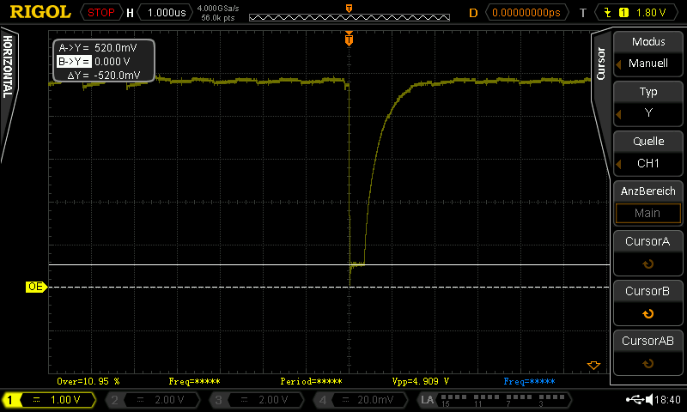

Figure 1: The /OE pulse (low level = 520mV)

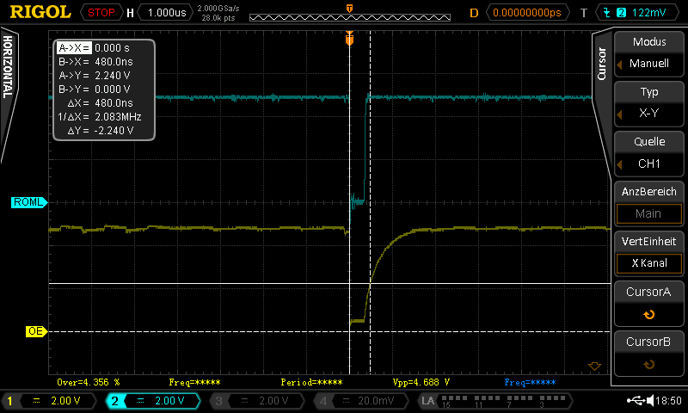

Figure 2: /OE pulse (pulse width = 480ns)

|  |  |  |
| --- | --- | --- |
| **Test** | **O**bservation | **T**esting |
| Low level of the 16k- OE pulse below 0.7V | The low level is 520mV | ok |
| Pulse width of the 16k-OE pulse less than 500ns (?) | The pulse width is 480ns | ok (?) |

|  |  |  |
| --- | --- | --- |
| **Test** | **O**bservation | **T**esting |
| Neutron.bin & LalaPrologue.bin were programmed into a 27C256, A15 was set HIGH | Both games started and played properly. | ok |
| LalaPrologue.bin was programmed into a 27C128A, A15 & A14 were set HIGH | Game started and played properly. | ok |
| 1541diagcart.bin was programmed into a 27C164A, A13..A15:HHH, : H, : L, : ROML | Software started and worked properly | ok |

# Testing the Rev. 1.6 in a Stumpy Cartridge Case

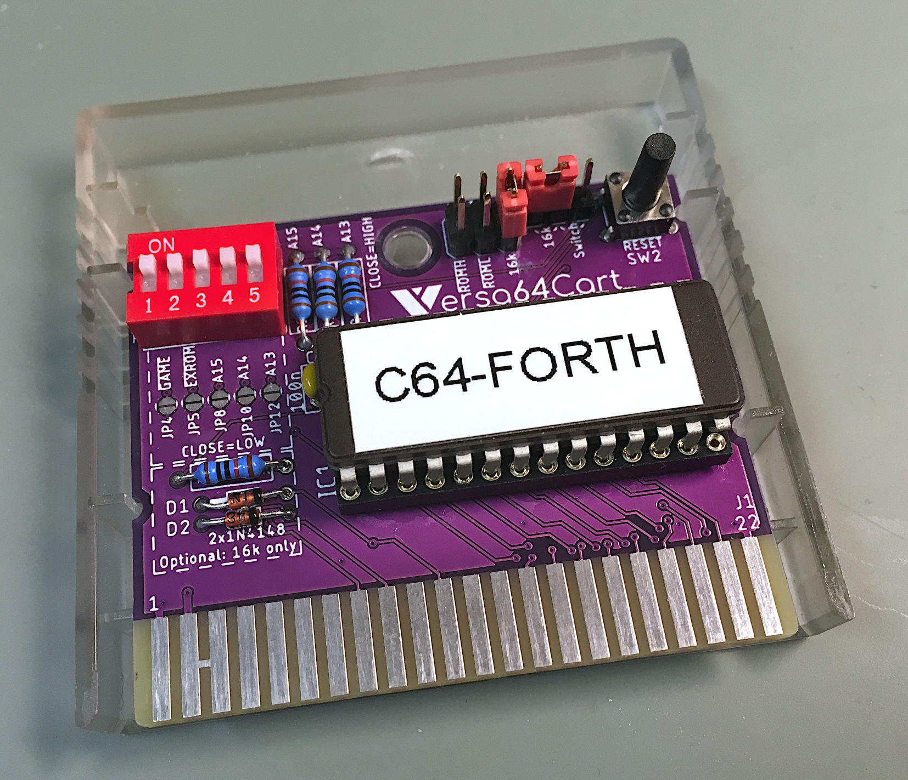

Figure 3: Versa64cart Rev. 1.6 on an open Stumpy cartridge case

# Conclusion

* All extra address lines (A15 … A13) can be asserted
* can be configured properly
* can be configured properly
* works as a chip select
* works as a chip select
* The 16k works properly, the timing cannot be proved ok, due to a lack of information.
* All binaries are running (16k, 8k Game, 8k Exrom)
* EPROM types tested: ST M27C512, M27C256B, M27C128A, M27C64A
* The notches of Rev. 1.6 fit the Stumpy cartridge case.

**The Versa64Cart v1.6 is fully functional.**