**Initial Results and Code – CKME 136**

|  |  |
| --- | --- |
| NAME: | Sung Mo Cheong |
| Student #: | 501001285 |
| Email Address: | sung.cheong@ryerson.ca |

Code_Home-Advantage-In-Sports.R

sung.cheong

2020-07-07

#Load the three datasets  
soccer <- read.csv("C:/Users/sung.cheong/Desktop/SoccerLEagues.csv")  
NBA <- read.csv("C:/Users/sung.cheong/Desktop/NBA.csv")  
Country_fact <- read.csv("C:/Users/sung.cheong/Desktop/Country_facts.csv")  
  
#View the top / bottom of all dataset  
head (soccer, n = 5)

## Sport Country League Year Season Team Games HomeWins  
## 1 Football Algeria Algeria-Ligue-1 2010 - MC Oran 34 10  
## 2 Football Algeria Algeria-Ligue-1 2010 - NA Hussein Dey 34 3  
## 3 Football Algeria Algeria-Ligue-1 2011 - MC El Eulma 29 9  
## 4 Football Algeria Algeria-Ligue-1 2011 - Annaba 29 10  
## 5 Football Algeria Algeria-Ligue-1 2012 - Khroub 30 7  
## HomeDraw HomeLoss HomeRatio AwayWins AwayDraw AwayLoss AwayGoalsDiff X  
## 1 5 2 11 0 6 11 -20 NA  
## 2 5 9 -8 0 5 12 -19 NA  
## 3 3 2 13 0 6 9 -19 NA  
## 4 5 0 14 0 1 13 -23 NA  
## 5 5 3 0 0 5 10 -23 NA

head (NBA, n = 5)

## Year Team Wins Loss Home.Wins Home.Loss Away.Wins Away.Loss  
## 1 1968 Atlanta Hawks 48 34 28 12 18 21  
## 2 1969 Atlanta Hawks 48 34 25 13 18 16  
## 3 1970 Atlanta Hawks 36 46 21 20 14 26  
## 4 1971 Atlanta Hawks 36 46 22 19 13 26  
## 5 1972 Atlanta Hawks 46 36 28 13 17 23  
## HomePCT AwayPCT TotalPCT  
## 1 0.7000000 0.4615385 0.5853659  
## 2 0.6578947 0.5294118 0.5853659  
## 3 0.5121951 0.3500000 0.4390244  
## 4 0.5365854 0.3333333 0.4390244  
## 5 0.6829268 0.4250000 0.5609756

head (Country_fact, n = 5)

## Country Region Population Area PopDensity  
## 1 Nigeria SUB-SAHARAN AFRICA 131859731 923768 142.7  
## 2 Guatemala LATIN AMER. & CARIB 12293545 108890 112.9  
## 3 Indonesia ASIA (EX. NEAR EAST) 245452739 1919440 127.9  
## 4 Ghana SUB-SAHARAN AFRICA 22409572 239460 93.6  
## 5 Uzbekistan C.W. OF IND. STATES 27307134 447400 61.0  
## Coastline Net.migration Infant_mortality GDP Literacy Phones Arable Crops  
## 1 0.09 0.26 98.80 900 68.0 9.3 31.29 2.96  
## 2 0.37 -1.67 35.93 4100 70.6 92.1 12.54 5.03  
## 3 2.85 0.00 35.60 3200 87.9 52.0 11.32 7.23  
## 4 0.23 -0.64 51.43 2200 74.8 14.4 16.26 9.67  
## 5 0.00 -1.72 71.10 1700 99.3 62.9 10.83 0.83  
## Other Climate Birthrate Deathrate Agriculture Industry Service FIFA_Rank  
## 1 65.75 1.5 40.43 16.94 0.269 0.487 0.244 62  
## 2 82.43 2.0 29.88 5.20 0.227 0.188 0.585 95  
## 3 81.45 2.0 20.34 6.25 0.134 0.458 0.408 178  
## 4 74.07 2.0 30.52 9.72 0.366 0.246 0.387 41  
## 5 88.34 1.0 26.36 7.84 0.342 0.229 0.430 74  
## UEFA_Rank Attendance Home_Away_Contrast  
## 1 NA NA 0.8366959  
## 2 NA NA 0.6416290  
## 3 NA 9368 0.5861931  
## 4 NA NA 0.5580267  
## 5 NA 6911 0.4860084

tail (soccer, n = 5)

## Sport Country League Year Season Team  
## 8361 Football Zimbabwe Zimbabwe-Premier-Soccer-League 2011 apertura Gunners  
## 8362 Football Zimbabwe Zimbabwe-Premier-Soccer-League 2010 apertura Gunners  
## 8363 Football Zimbabwe Zimbabwe-Premier-Soccer-League 2010 apertura CAPS United  
## 8364 Football Zimbabwe Zimbabwe-Premier-Soccer-League 2009 apertura Eagles  
## 8365 Football Zimbabwe Zimbabwe-Premier-Soccer-League 2015 apertura Tsholotsho  
## Games HomeWins HomeDraw HomeLoss HomeRatio AwayWins AwayDraw AwayLoss  
## 8361 23 4 5 4 -1 4 1 5  
## 8362 30 6 6 3 8 8 5 2  
## 8363 30 5 6 4 7 8 3 4  
## 8364 30 3 10 2 1 5 4 6  
## 8365 29 2 9 4 -4 4 4 6  
## AwayGoalsDiff X  
## 8361 0 NA  
## 8362 11 NA  
## 8363 6 NA  
## 8364 -9 NA  
## 8365 -4 NA

tail (NBA, n = 5)

## Year Team Wins Loss Home.Wins Home.Loss Away.Wins Away.Loss  
## 1212 2006 Washington Wizards 41 41 26 15 15 26  
## 1213 2007 Washington Wizards 43 39 25 16 18 23  
## 1214 2008 Washington Wizards 19 63 13 28 6 35  
## 1215 2009 Washington Wizards 26 56 15 26 11 30  
## 1216 2010 Washington Wizards 23 59 20 21 3 38  
## HomePCT AwayPCT TotalPCT  
## 1212 0.6341463 0.36585366 0.5000000  
## 1213 0.6097561 0.43902439 0.5243902  
## 1214 0.3170732 0.14634146 0.2317073  
## 1215 0.3658537 0.26829268 0.3170732  
## 1216 0.4878049 0.07317073 0.2804878

tail (Country_fact, n = 5)

## Country Region Population Area  
## 84 Puerto Rico LATIN AMER. & CARIB 3927188 13790  
## 85 Qatar NEAR EAST 885359 11437  
## 86 Mali SUB-SAHARAN AFRICA 11716829 1240000  
## 87 Scotland 5000000 77900  
## 88 Lebanon NEAR EAST 3874050 10400  
## PopDensity Coastline Net.migration Infant_mortality GDP Literacy Phones  
## 84 284.8 3.63 -1.46 8.24 16800 94.1 283.1  
## 85 77.4 4.92 16.29 18.61 21500 82.5 232.0  
## 86 9.5 0.00 -0.33 116.79 900 46.4 6.4  
## 87 NA NA NA NA NA NA NA  
## 88 372.5 2.16 0.00 24.52 4800 87.4 255.6  
## Arable Crops Other Climate Birthrate Deathrate Agriculture Industry Service  
## 84 3.95 5.52 90.53 2 12.77 7.65 0.010 0.450 0.540  
## 85 1.64 0.27 98.09 1 15.56 4.72 0.002 0.801 0.197  
## 86 3.82 0.03 96.15 2 49.82 16.89 0.450 0.170 0.380  
## 87 NA NA NA NA NA NA NA NA NA  
## 88 16.62 13.98 69.40 NA 18.52 6.21 0.120 0.210 0.670  
## FIFA_Rank UEFA_Rank Attendance Home_Away_Contrast  
## 84 7 NA NA 0.060580596  
## 85 80 NA 5073 0.046824819  
## 86 73 NA NA 0.036594879  
## 87 45 25 NA -0.004060382  
## 88 145 NA NA -0.011744120

#View its class  
class(soccer)

## [1] "data.frame"

class(NBA)

## [1] "data.frame"

class(Country_fact)

## [1] "data.frame"

#View its dimensions (It shows row and column respectively)  
dim(soccer)

## [1] 8365 16

dim(NBA)

## [1] 1216 11

dim(Country_fact)

## [1] 88 24

#Look at the column names  
names(soccer)

## [1] "Sport" "Country" "League" "Year"   
## [5] "Season" "Team" "Games" "HomeWins"   
## [9] "HomeDraw" "HomeLoss" "HomeRatio" "AwayWins"   
## [13] "AwayDraw" "AwayLoss" "AwayGoalsDiff" "X"

names(NBA)

## [1] "Year" "Team" "Wins" "Loss" "Home.Wins" "Home.Loss"  
## [7] "Away.Wins" "Away.Loss" "HomePCT" "AwayPCT" "TotalPCT"

names(Country_fact)

## [1] "Country" "Region" "Population"   
## [4] "Area" "PopDensity" "Coastline"   
## [7] "Net.migration" "Infant_mortality" "GDP"   
## [10] "Literacy" "Phones" "Arable"   
## [13] "Crops" "Other" "Climate"   
## [16] "Birthrate" "Deathrate" "Agriculture"   
## [19] "Industry" "Service" "FIFA_Rank"   
## [22] "UEFA_Rank" "Attendance" "Home_Away_Contrast"

#View the structures of the dataset  
str(soccer)

## 'data.frame': 8365 obs. of 16 variables:  
## $ Sport : Factor w/ 1 level "Football": 1 1 1 1 1 1 1 1 1 1 ...  
## $ Country : Factor w/ 89 levels "Algeria","Angola",..: 1 1 1 1 1 1 1 1 1 1 ...  
## $ League : Factor w/ 91 levels "Algeria-Ligue-1",..: 1 1 1 1 1 1 1 1 1 1 ...  
## $ Year : int 2010 2010 2011 2011 2012 2012 2012 2014 2016 2016 ...  
## $ Season : Factor w/ 3 levels "-","apertura",..: 1 1 1 1 1 1 1 1 1 1 ...  
## $ Team : Factor w/ 1975 levels " de Febrero",..: 1145 1221 1144 165 1007 1221 1539 27 1852 209 ...  
## $ Games : int 34 34 29 29 30 29 30 29 22 22 ...  
## $ HomeWins : int 10 3 9 10 7 5 6 5 5 5 ...  
## $ HomeDraw : int 5 5 3 5 5 5 6 1 5 2 ...  
## $ HomeLoss : int 2 9 2 0 3 4 3 8 1 4 ...  
## $ HomeRatio : int 11 -8 13 14 0 5 10 -7 4 1 ...  
## $ AwayWins : int 0 0 0 0 0 0 0 0 0 0 ...  
## $ AwayDraw : int 6 5 6 1 5 5 1 4 6 1 ...  
## $ AwayLoss : int 11 12 9 13 10 10 14 11 5 10 ...  
## $ AwayGoalsDiff: int -20 -19 -19 -23 -23 -15 -27 -13 -12 -17 ...  
## $ X : num NA NA NA NA NA NA NA NA NA NA ...

str(NBA)

## 'data.frame': 1216 obs. of 11 variables:  
## $ Year : int 1968 1969 1970 1971 1972 1973 1974 1975 1976 1977 ...  
## $ Team : Factor w/ 56 levels "Atlanta Hawks",..: 1 1 1 1 1 1 1 1 1 1 ...  
## $ Wins : int 48 48 36 36 46 35 31 29 31 41 ...  
## $ Loss : int 34 34 46 46 36 47 51 53 51 41 ...  
## $ Home.Wins: int 28 25 21 22 28 23 22 20 19 29 ...  
## $ Home.Loss: int 12 13 20 19 13 18 19 21 22 12 ...  
## $ Away.Wins: int 18 18 14 13 17 12 9 9 12 12 ...  
## $ Away.Loss: int 21 16 26 26 23 25 32 32 29 29 ...  
## $ HomePCT : num 0.7 0.658 0.512 0.537 0.683 ...  
## $ AwayPCT : num 0.462 0.529 0.35 0.333 0.425 ...  
## $ TotalPCT : num 0.585 0.585 0.439 0.439 0.561 ...

str(Country_fact)

## 'data.frame': 88 obs. of 24 variables:  
## $ Country : Factor w/ 88 levels "Angola ","Argentina ",..: 55 32 36 30 84 8 60 58 79 15 ...  
## $ Region : Factor w/ 12 levels "","ASIA (EX. NEAR EAST) ",..: 11 6 2 11 4 6 6 10 8 6 ...  
## $ Population : int 131859731 12293545 245452739 22409572 27307134 8989046 28302603 5670544 10175014 43593035 ...  
## $ Area : int 923768 108890 1919440 239460 447400 1098580 1285220 462840 163610 1138910 ...  
## $ PopDensity : num 142.7 112.9 127.9 93.6 61 ...  
## $ Coastline : num 0.09 0.37 2.85 0.23 0 0 0.19 1.11 0.7 0.28 ...  
## $ Net.migration : num 0.26 -1.67 0 -0.64 -1.72 -1.32 -1.05 0 -0.57 -0.31 ...  
## $ Infant_mortality : num 98.8 35.9 35.6 51.4 71.1 ...  
## $ GDP : int 900 4100 3200 2200 1700 2400 5100 2200 6900 6300 ...  
## $ Literacy : num 68 70.6 87.9 74.8 99.3 87.2 90.9 64.6 74.2 92.5 ...  
## $ Phones : num 9.3 92.1 52 14.4 62.9 ...  
## $ Arable : num 31.3 12.5 11.3 16.3 10.8 ...  
## $ Crops : num 2.96 5.03 7.23 9.67 0.83 ...  
## $ Other : num 65.8 82.4 81.5 74.1 88.3 ...  
## $ Climate : num 1.5 2 2 2 1 1.5 1.5 2 3 2 ...  
## $ Birthrate : num 40.4 29.9 20.3 30.5 26.4 ...  
## $ Deathrate : num 16.94 5.2 6.25 9.72 7.84 ...  
## $ Agriculture : num 0.269 0.227 0.134 0.366 0.342 0.128 0.08 0.353 0.132 0.125 ...  
## $ Industry : num 0.487 0.188 0.458 0.246 0.229 0.352 0.27 0.381 0.318 0.342 ...  
## $ Service : num 0.244 0.585 0.408 0.387 0.43 0.52 0.65 0.266 0.55 0.533 ...  
## $ FIFA_Rank : int 62 95 178 41 74 72 42 55 47 8 ...  
## $ UEFA_Rank : int NA NA NA NA NA NA NA NA NA NA ...  
## $ Attendance : int NA NA 9368 NA 6911 6148 5178 NA NA 8594 ...  
## $ Home_Away_Contrast: num 0.837 0.642 0.586 0.558 0.486 ...

#View the summary of the dataset  
summary(soccer)

## Sport Country League   
## Football:8365 Mexico : 216 Mexico-Liga-MX : 216   
## United : 202 Russia-Premier-Liga : 192   
## South : 196 Guatemala-Liga-Nacional : 156   
## Russia : 192 Paraguay-Division-Profesional: 156   
## Guatemala: 156 Japan-J.-League : 144   
## Paraguay : 156 Moldova-National-Division : 144   
## (Other) :7247 (Other) :7357   
## Year Season Team Games   
## Min. :2009 - :2179 Olimpia : 26 Min. : 2.00   
## 1st Qu.:2011 apertura:3608 Victoria : 14 1st Qu.:22.00   
## Median :2012 clausura:2578 ?guila : 13 Median :30.00   
## Mean :2012 Alianza FC : 13 Mean :26.99   
## 3rd Qu.:2014 Atl?tico Marte: 13 3rd Qu.:34.00   
## Max. :2016 CD FAS : 13 Max. :57.00   
## (Other) :8273   
## HomeWins HomeDraw HomeLoss HomeRatio   
## Min. : 0.00 Min. : 0.000 Min. : 0.000 Min. :-83.000   
## 1st Qu.: 4.00 1st Qu.: 2.000 1st Qu.: 2.000 1st Qu.: -1.000   
## Median : 6.00 Median : 3.000 Median : 3.000 Median : 4.000   
## Mean : 6.23 Mean : 3.539 Mean : 3.693 Mean : 5.218   
## 3rd Qu.: 8.00 3rd Qu.: 5.000 3rd Qu.: 5.000 3rd Qu.: 11.000   
## Max. :19.00 Max. :12.000 Max. :17.000 Max. : 62.000   
##   
## AwayWins AwayDraw AwayLoss AwayGoalsDiff   
## Min. : 0.000 Min. : 0.000 Min. : 0.000 Min. :-98.000   
## 1st Qu.: 2.000 1st Qu.: 2.000 1st Qu.: 4.000 1st Qu.:-12.000   
## Median : 3.000 Median : 3.000 Median : 6.000 Median : -5.000   
## Mean : 3.738 Mean : 3.583 Mean : 6.333 Mean : -5.336   
## 3rd Qu.: 5.000 3rd Qu.: 5.000 3rd Qu.: 9.000 3rd Qu.: 1.000   
## Max. :16.000 Max. :12.000 Max. :19.000 Max. : 50.000   
##   
## X   
## Min. :0.307   
## 1st Qu.:0.307   
## Median :0.307   
## Mean :0.307   
## 3rd Qu.:0.307   
## Max. :0.307   
## NA's :8364

summary(NBA)

## Year Team Wins Loss   
## Min. :1950 Boston Celtics : 61 Min. : 8.00 Min. :10.00   
## 1st Qu.:1976 NewYork Knicks : 61 1st Qu.:31.00 1st Qu.:31.00   
## Median :1989 Detroit Pistons : 54 Median :41.00 Median :40.00   
## Mean :1987 LosAngeles Lakers : 51 Mean :40.18 Mean :40.18   
## 3rd Qu.:2000 Philadelphia 76ers: 48 3rd Qu.:49.00 3rd Qu.:49.00   
## Max. :2010 Chicago Bulls : 45 Max. :72.00 Max. :73.00   
## (Other) :896   
## Home.Wins Home.Loss Away.Wins Away.Loss   
## Min. : 2.0 Min. : 1.00 Min. : 0.00 Min. : 7.00   
## 1st Qu.:19.0 1st Qu.:10.00 1st Qu.:10.00 1st Qu.:20.00   
## Median :25.0 Median :14.00 Median :14.00 Median :24.00   
## Mean :24.4 Mean :14.67 Mean :14.67 Mean :24.41   
## 3rd Qu.:30.0 3rd Qu.:19.00 3rd Qu.:19.00 3rd Qu.:29.00   
## Max. :40.0 Max. :35.00 Max. :33.00 Max. :40.00   
##   
## HomePCT AwayPCT TotalPCT   
## Min. :0.07143 Min. :0.0000 Min. :0.1098   
## 1st Qu.:0.51220 1st Qu.:0.2439 1st Qu.:0.3902   
## Median :0.63415 Median :0.3659 Median :0.5122   
## Mean :0.62477 Mean :0.3733 Mean :0.4999   
## 3rd Qu.:0.75610 3rd Qu.:0.4878 3rd Qu.:0.6098   
## Max. :0.97561 Max. :0.8158 Max. :0.8780   
##

summary(Country_fact)

## Country Region Population   
## Angola : 1 LATIN AMER. & CARIB :18 Min. :7.843e+05   
## Argentina : 1 WESTERN EUROPE :15 1st Qu.:5.387e+06   
## Australia : 1 EASTERN EUROPE :11 Median :1.110e+07   
## Austria : 1 SUB-SAHARAN AFRICA :10 Mean :5.872e+07   
## Azerbaijan : 1 C.W. OF IND. STATES : 8 3rd Qu.:4.061e+07   
## Belarus : 1 ASIA (EX. NEAR EAST) : 6 Max. :1.314e+09   
## (Other) :82 (Other) :20   
## Area PopDensity Coastline Net.migration   
## Min. : 5128 Min. : 2.60 Min. : 0.0000 Min. :-10.83000   
## 1st Qu.: 70135 1st Qu.: 27.82 1st Qu.: 0.0875 1st Qu.: -0.92750   
## Median : 292395 Median : 70.65 Median : 0.3150 Median : 0.00000   
## Mean : 1106413 Mean : 93.73 Mean : 1.5040 Mean : -0.03143   
## 3rd Qu.: 914980 3rd Qu.:113.38 3rd Qu.: 1.0075 3rd Qu.: 0.97500   
## Max. :17075200 Max. :397.10 Max. :16.9700 Max. : 16.29000   
## NA's :4 NA's :4 NA's :4   
## Infant_mortality GDP Literacy Phones   
## Min. : 2.770 Min. : 700 Min. : 42.00 Min. : 0.2   
## 1st Qu.: 6.755 1st Qu.: 3850 1st Qu.: 86.40 1st Qu.:108.0   
## Median : 20.405 Median : 7500 Median : 96.20 Median :225.3   
## Mean : 27.520 Mean :11767 Mean : 89.27 Mean :258.6   
## 3rd Qu.: 33.343 3rd Qu.:19050 3rd Qu.: 99.00 3rd Qu.:402.2   
## Max. :191.190 Max. :37800 Max. :100.00 Max. :898.0   
## NA's :4 NA's :4 NA's :7 NA's :5   
## Arable Crops Other Climate   
## Min. : 0.460 Min. : 0.000 Min. :33.91 Min. :1.000   
## 1st Qu.: 7.162 1st Qu.: 0.415 1st Qu.:69.15 1st Qu.:2.000   
## Median :13.295 Median : 1.415 Median :83.47 Median :3.000   
## Mean :18.000 Mean : 2.717 Mean :79.28 Mean :2.426   
## 3rd Qu.:26.980 3rd Qu.: 3.205 3rd Qu.:92.16 3rd Qu.:3.000   
## Max. :56.210 Max. :13.980 Max. :98.24 Max. :4.000   
## NA's :4 NA's :4 NA's :4 NA's :14   
## Birthrate Deathrate Agriculture Industry   
## Min. : 8.25 Min. : 2.580 Min. :0.00200 Min. :0.1100   
## 1st Qu.:10.39 1st Qu.: 6.220 1st Qu.:0.03475 1st Qu.:0.2587   
## Median :14.45 Median : 9.050 Median :0.07500 Median :0.3040   
## Mean :17.81 Mean : 9.447 Mean :0.11149 Mean :0.3251   
## 3rd Qu.:22.00 3rd Qu.:10.580 3rd Qu.:0.14125 3rd Qu.:0.3695   
## Max. :49.82 Max. :24.200 Max. :0.55000 Max. :0.8010   
## NA's :5 NA's :5 NA's :4 NA's :4   
## Service FIFA_Rank UEFA_Rank Attendance   
## Min. :0.1970 Min. : 1.00 Min. : 1.00 Min. : 316   
## 1st Qu.:0.4898 1st Qu.: 18.75 1st Qu.:10.25 1st Qu.: 3132   
## Median :0.5740 Median : 53.00 Median :20.50 Median : 6323   
## Mean :0.5634 Mean : 62.03 Mean :21.26 Mean : 9728   
## 3rd Qu.:0.6703 3rd Qu.: 82.75 3rd Qu.:29.75 3rd Qu.:11070   
## Max. :0.7870 Max. :204.00 Max. :51.00 Max. :43534   
## NA's :4 NA's :50 NA's :36   
## Home_Away_Contrast  
## Min. :-0.01174   
## 1st Qu.: 0.16049   
## Median : 0.26528   
## Mean : 0.26068   
## 3rd Qu.: 0.33081   
## Max. : 0.83670   
##

###### NBA #########  
#plot of two variables  
plot(NBA$HomePCT, NBA$AwayPCT, main= "Home vs Away PCT in the NBA", xlab = "Home PCT", ylab = "Away PCT", col = "Red", xlim = c(0,1),ylim = c(0,1))  
lm(NBA$HomePCT~NBA$AwayPCT)

##   
## Call:  
## lm(formula = NBA$HomePCT ~ NBA$AwayPCT)  
##   
## Coefficients:  
## (Intercept) NBA$AwayPCT   
## 0.3442 0.7516

abline(a=0.000, b=1, col = "Blue")  
abline (a =0.3442, b=0.7516, col = 'Black')

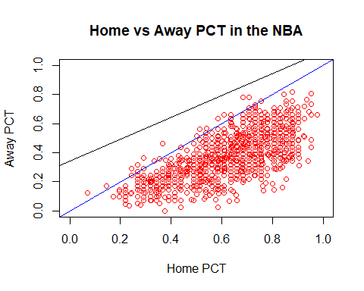

#the dataset with linear regression and symmetric diagonal line to see the comparison.  
#Clearly, we can see that home win percentage is huch higher than away win percentage.  
#Approximely, around 13-16 games won in away game among 1216 NBA games.  
  
#updated dataset  
soccer1 <- read.csv("C:/Users/sung.cheong/Desktop/SoccerLEagues1.csv")  
NBA1 <- read.csv("C:/Users/sung.cheong/Desktop/NBA1.csv")  
  
##### Soccer ########  
names(soccer1)

## [1] "Sport" "Country" "League" "Year" "Team" "Games"   
## [7] "HomeWins" "HomeDraw" "HomeLoss" "AwayWins" "AwayDraw" "AwayLoss"  
## [13] "X" "Home.PCT" "Away.PCT"

plot(soccer1$Home.PCT, soccer1$Away.PCT, main= "Home vs Away PCT in the soccer", xlab = "Home PCT", ylab = "Away PCT", col = "Red", xlim = c(0,1),ylim = c(0,1))  
abline(a=0.000, b=1, col = "Blue")  
lm(soccer1$Home.PCT~soccer1$Away.PCT)

##   
## Call:  
## lm(formula = soccer1$Home.PCT ~ soccer1$Away.PCT)  
##   
## Coefficients:  
## (Intercept) soccer1$Away.PCT   
## 0.3599 0.3633

abline(a=0.3599, b=0.3633, col = "Black")

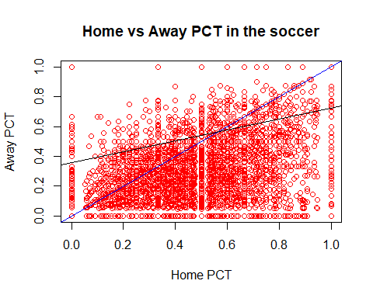

#data that under the both lines are more than above the lines.   
#Not as much clear as NBA, however home win percentage is more crowded than away win percentage.  
#Not sufficient to conclude that there is home advantage in soccer yet.  
  
#according to the soccer dataset, we could say that the teams are scoring more goals at home than away games.   
names(soccer)

## [1] "Sport" "Country" "League" "Year"   
## [5] "Season" "Team" "Games" "HomeWins"   
## [9] "HomeDraw" "HomeLoss" "HomeRatio" "AwayWins"   
## [13] "AwayDraw" "AwayLoss" "AwayGoalsDiff" "X"

plot(soccer$HomeRatio, soccer$AwayGoalsDiff, main= "Home vs Away Goal Difference in soccer game", xlab = "Home Goals Difference", ylab = "Away Goals Difference", col = "Red", xlim = c(-50,50),ylim = c(-50,50))  
abline(a=0, b=1, col = "Black")

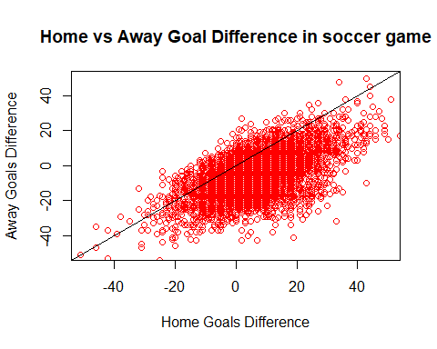

#Let's see other factors from Country_fact dataset  
names(Country_fact)

## [1] "Country" "Region" "Population"   
## [4] "Area" "PopDensity" "Coastline"   
## [7] "Net.migration" "Infant_mortality" "GDP"   
## [10] "Literacy" "Phones" "Arable"   
## [13] "Crops" "Other" "Climate"   
## [16] "Birthrate" "Deathrate" "Agriculture"   
## [19] "Industry" "Service" "FIFA_Rank"   
## [22] "UEFA_Rank" "Attendance" "Home_Away_Contrast"

plot(Country_fact$FIFA_Rank, Country_fact$Home_Away_Contrast, main= "Home Advantage vs FIFA Rank", xlab = "FIFA Ranks", col = "blue", xlim = c(0,250),ylim = c(0,0.8))

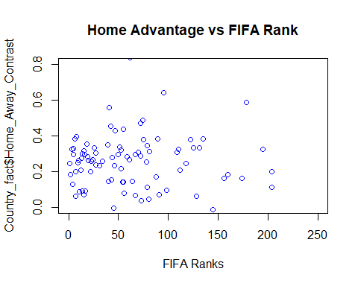

plot(Country_fact$Attendance, Country_fact$Home_Away_Contrast, main= "Home Advantage vs Attendance", xlab = "FIFA Ranks", col = "blue", xlim = c(0,45000),ylim = c(0,0.8))

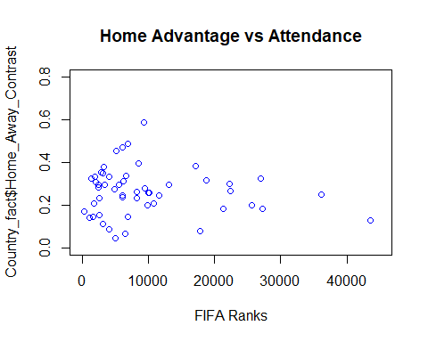

reg <-lm(Country_fact$Attendance~Country_fact$Home_Away_Contrast)  
#not much changes in home advantage over average attendance. Actually it decreased. FIFA Rank also does not effect the home advantage that much according to the data that we plot.  
  
#Home Advantages vs literacy rate  
#Home Advantages vs Infant mortality  
#Home Advnatages vs Industry   
#Home Advantages vs # of phone  
  
names (Country_fact)

## [1] "Country" "Region" "Population"   
## [4] "Area" "PopDensity" "Coastline"   
## [7] "Net.migration" "Infant_mortality" "GDP"   
## [10] "Literacy" "Phones" "Arable"   
## [13] "Crops" "Other" "Climate"   
## [16] "Birthrate" "Deathrate" "Agriculture"   
## [19] "Industry" "Service" "FIFA_Rank"   
## [22] "UEFA_Rank" "Attendance" "Home_Away_Contrast"

plot(Country_fact$Literacy, Country_fact$Home_Away_Contrast, main= "Home Advantage vs Literacy", xlab = "FIFA Ranks", col = "blue", xlim = c(0,100),ylim = c(0,0.8))

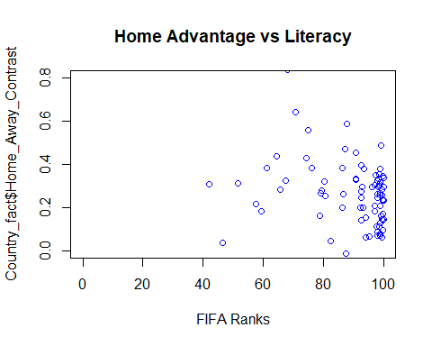

plot(Country_fact$Infant_mortality, Country_fact$Home_Away_Contrast, main= "Home Advantage vs Infant Mortality", xlab = "FIFA Ranks", col = "blue", xlim = c(0,200),ylim = c(0,0.8))

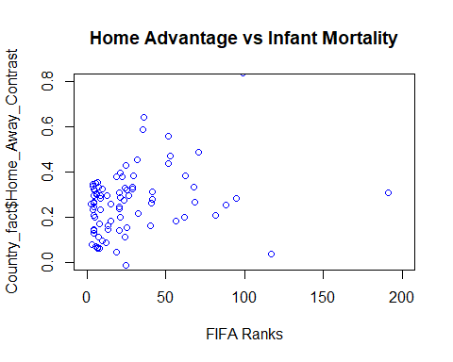

plot(Country_fact$Phones, Country_fact$Home_Away_Contrast, main= "Home Advantage vs Attendance", xlab = "# of Phone/person", col = "blue", xlim = c(0,900),ylim = c(0,0.8))

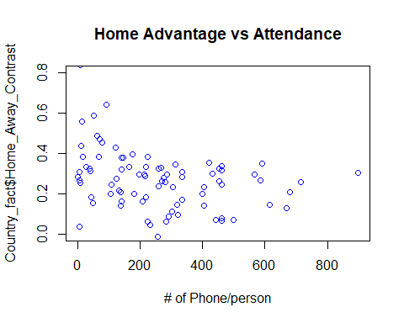

plot(Country_fact$Industry, Country_fact$Home_Away_Contrast, main= "Home Advantage vs Attendance", xlab = "Industry", col = "blue", xlim = c(0,1),ylim = c(0,0.8))

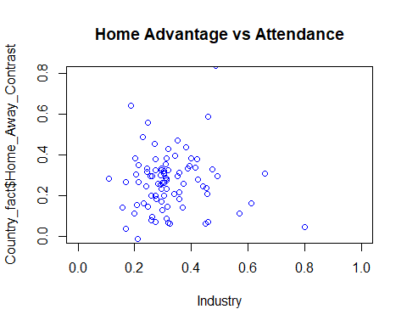

plot(Country_fact$GDP, Country_fact$Home_Away_Contrast, main= "Home Advantage vs Attendance", xlab = "GDP", col = "blue", xlim = c(0,40000),ylim = c(0,0.8))

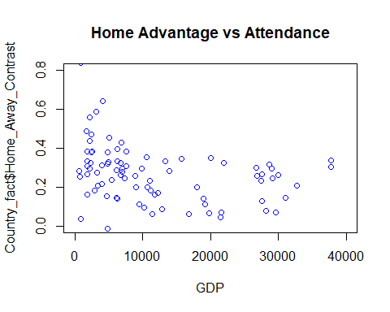

#Interestingly enough, it seems that the strongest predictors are indicators of general development such as # of phones/person literacy, GDP, Industry and Mortality rate for infant.   
#The more developed the country, it shows less significant the home advantage is (in soccer).