Psychometrics of the continuous mind: Time continuous multiple regression as a method to exploit the dynamics of computer mouse movements

Stefan Scherbaum & Maja Dshemuchadse

Supplement

A tutorial to the TCMR toolbox

This tutorial guides you through the basic steps of mouse movement analysis in Matlab using the TCMR toolbox.

In the tutorial data set (10 subjects from the data of Scherbaum et al, 2010, Cognition, study 1), you find the following data:

For each participant, you have a struct of trials. Each trial consists of fields for

* response code (the final response left/right): response
* congruency (1=congruent, 2=incongruent)
* time series of x coordinates
* time series of y coordinates
* time series of sample timings

For reasons of simplicity, invalid trials (erroneous response, missed deadlines) have been removed already.

Before starting the tutorial, make sure that you have the **Matlab Statistics Toolbox** installed, as well as **fminsearchbnd**: (https://de.mathworks.com/matlabcentral/fileexchange/8277-fminsearchbnd--fminsearchcon, John D'Errico, 2012) and **geom2d** (https://de.mathworks.com/matlabcentral/fileexchange/7844-geom2d, David Legland, 2017).

First load the data into the workspace and create a struct for each participant with the basic properties of the trials (response, congruency) as vectors. This is our usual way of organizing the data: one struct per participant. However, feel free to use any form of organization (tables, CSV files,…) you are familiar with.

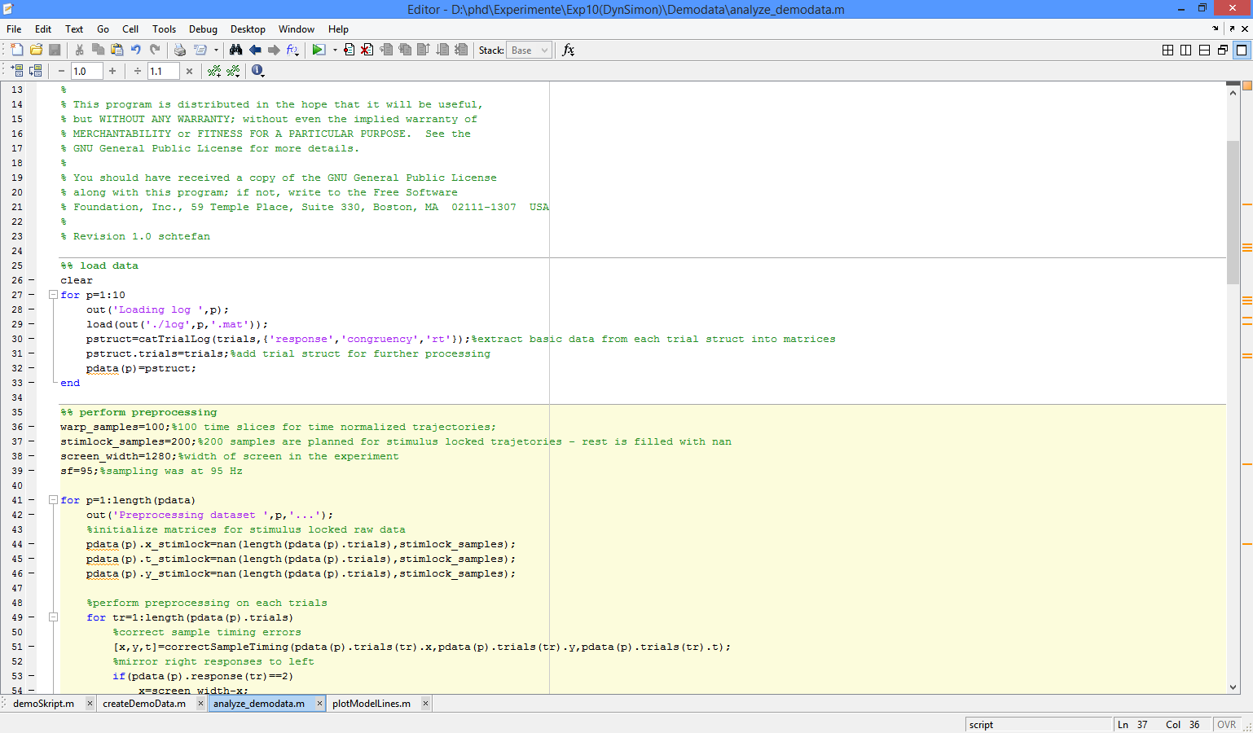

Then you will have to perform the following pre-processing steps for each participant:

1. Correct potential sample timing errors: since the mouse is not recorded by a hardware device (as for example in EEG recordings), samples might have been recorded irregularly in time.

2. Align start point of x coordinates to 0, then mirror responses so that all trials are aligned similarly (this step could be omitted if appropriate).

3. Extract the continuous signal properties (angle, velocity) from the raw data, in stimulus-locked and time-normalized format.

4. Extract the static signal properties, i.e. mean deviation and maximum deviation.

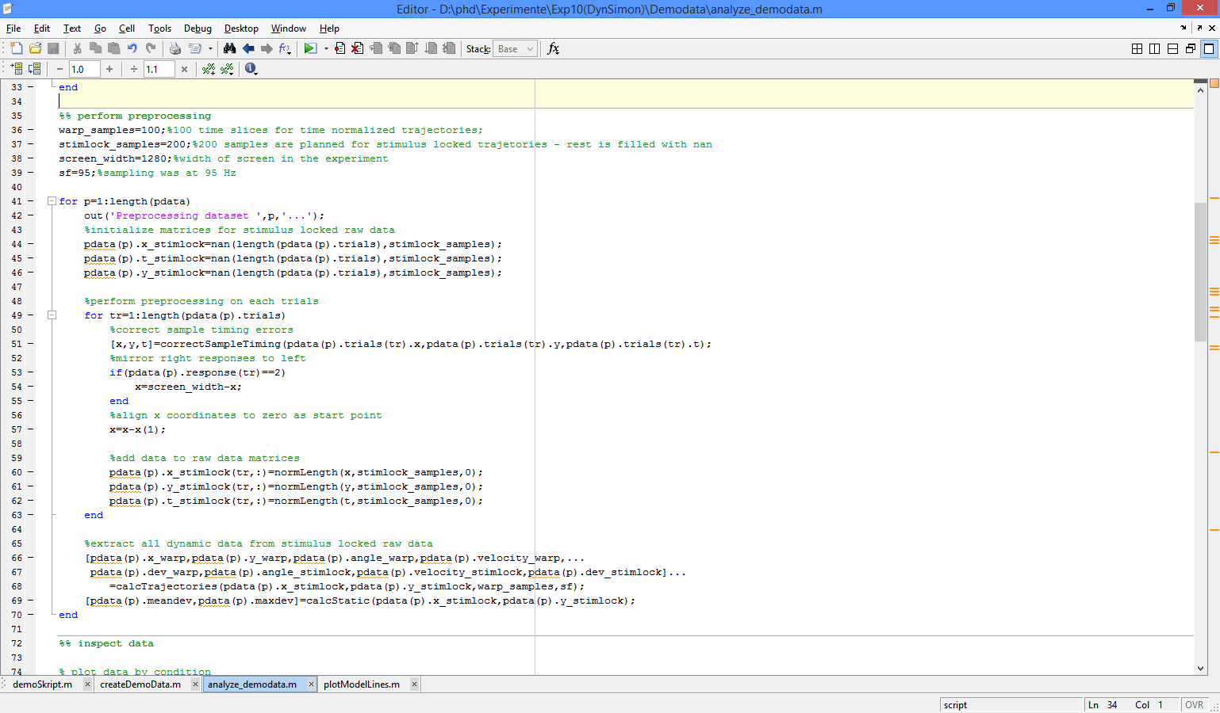

After these preprocessing steps, first check the data quality.

1. Draw the time course of average movements on X-axis for both conditions

2. Check movement consistency by calculating the movement index (how consistent/straight was the upwards movement, how many backwards movements occurred)

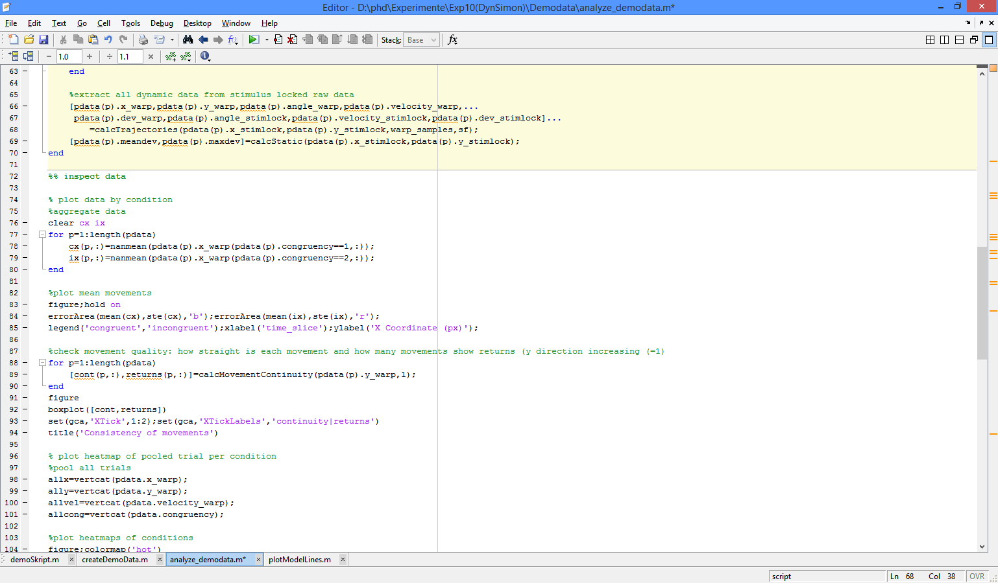

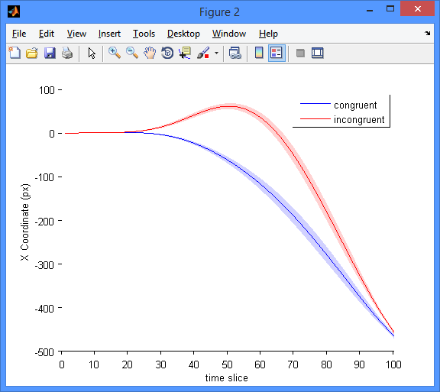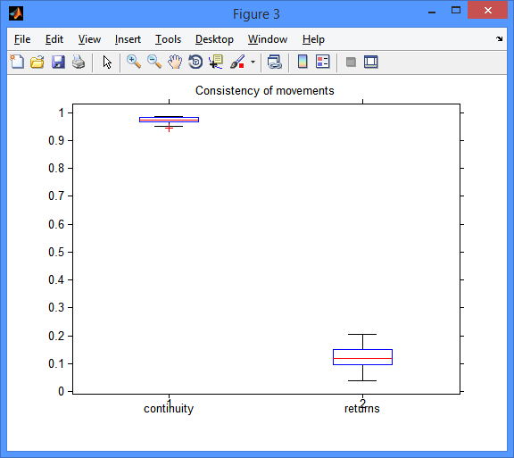

3. Draw X/Y heatmaps for both conditions to judge movement distribution.

4. Draw a heatmap of movement velocities to check the regularity of movements.

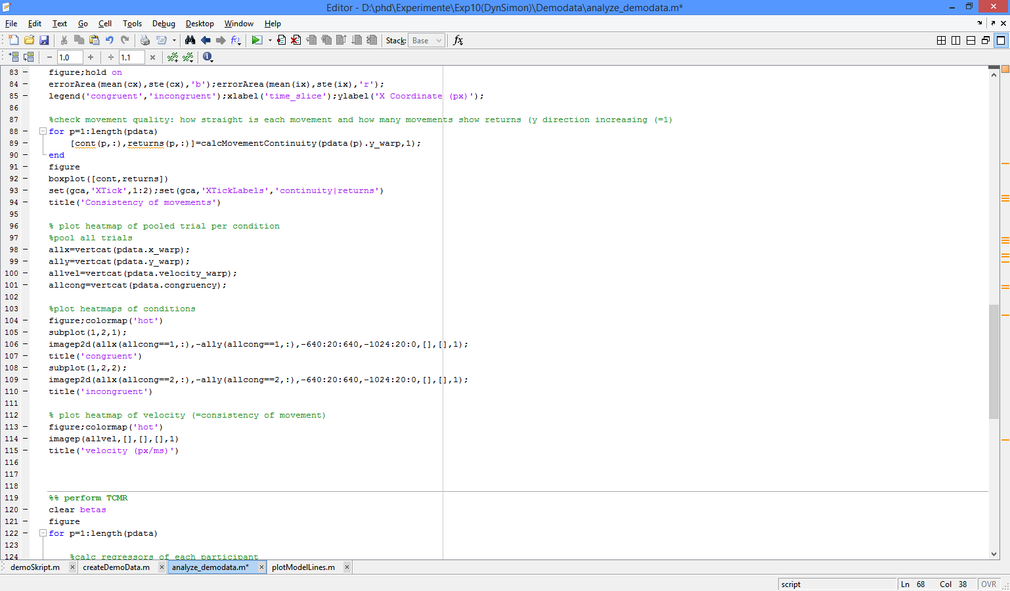

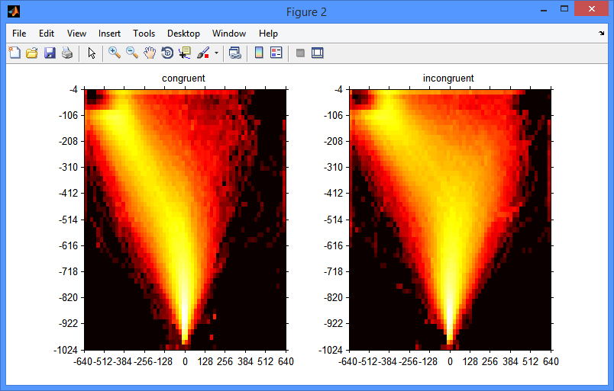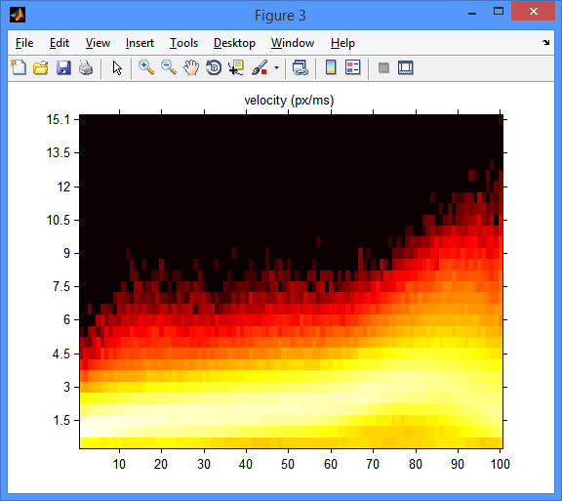

After checking the preconditions, you can now apply TCMR to each participants dataset in the following steps:

1. Code the regressors for the response repetition bias and for congruency.

2. Normalize the regressors to [-1,1].

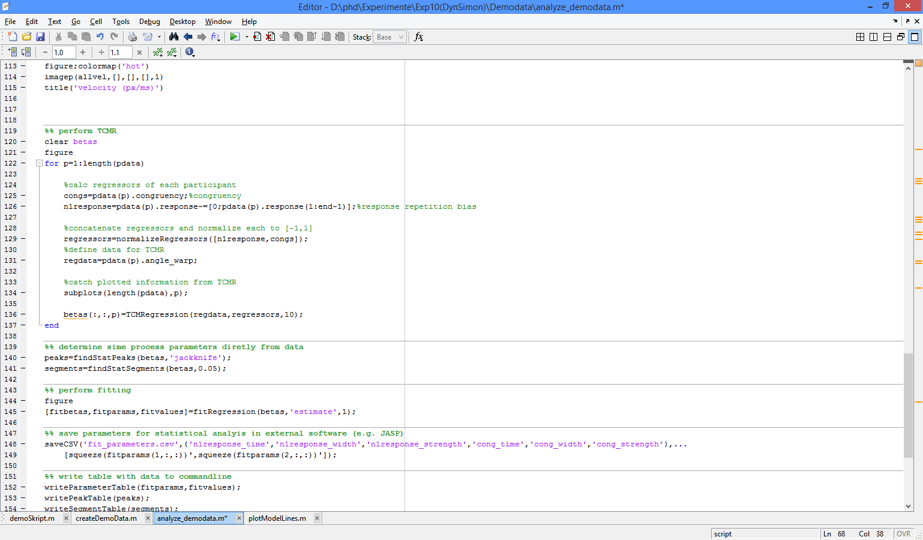3. Perform TCMR.

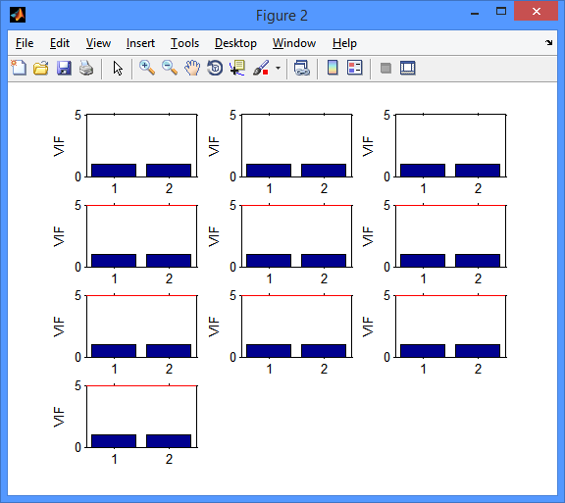

Variance inflation factors will be shown for each participant’s two regressors. As long as they stay below 5, multicollinearity is no issue.

After performing TCMR per participant, you can extract group-level properties of each beta, e.g. significant segments and peaks.

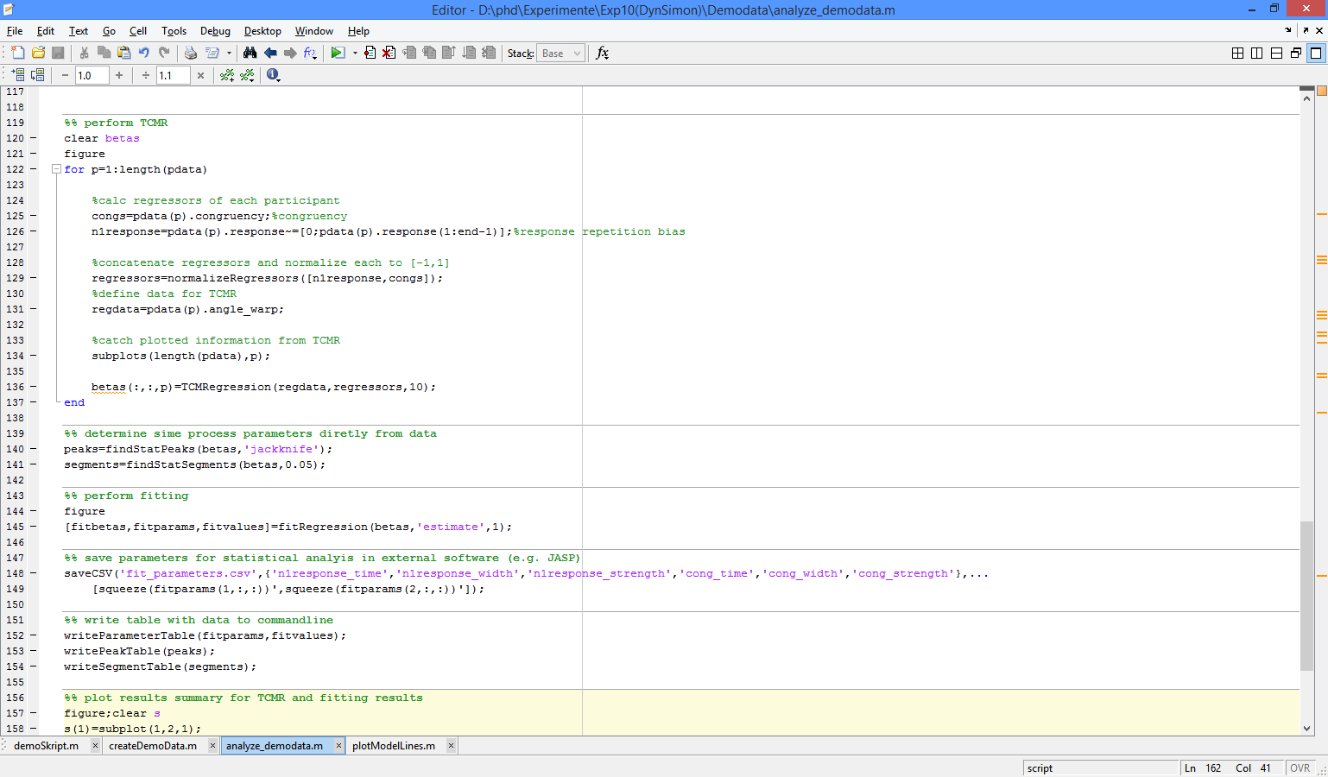

To extract individual parameters, apply the gauss fit procedure to the complete set of beta weights extracted by TCMR: run the gauss fit function.

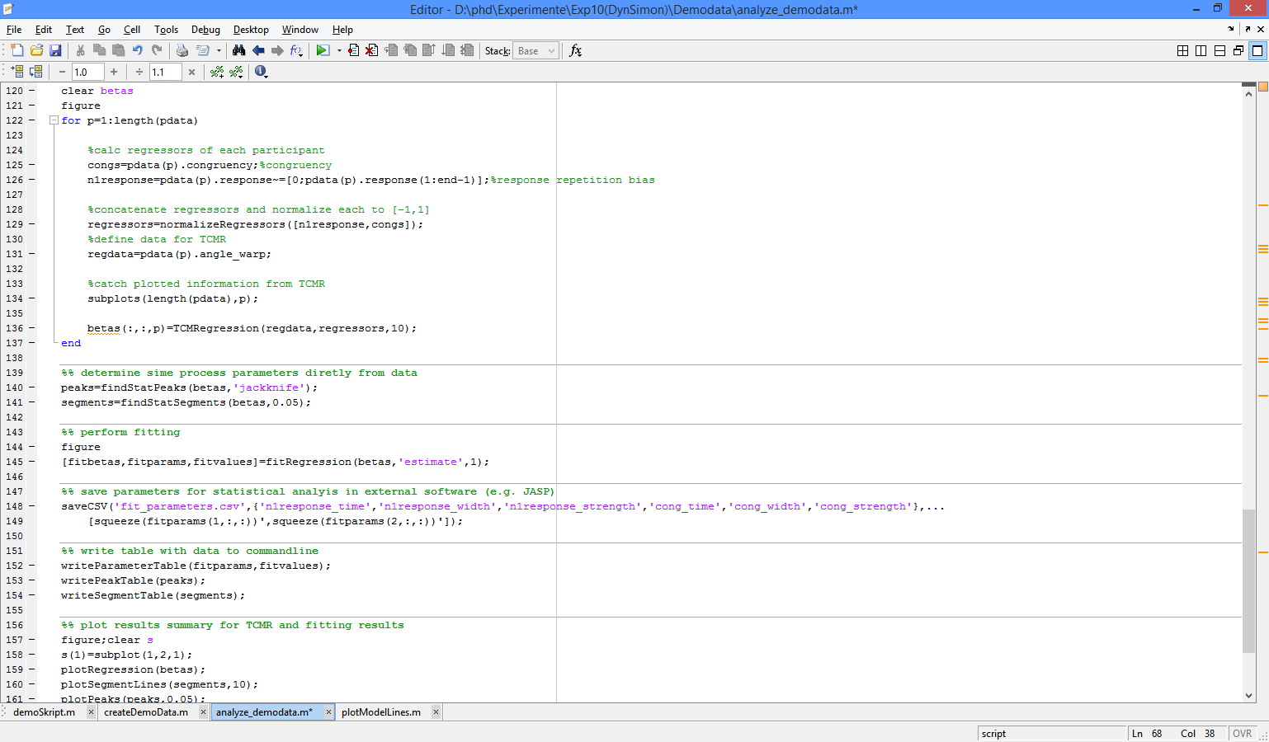

Afterwards, plot a summary of the results. The parameters can be analysed or exported for further statistical analysis.

