# **Alf Scherer**

**User guide**

|  |  |
| --- | --- |
| **Project title** | Managing a 3D Printer Farm |
| **Project manager** | Alf Scherer |
| **Created on** | 17.03.2022 |
| **Last modified on** | 01.04.2022 |
| **Status** | Under way |
| **Current Version** | 1.1 |

**Change History**

|  |  |  |  |  |  |  |
| --- | --- | --- | --- | --- | --- | --- |
| **No.** | **Date** | **Version** | **Amended chapters** | **Type of modification** | **Author** | **Status** |
| 1 | 17.03.2022 | 1.1 | All | Building | Alf Scherer | Under way |
| 1 | 01.04.2022 | 1.2 | All | Building | Alf Scherer | Under way |

Content

1 Requirements 3

2 Goal 3

3 UI: Description of the windows **.**4

3.1 Printer Tab: "Printers" 4

3.2 Orders: Orders tab 5

3.3 Material 6

3.4 Disposition .. 7

3.5 Maintenance and service 8

4 Data 9

4.1 Database 9

*4.2* Exportfiles*:* 9

# Requirements

The program was developed as a stand-alone solution:

* Standard Windows 10 PC with .Net 8.0 installed.
* Graphical User Interface (WPF)

# Goal

The app is intended to be used to manage the data of a 3D printer farm consisting of one or more FDM printers. It includes:

* Quickly manage the print parameters for individual print orders and the printing jobs they contain.
* Management of maintenance calendars, maintenance incidents and costs.
* Display of the scheduling of all print operations on a weekly scheduling wall with access to the planning of all orders for each week of the year via "Click Right >>" or "<< Click Left" navigation buttons.
* Summary of costs and revenues for the entries for the entire current year.

# UI: Description of the windows

The app presents itself as a tab view where you can choose from five active tabs: Printers, Orders, Material, Schedule and Incident Log and Revenues+Costs. The Cockpit tab can be used to providerun as a standalone solution wjobs that cannot be scheduled because of lack of capacity during the required timeframe shall be highlighted and made available as aprintable listing. the basic assumptions, i.e. the current year, the return on equity or the hourly staff rate of the service and maintenance personnel.

## Printers: Printers tab

The "Printers" tab can be used to manage a DruckerPark (type, date of purchase, cost in euros). This is where printers can be added or removed. The ServiceTime column shows the estimated service days over the year for the printer.

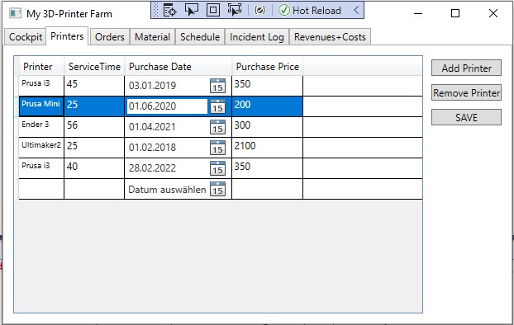

## Orders: Orders tab

### Orders

Orders can be managed via the "Orders" tab.

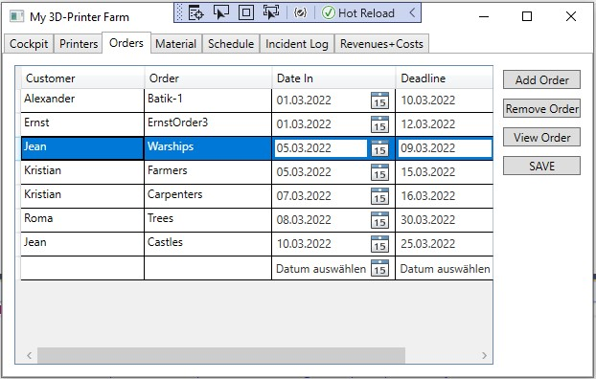

The Printing Operations

The "View Order" button specifies the printing processes for a given order.

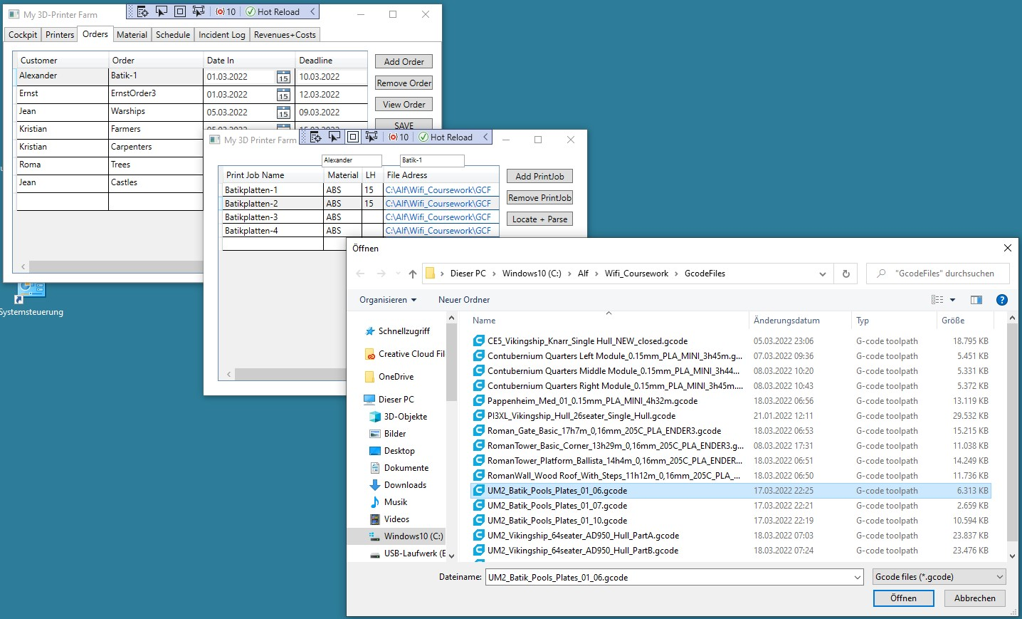

For each printing process, you can use the button "Locate + Parse" to evaluate a Gcode file for the printing process. Printing time, material consumption, degree of resolution (nozzle diameter and layer height) as well as the printer, slicer and material used are determined

## Material

Material types are managed via the "Material" tab.

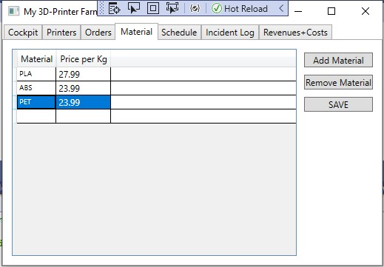

## Disposition

In the "Schedule" tab, a simple weekly schedule can be created. By entering the calendar week (1-52) in the input field, the button leads us to a disposition of the print jobs based on the stored time frame as well as the printers and print routes specified in the Gcode files.

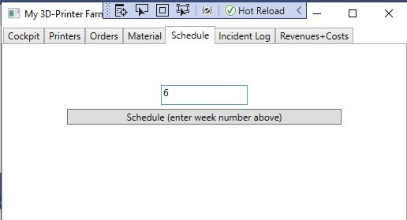

The printing processes are indicated there in several colors, a click on the respective print section opens further job details in an additional window if required.

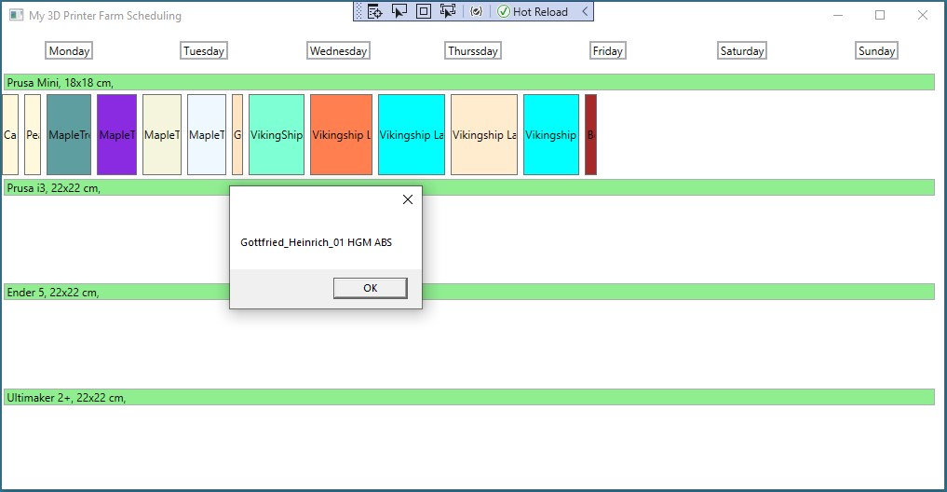

## Maintenance and service

In the "Incident Log" tab, you can record service entries for each printer.

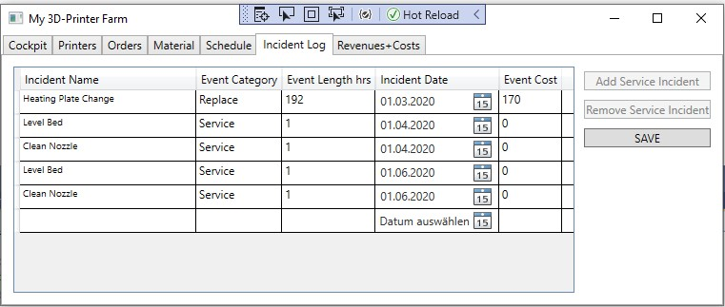

The date, duration and cost of the maintenance events can be recorded.

There are three basic categories of events:

* Routine: Bed leveling, nozzle cleaning, more.
* Spare parts: Again, it is easy to group them, e.g. replace the print bed or replace the cable.
* Other events: Unforeseen incidents, e.g. caused by power failure.

# Data

## Database

The basis for data management is a SQLite database, which is supplied with the zip file. Please keep this database(MyPrinterFarm.db) in the same directory as the rest of the elements from the zip file! The database is already pre-populated with some of my own print jobs from 2022: you can easily delete them for your own setup.

Basic areas of printer management must be stored in the enclosed SQLite database before scheduling can succeed:

* The names of the print jobs and their Gcode file addresses, the parent orders, the sales prices of each order, as well as the receipt and delivery dates.
* The running distances of the jobs are fetched from the Gcode files, the set-up times are calculated separately by the app from quality characteristics and material specifications.
* Definition of installed printers, as well as data on their maintenance events and their material compatibilities. (TODO: Regular maintenance times can soon be added automatically to the MRP based on the service log entries).

The link between the print jobs and the printers is the current MRP results – MRP connects the print jobs with the available free time periods on the printers. (TODO: In the next version, maintenance times will be automatically scheduled).

## Export:

The pdf printout of a weekly disposition can currently only be created via screenshot.

In the future, it will also be possible to print out an economic summary or evaluation as a simple text file over a predefined period of time.