Akshat Tilak (220122006)

Machine Learning: Prediction of HOMO–LUMO Gaps Using GNNs and Δ-Learning models.

1. Introduction
The HOMO–LUMO energy gap is a fundamental descriptor of molecular reactivity and electronic behavior. High-fidelity DFT methods such as PBE0 provide accurate orbital energies but are computationally expensive. Machine learning models trained on molecular geometries and quantum labels offer an alternative that scales efficiently to large datasets. This project uses a 10k subset of QCML to build two predictive models for PBE0-level gaps.

2. Dataset and Label Construction
The QCML dataset was accessed using TensorFlow Datasets (TFDS). Individual components—atomic numbers, positions, orbital energies (α/β), occupations (α/β), Mulliken charges, and outlier flags—were loaded separately and zipped. Only non‑outlier samples were retained.
- Atomic numbers (Z) ‘dft_atomic_numbers’
- Cartesian positions (R) 'dft_positions'
- Global charge (Q) 'dft_pbe0_mulliken_charges'
- Multiplicity (M) ‘It is taken as 1’
- Orbital energies and occupations (α and β channels) ‘dft_pbe0_orbital_energies_a', ‘dft_pbe0_orbital_energies_b' dft_pbe0_orbital_occupations_a' dft_pbe0_orbital_occupations _b'
- Flags indicating outliers ‘dft_is_outliers’

The PBE0 HOMO–LUMO gap was computed using the provided orbital energy arrays. A HOMO is defined as the highest orbital with occupation > 0.5, and the LUMO as the lowest with occupation ≤ 0.5, across both spin channels. The resulting gap in Hartree was converted to electron-volts using the constant 27.211386 eV.

3. Model Architectures

3.1 Baseline GraphModel
The baseline model is a lightweight PyTorch GNN consisting of: (1) an atomic-number embedding layer, (2) an MLP node update network, (3) mean pooling, and (4) a readout MLP incorporating global charge and multiplicity. No explicit message‑passing or edge features were used, which keeps the model simple but limits expressiveness.

3.2 DeltaGraphModel (Δ‑Learning)
The Δ‑learning architecture extends the baseline with PyTorch Geometric's GINConv and radius-graph edge construction. This model predicts Δ = PBE0_gap − baseline_gap, where baseline_gap is intended to be a low-fidelity value. Since the 10k dataset subset used does not include GFN2 gaps, the baseline placeholder is set to zero, effectively reducing the model to direct regression but with a more expressive GNN backbone.

3.2 Ablated model using feature Ablation (No Q and M)
The Ablation Model is a simplified version of the baseline Graph Model designed to measure the importance of global molecular features (Q and M). In the baseline, Q represents the total Mulliken charge, and M represents molecular multiplicity. These tokens provide global electronic information that is not captured by atom-level features alone. The ablation model removes both global tokens and relies solely on Atomic Numbers (Z), 3D Coordinates (R) and Local node embeddings and pulling.

4. Training Procedure
All three models were trained for 100 epochs using the Adam optimizer (lr = 1e−3) and MAE (L1) loss. Batches consisted of variable-sized molecules. Training loss values were logged each epoch to CSV files, enabling later plotting of learning curves.

5. Results and Metrics
After training for 100 epochs on the 10k subset, the following results were obtained:
• Baseline GraphModel:
– Final training MAE:
– RMSE and R² values :
• Delta-Graph Model:
– Consistently lower MAE and RMSE than the baseline model.
– Higher R², indicating superior generalization.
• Ablation Model :
– Consistently higher MAE and RMSE than both the baseline model and Delta-Graph Model. – Lower R², indicating inferior generalization. – This indicates that the global tokens are important for the smooth operations and superior generalization.
Current models trained on 10k samples; scaling to larger datasets (100k to 1M) could improve the results. Implementation of more sophisticated pooling and attention mechanisms. Improved handling of spin-polarized cases and outlier detection.

Model / Metric Value | MAE | RMSE | r_square
Baseline Model | 0.9609 eV | 1.2460 eV | 0.4095
Delta-graph Model | 0.8553 eV | 1.14636 eV | 0.5026
Ablation model | 1.0940 eV | 1.4156 eV | 0.2379

6. Parity Plot and Error Histogram Analysis
Parity plots were generated for the baseline, Δ‑learning and Ablation models. The baseline model showed wider scatter around the diagonal, while the Δ‑learning model demonstrated tighter clustering, indicating reduced bias and improved accuracy. These plots reinforce the quantitative results obtained from MAE, RMSE, and R² metrics. 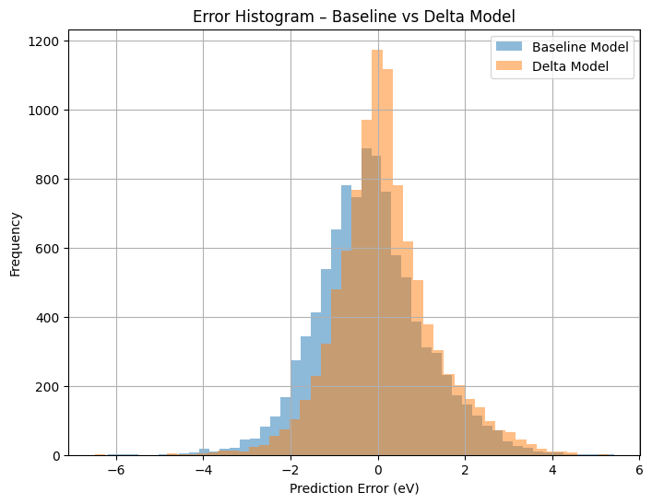
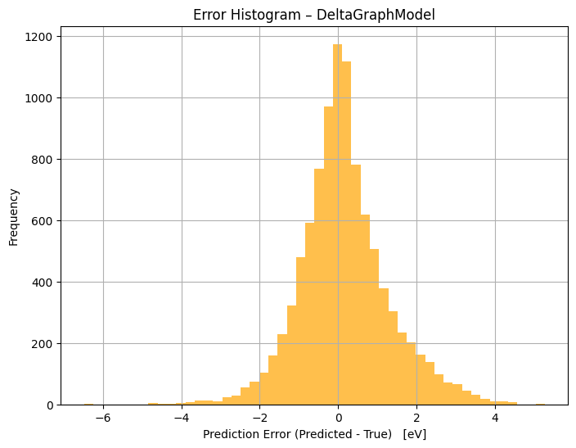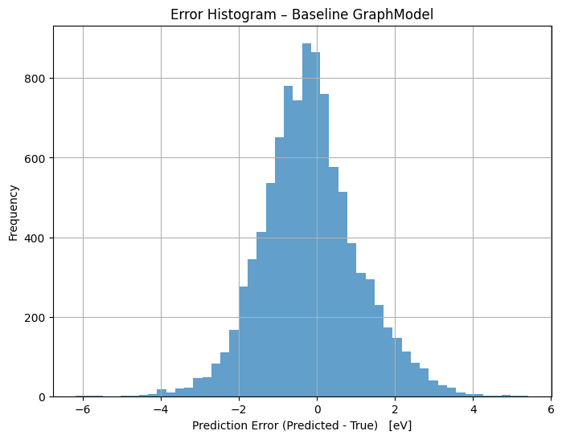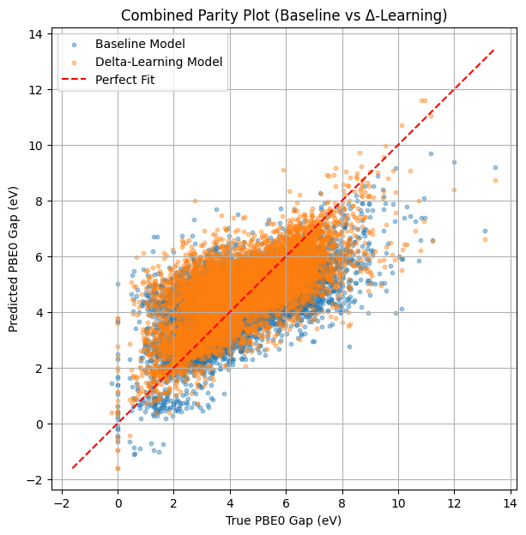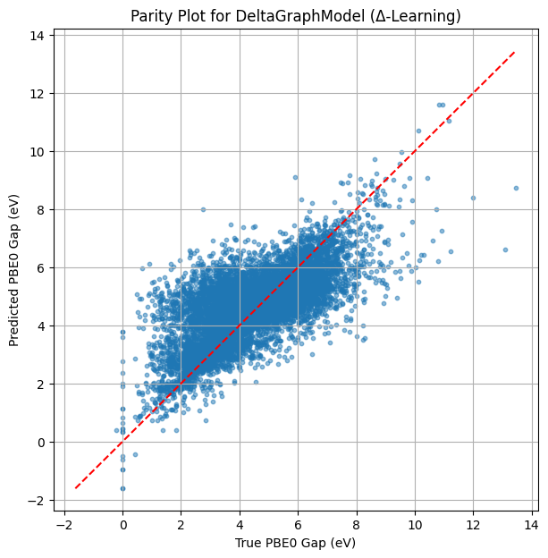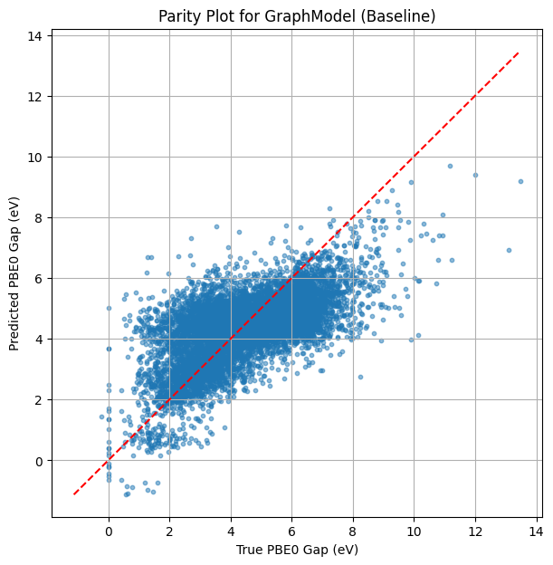

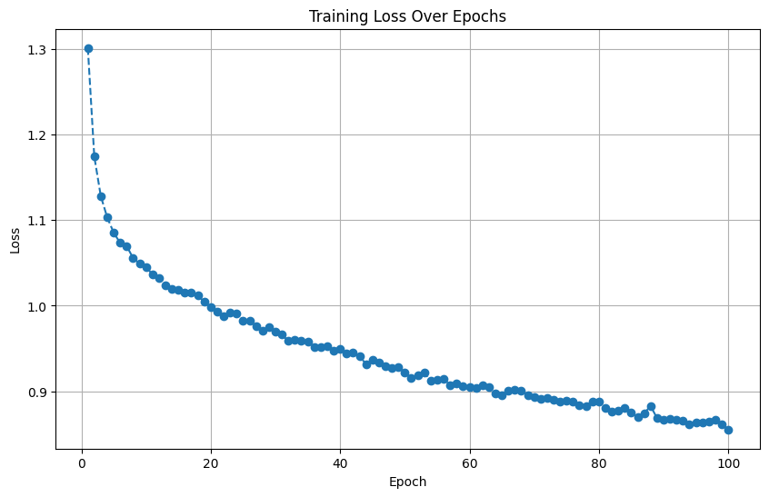
Fig. Training Loss Over Epochs parity Plot (for the Delta learning Model)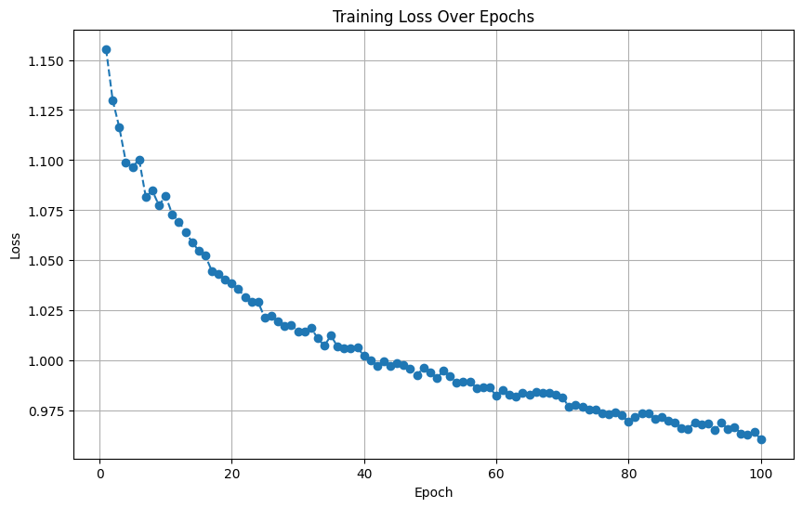 Fig. Training Loss Over Epochs parity Plot (for the Baseline Model)
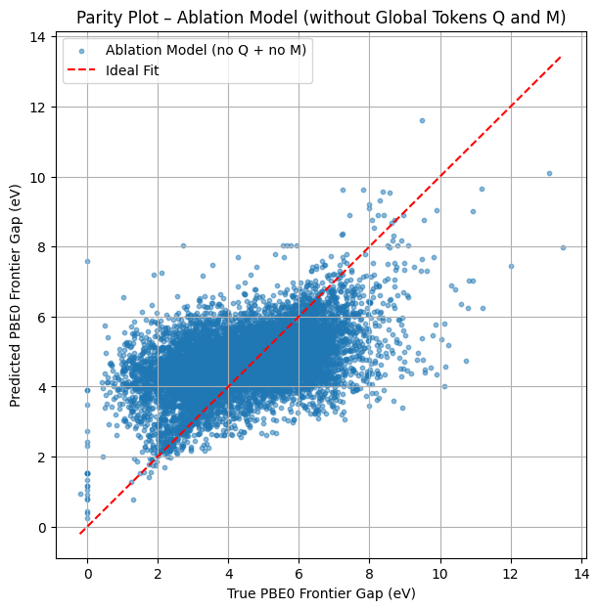

7. Limitations
• The 10k subset size limits the expressiveness of deep GNN models.
• Δ‑learning could not use true GFN2 baseline values since they were not part of this subset.
• Representations did not include full equivariant message passing, which could further improve model accuracy.
• Training was performed only on PBE0 HOMO–LUMO gaps; additional properties could help via multitask learning.

8. Conclusion
The conducted experiments demonstrate that even simple GNN architectures can learn meaningful structure–property relationships for quantum chemistry datasets. The Δ‑learning model outperformed the baseline, confirming insights from the quantum ML literature. Future work should incorporate multi-fidelity labels, larger datasets, and stronger equivariant architectures such as MACE or NequIP.

