Event Feedback

Thank you for having your event with us! We hope your event was a huge success. Alas Creative Events goal is to provide exceptional service to our clientele and guests. We hope you had as much fun attending as we did our very best organizing it.  
  
Please take a few moments to provide us with your feedback so that we can continuously improve our services and exceed our guest's expectations (your answers will be much appreciated).

**EVENT INFORMATION**

**Event Type** *

Wedding

Debut

Pageant

Birthday

Awarding Ceremony

Corporate

Convention

Grand Opening

Private Event

Other:

**Event Name** *

Example: Nestor & Ivy Wedding, Argelyn Belarmino: A decade and Eight, Binibining Carmen 2018, ACFI JS Prom 2020 and others.

**What is your role from this event? \***

Costumer/Client

Guest

Visitor

Attendee

Other:

**Event Date \***

**_____________**

**What is your name? \***

Example: Ace G. Cadayona

**Please Rate The Following**

**Venue Rating \***

Excellent

Very Good

Good

Fair

Poor

Other:

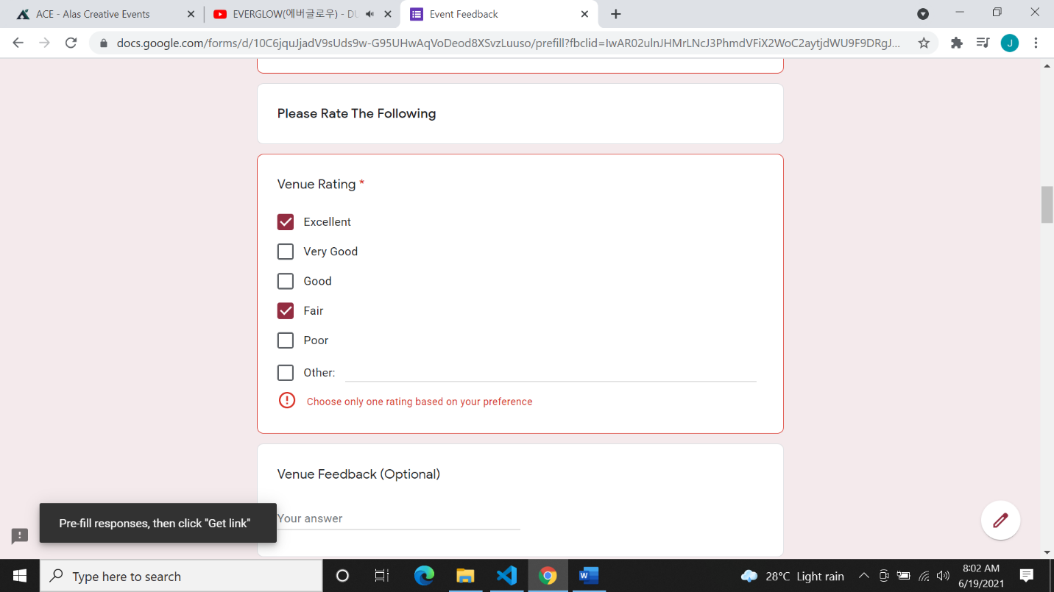

**Venue Feedback (Optional)**

**_________**

**Event Styling / Set- Up Rating \***

Excellent

Very Good

Good

Fair

Poor

Other:

**Event Styling/ Set- Up Feedback (Optional)**

**____________**

**Light & Sound Effect and Audio Visual Rating \***

Excellent

Very Good

Good

Fair

Poor

Other:

**Light & Sound Effect and Audio Visual Feedback (Optional)**

**____________**

**Catering Services Rating (If applicable only)**

Excellent

Very Good

Good

Fair

Poor

Other:

**Catering Services Provider (Optional)**

Example: J & M Catering Services

**______________**

**Catering Services Feedback (Optional)**

**______________**

**Photo & Video Rating (If applicable only)**

Excellent

Very Good

Good

Fair

Poor

Other:

**Photo & Video Provider (Optional)**

Example: Focal Point Still & Motion

**_____________________**

**Photo & Video Feedback (Optional)**

**_____________________**

**Wardrobe/ Make- Up Rating (If applicable only)**

Excellent

Very Good

Good

Fair

Poor

Other:

**Wardrobe/ Make- Up Provider (Optional)**

Example: Kyla's Boutique with Team Edgar

**_______________________**

**Wardrobe/ Make- Up Feedback (Optional)**

**_______________________**

**Organizer & Staff Courtesy & Helpfulness Rating \***

Extremely Friendly

Very Friendly

Somewhat Friendly

Not So Friendly

Not At All Friendly

Other:

**Organizer & Staff Courtesy & Helpfulness Feedback (Optional)**

**______________________**

**Overall, how will you rate your event with us? \***

Excellent

Very Good

Good

Fair

Poor

Other:

**Overall Service Rating? \***

Excellent

Very Good

Good

Fair

Poor

Other:

**What did you like most about your event with us? (Optional)**

____________

**What did you dislike most about your event with us? (Optional)**

**________________**

**How satisfied were you as client, guest or attendee? \***

Extremely Satisfied

Very Satisfied

Satisfied

Somewhat Satisfied

Not So Satisfied

Not At All Satisfied

Other:

**Any overall suggestions for improvement?**

**____________**

**Would you recommend us to your friends, relatives, families and contacts? \***

Yes

No

Maybe

Other:

If YES, please tell them that we will organize their dream into reality and to fulfill A Dream Beyond Forever.