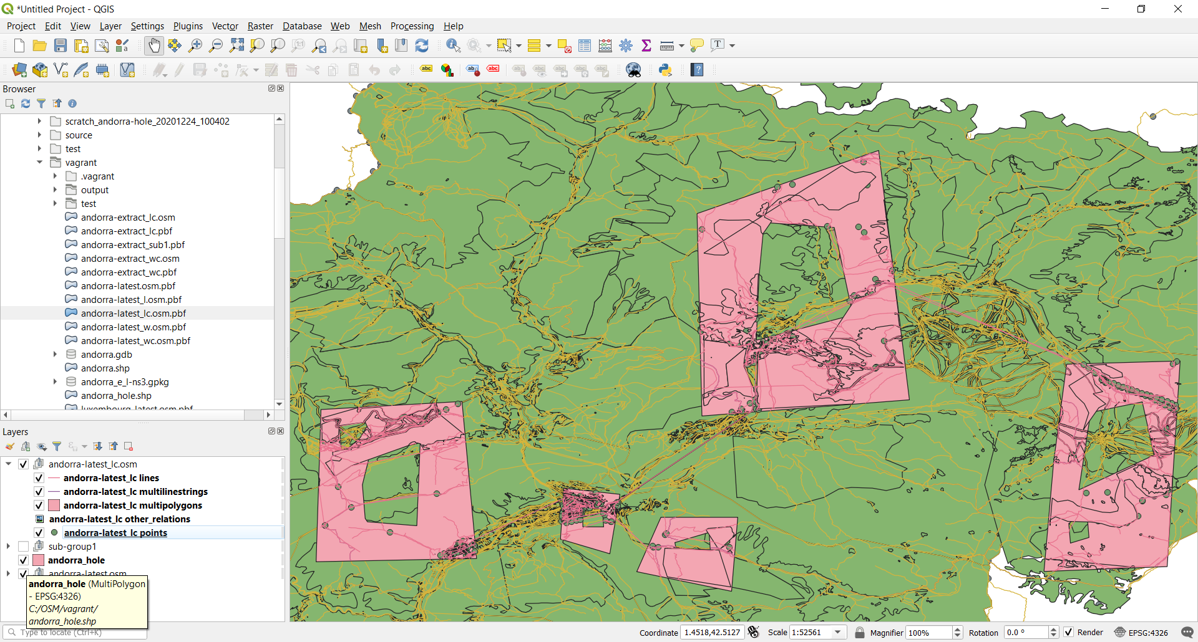

Figure OSM File and Hole Shapefile

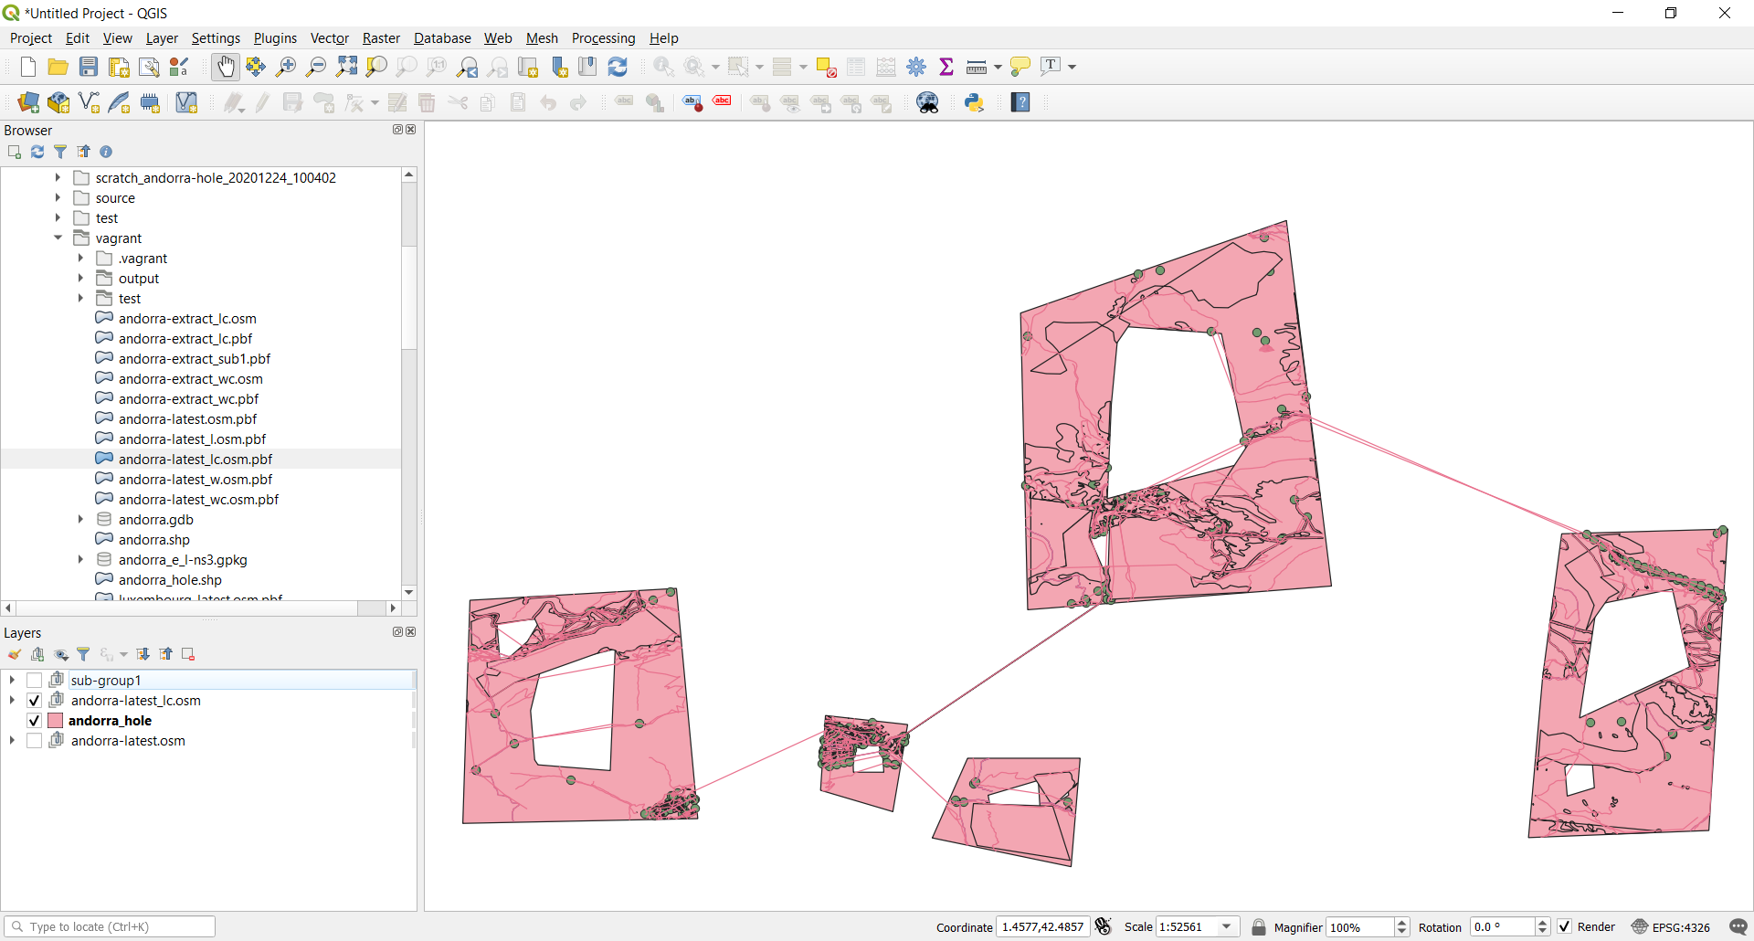

Figure OSM.PBF clipped with OSMCONVERT Notice some ways are not clipped

osmgo extract andorra-latest.osm.pbf andorra-extract_lc.pbf -c ../andorra_hole.shp

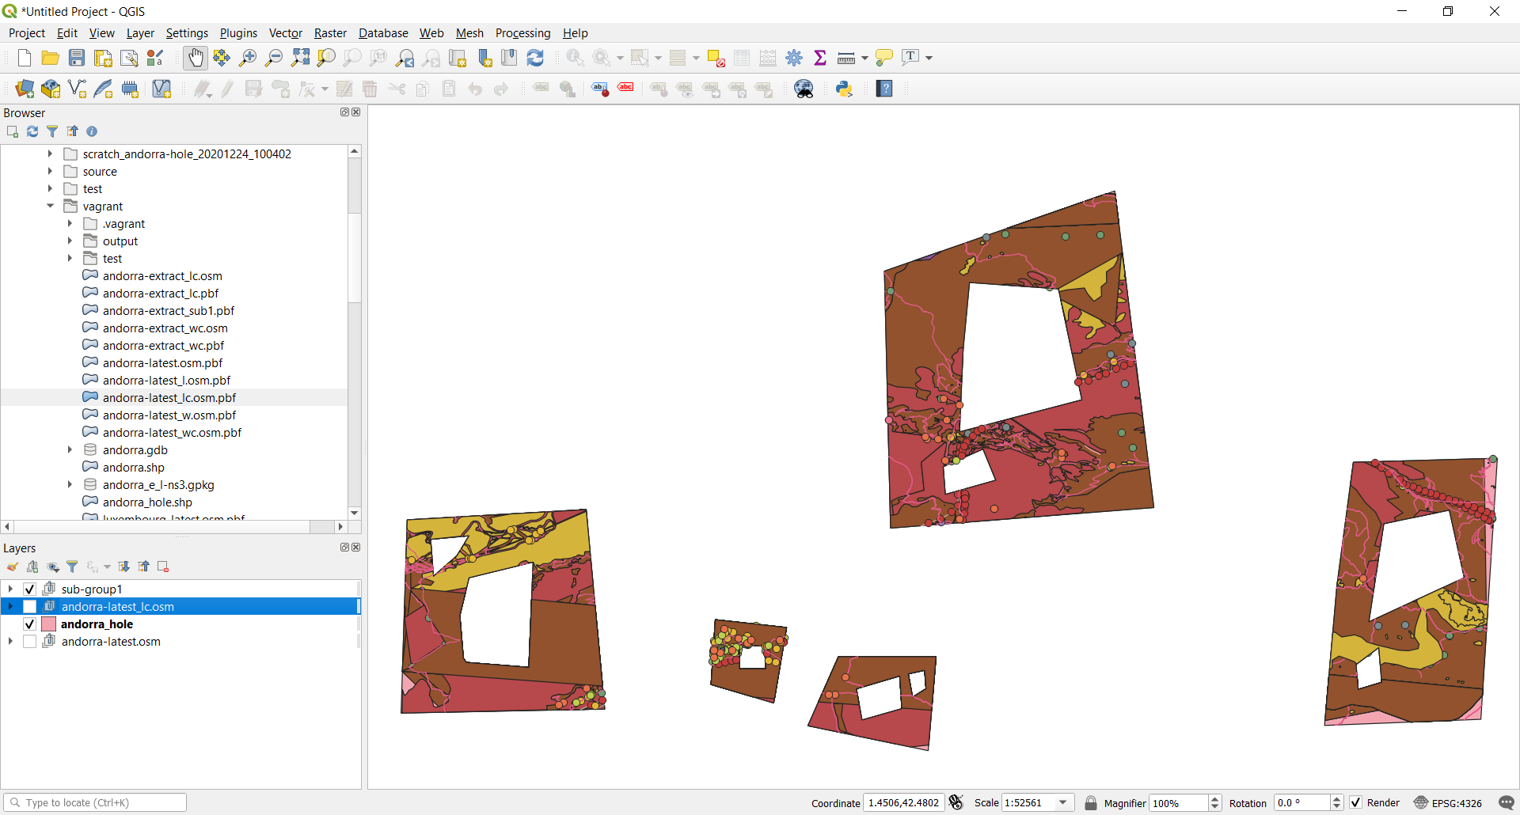

Figure Clipped OSM.PBF Cliped Again with OSMGO

osmgo export andorra-latest.osm.pbf output andorra-l-nsws -w 2 -c andorra_hole.shp