Sprint 5 Status Report
For the Girl Scouts of America Badge Tracking
Application

By
Matt Eck
Michael Glosecki
Nathan Martz
Ryan Schroeder

Of
Team Cookie Council

1. The Council estimated 80 hours to complete sprint 5 however the sprint took us ## hours. After the sprint was completed we had 0 hours left on the story tasks selected.

2. All stories on product backlog were selected for Sprint five. The goal of sprint five was to continue working on the web page, relearn git, study and implement Django.
- Home page made by Matt
- Template HTML & CSS made by Matt
- My troop page, badge overview, and Journeys page made by Nate.
- Django Research done by Ryan & Mike
- Django server & database connections set up by Ryan
- Django HTML rendering done by Mike
3. Client meeting set up for Feb. 7th at 5:30 on campus. IT for the Girl Scout council was contacted with no response.
4. Attempted to mitigate server risk but with no response. Django knowledge risk mitigated through research.

Project Burndown chart
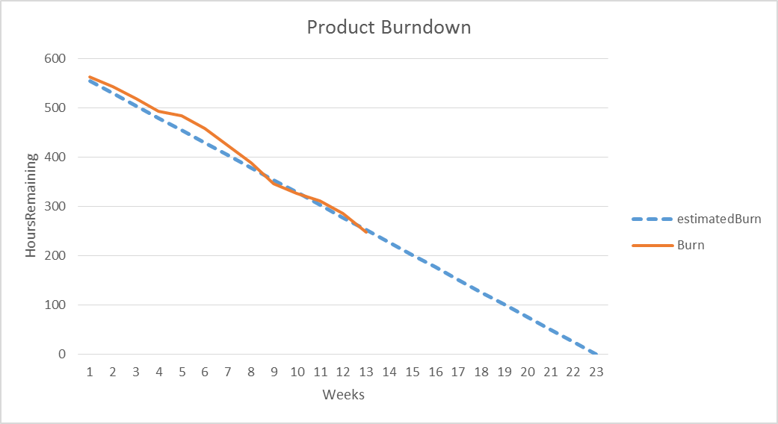

**Estimated total hours re-evaluated.

Sprint Burndown Chart
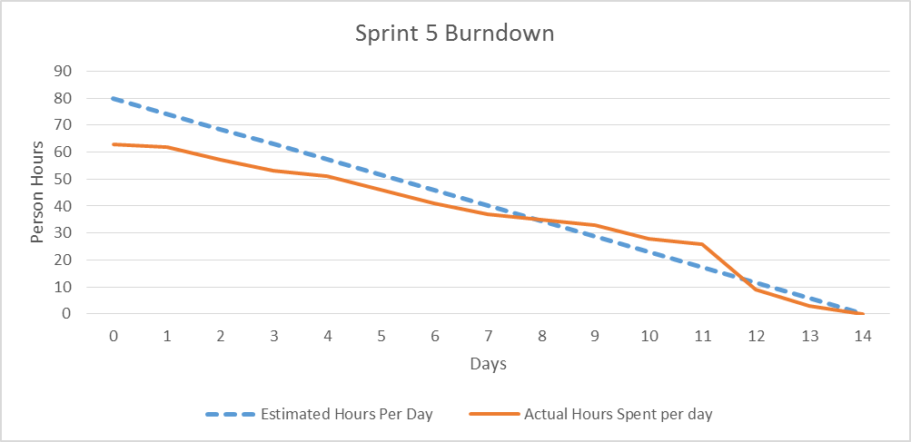

Weekly Development Effort
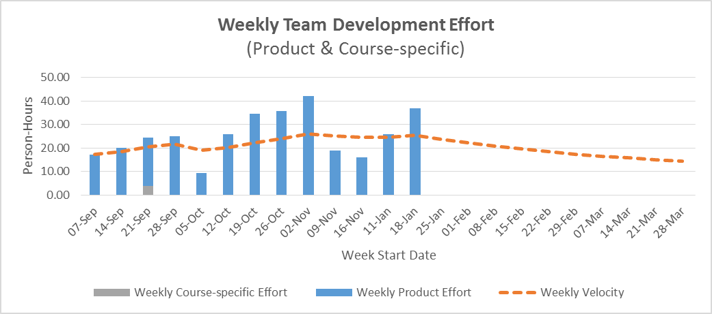

Daily Team Effort
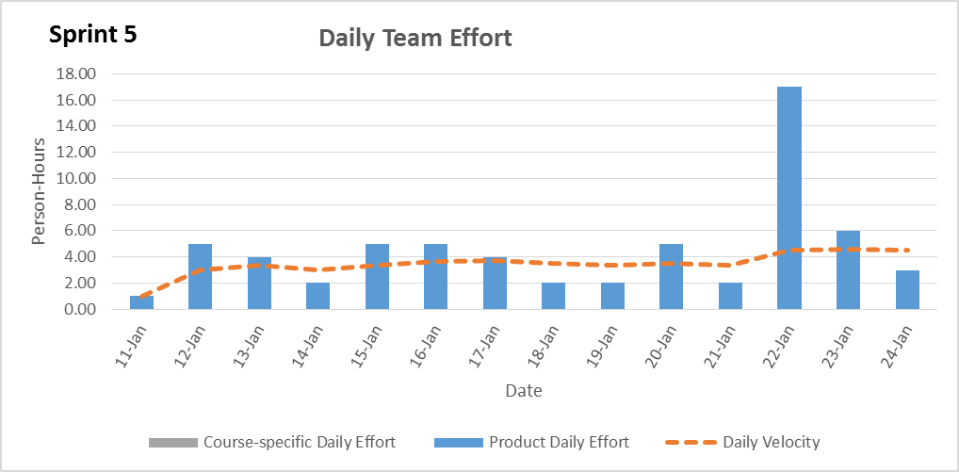

Team Member Effort
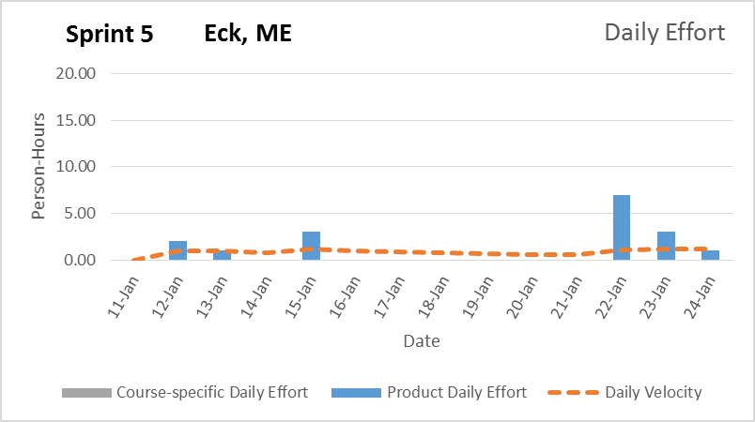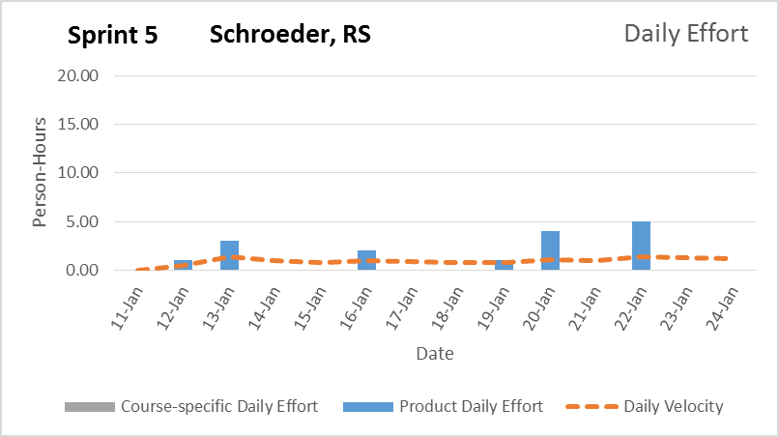

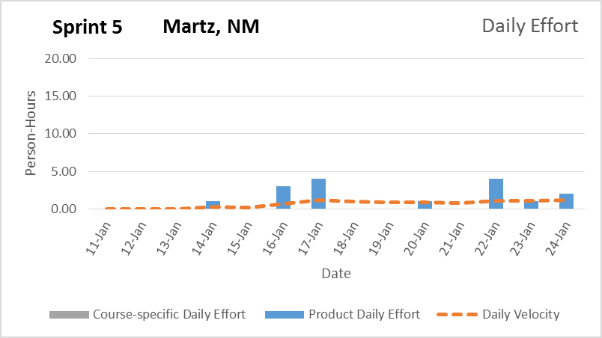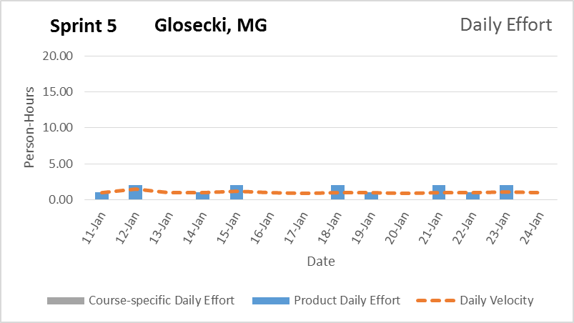

6. Time estimations on tasks were re-evaluated to more accurately reflect the amount of work the team thought was left. The team feels like the project’s web interface will be complete on schedule but the mobile interface might be lacking come release.

Signature Date

__________________________________________ ______________

__________________________________________ ______________

__________________________________________ ______________

__________________________________________ ______________

