Sprint 2 Status Report
For the Girl Scouts of America Badge Tracking
Application

By
Matt Eck
Michael Glosecki
Nathan Martz
Ryan Schroeder

Of
Team Cookie Council

1. The Council estimated 70 hours to complete sprint 2 however the sprint took us 60.5 hours. After the sprint was completed we had 0 hours left on the story tasks selected.

2. All stories on product backlog were selected for Sprint two. The goal of sprint two was to create a good structure of the database and to get a rough html page up.
- ERD revised then completed by Matt and Ryan.
- Database Create table statements created by Matt and Ryan
- HTML frame work and CSS created by Nathan and Micheal
- Server research was performed by Micheal
- Quality plan revised by Micheal

3. Client was informed about some other server options the team explored and reminded about the need for a server from the girl scouts

4. The only risks we attempted to mitigate was the risk of not having a server to implement the system on. We did so by reminding the client of our need of a server and by researching alternative server options.

5. Project Burndown chart
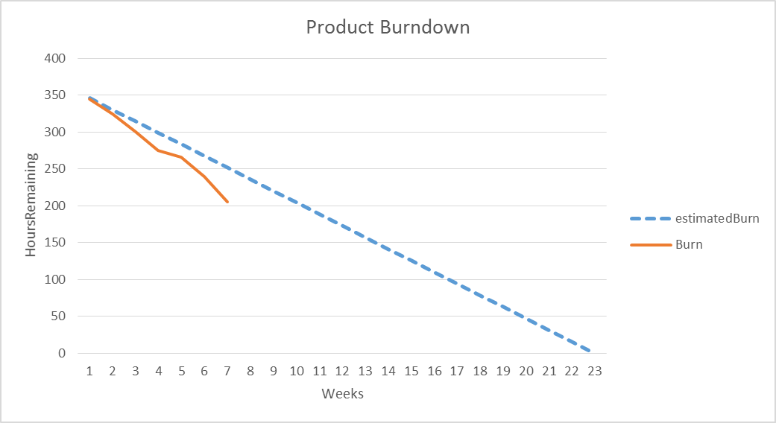

Weekly Development Effort
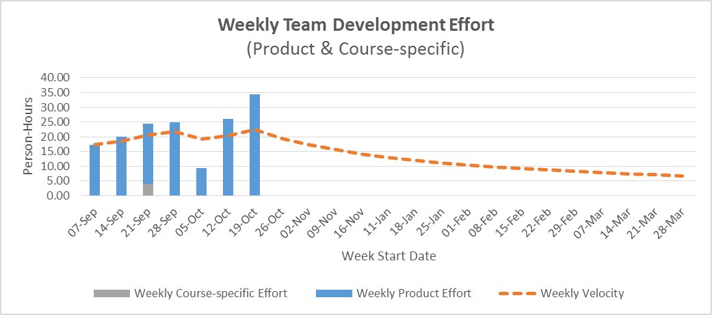

Daily Team Effort
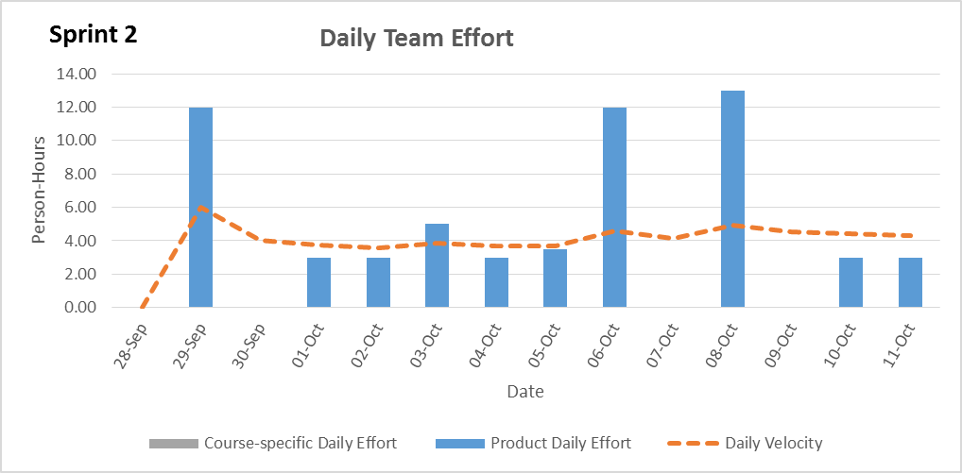

Team member Effort

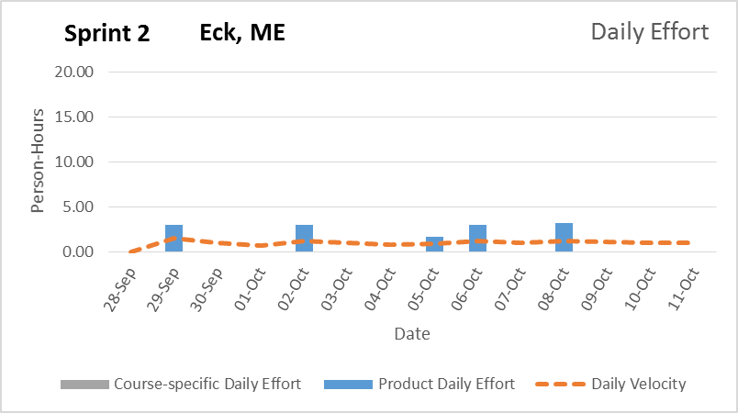
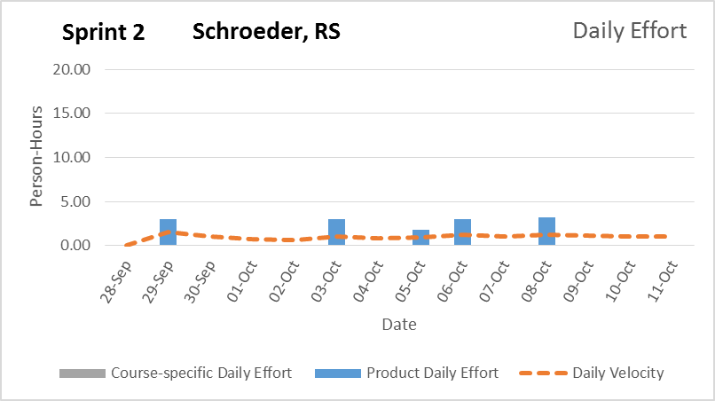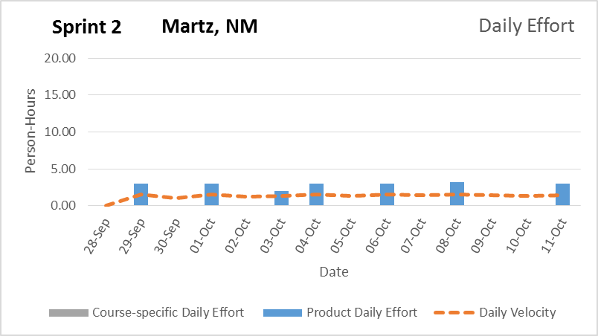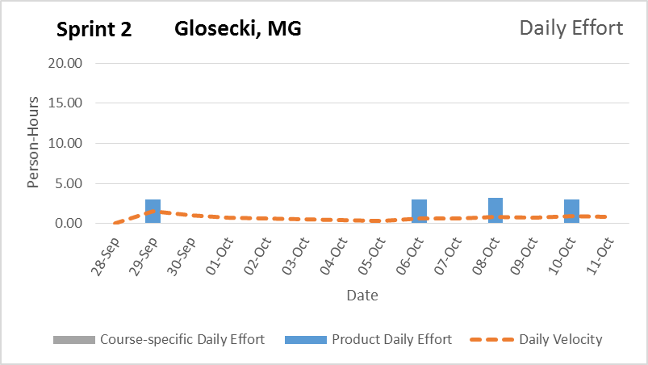

6. The team is confident that the product will be delivered to the client within the time frame with all functionality implemented. Our product Burn down shows that our progress is a bit behind but we feel that this is due to poor estimations of tasks.

Signature Date

__________________________________________ ______________

__________________________________________ ______________

__________________________________________ ______________

__________________________________________ ______________

