Sprint 6 Status Report
For the Girl Scouts of America Badge Tracking
Application

By
Matt Eck
Michael Glosecki
Nathan Martz
Ryan Schroeder

Of
Team Cookie Council

1. The Council estimated 80 hours to complete sprint 6 however the sprint took us 71 hours. After the sprint was completed we had 0 hours left on the story tasks selected.

2. All stories related were pulled for this Sprint. We started out trying Django and we decided very early on that we should switch to PHP and develop with it. We then moved towards fully implementing the Badge overview page to show the client what we have and the general layout of the website.
- Badge overview.php donw by Ryan
- Query.php done by Ryan
- BadgeTracking.html done by Nathan
- UpdateRecords.php done by Mike
- Home page done by Matt
- Login/Account Creation done by Matt

3. Client meeting set up for Feb. 7th at 5:30 on campus. Client liked what we had to show her and was impressed with the layout of the site so far.
4. Lack of Django knowledge was encountered. In response to this we switched back to PHP and developed with that.

Project Burndown chart
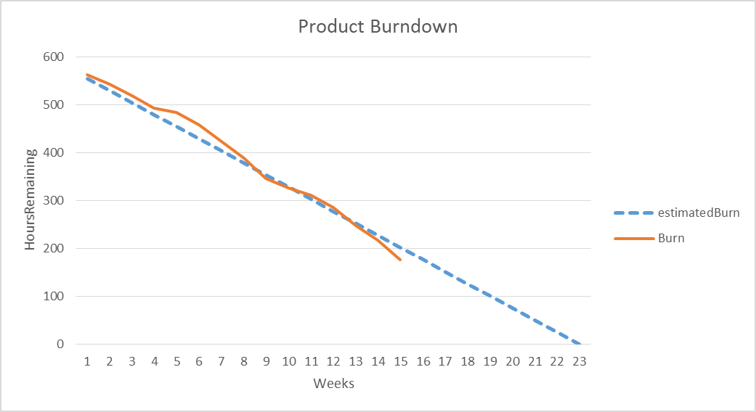

**Estimated total hours re-evaluated.

Sprint Burndown Chart
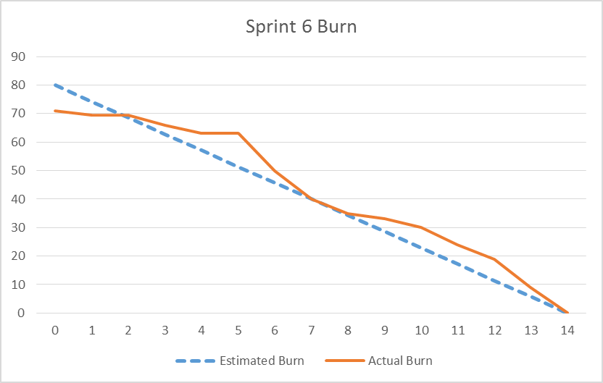

Weekly Development Effort

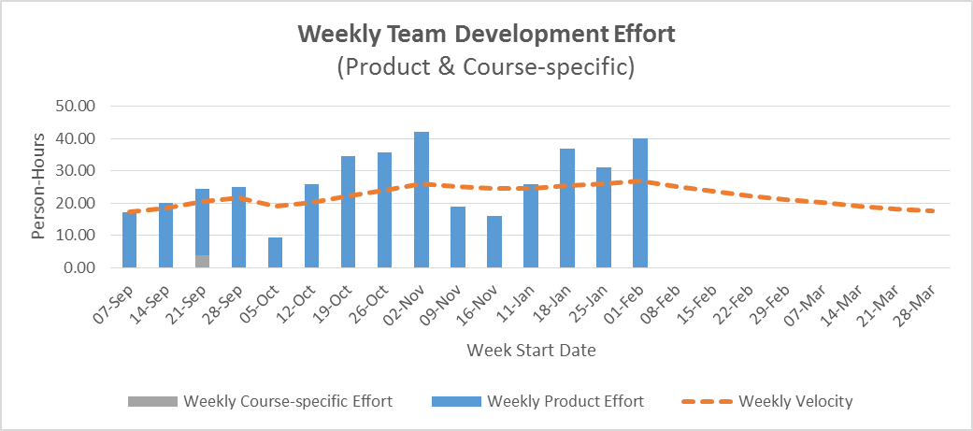

Daily Team Effort
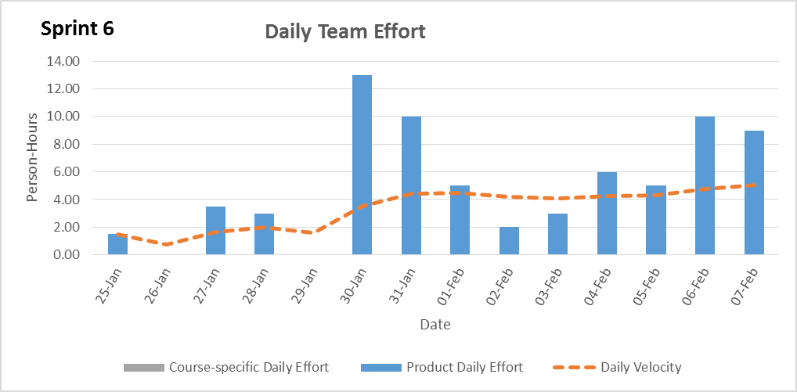

Team Member Effort
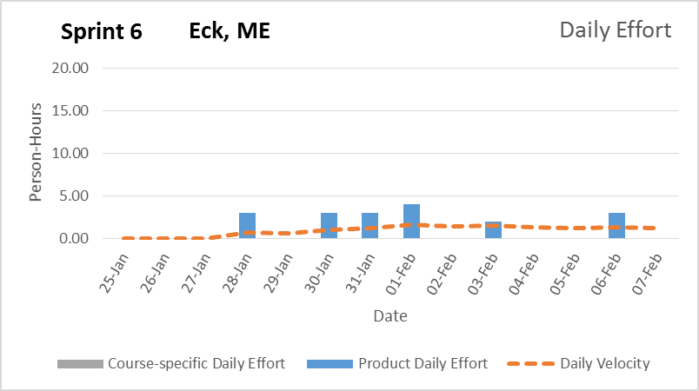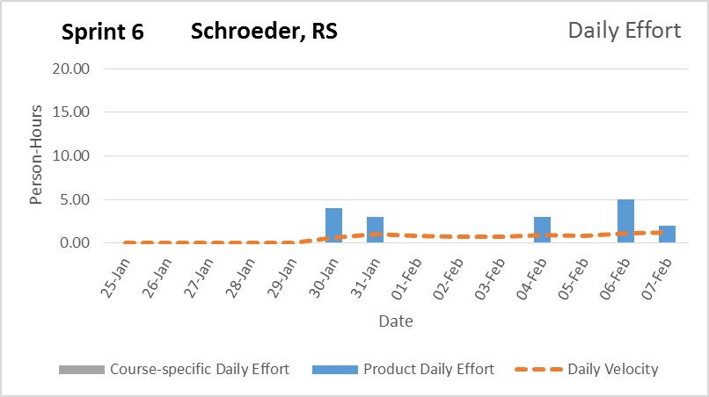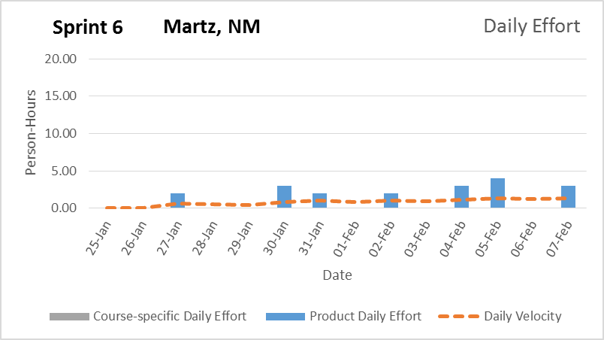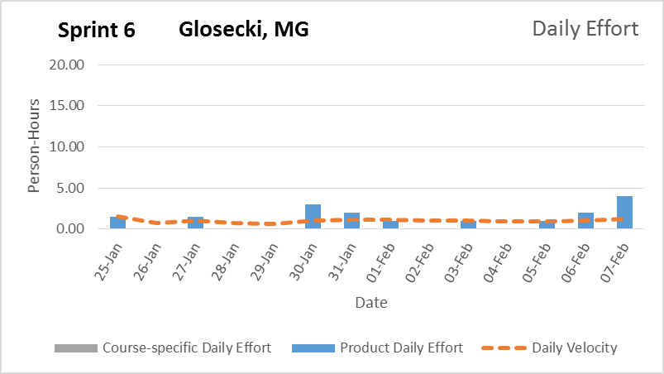

6. Switching to PHP did leave us a sprint behind but we have been completing pages faster as a result. The team feels like the project’s web interface will be complete on schedule but the mobile interface might be lacking come release.

Signature Date

__________________________________________ ______________

__________________________________________ ______________

__________________________________________ ______________

__________________________________________ ______________

