NParks New Hire Introduction — HR User Guide
🌿🌸🦋🌳
National Parks Board · Singapore

New Hire Introduction Portal
HR User Guide — how to invite new hires, review their introductions, and send the welcome email (eDM).
Audience: HR officers / executives who run the welcome-email process. Version: 1.0 · Companion: "Technical & Continuity Guide" (for whoever maintains the app).

Contents
- What this portal does
- Your two links & passwords
- Part A — What to send new hires
- Part A — The new hire's journey
- Part B — Signing in to the HR console
- Part B — Reviewing submissions
- Part B — Adjusting a photo
- Part B — Generating & sending the eDM
- Part B — Archiving & the eDM log
- Part C — Housekeeping (passwords, access)
- Troubleshooting & FAQ

1 · What this portal does
The New Hire Introduction Portal collects a short self-introduction and photo from every new NParks joiner, lets HR review and tidy each one, and then produces a ready-to-send welcome email ("eDM") that introduces the new colleagues to the rest of NParks.
There are two sides to it:
- New hires open a link, verify their email with a one-time code, and submit their introduction + photo.
- HR opens a separate, private console to review each submission (the app runs an AI first-pass check to flag anything sensitive), add the person's job title / division / start date, approve it, and generate the welcome email.
New hire submits→ AI first-pass check→ HR reviews & approves→ HR generates eDM→ HR sends in Outlook→ HR archives
Good to know: The AI check is only a first pass. It helps you spot things like a home address or medical detail that shouldn't go in a mass email — but the final decision is always yours, including checking each photo.

2 · Your two links & passwords
You work with two web addresses. Replace <your-portal-address> below with the actual link from your deployment (the "Rabbit" app URL).
Who | Link | What they need
New hires | https://<your-portal-address>/ | The shared access password + their own email (to receive a one-time code)
HR officers | https://<your-portal-address>/admin keep private | The HR password + a work email that is on the approved HR list
Never put the /admin link on any page a new hire sees. It isn't linked anywhere — HR reaches it by typing the address. Share it only within the HR team.
Who holds the passwords: the shared access password for new hires, the HR password, and the list of approved HR emails are all set by whoever deployed the app (see the Technical & Continuity Guide, "Environment variables"). Keep a secure record of them in your team's password vault.

3 · Part A — What to send new hires
Send each new joiner (or a batch) an email like the one below. Fill in the red bits.
Subject: Introduce yourself to the NParks family 🌿
Dear [name],
A warm welcome to NParks! We'd love to introduce you to your new colleagues through our fortnightly welcome email. Please take 5 minutes to share a short introduction and a photo of yourself.
How to submit:
- Go to https://[your-portal-address] and click "Start my introduction".
- Enter the access password [shared access password] and your email address, then click "Send me a code".
- Check your inbox for a 6-digit one-time code, enter it, and click Verify.
- Fill in your name, upload a clear head-and-shoulders photo, and write a short paragraph about yourself (max 100 words).
- Click "Send my introduction". That's it!
Photo tip: a clear, sharp head-and-shoulders photo (top half only — not a full-body shot), face clearly visible, no sunglasses or headgear, in suitable attire. JPG or PNG, up to 5MB.
Your write-up: one short paragraph (not bullet points). You might mention which industry/sector you came from, your hobbies, and why you joined NParks.
Need to change something after submitting? Return to the same link and choose "Amend my introduction" any time before HR approves it.
Warm regards,
[HR team / name]
Why the one-time code? It confirms the person owns the email address they're submitting under, and keeps the form closed to the public. Each new hire's submission is tied to their verified email — so only they can edit it.

4 · Part A — The new hire's journey (what they'll see)
These are the exact screens a new hire moves through, so you can guide anyone who gets stuck.
- The home page. They click "Start my introduction".
- 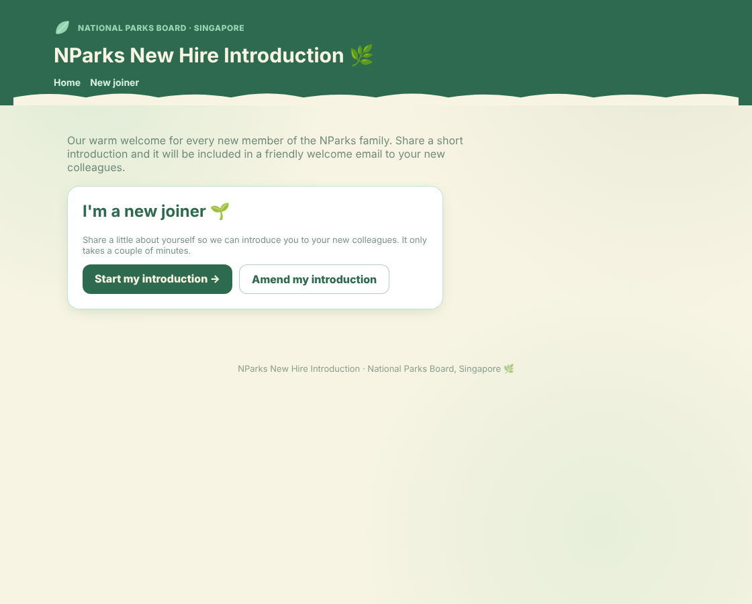
- Figure 1 — Home page. New hires click "Start my introduction"; "Amend my introduction" is for editing a previous submission.
- The access gate. They enter the shared access password and their email, then click "Send me a code".
- 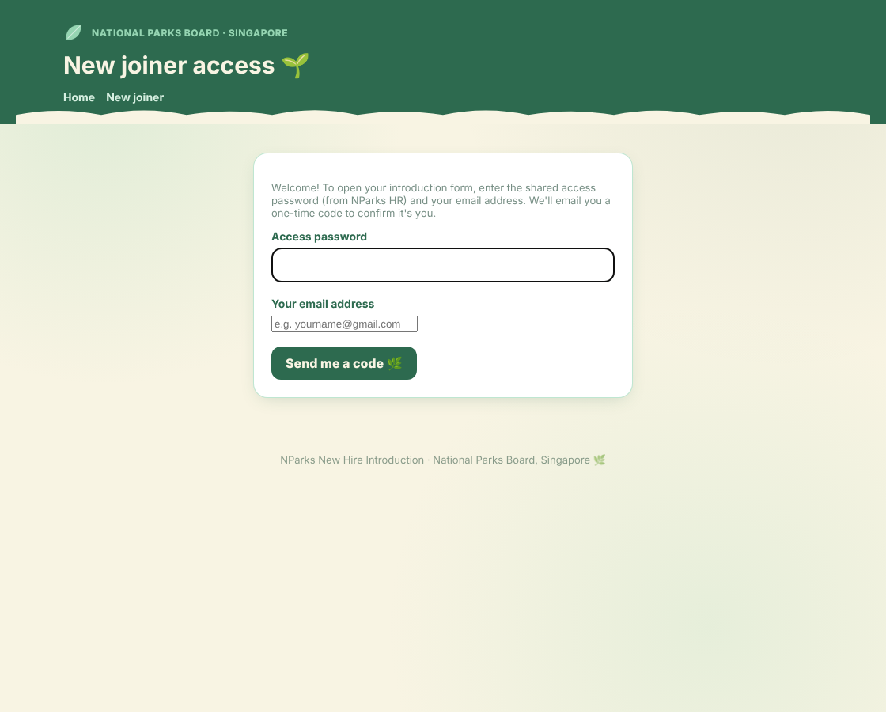
- Figure 2 — Access gate. The shared password comes from HR; the email is where the one-time code is sent.
- The one-time code. They enter the 6-digit code emailed to them. (It expires after about 10 minutes; "Resend code" sends a fresh one.)
- 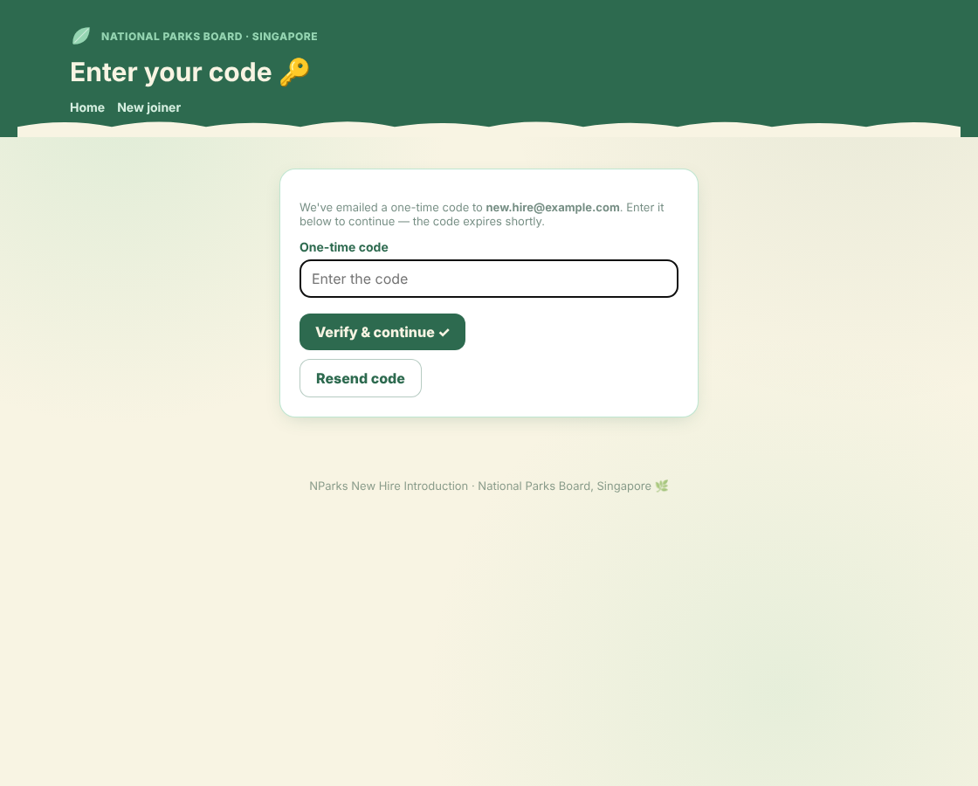
- Figure 3 — One-time code entry. After 5 wrong tries they're asked to start again with a new code.
- The introduction form. Their email is already filled in and locked. They add their name, a photo, and a short paragraph. A live word counter helps them stay under 100 words.
- 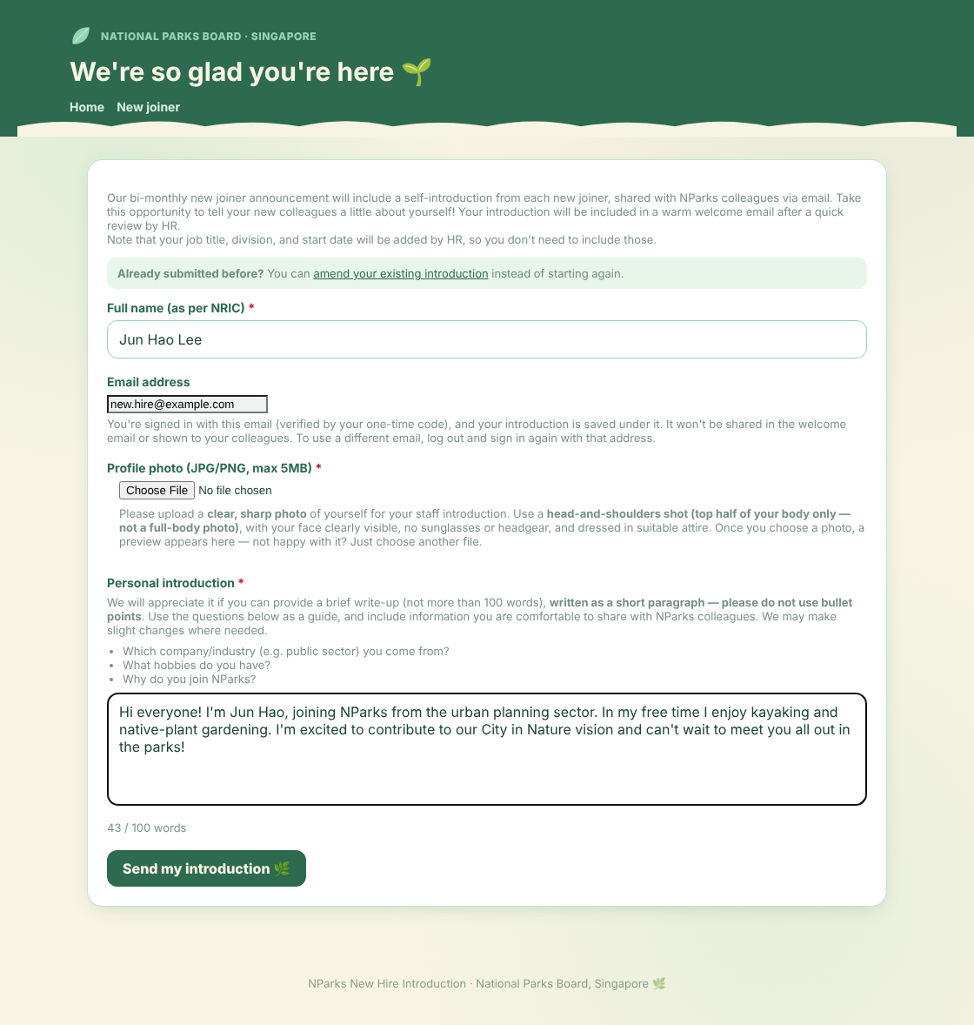
- Figure 4 — The introduction form. Job title, division and start date are deliberately not here — HR adds those later.
- Confirmation. After submitting, they see a thank-you page. Their entry now appears in the HR console as "Awaiting HR Review".
- 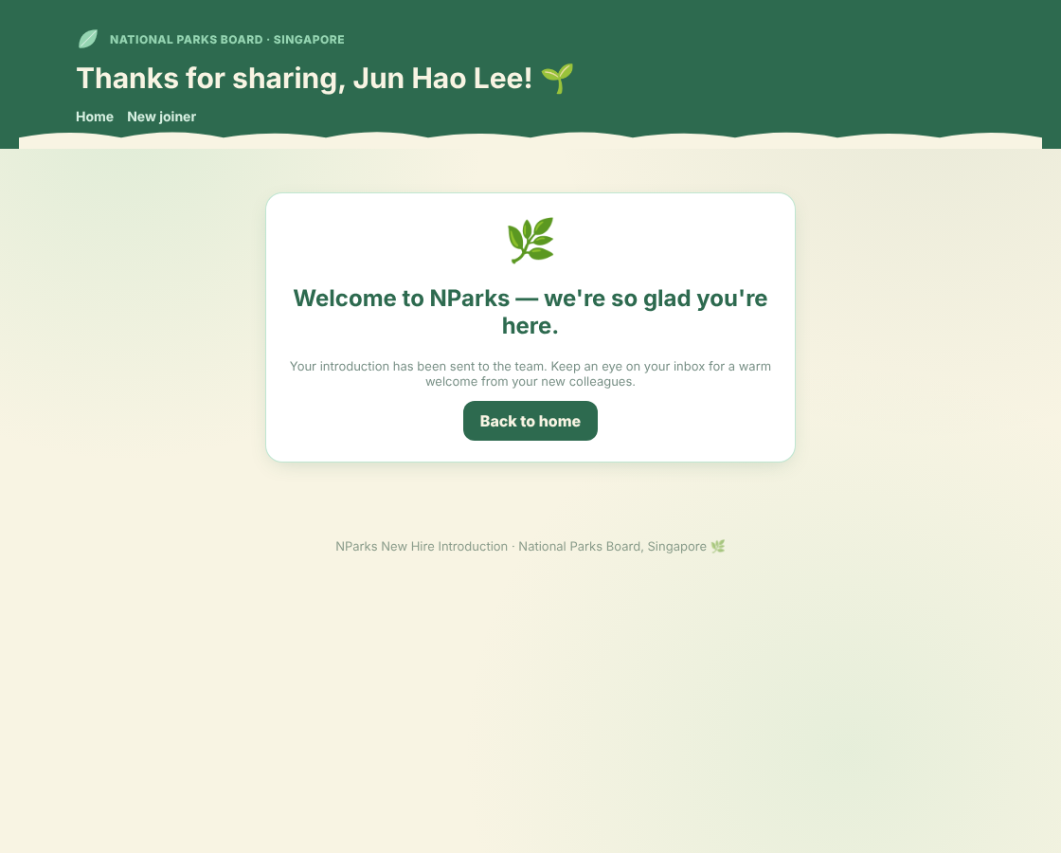
- Figure 5 — Confirmation. The entry is now waiting for HR.

If a new hire needs to change their entry
They return to the home page, click "Amend my introduction", sign in again (password + code), and their existing introduction is brought up for editing — but only the one saved under their email. They can amend any time until HR approves it; after approval, they contact HR.
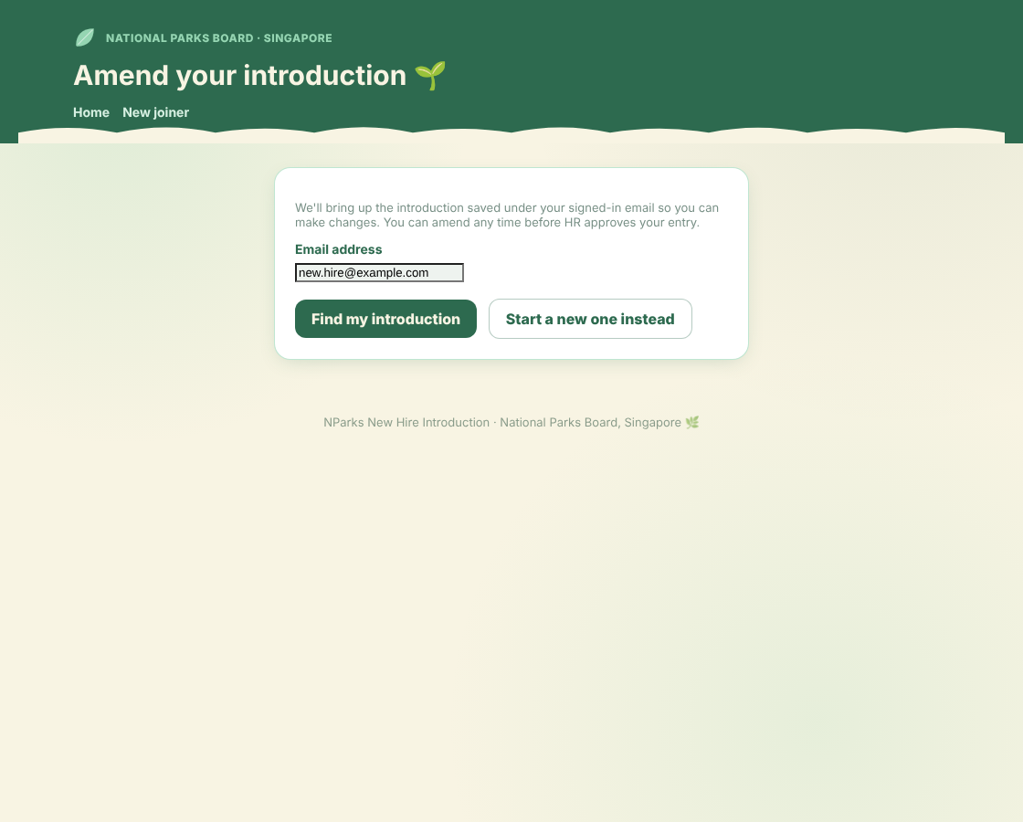
Figure 6 — "Amend my introduction" brings up the entry saved under the signed-in email.

5 · Part B — Signing in to the HR console
- Go to the admin link (https://<your-portal-address>/admin). Enter the HR password and your work email, then click "Send me a code".
- 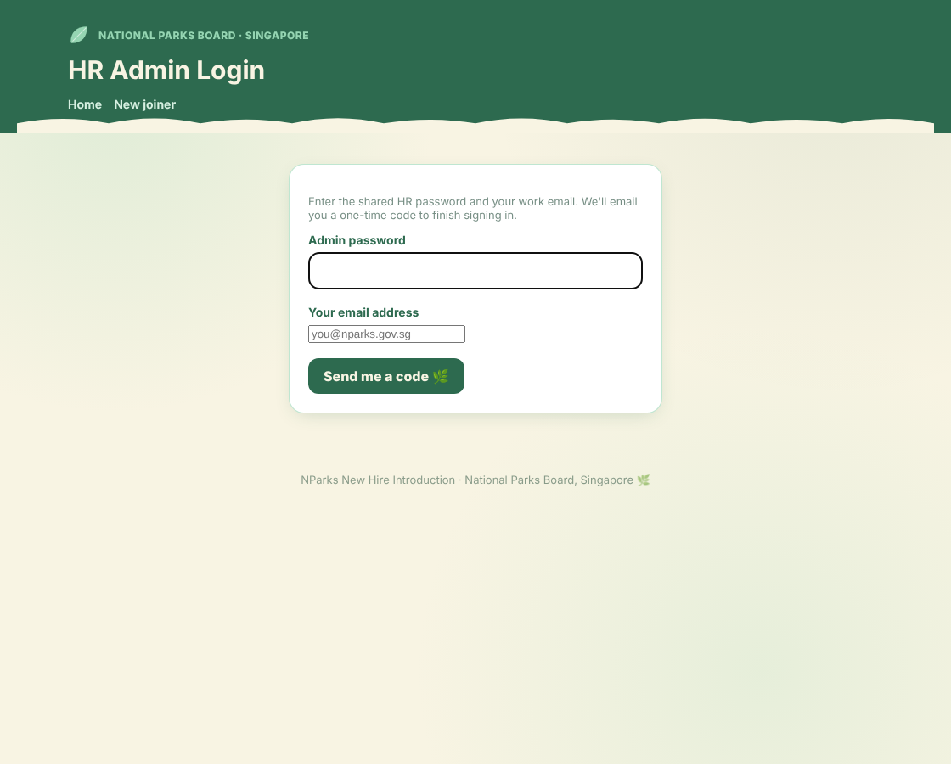
- Figure 7 — HR login. Your email must be on the approved HR list, or you'll be told it isn't authorised.
- Enter the one-time code emailed to you to finish signing in. Your HR session then stays active for about 12 hours.
- 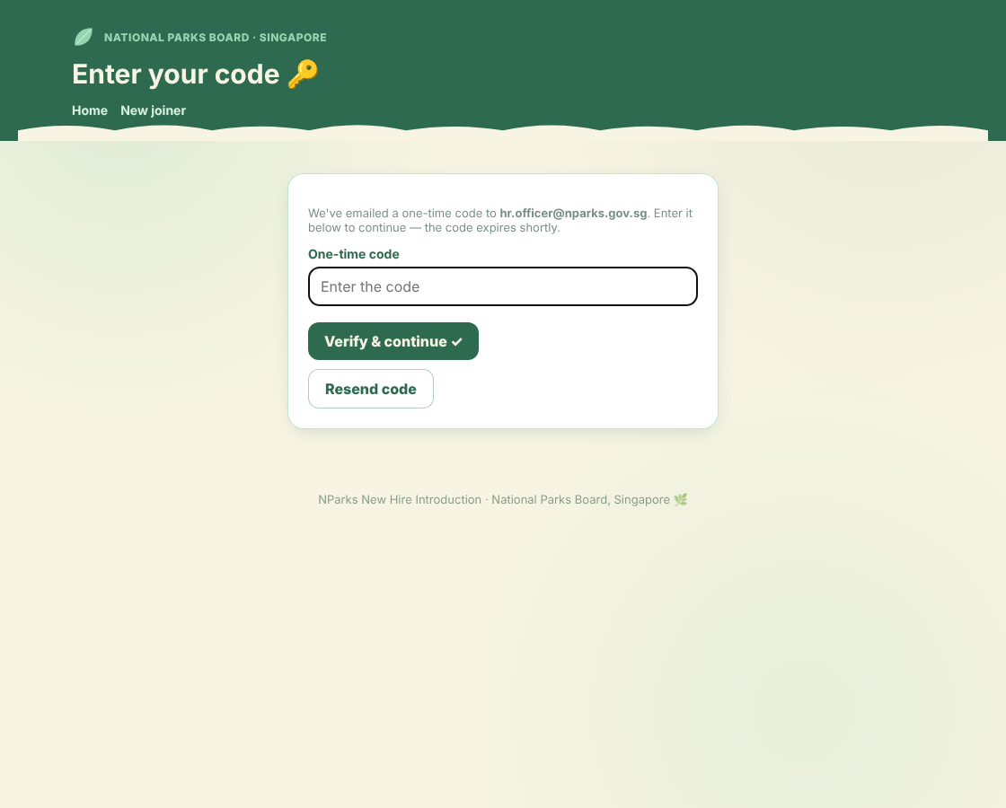
- Figure 8 — HR one-time code. Same two-factor step as the new hires, for the console.
Locked out? If your email isn't on the approved list, ask whoever maintains the app to add it to the ADMIN_EMAILS setting (separate multiple emails with commas). See the Technical & Continuity Guide.

6 · Part B — Reviewing submissions
The console opens on the Review tab. Submissions are grouped into Awaiting HR Review, Approved, Archived and Rejected. The "Jump to" panel on the left lets you skip to any group.
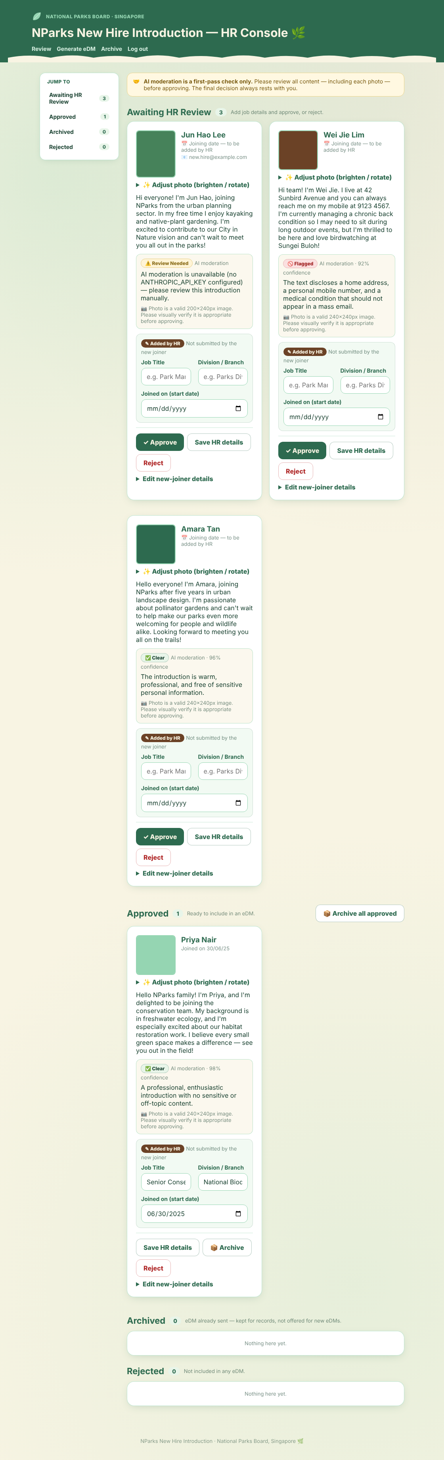
Figure 9 — The Review console. Each card shows the photo, the introduction, the AI first-pass result, and the fields HR fills in.

What each card shows
- Photo & introduction exactly as the new hire submitted them.
- AI moderation — a Clear, Review Needed or Flagged tag with a one-line reason (e.g. it may flag a phone number or medical detail). Treat it as a prompt to look closely, not a verdict.
- Added by HR box — where you type the Job Title, Division / Branch and Joined on (start date). These appear in the welcome email.

The buttons
Button | What it does
✓ Approve | Marks the entry ready for an eDM. You must fill in Job Title, Division and Start Date first.
Save HR details | Saves the job title / division / start date without approving yet.
Reject | Moves the entry to "Rejected" (kept on record, never included in an eDM). You can restore it later.
📦 Archive (on approved cards) | Moves an approved entry to "Archived" — kept for records but no longer offered for new eDMs (use after you've sent their welcome email).
Edit new-joiner details | A collapsible section to correct the name, email, or introduction text on the person's behalf.
Typical flow for one person: read the introduction → glance at the AI note → check the photo → type Job Title + Division + Start Date → click Approve.

7 · Part B — Adjusting a photo
If a photo is a little dark or needs rotating, click "✨ Adjust photo (brighten / rotate)" on the card. You can:
- Brighten, adjust contrast/saturation, or rotate in 90° steps;
- Or load a completely different photo file;
- Click Save adjusted photo to replace the stored image.
The first time you edit a photo, the app keeps a copy of the new hire's original, so you can always click "↩ Revert to joiner's original photo" to undo your changes.

8 · Part B — Generating & sending the welcome email (eDM)
- Open the "Generate eDM" tab. You'll see every approved joiner, grouped by joining fortnight (1st–15th, 16th–end of month). Tick the people to include. Use the quick-select buttons to pick a whole period at once.
- 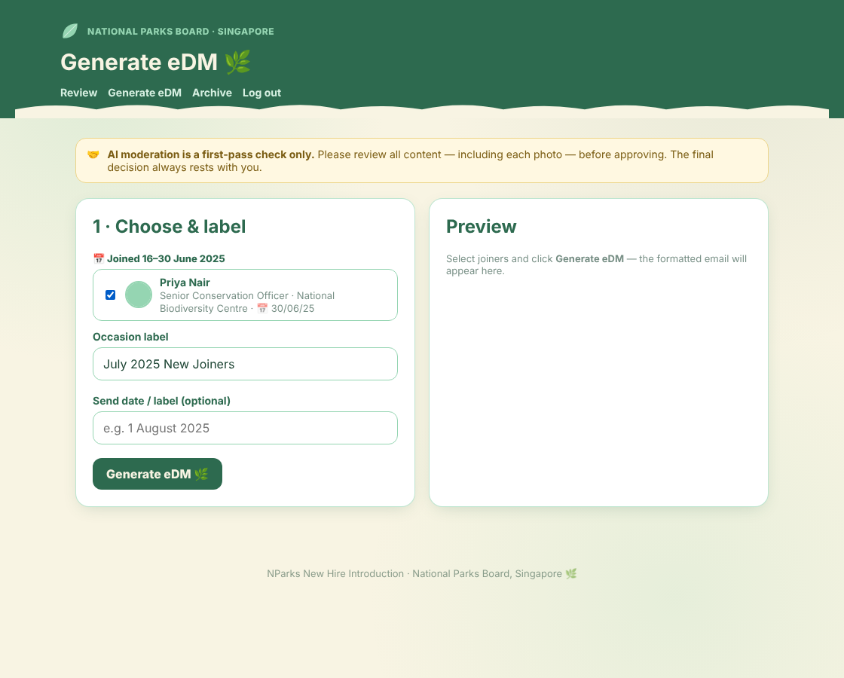
- Figure 10 — Choose who to include and give the email an "Occasion label" (e.g. "July 2025 New Joiners").
- Click "Generate eDM". A formatted preview appears on the right — a warm, NParks-themed welcome card for each person.
- 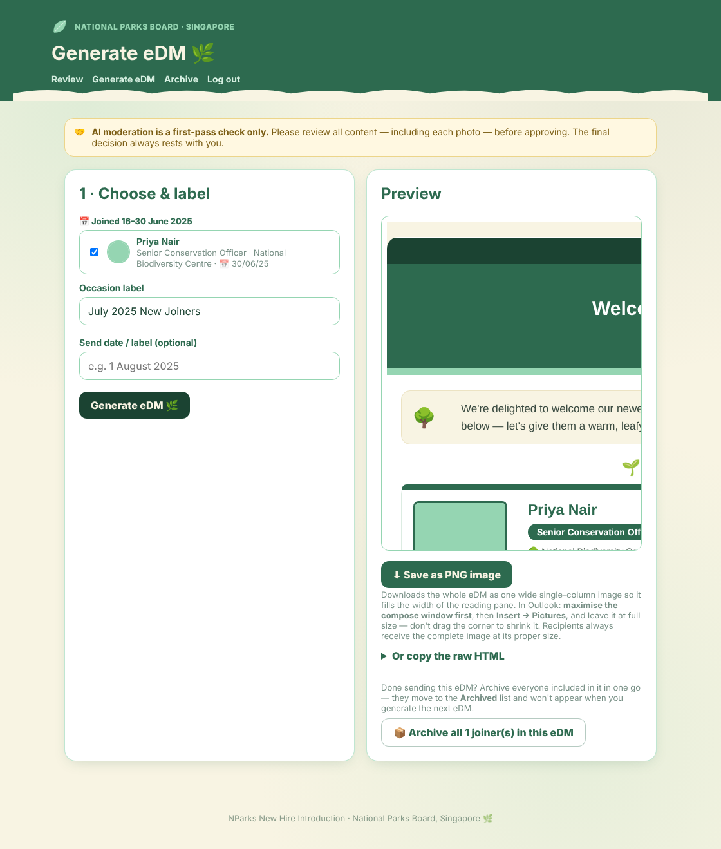
- Figure 11 — The generated eDM preview. Each new hire gets a "spotlight" card with their photo, role and introduction.
- Get it into Outlook. You have two options:
  - Save as PNG image (simplest) — downloads the whole email as one wide image. In Outlook: maximise the compose window first, then Insert → Pictures, and leave it at full size (don't drag the corner to shrink it). Recipients always receive the complete image at its proper size.
  - Copy the raw HTML — click "Or copy the raw HTML", copy it, and paste straight into the Outlook message body. All styling and images are built in.
- Send the email from Outlook to your NParks distribution list as usual.
Every eDM you generate is logged automatically in the "Archive" tab (see below), so you always have a record of what was sent and to whom.

9 · Part B — Archiving & the eDM log
After you've sent a welcome email, archive the people included in it so they don't reappear next time. On the Generate eDM screen, after generating, use "📦 Archive all N joiner(s) in this eDM" — or archive people individually from the Review tab.
The Archive tab is a read-only history of every eDM you've generated — the occasion, the date, the people included, and a preview of the email.
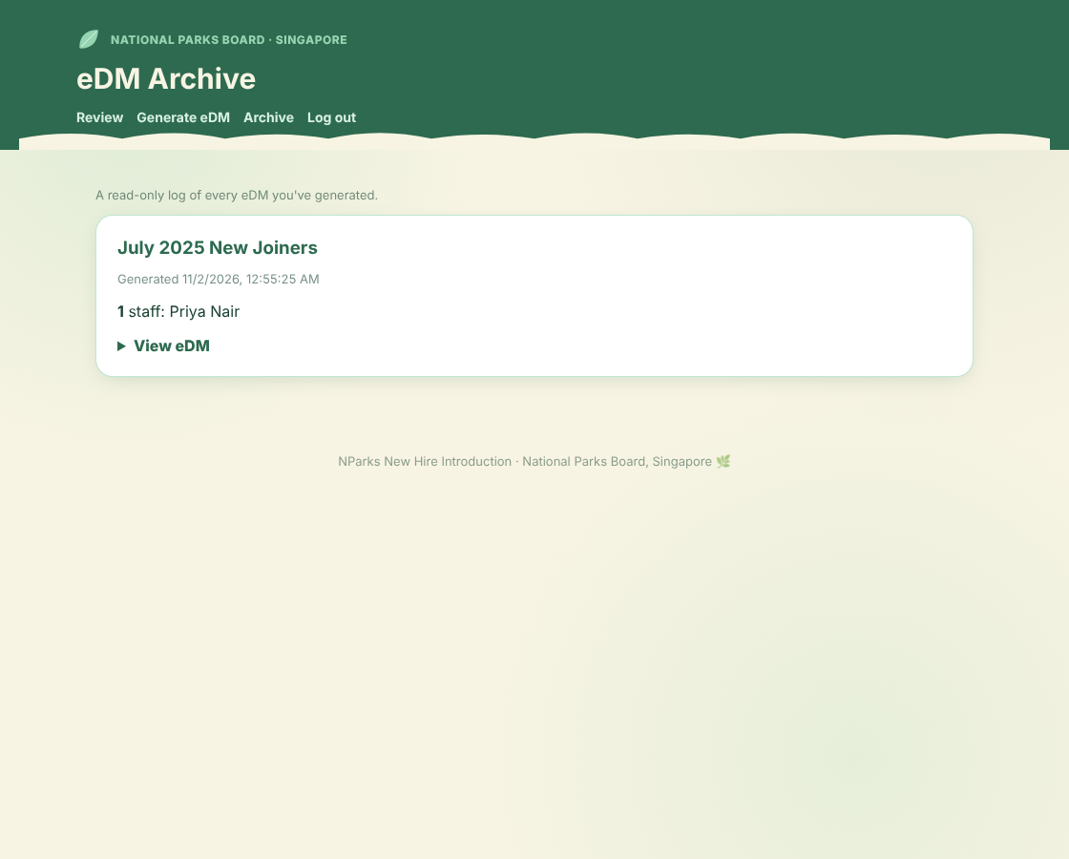
Figure 12 — The eDM archive: a permanent log of every welcome email generated.
When you're done, use "Log out" in the top navigation to end your HR session.

10 · Part C — Housekeeping (passwords & access)
These are set once, usually by whoever deployed the app. You don't change them day-to-day, but it helps to know what they are:
Setting | What it controls
Shared access password | What new hires type to open the form (JOINER_PASSWORD).
HR password | What HR types to open the console (ADMIN_PASSWORD).
Approved HR emails | The list of work emails allowed into the console (ADMIN_EMAILS, separated by commas).
Code-sending service | The email service that delivers the one-time codes (Postman.gov.sg). If this is ever switched off, logins fall back to password-only so no one is locked out.
To change any of these, see the Technical & Continuity Guide → "Environment variables" and hand it to whoever maintains the deployment.

11 · Troubleshooting & FAQ
Situation | What to do
A new hire didn't get the one-time code | Ask them to check spam, then click "Resend code". Codes expire after ~10 minutes.
"That code was not correct" | Re-enter carefully. After 5 wrong tries they must start again to get a fresh code.
A new hire wants to change an approved entry | They can't self-edit after approval. In the Review tab, use "Edit new-joiner details", or move it back with Restore to review.
HR email "not authorised" | The email isn't on the approved list — have it added to ADMIN_EMAILS (commas between emails).
The photo looks too dark / sideways | Use "✨ Adjust photo" on the card to brighten or rotate, then Save.
Someone appears twice in Generate eDM | They likely submitted twice; reject or archive the duplicate in the Review tab.
The eDM image looks small in Outlook | Maximise the compose window before Insert → Pictures, and don't drag to resize. The recipient still gets the full-size image regardless.
NParks New Hire Introduction · National Parks Board, Singapore 🌿 · Internal document — handle in line with NParks information-management policy.

