|  |  |
| --- | --- |
| Nonterminal | 1st |
| S | {a} |
| A | {a} |
| B | {b,c} |
| C | {b,c} |

**PART 2: #1**

|  |  |  |  |
| --- | --- | --- | --- |
| Pointer/goTo | Kernel | State | 1st close |
|  | [S 🡪 .aC,$] | 0 | [S 🡪.aC, $] |
| 0,a | [S 🡪 a.C, $] | 1 | {[S 🡪 a.C, $]  [C 🡪 .cC, $]  [C 🡪 .d, $]} |
| 1,C | [S 🡪 aC., $] | 2 | [S 🡪 aC., $] |
| 1,c | [C 🡪 c.C, $] | 3 | {[C 🡪 c.C, $]  [C 🡪 .cC, $]  [C 🡪 .d, $]} |
| 1,d | [C 🡪 d., $] | 4 | [C 🡪 d., $] |
| 3,C | [C 🡪 cC., $] | 5 | [C 🡪 cC., $] |
| 3,c | [C 🡪 c.C, $] | 3 |
| 3,d | [C 🡪 d., $] | 4 |

1. abbbccd

|  |  |  |
| --- | --- | --- |
|  | Action | goTo |
| a | b | c | d | $ | S | A | B | C |
| 0 | S1 |  |  |  |  |  |  |  |  |
| 1 |  |  | S3 | S4 |  |  |  |  | 2 |
| 2 |  |  |  |  | acc |  |  |  |  |
| 3 |  |  | S3 | S4 |  |  |  |  | 5 |
| 4 |  |  |  |  | R7 |  |  |  |  |
| 5 |  |  |  |  | R6 |  |  |  |  |

|  |  |  |  |
| --- | --- | --- | --- |
| Step | Stack | Input | Action |
| 1 | 0 | abbbccd$ | S1 |

1. accd

|  |  |  |  |
| --- | --- | --- | --- |
| Step | Stack | Input | Action |
| 1 | 0 | accd$ | S1 (a) |
| 2 | 0a1 | ccd$ | S3 |
| 3 | 0a1c3 | cd$ | S3 |
| 4 | 0a1c3c3 | d$ | S4 |
| 5 | 0a1c3c3d4 | $ | R7 |
| 6 | 0a1c3c3C | $ | 5 |
| 7 | 0a1c3c3C5 | $ | R6 |
| 8 | 0a1c3C | $ | 5 |
| 9 | 0a1c3C5 | $ | R6 |
| 10 | 0a1C | $ | 2 |
| 11 | 0a1C2 | $ | acc |

1. acdbaacd

|  |  |  |  |
| --- | --- | --- | --- |
| Step | Stack | Input | Action |
| 1 | 0 | acdbaacd$ | S1 |
| 2 | 0a1 | cdbaacd$ | S3 |
| 3 | 0a1c3 | dbaacd$ | S4 |
| 4 | 0a1c3d4 | baacd$ |

1. acdbd

|  |  |  |  |
| --- | --- | --- | --- |
| Step | Stack | Input | action |
| 1 | 0 | acdbd$ | S1 |
| 2 | 0a1 | cdbd$ | S3 |
| 3 | 0a1c3 | dbd$ | S4 |
| 4 | 0a1c3d4 | bd$ |

1. abcdbad

|  |  |  |  |
| --- | --- | --- | --- |
| Step | Stack | Input | Action |
| 1 | 0 | abcdbad$ | S1 |
| 2 | 0a1 | bcdbad$ |

**PART 2: #3**

1. abBbcC

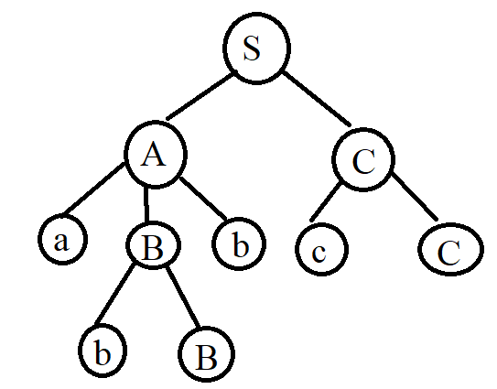

Handle: bB

Simple phrase: bB, cC

Phrase: abBb, cC, bB, abBbcC

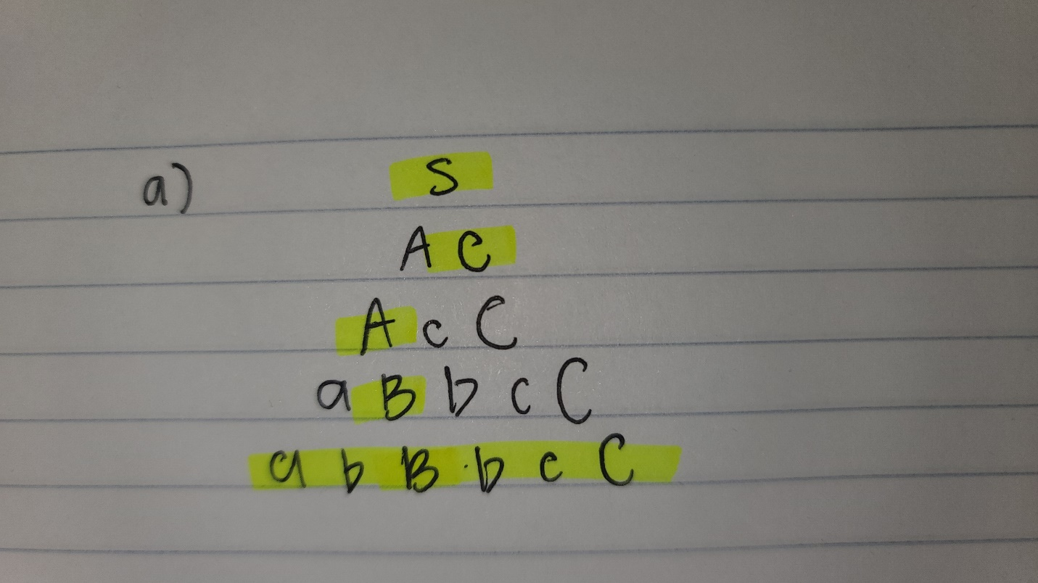

Right most derivation

1. accCd

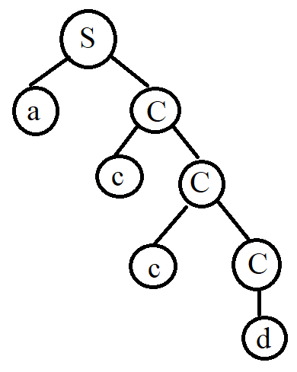

Handle: cC

Simple phrase: cC, d

Phrase: accCd, cC, ccc, accc, d

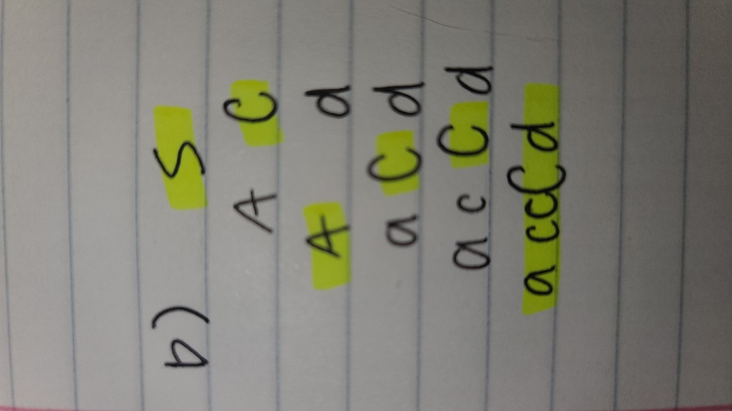 Right most derivation

1. aCbaacd

Not part of language

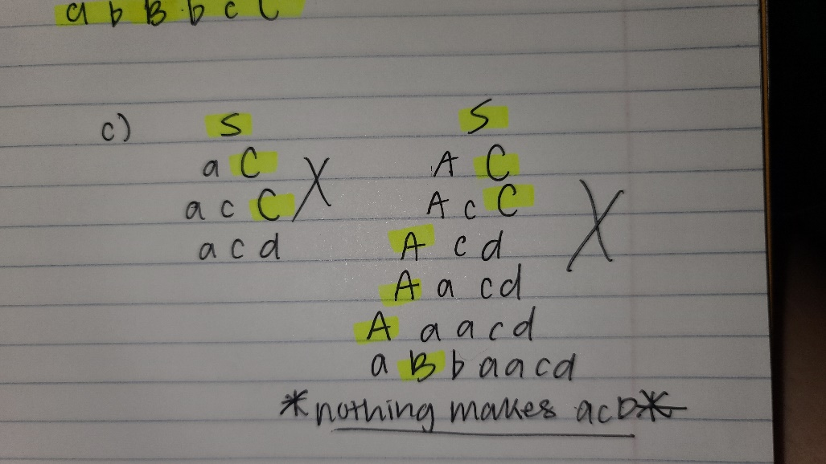

1. acdabd

Not part of language

1. abCbad

Not part of language

