# Problem 1: Infinite Triangle 8 points

**Description**

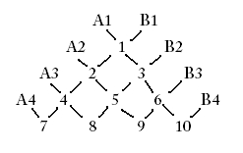Natural number are displayed in a triangle as shown in image. Each number is placed atop a rhomb and is uniquely determined by the two diagonals A and B, numbered from A1 and B1 respectively.

Given a number n natural than 9 digits (n ≤ 999999999), calculate and display the coordinates of diagonals that is it.

**INPUT**

Example1: 5

Example2: 11

**OUTPut**

Example1:

Position: A2 B2

Example2:

Position: A5 B1