# Problem 3: Find HIdden keywords 20+4 points

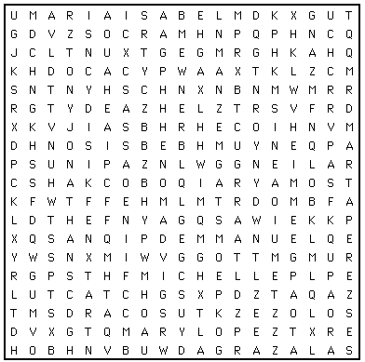

**Description**

In the end of each English lesson students usually have to remember new studied words exercising. One of the most popular exercises is finding keywords in the puzzle. Keywords may appear horizontal, vertical or diagonal, forward or backward.

Your goal is to help millions of students to do it faster. Write a program that finds the keywords in the puzzle and saves a lot of time for many lazy people.

The first line of the input should indicate the number of new keywords, then the number of rows and numbers of columns in the puzzle. All values range from 3 to 10. Each keyword appears on a separate line, followed by the puzzle itself.

The output should enumerate only the keywords that were found in the puzzle (not all of them are there). To get additional **4 points** print the puzzle using only the letters that form the words. Print periods in all other locations to maintain proper spacing.

|  |  |
| --- | --- |
| **INPUT**  7 5 8  FOR  FLOAT  FUNCTION  ERROR  VOID  DEFAULT  ABSTRACT  F O U A T U A E  L I R S I M R D  O L S Z P R O N  A E P V O I D C  T C A R T S B A | **OUTPut**  Keywords found:  FLOAT  ERROR  VOID  ABSTRACT  F . . . . . . E  L . . . . . R .  O . . . . R . .  A . . V O I D .  T C A R T S B A |