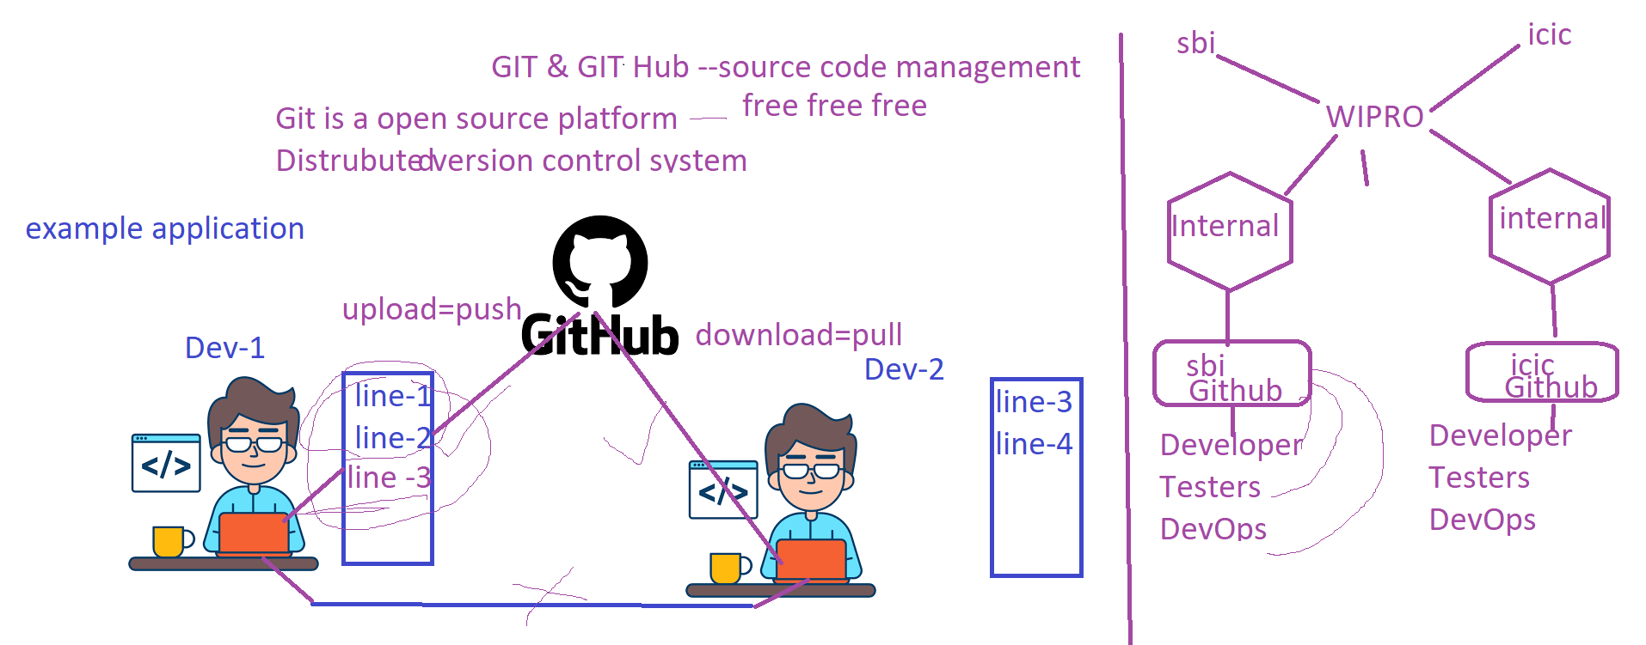**Git Class -1**

--------------------git--------------------------------

Git is a free and open source distributed version control system designed to handle everything from small to very large projects with speed and efficiency.

*****Installation for Git in your local laptop :

URL- https://git-scm.com/downloads #it support os like Windows,Linux,Mac.

yum install git -y # for linux

After completed of installation go to cmd/terminal promt check : git --version

Creat sample folder and open gitbash in same path

( Create a folder give name ‘git’

In terminal go to git directory )

git init -----to intilaise git process

-----introduce yourself to Git--------------

------all commands start with git only-----------------

---------------------Git commands---------------------

----------------### Tell Git who you are----------------------------

git config --global user.name --- to check configured name

git config --global user.email --- to check configured email

git config --global user.name "veer"

git config --global user.email "cloud87777@gmail.com"

--------------------day-1------------------------------------------------

Touch app.py---- to create sample file

git add -----to add file into staging area from local working directory

git status ----to see the status of the file where it is

git commit -m "comment"

git log -- to check commit history

**-------------------------GITHUB DAY - 2------------------------------**

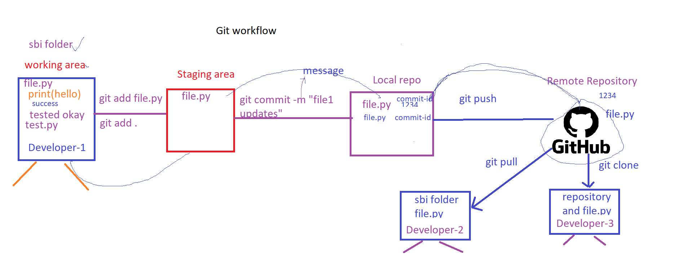

GitHub is one of the most popular resources for developers to share code and work on projects together. It’s free, easy to use, and has become central in the movement toward open-source software.

git clone ---- to clone entire repository in first time

git pull ------to pull the updates and chnages from repository

git push ------to push the local updates into remote repo

-----git push-----

# push the changes by using SSH #

### To generate SSH Key

ssh-keygen (give this command into your terminal)

copy the publickey id_rsa.pub

paste into github ssh keys

path : settings-->ssh and GPG keys--> Add new ssh key and give any name and paste it your publickey over there

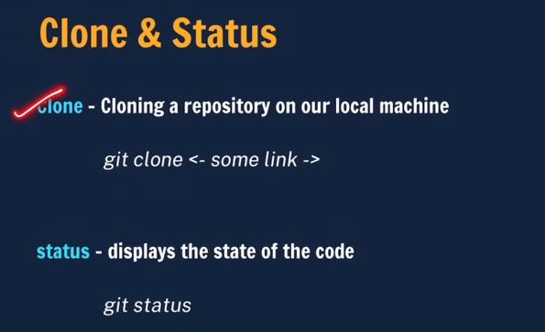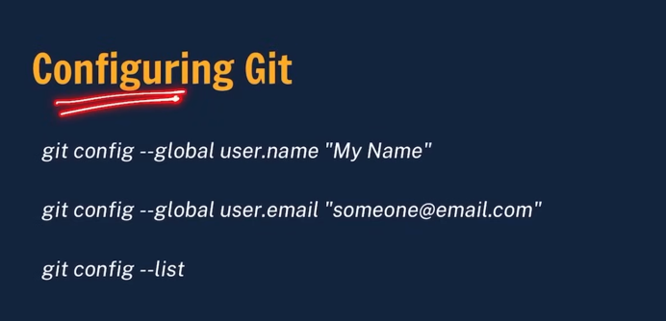

<https://www.youtube.com/watch?v=Ez8F0nW6S-w&t=3355s>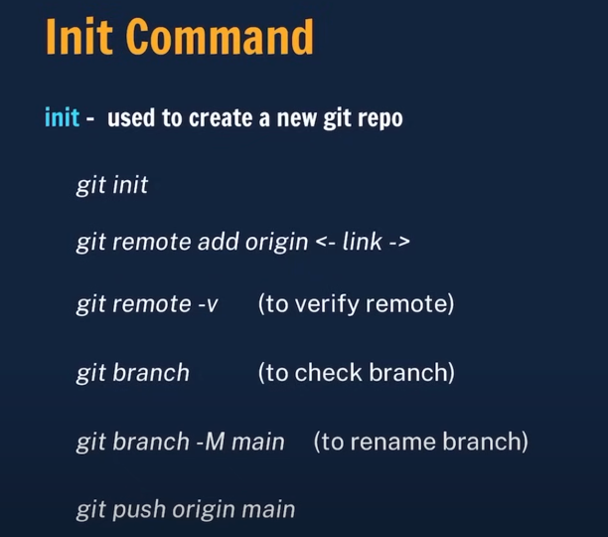 (Apna college – Git and Girhub in 1 Hour)

