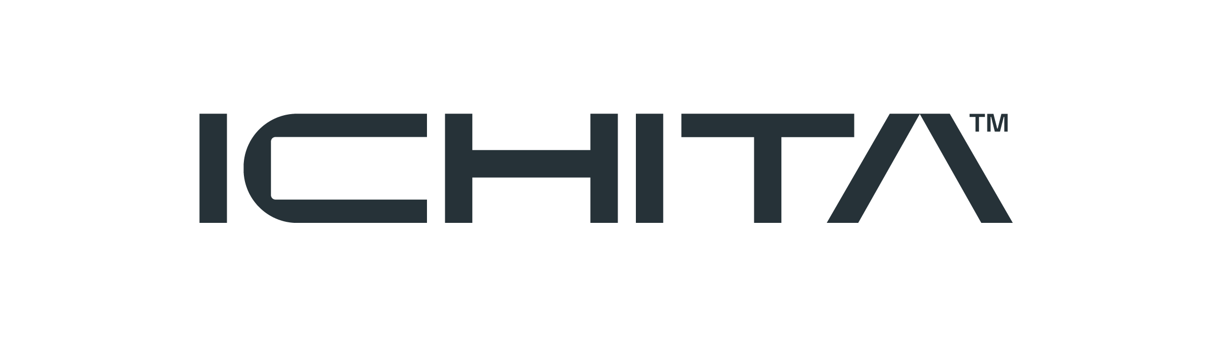

Company Profile

Liquid Separation and Biorefinery Process Technologies

About Us
ICHITA Co., Ltd. was established in 2002 as an Engineering, Procurement, and Construction (EPC) company specializing in liquid separation and biorefinery process technologies for sugar refineries. Over two decades of continuous innovation, ICHITA has grown into a trusted provider of advanced liquid separation and biorefinery process solutions across the food, beverage, and bioindustry sectors.
As the demands of the sugar refinery industry became increasingly sophisticated — with clients seeking greater product diversification — ICHITA was called upon to deliver total turnkey package solutions that ensure final product quality from end to end.
ICHITA is an affiliate company with SRYA (Sriarayathep), which distributes advanced industrial technologies including ion exchange resin, membranes, and adsorbent solutions across Thailand, focusing on liquid separation, biorefinery processes, and environmental sustainability.
Today, ICHITA serves as a partner to manufacturers in sugar, sweetener, beverage, and food ingredient industries, delivering advanced liquid separation and biorefinery process technologies that drive efficiency, quality, and sustainability.

Our History
Year | Milestone
2002 | Founded as an EPC company for liquid separation and sugar refinery biorefinery process consultation
2000s | Expanded into total turnkey solutions for sugar refinery product diversification
2010s | Invested in R&D team and pilot-scale units for advanced separation processes
Present | Full-service provider with proprietary technologies and OEM capabilities

Core Services

Engineering, Procurement & Construction (EPC)
ICHITA provides end-to-end EPC services for liquid separation systems and biorefinery process lines. From initial consultation and design through procurement and commissioning, we deliver complete solutions tailored to each client's requirements.
[Image: ICHITA water treatment system]

OEM Process Solutions
Our OEM services cover a comprehensive range of process solutions:
- Sugar Decolorization — advanced separation for crystal-clear refined sugar
- Glucose and Fructose Deashing & Decolorization — precision purification for sweetener production
- Fruit Juice Clarification — membrane-based clarification for beverage manufacturers
- Wastewater Recycling — UF, NF, and RO technologies for sustainable water reuse

Separation Technologies
We utilize industry-leading separation technologies including:
- Ion exchange resin systems
- Membrane microfiltration and ultrafiltration
- Nanofiltration and reverse osmosis (RO)
- Adsorbent media including activated carbon and Ecosorb technology
- Chromatography SMB (Simulated Moving Bed) modules

Ion Exchange Services
For customers who purchase resin from ICHITA, we provide professional ion exchange removal and replacement services. Our trained staff manage every transaction with meticulous care to prevent contamination. In ultrapure water systems, our service is guaranteed for zero contamination.

Proprietary Technologies
ICHITA has invested significantly in research and development, establishing dedicated R&D teams and pilot-scale units for various separation processes. This investment has resulted in a portfolio of proprietary technologies:
- Sweetener from Pineapple Peel System — innovative extraction of value from agricultural waste
- Liquid Sugar System — high-purity liquid sugar production with floc prevention
- Brine Recovery System — efficient recovery and recycling of brine solutions
- Chromatography System — precision separation for high-value compounds
- Gas-Liquid Separator System — advanced degasification technology
- Demineralization Modules — removal of mineral content for ultra-pure applications
- Degasifier Modules — dissolved gas removal systems
[Image: Membrane separation technology]

Innovation Highlights

Membrane Technology for Sugar Derivatives
ICHITA has developed a revolutionary approach to purify sugar derivatives — including Isomalto-oligosaccharides (IMO) and Resistant Maltodextrin — using advanced membrane technology. By selecting membranes with precisely calibrated pore sizes, glucose passes through while retaining IMO and resistant maltodextrin content, achieving product purity exceeding 95%.

Key Advantages
Advantage | Description
Organic Certification | Without ion-exchange resin, products qualify for organic certification at premium pricing
Zero Solid Waste | Membrane technology eliminates cake and floc waste from traditional processes
Compact Footprint | Membrane systems complete primary decolorization independently, ideal for space-constrained facilities
Simple Operation | Fully automatic systems designed for ease of use without requiring specialized operators
Floc Prevention | Effective elimination of floc-forming particles that typical filters cannot remove

Industries Served
- Sugar Refining — decolorization, purification, and product diversification
- Food Ingredients — sweetener production, functional ingredient separation
- Beverage Manufacturing — juice clarification, liquid sugar supply, quality assurance
- Water Treatment — industrial water purification, wastewater recycling, ultrapure water systems
[Image: ICHITA industrial process solutions]

Why ICHITA
- 20+ Years of Experience — established track record since 2002
- Proprietary Technology — in-house developed solutions for unique challenges
- Total Turnkey Solutions — from consultation and design through commissioning and after-sales service
- R&D Driven — continuous investment in pilot-scale testing and new process development
- Zero Contamination Guarantee — highest standards in service delivery for critical applications
- Compact & Efficient — solutions designed for real-world factory constraints

Company Information
Company Name | ICHITA Co., Ltd.
Founded | 2002
Industry | Liquid Separation & Biorefinery Process Technologies
Specialty | Separation Technologies for Food, Beverage & Bioindustry
Employees | 20 - 49
Headquarters | 399/75 Phongpetnivet, Prachacheun Rd., Jatujak, Chatuchak, Bangkok 10900, Thailand
Phone | +66 2 585 1344
Website | www.ichita.co.th
Affiliate | SRYA (Sriarayathep)

Contact Us
For inquiries about our products and services, or to discuss your specific process requirements, please reach out to our team.
ICHITA Co., Ltd.
399/75 Phongpetnivet, Prachacheun Rd.
Jatujak, Chatuchak
Bangkok 10900, Thailand
Tel: +66 2 585 1344
Web: www.ichita.co.th

ICHITA — Separation Technologies

