Intechopen.com

**Molecular Informatics of Trypanothione Reductase of *Leishmania major* reveals novel chromen-2-one analogues as Potential Leishmanicides**

Samuel K. Kwofie1,2,*, Gabriel B. Kwarko2, Emmanuel Broni1,3, Michael B. Adinortey4, Michael D. Wilson3,5

1. Department of Biomedical Engineering, School of Engineering Sciences, College of Basic and Applied Sciences, University of Ghana, LG77, Legon, Accra, Ghana.
2. West African Centre for Cell Biology of Infectious Pathogens, Department of Biochemistry, Cell and Molecular Biology, College of Basic and Applied Sciences, University of Ghana, LG 54, Legon, Accra, Ghana.
3. Department of Parasitology, Noguchi Memorial Institute for Medical Research, University of Ghana, LG 581, Legon, Accra, Ghana
4. Department of Biochemistry, School of Biological Science, University of Cape Coast, Cape Coast, Ghana
5. Department of Medicine, Loyola University Medical Center, Maywood, IL 60153, USA.

*Corresponding Author:

Samuel K. Kwofie

Email: skkwofie@ug.edu.gh

**Table S1**. Predicted amino acid residues

|  |
| --- |
| Leu10, Gly11, Gly13, Ser14, Gly15, Gly16, Val34, Asp35, Val36, Phe44, Ala46, Ala47, Gly50, Thr51, Cys52, Val55, Gly56, Cys57, Lys60, Lys61, Gly125, Phe126, Gly127, Ala128, Arg138, Ser140, Glu141, Pro143, Ala159, Thr160, Gly161, Ser162, Trp163, Pro164, Thr165, Thr177, Ser178, Asn179, Phe182, Tyr198, Ile199, Glu202, Phe203, Met282, Leu283, Ala284, Ile285, Gly286, Arg287,Arg290, Thr293, Leu294, Gln295, Ile325, Gly326, Asp327, Val332, Met333, Leu334, Thr335, Pro336, Val337, Ala338, Ile339, Asn340, Arg355,Thr357, Asp358, His359, Thr360, Lys361,Val362, Ala363, Cys364, Ala365, Phe367, Pro435, Glu436, Ile438, Gln439, Gly442, Ile443, Lys446 |

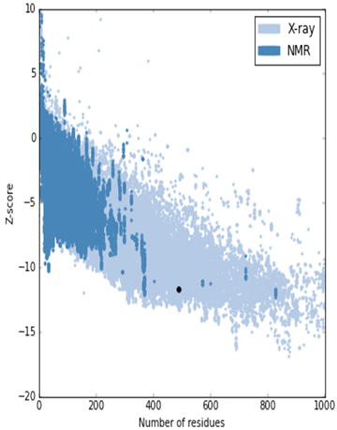

**(A)**

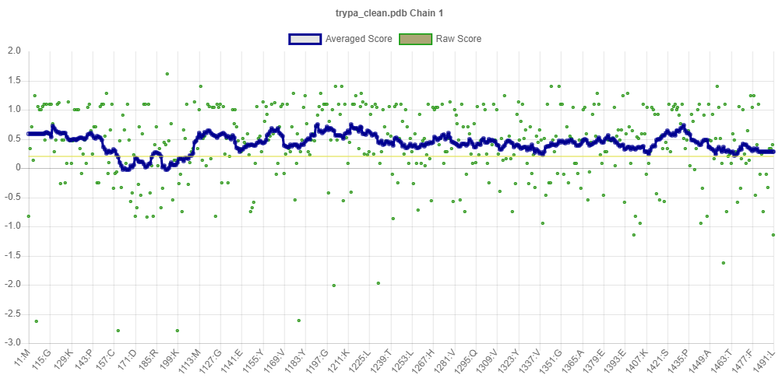

**(B)**

**Figure S1**: (A)The Z-score of the modelled *Lm*TR (represented in dot) estimated to be -11.68 which is within the range of experimentally determined proteins by X ray method. (B). Verify3D plot of the modelled protein structure, LmTR. This shows 91.65% of its amino acid residues with an average 3D-1D score greater than or equal to 0.2, which is a positive inference to the expected 80% of amino acids with 3D-1D score above or equal to 0.2.

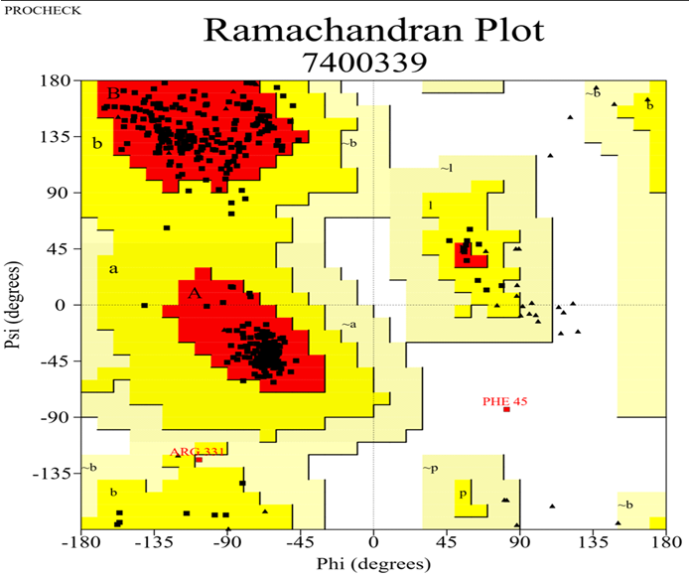

**Figure S2**: Ramachandran plot of the modelled *Lm*TR protein structure. The percentage of residues in the most favored region (red) was 93.6% which is favorable for the protein’s stereochemistry. The percentage of residues in the allowed region (yellow) was 6%. 0nly 0.2% of protein residues (Phe45) showed probable stereochemical hindrance or collision.

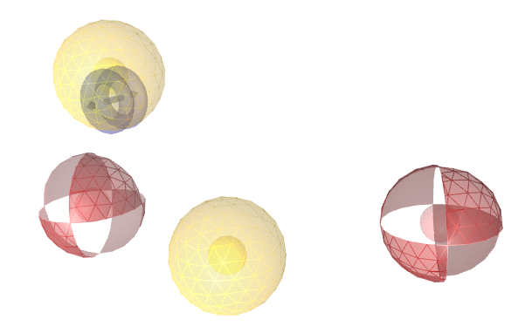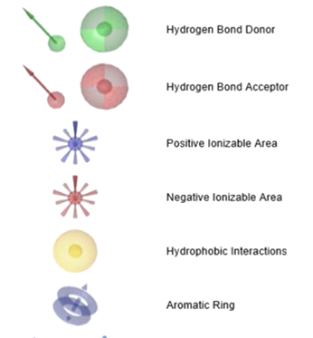

**Figure S3:** A 3D geometry of the generated pharmacophore. The nitrogen on the bicyclic ring of CNQB with the oxygen from the nitro group on its purine ring derivative contributed a hydrogen bond acceptor HBA (red sphere). The oxygen from the nitrogen dioxide group on the conjugated benzene in addition to the nitrogen on the five-member ring of PNTPC also contributed to HBA. Both had an aromatic ring (blue ring) as a common feature (blue ring in yellow 3D sphere) which contributed to hydrophobic interactions and the alkene feature shared amongst them generated the same hydrophobicity.

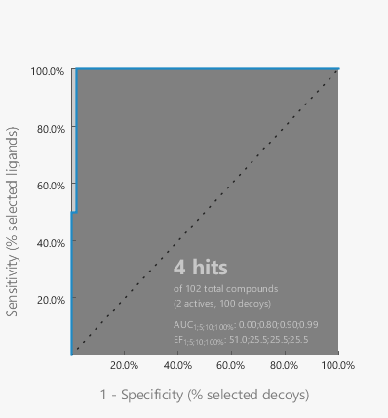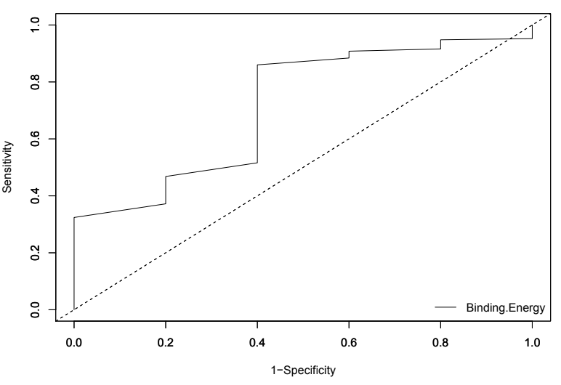

1. **(B)**

**Figure S4**. (A) AUC score of 0.99 for the pharmacophore model. Determined at 1, 5, 10 and 100% of the selected database were the AUC and EF values as shown. The median is shown by dotted lines. If the curve is closer to the median it would suggest poor model. (B) AUC score of 0.702 generated for validating the docking system used. It verified the correlation between virtual screening performance and binding site descriptors of protein targets model (*Lm*TR).

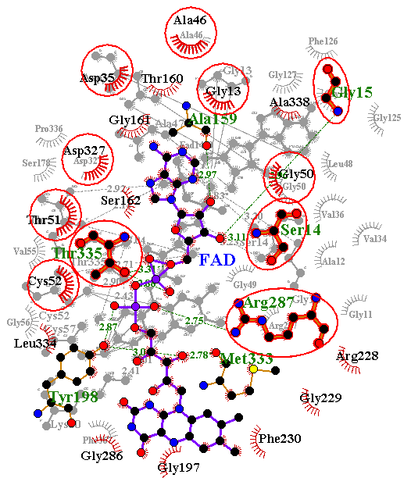 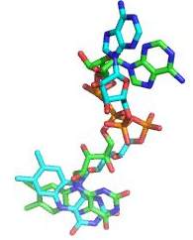

**Figure S5**: (A) 2D schematic diagram of co-crystallized FAD (PDB ID: 2JK6) and FAD docked in *Lm*TR superimposed together. Similar hydrogen bonding residues include Ser14, Gly15, Arg287 and Thr335. Similar hydrophobic residues in addition confirm the predicted active site. (B) Ligand alignment of co-crystalized FAD and FAD docked in *Lm*TR.

**Table S2**. The 42 hits obtained from pharmacophore screening with their respective pharmacophore fit score, binding energies and data sources

|  |  |  |  |  |
| --- | --- | --- | --- | --- |
| **Name** | **P-Fit Score** | **Binding energy (kcal/mol** | **Active/Decoy** | **Source Database** |
| ZINC95486081 | 55.95 | -9.8 | active | AfroDB |
| (S)-alpha-methoxy-alpha-trifluoromethyl -alpha-phenylacetate (MTPA) | 56.37 | -9.4 | active | NANPDB |
| Karatavicinol | 56.5 | -9.4 | active | NANPDB |
| Taccalin | 56.42 | -9.4 | active | NANPDB |
| Marmin | 56.18 | -9.3 | active | NANPDB |
| 3-hydroxyfeselol | 55.62 | -9.1 | Active | NANPDB |
| ZINC95486257 | 55.9 | -9.0 | Active | AfroDB |
| Betaxanthin | 56.97 | -8.9 | active | NANPDB |
| Coladonin | 56.58 | -8.8 | active | NANPDB |
| Feselol | 56.41 | -8.8 | active | NANPDB |
| ZINC38658035 | 55.9 | -8.7 | active | AfroDB |
| Pectachol | 57.18 | -8.5 | Active | NANPDB |
| ZINC85967928 | 55.85 | -8.4 | active | AfroDB |
| Polyanthin | 56.39 | -8.4 | active | NANPDB |
| ZINC95486047 | 57.98 | -8.3 | active | AfroDB |
| 4'-methyl gossypetin | 56.17 | -8.2 | active | NANPDB |
| 2-(nonan-8-one)-4-methoxy-quinoline | 56.41 | -8.2 | active | NANPDB |
| Orientin | 55.53 | -8.1 | Active | NANPDB |
| Kaempferol-3,6-dimethyl ether-7-glucoside | 57.15 | -7.8 | Active | NANPDB |
| ZINC95486129 | 56.43 | -7.8 | Active | AfroDB |
| Ethuliaconyzophenone | 56.9 | -7.7 | Active | NANPDB |
| ZINC95486209 | 56.55 | -7.5 | Active | AfroDB |
| (+)-1,2-bis-(4-hydroxy-3-methoxyphenyl)-propane-1,3-diol [erythro form] | 55.9 | -7.4 | Active | NANPDB |
| 4-hydroxy-2',4'-dimethoxy-dihydrochalcone | 55.58 | -7.4 | Active | NANPDB |
| Drimartol A | 56.31 | -7.4 | Active | NANPDB |
| Isoarnottinin-4'-O-beta-D-glucoside | 55.71 | -7.4 | Active | NANPDB |
| 4beta-hydroxy-6alpha-(4-hydroxy-3-methoxybenzoyl)-7-daucen-9-one | 55.93 | -7.4 | Active | NANPDB |
| ZINC14686464 | 56.55 | -7.4 | Active | AfroDB |
| 6-(3',4'-dimethoxybenzoyl)-jaeschkeanadiol | 57.17 | -7.3 | Active | NANPDB |
| ZINC14887523 | 56.88 | -7.3 | Active | AfroDB |
| orientin-7-methoxide | 56.26 | -7.2 | active | NANPDB |
| ZINC14444870 | 56.35 | -7.2 | active | AfroDB |
| ZINC14689062 | 56.5 | -7.2 | active | AfroDB |
| 1-dehydrogingerdione | 56.05 | -7.1 | active | NANPDB |
| onopordin | 56.27 | -7.1 | active | NANPDB |
| ZINC95486194 | 56.79 | -7.1 | active | AfroDB |
| Methyl 5-(3-4-dihydroxyphenyl)-3-hydroxypenta-2,4-dienoate | 55.32 | -7 | active | NANPDB |
| Corniculatusin | 56.23 | -7 | active | NANPDB |
| 3-(10-acetoxygeranyl)-4-acetoxy-p-coumaric acid | 56.14 | -7 | active | NANPDB |
| ZINC00035526 | 56.66 | -7 | active | AfroDB |
| ZINC00608186 | 57.08 | -6.8 | active | AfroDB |
| Evoxine | 57.32 | -6.2 | active | NANPDB |

**Table S3**

Physicochemical profiling of the 11 hit compounds. All the hits showed good druglikeness. (where MW = Molecular weight, No. HD = Number of H-bond donors, Bio Sc = Bioavailability Score, No. HA = Number of H-bond acceptors).

|  |  |  |  |  |  |  |  |  |
| --- | --- | --- | --- | --- | --- | --- | --- | --- |
| Compound ZINC ID/Name | Number of  Lipinski’s  Rules Violated | MW  (g/mol) | No. HA | No. HD | xLogP | Water  Solubility  (mg/mL) | Log S | Bio. Sc |
| ZINC95486081 | 0 | 382.45 | 5 | 2 | 4.52 | Moderately  soluble | −5.84 | 0.55 |
| MTPA | 0 | 470.52 | 8 | 0 | 6.35 | Moderately soluble | −6.00 | 0.55 |
| Karatavicinol | 0 | 400.51 | 5 | 2 | 4.66 | Moderately  soluble | −4.85 | 0.55 |
| Taccalin | 0 | 418.48 | 9 | 6 | -1.45 | Moderately soluble | 1.66 | 0.55 |
| Marmin | 0 | 332.39 | 5 | 2 | 2.81 | Soluble | −3.52 | 0.55 |
| 13-hydroxyfeselol | 0 | 400.51 | 5 | 2 | 1.45 | Moderately  Soluble | −5.93 | 0.55 |
| Betaxanthin | 0 | 370.44 | 8 | 7 | -1.17 | Moderately soluble | −2.11 | 0.55 |
| Colladonin | 0 | 384.51 | 4 | 1 | 5.76 | Poorly  soluble | −6.50 | 0.55 |
| Feselol | 0 | 384.51 | 4 | 1 | 5.76 | Poorly  Soluble | -6.5 | 0.55 |
| ZINC38658035 | 0 | 464.63 | 6 | 3 | -4.47 | Soluble | -3.28 | 0.55 |
| Pectachol | 0 | 444.56 | 6 | 1 | 5.70 | Poorly  soluble | -6.70 | 0.55 |

**Table S4**

Pharmacological profiling of top 11 compounds characterized by gastrointestinal (GI) absorption, blood brain barrier (BBB) permeant, p-gp substrates and cytochrome P450 inhibitors. Four compounds out of the 11 showed an appreciable pharmacological property. This included Karatavicinol, Marmin, Colladonin and Pectachol.

|  |  |  |  |  |  |  |  |  |
| --- | --- | --- | --- | --- | --- | --- | --- | --- |
| Compound ZINC ID | GI Absorption | BBB Permeant | P-gp Substrate | CYP1A2  Inhibitor | CYP2C19  Inhibitor | CYP2C9  Inhibitor | CYP2D6  Inhibitor | CYP3A4  Inhibitor |
| ZINC95486081  MTPA  Karatavicinol  Taccalin  Marmin  13hydroxyfeselol  Betaxanthin  Colladonin  Feselol  ZINC38658035  Pectachol | High  High  High  Low  High  High  Low  High  High  High  High | Yes  No  No  No  No  No  No  Yes  Yes  No  No | Yes  No  No  Yes  No  Yes  No  No  No  Yes  Yes | No  No  No  No  No  No  No  No  No  No  No | No  No  No  No  No  No  No  No  No  No  No | Yes  No  No  No  No  No  No  No  No  No  No | Yes  Yes  No  No  No  Yes  No  Yes  Yes  No  Yes | Yes  Yes  Yes  No  No  Yes  No  No  No  No  No |

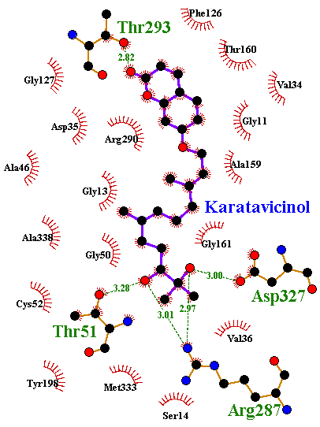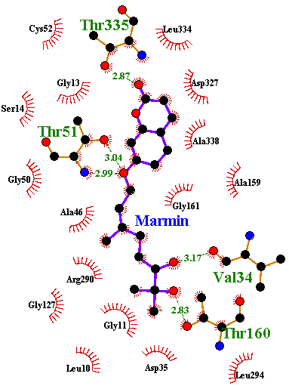

**(A)** **(B)**

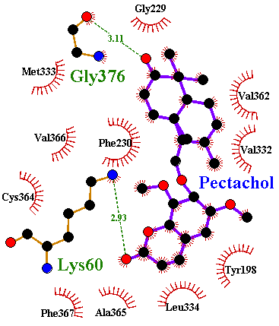 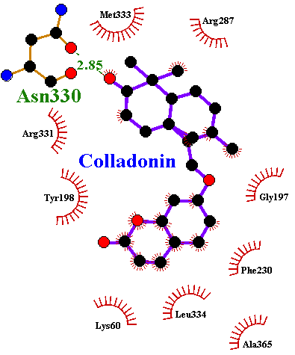

**(C) (D)**

**Figure S6:** 2Dschematic diagram showing protein-ligands interaction of some leads at the active site of *Lm*TR. (A) *Lm*TR-karatavicinol interaction profile, (B) *Lm*TR-marmin interaction profile (C) *Lm*TR-Pectachol interaction profile and (D) *Lm*TR-Colladonin interaction profile.

**Table S5**

This table shows the 10 top hit compounds and their predicted antileishmanial activity. Karatavicinol, Taccalin, Marmin, 13-Hydroxyfeselol, Colladonin, Feselol and Pectachol had a greater positive prediction above 0.5. If 0.5 < Pa < 0.7, the substance is likely to exhibit activity in experiment, but the probability of being a known pharmaceutical agent is less.

|  |  |  |
| --- | --- | --- |
| Lead compounds | Antileishmanial Predicted Activity | |
| Pa | Pi |
| ZINC95486081 | 0.224 | 0.168 |
| MTPA | 0.263 | 0.130 |
| Karatavicinol | 0.513 | 0.021 |
| Taccalin | 0.711 | 0.009 |
| Marmin | 0.557 | 0.024 |
| 13-hydroxyfeselol | 0.658 | 0.030 |
| Betaxanthin | - | - |
| Colladonin | 0.768 | 0.006 |
| Feselol | 0.768 | 0.006 |
| ZINC38658035 | 0.345 | 0.074 |
| Pectachol | 0.694 | 0.009 |

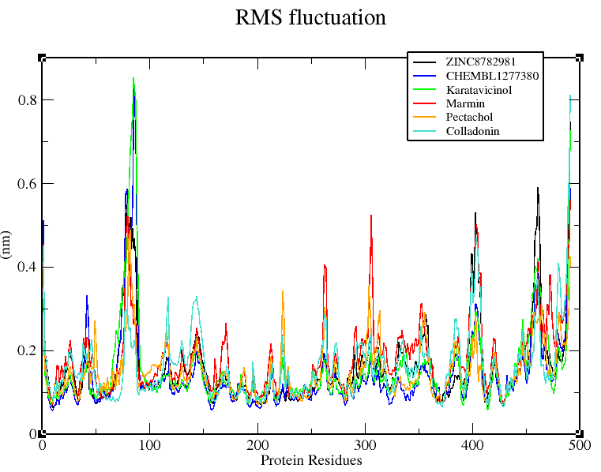

**Figure S7**. Root Mean Square Fluctuations of 6 complexes. The complexes are color coded in the graph*.* Karatavicinol and CHEMBL1277380 experienced the highest fluctuation at around residue number 80. Remaining complexes had similar patterns of fluctuations.

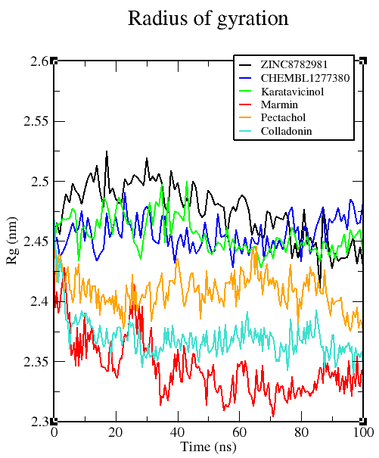

**Figure S8**. The radius of gyration (Rg) plots of seven complexes within 100 ns simulation time. The complexes are represented in color code in the graph*.* Marmin showed the most preferentially well folded protein complex with Rg value of 2.33 nm.

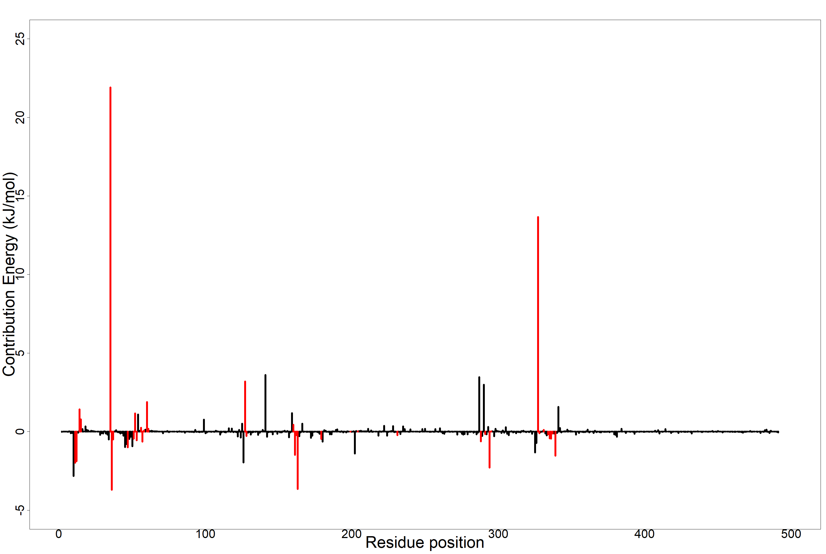

**Figure S9.** MM-PBSA plot of the binding free energy decomposition contribution per residue of *Lm*TR-Karatavicinol complex. Coded red lines represent surrounding active site amino acid residues.

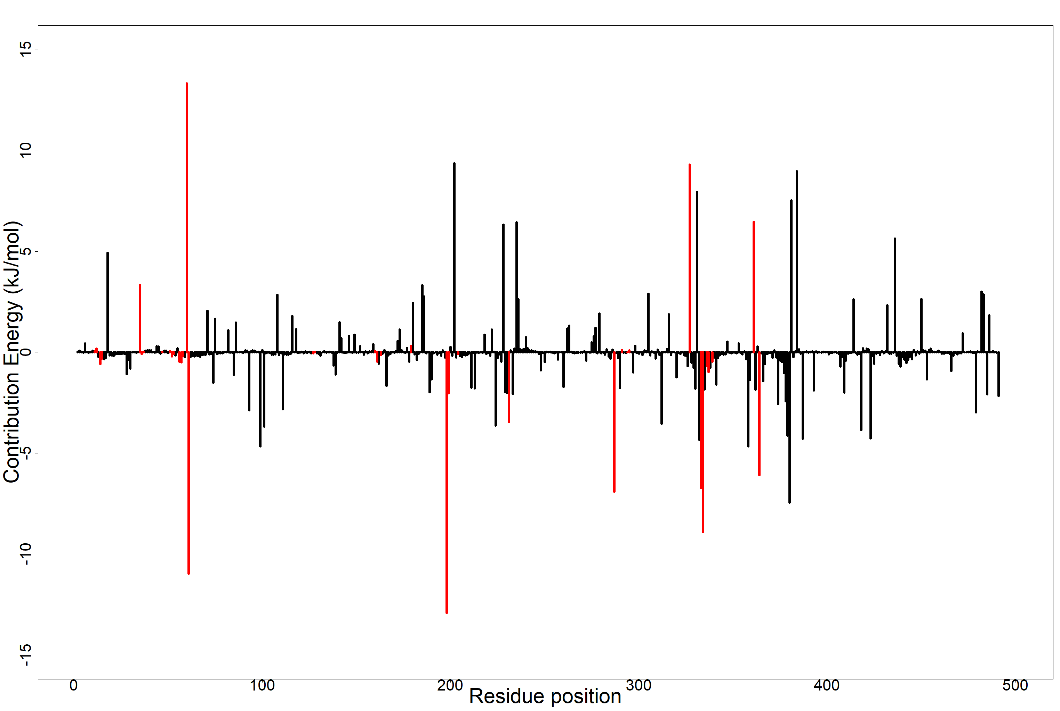

**Figure S10.** MM-PBSA plot of the binding free energy decomposition contribution per residue of *Lm*TR-Pectachol complex. Coded red lines represent surrounding active site amino acid residues.

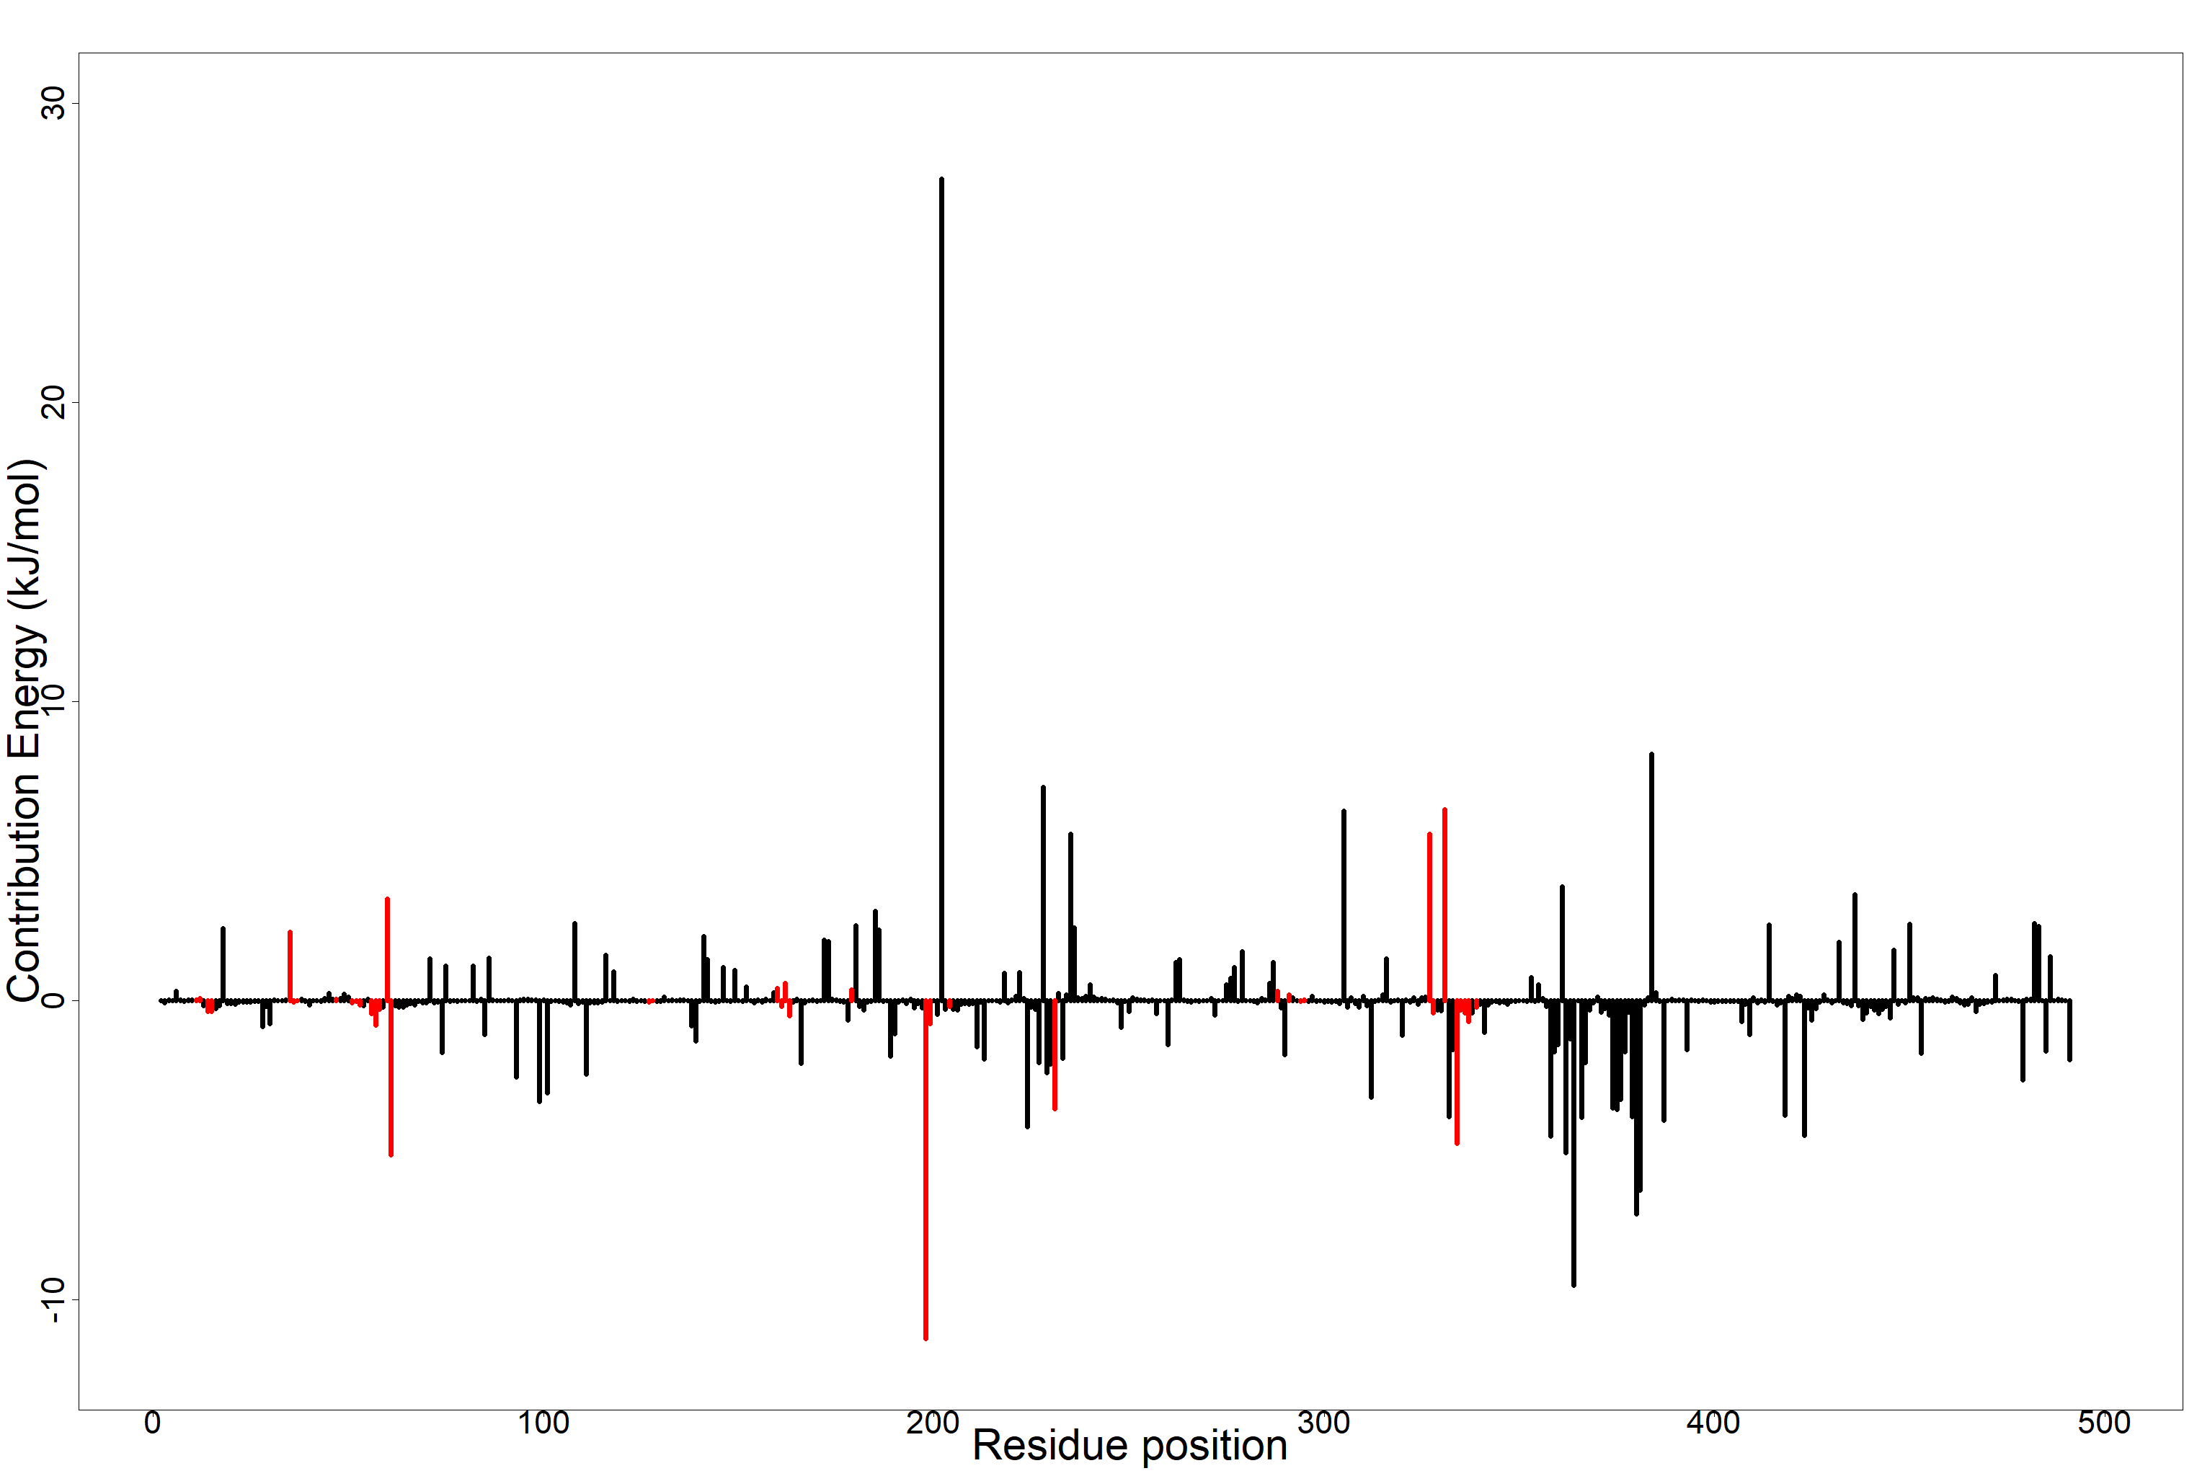

**Figure S11.** MM-PBSA plot of the binding free energy decomposition contribution per residue of *Lm*TR-Colladonin complex. Coded red lines represent surrounding active site amino acid residues.

**Table S6**. Structure and IUPAC names of the three novel lead compounds

|  |  |  |
| --- | --- | --- |
| LEAD COMPOUNDS | 2D STRUCTURE | IUPAC NAMES |
| Marmin |  | 7-[(E,6R)-6,7-dihydroxy-3,7-dimethyloct-2-enoxy]chromen-2-one |
| Pectachol |  | 7-[(6-hydroxy-5,5,8a-trimethyl-2-methylidene-3,4,4a,6,7,8-hexahydro-1H-naphthalen-1-yl)methoxy]-6,8-dimethoxychromen-2-one |
| Colladonin |  | 7-[[(4*aS*)-6-hydroxy-5,5,8*a*-trimethyl-2-methylidene-3,4,4*a*,6,7,8-hexahydro-1*H*-naphthalen-1-yl]me thoxy]chromen-2-one |
| Karatavicinol |  | 7-[(2E,6E,10S)-10,11-dihydroxy-3,7,11-trimethyldodeca-2,6-dienoxy]chromen-2-one |

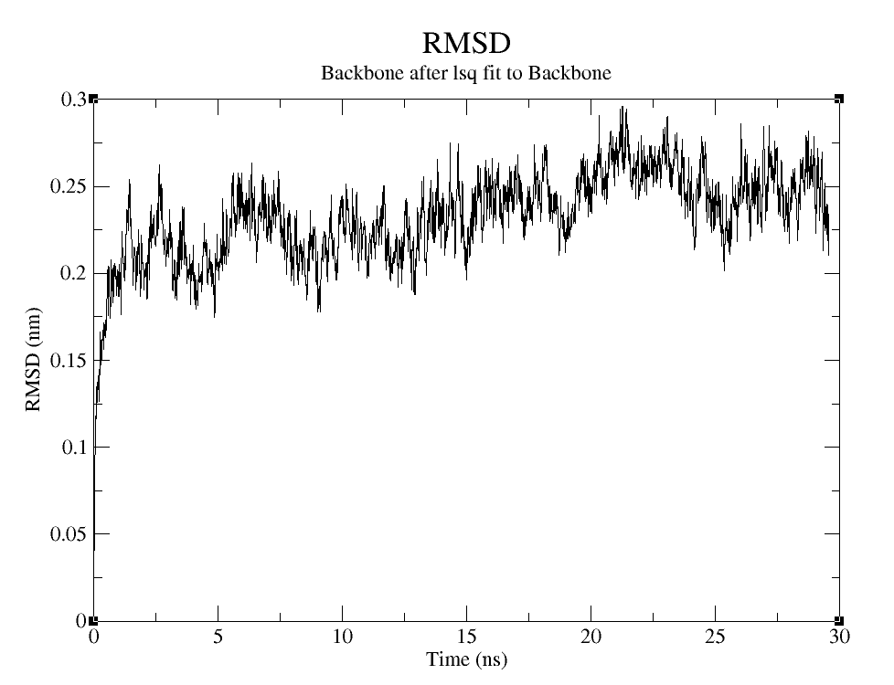

**Figure S12.** Shows a graph of RMSD of the backbone of atoms in nm versus time in nanoseconds (ns). This graph is a representation of the average distance of the atoms of the residues at the backbone of the target protein. RMSD of 0.25 Å showed deviation from protein backbone.

**List of Abbreviations**

ADMET Absorption, distribution, metabolism, excretion and toxicity

AUC Area Under Curve

CYP Cytochromes P450

DUD-E Directory of Useful (Docking) Decoys- Enhanced

GROMACS GROningen MAchine for Chemical Simulations

HPC High Performance Computing

ID Identification

Log P Logarithm of the octan-1-ol/water partition coefficient

MD Molecular Dynamics

MM-PBSA Molecular Mechanics Poisson Boltzmann Surface Area

Mw Molecular Weight

P-gp Permeability glycoprotein

PASS Prediction of Activity Spectra for Substance.

PDB Protein Data Bank

Rg radius of gyration

RMSD Root Mean Square Deviation

RMSF Root Mean Square Fluctuation

ROC Receiver Operating Characteristic

SDF Structure Data File

SMILES Simplified Molecular Input Line Entry System

UFF Universal Force Field