Roadmap AW101: version 0.1

libDSP:
- signal direction and order algorithm
- unit-tests
- API refactoring
- un-invalidating pointers for containers (André Bergner c++ Meetup talk)

Modular Playground Example:
- Export WebUI as linkable Library
- implement and document plug-in system

WebUI:
- register WebUI Module for external DSPModules
- rework over all design

External Modules:
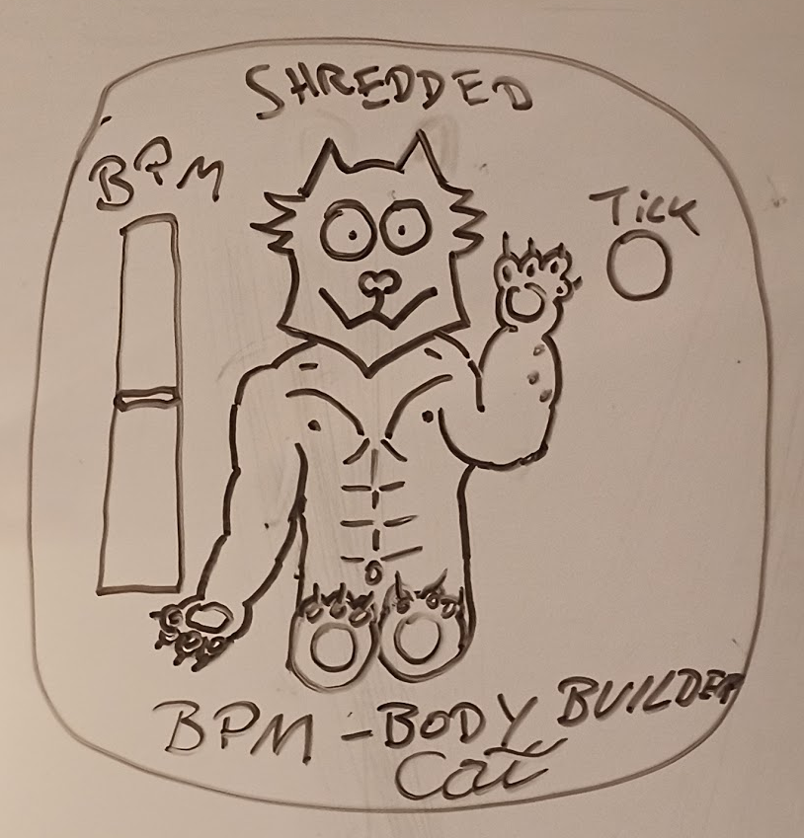
SHREDDED BPM-Bodybuilder-Cat
- BPM Parameter
- Tick out

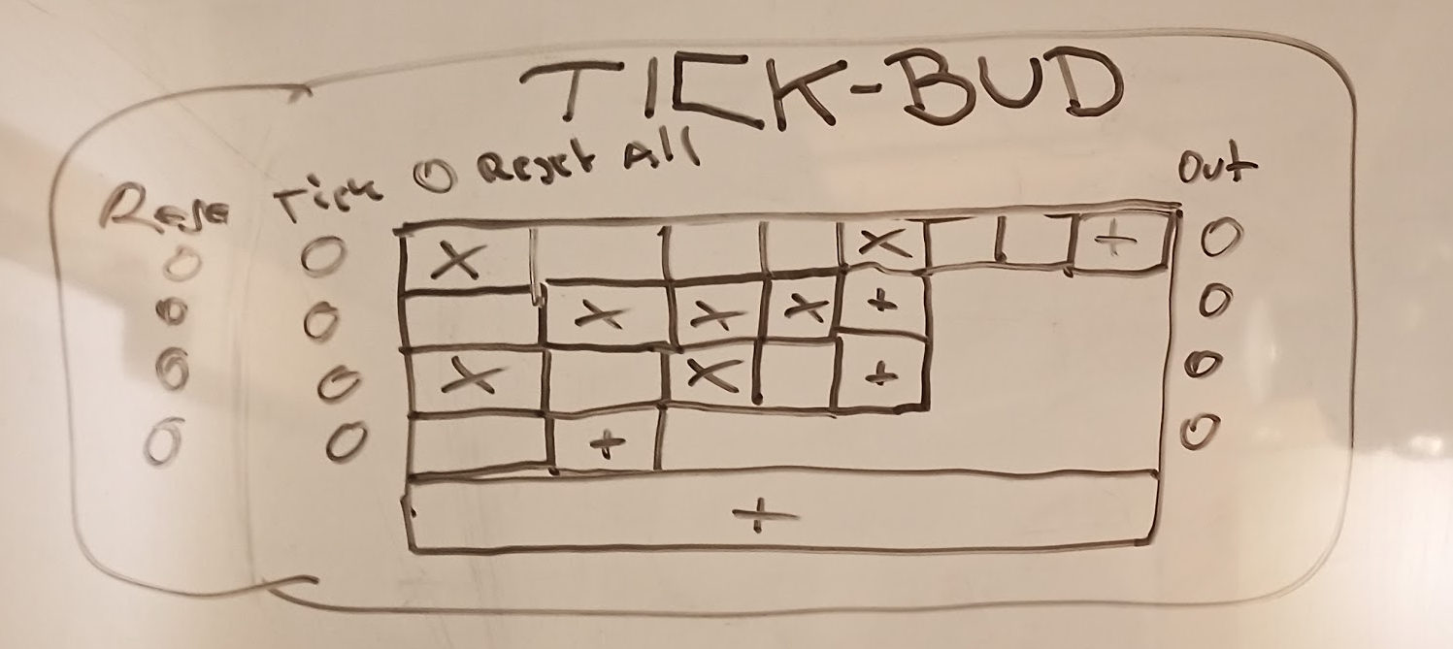
Tick-Bud
- Adding N-Tracks
- Tracks can vary in step length
- toggle on/off for steps, reset trigger, tick in, value out per track
- Reset All Trigger

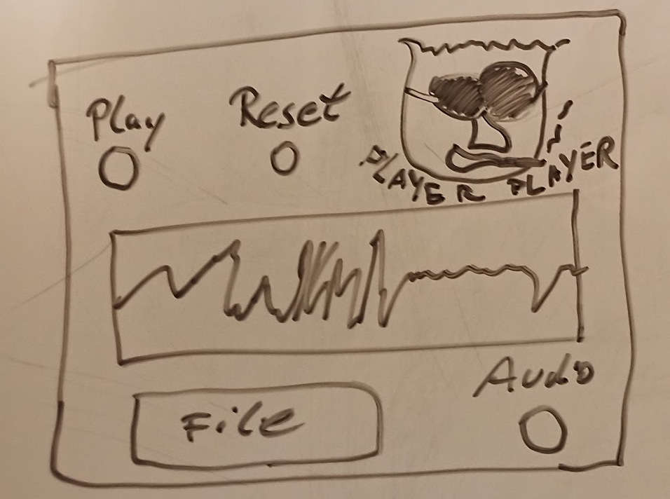
PLAYER-Player
- Filebrowser
- Sample replay
- Play toggle trigger
- reset trigger
- audio out

Internal Modules:
Mixer Module
- add N Inputs
- output is weigthed sum over all inputs

Multiplication Module
- 2 Inputs

Basic Oscillator
- Sine/Saw/Triangle/Square
- frequency parameter
- absolute frequency offset input, reset trigger
- audio out

Number Module
- Text Input
- Number Output

🅱️utton Module
- trigger out

