

Villages Variant
version 1.0


Hah! Schau Dir diese königlichen Ignoranten an. Rennen durch das ganze Land und bauen neue Dörfer, die genauso schnell verschwinden wie sie errichtet wurden. Ich sag es euch: „Nicht das Bauen macht reicht sondern das Plündern ... brennt alles nieder ...“

Village Assault ist eine Einspieler Variante von Villages, die Du mit dem Basisspiel von Villages spielen kannst. Ein Spieler spielt gegen das Kartendeck und notiert seine Punkte (Goldstücke). Vergleiche Deine Ergebnisse mit anderen Spielern und mit Deinen vorherigen Spielen..

Aufbau

Entferne das Schloss, den Turm und die Taverne aus dem Deck. Lege die Punktekarten „Erster“ und „Letzter“ bereit.
Je nachdem wie Du die Punktekarten einsetzt, verändert sich die Schwierigkeit des Spieles.

- Für ein normales Spiel behalte die „Letzter“ Karte und leg sie zu Dir, die „Erster“ Karte kommt an das Ende der Spielzone.
- Für ein schwieriges Spiel behalte die „Erster“ Karte und leg sie zu Dir, die „Letzter“ Karte an das Ende der Spielzone.

Das Schloss wird unter die Punktekarte am Spielfeldende gelegt. Rechts und links vom Schloss werden der Turm und die Taverne platziert. Diese Anordnung stellt das Dorf dar das Du in jeder Runde angreifst und besiegen musst.

Shuffle the remaining cards and set them to the side as a deck. Draw 8 cards to form your starting hand. These are the units in your army. They're a rag-tag group, but they're all you've got!

Then deal 1 card, face up, onto each of the three buildings you laid out earlier. These are the lone residents of each of these villages, but their numbers will grow as time goes on.

How to Play

One game of Village Assault is split into multiple rounds. During each round, you must defeat all of the enemy units in the opposing villages using the units in your hand.

Battles are resolved in the same way as the base game, where the unit with the higher power wins. Your units are always the attacker and the opposing units are always the defender. This means that you win ties. All of your units are also considered to be hired for the sake of ability text.

However, the enemy units in the Castle village get a +1 bonus to their defense, making them tougher to defeat. The Tower and Tavern have no special effects.

Any unit that you play from your hand goes into a discard pile after it has been used. Defeated enemy units are taken prisoner. Unlike the base game, prisoners do not move directly to your hand; instead, they are kept in a separate prisoner pile until the end of each round.

During the first round, there will only be 1 face-up card in each village. In future rounds, however, there will be additional face-down cards stacked beneath the top face-up card. Once the top card is defeated or removed, flip over the next card in the stack and continue until you reach the building card at the bottom of the stack.

If you manage to clear all of the enemy villages, you successfully complete the round!

At this point, you may add cards from your hand to the prisoner pile if you want to. When you're finished, count up the gold value of your prisoners. This is your score for the round. Write it down and add it to your running total.

Next, you can draw more cards from the deck and add them to your hand by cashing in your prisoners.

- For a Normal game, draw 1 card for every 3 gold you earned this round.
- For a Hard game, draw 1 card for every 4 gold you earned this round.

Round down in all cases. Once you've cashed in your prisoners, move them to the top of the discard pile. You can't save prisoners from one round to the next.

To begin the next round, deal a new set of cards to each enemy village. Deal a number of face-down cards equal to the number of rounds you've played so far, followed by one more face-up card. For example, on round 2, deal 1 card face-down, then 1 face-up to each village. On round 3, deal 2 cards face-down, then 1 face-up, and so on.

Continue using the cards in your hand to clear the enemy villages. If there are no more possible ways to defeat your enemies, it's game over! Score your current prisoners (without adding any cards from your hand) and add the result to your total score, as normal.

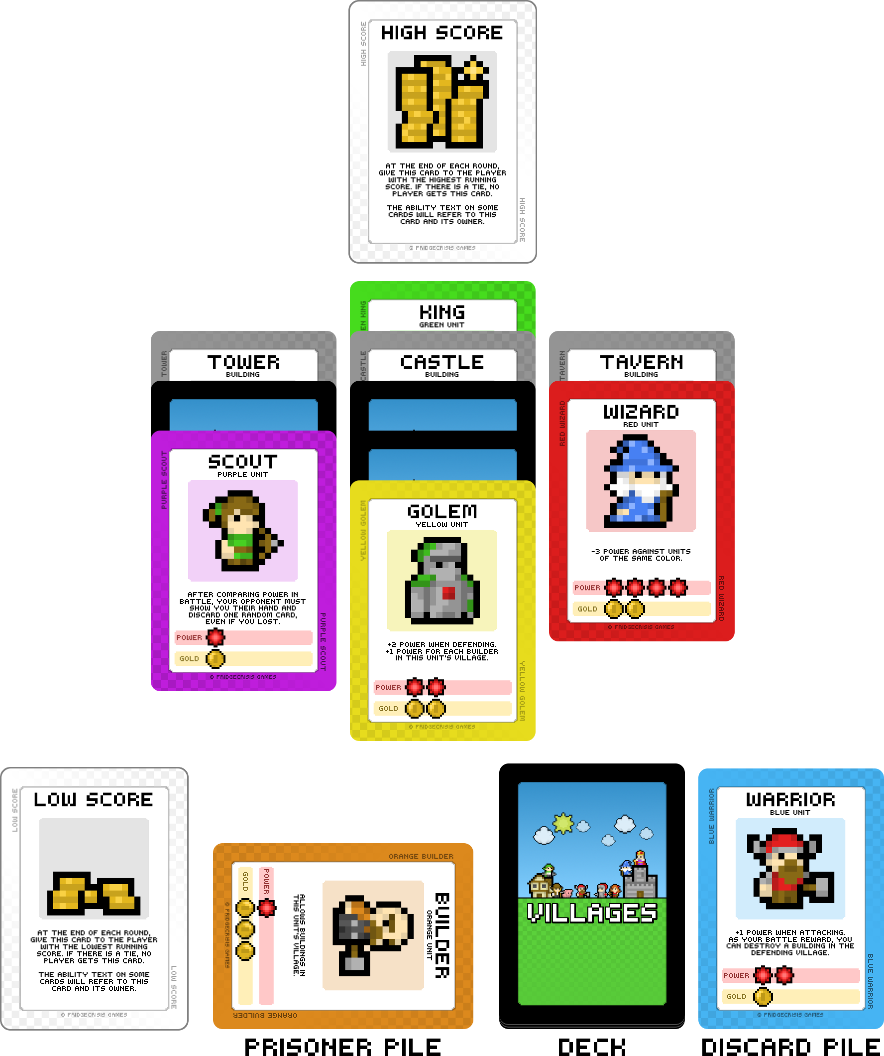
Other Rules

You may find animals in the enemy villages. These can be taken into your hand for free without spending cards to defeat them.

Enemy units with a power of 0 can be taken prisoner without spending a unit to defeat them. But remember that the Castle grants +1 power to every unit living in that village, so a unit that normally has 0 power would have 1 instead.

If the deck runs out of cards, shuffle the discard pile to form a new deck.

The following list explains each card's ability in detail as it relates to Village Assault.

 | Farmer: No ability.
 | Builder: No ability.
 | King: When a King is revealed in an enemy village, move it behind the Castle. Spawn one extra enemy from the Castle each round for each King living there. If you draw a King into your hand, discard it and do not draw a replacement.
 | Princess: No ability.
 | Merchant: At any time during a round, you can discard a Merchant from your hand to immediately add cards from your hand to your prisoner pile and cash in your prisoners to draw more cards. However, do not score any points for these prisoners.
 | Priest: As written, but change 'graveyard' to 'prisoner pile'.
 | Knight: As written.
 | Archer: As written. The Archer will always defend other villages and receive her +2 bonus for doing so, while attacking her village directly will not grant that bonus.
 | Golem: As written. Revealed Builders in other villages count toward the Golem's bonus power.
 | Warrior: Basically as written. The Warrior can also be used to discard an Inn while there are no units in its village (including the first round it appears). You can not destroy the Castle, Tower, or Tavern.
 | Orc: As written, but include all face-down cards when determining power. When attacking the Castle, also include any Kings living there.
 | Dragon: No ability.
 | Assassin: As written. Can also be used to discard a King if there are no other units in the Castle village.
 | Ace: As written.
 | Wizard: As written.
 | Thief: After defeating an enemy Thief, discard a card at random from your prisoner pile before taking the Thief prisoner. When using your own Thief, draw a card after battle and add it to your hand.
 | Scout: After defeating an enemy Scout, discard a card at random from your prisoner pile before taking the Scout prisoner. When using your own Scout, discard the next face-down card beneath the unit you just defeated.
 | Joker: As written.
 | Goblin: As written. The score card in front of you is yours, while the card at the far end of the play area is the enemy's.
 | Hero: As written. The score card in front of you is yours, while the card at the far end of the play area is the enemy's.
 | Chicken: As written, but change 'destroy' to 'discard'.
 | Pig: As written, but change 'destroy' to 'discard'. All units you play are eligible for the Pig's bonus power.
 | Bunny: Discard this Bunny to also discard any revealed enemy unit.
 | Sheep: Discard this Sheep in place of any used unit. This allows you to keep the unit in your hand and use it again.
 | Inn: When an Inn is revealed in an enemy village, move it to either side of the village stacks. At the start of the next round, begin adding enemy units to it as a new village. If you draw an Inn into your hand, discard it and do not draw a replacement.
 | Tower: No ability.
 | Castle: As written.
 | Tavern: No ability.

Contact

Contact me at jaronfrost@fridgecrisis.com if you have any comments or questions. Thanks for playing!



