Mixing text + computations

Markdown, quarto, webpages, pandoc

Denis Schluppeck

2023-01-18

## Motivation

* often useful to produce short documents that mix code snippets, plots, text, images
* could use PPT, Keynote, Word (but don’t play nicely with version control)
* use a simple text based version

## Where would you use this?

* teaching (content changes slightly/a lot) each year
* research: publishing data + code is now a *must* for many journals
* after this walk-through, it would be great to discuss if people find this useful?! What for?

## markdown is widely used

* if you want some *light markup*
* go **beyond simple text**
* a couple of ~~key things~~ like
* [easy to write links](https://www.google.com)

## … images

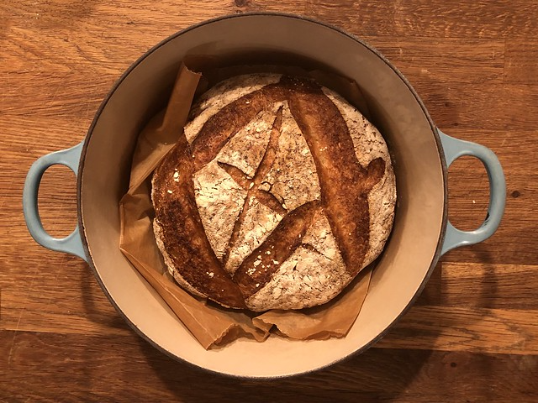

some bread in a dutch oven

## Maths, equations are easy



an online editor at [stackedit](https://stackedit.io/), to just have a play

## Challenges

* placing images where you want them (arbitrarily on page) requires some work
* you need to render / transform it (only seconds, but not instantaneous)
* if you make mistakes you (it’s a very light version of coding)
* if you link to local files (images, etc), you have to remember to move them along (not a problem if everything is online)

## Advantages

* markdown (itself) structures your documents
* can easily be **tranformed** into pdf, pptx, docx, revealjs, etc.
* gets rendered nicely on github.com, by defauilt
* easy to edit, rules are simple to learn
* you can add in computations code in r, python, julia et al and make them part of your documents $→$ quarto

## quick demo

* VSCode with markdown plugin (linting, preview)
* (! the github.com repo which gets rendered using a tool called jekyll under the hood)

## quarto

* a command line tool that renders a flavour of markdown called qmd (quarto-markdow)
* a superset of markdown, so any previous work should be ok
* by adding some additional info at top of document, you can opt into lots of good stuff

## info at top: YAML

A text block delimited by ---, key/value

---  
title: "Mixing text + computations"  
subtitle: "Markdown, quarto, webpages, pandoc"  
author: Denis Schluppeck  
date: 2023-01-18  
format:  
 revealjs:   
 mainfont: Helvetica  
 sansfont: Helvetica  
---

## quarto

* if you like RStudio, there is a nice interface
* VScode has a plugin that works well
* or if you prefer emacs/vim/nano/TextEdit, the command line tool is not that hard to use.

quarto preview test.qmd   
# or render  
quarto render test.qmd --to pdf

## Any Questions?

## Links

* <https://quarto.org/>
* <https://rstudio.org/> - now pos.it: <https://posit.co/>
* the original proposal for markdown: <https://daringfireball.net/projects/markdown/>
* <https://code.visualstudio.com/> - visual studio code (free download)

### related ideas

* literate programming
* Matlab / publish()
* notebooks, Pluto.jl