A Psychphysics Study on Glance reading accuracy in the peripheral field
Martin Schmettow
2026-04-24

Data reading
# A tibble: 180 × 11
participant xPos stimulusSet whichImage thisN blockNumber direction angle
<chr> <dbl> <chr> <chr> <dbl> <dbl> <chr> <dbl>
1 results1 4.5 ecc10pos left 0 1 direct 20
2 results1 4.5 ecc10pos left 1 1 right 19
3 results1 4.5 ecc10pos left 2 1 right 18
4 results1 4.5 ecc10pos left 3 1 right 17
5 results1 4.5 ecc10pos left 4 1 left 18
6 results1 4.5 ecc10pos left 5 1 right 17
7 results1 4.5 ecc10pos left 6 1 left 18
8 results1 4.5 ecc10pos left 7 1 left 19
9 results1 4.5 ecc10pos left 8 1 right 20
10 results1 4.5 ecc10pos left 9 1 left 19
# ℹ 170 more rows
# ℹ 3 more variables: stimulus <chr>, response <chr>, correct <dbl>
Obs Part trial angle eccentricity
Min. : 1 results1 : 180 Min. : 1.00 Min. : 1.00 Min. : 5
1st Qu.:1486 results10: 180 1st Qu.: 45.75 1st Qu.:14.00 1st Qu.: 5
Median :2970 results11: 180 Median : 90.50 Median :17.00 Median :10
Mean :2970 results12: 180 Mean : 90.50 Mean :15.83 Mean :10
3rd Qu.:4455 results13: 180 3rd Qu.:135.25 3rd Qu.:19.00 3rd Qu.:15
Max. :5940 results14: 180 Max. :180.00 Max. :20.00 Max. :15
(Other) :4860
correct
Min. :0.0000
1st Qu.:0.0000
Median :1.0000
Mean :0.5104
3rd Qu.:1.0000
Max. :1.0000

Exploration
The following plot shows the population level proportion of correct responses as a function of the angle and eccentricity. There is huge fluctuations with angles below 10 degree, which is due to the adaptive staircase procedure, which results in fewer observations for these angles. The tendency above 10 degree is
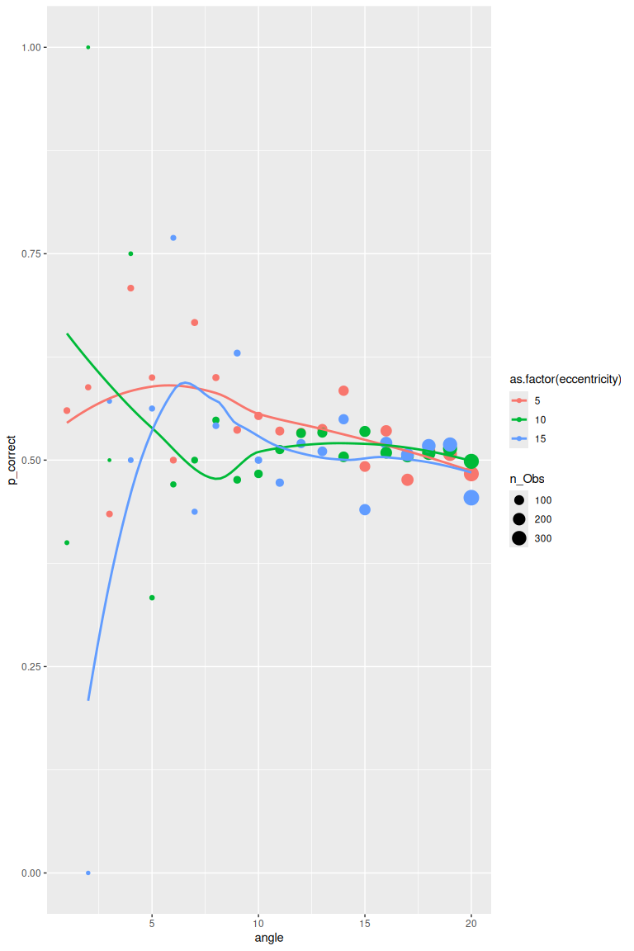
The figure below shows the proportion of correct responses as a function of the Angle (in three ranges) and eccentricity, separately for each participant.
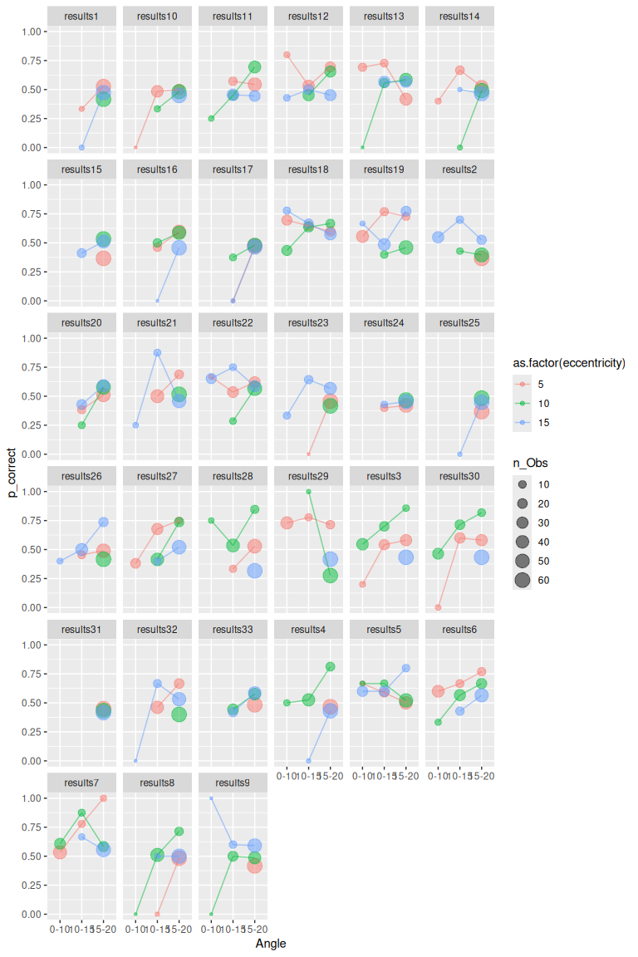

Conclusion
Many participants even the easiest condition don’t improve beyond chance level. Only in a few do we observe a regular pattern that matches our expectations. Still, a subset of participants can perhaps be used with the model. Legit participants should show performance above chance level and have clear upwards trend, as well as the expected ordering of eccentricity.

Modelling
The theoretically complete Psychophysics function would have: + dprime + a guessing rate + a lapse rate (readout error) + a decision bias
The theoretical base for lapse is that the response depends on the sensory characteristics and the readout process (Gold and Ding 2013).
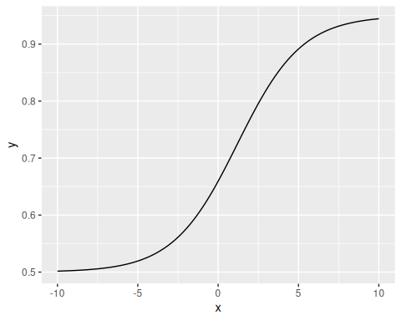
The lapse rate and decision bias are modeled as functions of the participant, but not of the eccentricity, because it is assumed to be a readout error that is independent of the stimulus. Dprime is modelled as a function of eccentricity.
Since we have no data at the upper end of performance, the lapse parameter cannot be estimated neither on participant level nor on population level. The same holds for the bias parameter. Therefore, a much simplified model is used.
Here we extract the posterior samples.
This extracts the population-level parameters. Parameters are transformed back to their original scale. Note that by the back-transformation dprime is a multiplicative parameters.
Coefficient estimates with 95% credibility limits
fixef | center | lower | upper
Intercept | -0.4438282 | -2.367825 | 1.428337
eccentricity | -2.2757021 | -3.454772 | -1.487004
This figure shows the posterior distributrions of population-level parameters.
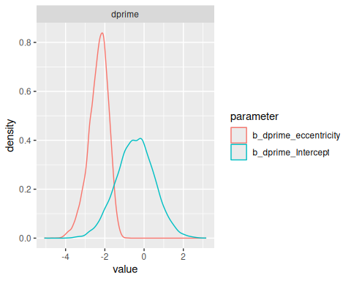

Posterior predictions
Gold, Joshua I., and Long Ding. 2013. “How Mechanisms of Perceptual Decision-Making Affect the Psychometric Function.” Progress in Neurobiology 103: 98–114. https://doi.org/https://doi.org/10.1016/j.pneurobio.2012.05.008.

