Parametric learning curve models for simulation-based surgery training
Martin Schmettow
Russell W. Chan
Marleen Groenier
2026-03-08

Introduction
Training processes in medical care, and in particular in technically demanding domains such as minimally invasive surgery, are commonly described using the metaphor of the learning curve. The appeal of this metaphor is obvious: performance improves with training, improvement is initially rapid, and later gains become progressively smaller. Despite its intuitive value, however, the learning curve is often treated as a descriptive object rather than as a generative model of learning. As a result, much of the existing literature relies on loosely specified curves, endpoint comparisons, or linearized summaries that obscure the underlying mechanisms of skill acquisition and limit the interpretability of estimated effects.
This paper argues that modelling training processes requires a shift from descriptive learning curves to parametric learning models whose parameters have direct real-world interpretations. In particular, we focus on performance measures that decrease with skill acquisition, such as time on task, error counts, or motion inefficiency, and propose a simple three-parameter model that decomposes observed performance trajectories into interpretable components of learning.

Problems in Training Research
A parametric perspective on learning is motivated by three recurring research problems in medical training research.
The first question concerns selection: can we identify trainees with high long-term potential early in training? In surgical education, this question is often framed in terms of aptitude testing, simulator performance, or early learning speed. From a modelling perspective, this corresponds to predicting an individual’s maximum achievable performance, that is, the asymptotic level of performance once training effects are exhausted. A model that does not contain an explicit asymptote cannot address this question in a principled way.
The second question concerns training efficiency: how can different training methods, curricula, or feedback regimes be compared in terms of how quickly they lead to improvement? This question maps naturally onto a learning rate parameter that quantifies how rapidly performance approaches its asymptote. Without an explicit rate parameter, efficiency is often approximated using arbitrary endpoints or time-to-criterion measures, both of which conflate learning dynamics with prior experience and measurement noise.
The third question concerns transfer and preparation: which preparatory activities lead to effective downstream learning? Examples include box trainers, virtual reality simulators, or simplified tasks such as practicing surgical maneuvers on fruit or synthetic materials. Here, the central interest lies in previous experience—how much effective training time a learner brings into a new task before formal training begins. From a modelling standpoint, this corresponds to a horizontal shift of the learning trajectory rather than a change in its shape.
A unifying challenge across these three questions is that they cannot be answered independently unless the learning process is decomposed into separable, interpretable components.

Limitations of prevailing approaches
A brief look at the learning-curve literature in medical education reveals a striking pattern. While the term learning curve is ubiquitous, the majority of empirical studies rely on linear or piecewise linear analyses, often focusing on performance at a predefined endpoint (e.g., after a fixed number of cases) or on the slope of a regression line fitted to early training data. In many cases, improvement is summarized by subtracting early from late performance, or by testing whether a slope differs from zero.
Such approaches have two fundamental limitations.
First, previous experience and learning rate are inseparable in linear endpoint analyses. A trainee who starts at a better performance level due to prior exposure or positive transfer will often appear to “learn slow,” even if the underlying learning dynamics are identical. Conversely, a genuinely low learning rate cannot be distinguished from a advanced learner, already approaching the asmptote. Without an explicit model that accounts for horizontal shifts in training time, these effects are confounded by design.
Second, maximum performance cannot be predicted at all. Linear models either imply unbounded improvement or require an arbitrary stopping rule. Endpoint analyses implicitly assume that the observed endpoint is informative about ultimate performance, an assumption that is rarely justified, especially in long training trajectories where asymptotic performance may lie far beyond the observation window.
These limitations are not merely technical; they directly constrain the kinds of substantive questions that can be addressed. As long as learning curves are treated as descriptive trends rather than as parameterized processes, claims about aptitude, efficiency, or transfer remain underdetermined.

A macro theory of skill acquisition
The proposed learning function is not merely a convenient mathematical form; it arises naturally from a simple generative account of how skills are built. We refer to this account as the tweak-finder model.
The model starts from three assumptions. First, complex skills consist of a finite set of possible refinements or tweaks to an initial action plan. The initial condition is a pool of undiscovered tweaks and progress in learning is ascribed as discovering these tweaks, which improves performance. Second, discovering a tweak is effectively irreversible: once a refinement is found and incorporated, it remains available in future executions. Third, each undiscovered tweak has a fixed probability of being found on any given training trial. While probabilities may differ across tweaks, their average remains stable across the learning process.
Under these assumptions, skill acquisition is not a linear accumulation of improvement but a stochastic search process in a diminishing space of possibilities. Early in training, many tweaks are in the pool, and performance improves rapidly. As training progresses, fewer tweaks remain, and improvements become rarer.
Formally, if the probability that a given tweak survives (i.e., remains undiscovered) from one trial to the next is constant, the expected number of remaining tweaks declines exponentially with training time. Performance, in turn, can be expressed as the sum of a non-trainable component and a trainable component proportional to the number of remaining tweaks. Collapsing the unknown number of initial tweaks and their average effect yields a three-parameter exponential model with a clear psychological interpretation.

A parametric model of continuous learning
To address these issues, we introduce a simple three-parameter model for performance measures that decline with improvement, as is most often the case. Let performance at training trial $t$ be given by
$$\text{perf}\left(t\right)={\left(1−\text{leff}\right)}^{\left(t+\text{pexp}\right)}+\text{maxp}.$$
with $0≤\text{leff}≤1$ and $\text{maxp}≥0$.
This formulation separates three conceptually distinct components of learning.
The parameter previous experience shifts the learning curve along the axis of trials axis, representing effective training that occurred prior to observation. Preparatory exercises, informal practice, or transferable skills are captured as prior exposure measured in units of training. For example, it would be fair to say: “Two days using a box trainer is equivalent to 10 trials on the VR simulator.”
The parameter learning efficiency determines how rapidly performance improves with training. It governs the curvature of the learning trajectory and directly corresponds with measuring training efficiency.
The parameter maximum performance represents the asymptotic lower bound of performance (with lower numbers being better): the level that cannot be surpassed even with unlimited training. It formalizes the notion of a non-trainable component of task execution, arising from anatomical, physiological, or system-level constraints.
Crucially, all three parameters are interpretable on their natural scales. Changes in any one of them have qualitatively distinct effects on the learning trajectory—effects that can be visualized and empirically tested. In the remainder of the paper, we illustrate these effects using simulated and give an example based on data collected with a laparascopy simulator.

Outlook
By grounding learning curves in a parametric, generative framework, we can align statistical estimation with substantive questions about selection, efficiency, and transfer. The remainder of this paper develops this approach in detail, illustrates the effects of each parameter, and discusses implications for the design and evaluation of medical training programs.
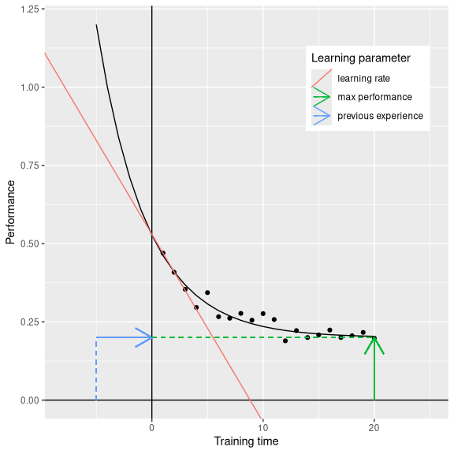
Figure 1: Observed duration to task completion with LOESS overlay.
_{Source: Article Notebook}
[fig: A learning curve with three parameters. The dashed lines illustrate the effects of each parameter on the learning trajectory. Previous experience shifts the curve horizontally, maximum performance sets a lower bound on performance, and learning rate determines the curvature of the trajectory.]

Simulation study
To illustrate the model, we simulate a training scenario with three trainees (Li, Wang, Smith) training on a laparoscopic task. Yet, each trainee has different characteristics, which are located in the past (previous experience), in the present (learning efficiency) and in the future (maximum performance). Li and Wand have already assisted during laparascopy procedures, whereas Smith only did a short prior training using a low fidelity box trainer. In effect, the learning curves appear shifted to the left in the order Li, Wang, Smith. Li started on a very good performance level, but due to the amount of previous experience made little progress anymore; in consequence the training was stopped after 20 trials. Wang showed moderate performance in the first trial but due to the lower previous experience, he progressed more quickly than Li. In the first trial to reach a stable level after 20 (of 30) trials. Smith started with little previous experience and due to her ADHD condition progressed rather slowly. During the first ten trials her performance even diverged further from Wang. However, Smith continues to improve steadily and starts outperforming Wang after 25 trial. When she reached the level of Li, the training was stopped, although it seemed she improve further.
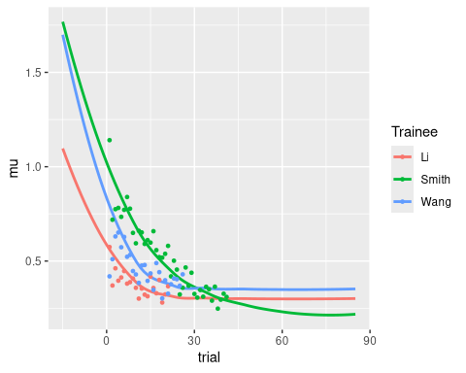
_{Source: Article Notebook}

Building multi-level learning curve models
For the inverse exponential learning curve model it is essential to start from individual curves. Averaging across individuals and estimate population level learning curves is not allowed, because sums and exponentials do not commute. Therefore, all simulations and model estimations are done on the lowest level of observation, which in the following is the individual $i$ on a fixed task. In the following we will demonstrate the building blocks of multi-level learning curve models.

Scaling
The three-parameter model is not flexible enough to fit real data, because it does not allow for a scale factor to accommodate real measurements. More precisely, the model cannot fit learning curves with $\text{perf}>1$.
To eliminate this problem, a a fourth parameter scale is introduced. If this parameter were allowed to vary across trainees, the model would be partly unidentifiable, as the same learning curve can be produced by different combinations of scale and pexp. To mitigate this issue, scale enters the estimation as a population-level parameter, such that the formula for trainee $i$ becomes:
$${\text{perf}}_{i}\left(t\right)={\left(1−{\text{leff}}_{i}\right)}^{t+{\text{pexp}}_{i}}\text{scale}+{\text{maxp}}_{i}.$$

Unbounding parameters
For the modelling task it is beneficial to parametrize the model in such a way that all parameters are unbounded on the real line. This makes it possible to use Gaussian priors and random effects throughout. In addition a parameter must be added to work with existing scales of performance.
Maximum performance and previous experience are bounded to $R⁺$. In order to stretch them into the entire real line the natural exponent is use. Learning efficiency is bound by the unit interval $\left[0;1\right]$ and can be extended to the real line be using the inverse logit function (also known as the probability mass function of logistic distributions).
With these transformations the likelihood function becomes
$${\text{perf}}_{i}\left(t\right)={\left(1−{\text{logit}}^{−1}{\text{leff}}_{i}\right)}^{t+exp{\text{pexp}}_{i}}exp\text{scale}+exp{\text{maxp}}_{i}.$$

Model formulation
To formulate a multi-level model for the simulated data, the likelihood formula is required, as well as random effects specifications and, for Bayesian models, prior distributions. With unbounded parameters, Gaussian random effects can be specified as follows:
$$
\text{pexp}_i \sim N(\mu_{\text{pexp}}, \sigma_{\text{pexp}})\\
\text{leff}_i \sim N(\mu_{\text{leff}}, \sigma_{\text{leff}})\\
\text{maxp}_i \sim N(\mu_{\text{maxp}}, \sigma_{\text{maxp}})\\
$$
Prior distributions capture the state of knowledge about the parameters before seeing any data. In the absence of strong prior knowledge, weakly informative priors are commonly employed, having only a regularizing effect on the model estimation. In the present case, we might specify weakly informative Gaussian priors, which are centered around plausible values with relatively large standard deviation to capture the state of high uncertainty. Since parameters have been transformed, mean and standard deviation are specified on the logarithmic scale.
$$
\mu_{\text{leff}} \sim N(-1, 5)\\
\mu_{\text{pexp}} \sim N(1, 5)\\
\mu_{\text{maxp}} \sim N(1, 5)\\
\text{scale} \sim N(1, 5)\\
$$
Finally, the distribution of the outcome variable must be specified. For time on task, a log-normal distribution is often appropriate, as it captures the positive skew commonly observed in performance data. As a fat-tailed distribution, it is also relatively robust to outliers. Since the likelihood function is guaranteed to produce positive values, the identity link function can be used directly without additional transformations.
_{Source: Article Notebook}
_{Source: Article Notebook}

Applications in Laparascopy training
In the area of research and testing of training methods, a whole range of possibilities opens up, as the three aspects of learning can be considered separately. With pexp it is possible to investigate positive transfer effects. For example, one can expect a positive parameter for a trainee which already has prior experience on a siomulator or box trainer. With leff it is possible to compare different training methods, curricula, or feedback regimes in terms of how quickly they lead to improvement. With maxp and it becomes possible to predict the future of a trainee, which can be useful to select trainees based on their potential.
The following study aimed to investigate the extent to which so-called innate abilities (spatial rotation speed, visual working memory) play a role in learning laparoscopy. Since this proved not to be the case, we place the same data in a hypothetical competitive context, asking: Which trainee learns the fastest (leff) and which trainee has the greatest potential (maxp)? Since all trainees were absolute beginners, pexp is expected to be close to zero for all trainees.

Exploration
_{Source: Article Notebook}
_{Source: Article Notebook}
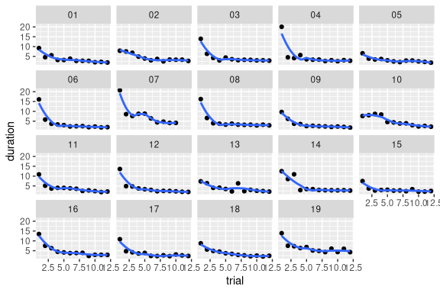
Figure 2: Observed duration to task completion with LOESS overlay.
_{Source: Article Notebook}

Fitted learning curves
_{Source: Article Notebook}
_{Source: Article Notebook}
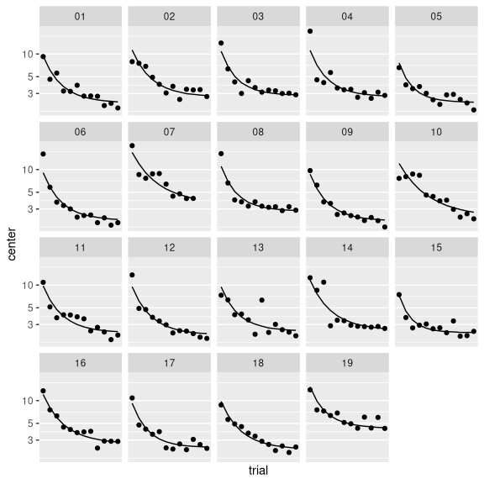
Figure 3: Fitted individual learning curves
_{Source: Article Notebook}

Population level effects
Table 2 shows the population-level estimates, representing the average learning curve. Learning efficiency is $0.4368073$, which means that every new trial cuts task duration to slightly more than a half (relative to maxp), with some uncertainty about the true value. Previous experience is estimated to practically zero. Maximum performance is estimated to be slightly less than a minute ($0.9074563$), with high certainty.
_{Source: Article Notebook}

Errors
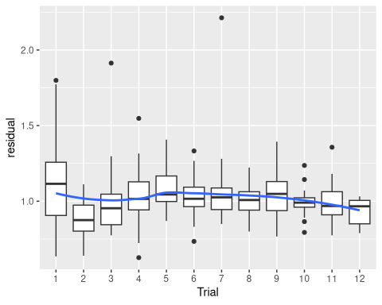
Figure 4: Posterior predictive checks for the fitted model (M_2). Residuals are multiplicative.
_{Source: Article Notebook}
Figure 4 shows the distribution of (multiplicative) residuals across trials. In the ideal case, this is independent of trial, which is approximately the case, except for the first three trials, where the first trial produce longer durations, briefly followed by an opposite trend. This bias, if systematic and not just a random fluctuation, is critical only when estimating very short training sequences.

Trainee level effects
Trainee-level random effects represent the deviation of each trainee from the population-level learning curve. For example, a positive random effect for learning efficiency indicates that a trainee learns faster than average.
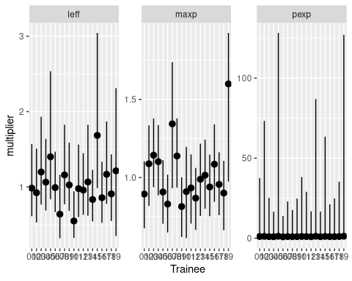
_{Source: Article Notebook}

Predictions and biases
If the question of the study is to predict future performance, it is important to know how much data is required to make useful predictions and whether any biases exist with shorter learning sequences.
As we do not have a ground truth to compare the predictions to, we can only compare the estimates of the model when fitted to incomplete data. In the following, we compare the estimates of the full-data model ($M_{2}$) to estimates of the same model but with the data reduced to the first seven trials ($M_{5}$) and the last seven trials ($M_{6}$).
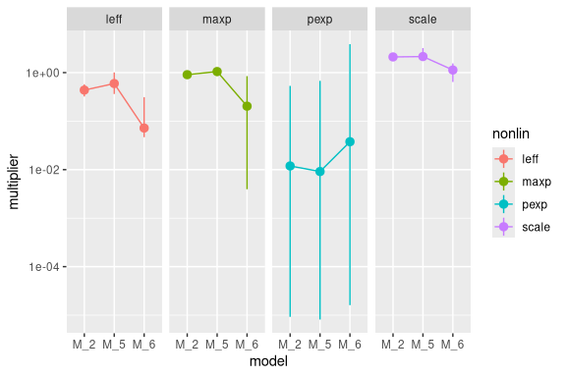
Figure 5: Robustness of population-level estimates with reduced data sets (M_5 and M_6).
_{Source: Article Notebook}
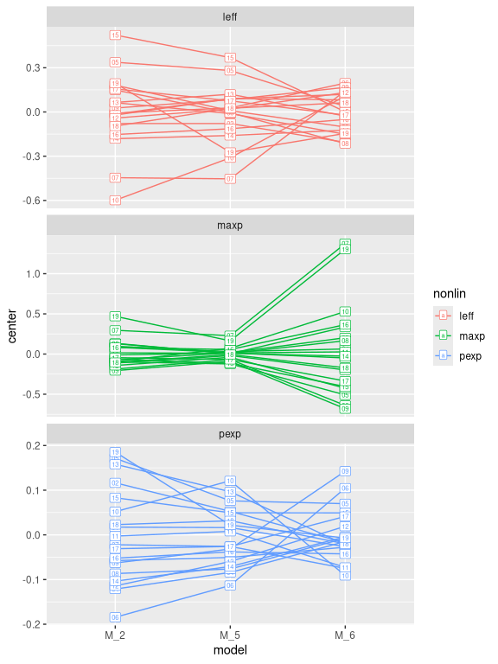
Figure 6: Robustness of participant-level estimates with reduced data sets (M_5 and M_6).
_{Source: Article Notebook}
Comparing M_5 to M_2 in Figure 6 shows two main patterns: With only seven trials the rank order of the trainees is already stable on all three parameters, with only two outliers (trainees 19 and 10). Second, all three parameters regress towards the sample mean when less data is available. This is not a bias, but a feature of multi-level models called shrinkage. For a predictive system this is a desirable property as can be seen at two extreme: if a decision maker had to predict the performance of the next trainee before any individual data becomes available, the best guess is the average learning curve Table 2. By gradually giving more weight to the individual parameters, the model predictions are always conservative. Shrinkage also allows the researcher to perform pairwise comparison without having to adjust for multiple comparisons, which is immediately relevant for trainee selection.
In contrast, removing the first five trials ($M_{6}$) leads to a somewhat higher estimate for pexp, as expected, but also introduces biases. On the population level, leff, maxp and scale are all estimated lower than before, whereas on the trainee level the order of trainees is well preserved for maxp, but not for pexp and leff.

Discussion
…
The newly introduced parameter pexp is particularly interesting, as it captures the effect of previous experience on the learning trajectory. This makes it a potentially powerful tool for quantifying transfer effects, which are often difficult to measure with traditional learning curve analyses. By estimating pexp, we can directly assess the effectiveness of any preparatory activities, such as box trainers or simplified tasks, in terms of their contribution to effective training time. This has practical implications for curriculum design and the optimization of training programs.

Limitations
- In contrast to most common learning curve models, we used four parameters to describe the learning process. While this is a strength in terms of interpretation, it introduces the risk of unidentifiability, which is mitigated by the use of population-level parameters and regularizing priors. This implies that the model cannot estimate a single learning curve, although that may be required by the situation (e.g. an adaptive training). In the Bayesian framework, this resolved by establishing a strong prior on the scale parameter using an adjustment sample of trainees.
- The model assumes that tweaks have equivalent impact, which is unlikely to be the case in real learning processes. While the empirical example shows a good fit to the data despite this simplification, future work could explore extensions of the model that allow for heterogeneous tweak effects, such as a power law or a mixture of exponentials.
- While the idea of estimating previous performance is intriguing, in the example data it was not possible to estimate it with a useful level of certainty. We believe that this is a consequence of the relatively high learning rates, which leads to a lack of repeated measurements in the early learning phase, where the effect of previous experience is most pronounced. Future work could explore this parameter in training scenarios with slower learning rates, such as more complex tasks or trainees with less prior experience. Another possibility is to use shorter periods of trials.

