**The Land**

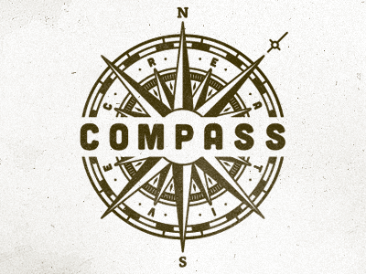



Earth Tone Color Scheme: <http://www.creativecolorschemes.com/resources/free-color-schemes/earth-tone-color-scheme.shtml>