Measure intensity
1.0.0

Fiji Macro and R Script

Christopher Schmied

Prerequistes
Fiji https://fiji.sc/
R https://www.r-project.org/
Rstudio https://posit.co/

For the R script to work you need to install (http://www.sthda.com/english/wiki/installing-and-using-r-packages)
plyr, ggplot2, tidyvers, openxlsx and ggsignif

IMPORTANT: This is a script that it is tuned to a specific dataset. I made no provisions for easily adapting the processing parameters. Using it on a different dataset will maybe result in wrong segmentations.

Expected input file
Prepare the input images in an input folder. I recommend a separate folder for the result files.
The macro will only run if the input files adhere to the following requirements:
- 3D stack
- Channel 1: Nuclei
- Channel 2: Measurement channel

Introduction

Documentation:
https://www.notion.so/Measure-Intensity-Alessia-Petrella-0972ef2c22fe45d98f3d1c85ca0ddaca

Image analysis

Mean intensity was measured per field of view on segmentations of the nuclei area as well as the cell area (excluding the nuclei) using a ImageJ/Fiji (*Schindelin, J., et al. (2012). Fiji: an open-source platform for biological-image analysis. Nature Methods, 9(7), 676–682. [doi:10.1038/nmeth.2019](https://doi.org/10.1038/nmeth.2019)*) batch macro.

Segmentation of nuclei area

The nuclei area per field of view was segmented based on a maximum intensity projection of the DAPI channel. The projection was then filtered using a median filter with a radius of 5 px. Background was subtracted using the rolling ball background subtraction method using a sliding paraboloid. An automatic intensity threshold based on the Huang algorithm was used for segmentation. Small segmentation fragments of less than 50 square micron was used to filter out smaller objects from the segmentation mask.

Segmentation of cell area

The cell area was segmented based on a maximum intensity projection of the measurement channel. A Guassian filter with a sigma of 10 px was applied to the projection. An empirically determined global background value was used for background subtraction. An automatic intensity based threshold was applied using the Triangle algorithm. Smaller objects of less than 50 square microns were filtered from the binary mask. For creating the final cell area mask for measurement the nuclei mask was subtracted from the cell mask.

Measurement

For the intensity measurement only an sub-stack was projected using an average projection. To automatically determine this sub-stack first the on average brightest slice was determined in the DAPI channel (approximation for the slice with the best focus). The average projection was performed 5 slices above to 5 slices below the brightest slice. Mean intensity was then measured in the segmentation of the nuclei as well as the cell area. The entire cell area was also measured per field of view.

Run the macro
Drag and drop the script into Fiji to open it.
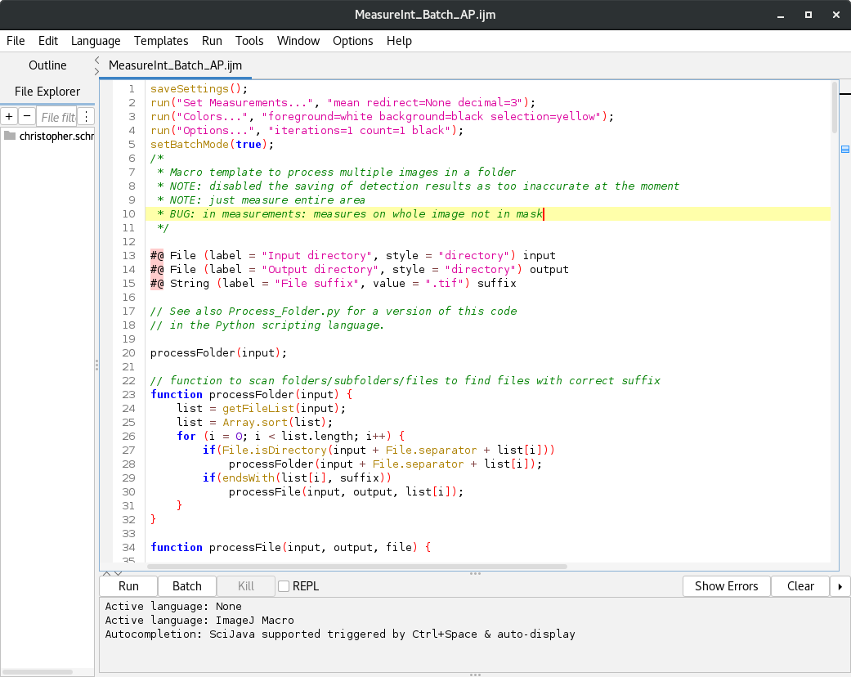
To run the macro press Run.

The script then asks for input and output directories as well as the input file format.
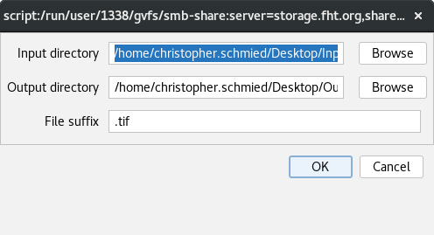

It then performs the described image analysis of the input stacks. IMPORTANT: if the input files deviate from the expected file structure the script breaks. Also if the image quality changes the used settings will not work and produce unexpected results.

Image analysis results

There are the following result files
<image_name>_area.csv
<image_name>_MeasCell.csv
<image_name>_MeasNuc.csv
<image_name>_segRes.tif

The <image_name>_segRes.tif file saves the segmentation result of the nuclei segmentation (Channel 1 – green), cell are segmentation (Channel 3 – magenta) over the measurement channel (Channel 2 -gray scale).
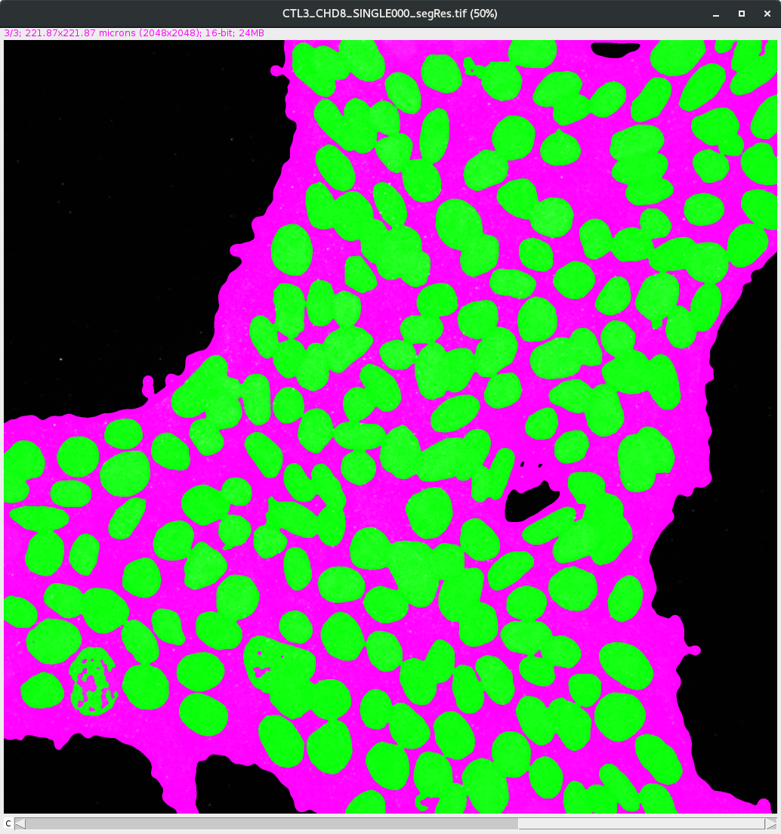

The result tables (<image_name>_area.csv, <image_name>_MeasCell.csv, <image_name>_MeasNuc.csv) save the different analysis results. I wrote an Rscript for their analysis.

Collect results and plot

Open the MeasureInt_Analysis.R file in Rstudio.
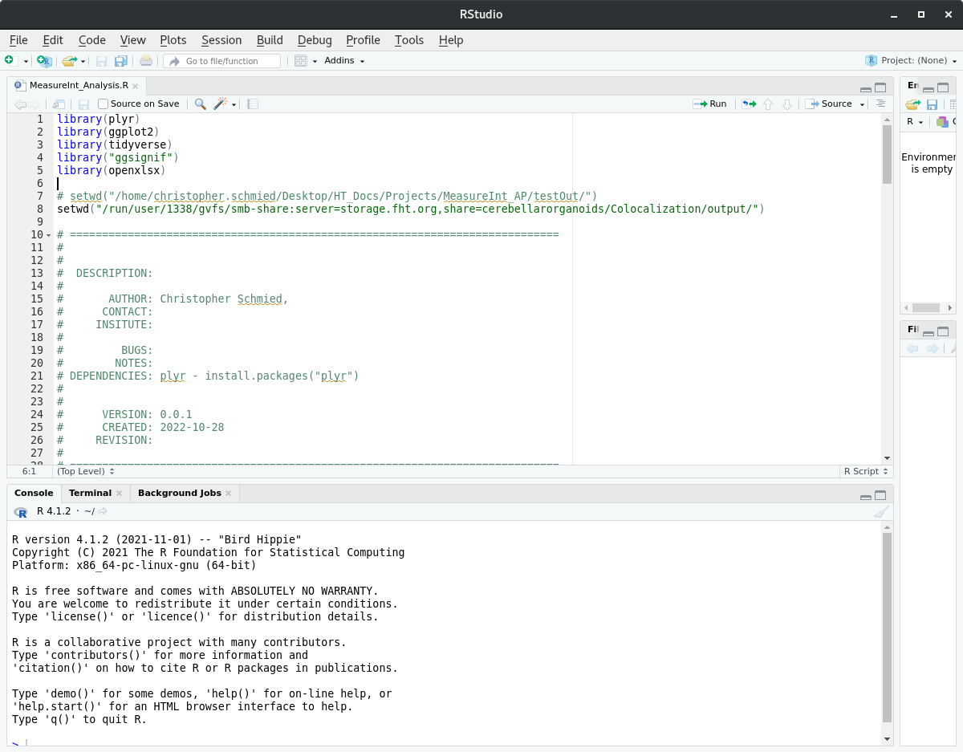
Change the location of the working directory to the location of the output files (lines 7, 8):
Press Source (Upper right corner) to run the script.

R script results

The result table (measureInt_result.xlsx) will be written in the working directory.
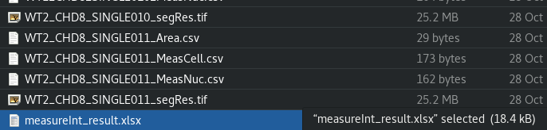
The plots will appear in the Plots window of Rstudio (lower right corner – Plots):
