## Python Tools

used in MusicMood

(website: http://sebastianraschka.com/Articles/2014_musicmood.html; github: https://github.com/rasbt/musicmood)

**pandas** - Python Data Analysis Library

**scikit-learn** - Machine Learning in Python (classification, regression, clustering, …)

**hdf5** - lets you store huge amount of numerical data

**Natural Language Toolkit** - classification, tokenization, stemming, tagging, parsing, semantic reasoning

# NAIVE BAYES AND TEXT CLASSIFICATION

(http://sebastianraschka.com/Articles/2014_naive_bayes_1.html#3_1_2_stop_words)

## THE BAG OF WORDS MODEL

* **feature extraction**
  + dictionary: non-redundant items
  + vectorization: construct d-dimensional feature vectors

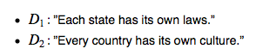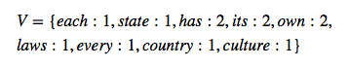

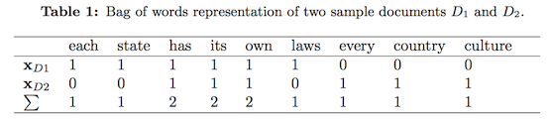

* **tokenization**
  + break down text corpus into individual elements

-> input for natural language processing algorithm

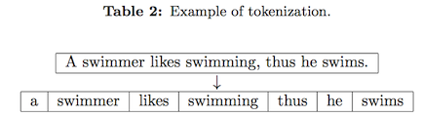

* + remove stop-words
    - * search against language specific stop word dictionary OR
      * create a stop list by sorting all words in the entire text corpus by frequency
      * then remove all stop words

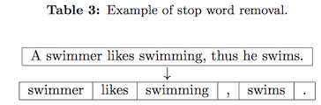

* + stemming and lemmatization *-> use natural language tool kit!!!*
    - * stemming: transform words into root from

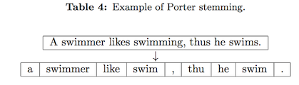

* + lemmatization: obtain canonical forms of words (lemmas)

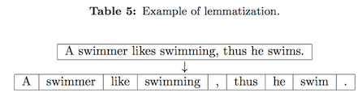

* **construction of n-grams**
  + define tokens as sequence of n items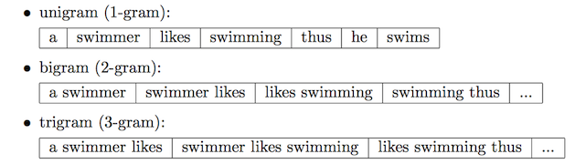
* **multinomial naïve bayes** *(characterize text documents)*
  + term frequency

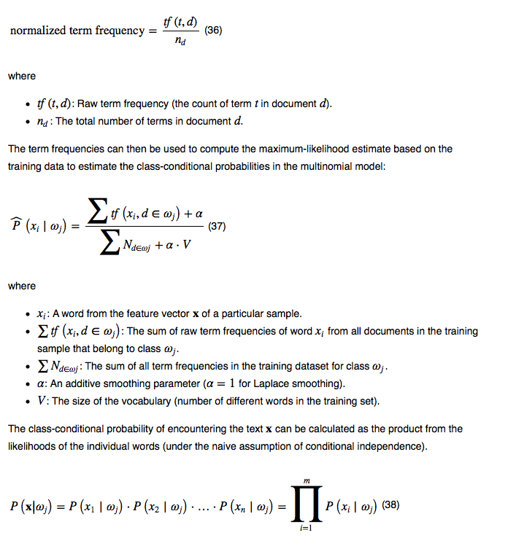

* + Term Frequency - Inverse Document Frequency (Tf-idf)

*-> often used in related papers*

* + - Weighted term frequency

*(useful when stop-words still in text)*

* + - assumes that the importance of a word is inversely proportional to how often it occurs across all documents

