Jacked

The Shadowrun Matrix Tower Defense Game

1. High Concept

The player selects their load out of attack and defense programs and uses them to protect their persona while trying to break into various data servers to extract the data they were hired to take.

1. Genre

Tower Defense

1. Game Play

Like in classic tower defense you have your programs (towers) to use to protect your persona from the ICE (attackers) so you don’t get burned. You select your load out determined by how much memory your deck allows. The stats of your deck and your programs current level determines how well you perform. Programs are upgradable to a maximum level. You can purchase new decks with the creds (money) you earn from completing missions.

1. Features
   1. Multiple, upgraded programs to use
   2. Upgradable deck
   3. Multiple data centers to crack
   4. Increase / pause game speed
2. Setting / Story

You are a shadowrunner in the year 2058, one whose weapon of choice is a cyberdeck and their wits. You are hired to break into various corporations and steal their data so that you can get paid. While improving your reputation you can get better jobs, which means more creds and that is never bad. As a decker you, jack into the matrix and traverse the world in which the one with quicker fingers and a fast CPU determines who will come out on top.

1. Target Audience

Teens, Adults

1. Hardware Platform

PC

1. Budget and Estimated Schedule
   1. Software: Gamemaker 8.1 – Free
   2. Programming: Self – Free
   3. Graphics: Sega Shadowrun game and other Creative commons - Free

Programming on own and using free graphics & sounds this project will cost nothing.

Estimated time to complete this project is 8 weeks.

1. Competitive Analysis
   1. Desktop Tower Defense: Classic tower defense that has no paths but the AI finds the shortest path.
   2. Ghost Hacker 1 & 2: Closest look and feel to Shadowrun where inside the “matrix”. It has you able to play both sides, attack and defense.
   3. GemCraft: Stat tracking. Big map. Lots of upgradability.
2. Team

Design and Programming: Joseph Schmidt

1. Summary

Wanting to create a nostalgic game for the older generation to remember the good ol’ days of games while drawing in the younger crowd to show them what a great IP Shadowrun is.

There will be many options to expand upon after initial release of game. In order to make project do-able in the allotted amount of time, I am holding back on a lot of design features that would like to see in game.

1. 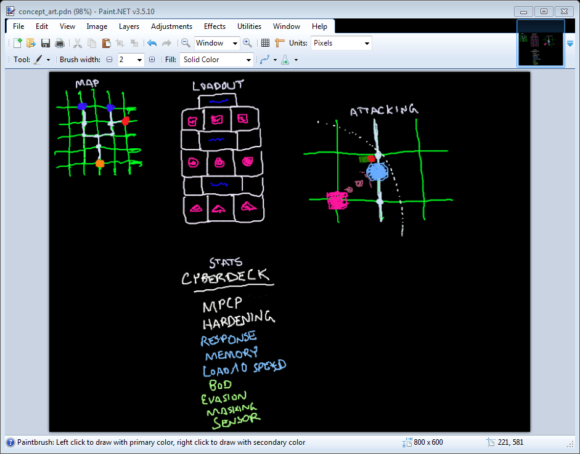Concept Art



