Gallery 404

David Schmudde1

1 Chief Technology Officer, Yorba, Berlin, Germany

d@schmud.de

**Abstract:**

Digital artifacts are trivial to copy but very difficult to preserve. [*Gallery 404*](http://www.netart.today/) highlights over twenty years of misplaced and broken digitally native works of art from the net.art movement.

net.art embodies the output of a generation of web pioneers. Much of it has already been lost to time. *Gallery 404* responds to this loss of culture by showing the work as it naturally appears on today’s world wide web. The pieces feature missing plugins, broken links, fatal errors, mismanaged URLs, API issues, and incompatible stylesheets. Digital rot is foregrounded in an emphatic statement on the value of culture in cyberspace.

**Keywords:** fine art, internet history, net art, art preservation, telematic art

# Description

[*Gallery 404*](http://www.netart.today/) collects and displays hyperlinks to prominent net.art artworks on the world wide web. These links point to a place where net.art happened. The links are displayed along side of more traditional media: written biographical information and images of the artwork’s current state.

The holdings of *Gallery 404* no longer function as the artists originally intended. Each artwork has yielded to the passing of time. But like all things computable, time passes faster in a digital space. Some of these works are less than a decade old.

*Gallery 404* is net.art today. Much of what was created by the first generation of digital natives is now broken. While some works of net.art have benefited from institutional preservation, even these are vulnerable to software updates, infrastructure changes, and negligence.[1] As software eats the world, it also consumes itself.

## The Preservation of net.art

net.art is a peculiar art form. Its growth paralleled the emergence of the commercial internet. The lack of a formal language or framing device made the work difficult to spot; “art” websites and “non-art” websites looked similar. There were few celebrity practitioners and virtually no exhibition spaces.

The net.art movement liberated artists and audiences from Duchamp-style Modernism. Duchamp’s Modernism crystallized when the artist submitted Fountain, a urinal bought at a hardware store in Manhattan, to the Society of Independent Artists exhibit in 1917. Fountain brought the power of art-signifying frames to the forefront: “this urinal is art because it is being exhibited as art.”

net.art lacked an equivalent to trendy exhibition spaces, deliberate lighting, and expensive picture frames. The blurred boundaries were reflected in pieces such as [*Airworld*](https://sites.rhizome.org/anthology/airworld.html) and website awards like Alexei Shulgin’s [*WWWART MEDAL*](http://www.easylife.org/award/), which presented “non-art” websites awards for providing a “definite ‘art’ feeling” (Murakami 2013).

While much has been written on how the “[internet never forgets](https://www.nytimes.com/2010/07/25/magazine/25privacy-t2.html)”, much of what was created in the last twenty plus years has disappeared from neglect or deliberate corporate purging. This includes countless websites, Flickr (2019), and Tumblr (2018) accounts, all of Google+ (2019), all of Geocities (2009), and 50 million songs by 14 million artists on MySpace (2003-2015) (Le 2020, Shaban 2019).[2]

net.art was a generation’s attempt to plant a cultural stake in cyberspace. Their work is a reflection of what the internet was and could be. But the cultural artifacts of the first digital natives are quickly being lost to time. *Gallery 404* presents this broken history in its unvarnished reality.

## Historical Context

The world wide web is just one part of the internet. Some historical context will help convey the difference between net.art and the [telematic art](https://en.wikipedia.org/wiki/Telematic_art) that existed in the years prior (Frazer 1995, Hoffmann 2020).

* 30 August 1969: the ARPANET, an early military computer network, comes online in the United States. The network is used to coordinate information and share computing resources.
* 15 July 1980: Minitel, a popular public computer network, comes online in France. This network is used to provide online services to the general public.
* 1 January 1983: the ARPANET adopts TCP/IP, the fundamental protocol of today’s internet. The usage of the internet expands to fulfill many governmental and academic interests.
* 12 March 1989: Tim Berners-Lee proposes the world wide web (www) in Information Management, a Proposal.
* 6 August 1991: Tim Berners-Lee publishes the first website on the internet.
* 2 October 1992: the [Scientific and Advanced-Technology Act](https://www.congress.gov/bill/102nd-congress/senate-bill/1146) is passed, allowing the US taxpayer-funded internet backbone (NSFNET) to “be used substantially for additional purposes” beyond research and education (i.e. commercial use).
* April 1995: the world wide web becomes the most popular service on the internet backbone (NSFNET).
* 30 April 1995: the public internet backbone (NSFNET) is officially decommissioned, marking the birth of today’s commercial internet.

net.art arrives in the early 1990s, after the invention of the world wide web and the legislative move to open the internet up for “additional purposes.” Artists immediately created work that reflected the cultural milieu of the time. For example, the internet started to shift from interoperable public spaces to siloed corporate spaces by the turn of the millennium; parallel concerns about the corporatization of the internet are reflected in prominent net.art artworks like [*Toywar*](http://history.etoy.com/stories/entries/49/index.html) (1999) and the aforementioned [*Airworld*](https://sites.rhizome.org/anthology/airworld.html) (1999).

It can be difficult to see a technology’s implicit political bias decades removed from its use. Today’s centralized algorithms for search (Google) and social (Facebook) are fundamentally different than yesterday’s homespun [webring](https://en.wikipedia.org/wiki/Webring). Cultural artifacts are the best evidence of what kind of internet is not only possible, but just as plausible.

# References

**Frazer, Karen D.** 1995. NSFNET: A Partnership For High-Speed Networking, Final Report 1987-1995. Merit Network, Inc. https://www.merit.edu/wp-content/uploads/2019/06/NSFNET_final-1.pdf.

**Hoffmann, Jay**. 2020. “The Web’s Timeline 1989-1994.” The History Of The Web. https://thehistoryoftheweb.com/timeline/?date_from=1989&date_to=1994.

**Le, Vivian**. 2020.“The Lost Cities Of Geo.” 99% Invisible. https://99percentinvisible.org/episode/the-lost-cities-of-geo/.

**Murakami, Kenta**. 2013. “The Demise Of Net.Art: A Look At Artifacts Past.” *Digital America*. https://www.digitalamerica.org/the-demise-of-net-art-a-look-at-artifacts-past-kenta-murakami/.

**Shaban, Hamza**. 2019. “Loss Of Old Myspace Artifacts Highlights The Impermanence Of The Web.” The Seattle Times. https://www.seattletimes.com/business/loss-of-old-myspace-artifacts-highlights-the-impermanence-of-the-web/.

# Appendices: Technical requirements and documentation

* *Gallery 404* is hosted on [GitHub Pages](https://pages.github.com/) here: [http://www.netart.today](http://www.netart.today/).
* The page is generated using Clojure.
* The *Gallery 404* [GitHub Repository](https://github.com/schmudde/netart.today) provides deep insight into the information collected for each artwork and instructions for artwork submissions.
* External Dependencies: [Goat Counter](https://www.goatcounter.com/) for site analytics.

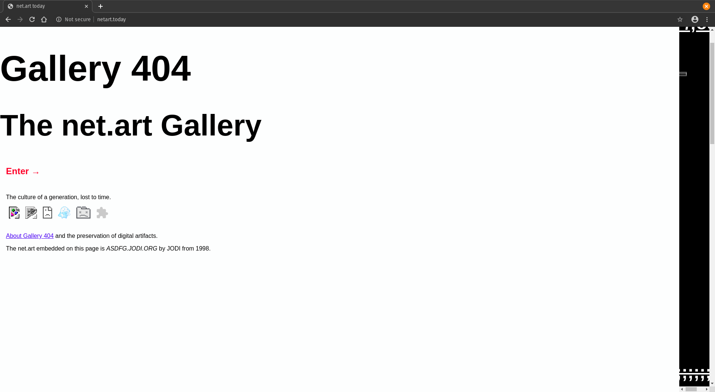Figure 1: Gallery 404 landing page (http://netart.today/)

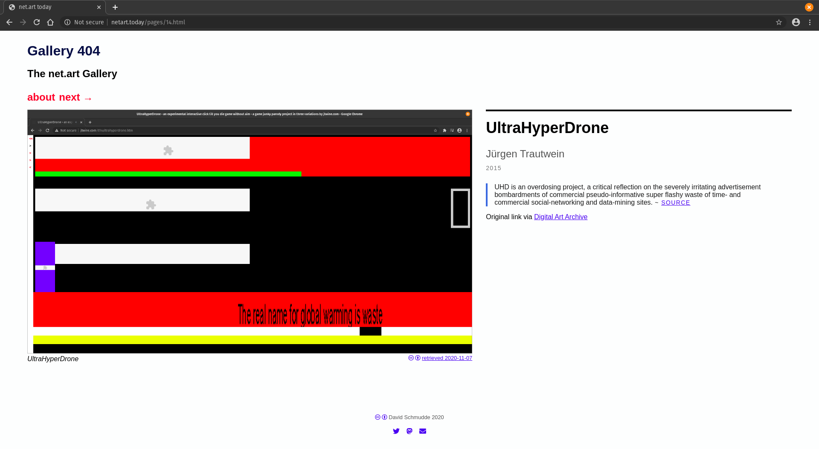Figure 2: Gallery 404 exhibition page (http://www.netart.today/pages/14.html)

1. The Whitney’s 2013 restoration of The World’s First Collaborative Sentence (Douglas Davis 1994) is probably the most salient example. As of January 2021, it no longer functions properly.
2. This is in spite of the best efforts of the Archive Team, the Internet Archive, and similar initiatives around the world.