Funambol JSON fake backend

Last modified: June 29, 2010
Revision History

Name | Date | Reason for Change | Ver./Rev.
Paulo Fernandes | 07-11-2008 |  | 1.0
Filippo Machi | 12/17/08 | Added documentation for user web application | 1.1

Table of Contents
1.Overview 4
2.Architecture 5
2.1. Implementation 5
3.Build, install and configure 6
3.1. Build 6
3.2. Install 6
3.3. Configuring the connector with fake backend 6
4.User Web Application 7
4.1. Introduction 7
4.2. Access 7
4.3. Manage backend repository 7
4.4. Add an item 8
4.5. Delete an item 10
4.6. Modify an item 10
4.7. DS database configuration 11
4.8. Deleting last sync data 12
5.References 13

Overview
The objective of this project is to provide a simple implementation of the Funambol JSON Connector API.
Funambol fake backend should implement all the methods to allow a successful synchronization using the Funambol JSON Connector. As specified in Funambol JSON connector API this application will implement a REST web-service that can be used by the connector in order to store data.
A simple web application is provided in order to let users inspect, modify or delete data stored into memory database. Using this application, you can easily simulate user interaction while running tests.

Architecture
The basic idea of the backend is to loop-back the JSON calls to the Funambol Foundation database. So, ideally you can plug the JSON connector plus the JSON fake backend, and see the system works as if the standard foundation connector is in use.
A specific UI has been developed, reachable at url syncapi/gui, to give a way to easily simulate the JSON calls (you can copy/paste JSON objects as they are send by a real backend).
In order to fully support the Funambol JSON connector, this Web-application will provide http access using the methods: POST, PUT, DELETE and GET (as specified by the API).

Implementation
The requests to the web-service are handled by a servlet and the request to a specified path (eg .../syncapi/contacts/items/12345) is parsed and redirected to the requested resource, as specified by the API all the requests and answers must use the specified JSON format.
The user web application is based on servlets too. They perform access to fake backend memory and ds server databases. Using your preferred browser, you can access this application at the url:
../syncapi/gui
the prefix depends on where you install the module. For further info, please read the configuration chapter.

Build, install and configure

Build
The Funambol fake JSON backend is a maven project and therefore can be built by running: “mvn install”. The resultant artifact will be a Funambol module and therefore it can me installed in any Funambol server.

Install
This application can be installed as a regular Funambol (.s4j) module. The install steps are the usual ones for a Funambol module:
- copy the s4j should to <Funambol_home>/ds-server/modules
- add the module name (without the extension “.s4j”) to <Funambol_home>/ds-server/install.properties file (add the name to “modules-to-install=”)
- run the install-module script.
After the successful install and the first run, you will find a log file named fake-jsonbackend.log in the ds server log directory.
NOTE: if you are installing on a Funambol Carrier Edition, and you want to be able to use the Funambol Portal to access the data, you need to manually copy the json-core-X.Y.Z.jar to webapps/ROOT/WEB-INF/lib folder.

Configuring the connector with fake backend
When configuring the Funambol JSON connector to work with a specified backend, the user is asked for a server URL, when the backend in use is the fake-backend the address should be : http://<server_address>:<server_port>/syncapi
The fake backend can provide configuration informations about the time and the timezone of the backend. You can configure the backend in order to enable or disable this behavior, in this case an error message will be sent back upon configuration request.
To do that, after having deployed the web application, you need to open the web.xml file of the syncapi web application (you can found it in ...\Funambol\tools\tomcat\webapps\syncapi\WEB-INF\web.xml).
The parameter that rules the configuration behavior is enableConfiguration as you can see in Table 1.

<servlet>
<servlet-name>JsonServlet</servlet-name>
<servlet-class>com.funambol.json.server.JsonServlet</servlet-class>
<init-param>
<param-name>enableConfiguration</param-name>
<param-value>true</param-value>
</init-param>
</servlet>

Table 1: enableConfigutarion servlet parameter

To apply changes, you need to restart the Funambol Server. The fake backend getConfiguration api is enabled by default.
Some more configuration is needed to access to the ds server database, you can provide the requested parameters accessing the user web application.
In the user web application chapter, we will show how configuration can be achieved.

User Web Application

Introduction
As we said before, you can use this web application to add, modify or delete json items stored into the fake backend, directly using the JSON format.
Besides, in order to provide an efficient tool, you can browse on the file system the json item to add.
Different approaches are allowed, you can simply upload file as well as you can decide to apply a conversion before storing content.
At the present time, the fake backend is able to handle contacts, appointments or tasks.
Note support is still under development.

Access
Assuming you installed the module inside a local bundle, you can access to the user web interface, using the following url:
http://localhost:8080/syncapi/gui
When you browse this url, a page is shown where you can choose what to do:
Manage backend repository | Following this link, you'll be able to list all types managed by the fake backend. Choosing one type, all items stored into memory database will be shown and you will be able to add, delete and modify items too.
Manage DS database | Following this link you'll be able to inspect last sync table and to delete elements in order to force slow sync.
Configure | Following this link you'll be able to configure user web interface. Actually, configuring this web application only means to configure access to the ds server database.

In the next chapters, you'll find further info about any of the listed functionalities.

Manage backend repository
If you want to inspect or modify fake backend database, you need to follow the link Manage backend repository, then a list of item types is shown. You need to choose which type you want to handle.
Choosing a type, a list page containing all items of that type is shown.
The list is arranged into a table and some precious info are provided. The different columns, as shown in Figure 1, are listed and described in Table 2:

Column | Description
Status | It's the char that describes the item status
Creation Time | It's the creation time (translated in a human readable form)
Update Time | It's the update time(translated in a human readable form)
Item Key | It's the item key
Operations | Contains the operations allowed on the item
Table 2: Columns meaning in list page

Considering the list page, you can inspect any item by clicking on the item key value.
In the footer of the page, you'll find some links that allow you to change item type, to come back to the home page or to the repository page.

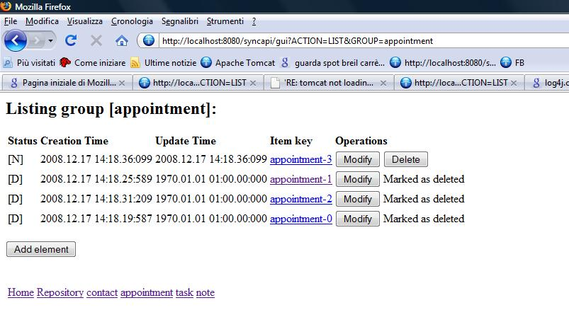Figure 1: A list of appointment
The following chapters describe operations you can apply on json items. When an operation is successfully completed, an “Operation successfully completed” page will be shown, on the contrary you'll see an error page containing error informations.

Add an item
Add operations are launched from list pages. You can start an add operation pressing the Add element button, Figure 1. Clicking on it, a new page will be shown, as in Figure 2.
Since json objects are text representations, an input text area is provided to enter text. You can enter text and click the add button. Remember, the new item is stored without performing any validity check.
You can abort add operation, clicking the cancel button.
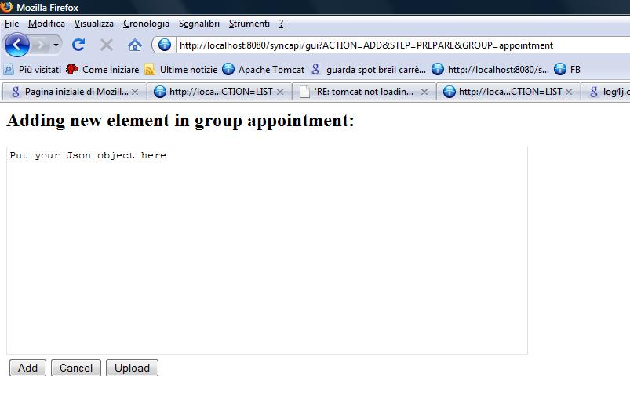Figure 2: Adding a new appointment

Anyway, to make life easier, you are allowed to upload file by clicking the upload button.
A new page is shown and you are supposed to provide some further info to complete the operation:
- input file format
- output desired format
- the file to upload

Before going on, let's take a deeper look at these parameters, considering Figure 3 .
You are allowed to specify an input format for your file, that is the format of informations it stores. Then, you need to choose the output format, deciding what kind of backend are you dealing with, that is you are deciding whether your backend receives extended format or the rfc one (see json api reference for further info).
Input format and output format depend on the type of item you're working with.
Anyway, the raw input type is always shown and means that your content need no conversion.
You can abort an upload operation pressing cancel button or you can proceed with the upload pressing the upload button.
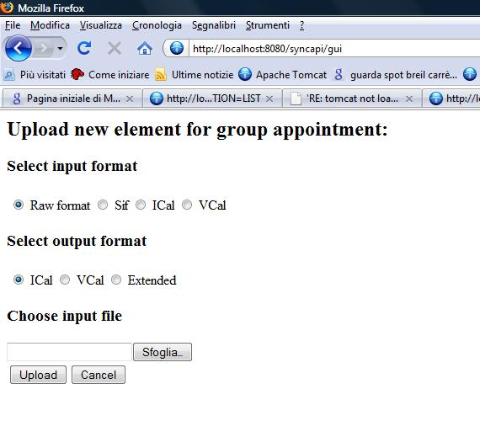Figure 3: Uploading an appointment

Delete an item
Before describing how you can delete an item, you need to know that item deletion means changing item status and it doesn't cause item physical removal from the repository map.
So deleted items are still in the list but their status is changed (D) and you cannot delete them twice.
A message is shown instead of delete button.
Delete operations are launched from list pages. For each row in the list page, you can launch such an operation using the delete button you find in the last column.

Modify an item
Delete operations are launched from list pages. For each row in the list page, you can launch such an operation using the modify button you find in the last column.
When you pressed the button, the page in is shown and you can change item content as you want.
You need to press the update button to commit change you made or the cancel button to discard them and keep the original item ad depicted in Figure 4.
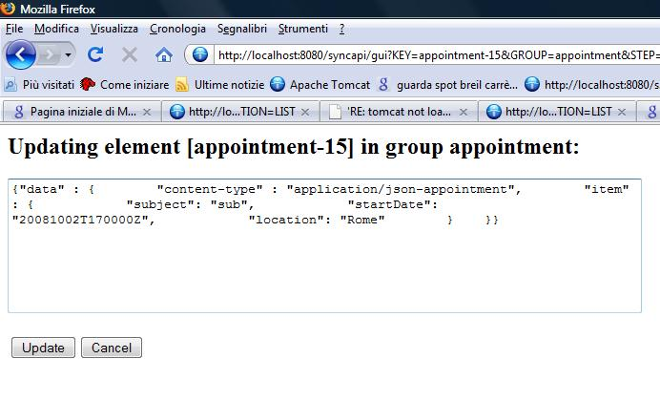Figure 4: Updating an item

DS database configuration
Accessing ds database requires you to provide some details: a jdbc driver, a user, a password and a database url. Those informations allow to build database connection pool used to execute query or to delete last sync elements.

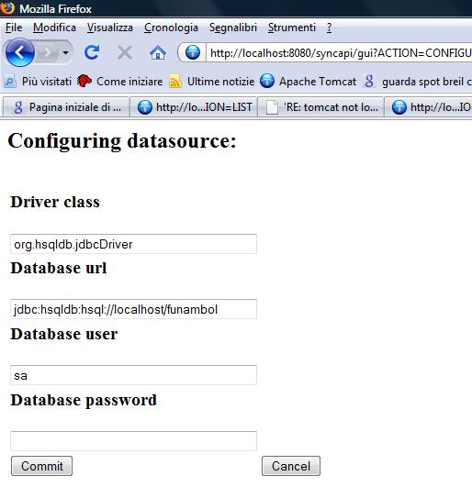Figure 5: Configuring datasource
You can configure ds database accessing to the Configure page and then to the Datasource page.
After having set database details in the configuration page as shown in Figure 5, you can commit changes pressing commit button or you can abort the configuration, pressing cancel button.

Deleting last sync data
Accessing to page Manage DS database, a complete list of all last sync values stored into the ds database will be shown, see Figure 6.
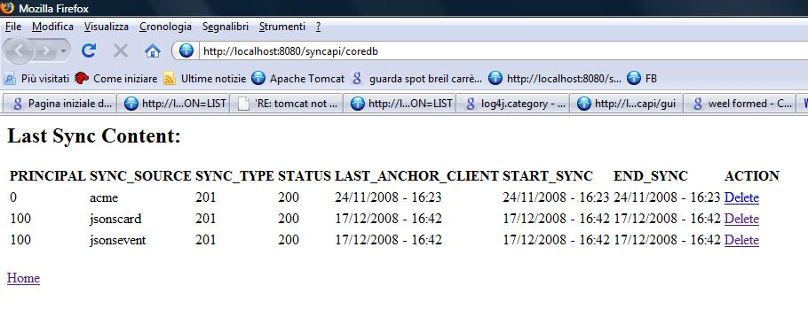Figure 6: Managing DS Last Sync
This page allows you to delete last sync data in order to force a slow sync to happen.
To delete an existing slow sync, just click on the Delete link you can find at the end of the row you're interested in. Pay attention in choosing the right row, last sync deletion cannot be rolled back.

References
* Funambol JSON API connector design document

