USER-FRIENDLY FLOWSHEET EDITOR

Simulation starts with a definition of the flowsheet that is drawn initially on the computer monitor screen using a graphics editor that is tailored specifically to the task of drawing flowsheets. The editor has an extensive array of icons which represent all the mineral processing unit operations that are encountered in practice. The editor can be used to quickly modify the flowsheet structure and to replace existing units.

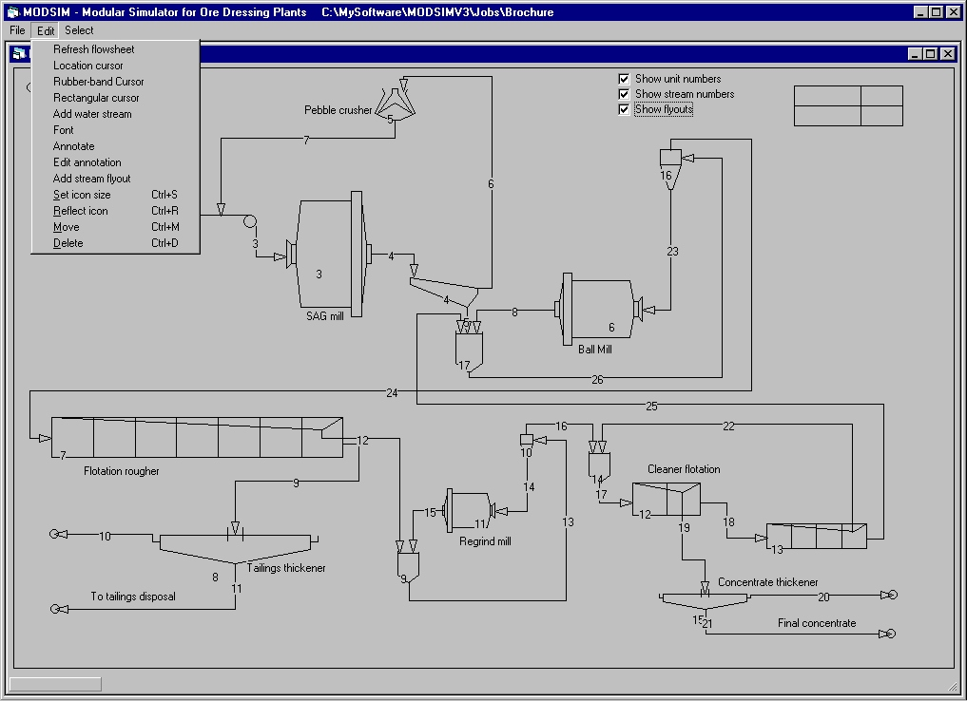

DATA SPECIFICATION

Data processing plants must describe the characteristics of the material to be treated, the production rates required and the details of the unit operations that are included in the flowsheet. The processing units are described in terms of their physical characteristics and in terms of the parameters of the mathematical models that describe the operation of physical equipment. MODSIM is based on the population balance method and is therefore capable of accounting accurately for variations in particle size and mineral liberation characteristics together with other critical properties such as density, mineralogical texture, elemental composition, magnetic susceptibility, energy content etc. Data structures incorporate mineral and coal processing flowsheets.

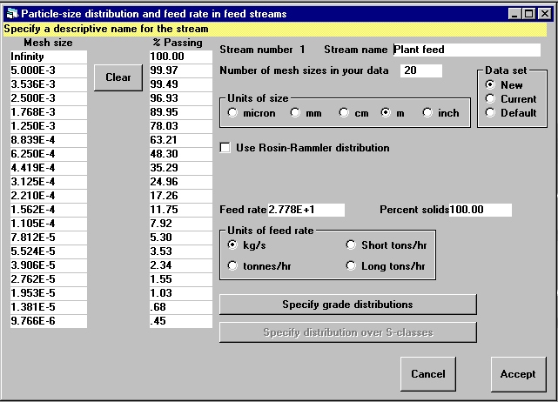

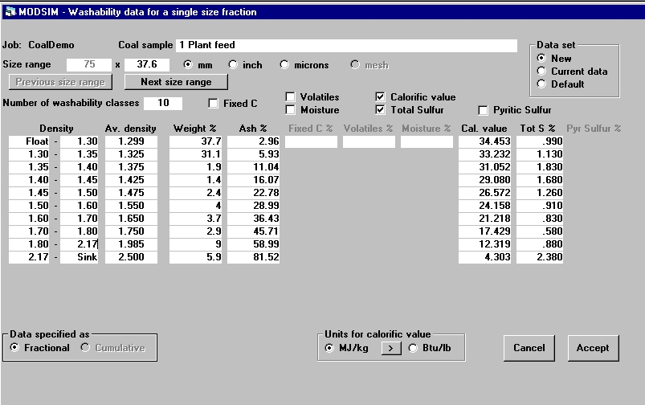

DATA OUTPUT

A range of graphical, tabular and text output features are provided to allow rapid and clear presentation of simulation results. All output can be copied to most word processing systems for convenient and effective report production. Graphics can be exported as encapsulated PostScript or Windows metafile.

MODELS

A wide array of models for the unit operations is supplied. In most cases alternative models are available so that the user can investigate the differences between different models of the same unit. Most of the significant models that are available from the scientific literature are included. User specified models for any unit can be easily incorporated. Model selection is fully interactive so models can be changed with a simple mouse click.

INTEGRATED FLOWSHEETS

MODSIM simulates integrated flowsheets including crushing, grinding, gravity separation, and magnetic separation.

FEATURES

- Fully interactive user-friendly software.
MODSIM runs under Windows 95, Windows 98 and Windows NT. The software is designed for convenient , intuitive operation to minimize time-wasting learning. Basic user proficiency is achieved in less than 1 hour. No special training in computing modeling or simulation is required.

- Full implementation of Andrews-Milea liberation modeling of mineral liberation in ball and rod mills.

- Comprehensive documentation includes full description of mathematical modeling methods and detailed description of all models that are used. A comprehensive user manual is provided.

- Open ended software allows new models to be incorporated easily.

- Direct import of mineral liberation data SEM or optical microscopes through the MMIA image analysis software system.

6. Automatic calculation of recycle streams including regrinding.

