MODular SIMulator
for
Mineral Processing Plants
TM
MODSIM

USER MANUAL


Mineral Technologies International, Inc.

MODSIM™

Modular Simulator for
Mineral Processing Plants

User Manual
12th Edition
July, 2009

Mineral Technologies International, Inc.
1147 East 700 South
Salt Lake City, UT 84102 USA
Phone: +1 (801) 401-7115
Fax: +1 (801) 880-2645
Email: info@mineraltech.com

Copyright © 1998-2004 R.P. King
Copyright © 2005-2009 Mineral Technologies International, Inc.
All Rights Reserved
Printed in the USA

This manual and the software it describes are copyrighted with all rights reserved. No part of this publication may be produced, transmitted, transcribed, stored in a retrieval system, or translated into any language in any form by any means without the written permission of Mineral Technologies International, Inc.
TABLE OF CONTENTS

1 WHAT IS MODSIM? 1
2 HOW TO USE MODSIM 3
3 THE GRAPHICS EDITOR 5
3.1 Drawing Icons on the Flowsheet 6
3.2 Drawing Streams on the Flowsheet 7
3.3 Changing Icon Size or Orientation 9
3.4 Deleting Icons or Streams from a Flowsheet 9
3.5 ANNOTATING THE FLOWSHEET 9
3.6 Saving Flowsheets 11
3.7 Attaching Unit Models to Icons 11
3.8 Pseudo Streams 11
3.9 Saving the flowsheet 11
3.10 Printing the Flowsheet 12
3.11 DATA ENTRY 13
3.12 Specifying the System Data 13
3.13 Setting up the Grade Classes 15
3.14 Setting up the S-classes 18
3.15 Setting the Convergence Properties 19
3.16 SPECIFYING THE DATA IN THE PLANT FEED STREAMS 20
3.17 Specify the Distribution over Grade Classes 23
3.18 Specify the Distribution over the S-classes 23
3.19 Specify Water Feeds 24
3.20 Specifying Data for Internal Flow Streams 25
4 SPECIFYING PARAMETERS FOR THE UNIT MODELS 27
5 THE UNIT MODELS 29
5.1 Comminution Models 29
5.1.1 Crushers 29
5.1.2 Grinding Mills 36
5.2 Models for Classifiers 63
5.3 Models for Dewatering Operations 77
5.4 Models For Stream Splitters And Mixers 80
5.5 Models for Concentrating Units 81
5.5.1 Flotation 81
5.5.2 Gravity Separation Operations 85
5.5.3 Models for Magnetic Separators 91
5.6 Models for Material Transport 95
5.7 Models for Coal Washing Units 95
6 RUNNING THE SIMULATOR AND GETTING RESULTS 101
6.1 The Output Data File 102
6.2 Graphs of the Particle Size Distributions 103
6.3 The Liberation Spectra 105
6.4 The Report File 106
6.5 Driving the simulator from the flowsheet 108
6.6 Repetitive Simulations (Professional version only) 109
7 COAL WASHING PLANTS 111
8 WRITING SUBROUTINES FOR UNIT MODELS 113
8.1 Model Subroutine Structure 113
8.2 Accessing System Data in Model Subroutines 116
8.3 Accessing Unit Model Parameters 117
8.3.1 Using the standardized parameter input form 117
8.3.2 Adding new parameter input forms 117
8.4 Handling Water Feeds in Unit Subroutines 118
8.5 Handling Pseudo Streams in Unit Subroutines 118
8.6 Setting up the Report File 118
8.7 An Example of a Unit Model Subroutine 118
8.8 An Example of a Parameter Input Entry in File MODQUES.DAT 119
8.9 Inserting new Models for Units 119
8.10 Adding new icons to Modsim 120
9 TROUBLESHOOTING 122
10 INDEX 124

WHAT IS MODSIM?

MODSIM is a simulator that will calculate the detailed mass balance for any ore dressing plant. The mass balance will include total flowrates of water and solids, the particle size distribution of the solid phase, the distribution of particle composition and the average assay of the solid phase. The assay can include mineralogical composition, metal content and element content. Other special particle properties that are specific to particular systems can also be accounted for. Some are calorific value, volatile matter, pyritic sulfur, organic sulfur and ash content for coal, and magnetic susceptibility and electrical conductivity for mineral systems that are processed by magnetic or electrostatic separators. Other, sometimes very subtle, particle properties such as particle shape, mineralogical texture and surface characteristics have important influences on the behavior of some of the unit operations of mineral processing. MODSIM can accommodate all of these particulate properties. The main unit operations of ore dressing include the size-reduction operations, crushing and grinding, classification operations for separation of particles on the basis of size, concentration operations that separate particles according to their mineralogical composition and solid-liquid separations. MODSIM provides a repertoire of standard models for these operations.

MODSIM has a completely modular structure which allows models for the unit operations to be added into the simulator. Thus the models that are used to simulate the operation of the various unit operations can be developed and modified to suit the plant under any operating conditions and can be tuned to meet the needs of any application. This characteristic of MODSIM also allows the user to develop and incorporate the results of ongoing research in the mathematical modeling of the unit operations of mineral processing. The repertoire of models available to the system increases continuously as more are added by users. The user can call on any available model.

MODSIM calculates the composition and completely characterizes the particulate material in each stream of the plant. The output includes the total flowrates of water and solid, the particle-size distribution and the distribution of particle composition over the particle population as well as the detailed assay of each stream. In addition a comprehensive report is produced for the performance of each unit in the plant. The report will vary according to the duty that the unit must handle in its position in the flowsheet. The data in the report can be used for detailed unit design and sizing, for unit costing, for equipment selection and for equipment and process evaluation.

MODSIM is unique among currently available simulators in that it can simulate the liberation of minerals during comminution operations. This aspect of mineral processing plant operation is becoming increasingly relevant as plant managers seek greater operating and plant efficiency.
MODSIM is a steady-state simulator and is not designed to simulate dynamic operations. It is not suitable for the design and simulation of process control systems.

HOW TO USE MODSIM

MODSIM has been designed for convenience and speed of use. No elaborate set-up procedures are required and even complex ore dressing plants can be successfully simulated in no more than a few hours. The operation of the system allows the user to concentrate on the metallurgical application and the user is not distracted by specific computational problems. Input of information is accomplished through graphic construction of the flowsheet by an easy-to-use graphic editor at the user's workstation. Numerical input is through menus and data input forms that allow quick and easy specification of data to define the properties of the ore and the operating parameters for the equipment in the plant. Output is through clearly annotated and formatted printed output supplemented by appropriate graphical representations. Output report files can be browsed from within MODSIM. Copy and paste editing is used to facilitate transfer of output data to spreadsheets and graph plotting programs of the user=s choice.
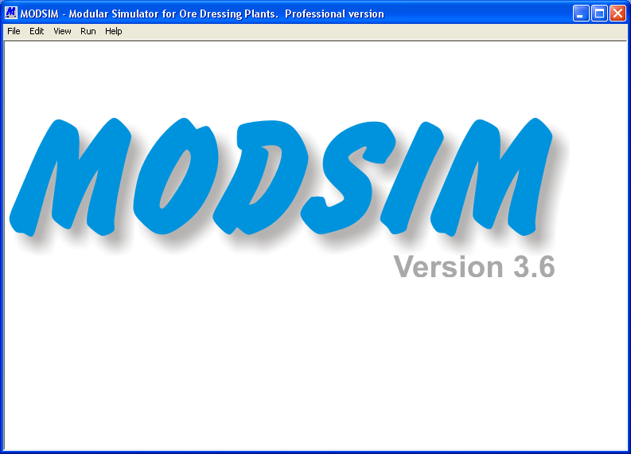
Figure 1 The main window from which the operation of the simulator is controlled.

The operation of the simulator is driven from the main menu which is shown in Figure 1.
The data and simulations are organized on the basis of individual job names. Each distinct simulation should be given a unique job name. Data and information for each job is saved under the job name so that these can be conveniently stored and recovered. Job names can be up to 80 characters. Job names must not have file extensions and MODSIM allocates various file extensions to its internal files for each job.

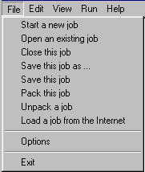
From the FILE menu you can start a new job, open an existing job that was previously saved, close the current job, and save the current job. Jobs can be packed into a single file which is convenient when transferring the job by e-mail or via the Internet.
Menu 1 The File menu

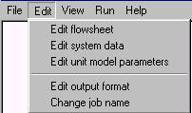
From the EDIT menu you can edit the flowsheet using the graphic editor, edit the system data, edit the models and the operating parameters, edit the output file format or change the name of the current job. The set up of repetitive simulation data can also be edited. (Professional version only). The data and simulations are organized on the basis of individual job names.
Menu 2 The Edit menu
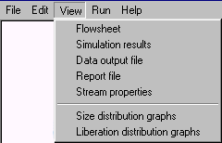
Menu 3 The View menu
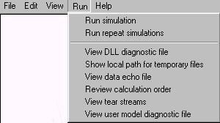
From the VIEW menu you can view the flowsheet, view the data output file, view the report file, view all the properties of each stream, view the particle size distribution and/or liberation distribution plots for any stream in the flowsheet and view the liberation spectra in any stream.
Menu 4 The Run menu

From the RUN menu you can run the simulation and view six different files that can help diagnose any problems. Repetitive simulations can also be run to help find optimal combinations of unit parameter settings. (Professional version only)

THE GRAPHICS EDITOR

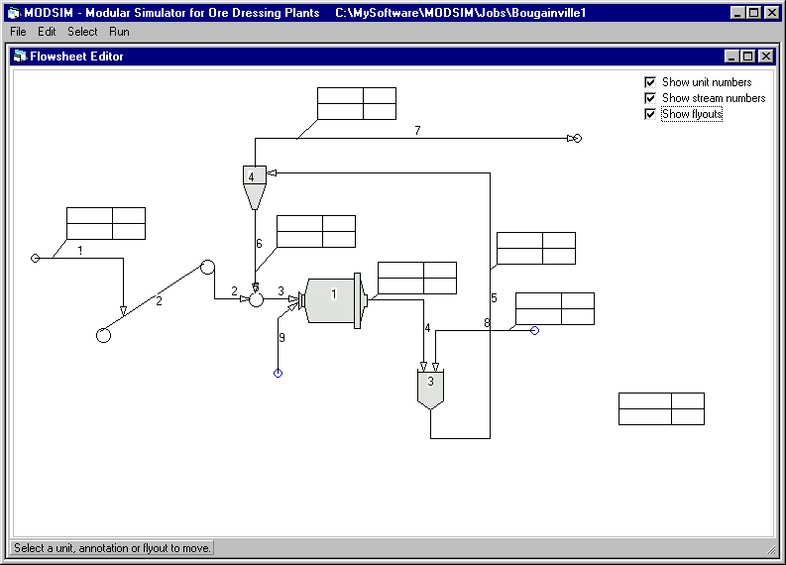
Figure 2 A typical plant flowsheet as it appears on the screen during flowsheet construction or editing using the graphics editor.
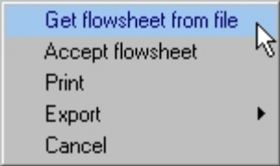
Menu 5 File menu on the flowsheet editor
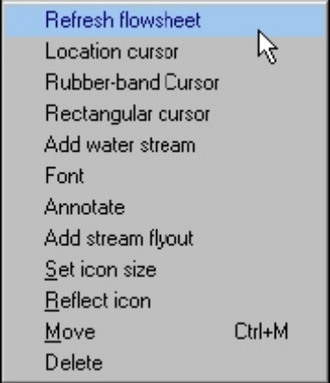
The essential description of a mineral processing plant is the plant flowsheet. This identifies each of the unit operations in the plant and defines the flow interconnections between them. Process engineers recognize and use the flowsheet to communicate plant structure. MODSIM exploits this practice and allows the user to construct the flowsheet directly on the computer screen or workstation. The flowsheet is drawn using the built-in graphic editor.
Menu 6 The edit menu of the flowsheet editor.

flowsheet editor.

The graphics editor is called from the EDIT menu on the main form.
From the FILE menu of the flowsheet editor you can get a pre-saved flowsheet from file including flowsheets saved from MODSIM Version 2 under DOS (Version 2 flowsheet files have the file extension .tr), accept the currently displayed flowsheet, print the flowsheet, export the graphic image as a Windows metafile or PostScript file or cancel the current editing session.
The editing tools that are used to draw the flowsheet are available from the EDIT menu on the graphics editor.

Drawing Icons on the Flowsheet
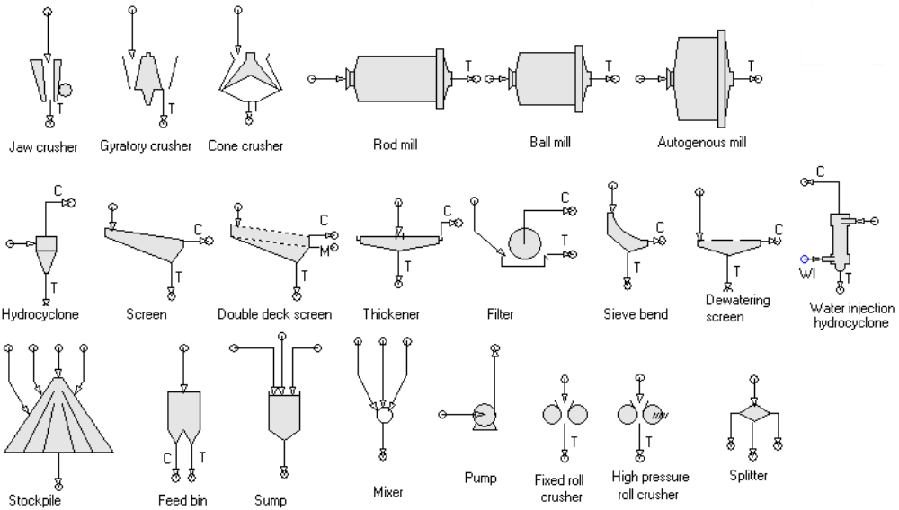
Figure 3 The unit icons. Concentrate streams are identified by C, tailings streams by T and middling streams by M
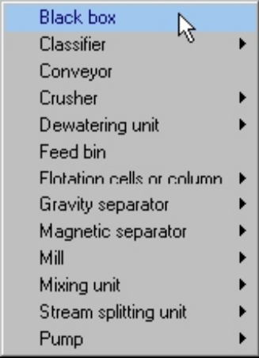
Menu 7 The select menu of the flowsheet editor from which unit icons are selected.
The flowsheet is constructed by placing unit icons at the desired positions on the flowsheet and connecting the units by means of the appropriate flow streams. Icons are selected from the SELECT menu and they appear on the flowsheet at the current location of the LOCATION CURSOR. When the location cursor is showing on the flowsheet, it can be dragged and dropped using the mouse. To make the location cursor visible on the flowsheet, select LOCATION CURSOR from the EDIT drop-down menu on the graphics editor.
The available icons are shown in Figure 3 and Figure 4 and in Table 2 at the end of this section. Each type of unit operation has its associated pictorial icon and the appropriate icon is chosen automatically when the unit operation is selected from the SELECT drop-down menu.
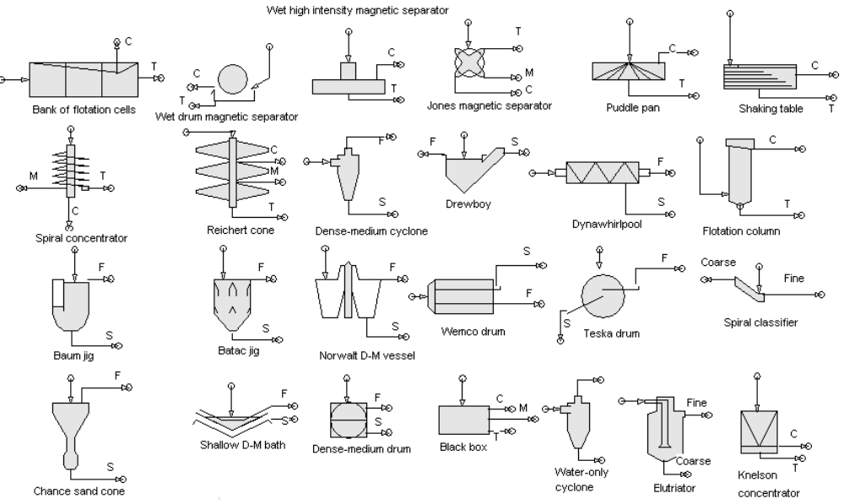
Figure 4 The unit icons. Concentrate streams are identified by C, tailing streams by T and middling streams by M. Dense medium and gravity units have float and sink streams which are identified by F and S in the figure.

Drawing Streams on the Flowsheet
Units are connected on the flowsheet by streams. A stream is started by positioning the cursor at the appropriate point on the flowsheet and is ended at the appropriate unit. Two different cursors are available to draw process streams. The RECTANGULAR CURSOR is used to draw streams that consist entirely of horizontal and/or vertical segments. If the stream to be drawn has diagonal segments, use the RUBBER BAND CURSOR. Once the appropriate cursor has been chosen, left click the mouse at the starting point of the stream, left click the mouse wherever a corner is required in the stream and end the stream by clicking the right button. Streams normally start and end at a unit icon. This means that the starting and ending points of the stream must touch the appropriate unit at the point on the icon where the connection is to be made.

Plant feed streams do not start at a unit and plant products do not end at a unit. All units with the exception of a mixer, sump or stockpile can have only a single feed stream. Thus all units that are fed from more than one point in the plant must be preceded by a mixer, conveyor or a sump. There is one exception to this rule. A unit can have an additional water feed stream in addition to the slurry feed. This is useful whenever water is added directly to the unit feed or when water is added to the unit to achieve some physical effect such as rinsing on a screen or adding water to the froth launder of a bank of flotation cells. Water can enter the plant through a water feed stream which is started by selecting ADD WATER STREAM from the EDIT drop-down menu and then completing the construction of stream in the same way as for other plant stream after selecting either the RECTANGULAR CURSOR or the RUBBER BAND CURSOR.
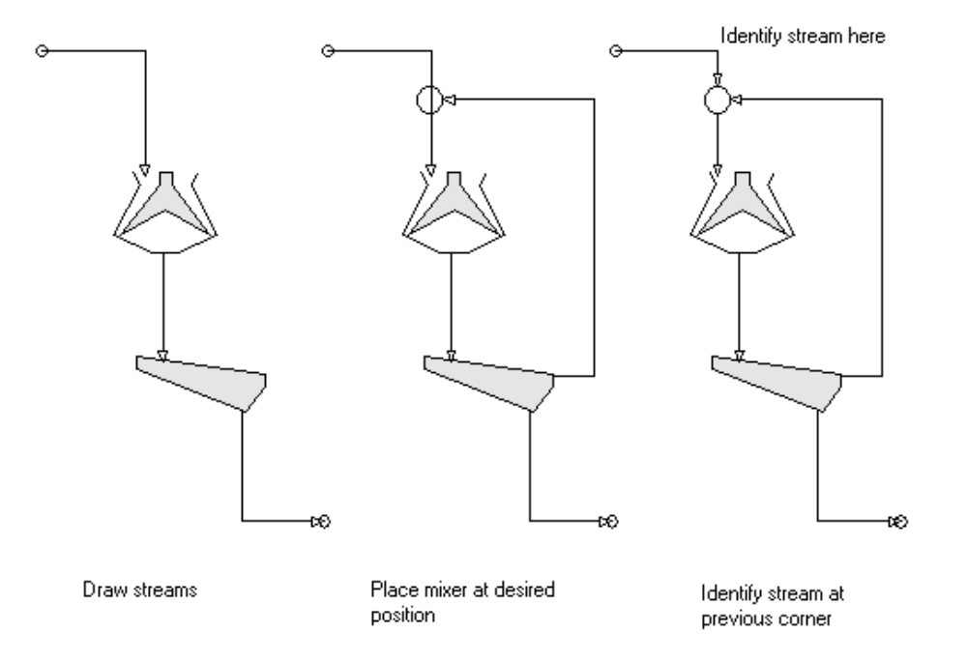
Figure 5 Sequence of operations showing the insertion of a mixer into an existing stream. The mixer is placed then the stream that is being broken into is identified.

HINT: A stream that does not attach to a unit icon has a colored circle attached to its end. This makes it easy to detect unattached streams. The audio alarm also sounds when a stream is drawn that does not attach to any unit.

Mixing units may be inserted into streams that have already been placed on the flowsheet. However, after locating the mixer at the desired point, the stream that is broken into must be identified. This is done by locating an identifiable point (stream start or corner) in the stream immediately preceding the mixer and then immediately clicking the mouse on this point. If any other action is selected before identification of the stream, the mixer will not be inserted into the stream. This sequence of operations is shown in Figure 5.
Streams that feed units are usually attached to a unit that already exists on the flowsheet. To attach a unit to the end of an already existing stream, move the unit until it touches the arrowhead of the desired feed stream. The stream will be attached when the flowsheet is next refreshed or saved.

Changing Icon Size or Orientation

The size and orientation of unit icons can be varied during the construction of the flowsheet. The size is changed by selecting CHANGE ICON SIZE from the EDIT drop-down menu and specifying the new size in the range 1-20. The new size remains in effect until changed.
Icons that do not have a vertical axis of symmetry can be reflected about their vertical axis by selecting REFLECT ICON from the drop-down menu. The reflection will apply only to the next unit selected after which orientation returns to normal.

Deleting Icons or Streams from a Flowsheet

Streams and icons can be deleted from the flowsheet by selecting DELETE from the drop-down menu and right clicking on the stream or icon. When an icon is deleted, all output streams that are attached to that icon are automatically deleted as well. Icons may be moved on the flowsheet by selecting MOVE from the EDIT drop-down menu and dragging the icon with the mouse. When an icon is moved all of its associated output streams will be deleted before the move and these will have to be replaced. Any system data associated with those streams will be lost!!

ANNOTATING THE FLOWSHEET

Annotations may be added to the flowsheet by positioning the LOCATION CURSOR at the point where the annotation is to start and selecting ANNOTATE from the drop-down EDIT menu. An annotation can be deleted by selecting DELETE from the EDIT drop-down menu and clicking on the bottom left corner of the annotation. An existing annotation can be moved by selecting MOVE from the EDIT drop-down menu and dragging the annotation with the mouse.
A typical flowsheet is shown in Figure 2. Annotations may be added freely to the flowsheet to improve its information content. The models that are associated with each icon are given in Table 2.
Table 2 Unit models available in MODSIM
UNIT | Models available
Autogenous mill  Ball mill  Batac jig  Baum jig  Black box  Chance sand cone  Compound screen  Cone crusher  Conveyor  Dense-medium bath  Dense-medium cyclone  Dewatering screen  Drewboy dense-medium vessel  Double deck screen  Dynawhirlpool  Elutriator  Feed bin  Filter  Fixed-roll mill  Flotation column  Bank of flotation cells  Gyratory crusher  Hydrocyclone  High pressure roll crusher  Jaw crusher  Knelson concentrator  Magnetic separator  Mixer  Norwalt dense-medium separator  Puddle pan  Pump  Reichert cone  Rod mill | FAGM, SAGM, MILL  MILL GMIL GMI1 GMSU UMIL HFMI HFML HFSU SB16  BATJ  BAUJ  BLBX  CHAN  CSCN  CRSH CRS1 SHHD  CONV MIXR  TESK BATJ SLIP CHAN BAUJ WEMC NORW WASH DREW DRUM  DMCY DMHC  DWSC  WASH DREW  DSC1 DSC2  DYNA  ELUT  SEGB  FILT  CRSH  FLTK FLTN KLIM  GYRA  CYCL CYCA NAGE  CRSH  JAW1 JAW2  KNEL  WDMS  MIXR  NORW  PAN1  NOP  CONE  MILL RODM RODL
Shaking table  Screen  Shallow dense-medium bath  Sieve bend  Spiral separator  Spiral classifier  Stockpile  Stream splitter  Sump  Teska drum  Thickener  Water-only cyclone  Water-injection hydrocyclone  Wemco drum  Wet high-intensity magnetic separator | SHAK  SCRN SCR1 SCR2 CYCA KSCN  SLIP  SCR1 CYCB  SPIR, KELL, LISP  CYCA  MIXR  SPLT SPL1  MIXR  TESK  THIC, KYNC  WOCY  WICY  WEMC  WHIM, DOFI

Saving Flowsheets

A typical flowsheet is shown in Figure 2 on page 4 as it appears on the screen. Annotations may be added freely to the flowsheet to improve its information content and all graphic elements and annotations may be moved or erased to ensure effective and appropriate layout of the flowsheet. A flowsheet is saved by selecting SAVE FLOWSHEET on the FILE drop-down menu. The flowsheet should always be saved before proceeding to data specification.

Attaching Unit Models to Icons

Each icon in the flowsheet represents a physical unit in the plant. In order to simulate the operation of the plant, the behavior of each unit must be modeled. You will need to associate an appropriate model with each unit and the models that are available for use with each icon are listed in Table 2. Details of the models are given in section 7. The final choice of models is made by selecting EDIT MODEL PARAMETERS from the EDIT drop-down menu shown on Figure 1. The details of model selection and parameter specification are given in section 6.

Pseudo Streams

Sometimes it is useful to have information about the particle load inside a particular unit. For example, it is useful to know the size distribution of the load in an autogenous or ball mill. This information can be gathered in two ways: through the report file (see section 8.4), the unused product streams can be used to report the information during the simulation. The pseudo stream will have zero flowrate but will carry all the composition data. It is drawn on the flowsheet as a product stream that emanates directly from the unit but does not connect to any other unit. This stream will be included in the simulator output and will generate data that can be used to plot the size distributions and the liberation spectra. See section 10.5 for details on how to include pseudo streams in the unit models.

Saving the flowsheet

The editor is easy to learn and easy to use and even complex flowsheets may be drawn in short sessions. It is recommended that a flowsheet be saved several times during creation to ensure against loss of information caused by any system malfunction.
The flowsheet can be redrawn at any time during the edit session by selecting REFRESH FLOWSHEET from the EDIT drop-down menu and the flowsheet will be redrawn.
The units and streams are numbered automatically by the editor and these numbers are used in the output stage for identification. The structure of the flowsheet is automatically transmitted to subsequent stages in the simulator for interpretation and processing which includes cycle finding and decomposition algorithms to establish a feasible sequential calculation path for the flowsheet. These algorithms are completely transparent to the user so the step from flowsheet construction to final output is convenient and fast. However, the user must supply the essential numerical data that describes the material to be processed and the set up of the individual units in the flowsheet. These data specification steps are described in sections 4, 5 and 6.

Printing the Flowsheet

The quickest way to print a hard copy of the flowsheet is to select PRINT from the FILE drop-down menu in the flowsheet graphics editor. High-quality hard copy can be produced offline using a PostScript image of the flowsheet by selecting EXPORT from the FILE drop-down menu on the graphic editor. The PostScript image can be sent to any device or application that is capable of rendering PostScript images. However this file cannot be sent to an external device from within MODSIM. If you want to import the PostScript image directly into a word processor export the flowsheet as an encapsulated PostScript image. Publication quality diagrams can be created by exporting as a PostScript image.
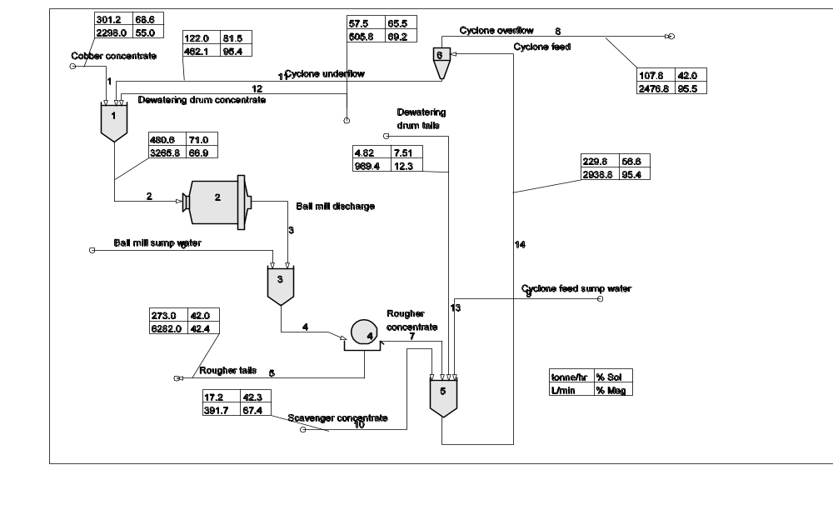
Figure 6 Graphical output of a typical flowsheet using the PostScript image.

DATA ENTRY

Once the flowsheet has been constructed, MODSIM will take you through a sequence of menus that will define the data set required by the flowsheet and the included models. The data is separated into two sections. The first defines the system and plant data which includes all information required to define the plant structure and the characteristics of the feed material. The second section includes all the parameters required by each of the unit models included in the flowsheet. These are the unit parameters. Each section may be accessed separately from the main menu.
Some familiarity with the terminology of particulate mineral systems is necessary to specify the data correctly and the user is referred to the book Modeling and Simulation of Mineral Processing Systems for assistance in this regard.

Specifying the System Data

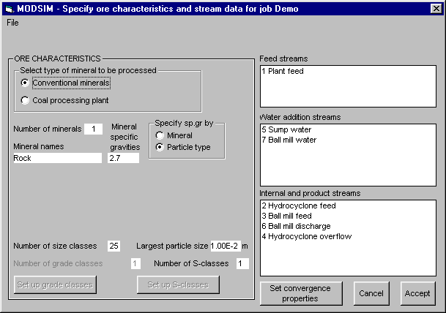
Figure 7 Form to specify the properties of the ore and to select streams that have data to be specified. This form is entered by selecting the System data item on the EDIT menu.

The system data describes the characteristics of the ore that is processed in the flowsheet. These characteristics remain fixed throughout the flowsheet and hence the name system data. Characteristics and quantities of the feed streams are also included in the system data. The system data form is used to set up the system data and to identify streams that feed ore to the plant or that have experimental data which is to be compared to the simulator output. The format of the form to specify system data is shown in Figure 7.
The data fields in this form are described in the sections that follow. The frame labeled ORE CHARACTERISTICS on this form is reserved for the specification of properties that characterize the nature of the solid material that is processed in the plant.
The nomenclature of coal washing technology has evolved separately to that of conventional mineral processing and the user can choose either nomenclature to specify the data. Although the nomenclature varies, the principles that govern the specification of data in these two situations are identical and the simulator works the same way for both type of plant.

ORE CHARACTERISTICS: This composite field is used to specify the physical properties of the ore that is to be processed in the plant.
Number of minerals: Specify the number of mineral species that are significant in the simulation.
Mineral names: The names of the minerals must be specified in this field. There must be as many names as are specified in the Number of minerals field. Only the first four letters of the mineral name are significant.
Mineral specific gravities: The specific gravities of the individual minerals can be inserted here.
The specific gravity of individual particle types can be specified in one of two ways: either they are calculated from the mineral composition of the particle type and the specific gravity of the individual minerals or the specific gravities of the particle types can be specified explicitly. One of the two methods is chosen on this form. If the latter method is chosen the specific gravities of the particle types must be specified when specifying the distribution of particle types as shown on Figure 8.
Number of size classes: Specify the number of size classes that you want MODSIM to use for the simulation. 25 is recommended since this will provide the greatest resolution with respect to size. The number specified here need not be equal to the number of sizes that are available as data that defines the plant feeds nor to the number of size classes that are available in experimental data that is available for comparison with the simulator output. If particle size effects will not be significant in the simulation, the number of particle size classes can be set to 1 and MODSIM will consider that all particles have the same size equal to that specified in the largest particle size field.
Largest particle size: Specify the largest particle size that is of interest in the simulation. This should be just larger than the largest size in the feed. Note that the size must be specified in meters.
Number of grade classes: Specify the number of grade classes that are required to define the liberation characteristics of the ore. If mineral liberation will not be significant, this field should be set equal to the number of minerals. The number of grade classes should never be less than the number of minerals otherwise the simulator cannot distinguish between the separate mineral species.
Number of S-classes: In MODSIM S-classes allow the particle population to be distributed over an additional physical variable such as the magnetic susceptibility for example. Distribution over several values of the flotation rate constant is probably the best known example of the use of S-classes in ore dressing plant simulations.

Setting up the Grade Classes

The composition of the grade classes can be specified using Form in Figure 8, which is entered by clicking the Set up grade classes control on the systems data form. If the number of grade classes exceeds the number of minerals, the composition of the particles in each grade class must be specified.
Composition: This form requires the composition of each grade class to be specified. The composition for each grade class is specified in terms of either the mass fraction or the volume fraction of each mineral in the particle. The entry for each grade class is a vector of mineral compositions. The ordering of the minerals in the vector corresponds to the order in which the mineral names are entered in the system data form (Figure 7).
Specific gravity of class: By default MODSIM calculates the specific gravity of particles in each grade class from the mineral fractions in the particles and the specific gravities of the minerals that are specified on the system data form. If data on the actual particle specific gravities are available these may be entered on this form. These data will be used instead of the calculated default values. See section 10.1 Accessing system data in model subroutines for information on how to access this data from any model subroutines that you write.
Specify composition by: The composition can be specified either by mass or by volume.
Magnetic susceptibility of class: The magnetic susceptibility for each class of particle can be specified here.
Other property: Values for any other physical property can be specified here.
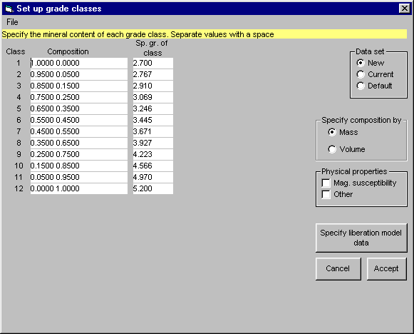
Figure 8 Form to specify the composition and other properties of the particle types or grade classes. This form is entered by clicking the Set up grade classes control on the system data form. See Figure 7.

Specify liberation model data: Click this control to specify details of the liberation model. The liberation model defines the structure of the Andrews-Mika diagram. This diagram is central to the modeling of mineral liberation using the population balance method that forms the basis of the simulation engine in MODSIM. The Andrews-Mika diagram shows how the minerals are distributed when a parent particle of any specified size and composition is broken in a comminution device. This information is used in the population balance equations for comminution so that the distribution of particle compositions in the discharge product from the mill can be calculated.
Two models for the Andrews-Mika diagram are provided in MODSIM. The first is a simple model that was published in King R.P. Calculation of the Liberation Spectrum in Products Produced in Continuous Milling Circuits. Proc. 7th European Symposium on Comminution. Vol 2, pp429-444, Ljubljana, 1990. This is referred to as the Ljubljana model. The second model is more realistic and was developed from experimental data by C.L. Schneider, The Measurement and Calculation of Liberation in Continuous Grinding Circuits. PhD. Thesis, University of Utah, 1995. This is referred to as the beta function model since it uses the beta function to describe the mineral distribution at each progeny size in the Andrews-Mika diagram. The construction of the Andrews-Mika diagram using this model is described in detail in Chapter 3 of Modeling and Simulation of Mineral Processing Systems by R P King, Butterworth-Heinemann, 2001

PHIA parameter: This is a parameter that defines the phase interfacial area per unit volume in the mineral. It characterizes the mineral texture for use in the ALjubljana@ liberation model. This parameter takes values in the range of 10 to 200. Minerals that have lower values of Φ_{A} have comparatively coarse-grained textures and are comparatively easy to liberate while textures that have Φ_{A} larger than 100 are finely intergrown and difficult to liberate.
Calculate Andrews-Mika diagram on exit: Check this box if you want the matrix of cross transfer coefficients for the liberation model to be computed according to the ALjubljana@ model. This is always necessary whenever the value of Φ_{A} is changed.
Parameters for the Beta Function Andrews-Mika diagram: The beta function model of the Andrews-Mika diagram requires 7 parameters. These are described in Modeling and Simulation of Mineral Processing Systems, Chapter 3.
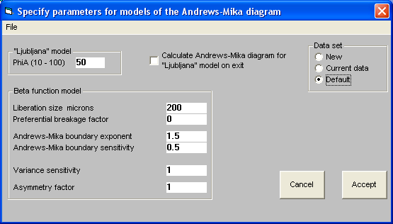
Figure 9 Form to specify parameters of the Andrews-Mika diagram.

Liberation size (D_{lib}) defines the scale of the mineralogical texture. The mineral phase starts to liberate significantly when the particle size becomes smaller than the liberation size. Preferential breakage factor () defines the relative tendencies for cracks to branch in the mineral phase. If cracks branch preferentially in the mineral phase this factor is greater than 0. If cracks branch preferentially in the gangue phase this factor is less than 0. Andrews-Mika boundary exponent (δ₀) is the exponent of the Andrews-Mika boundaries. For coarse-grained textures this exponent approaches 3 and is less that 3 for finer grained textures. Andrews-Mika boundary sensitivity (x) is the sensitivity of the boundary exponent to parent size. The variance of the liberation distribution determines how quickly the minerals separate by liberation as the progeny size decreases. If the variance is high the minerals separate quickly at comparatively small size reduction ratios and vice versa. The variance sensitivity (λ) determines the sensitivity of the variance exponent to the parent size. The asymmetry factor (δ_{u}/δ_{l}) defines the relative rate of liberation of the mineral phase relative to the gangue phase. If the asymmetry factor is greater than 1 the mineral phase liberates relatively quickly; if this factor is less than 1, the mineral liberates more slowly than the gangue phase.

Data set: This form allows you to display the default data set, the current data set in the simulator and the new data set that is under construction and to switch among these data sets.

Setting up the S-classes

The values associated with each s-class can be specified on Form shown in Figure 10, which is entered by clicking the Set up S-classes control on the system data form (Figure 7).
Flotation rate constants: Specify the values of the flotation rate constants that characterize the ore. A common model for flotation cells is the so-called ultimate recovery model which considers each type of grade class to have a floatable and a non-floatable component. The value of the specific flotation rate constants are specified on this form. The rate constant for the non flotable component is set equal to zero. Two models for mineral flotation are provided as standard in MODSIM: the distributed models due to King and Sutherland. The King model allows for bubble loading limitations and the specific rate constant is specified in m/s. The Sutherland model is based on the analogy with a chemical reaction and the rate constants are specified in mins⁻¹.
Magnetic susceptibility: Specify the values of the magnetic susceptibility for each of the s-classes here if you plan to use these values in any of the models for the plant unit operations..
Additional property: Specify here values for any other property that is to be distributed over s-classes for subsequent use in any unit model.
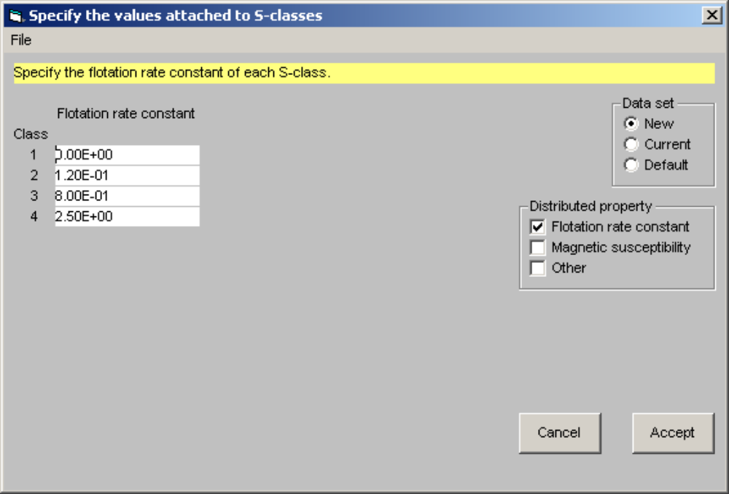
Figure 10 Form to specify the values of properties that are attached to S-classes. This form is entered by clicking the Setup S-classes control on the system data form.

NOTE: It is not necessary to specify values for more than one property for distribution over the S-classes but if S-classes are to have any influence in any of the models, at least one property must be specified. If the number of S-classes is specified as 1 on the system data form (Figure 7), then it is obviously not possible to specify properties for S-classes. See section10.1 Accessing System Data in the Model Subroutines for information on how to access this data in any model subroutines that you write.
Data set: This form allows you to display the default data set, the current data set in the simulator and the new data set that is under construction and to switch among these data sets.

Setting the Convergence Properties

MODSIM provides two different methods to improve the rate of convergence of the iterative calculation: direct substitution and modified Newton. The convergence characteristics of the computation can be specified on this form.
Convergence method: Select the desired convergence method from the four methods. The Modified Newton method is preferred but sometimes its radius of convergence can be quite small and direct substitution is more robust but generally slower. Bounded Wegstein and midpoint convergence can be tried when convergence appears to be oscillatory but they tend to be very slow. It is always possible that the data specified for the unit models may produce a plant set up that has no finite steady state solution. Persistent lack of convergence is usually an indication of this condition and you will need to examine your models very carefully to ensure that they do produce physically realistic outputs.
Tolerance required: Select the required tolerance for the iterative calculation.
Maximum number of iterations: In case convergence is difficult, the total number of iterations is limited to the number specified in this field.
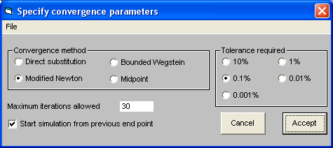
Figure 11 Form to specify the convergence method that is to be used for the simulation. This form is entered by clicking the Set convergence properties control on the system data form.

Start simulation from previous end point: when a flowsheet contains recycle streams it is necessary to decompose the flowsheet for sequential calculation. This is done internally in MODSIM by using tear streams. At the start of the calculation these streams are virtually torn open and initial trial values for the flowrates of each of the particle types are assigned. These are the starting values for the iterative calculation. When the simulation ends the final values of these flowrates are recorded so that they are available as starting values for the next calculation. This usually reduces the number of iterations required for convergence of the iterative calculation and can save significant amounts of time especially if the simulation is run on slower machines. This is the default condition.
If the calculation terminates abnormally, these starting values may be inappropriate or the set of values may be incomplete. Under these circumstances, the simulation should not start at the previous end point and this box should not be checked.

SPECIFYING THE DATA IN THE PLANT FEED STREAMS

The feed streams to the plant must be completely specified with respect to their flowrates, composition and size distribution. These specifications are made using the feed stream form.
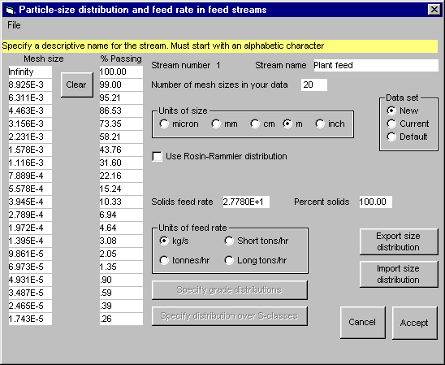
Figure 12 Form to specify the particle size distribution and the feed rate of a feed stream. A separate form must be filled for each feed stream in the flowsheet. The form is entered by double clicking on the system data form (Figure 7)

Stream: The number of the stream in the flowsheet is specified here. You can allocate a descriptive name to the stream to assist identification of the stream data from the simulator. The name that is specified here is transferred to the feed stream field in the system data form. Stream names must start with an alphabetic character.
Number of sizes: Specify here the number of mesh sizes that are available in the distribution data for this stream. This need not be the same as the number specified on the system data form.
Size: List the mesh sizes that define the size distribution for this stream.
%Passing: Specify the cumulative size distribution as percent passing the mesh size.
Units of size: The mesh sizes can be specified in any of the common units that are listed. Check the unit of size that you use. Use a left mouse click to select a unit of size. Use a right mouse click to convert existing sizes to a new unit.
Use Rosin-Rammler distribution: If the size distribution in the stream is not known a Rosin-Rammler distribution can be used by checking this box. The parameters in the Rosin-Rammler distribution can be specified in the following fields.
D63.2: Specify the 63.2% passing size for the distribution.
Lambda: Specify the exponent of the distribution.
Feed rate: Specify the feedrate of solids in this stream. Check the appropriate units used in Units of feedrate field. Use a left mouse click to select a unit of size. Use a right mouse click to convert existing sizes to a new unit.
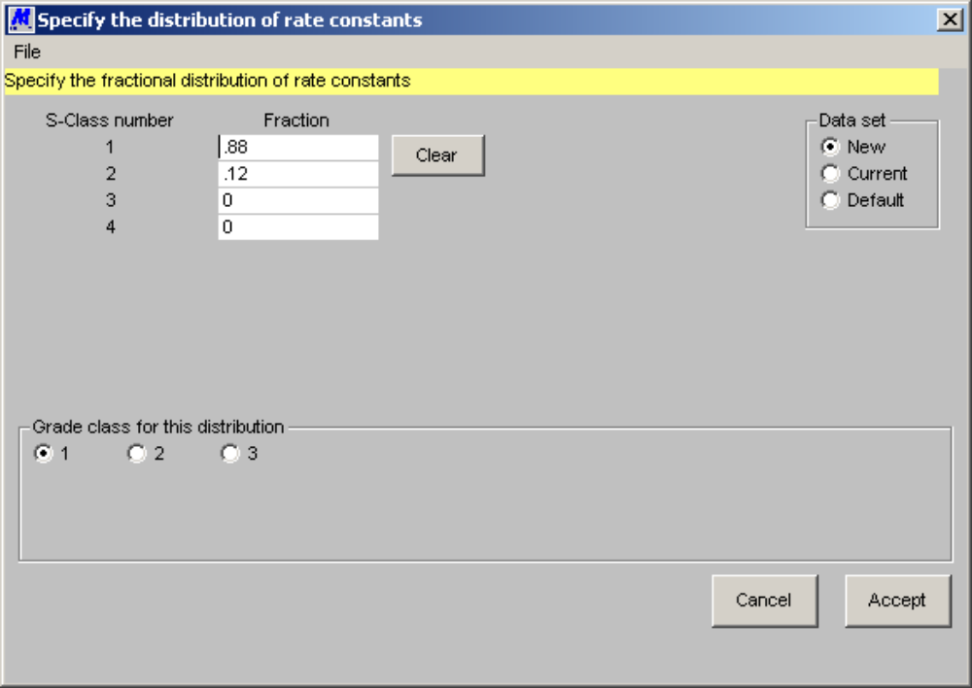
Figure 13 Form for the specification of the distribution over the S-classes. A separate form must be filled for each feed stream in the flowsheet. This form is entered by clicking the Specify distribution over S-classes control on the feed stream form. (Figure 12).

Percent solids: Specify the percent solids in this stream.
Specify grade distributions: Define the mineralogical composition of this stream by specifying the distribution of particles over the grade classes. Click on this control to bring up the grade class distribution form.
Specify distribution over s-classes: If s-classes have been requested click this control to bring up the s-class distribution form.
Clear: This control has two functions: click it to clear the size distribution fields if you want to re-specify the entire distribution; click this button to generate the Rosin-Rammler distribution if the R-R distribution has been selected.
Data set: This form allows you to display the default data set, the current data set in the simulator and the new data set that is under construction and to switch among these data sets.

Specify the Distribution over Grade Classes

The mineralogical composition of the solids in any stream is defined by specifying the distribution of particles over the grade classes that are being used. The composition can vary from size to size and this form allows the distribution to be specified for many size ranges depending on what data is available.
Mass fraction: Specify the fraction by mass of the total amount of solid in the size interval selected that is allocated to each grade class.
Size range: The distribution over the grade classes is specific to a size interval C smaller particle are in general more completely liberated than larger particles C so a separate distribution must be specified for each size interval. The size intervals are specified as contiguous size ranges. The default is a single size range from zero to the maximum size that is specified on the system data form. To increase or decrease the number of size intervals, edit the upper or lower size of any subrange.
Import data from file: The distribution data can be imported from an external ASCII file. This happens for example when the liberation spectrum of the material in the stream has been determined by image analysis at a number of sizes and the distribution results from a stereological correction program. The format of the file is ASCII.
Data set: This form allows you to display the default data set, the current data set in the simulator and the new data set that is under construction and switch among these data sets.

Specify the Distribution over the S-classes

The distribution over the s-classes is specified as the mass fraction in each s-class.
Fraction: The distribution is specified as fraction by mass.
Grade class for this distribution: Each grade class has its own s-class distribution. Click the number of the grade class to which this distribution refers. You must select each grade class before leaving this form. Those classes not selected will be assigned the default distribution.
Clear: Click this control to clear the distribution fields.
Data set: This form allows you to display the default data set, the current data set in the simulator and the new data set that is under construction.
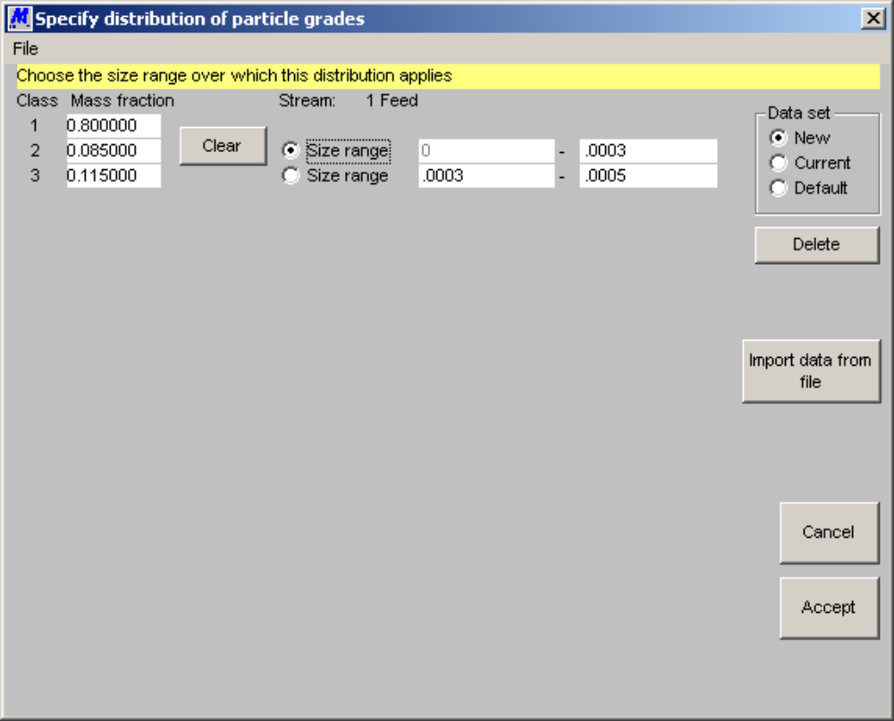
Figure 14 Form to specify the distribution of particles over the grade classes in the feed stream that is identified in the stream field. A separate form must be filled for each feed stream in the flowsheet. This form is entered by clicking the Specify grade distributions control on the feed stream from (Figure 12).

Specify Water Feeds

Any water feeds to the plant must be specified.
Stream: The number of the stream in the flowsheet is displayed. A descriptive name for the stream can be specified.
Specify water addition by: The water addition rate can be specified in one of two ways. The rate can be specified as a fixed rate of addition or the required percent solids in the stream leaving the unit that takes the water feed can be specified. In the latter case, MODSIM will adjust the water addition rate to ensure that the required percent solids in the outlet stream from the unit is achieved.
Water addition rate: Specify the water rate.
Units for the flow rate: Click the appropriate units.
Percent solids in unit: Specify the required percent solids required in the unit indicated.
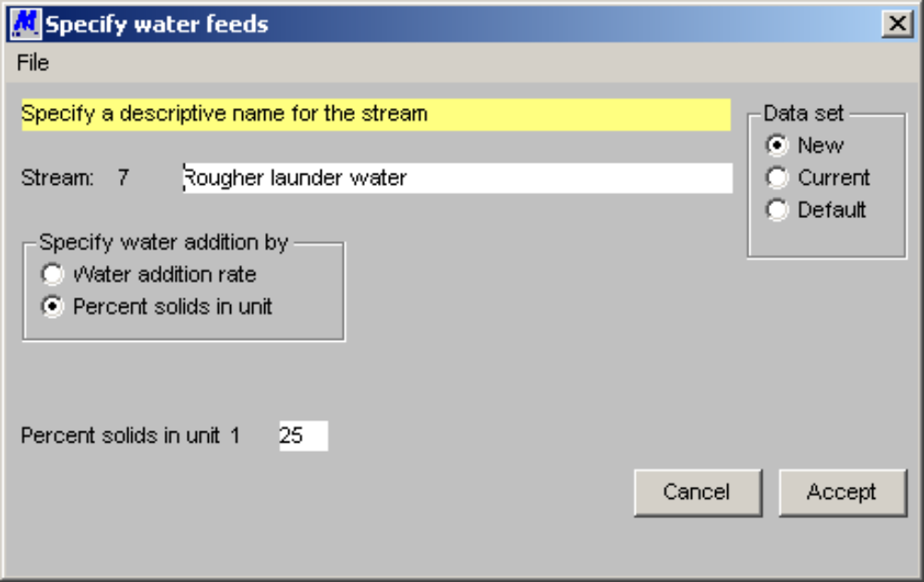
Figure 15 Form to specify water addition rates. This form is entered by double-clicking the stream in the Water addition streams field on the system data form (Figure 7).

Data set: This form allows you to display the default data set, the current data set in the simulator and the new data set that is under construction and to switch among these data sets.

Specifying Data for Internal Flow Streams

If you have experimental data that describes the size distributions and the liberation spectra in any internal streams in the plant, these can be displayed on the output graphs for comparison with the simulator output. The simulator will not use the data directly and it is available only for comparison purposes. These data can be specified through windows as shown in Figure 12 and Figure 14. These windows are accessed for this purpose by double clicking the appropriate stream number in the Internal and product streams field on the window shown in Figure 7. If no size distribution data are available, the number of sizes should be set to 1 in the window in Figure 12. When specifying grade class-data for internal and product streams, only composite data over all particle sizes is allowed and not distributions for separate particle sizes. Internal and product streams can be given descriptive names using the window in Figure 7.

SPECIFYING PARAMETERS FOR THE UNIT MODELS

Most of the models that are incorporated in MODSIM require one or more parameters to be specified so that the model will describe the unit as it is set up in the flowsheet. Parameter specification is done through forms that are specifically designed for the purpose. The Unit parameters entry on the main menu will bring up a form for the selection of units for parameter specification. This is shown in Figure 16.
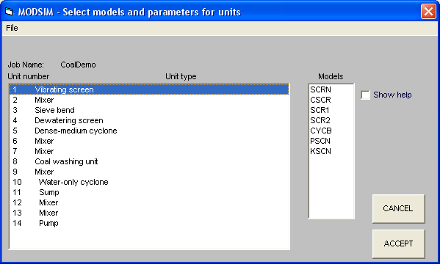
Figure 16 Selection of units for specification of unit parameters. This form is entered by executing Unit parameters on the main menu.

Fields on the Form shown in Figure 16 have the following significance.
Unit number Unit type A list of unit numbers from the flowsheet and the corresponding type of unit. A single click on any unit is this field will display the list of models that are currently available in MODSIM for the selected unit. The list of models is displayed in the Models list.
Models A list of models that are currently available for the unit that is selected in the Unit type list. Double click on the model to choose it for the unit. The parameter specification form for that model will be brought up. The model that appears at the top of the list is the one that is currently selected for the unit.

Help If the help box is checked, double clicking the model name will display the help screen for the chosen model. This screen will present a brief description of the model and will explain the significance of each of the parameters in the model.
…

THE UNIT MODELS

At the heart of MODSIM are the unit models. The simulator is only as good as the models that it contains. If any model does not accurately describe the operation of the unit the simulator can not give a reliable picture of the behavior of the plant. Models must be chosen with care and for accurate work they should be carefully calibrated against appropriate experimental data.

A brief description of each of the unit models that are supplied as standard is given in this section.

Comminution Models

Crushers

JAW1: Simple model for a jaw crusher.
This model produces a size distribution in the product that is of standard type which is independent of the size distribution in the feed except that the crusher cannot discharge material in size classes that have size larger than the largest size in the feed.
The standard size distribution that is assumed is taken from NORDBERG PROCESS MACHINERY REFERENCE MANUAL May 1976
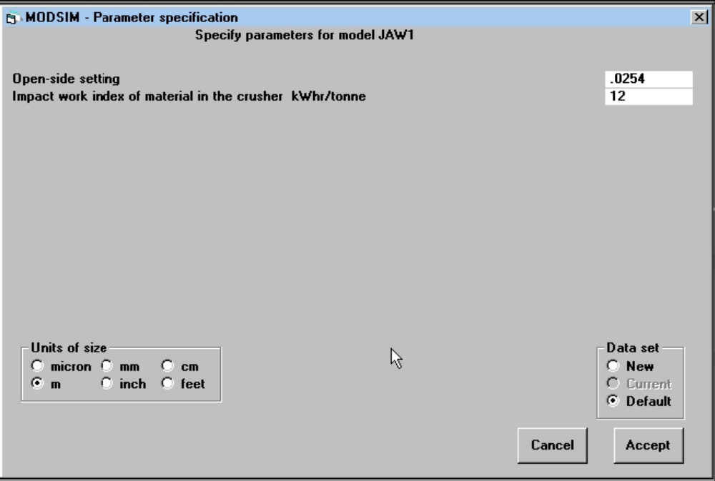
Figure 17 Parameter input form for jaw crusher models JAW1 and JAW2.

PARAMETERS
1...Open-side setting
2...Impact work index of the material in this unit
The form for specifying these parameters is shown in Figure 17.

JAW2: Simple model for a jaw crusher.
This model produces a size distribution in the product that is of standard type which is independent of the size distribution in the feed except that the crusher cannot discharge material in size classes that have size larger than the largest size in the feed.
The standard size distribution that is assumed is from Samancor's Mamatwan plant.

PARAMETERS:
1...Open-side setting
2...Impact work index of the material in this unit
The form for specifying these parameters is shown in Figure 17.

GYRA: Model for the gyratory crusher.
This model assumes that the size distribution in the product is of standard type. This means that the size distribution of the product is determined entirely by the open-side setting of the crusher and does not depend on the size distribution of the feed.
The shape of the size distribution is determined from data in the Nordberg Process Machinery Reference Manual May 1976.
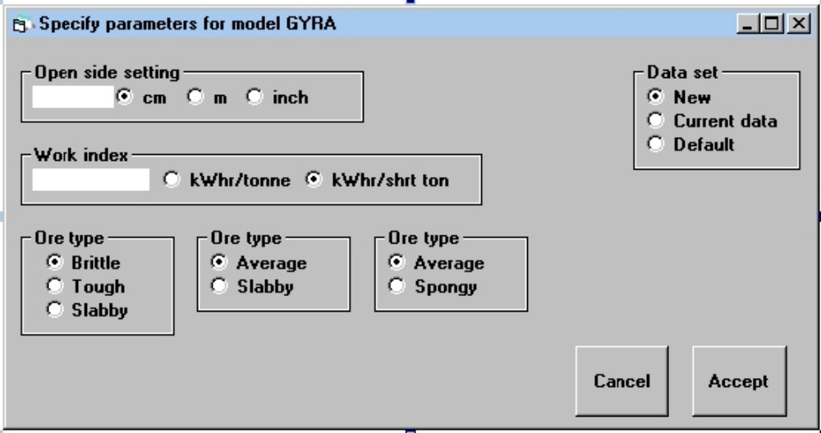
Figure 18 Form to specify parameters for model GYRA.
PARAMETERS:
1...Open side setting in meters
2..."Material type": slabby, tough, brittle or spongy3...Impact work index of the material

The form for specifying these parameters is shown in Figure 18.

EMJC: Empirical Model for Jaw and Gyratory Crushers.
This model is based on reference Csoke B, Petho S, Foldesi J. and Meszaros. Optimization of stone-quarry technologies. Intl. Jnl. of Mineral Processing 44-45 (1996) 447 - 459.
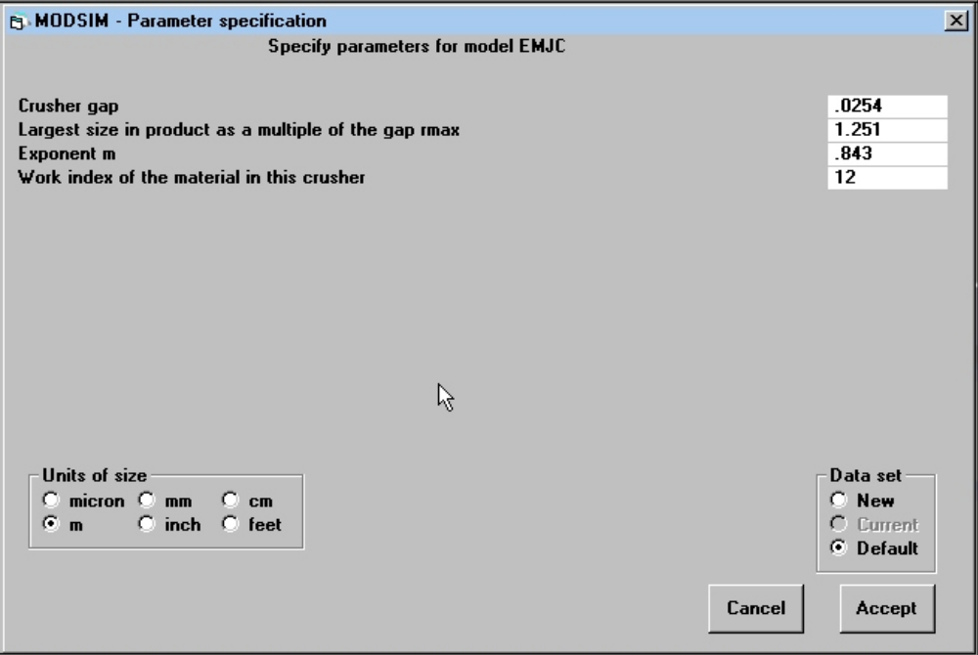
Figure 19 Form to specify parameters for model EMJC — empirical model for jaw crishers.

The model is based on the idea that material in the feed smaller than the gap passes straight through the crusher and the larger material is crushed to a predefined size distribution that is modeled by
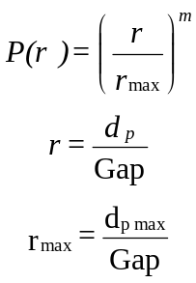

PARAMETERS:

1...Crusher gap
2...r_{max}
3...Coefficient m
4...Impact work index of the material in this crusher

The form for specifying these parameters is shown in Figure 19.

CRSH: Standard model for a crusher.
This model can be used for jaw crushers, gyratory crushers and cone crushers. The default data is for a Symons standard cone crusher. This model is based on the crushing zone and internal classification behavior described by Whiten et. al. The classification action is modeled by
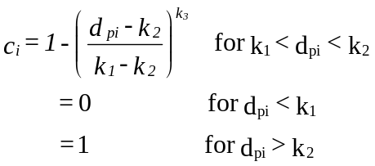
The values of k₁ and k₂ are related to the closed-side setting by

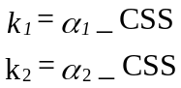

The breakage function is modeled by
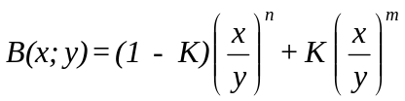
References:
1 Whiten W J The simulation of crushing plants with models developed using multiple spline regression. Application of Computer methods in the Mineral industry. Eds. M.D.G. Salamon and Lancaster. S. Afr. Inst. Min. Metall. Johannesburg, 1973. Pp. 317-323
2 Whiten W.J, Walter G.W, and White M.E, A breakage function suitable for crusher models. 4TH TEWKSBURY SYMPOSIUM, MELBOURNE, FEB 1973 P19.1-19.32
Breakage and classification functions were taken from reference 2.
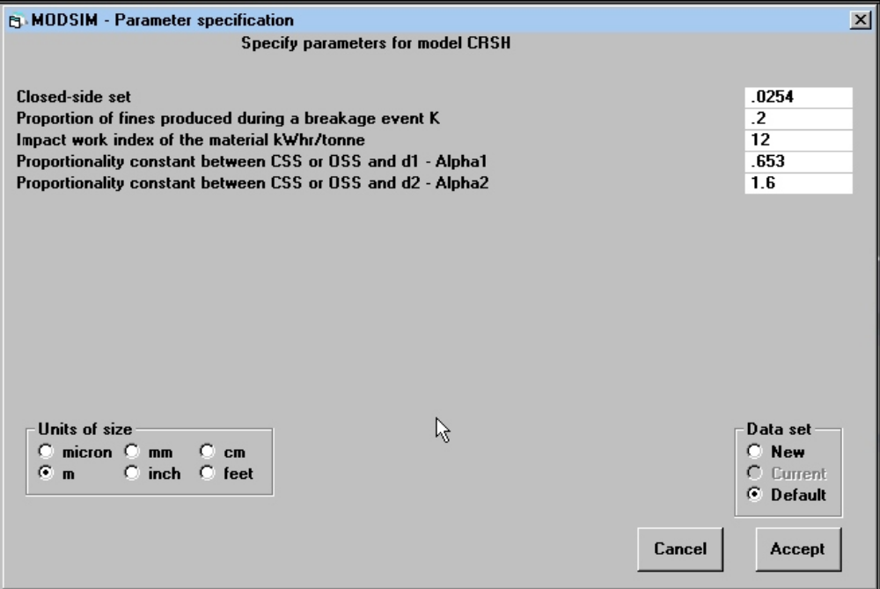
Figure 20 Form to specify parameters for model CRSH.

PARAMETERS:
1...Closed side setting for cone crushers, open side setting for gyratory or jaw crushers
2...Proportion of fines produced during breakage events
3...Impact work index of the material
4...Factor for classification parameter k₁
5...Factor for classification parameter k₂

The form for specifying these parameters is shown in Figure 20.

CRS1: Model for a Symons cone crusher.
This model should be used only for preliminary calculations. The size distribution in the product is assumed to be of the standard type and is therefore independent of the size distribution in the feed. The standard size distribution is taken from the Nordberg Process Machinery Reference manual, MAY 1976.

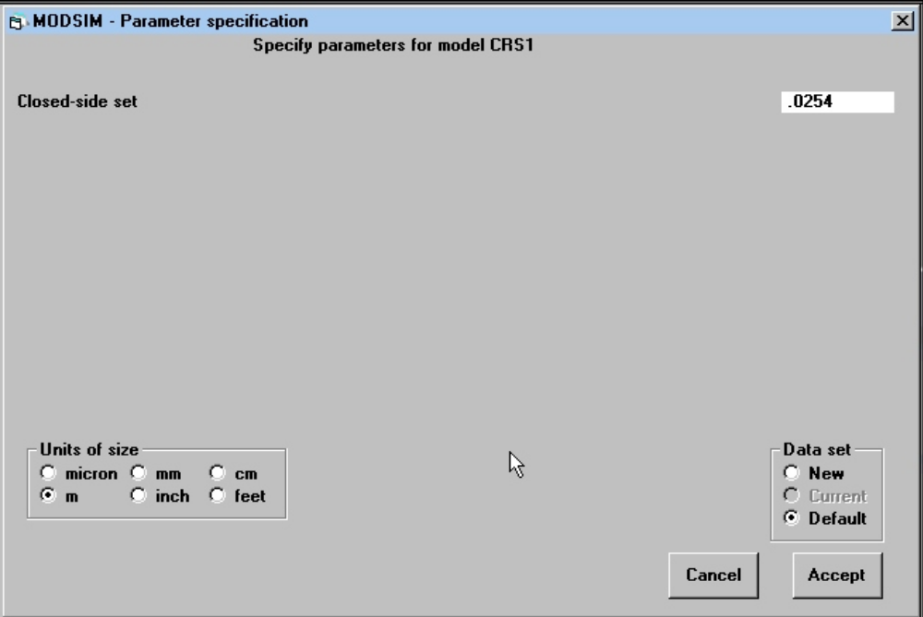
Figure 21 Parameter input form for crusher model CRS1.

PARAMETER:
1...Closed side setting
The form for specifying these parameters is shown in Figure 21.

SHHD: Short-head crusher
This model is based on the crushing zone and internal classification behavior described by Whiten et. al. The parameters in the model were determined by V J Karra - see reference 3 below.
References:
1 Whiten W J The simulation of crushing plants with models developed using multiple spline regression. Application of Computer methods in the Mineral Industry Eds. M.D.G. Salamon and Lancaster. S. Afr. Inst. Min. Metall. Johannesburg, 1973. Pp. 317-323
2 Whiten W.J, Walter G.W, and White M.E, A Breakage function suitable for crusher models. 4TH TEWKSBURY SYMPOSIUM, MELBOURNE, FEB 1973 P19.1-19.32
3 Karra V. K.. A process performance model for cone crushers. PROC. 15th INT. MINERAL PROCESSING CONGRESS. TORONTO. CAN. INST. MIN. METALL. 1982. pp III-6.1 - III-6.14.
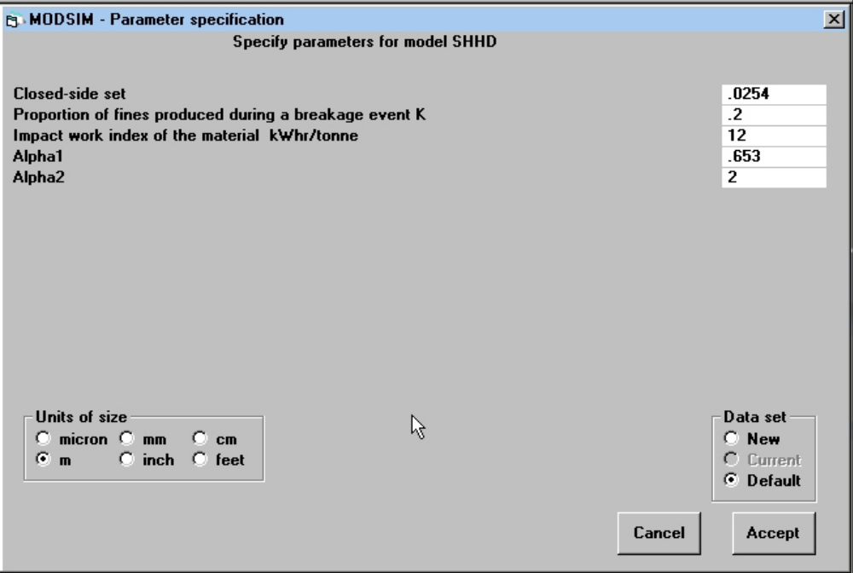
Figure 22 Form to specify parameters for the model SHHD for short head crushers.

PARAMETERS:
1...Closed side setting in meters
2...Proportion of fines produced during breakage events
3...Impact work index of the material
4...Factor for classification parameter k₁
5...Factor for classification parameter k₂

Grinding Mills

FAGM: Fully autogenous mill.
Fully autogenous mill modeled using the full population balance including particle attrition and wear as developed by Austin and Hoyer. See Modeling and Simulation of Mineral Processing Systems Section 5.10. Three distinct breakage processes are modeled: surface attrition, impact breakage and self breakage. Consult Modeling and Simulation of Mineral Processing Systems, section 5.13 for details.
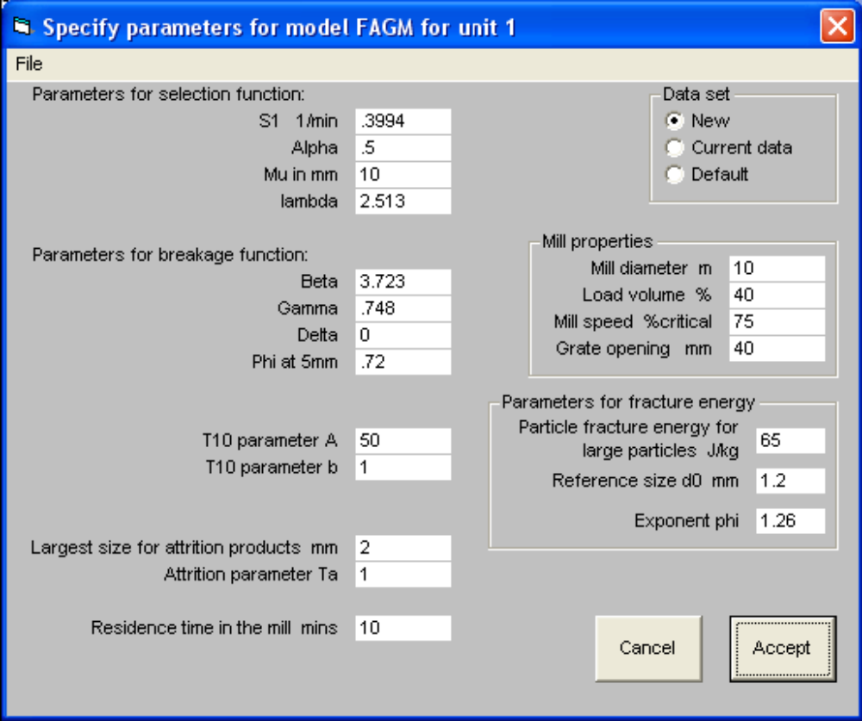
Figure 23 Form to specify parameters for model FAGM for a fully autogenous mill.

The rate of attrition can be measured using a tumbling test such as that described in Napier-Munn et. al. Mineral Comminution Circuits, Their Operation and Optimization. Julius Kruttschnitt Mineral research Center, Brisbane 1996. and Goldman M and Barbery G. "Wear and Chipping of Coarse Particles in Autogenous Grinding: Experimental Investigation and Modeling". Minerals Engineering. 1(1988)67-76. Goldman M, Barbery G, and Flament F. "Modeling load and Product Distribution in Autogenous and Semi-Autogenous Mills: Pilot-Plant Tests". CIM Bulletin Vol 84 No 946 Feb 1991 pp80-86. The attrition parameter Ta is 1/10 of the height of the plateau on the cumulative size distribution plot of the attrition products after tumbling 46 mm lumps for 10 minutes. The breakage function for attrition products is assumed to be logarithmic with exponent 0.67 and the largest size determined from the attrition test as described in Modeling and Simulation of Mineral Processing Systems section 5.14.
Impact fracture is modeled using the standard Austin breakage and selection functions. See Austin LG, Barahona CA, Menacho JM. "Investigations of Autogenous and Semi-Autogenous Grinding in Tumbling Mills". Powder Technology 51(1987) 283-294.
Rate of self breakage is modeled using the distribution of particle fracture energy and the consequent breakage probability. The average kinetic energy of impact is determined assuming the lumps fall a fraction of the mill diameter. The selection function for self breakage on impact is modeled by calculating the rate of breakage as the number of drops of lumps of size d_{p} per second  mass of lump  probability of breakage. All drops are assumed to be 0.5  mill diameter. The distribution of drop heights from DEM simulations will be incorporated in a later version of this model. The breakage probability is modeled on the measured particle fracture energy reported by Tavares and King "Application of Thermal Treatment to improve Comminution" SME Annual Meeting Denver 1995 95-238 with later modifications to reflect measurements on a wider range of materials. The median particle fracture energy varies with particle size according to
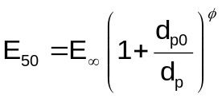
The breakage function for self breakage is based on C Leung, Morrison and Whiten Copper '87 who recommend the T₁₀ breakage function model with parameters determined using a dual pendulum or drop weight test. T₁₀ is modeled as a function of impact energy using a simple exponential function. Two parameters A and b are used to describe this function. These are ore-specific and MODSIM requires them as unit parameters.
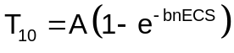
The parameter b is proportional to the median particle fracture energy of the material and consequently is a function of particle size. ECS is the mass specific energy absorbed during breakage in kWhr/tonne. The energy is related to the height of fall and therefore proportional to the mill diameter.

Breakage function for products from abrasion in the autogenous mill is modeled using data from Leung K, Morrison R.D. and Whiten W.J. AAn Energy-Based Ore-Specific Model for Autogenous and Semi-Autogenous Grinding@. Copper 87 Santiago, Chile, Universidad de Chile (1987-1988) pp71-85

The mill is assumed to be perfectly mixed with post classification at the grate. This model permits the use of a pseudo stream from the mill to report the size distribution of the mill load.

PARAMETERS:
Impact breakage:
Parameters for breakage function:
1…β
2…γ
3…δ
4…Φ at 5mm
Parameters for selection function:
5…S₁
6…α
7…μ
8…Λ
Self breakage:
Particle fracture energy:
9…E
10…d_{p0}
11…φ
Parameters for variation of T10 with impact energy:
12…A
13..b
Attrition
14…Largest size for attrition products
15…Attrition parameter Ta
Mill parameters
16…Mill diameter
17…Mill filling
18…Mill speed
19…Grate aperture
20…Residence time

FAGT: Fully autogenous mill with trommel screen.
This model is identical to FAGM but the product from the mill is classified by a trommel screen as it leaves the mill. One additional parameter is required to describe the mesh size of the trommel screen. The Rosin-Rammler classification function for the trommel is used with exponent 6.9

SAGM: Semi-autogenous mill
Semi autogenous mill modeled using the full population balance including particle attrition and wear as developed by Austin and Hoyer. See Modeling and Simulation of Mineral Processing Systems Section 5.10. Austin L G, J M Menacho and F Pearcy. "A general model for semi-autogenous and autogenous milling". APCOM 87 Proc 20th Intnl. Symp. on the Application of Computers and Mathematics in the Mineral Industries. Vol 2 SAIMM Johannesburg 1987 pp 107 - 126. L G Austin, C. A. Barahona and J. M. Menacho "Investigations of autogenous and semi-autogenous grinding in tumbling mills" Powder Technology 51 (1987) 283 - 294. See Modeling and Simulation of Mineral Processing Systems Section 5.11.
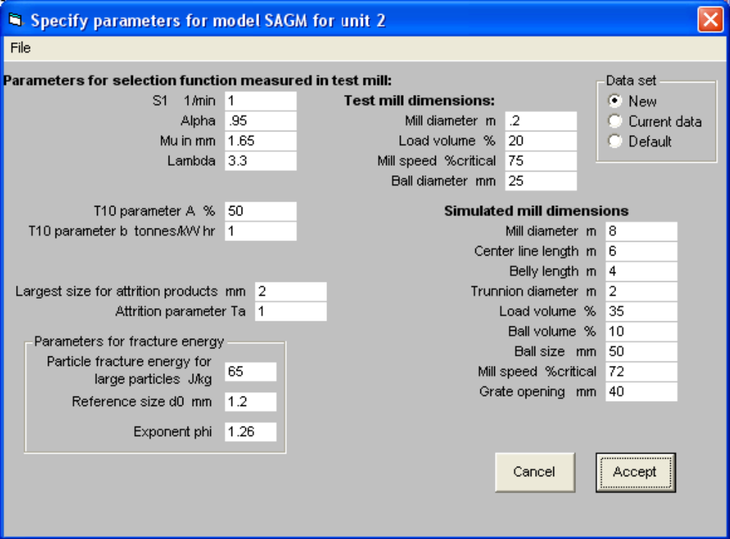
Figure 24 Form to specify parameters for SAG mill model SAGM.

Three distinct breakage processes are modeled: surface attrition, impact breakage and self breakage. See model FAGM for more details.
Goldman M and Barbery G. "Wear and Chipping of Coarse Particles in Autogenous Grinding: Experimental Investigation and Modeling". Minerals Engineering. 1(1988)67-76 Goldman M, Barbery G, and Flament F. "Modeling load and Product Distribution in Autogenous and Semi-Autogenous Mills: Pilot-Plant Tests". CIM Bulletin Vol 84 No 946 Feb 1991 pp80-86 Impact fracture is modeled using the standard Austin breakage and selection functions. See Austin LG, Barahona CA, Menacho JM. "Investigations of Autogenous and Semi-Autogenous Grinding in Tumbling Mills". Powder Technology 51(1987) 283-294. The parameters for the selection function are assumed to be available from a small scale ball mill test. Scale up is based on the size distribution and densities of the autogenous media which is defined as all lumps larger than the grate aperture size. Due allowance is made for the volume fraction and density of the media and balls.
Rate of self breakage is modeled using the variation of particle fracture energy and the consequent breakage probability with size. The average kinetic energy on impact is determined assuming the lumps fall a fraction of the mill diameter. The mill is assumed to be perfectly mixed with post classification at the grate. The load in the mill is calculated from the mill dimensions and the average residence time calculated as the ratio of the load to the throughput. The power drawn by the mill is determined using formulas of Austin and Morrell. This model permits the use of a pseudo stream from the mill to carry the size distribution of the mill load. Water can be added directly to the mill feed at a pre-specified rate or the simulator will calculate the water addition rate that is required to achieve a specified solid content in the mill discharge.
PARAMETERS:
Impact breakage parameters for selection function determined in a small scale ball mill:
1…S₁
2…α
3…μ
4…Λ
Self-breakage:
Particle fracture energy:
5…E
6…d_{p0}
7…φ
Breakage function:
T10 model used
8…A
9…b
Attrition:
10…Largest size for attrition products
11…Attrition parameter Ta
Test mill parameters:
12…Test mill diameter
13…Test mill filling
14…Test mill speed
15…Ball size
SAG mill dimensions:
16…Diameter
17…Center line length
18…Belly length
19…Trunnion diameter
20…Load volume
21…Ball volume
22…Ball size
23…Mill speed
24…Grate aperture

SAGT: Semi autogenous mill with trommel screen.
This model is identical to SAGM but the product from the mill is classified by a trommel screen as it leaves the mill. One additional parameter is required to describe the mesh size of the trommel screen. The Rosin-Rammler classification function for the trommel is used with exponent 6.9

HPGR: High Pressure Grinding Rolls (Roller Press)
High Pressure Grinding Rolls modeled using the full population balance including nipping breakage of large particles and compressive breakage in the gap, developed by Austin and Trubelja. This is a scale-up model for the HPGR. See L.G. Austin and M.P. Trubelja, "The Capacity and Product Size Distributions of High Pressure Grinding Rolls", Proc. IV Encuentro Hemisferio Sur Sobre Tecnologia Mineral, University of Concepcion, Concepcion, Chile, November,1994, pp.49-67.
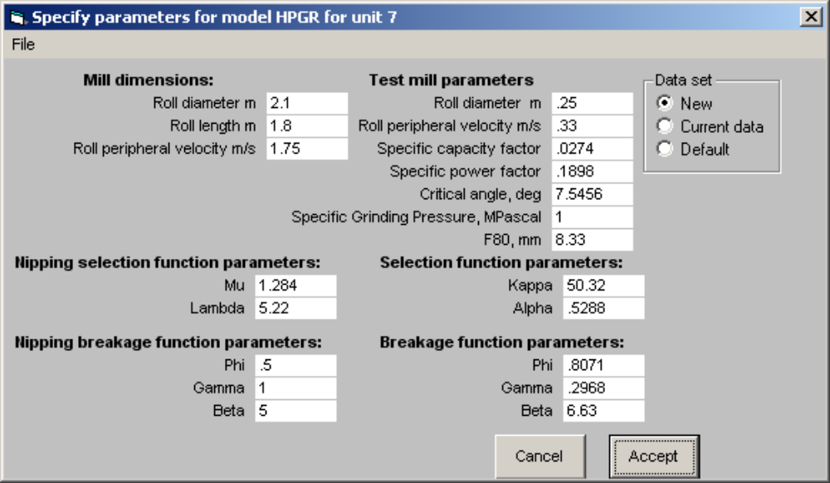
Figure 25 Form to specify parameters for the HPGR model

PARAMETERS
Production mill configuration (these parameters describe the simulated roller press)
1…Production mill roll diameter
2…Production mill roll length
3…Production mill peripheral roll velocity
4…Production mill grinding pressure
5…Critical angle of nip (Assumed equal to test mill, at the grinding pressure considered.)
Nipping breakage parameters (for particles larger than the operating gap. These parameters can be measured using a roll crusher and carefully prepared mono-size particles.)
Nipping selection function parameters
6…Parameter μ
7…Parameter λ
Nipping breakage function parameters
8… Parameter φ
9…Parameter γ
10…Parameter β
Compressive breakage parameters (These parameters can be measured in a bench scale HPGR, operated under different grinding pressures. Usually a set of six grinding pressures is suitable for parameter estimation.)
Compressive breakage selection function
11… Parameter κ
12…Parameter α
Compressive breakage function parameters
13… Parameter φ’
14…Parameter γ’
15…Parameter β’
Test mill parameters
16...Test mill roll diameter
17…Test mill peripheral roll velocity
18…Test mill specific capacity factor at the grinding pressure considered (see definition below)
19…Test mill specific power factor at the grinding pressure considered (see definition below)
20…F80 of test mill feed material

The specific capacity factor here is not defined as the traditional 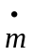 found in the literature and adopted by the manufacturers. For this model, the specific capacity factor is defined as the dimensionless m:
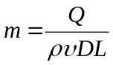
Where:
m = specific capacity factor
Q = production in kg/s
ρ = sample density in kg/m³
υ = roll peripheral velocity, in m/s
D = roll diameter
L = roll length
The specific power factor is defined as
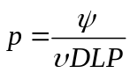
Where:
p = dimensionless specific power factor
Ψ = grinding power, in Watts
P = Grinding pressure, in Pascal
The grinding power is the power used for grinding only. To calculate grinding power, simply subtract no-load power from the total power measured in a given grinding test. No-load power should be constant for a given test mill. The grinding pressure is defined as the grinding force divided by DL so the specific power factor is in fact only a function of the grinding force applied, the peripheral roll velocity, and the observed grinding power.

The critical angle of nip is assumed constant for the industrial and the test roller press. It is defined as
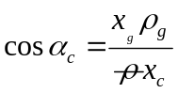
Where:
x_{g} = grinding gap
ρ_{g} = apparent density of particle bed at the gap
x_{c} = gap at the critical angle of nip
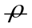= feed apparent density
With the gap at the critical angle of nip calculated from the following expression:
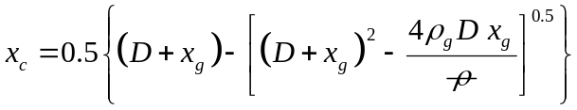

To simulate the industrial mill, the user must define the grinding pressure. This is usually a value between 1 and 6 MPascal for most operations. The critical angle of nip (parameter 5), as well as the scale-up factors m and p are a function of grinding pressure, so whenever the grinding pressure is changed, these parameters must be correspondingly adjusted.

The HPGR model is insensitive to the simulator feed rate. The report file shows the calculated capacity of the industrial roller press according to the input parameters, and the number of roller presses required for the specified application. Proper scale-up is achieved by changing roll dimensions and peripheral speed of the rolls.

RODM: Rod mill
This model is based on plug flow of the charge through the rod mill. Solids move through the mill in plug flow but the longitudinal transport velocity varies with particle size. Larger particles move more slowly than smaller particles and solids move slower than the water except particles in the last class which move with the water.
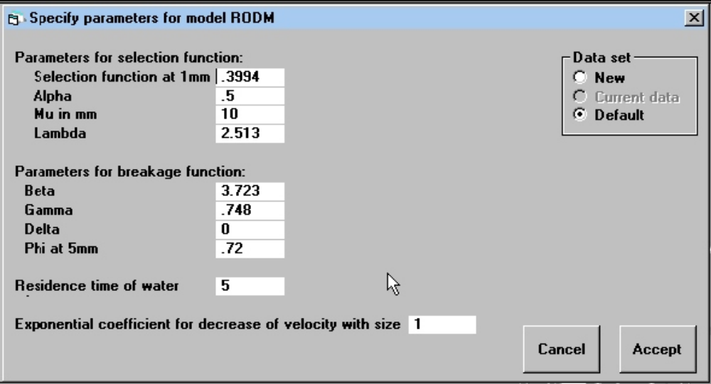
Figure 26 Form to specify parameters for the model RODM for rod mills.

The velocity distribution is modeled by
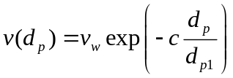
where v_{w} is the water velocity.
The model structure is defined by
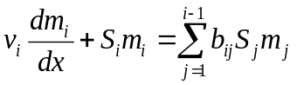
The residence time of the water must be specified.

Parameters:
1...α
2...β
3...γ
4...δ
5...S₁ (close to selection function at 1mm)
6...Φ at 5mm (Φ₅)
7...Mean residence time in the mill (mins)
8...μ
9...Λ
10...Coefficient c for variation of transport velocity with particle size.
References:
1. Rogovin Zvi, Casali Aldo and Herbst J.A. Tracer study of mass transport and grinding in a rod mill. Intl Jnl of Mineral Processing 22(1988) 149-167.
2. Austin L.G, Klimpel R.R. and Luckie P.T. "Process Engineering of Size Reduction: Ball Milling" SME 1984 p123 et seq.
3. King R.P. "Modeling and Simulation of Mineral Processing Systems" Section 5.9

RODL: Rod mill with liberation
This model is identical to RODM in structure but it includes the model for mineral liberation.
Liberation of the mineral phases is computed using the Andrews-Mika model as developed in King R. P. "Calculation of the Liberation Spectrum in Products Produced in Continuous Milling Circuits". Proc 7th European Symposium on Comminution. Ljubljana June 1990 Vol 2 pp429-444. THIS LIMITS THIS MODEL TO BINARY ORES when mineral liberation must be modeled. However the liberation feature can be switched off and the model can be used for any number of minerals.
Claudio Schneider's Beta function model of the internal structure of the Andrew's Mika diagram is available as an alternative liberation model. Schneider, C.L. The Measurement and Calculation of Liberation in Continuous Grinding Circuits. PhD Thesis, University of Utah, 1995. This model is described in King, R.P. Modeling and Simulation of Mineral Processing Systems. Butterworth-Heinemann, Oxford, 2001
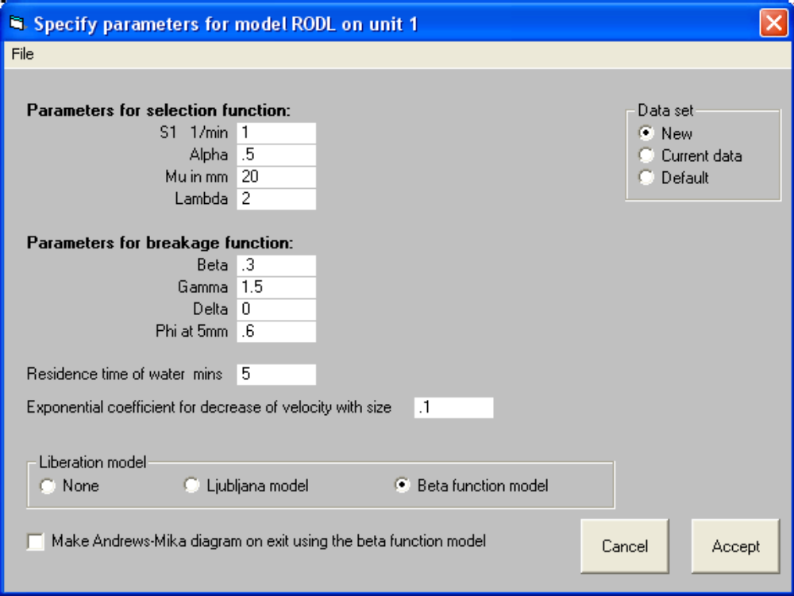
Figure 27 Form to specify parameters for model RODL for rod mill with liberation.

Parameters:
1...α
2...β
3...γ
4...δ
5...S₁ (close to selection function at 1mm)
6...Φ at 5mm (Φ₅)
7...Mean residence time in the mill (mins)
8...μ
9...Λ
10...Coefficient c for variation of transport velocity with particle size

MILL: Ball mill
This is the simplest model for the ball mill using the selection and breakage functions. The mill is assumed to consist of a single perfectly mixed region. The selection function is the standard Austin function including the maximum that defines the decrease of the breakage rate as size gets large.
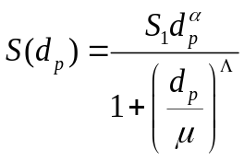
The breakage function is not necessarily normalized and is also of the standard Austin form.
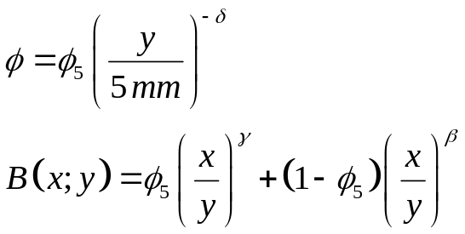

The breakage function is normalized if δ = 0.0
No scale-up relationships are provided and liberation is not modeled. The mean residence time of the solids must be given.
The model does not need any details of the mill geometry.
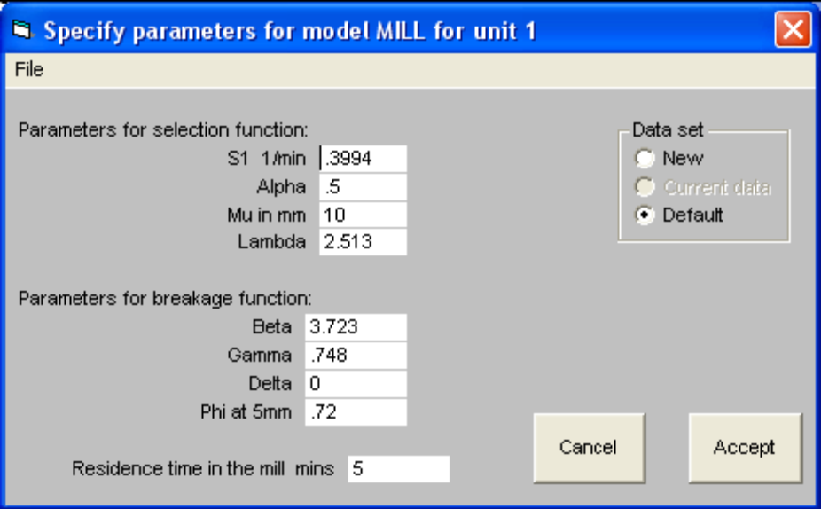
Figure 28 Form to specify parameters for model MILL for autogenous, rod and ball mills.

PARAMETERS:
1...α
2...β
3...γ
4...δ
5...S₁ (close to selection function at 1mm)
6...φ at 5mm (φ₅)
7...Mean residence time in the mill (mins)
8...μ
9...Λ
References:
1. Austin LG Chap.7 of "Grinding - Theory and practice" School notes, S.Afr.Inst. Min. Metall. Johannesburg. 1977
2. Austin LG and Weller KR. Simulation and scale-up of wet ball milling. Proc 14th Int. Mineral Processing Congress. PDR Maltby (Ed.) Can. Inst. Mining Metall. Montreal (1982) pp I 8.1 - I 8.13
3. Rogers R.S.C, Shoji K, Hukki A.M. and Linn. The effect of liner design on the performance of a continuous wet ball mill. Proc 14th Int. Mineral Processing Congress. PDR Maltby (Ed.) Can. Inst. Mining Metall. Montreal (1982) pp I 5.1 - 5.20
4. Austin L.G., Kimpel R.R. and Luckie P.T. Process Engineering of Size Reduction: Ball Milling" SME 1984
5. King R. P. Modeling and Simulation of Mineral Processing Systems, Butterworth-Heinemann, Oxford, 2001

SB16: Selection and Breakage values mill
This model is for research and education. This is an implementation of the MILL model for the ball mill using the selection and breakage functions. The mill is assumed to consist of a single perfectly mixed region. The selection function is a set of 16 values of S(x_{i}) 1/min, for a √2 sequence of size intervals, i.e. x_{i} = √2 x_{i+1}. The breakage function values b_{ij} must be defined for the same set of size intervals. The breakage function values are represented by a lower triangular matrix with each column adding to 100%. As long as these constraints are observed, any form of breakage and selection functions may be used to simulate a perfectly mixed mill region.

In order to use this model, the number of internal size classes must be defined and equal to
16 in the system data, and the top size, also defined in the system data main form, must be equal to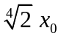. The feed size distribution can be defined freely.

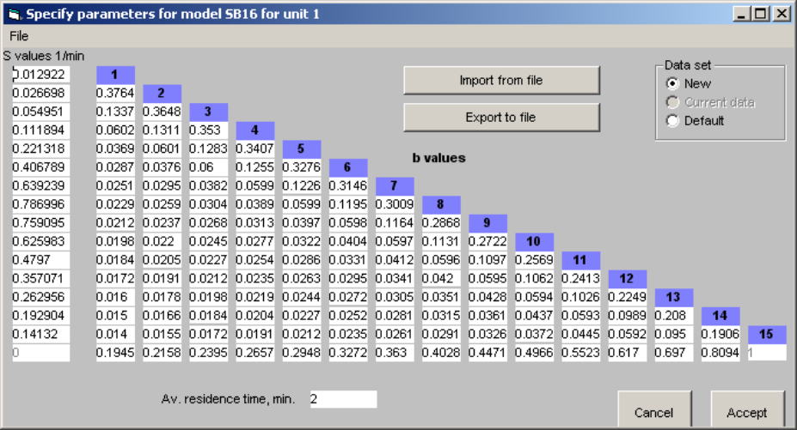
Figure 29 Form to specify the parameters for model SB16 for grinding mills.

HFMI: Herbst-Fuerstenau model for the ball mill.
The entire mill is modeled as a single perfectly mixed section. The selection function is modeled using the energy-specific selection function proposed by Herbst and Fuerstenau. J A Herbst and D W Fuerstenau. Intl. Jnl. Mineral Processing 7 (1980) 1-31. The energy-specific selection function is calculated as a function of particle size using
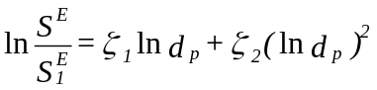 with d_{p} in mm.
where S₁E is the energy-specific selection function at size 1 mm.

The breakage function is the standard Austin model.
This model requires the net power input to the mill charge to be specified and does not require the average residence time to be known.
Water can be added directly to the mill feed at a pre-specified rate or the simulator will calculate the water addition rate that is required to achieve a specified solid content in the mill.

PARAMETERS:
Parameters for the selection function:
1...S₁E in t/kW h
2...ζ₁
3...ζ₂
Parameters for the breakage function:
4...β
5...γ
6...δ
7...Φ at 5mm
Parameter to define the mill operating condition:
8...Net power drawn by the charge, kW

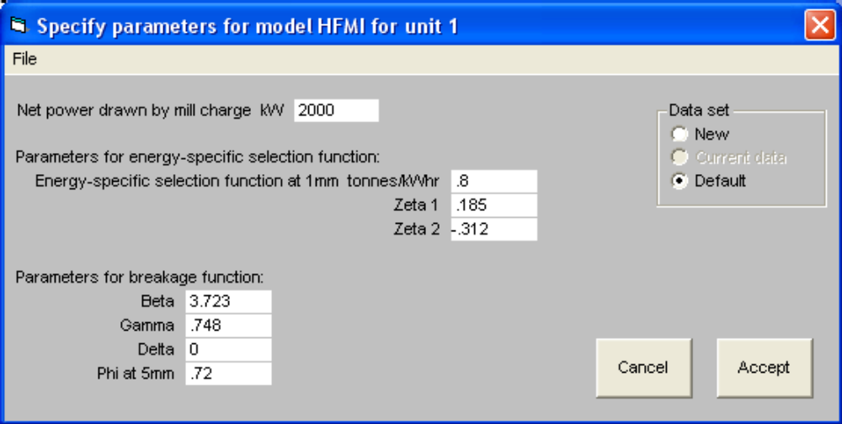
Figure 30 Form to specify the parameters for model HFMI for ball mills.

References:
Herbst J A and Fuerstenau D W. Influence of mill speed and ball loading on the parameters of the batch grinding equation. Trans SME 252 (1972) p169.
Herbst J A and Fuerstenau D W, Mathematical simulation of dry ball milling using Specific power information. Trans SME 254 (1973) p343.
Herbst J A and Fuerstenau D W, Scale-up procedure for continuous grinding mill design using population balance models. International Journal of Mineral Processing, 7 (1980) 1-31.
Herbst J A, Lo Y C and Rajamani R K , Population balance model predictions of the performance of large-diameter mills. Minerals and Metallurgical Processing, May 1985 p114.
Lo Y C and Herbst J a, Consideration of ball size effects in the population balance approach to mill scale-up. Advances in Mineral Processing. P Somasudaran ED., Soc. Mining Engrs. Inc, Littleton CO 1986, Chapter 2.
Lo Y C and Herbst J A, Analysis of the performance of large-diameter ball mills at Bougainville using the population balance approach. Minerals and Metallurgical Processing, Nov 1988 p221.

HFML: Herbst-Fuertenau model for the ball mill with liberation
Model for a ball mill using three perfectly mixed regions in series. Residence times in the 3 regions is distributed in the proportions 0.0137:0.2123:0.7740 There is no classification between stages and no post classification at the discharge end. This model should be used when the HOLD-UP in the mill is known.
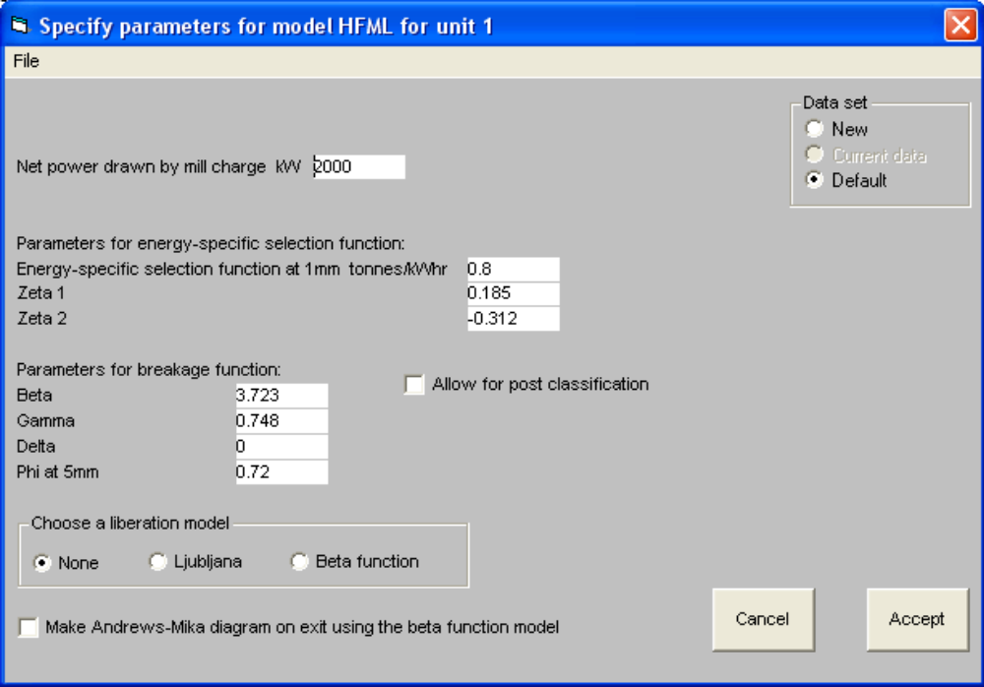
Figure 31 Form to specify the parameters for model HFML for a ball mill with mineral liberation.

Liberation of the mineral phases is computed using the Andrews-Mika model as developed by in King R P "Calculation of the Liberation Spectrum in Products Produced in Continuous Milling Circuits". Proc 7th European Symposium on Comminution. Ljubljana June 1990 Vol 2 pp429-444. THIS LIMITS THIS MODEL TO BINARY ORES when mineral liberation must be modeled. However the liberation feature can be switched off and the model can then be used for any number of minerals.
Claudio Schneider's Beta function model of the internal structure of the Andrews-Mika diagram is available as an alternative liberation model. Schneider, C.L. The Measurement and Calculation of Liberation in Continuous Grinding Circuits. PhD Thesis, University of Utah, 1995. This model is described in King, R.P. Modeling and Simulation of Mineral Processing Systems. Butterworth-Heinemann, Oxford, 2001

The selection function is modeled using the energy-specific selection function proposed by Herbst and Fuerstenau. The energy-specific selection function is calculated as a function of particle size using
with d_{p} in mm.
S₁E is the energy-specific selection function at size 1 mm.
The breakage function is the standard Austin model. The effect of overfilling is not modeled.
This model requires the net power input to the mill charge to be specified and does not require the average residence time to be known.
Water can be added directly to the mill feed at a pre-specified rate or the simulator will calculate the water addition rate that is required to achieve a specified solid content in the mill.

PARAMETERS:
Parameters for the selection function:
1...S₁E in tonnes/kWhr
2...ζ₁
3...ζ₂
Parameters for the breakage function:
4...β
5...γ
6...δ
7...Φ at 5mm
Parameter to define the mill operating condition:
8...Net power drawn by the charge, kW
9...Liberation model

HFSU: Herbst-Fuerstenau model for the ball mill with scale-up features.
The model offers a range of options for defining the residence time distribution of the solids in the mill. The mill can be modeled as 1, 2 or 3 perfectly mixed regions in series with or without post and/or interstage classification.

This model requires the dimensions of the mill to be specified and the net power draw is calculated by the model. User can select from among power draw models that were developed by Bond, Austin or Morrell. This model is therefore useful for scale-up calculations.
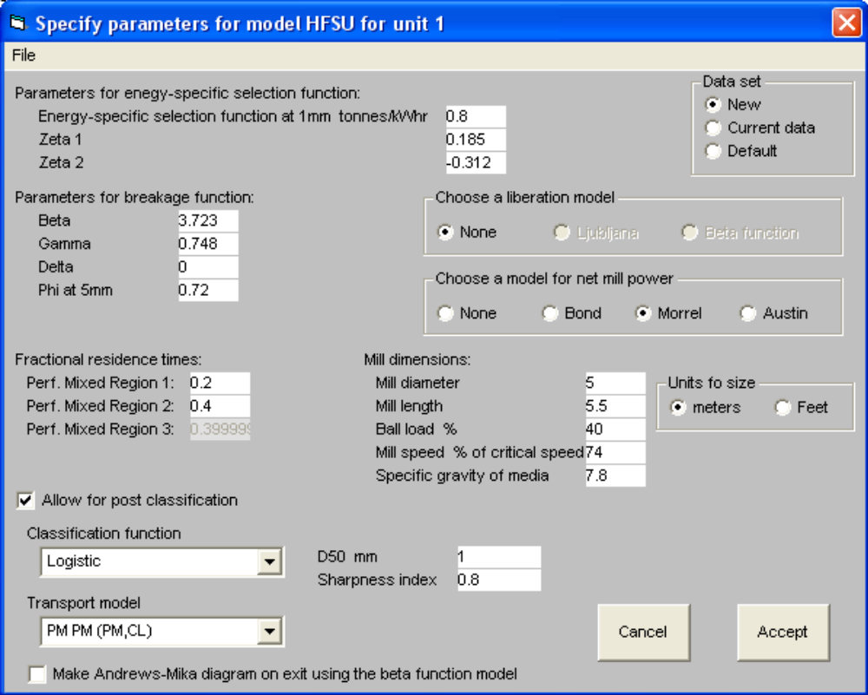
Figure 32 Form to specify the parameters for model HFSU for a ball mill.

The selection function is modeled using the energy-specific selection function proposed by Herbst and Fuerstenau. The energy-specific selection function is calculated as a function of particle size using
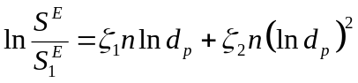
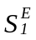 is the energy-specific selection function at size 1mm.
The breakage function is the standard Austin model.

Liberation of mineral phase during comminution can be calculated using the Andrews-Mika model. THIS LIMITS THIS MODEL TO BINARY ORES when mineral liberation must be modeled. However the liberation feature can be switched off and the model can be used for any number of minerals. Two models for the internal structure of the A-M diagram are provided: the simple "Ljubljana model" and Claudio Schneider's Beta function model. Schneider, C.L. The Measurement and Calculation of Liberation in Continuous Grinding Circuits. PhD Thesis, University of Utah, 1995. This model is described in King, R.P. Modeling and Simulation of Mineral Processing Systems. Butterworth-Heinemann, Oxford, 2001.

Water can be added directly to the mill feed at a pre-specified rate or the simulator will calculate the water addition rate that is required to achieve a specified solid content in the mill discharge.

PARAMETERS:
Parameters for the selection function:
1... in t/kW h
2...ζ₁
3...ζ₂
Parameters for the breakage function:
The breakage function is the standard Austin model.
4...β
5...γ
6...δ
7...Φ at 5mm
Dimensions of the mill:
8...Diameter of the mill inside the liners
9...Mill length inside liners
10...Media load in the mill
11...Mill speed as a fraction of critical speed
12...Choice of liberation model
0 = None, 1 = Ljubljana model, 2 = Beta function model
13…Choice of internal classification model:
0 = None, 1 = Logistic, 2 = Rosin-Rammler, 3 = Exponential sum
14...d50 size for post classification in mm
15...Sharpness index for post classification
16...Specific gravity of charge media
17…Choice of power model:
0 = None(user supplies net power draw for the mill), 1 = Bond, 2 = Morrell, 3 = Austin
18...Net grinding power in kW supplied by user if parameter 17 = 0
19...Makeup ball size (mm) (Required by Bond's power formula)
20...Choice of Transport Model:
0 = PM;PM;(PM-Cl), 1 = (PM;PM;PM;Cl), 2 = (PM-Cl);(PM-Cl);(PM-Cl),
4 = PM;PM;PM (used when parameter 13 = 0).
PM = perfect mixer, Cl = classifier. Parentheses indicate the scope of the
post-classification loop
21...Fraction of total residence time in Region 1
22...Fraction of total residence time in Region 2

References:
1 King R P "Calculation of the Liberation Spectrum in Products Produced in Continuous Milling Circuits". Proc 7th European Symposium on Comminution. Ljubljana, June 1990 Vol 2 pp429-444.
2 King R P Modeling and Simulation of Mineral Processing Systems, Butterworth-Heinemann, Oxford, 2001 Sections 3.4, 5.8.2, 5.9 and 5.12.3.
3 Herbst J A and Fuerstenau D W Scale-up procedure for continuous grinding mill design using population balance models. International Journal of Mineral Processing 7(1980)1-31

GMIL: Ball mill including mineral liberation
Model for a ball mill using three perfectly mixed regions in series. Residence times in the 3 regions are distributed in the proportions 0.0137:0.2123:0.7740. There is no classification between stages. This model should be used when the RESIDENCE TIME in the mill is known.
Austin models for the selection and breakage functions are used. A selection of previously determined parameters for selection and breakage function are provided. These may be used as they are or modified to suit the application.
Liberation of the mineral phases is computed using the Andrews-Mika model as developed in King R P "Calculation of the Liberation Spectrum in Products Produced in Continuous Milling Circuits". Proc 7th European Symposium on Comminution. Ljubljana June 1990 Vol 2 pp429-444. THIS LIMITS THIS MODEL TO BINARY ORES when mineral liberation must be modeled. However the liberation feature can be switched off and the model can be used for any number of minerals.
Claudio Schneider's Beta function model of the internal structure of the Andrews-Mika diagram is available as an alternative liberation model. Schneider, C.L. The Measurement and Calculation of Liberation in Continuous Grinding Circuits. PhD Thesis, University of Utah, 1995. This model is described in King, R.P. Modeling and Simulation of Mineral Processing Systems. Butterworth-Heinemann, Oxford, 2001
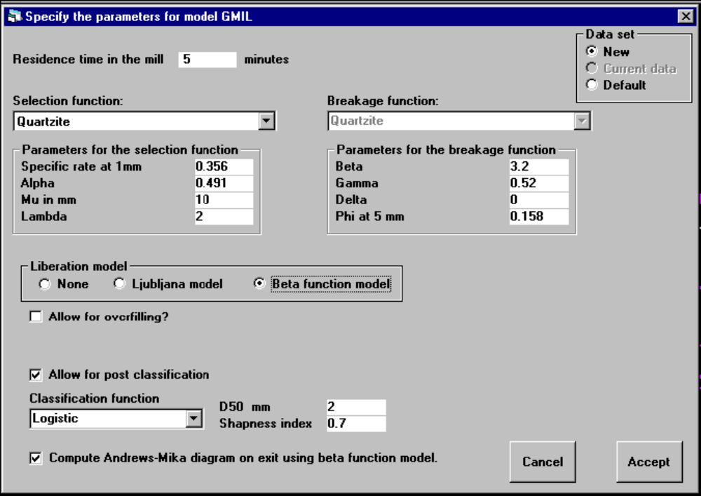
Figure 33 Form to specify parameters for model GMIL.

PARAMETERS:
1...Total residence time in the mill
2...Used to choose a selection function. The following models are available as standard and are accessed through a drop-down menu
1 = Standard quartzite
2 = Rogers' function for phosphate
3 = Reed, Brame and Austin scale-up model for coal
4 = Standard Austin model for taconite
3...Used to choose a breakage function. Selected to match the selection function that is chosen
1 = Standard quartzite
2 = Rogers' function for phosphate
3 = Reed, Brame and Austin scale-up model for coal
4 = Standard breakage function for taconite
4...Hardgrove Grindability Index - used only for coal
5...Choice of liberation model
0 = None
1 = Ljubljana model
2 = Beta function model

GMI1: Ball mill.
Model for a ball mill using three perfectly mixed regions in series. Residence times in the 3 regions are distributed in the proportions 0.0137 : 0.2123 : 0.7740 There is no classification between stages. This model should be used when the HOLD-UP in the mill is known.
Austin models for the selection and breakage functions are used. A selection of previously determined parameters for selection and breakage function are provided. These may be used as they are or modified to suit the application.
The model allows for liberation of the mineral phases which is computed using the Andrews-Mika model as developed in King R P "Calculation of the Liberation Spectrum in Products Produced in Continuous Milling Circuits". Proc 7th European Symposium on Comminution. Ljubljana June 1990 Vol 2 pp429-444. THIS LIMITS THIS MODEL TO BINARY ORES when liberation must be modeled. However the liberation feature can be turned off and the model will work for any number of minerals.
Claudio Schneider's Beta function model of the internal structure of the Andrew's Mika diagram is available as an alternative liberation model. Schneider, C.L. The Measurement and Calculation of Liberation in Continuous Grinding Circuits. PhD Thesis, University of Utah, 1995. This model is described in King, R.P. Modeling and Simulation of Mineral Processing Systems. Butterworth-Heinemann, Oxford, 2001

PARAMETERS:
1...Hold up in the mill in metric tons
2...Used to choose a selection function. The following models are available as standard from a pop-down menu
1 = Standard quartzite
2 = Rogers' function for phosphate
3 = Reed, Brame and Austin scale-up model for coal
3...Used to choose a breakage function. Selected to match the selection function.
1 = Standard quartzite
2 = Rogers' function for phosphate
3 = Reed, Brame and Austin scale-up model for coal
4...Switch for allowing for over filling.
0 = Overfilling does not influence the model
1 = Overfilling calculated using the Austin model
5...Hardgrove grindability index - only used for coal
6...Choice of liberation model
1 = Ljubljana model
2 = Beta function model
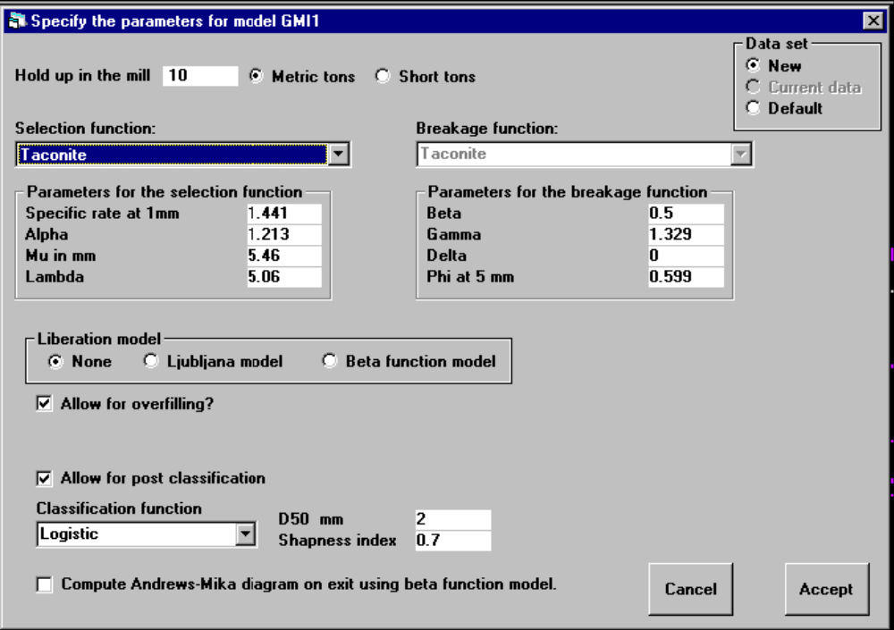
Figure 34 Form to specify parameters for model GMI1 for a ball mill.

GMSU: Model for the ball mill with scale-up.
Model for the ball mill with Austin's scale-up procedure. Mixing in the mill is modeled using three perfectly mixed regions in series. No classification between stages. This model should be used when the parameters for the selection and breakage functions have been determined from laboratory batch tests and the dimensions of the full scale mill are known.
Liberation of the mineral phases is computed using the Andrews-Mika model as developed in King R P "Calculation of the Liberation Spectrum in Products Produced in Continuous Milling Circuits". Proc 7th European Symposium on Comminution. Ljubljana June 1990 Vol 2 pp. 429-444. THIS LIMITS THIS MODEL TO BINARY ORES when liberation must be modeled. However the liberation feature can be turned off and the model will work for any number of minerals.
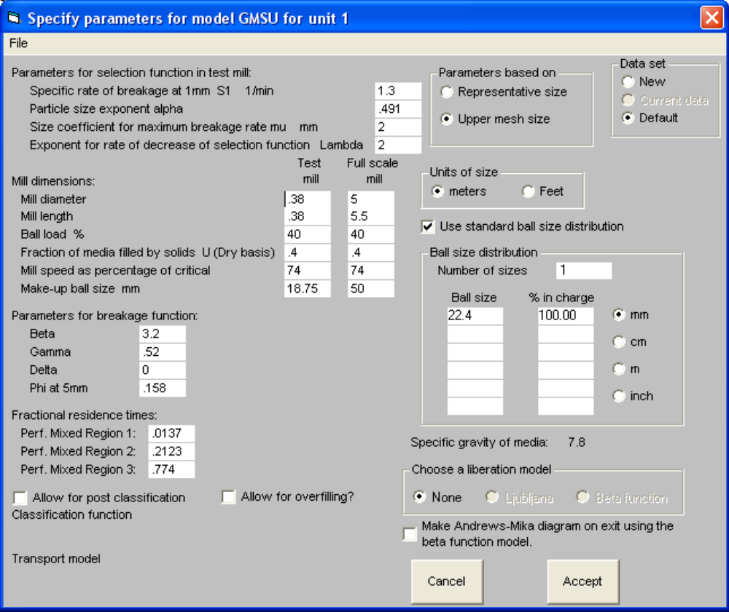
Figure 35 Form to specify parameters for model GMSU.

Claudio Schneider's Beta function model of the internal structure of the Andrew's Mika diagram is available as an alternative liberation model. Schneider, C.L. The Measurement and Calculation of Liberation in Continuous Grinding Circuits. PhD Thesis, University of Utah, 1995. This model is described in King, R.P. Modeling and Simulation of Mineral Processing Systems. Butterworth-Heinemann, Oxford, 2001.
Water can be added directly to the mill feed at a pre-specified rate or the simulator will calculate the water addition rate that is required to achieve a specified solid content in the mill discharge.

PARAMETERS:
Selection function parameters determined in the test mill:
1...Specific rate of breakage at 1mm
2...Particle size exponent alpha
3...Size coefficient for maximum breakage, mm
4...Exponent for fall off of selection function with size in the abnormal breakage region
Breakage function parameters determined in the test mill:
5...β
6...γ
7...δ
8...Φ at 5mm
Mill dimensions:
9...Test mill diameter
10...Test mill length
11...Ball load in test mill
12...Fraction of media filled with slurry in test mill
13...Mill speed of test mill, % of critical
14...Ball size in test mill
15...Full size mill diameter
16...Full size mill length
17...Ball load in full size mill %
18...Media filling in full size mill %
19...speed of full size mill % of critical
20...ball size in full size mill
21...Choice of liberation model. 0 = none, 1 = Ljubljana, 2 = Beta function
22....SWITCH FOR ALLOWING FOR OVERFILLING.
23....Choice of post classification function. 0 = None, 1 = Logistic, 2 = Rosin-Rammler, 3 = Exponential sum
24...D50 for post classifier
25...Sharpness index for post classifier

UMIL: Ball mill.
Model for a ball mill using three perfectly mixed regions in series. There is no classification between stages and post-classification is optional. This model allows the critical parameters for the Andrews-Mika diagram to be specified as parameters.
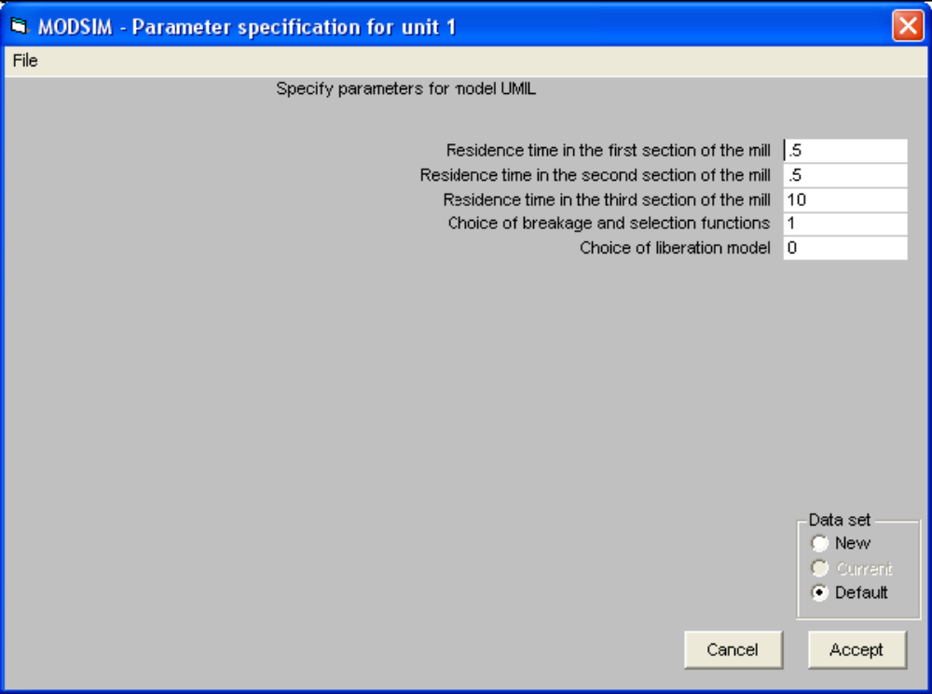
Figure 36 Form to specify parameters for model UMIL for a ball mill.

PARAMETERS:
1....Residence time in the first perfectly mixed region.
2....Residence time in the second perfectly mixed region.
3....Residence time in the third perfectly mixed region.
4....Functional forms chosen for breakage function and specific breakage rate constant.
1…3-parameter breakage function & 4-parameter rate constant without post classification.
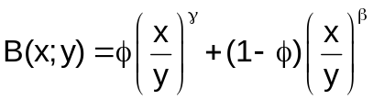 φ = 0.59948, γ = 1.32876 and β = 0.500.
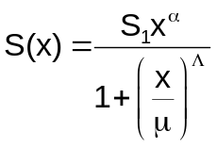 S₁ = 1.44054, α = 1.21291, μ = 5.4571 mm and Λ = 5.0625. x is in mm.

These parameters were estimated from data on taconite ore.

2…3-parameter breakage function & 4-parameter rate constant with post classification.
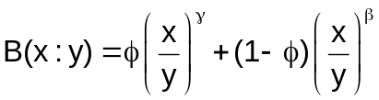 φ = 0.50153, γ = 1.71416 and β = 0.44145.
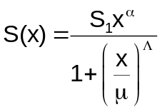 S₁ = 0.26015, α = 1.19798, μ = 1.4942 mm and Λ = 2.40181. x is in mm.
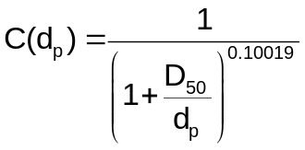 With D₅₀ = 3.985 mm.

These parameters were determined from data on Utah limestone in a 16" X 16" ball mill.

3…4-parameter breakage function & 4-parameter rate constant with post classification.
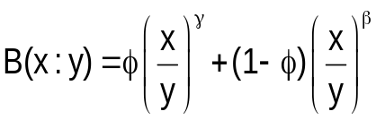 φ = 0.19946(1.0/y)^{0.10977}, γ = 1.40238 and β = 2.6576 .
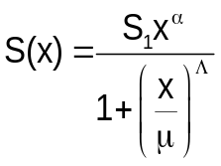 S₁ = 1.7671, α = 0.6658, μ = 1.7633 mm and Λ = 3.1953. x is in mm.
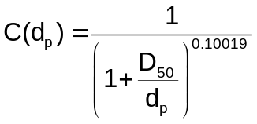 With D₅₀ = 0.91789 mm.

These parameters were determined from data on Utah limestone in a 16" X 16" ball mill.

Models for Classifiers

CSCN: Compound vibrating screen.
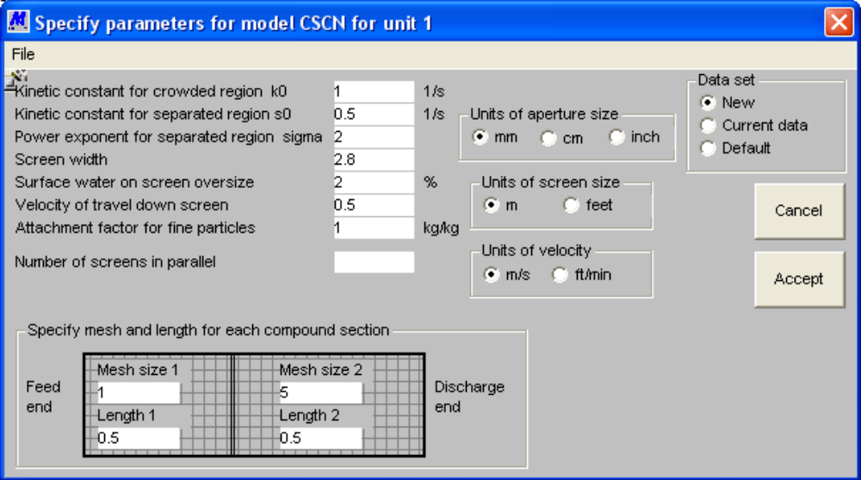
Figure 37 Form to specify parameters for model CSCN for a compound vibrating screen.

This is the model for a compound screen that has two different meshes on a single deck. The screen therefore produces two underflow streams.

This model uses the simple kinetic model for screening to describe the behavior of the vibrating screen. This model is described in the book Modeling and Simulation of Mineral Processing Systems by R P King in section 4.3. The model used in Modsim differs slightly from the description in the book because, in Modsim, the transition from heavily-loaded to lightly-loaded conditions is assumed to take place where the depth of the bed is equal to twice the d₈₀ size in the feed. Thus the screen can operate completely under heavily loaded conditions if the feed rate is too high, with a transition from heavily-loaded to lightly-loaded somewhere along the screen or entirely under lightly loaded conditions if the feed rate is low. The model calculates the transition point and reports this in the report file. The transition condition that is used in Modsim is more realistic than that used in the book.

Another feature that is available in the Modsim model but which is not described in the book is the carryover of fines into the overflow stream because these fine particles adhere to the larger particles particularly if water sprays are not used. This effect is modeled by specifying the attachment factor (A_{f}) as kg of fines adhering to 1 kg of oversize material. Finer particles attach more easily than coarser particles so that the actual attachment factor on a size-by-size basis is modeled by
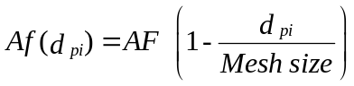
Water sprays can be added directly to the screen.

PARAMETERS:
- Kinetic constant for the crowded region 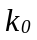
- Kinetic constant for separated region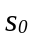. Note that 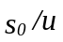is equivalent to 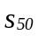 in the textbook so that is the value of s at half the mesh size
- Power exponent for separated region kinetic constant. σ
- Screen width
- Water on screen oversize
- Velocity of travel down the screen
- Mesh size on first mesh
- Length of first mesh
- Mesh size on second mesh
- Length of second mesh
- Attachment factor A_{f}
- Number of screens in parallel

CYCL: Plitt=s model for the hydrocyclone.
This is the hydrocyclone model according to L R Plitt (CIM Bul. Dec. 1976 p. 114). The subroutine calculates the actual classification curve allowing for bypass fraction. The default parameters relate to the standard geometry but any geometrical configuration can be specified. The geometry of the cyclone can be specified as a standard configuration or each dimension can be specified individually.
Roping of the cyclone is tested using the Mular-Jull and the Concha criteria.
The effect of slurry viscosity is modeled by scaling the d₅₀ cut size by a factor (viscosity/viscosity of water)^{0.35} in accordance with the recommendation of S K Kawatra, A K Bakshi and M T Rusesky "The effect of slurry viscosity on hydrocyclone classification" Int. Jnl. of Mineral Processing 48(1996)39-50
PARAMETERS:
1…Cyclone diameter m
2…Vortex-spigot distance as a fraction of cyclone diameter
3…Inlet diameter as fraction of cyclone diameter
4…Vortex finder diameter as a fraction of cyclone diameter
5…Spigot diameter as a fraction of cyclone diameter
6…Head of feed slurry m
7…Number of cyclones in parallel
8…Plitt's calibration parameters for d₅₀
9…Plitt=s calibration parameter for sharpness
10…Plitt=s calibration parameter for the flow split
11…Viscosity of the slurry
12…Exponent for density variation
13…Slurry density in separating zone. As a fraction of the difference between the carrier fluid and the lightest solid

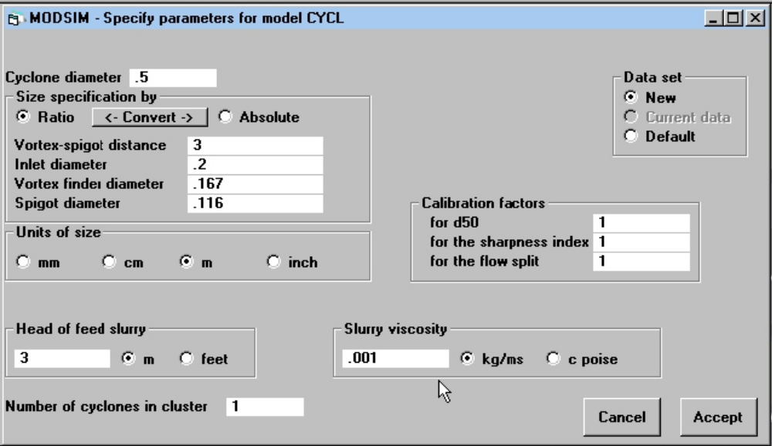
Figure 38 Form to specify parameters for model CYCL for a hydrocyclone.

The geometry may be specified on the data entry form (Figure 38) in absolute units or relatively to the cyclone diameter.
The exponent for the slurry density defines the variation of d₅₀ with particle density. It reflects the flow conditions in the cyclone. If Stokes law applies the exponent is 0.5 as was recommended tentatively by Plitt. However the level turbulence in the cyclone is always high and higher values of the exponent are usually required to match actual performance.

The density of the slurry in the separating zone of the cyclone also has strong influence on the cut point. This density is always between the density of the carrier fluid and the density of the lightest solid component. Enter the fraction of the difference between these two values.

The effect of slurry viscosity is modeled by scaling the d₅₀ cut size by a factor (viscosity/viscosity of water)^0.35 in accordance with the recommendation of S K Kawatra, A K Bakshi and M T Rusesky "The effect of slurry viscosity on hydrocyclone classification" Int. Jnl. of Mineral Processing 48(1996)39-50

Roping of the cyclone is tested using the Mular-Jull and the Concha criteria.

References:
Mular AL and Jull NA. The selection of cyclone classifiers, pumps and pump boxes for grinding circuits. In Mular AL and Bhappu RB Eds. Mineral Processing Plant Design AIME 2nd Ed 1980 pp376-403.
Concha FA, Barrientos AC Montero J and Sampaio R. "Air core and roping in hydrocyclones". Preprints 8th European Symposium on Comminution, Stockholm May 1994 Vol 2 pp814-823

CYCA: Hydrocyclone.

Description: General empirical model for a classifier as described by Austin, Klimpel and Luckie "Process Engineering of Size Reduction - Ball Milling" SME 1984 p 305.
The corrected partition curve can be modeled by any one of three standard mathematical functions - the exponential sum or Lynch model, the Rosin-Rammler function or the logistic function. These all have the typical S-shape and are characterized by 2 parameters, the corrected d₅₀ and the sharpness index. The sharpness index is d₂₅/d₇₅ and therefore varies between 0 and 1. No classification is represented by 0 and 1 is perfect classification. By-pass to underflow can be specified.

If the unit to be modeled is a cyclone or other classifier that depends on terminal settling velocity, separation size will vary with particle density. This variation is modeled as a simple power function with the exponent selectable as a parameter. The exponent should have a value between 0.5 and 1.0, 0.5 corresponding to Stokes' Law and 1.0 corresponding to Newton's Law for the particle drag coefficient.
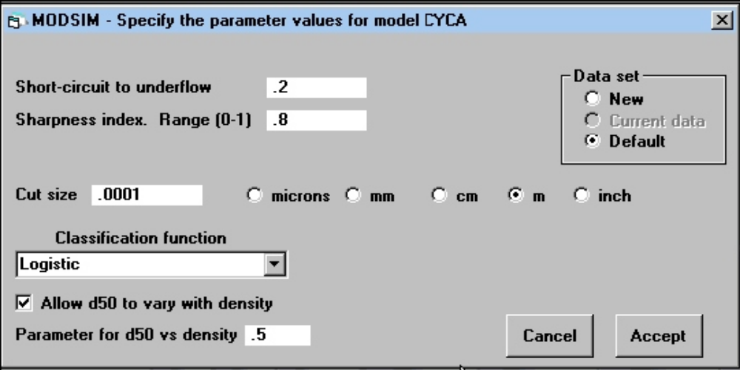
Figure 39 Form to specify parameters for the model CYCA for a hydrocyclone.

PARAMETERS:
1...By-pass fraction
2...Sharpness index
3...Corrected d₅₀ for particle having specific gravity 2.67
4...Exponent for variation of corrected d₅₀ with density
5...Choice of model:
1...Exponential-sum or Lynch model
2…Rosin-Rammler model
3...Logistic model

DSC1: Double-deck screen.
This is the simple ideal model for double deck screening. The model used is identical to that used in SCRN for single-deck screens. This model should be used only for preliminary simulations before equipment has been chosen. Model can accommodate water sprays.
PARAMETERS:
- Mesh size on top deck m
- Efficiency of transmission of undersize on top deck
- Surface water on top deck oversize
- Mesh size on lower deck m
- Efficiency of transmission of undersize on lower deck
- Surface water on lower deck oversize
- Dimensions of the screens (optional)
- Number of screens in parallel
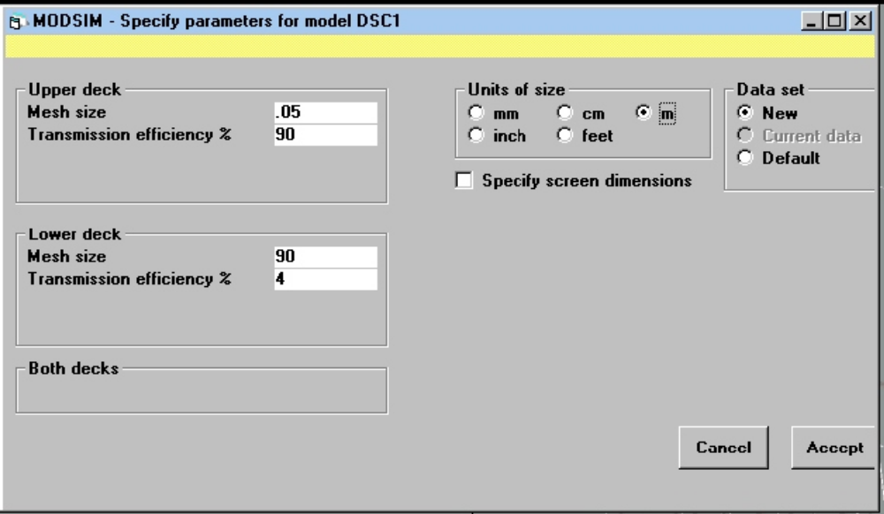
Figure 40 Form to specify parameters for model DSC1 for a double-deck screen.

DSC2: Double-deck screen.
This is the double-deck version of the Karra model SCR2. See above for details of the model.
PARAMETERS:
- Mesh size on upper deck m
- Mesh size on lower deck m
- Wire diameter on upper deck m
- Wire diameter on lower deck m
- Angle of inclination of the deck degrees
- Length of top deck m
- Width of screen deck m
- Bulk density of material kg/m³
- Screen type
- Length of lower deck
- Number of screens in parallel

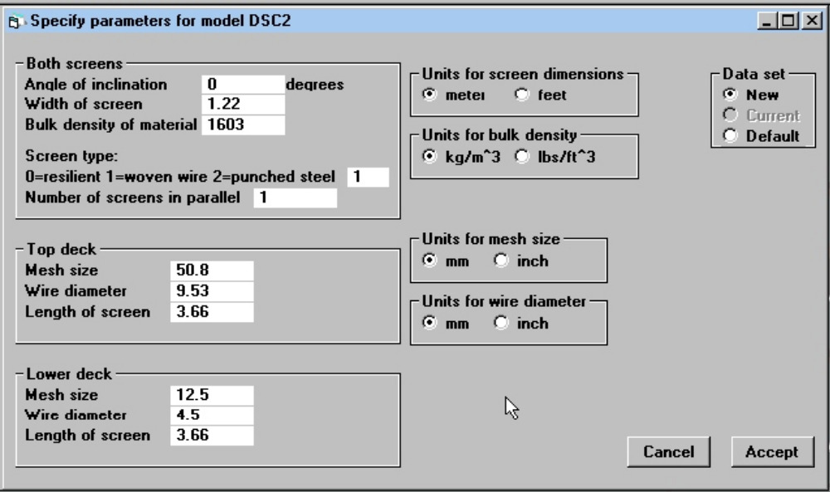
Figure 41 Form to specify parameters for model DSC2 for a double-deck screen.

ELUT: Elutriator
This elutriator model is based on the partition function using the terminal settling velocity as the independent variable. Separation is therefore a function of both particle size and particle velocity.
The logistic model is used for the partition function and the terminal settling velocity for an arbitrary-shaped particle in water is calculated using the Concha-Almendra procedure. This procedure is described in R. P. King Introduction to Practical Fluid Flow. Butterworth-Heinemann, Oxford, 2002 Sections 3.2 and 3.3
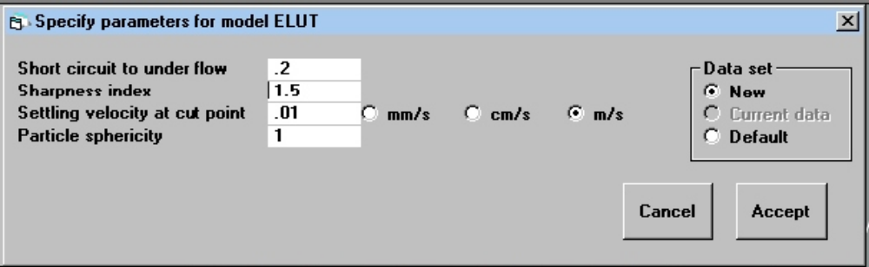
Figure 42 Form to specify parameters for model ELUT for an elutriator.

PARAMETERS:
1...Short circuit to underflow
2...Sharpness index for the partition function
3...Separation velocity V₅₀. This should be close to the average velocity of liquid flow in the separation section of the elutriator
4...Particle sphericity = surface area of sphere with same volume/surface area of particle. (This can be measured by image analysis.)

KSCN: Kinetic model for the vibrating screen
This model uses the simple kinetic model for screening to describe the behavior of the vibrating screen. This model is described in the book Modeling and Simulation of Mineral Processing Systems by R P King in section 4.3. The model used in Modsim differs slightly from the description in the book because, in Modsim, the transition from heavily-loaded to lightly-loaded conditions is assumed to take place where the depth of the bed is equal to twice the d₈₀ size in the feed. Thus the screen can operate completely under heavily loaded conditions if the feed rate is too high, with a transition from heavily-loaded to lightly-loaded somewhere along the screen or entirely under lightly loaded conditions if the feed rate is low. The model calculates the transition point and reports this in the report file. The transition condition that is used in Modsim is more realistic than that used in the book.
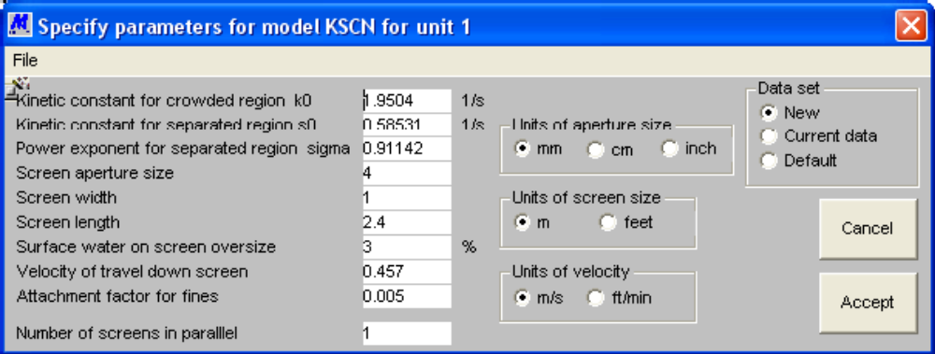
Figure 43 Form to specify parameters for model KSCN for a vibrating screen.

Another feature that is available in the Modsim model but which is not described in the book is the carryover of fines into the overflow stream because these fine particles adhere to the larger particles particularly if water sprays are not used. This effect is modeled by specifying the attachment factor (Af) as kg of fines adhering to 1 kg of oversize material. Finer particles attach more easily than coarser particles so that the actual attachment factor on a size-by-size basis is modeled by
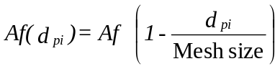
Water sprays can be added directly to the screen.

PARAMETERS:
- Kinetic constant for the crowded region
- Kinetic constant for separated region. Note that is equivalent to in the textbook so that is the value of s at half the mesh size
- Power exponent for separated region kinetic constant. σ
- Screen aperture size
- Screen width
- Screen length
- Water on screen oversize
- Attachment factor Af
- Velocity of travel down the screen
- Number of screens in parallel

PSCN: Probability screen
Probability screen on which the particles are subjected to a separation process which is size sensitive over a wide range of sizes. This type of screening occurs with a relatively steeply inclined screen is subjected to vibrations having a substantial component perpendicular to the plane of the screen. This contrasts with conventional vibrating screens that have vibrations predominantly in the parallel direction. The main advantage that is claimed for probability screening is the reduction of blinding because near-size material does not penetrate the screen. Probability screening is sometimes associated with the name of Mogensen who patented the principle in 1951 ( US Patent 2 512 177). This model can accommodate water sprays. WARNING!!!! This model is based on multilinear regression and is very sensitive to the combination of parameters chosen. It is also very sensitive to the feed rate. You should be certain of the parameter values before using this model.

PARAMETERS:
1...Amplitude of vibration
2...Vibration frequency
3...Angle of inclination of the screen - degrees
4...Screen vibration throw angle
5...Screen aperture size
6...Screen width
7...Screen length
8...Surface water on screen oversize
9...Number of screens in parallel
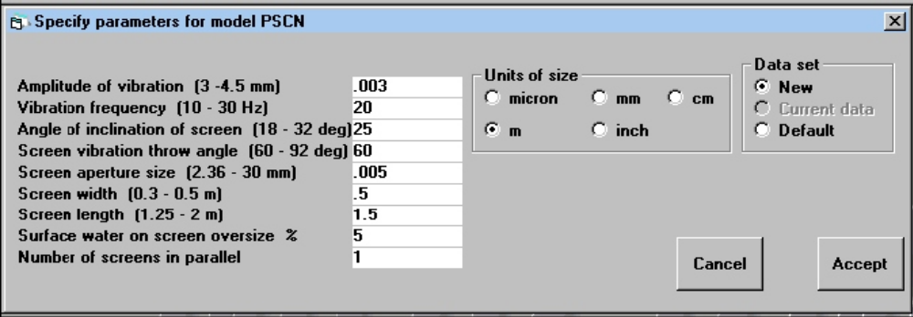
Figure 44 Form to specify parameters for model PSCN for a probability screen.

References: J M Beeckmans and Judy Hill, "Probability screening", Powder Technology 35(1983)263-269Chen Rongguang, JM Beekmans, and Chen Qingru, "A convenient correlation for modeling the performance of probability screens", Intl. Jnl. of Mineral Processing, 36(1992)31-40.

SCRN: Single-deck vibrating screen.
This is a simple ideal model for screening. The screen cuts at the specified mesh size but a certain fraction of the undersize is carried over the screen. This is defined by the transmission efficiency. Water sprays can be added to the screen.

PARAMETERS:
1…Mesh size m
2…Efficiency of transmission to undersize
3…Surface moisture on screen oversize
4…Dimensions of the screen. (Optional) Check Specify screen dimensions box if you wish to specify the dimensions of the screen
5…Number of screens in parallel

SCR1: Single-deck vibrating screen.
Description: A model for wet screening as described by R.S.C. Rogers (Powder Tech. 31(1982) 135-137). The classification function is described by
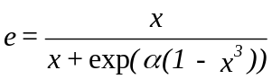
with
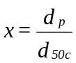
The short circuit to oversize follows the water split. The actual classification is described by
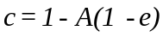
where A is the water split to undersize.

This model has been found to be effective for wet screening and has been tested for coal slurries on a Derrick high frequency screen.
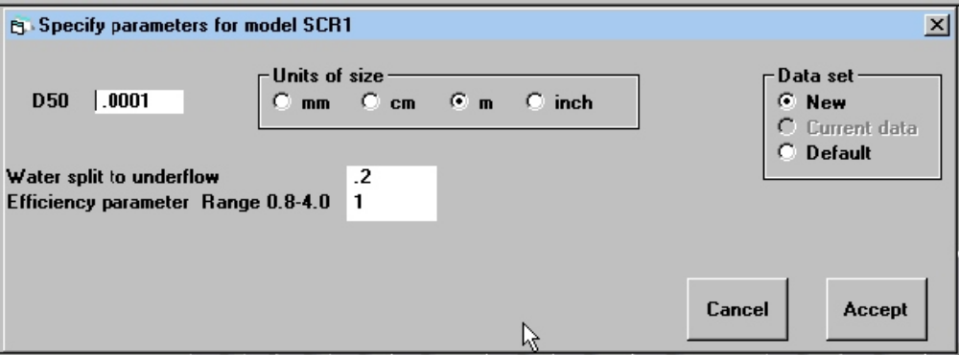
Figure 45 Form to specify parameters for model SCR1 for a single-deck vibrating screen.

PARAMETERS:
1…d₅₀ in meters
2…water split to underflow A
3…efficiency parameter α. Usually in range 0.8 to 4.0

SCR2: Single-deck vibrating screen.

Description: The screen simulation model developed by V K Karra (CIM Bulletin, April 1979, p. 167-171). This is a true simulation model in that the parameters are required to define the physical characteristics of the screen including the dimensions of the screen and the screen material. The model calculates the screen separation function from the characteristics and tonnage of the feed (which are supplied by the simulator) in relation to the physical description of the screen. Karra developed a procedure that agrees closely with the method used by engineers to assess screen performance. The subroutine produces a report file that gives a comprehensive description of the screen performance including the calculated screening efficiency which is represented by the usual efficiency factors together with an additional factor which accounts for the presence of near-size materials in the feed.
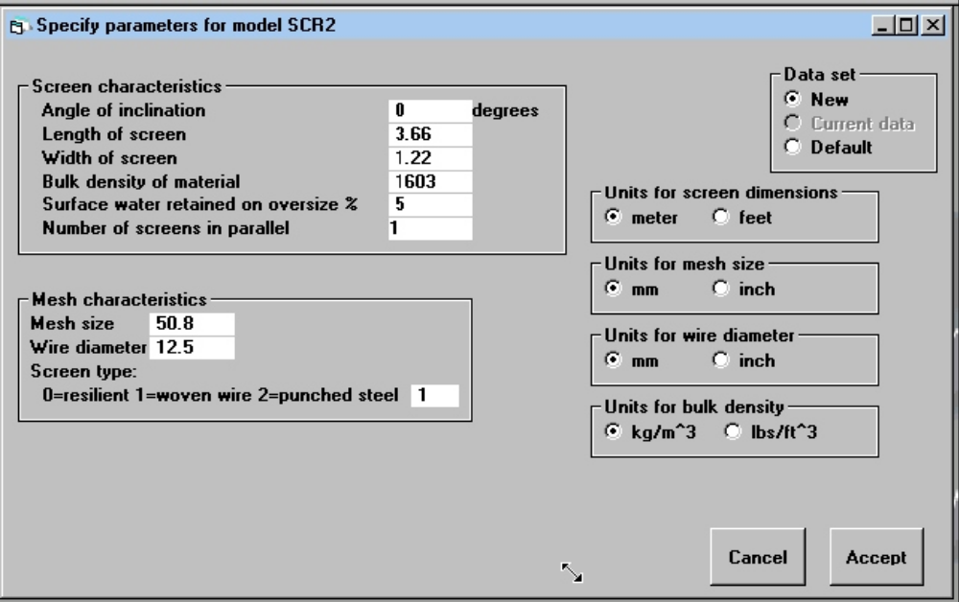
Figure 46 Form to specify parameters for model SCR2 for a single-deck vibrating screen.

An area utilization factor (AUF) is calculated which is given by

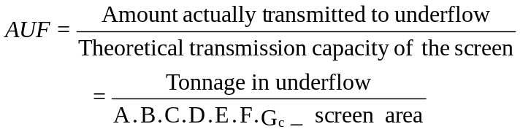

A,B,C,D,E and F are the usual capacity factors and G_{c} is the near-size capacity factor.

This model is effective for checking the performance of an existing screen or for checking the performance of a proposed screen once its dimensions have been established. The AUF gives an immediate indication as to whether the screen has been correctly sized for the application. (A correctly sized screen will have AUF close to unity). The individual efficiency factors indicate any reasons for poor efficiency and will give a guide as to what process changes are required to improve screen efficiency.

PARAMETERS:
1…Mesh aperture m
2…Wire diameter m
3…Angle of inclination of the screen. degrees
4…Length of top deck m
5…Width of screen m
6…Bulk density of materials to be screened kg/m³
7…Screen type
8…Number of screens in parallel

WICL: Water injection cyclone.

Description: water-injection cyclone using the model proposed by Bhaskar, K., Govindarajan, B., Barnwal, J.P., Rao, K.K., Gupta, B.K. and Rao, T.C. “Classification studies of lead-zinc ore fines using water-injection cyclone”, Int. J. Miner. Process. 77 (2005) pp80-94.

This model doesn’t have a provision to take into account the diameter of the truncated section. The model predicts the corrected cut size D50c and the amount of short circuit to the oversize. Imperfection is constant under all geometries and operating conditions.

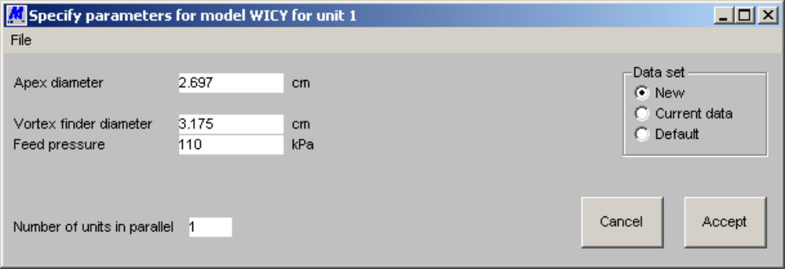
Figure 47 Form to specify parameters for the WICL water-injection cyclone model.

Parameters:
1....Apex diameter
2....Vortex finder diameter
3....Feed pressure
4....Number of units in parallel

Models for Dewatering Operations

DWSC: Dewatering screen
Dewatering screen using the model proposed by K L Ng. "Dewatering performance of vibrating screens". Proc. Instn Mech Engrs. Part E Journal of Process Mechanical Engineering. 204 (1990) pp73-79.
Undersize solid is carried through the screen in proportion to the water flow.
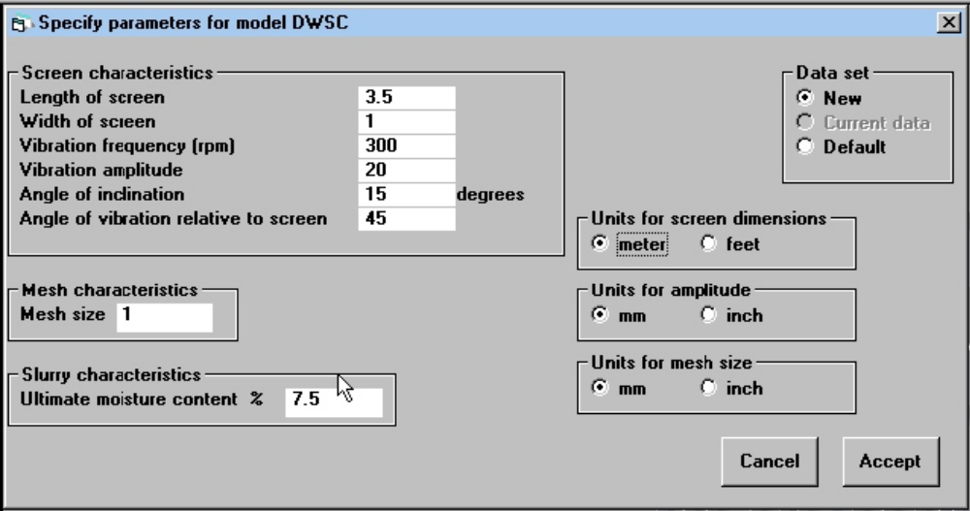
Figure 48 Form to specify parameters for model DWSC for a dewatering screen.

PARAMETERS:
1...Ultimate moisture content of the material (%)
2...Mesh size of the screen
3...Length of the screen
4...Width of the screen
5...Angle of inclination (degrees)
6...Vibration frequency (rpm)
7...Amplitude of vibration
8...Angle of vibration relative to screen surface (degrees)

FILT: Filter.
This is a simple model for the filter. All solids leave in the filter cake. The operation is specified completely when the water content of the filter cake is given.
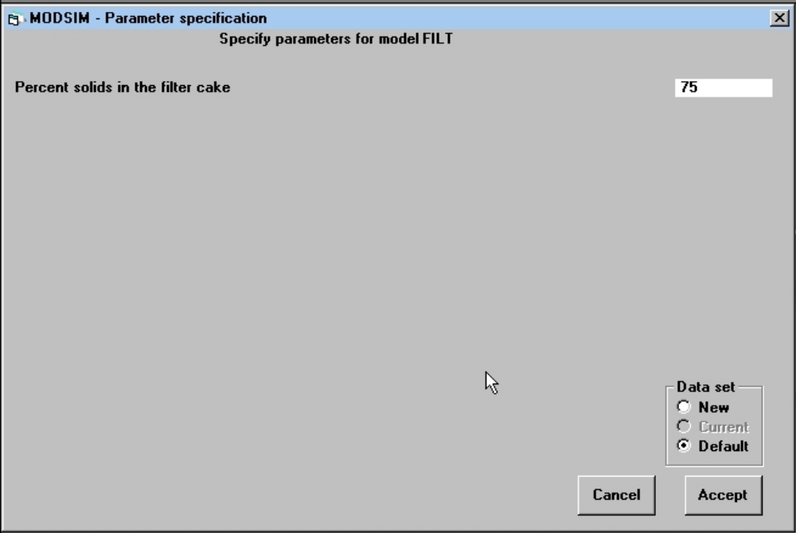
Figure 49 Form to specify parameters for model FILT for a filter.

PARAMETERS:
1...Percentage of solids in the filter cake

KYNC: Thickener
This model implements the ideal Kynch thickener method for incompressible pulps. The model uses the extended Wilhelm-Naide equation for the settling velocity of the flocculated slurry. A warning is issued if the feed flux is larger than the maximum flux that can be handled by the thickener. If the thickener is overloaded the concentration of solids in the overflow is estimated. Thickeners should never be operated for extended periods in an overloaded condition.
The graphical representation of the steady state operation is available on completion of the simulation.
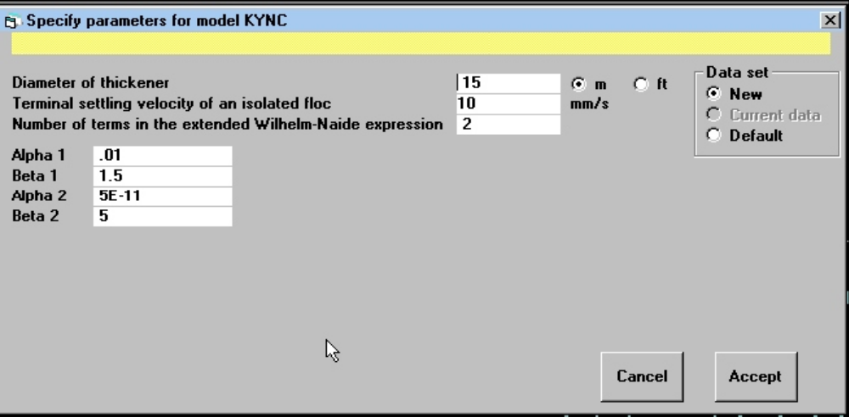
Figure 50 Form to specify parameters for thickener model KYNC.

PARAMETERS:
- Thickener diameter
- Terminal settling velocity of an isolated floc
- Number of terms in the extended Wilhelm-Naide equation
- Alpha, beta pairs for the extended Wilhelm-Naide equation

THIC: Thickener.
A simple model for the thickener. The model assumes that all solids leave in the underflow.

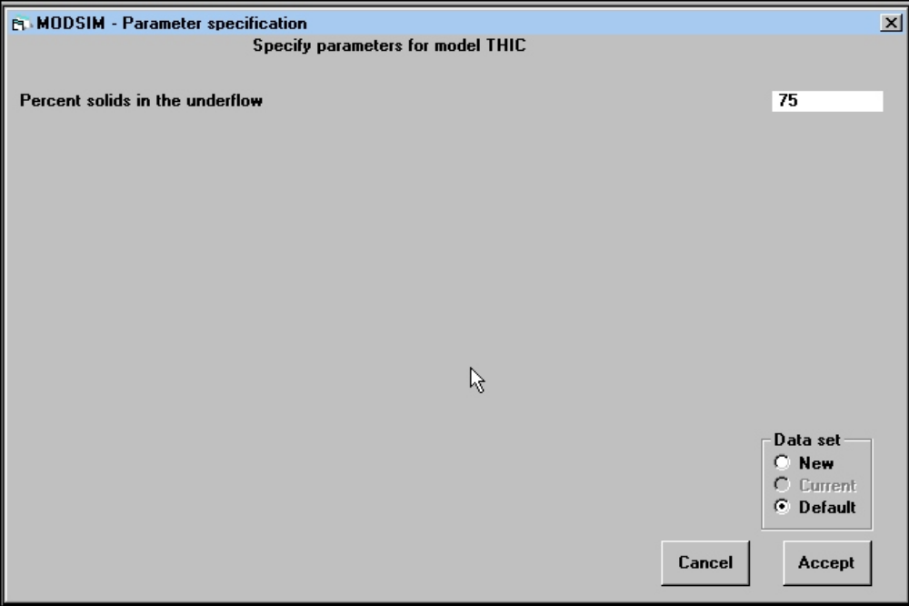
Figure 51 Form to specify parameters for model THIC for a thickener.

PARAMETER:
1...Percentage solids in the underflow

Models For Stream Splitters And Mixers

SPLT and SPL1: Stream splitters.
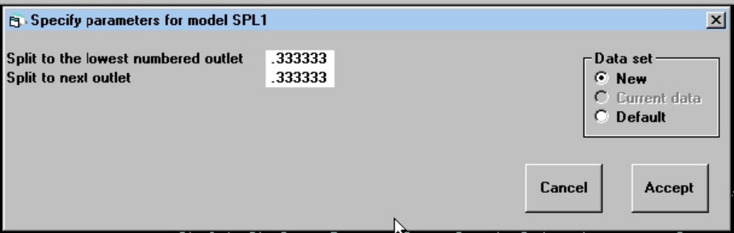
Figure 52 Form to specify parameters for splitter model SPL1.

SPLT
Model splits the feed equally into 2 or 3 streams.
MODSIM determines the number of output streams from the flowsheet.

SPL1
Model splits the feed into 2 or 3 unequal streams.
MODSIM determines the number of output streams from the flowsheet. User must specify the fractional split.

PARAMETERS:
1...Number of output streams
2...Fractional split to output stream 1
3...Fractional split to output stream 2

Models for Concentrating Units

Flotation

FLTK: Bank of flotation cells.
This model is the discrete distributed flotation kinetic constant model due to R P King. The true cell residence time is calculated from the tailings flowrate. The percentage solids in the froth is assumed known and this fixes the water balance. The Pogorely model for bubble loading is incorporated so that heavy bubble loads will reduce the flotation capacity in the cell. The froth phase is modeled using the froth transmission coefficient which is defined as the fraction of solid crossing the pulp-froth interface that is actually recovered in the concentrate stream. The remainder of the solid is returned to the pulp phase.
Note that the specific flotation rate constants are mass transfer coefficients because they model the rate of transfer of particulate matter across the phase boundary from pulp to bubble surface. The units of the specific flotation rate constants are therefore m/s.
This model allows water to be added to the concentrate launder so that the solid content of the concentrate that finally leaves the bank is less than the solid content of the concentrate that leaves each cell. The water can be added at a pre-specified rate or MODSIM will calculate the addition rate to meet a required final solid content in the concentrate.
Reference: R P King, Model for the design and control of flotation plants. Proc 10th International Symposium on Application of Computer Methods in the Mineral Industry. APCOM 10 (1972) S. Afr. Inst. Min. Metall. Eds Salamon M. D. G. and F. H. Lancaster p.341

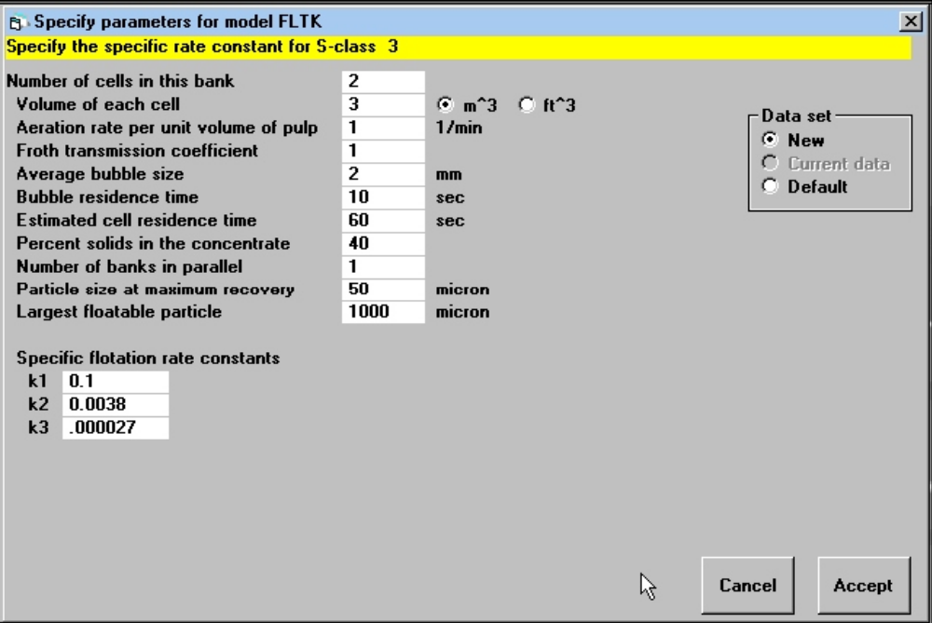
Figure 53 Form to specify parameters for model FLTK for a bank of flotation cells.

PARAMETERS:
1...Number of cells in series for this bank
2...Cell volume
3...Aeration rate in m³ of air per m³ of cell volume
4...Froth transmission coefficient
5...Bubble size
6...Bubble residence time
7...Estimate of cell holding time
8...Percent solids in the concentrate
9...Specific flotation rate constants - one for each S-class. Values default to the data set up as system data but different value in each flotation bank are allowed

FLTN: Bank of flotation cells

This model is based on the discrete distributed flotation kinetic constant model. The flotation process is modeled as a chemical kinetic process and therefore the specific rate constants must be specified in units of reciprocal time. The volume of pulp in each cell in the bank must be specified and the pulp residence time is calculated to be consistent with this volume and the tailings flow from the cell.

The water balance is fixed by assuming that the solids holdup per unit volume of pulp is fixed as proposed by D N Sutherland. The residence times of the solid and the water are assumed to be identical.
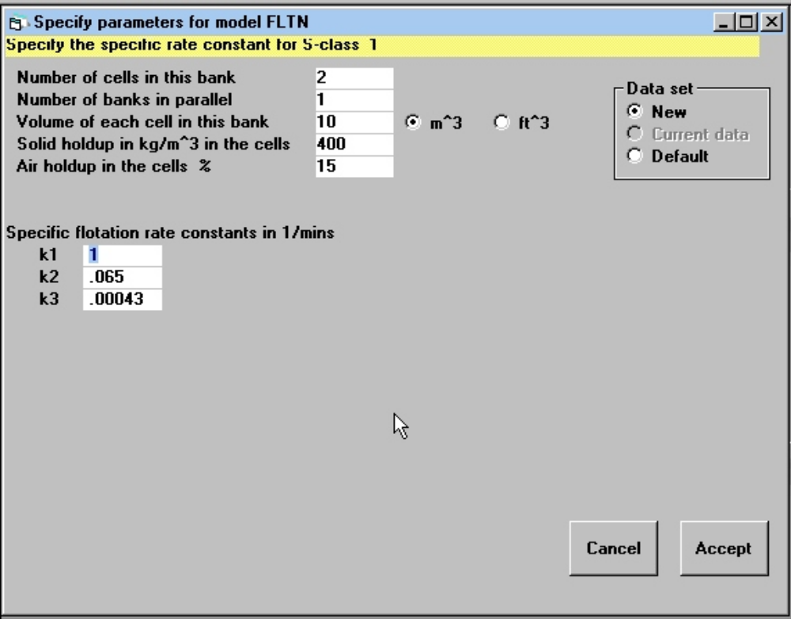
Figure 54 Form to specify parameters for model FLTN for a bank of flotation cells.

Reference: Sutherland D N Intl. Jnl. Mineral Processing 4 (1977) 149-162

This model allows water to be added to the concentrate launder so that the solid content of the concentrate that finally leaves the bank is less than the solid content of the concentrate that leaves each cell. The water can be added at a pre-specified rate or MODSIM will calculate the addition rate to meet a required final solid content in the concentrate.
PARAMETERS:
1...Number of cells in the bank
2...Number of banks in parallel
3...Volume of pulp in each cell m³
4...Solid holdup in kg per cub meter of pulp
5...Air holdup in the cell
6…Specific flotation rate constants in this bank. One for each S-class. Units are 1/mins. Defaults are the values specified as system data

KLIM: Klimpel flotation model

The kinetic model for the flotation cell that assumes that each type of particle has a floatable and a non-floatable component. This model is usually associated with Dick Klimpel who made it popular as a simple but useful and consistent model for the comparison of collectors and other conditions in industrial flotation systems. The floatable component of each particle type is recovered at a rate that is proportional to the amount of that species in the flotation cell. The influence of the bubble surface area and the characteristics of the froth phase are neglected entirely. The effect of particle size on the flotation kinetics is also neglected.

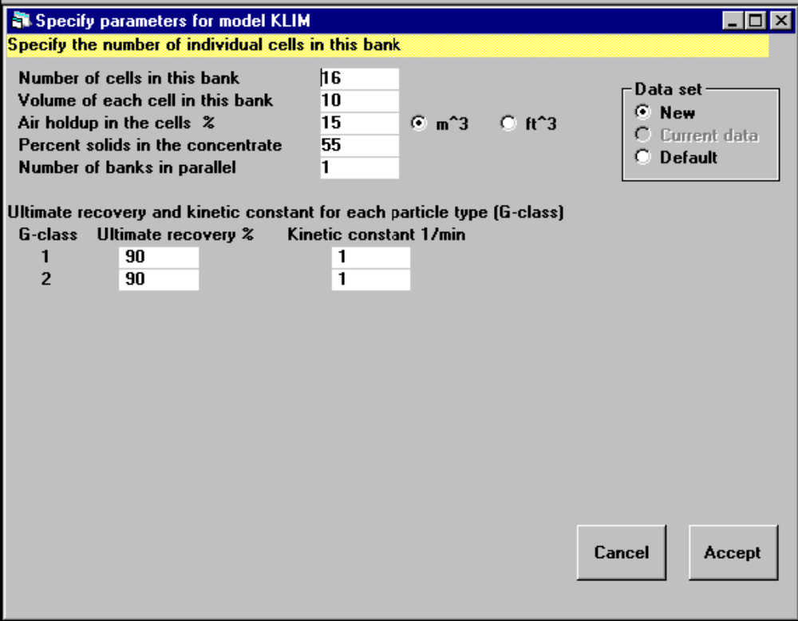
Figure 55 Form to specify parameters for model KLIM for a bank of flotation cells.
The water balance over the cell is established by specifying the percent solids in the concentrate. Water can be added directly to the froth launders in which case the final percent solids in the froth must be specified as well.

PARAMETERS:
1...Number of cells in the bank
2...Volume of each cell
3...Volume fraction of air in the pulp
4...Pecent solids in concentrate
5...Number of banks in parallel
6...Ultimate recovery for G-class 1
7...Kinetic constant for G-class 1
8...Repeat 6 & 7 for each G-class

Gravity Separation Operations

CONE: Reichert cone
Model for the Riechert cone based on the equilibrium stratification model.
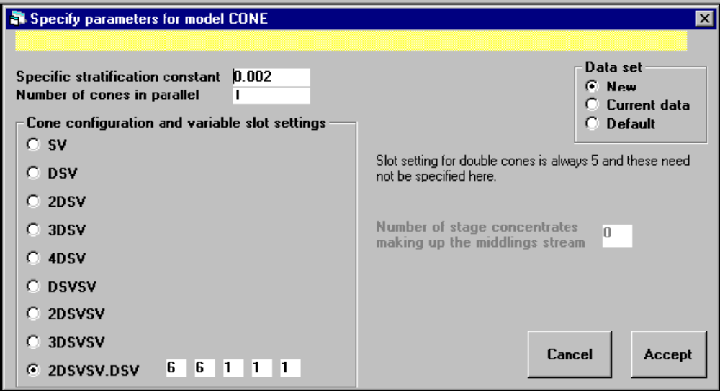
Figure 56 Form to specify parameters for model CONE for the Reichert Cone.

The performance of the Reichert cone is modeled using the stratification model. All combinations of double (D) and single variable (SV) cones can be selected for the cone stack. This makes it possible to model all commonly used industrial configurations. The slot positions on each single variable cone can be independently set. The capacity relationships are based on data provided by Prof E Forssberg of the University of Lulea.
PARAMETERS:
1...Specific stratification constant
2...Number of cones in parallel
3...Cone configuration and the slot numbers that define the gaps on each of the single cones in the configuration
The number of cones that produce middlings product can also be specified.

References:
1. King R P A quantitative model for gravity separation unit operations that rely on stratification. APCOM 87 Proc. 20th Intl Symp. on the Application of Computers and Mathematics in the Mineral Industries. Vol 2 Metallurgy Johannesburg, SAIMM 1987 pp 141 - 151.
2. Forssberg E. and sandstrom E. Utilization of the Reichert cone concentrator in ore processing. Industrie Minerale - Mineralurgie Nov 1979, pp 223-232.
3. King R. P. Flowsheet optimization using simulation: A gravity concentrator using Reichert Cones. Proc 21st International Mineral Processing Congress, Rome 2000.

DMCY: Dense-medium cyclone
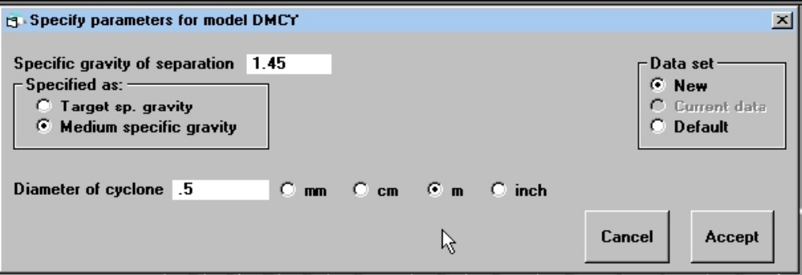
Figure 57 Form to specify parameters for model DMCY for the dense-medium cyclone.

Simulation of the dense-medium cyclone using a modified version of Lynch's equation for the partition curve. The cut point can be defined either by the Gottfried-Jacobsen procedure or the density of the medium can be specified. In the latter case the normalized cut point shift is calculated for each particle size according to the model developed in the M V Rueda study and in King R P and Juckes A H. “Performance of a dense-medium cyclone when beneficiating fine coal”. Coal Preparation 5 (1988) 185-210. Corrected imperfection varies with particle size and the cyclone diameter and is calculated according to the Rueda data and to the King and Juckes model.

PARAMETERS:
1...Operating density of the medium OR the target cut point
2...Cyclone diameter
3...Selector for the model. 1=Gottfried-Jacobsen cut point ratio. 2=Cutpoint shift

SPIR: Spiral concentrator.
This model includes the effects of particle size and particle density simultaneously. The model predicts that the recovery of any type of particle will pass through a minimum as the particle size changes.
The cutpoint increases with feed rate. The rate of increase is linear according to Gallagher E, Ellis R, Pitt G, Partridge A C, Randell J K. The integration of a 300t/hr spiral installation at the German Creek preparation plant. Coal Preparation 12 (1993) 163-186. This is consistent with the King Juckes and Stirling data.
The inner splitter must be set equal to outer splitter position if no middling product is taken from the spiral.

Reference:
King R P, Juckes A H and Stirling P A. “A quantitative model for the prediction of fine coal cleaning in a spiral concentrator”. Coal Preparation 1992 Vol 11 pp 51-66.

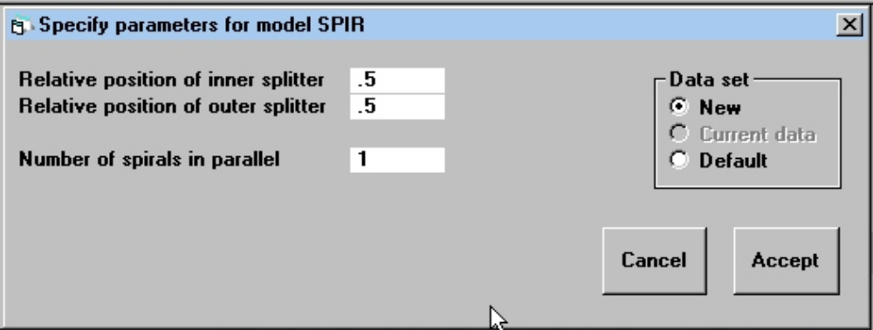
Figure 58 Form to specify the parameters for spiral model SPIR.

PARAMETERS:
1...Relative splitter position for outer splitter
2...Relative splitter position for the inner splitter
3...Number of spirals in parallel

LISP: SPIRAL CONCENTRATOR
The cut point for each particle size is determined primarily by the position of the cutter at the foot of the spiral. Thus the cutter position is the primary control on the spiral. The King-Juckes-Stirling model is used for water split. The cutpoint increases slightly with feedrate and % solids in the feed.
References:
Li M, Wood CJ, and Davis JJ "A study of coal washing spirals" Coal Preparation 1993 Vol 12 pp 1117-131.
King R P, Juckes A H and Stirling P A. “A quantitative model for the prediction of fine coal cleaning in a spiral concentrator”. Coal Preparation 1992 Vol 11 pp 51-66.
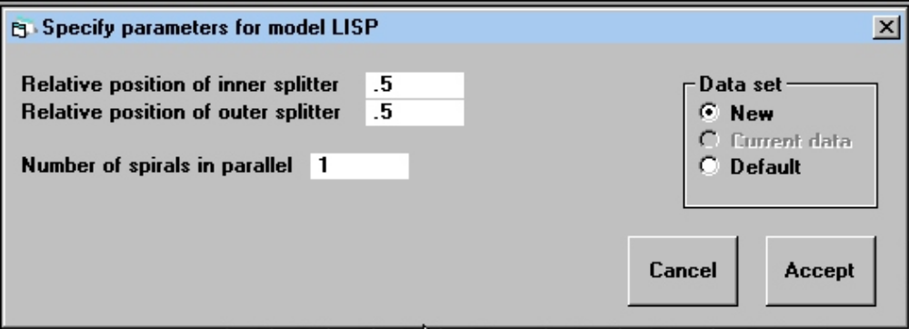
Figure 59 Form to specify the parameters for model LISP for the spiral concentrator.

PARAMETERS:
1...Relative splitter position for outer splitter
2...Relative splitter position for inner splitter
3...Number of spirals in parallel
Inner splitter must be set equal to outer splitter position if no middling product is taken from the spiral.

KELL: SPIRAL CONCENTRATOR (Mineral Deposits Reichert MK10A coal spiral).
This model assumes fixed cutter positions and does not make any provision for the control of the cut point. The model allows for the variation of particle recovery with particle size but the model is relatively crude in this respect.

Reference:
Kelly EG, Gomer JS, Pillai KJ, Bull WR, and Spottiswood DJ. Proc. XVI International Mineral Processing Congress Ed. E Forssberg. Elsevier 1988 pp1771-1780

Only one parameter can be set.
PARAMETER:
1...Number of spirals in parallel

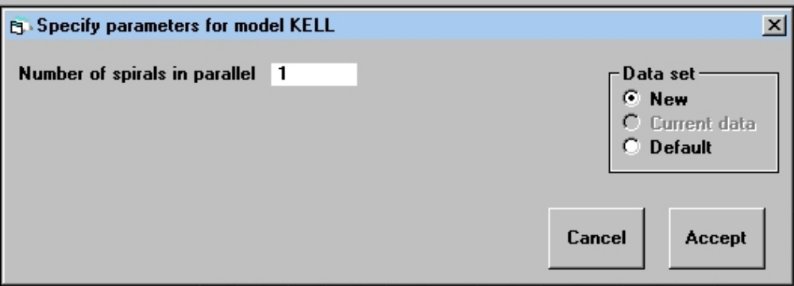
Figure 60 Form to specify the parameters for model KELL for the spiral concentrator.

KNEL: KNELSON CONCENTRATOR
This model is based on the work of Andre Laplante and his group. The concentrator is assumed to recover a fraction of the free gold. The recovery of free gold is a function
of the grain size given by
The concentrator also recovers a fraction of the locked gold from the highest-grade locked class in the fine size classes. The recovery of this fraction is given by
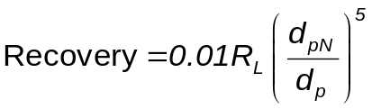
The water content of concentrate must be specified as a parameter.

References:
Laplante A R, Woodcock F, and Noaparast M. "Predicting Gravity Separation Gold Recoveries". Minerals & Metallurgical Processing May 1995 pp74-79

PARAMETERS:
- Maximum recovery of free gold as a function of grain size (R_{M})
- Recovery of locked gold in the finest size(R_{L})
- Water content of the concentrate in kg solid/liter of water
- Number of concentrators in parallel
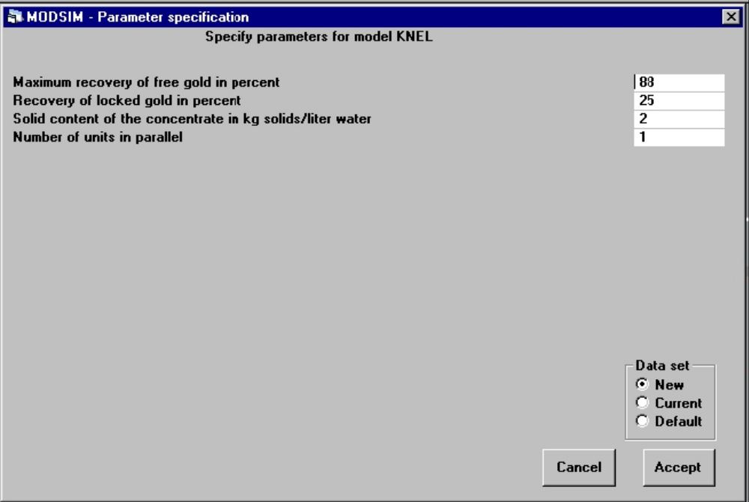
Figure 61 Form to specify parameters for model KNEL for the Knelson concentrator.

SJIG: Model for a single stage jig based on the equilibrium stratification model.
The equilibrium stratification profile for each particle type is calculated and is available from the model in graphical form. This model does not allow for a velocity profile in the continuous jig.

Reference:
R P King, Modeling and Simulation of Mineral Processing Sytems. Butterworth-Heinemann, Oxford, 2001, Section 7.3

PARAMETERS:
1...Relative height of the cutter in the bed
2...Specific stratification constant

VJIG: Model for a single stage jig based on the equilibrium stratification model.
The equilibrium stratification profile for each particle type is calculated and is available from the model in graphical form. This is accessed by right clicking the unit icon when viewing the flowsheet and selecting Stratification profiles from the pop-up menu.

This model does allow for a velocity profile in the continuous jig. The model for the velocity profile in the bed is

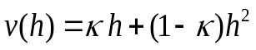

Reference:
R P King, Modeling and Simulation of Mineral Processing Sytems. Butterworth-Heinemann, Oxford, 2001, Section 7.3

PARAMETERS:
1...Relative height of the cutter in the bed
2...Specific stratification constant
3...Velocity profile constant κ

Models for Magnetic Separators

DOFI: Wet high-intensity magnetic separator
Dobby and Finch empirical model for the wet high intensity separator. Dobby G. and Finch J. A. An empirical model of capture in a high-gradient magnetic separator and its use in performance prediction. Proc. 12th International Mineral Processing Congress, Sao Paulo, Brazil 1977. Vol 1 pp 128 - 152. This model is described in King R. P. Modeling and Simulation of Mineral Processing Systems, Butterworth-Heinemann, Oxford, 2001 Section 8.6

The parameters of this model were subsequently upgraded to reflect additional test work which is described in Dobby, G. and Finch, J.A. “Capture of mineral particles in a high gradient magnetic field”. Powder Technology, Vol. 17. pp. 73-82, 1977.
The model is summarized as
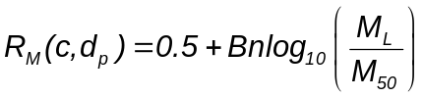
with 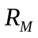 limited to the range 0.05 - 0.95.
The group 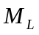 is defined as
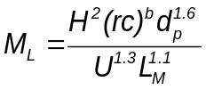
The parameter values are
β = 1.8, B = 0.383, M₅₀ = 2.63 for particles with ρχ < 6.3X10⁻³
and
β = 3.9, B = 0.413, M₅₀ = 1.062x10⁻⁴ for particles with ρχ  6.3X10⁻³ respectively.

This model expects the magnetic susceptibilities to be specified for each particle type (grade class) and not to be distributed over S-classes.
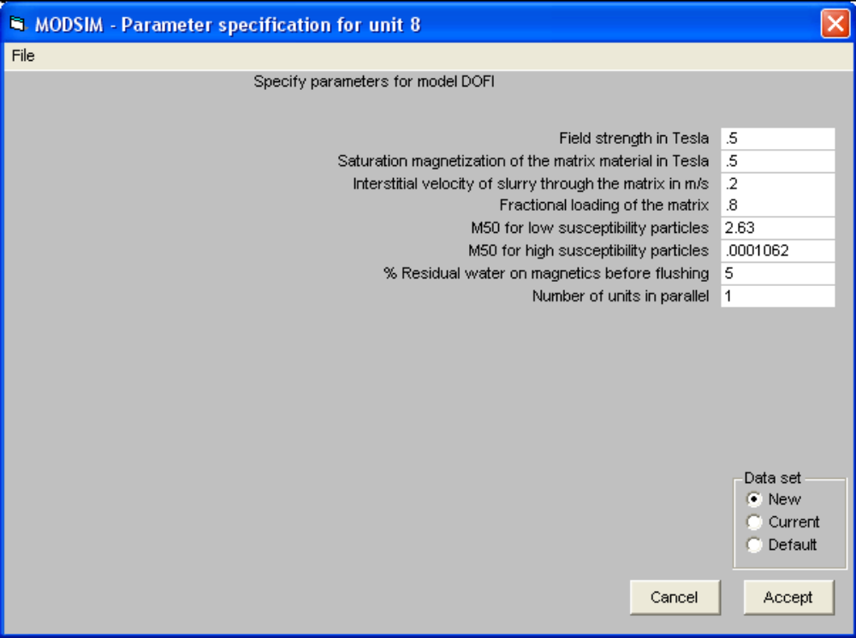
Figure 62 Form to specify the parameters for the wet high intensity magnetic separator model DOFI.

PARAMETERS:
1...Magnetic field strength in Tesla
2...Saturation magnetization of the matrix material in Tesla
3...Interstitial velocity of the slurry through the matrix U m/s
4...Fractional loading on the matrix L_{m}
5...The magnetic cut point M₅₀ for low susceptibility particles
6...The magnetic cut point M₅₀ for high susceptibility particles
7...Residual water on retained magnetics before flushing
8...Number of units in parallel

WDMS: Wet drum magnetic separator
A simple recovery model for a wet drum magnetic concentrator. The recovery of non-magnetics to the tailing stream is modeled. Particles with larger volumetric concentrations of mineral 1 are recovered more strongly into the non-magnetics stream. The magnetic minerals should be listed after the non-magnetic mineral when the system data is defined.

Recovery of particles of type J to the non-magnetic stream is given by
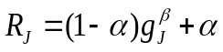
Where α is the short circuit to tailing and g_{J} is the volumetric fraction of mineral 1 in particles of type J.
The short circuit flow varies exponentially with particle size
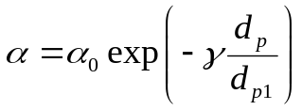

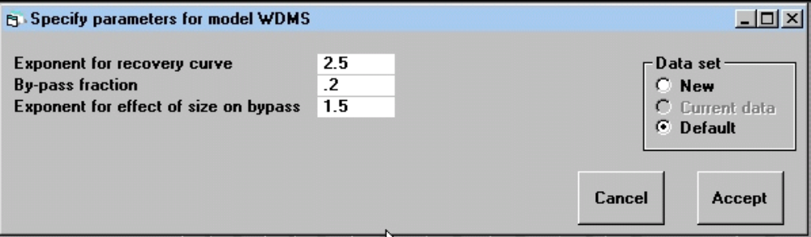
Figure 63 Form to specify the parameters for the wet drum magnetic separator model WDMS.

PARAMETERS:
1...Exponent on the volumetric fraction non-magnetics to model the recovery, β
2...By-pass fraction to non magnetics, α
3...Exponential coefficient to reduce by-pass as size increases, γ

WDM2: Wet drum magnetic separator
A simple model for a wet drum magnetic concentrator using a Rosin-Rammler partition function with the volumetric composition of the particle as the determining variable. The recovery of non-magnetics to the tailing stream is modeled. Particles with larger volumetric concentrations of mineral 1 are recovered more strongly into the non-magnetics stream. The magnetic minerals should be listed after the non-magnetic mineral when the system data is defined.

Recovery of particles of type J to the non-magnetic stream is given by
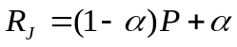
with
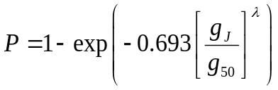
The short circuit to non-magnetics increases exponentially as particle size decreases.
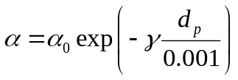
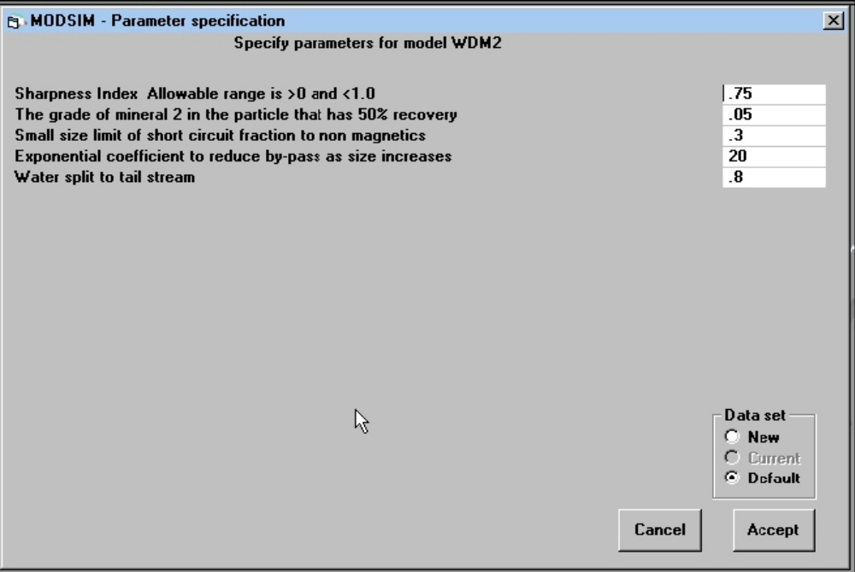
Figure 64 Form to specify the parameters for the wet drum magnetic separator model WDM2.

PARAMETERS:
1...Sharpness Index
2...The grade of mineral 1in the particle that has 50% recovery
3...Small size limit of short circuit fraction to non magnetics
4...Exponential coefficient to reduce by-pass as size increases
5...Water split to tail stream

Models for Material Transport

CONV: Belt conveyor
The conveyor functions essentially as a blender and can take any number of input streams. The capacity of the belt is calculated using the simple geometry of the solid profile to calculate the solid area which is multiplied by the belt velocity. The surface contour of the solid is governed by the angle of repose of the solid and the trough angle of the idlers. More accurate capacities can be obtained from manufacturers' tables or from the SME Mineral Processing Handbook section 10. Angles of repose for a range of materials can be found in the SME handbook.

PARAMETERS:
1...Width of the belt
2...Freeboard to prevent spillage
3...Idler trough angle
4...Belt speed
5...Angle of repose of the material to be transported
6...Bulk density

Models for Coal Washing Units

Most dense medium units that are used to wash coal have similar models. These models are based on a standard generalized partition function which is characterized by the imperfection. The imperfection varies for the different dense-medium vessels and these are hard programmed into MODSIM for each vessel based on a survey of several South African coal washing plants. The cut point is a function of the particle size. The relationship between cut point and particle size is modeled directly for some units using an experimentally determined model for the cut-point shift. The cut-point shift is the difference between the controlled density of the medium and the cut-point at a particular size. For these models the density of the medium must be specified. The effect of particle size in other units is modeled using the Gottfried-Jacobsen method which is based on the specification of a target specific gravity.

NORW
Simulation of the Norwalt coal washer using a modified version of Lynch's equation for a partition curve. Normalized cut-point shift is assumed constant at 0.005 and the corrected imperfection constant at 0.013.
PARAMETER:
1...Medium density

WEMC
Simulation of the Wemco drum coal washer using a modified version of Lynch's equation for a partition curve.
Normalised cut-point shift is assumed constant at -0.003. (Note negative value) corrected imperfection constant at 0.017.
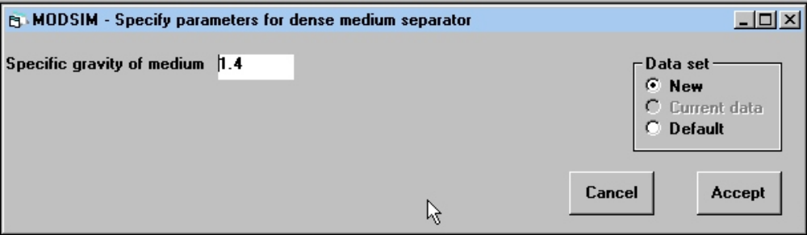
Figure 65 Form to specify parameters for dense medium units DYNA, TESK, BATJ, SLIP, CHAN, BAUJ, WEMC, NORW and WASH.

PARAMETER:
1...Medium density

DREW
Simulation of the Drewboy coal washer using a modified version of Lynch's equation for a partition curve. Normalised cut-point shift varies with particle size. Corrected imperfection constant at 0.008.
PARAMETER:
1...Medium density

CHAN
Simulation of the Chance sand coal washer using a modified version of Lynch's equation for the partition curve. Normalized cut-point shift is assumed constant at 0.013 and corrected imperfection constant at 0.015.
PARAMETER:
1...Medium density

SLIP
Simulation of the shallow bath coal washer using a modified version of Lynch's equation for a partition curve. Normalized cut-point shift varies with particle size. Corrected imperfection is constant at 0.009.
PARAMETER:
1...Medium density

BAUJ
Simulation of the Baum jig coal washer using a modified version of Lynch's equation for a partition curve. Normalized cut-point shift is 0. Corrected imperfection varies with feedrate.
PARAMETER:
1...Target separation density

SHAK
Model for a concentrating table. The Gottfried-Jacobsen procedure is used to estimate the cut-point for each size class. The model is calibrated against data from USBM RI 6239.
PARAMETER:
1....Target cut-point for the separation

BATJ
Simulation of the Batac jig coal washer using a modified version of Lynch's equation for a partition curve. Short circuit to overflow is a function of feedrate.
Cutpoint calculated using the Gottfried-Jacobsen procedure. Corrected imperfection constant at 0.06
Data based on the MV RUEDA study and LM TAVARES and J RUBIO. Performance evaluation and simulation of a batac jig cleaning pyrite from coal washery tailings. Presented at 4th Intnl. Conf. on Processing and Utilization of High-Sulphur Coals. Idaho Falls 1991.

PARAMETER:
1....Target cut-point for the separation

WASH
Coal washing unit according to B.S.GOTTFRIED INT J MIN PROCESS. 5 (1978)1-20
Data for composite feed to the Drewboy.

PARAMETER:
1....Target cut-point for the separation

DRUM
Model for a dense-medium coarse coal washing drum. The Gottfried-Jacobsen procedure is used to estimate the cut-point for each size class. Corrected imperfection is a function of particle size.
Data based on USBM RI 7154

PARAMETER:
1...Target cut-point for the separation

TESK
No model is available for the Teska Drum.

WOCY: Water-only cyclone.
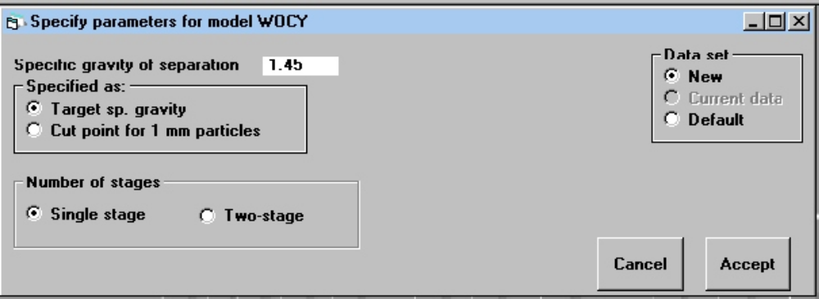
Figure 66 Form to specify parameters for model WOCY for a water-only cyclone.

Two models are provided for the calculation of the cutpoint.
1: The Gottfried-Jacobsen method using the generalized relationship between the cutpoint ratio and the ratio of particle size to the average size in the feed.
2: A simple partition function model based on the data presented by Hornsby D T, Watson S J and Clarkson C J. "Fine coal cleaning by spiral and water washing cyclone". Coal Preparation 1993 12 pp 133-161. The effective cut point is determined primarily by the vortex finder clearance. The performance is specified by providing an estimate of the cut point at 1mm.

The efficiency of separation is calculated following Hornsby et. al. The imperfection defined as EPM/(d₅₀ - 1) is assumed to be invariant with particle size.

PARAMETERS:
1...Selection of the cut point model
1=Gottfried-Jacobsen
2=Hornsby
2...Target cutpoint for the G-J procedure or cutpoint at 1mm for the Hornsby procedure.

RUNNING THE SIMULATOR AND GETTING RESULTS

When the flowsheet, system data and model parameters have been specified, the simulation can be run by choosing RUN SIMULATION from the Run drop down menu.
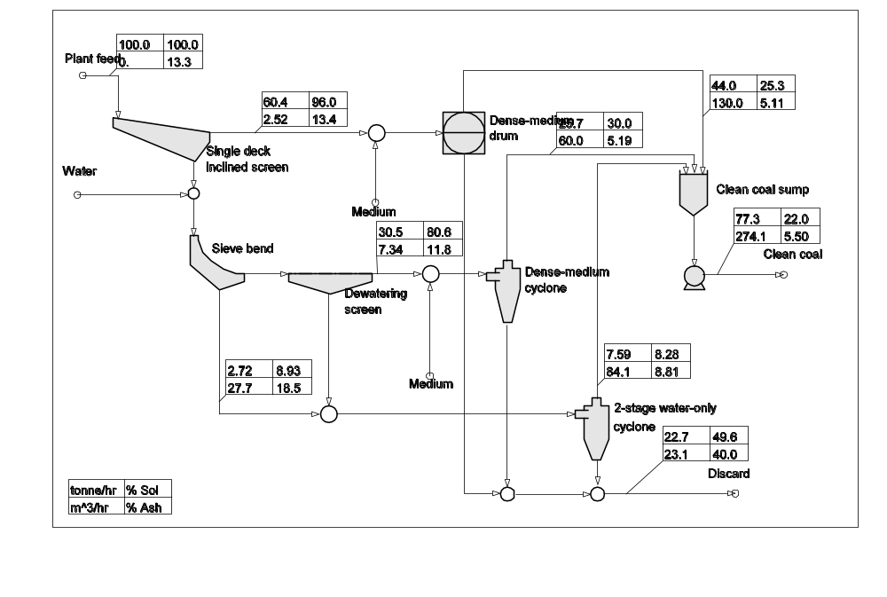
Figure 67 Flowsheet output showing stream flyouts that give summary information on the stream flows.

The simulation output is available in a number of formats that can be accessed easily. The first level of output data can be obtained from the flowsheet itself. This can be accessed by clicking View flowsheet from the View drop down menu. A typical flowsheet view is shown in Figure 67. Flyouts containing the total solids flowrate, the water flowrate, the percentage solids in the stream and an optional mineral or metal grade, can be attached to any stream using the Add stream flyout entry on the edit drop down menu on the flowsheet editor. The units used for the data in the stream flyouts are specified in the output format screen which is accessed from the edit menu. Stream flyouts can be deleted and moved like any other objects on the flowsheet. A right mouse click on any unit in the flowsheet will bring up the report file for that unit in its own window and any special graphic output that is specific to the unit. A right click on any stream in the flowsheet will bring up a summary of the stream contents including solid and water flowrates, particle-size distribution, d₈₀, d₅₀ and d₂₀ sizes.
The composition displayed in the lower right hand box of the stream flyouts is the first element listed in the Metals or elements list of the output format screen.

The Output Data File

The next most immediately useful output is a tabular summary of the material balance in the plant. This is accessed by clicking the Simulation results item on the view menu.
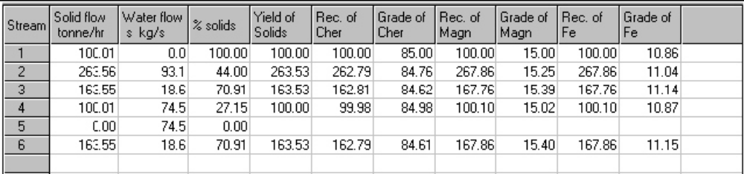
Figure 68 A typical presentation of the output data for each stream in the flowsheet.

The data is presented as mass flowrates of appropriate species in each stream together with the stream assays. The stream assay will be appropriate to the type of material that is processed. A typical set of output data is shown in Figure 68 and Table 2. The data in Figure 68 can be copied and pasted directly to most popular spreadsheets.

Table 2 Summary material balance for a typical coal washing plant flowsheet.
Stream Solid Water % Solids Rec. Grade Rec. Grade Rec. Grade
number flow flow solids yield of of of of of of CV Sulf
tonne/hr m^3/hr % Ash Ash Comb Comb Ash Ash MJ/kg %
1 100.01 0.00 100.00 100.00 100.00 13.34 100.00 86.66 100.00 13.34 30.36 1.16
2 42.73 -2.39 105.92 42.73 41.98 13.11 42.83 86.86 41.98 13.11 30.45 1.19
3 42.73 99.68 30.01 42.73 41.98 13.11 42.83 86.86 41.98 13.11 30.45 1.19
4 40.00 69.77 36.44 39.99 38.20 12.74 40.27 87.26 38.20 12.74 30.60 1.18
5 33.81 11.35 74.87 33.81 30.03 11.85 34.39 88.15 30.03 11.85 30.94 1.17
6 2.72 29.91 8.34 2.72 3.78 18.52 2.56 81.49 3.78 18.52 28.41 1.26
7 6.19 58.43 9.58 6.19 8.18 17.63 5.88 82.34 8.18 17.63 28.74 1.25
8 0.00 102.06 0.00
9 33.81 78.91 29.99 33.81 30.03 11.85 34.39 88.15 30.03 11.85 30.94 1.17
10 0.00 67.54 0.00
11 57.28 2.39 96.00 57.27 58.02 13.52 57.17 86.51 58.02 13.52 30.28 1.14
12 57.28 133.67 30.00 57.27 58.02 13.52 57.17 86.51 58.02 13.52 30.28 1.14
13 0.00 131.29 0.00
14 8.91 88.34 9.16 8.91 11.95 17.90 8.44 82.10 11.95 17.90 28.65 1.25
15 45.25 125.64 26.48 45.25 18.98 5.60 49.31 94.43 18.98 5.60 33.38 1.13
16 28.51 66.53 30.00 28.51 11.12 5.20 31.18 94.80 11.12 5.20 33.53 1.13
17 7.43 87.34 7.84 7.43 4.90 8.81 7.82 91.20 4.90 8.81 32.14 1.12
18 12.02 8.02 60.00 12.02 39.04 43.32 7.86 56.68 39.04 43.32 18.62 1.18
19 5.30 12.38 29.99 5.30 18.91 47.58 3.21 52.44 18.91 47.58 17.03 1.37
20 17.33 20.39 45.94 17.33 57.95 44.63 11.07 55.38 57.95 44.63 18.13 1.24
21 1.48 0.99 60.00 1.48 7.05 63.55 0.62 36.44 7.05 63.55 11.08 1.93
22 18.81 21.38 46.80 18.80 65.00 46.12 11.69 53.89 65.00 46.12 17.58 1.29
23 81.22 279.50 22.51 81.21 35.00 5.75 88.31 94.23 35.00 5.75 33.31 1.13
24 81.22 279.50 22.51 81.21 35.00 5.75 88.31 94.23 35.00 5.75 33.31 1.13

This file can be printed or saved for archival purposes or imported directly in tabular form into any word processor document.
The format of this display can be changed to suit the problem on hand by executing the Edit output format on the edit menu. This brings up the form shown in Figure 69, which allows you to format the output data file to meet the needs of the particular problem.
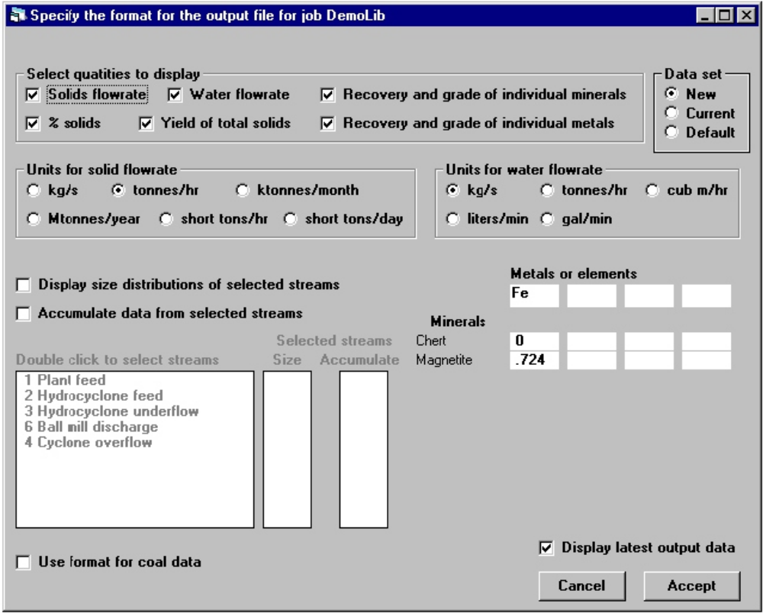
Figure 69 Form to design the output format of the data output file.

Graphs of the Particle Size Distributions

The next level of detail is the particle size distribution of the solid material in each stream. This is available in both tabular and graphical form. The graphical output is obtained by executing the Output PSD graphs from the main menu. The graph is set up using the form shown in Figure 70.
Select plant streams to plot: This field contains a list of the streams in the flowsheet. Double click the streams that are to be included in the plot. The selected streams will be listed in the graph field.
Graph: This field contains the list of selected stream numbers. To remove a stream from the list, double click the stream number in this field.
Coordinates: Two different coordinate systems are provided for plotting the cumulative particle size distributions C log-log and log-linear.
Show experimental data: If experimental data for the size distribution in any stream was specified as system data, this can be shown on the PSD plots by checking this field.
View graph: Click this control to display the graph.
Close: Click this control to return to the main menu.
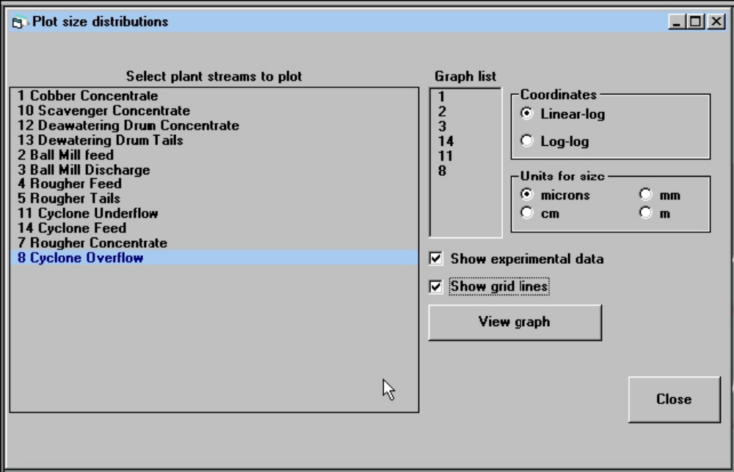
Figure 70 Form to setup the graphical output of the particle size distributions in selected streams. This form is entered by selecting the Output PSD graphs item from the main menu.

The graph can be exported as a PostScript file or as an encapsulated PostScript file.
To export the graph as an encapsulated PostScript file, the EPSI file must be generated when the graph is showing on the screen by pressing key F3. The EPSI file can be exported once the graph has terminated. Click Export as EPSI file from the File drop down menu. Encapsulated PostScript files are particularly useful for importing into word processors and other applications. If you do not have access to a PostScript printer, you can produce high-quality hard copy by importing the EPSI file into your usual word processor and printing the resulting document to your usual printer.
An example of the graphical display is shown in Figure 71.
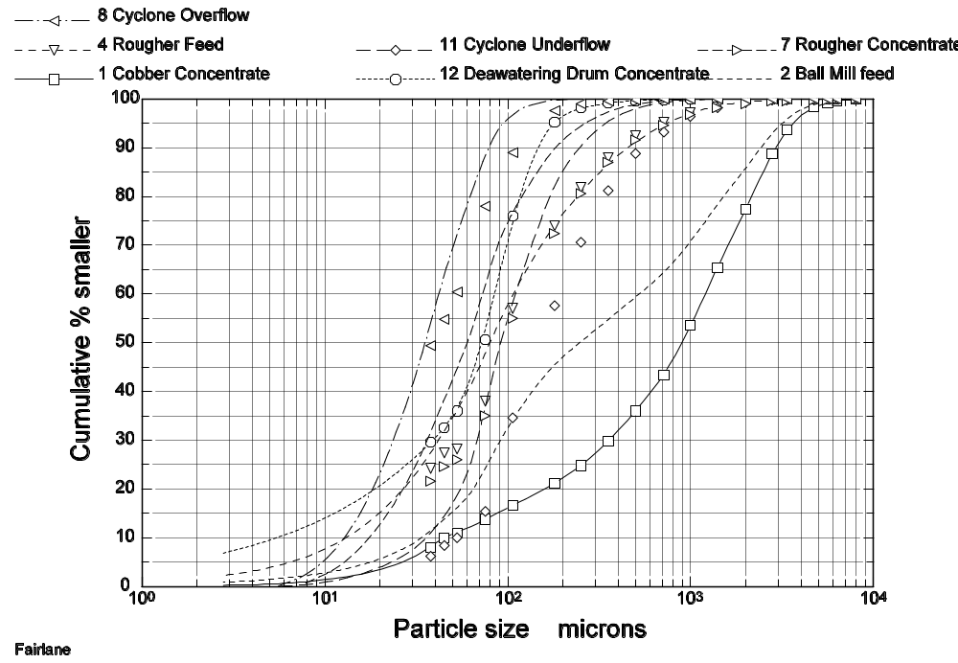
Figure 71 Graphical display of size distributions in Modsim exported as a Post Script file.

The Liberation Spectra

The liberation spectrum for the material in each stream is provided in tabular and graphical form whenever this is relevant to the plant operation. The tabular output is in the data output file. The liberation spectra can be plotted by selecting the Liberation distribution graphs entry in the View menu.

Select plant streams to plot: This field contains a list of the streams in the flowsheet. Double click the streams that are to be included in the plot. The selected streams will be listed in field Graph
Graph: This field contains the list of selected stream numbers. To remove a stream from the list, double click the stream number in this field.
Show experimental data: If experimental data for the size distribution in any stream was specified as systems data, this can be shown on the particle size distribution graphs by checking this field.

View graph: Click this control to display the graph.

An example of the liberation spectra graphical output is shown in Figure 72.
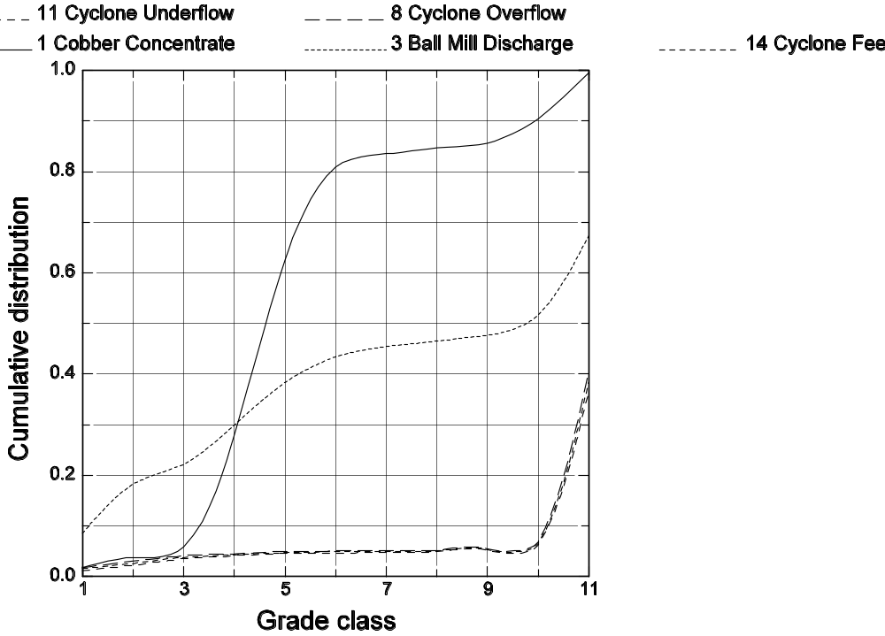
Figure 72 Liberation spectra exported as Post Script from Modsim.

The Report File

The next level of detail of output is provided by copious status reports on each of the units in the plant. An example of an entry in a typical report file is shown below. Each report is appropriate to the type of model that was selected to describe the behavior of the units and the reports will reflect the duty that the unit will actually be called upon to meet at its position in the plant. Models that are specifically developed for plant design and equipment selection will provide a guide to assist the design engineer choose the appropriate equipment. Models that are developed as true simulators will report on the performance of each unit in relation to the required duty. The report file generally will report on overload or underload conditions and any other information that will assist the engineer to determine the actual status of the operating unit and will assist in the diagnosis of operating problems. It is generally easy to identify and locate bottlenecks in the plant and to find cost effective solutions which may immediately be tested by further simulation. An example of a report file for a unit is given below.
The report file can be viewed in its entirety by clicking report file on the view drop down menu. The quickest way to access the report file for a particular unit is by right clicking the unit icon on the view flowsheet screen.

An example of a unit model report file

Unit number 2 MODSIM model name GMIL
Mill has 3 well-mixed segments in series without classification.
PARAMETERS:
Residence time in the mill 4.00 minutes.
Calculated tonnage through mill 772.49 tons/hr.
Calculated hold up in mill 51.50 tons.
Mineral liberation parameter PHIA. 50.0
Liberation model used... Ljubljana

Standard Austin selection function for taconite was used
Standard breakage function for taconite was used

Size distribution in FEED
Size % passing
mms
8.08 99.97
5.70 99.72
4.04 98.70
2.85 95.81
2.02 91.23
1.43 86.45
1.01 81.18
.713 76.11
.505 71.49
.357 66.03
.252 59.34
.178 50.58
.126 37.61
.892E-01 21.60
.631E-01 13.35
.446E-01 10.39
.315E-01 7.61
.223E-01 5.61
.158E-01 4.17
.112E-01 3.12
.788E-02 2.35
.557E-02 1.79
.394E-02 1.38
.279E-02 1.07
.000 .00

Size distribution in HOLDUP
Size % passing
mms
8.08 100.00
5.70 100.00
4.04 99.97
2.85 99.84
2.02 99.50
1.43 98.88
1.01 97.73
.713 95.92
.505 93.29
.357 89.26
.252 83.34
.178 74.80
.126 61.88
.892E-01 45.12
.631E-01 34.04
.446E-01 27.80
.315E-01 22.19
.223E-01 17.77
.158E-01 14.29
.112E-01 11.57
.788E-02 9.42
.557E-02 7.72
.394E-02 6.37
.279E-02 5.28
.000 .00

Size distribution in PRODUCT
Size % passing
mms
8.08 100.00
5.70 100.00
4.04 100.00
2.85 99.98
2.02 99.89
1.43 99.66
1.01 99.07
.713 97.89
.505 95.84
.357 92.35
.252 86.88
.178 78.65
.126 65.97
.892E-01 49.26
.631E-01 37.74
.446E-01 30.93
.315E-01 24.82
.223E-01 19.97
.158E-01 16.12
.112E-01 13.09
.788E-02 10.69
.557E-02 8.78
.394E-02 7.26
.279E-02 6.03
.000 .00
80% passing size in feed 928.5 microns
80% passing size in product 187.9 microns
The power required can be calculated from the Bond work
index of the material.
Power required = 310.1x W.I.

The final level of detail in the output is an extensive tabular listing giving the flowrate of every particulate species in every stream in the plant. It is only very seldom that this output needs to be examined and it is hardly ever used.

Driving the simulator from the flowsheet

All of the input and output data sets are accessible directly from the flowsheet. After running the simulation, view the flowsheet and right click on any stream or unit to access pop-up menus that will provide access to information about the selected stream or unit. Click on a feed stream to access input data for the stream. This data can be changed and the simulation run by right clicking anywhere on the page.
Click on any intermediate stream to see the properties of the stream or to generate a plot of the size distribution of the material in that stream.
Right click on any unit icon to change the model parameters for that unit or to specify a different model. If the unit is a grinding mill, a graph of the specific rate of breakage can be displayed. If the unit is a classifier, the classifcation function can be plotted.If the unit is a gravity concentrator that is modeled by a stratification process, the stratification profiles can be plotted..

Repetitive Simulations (Professional version only)

It is often useful to be able to run several simulations automatically with varying parameters for the different unit. This facilitates finding unit parameter settings that should be used to match observed experimental data for one or more process streams in the plant. Repetitive simulation is also useful to find combinations of unit parameters that optimize plant performance. This operation is easy to set up and implement in MODSIM.
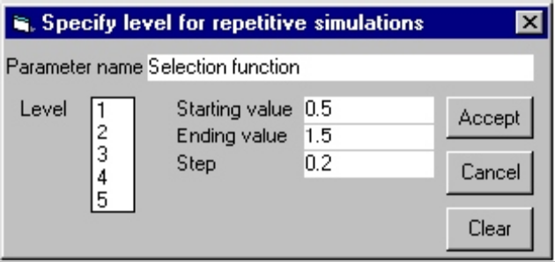
Figure 73 Pop-up menu to set repeat level and repeat values for a unit parameter.

It is possible to vary up to 5 unit parameters in 5 nested loops in which the parameters are varied automatically according to the pattern set by the user. With very few exceptions, any unit parameter that can be set can be chosen as a variable in one or more of the nested loops. The loop that is controlled by a particular parameter is called the level for that parameter. To assign a parameter to a particular level, the parameter is selected from the unit parameter editing form for the appropriate unit. Cntrl-click the parameter input field for the parameter to generate the pop-up menu shown in Figure 73. A descriptive name can be assigned to the parameter so that this can be identified properly in the output. Specify the starting value for the parameter, the ending value and the step length. If the end value is less than the starting value, the step length must be a negative number. The level to which this parameter is assigned must also be specified. This procedure can be repeated for up to 5 parameters. These can all be associated with the same unit or they can be selected from any combination of units in the flowsheet.
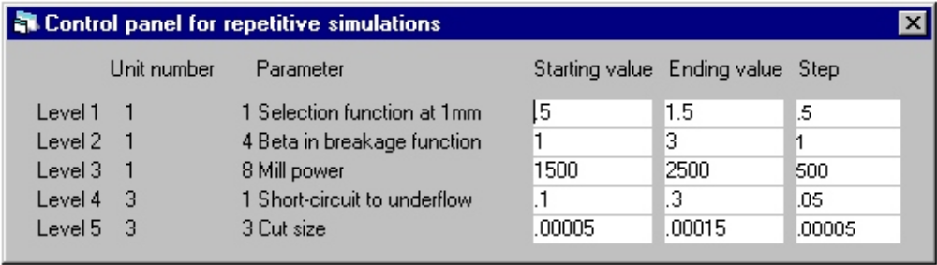
Figure 74 Levels editor for repetitive simulations.

The repetitive simulation pattern can be edited using the Edit repetitive simulation data item on the Edit menu. The level editor is shown in Figure 74.
Repetitive simulations produce a special data output form. It is necessary to select the streams that must be displayed on the output format editor. The accumulated output from the repetitive simulations can be displayed by selecting the accumulated output entry on the View menu.

COAL WASHING PLANTS

MODSIM can also handle coal washing plants and both data input and output formats are available to suit the normal common usage of coal processing technologists. The data input format is shown in Figure 75.
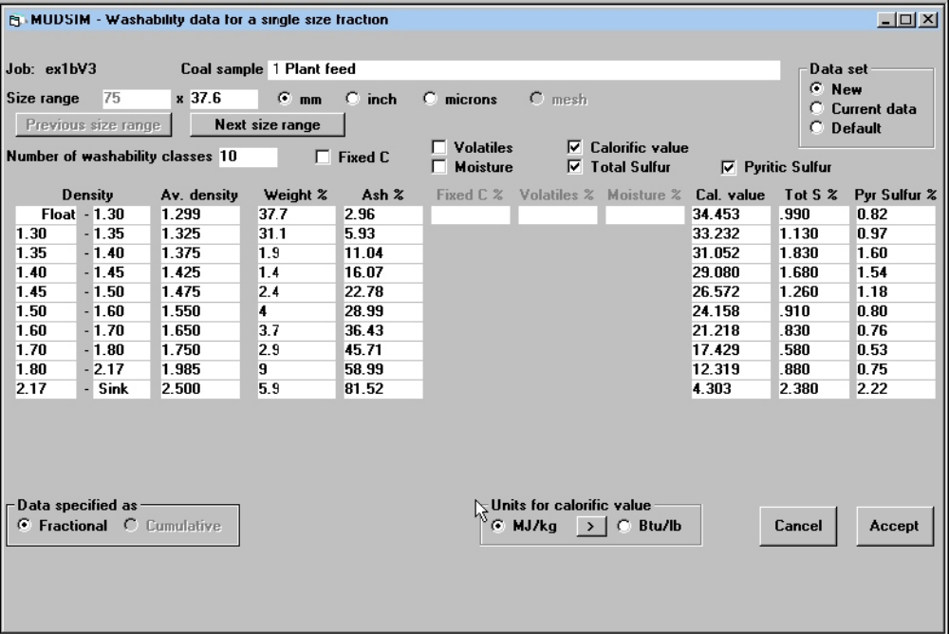
Figure 75 Form for coal washability data.

Coal sample: Indentifying name for this stream.
Size range: Particle size range for this washability set. Each size range for which washability data is available requires a separate form.

Number of washabilty fractions: Specify the number of density fractions that are available for this size faction.
☑ Ash: Check if ash content is known for each washability fraction in this data set.
☑ Fixed C: Check if fixed carbon is known for each fraction in this data set.
☑ Volatiles: Check if % volatiles are known for each fraction in this data set.
☑ Moisture: Check if moisture is known for each fraction in this data set.
☑ Cal. Value: Check if the calorific value is known for each fraction in this data set. Units are MJ/kg.
Sulfur: Check if the sulfur content is known for each fraction in this data set.

Density: Specify the density at the boundaries of each washability fraction.
Weight %: This column requires the weight percent in each washsbilty fraction. The data can be specified as fractional or cumulative.
() Fract () Cum Specify data in fractional or cumulative form.

WRITING SUBROUTINES FOR UNIT MODELS

Note: The following instruction is for programmers who have access to the full Modsim source code. Other users must use the Modsim Software Development Kit that is supplied with the Professional Version of Modsim to add new model subroutines.

Probably the most important feature of MODSIM is the facility to incorporate any model for a particular unit operation. The models must satisfy a minimum set of requirements and must be coded in FORTRAN according to the specifications listed below.

Model Subroutine Structure

Unit model subroutines are written in FORTRAN. Normally, all data required in the model are transmitted via the argument list but the user can transmit data freely through named COMMON.
Unit models are identified to the simulator by a 4-character (alphanumeric) subroutine name which may be chosen by the user. The argument list must necessarily be uniform for all subroutines and is defined by the following format.

SUBROUTINE name(TMSF,TMS1,TMS2,TMS3,FEED,OUT1,OUT2,OUT3,
DER1,DER2,DER3,NDC,NGC,NSC,WTR,WTR1,WTR2,WTR3,SIZE,
PARAM,PPROP,INDPP,FL,NPP,GRDM,GRDC,NMIN,NGCM)

REAL FEED(NDC,NGC,NSC)
REAL OUT1(NDC,NGC,NSC), OUT2(NDC,NGC,NSC), OUT3(NDC,NGC,NSC)
REAL DER1(NDC,NGC,NSC), DER2(NDC,NGC,NSC), DER3(NDC,NGC,NSC)
REAL GRDM(NGCM,NMIN), GRDV(NGCM,NMIN)
REAL SIZE(1), PARAM(1), PPROP(1)
INTEGER INDPP(NPP,2),FL
COMMON NPLNT, NUNIT, ITER,IW,IFLAG

Object time dimensioning for subscripted variables is used so that models need not be changed to suit different ore and mineral suites. The simulator ensures that dimensions are consistent throughout for each problem. This device also means that the subroutines can be compiled once for all thus minimizing waiting time.
The particulate state is described by 3-way classification. The particle population is distributed according to particle size (the D-classes), to mineralogical composition (the G-classes) and a third variable which is left free for specification by the user (the S-classes). The size distribution is normally based on a geometric progression for the interval boundaries while the G-classes normally included liberated mineral and liberated gangue as well as one or more types of locked particle. The S-classes are normally used for the distribution of flotation rate constants if flotation is used as a unit operation but can be used for any other particle property that can take distributed values. Every ore dressing plant must have more than one class in at least one of the three categories otherwise it will not achieve any useful purpose. Consult section 4.1 Setting up Grade Classes and section 4.3 Setting up S-classes to see how these class structures are set up in MODSIM. MODSIM will set up the size classes using a geometric progression of 25 size intervals starting at the largest particle size entered on the System Data Form, Figure 7.
The variables in the argument list are either transmitted by the simulator or are returned by the subroutine to the simulator as defined in the following lists.
Arguments transmitted by simulator to subroutine and which are available for use in the model.

TMSF total mass flow of solids in the feed, kg/s.
FEED(I,J,K) mass flowrate of solids in D-class I, G-class J and S-class K, kg/s.
NDC number of D classes.
NGC number of G classes.
NSC number of S classes.
WTR water flowrate to unit, kg/s.
SIZE vector of particle sizes, units are in meters and sizes are in descending order.
PARAM vector of parameter values for this unit models.
PPROP vector of all physical properties used in the simulator.
INDPP index of physical properties. Physical property I has its first element in vector PPROP in position INDPP(I,1) and has INDPP(I,2) elements.
FL condition indicator that is set to zero by the simulator when the subroutine is entered (see below).
NPP number of physical properties in use by the simulator.
GRDM two-dimensional array containing the mass distribution of minerals in each G class.
GRDV two-dimensional array containing the volume distribution of minerals in each G class.
NMIN number of minerals.
NGCM maximum number of G classes in all plants in the flowsheet.

Arguments transmitted by subroutine to simulator.

TMS1 total mass flowrate of solids in tailings stream kg/s.
TMS2 total mass flowrate of solids in concentrate stream if any, kg/s.
TMS3 total mass flowrate of solids in middlings stream if any, kg/s.
OUT1(I,J,K) flowrate of solid in D-class I, G-class J, and S-class K in the tailings, kg/s.
OUT2(I,J,K) flowrate of solid in D-class I, G-class J and S-class K in the concentrate, kg/s.
OUT3(I,J,K) flowrate of solid in D-class I, G-class J and S-class in the middling kg/s.
DER1(I,J,K) partial derivative of OUT1(I,J,K) with respect to FEED(I,J,K).
DER2(I,J,K) partial derivative of OUT2(I,J,K) with respect of FEED(I,J,K).
DER3(I,J,K) partial derivative of OUT3(I,J,K) with respect to FEED(I,J,K).
WTR1 water flowrate in tailing, kg/s.
WTR2 water flowrate in concentrate if any, kg/s.
WTR3 water flowrate in middling if any, kg/s.
FL output code = 1 if partial derivatives are calculated; = 2 not defined; = 3 fatal error in subroutine, simulation must terminate; = 4 the unit is overloaded.

NOTES:
i. The simulator always supplies quantities in SI units and unit model subroutines should be written appropriately.
ii. Not all units have concentrate or middling streams but every unit must have a tailing stream.
iii. The calculation of the partial derivatives is not essential but convergence is facilitated if they are.

The five entries in COMMON are supplied by the simulator and are defined by

NPLNT the number of the plant currently being simulated.
NUNIT the number of the unit currently being calculated.
ITER the number of the current iteration.
IW the logical unit number of the output device associated with the output file.
IFLAG a flag that has value 0 before convergence and is set equal to 1 for the last pass through the model subroutine at convergence. This is useful for output of information regarding the unit when the material balance has been attained.

These items of data are available for use in the subroutine if required.

The structure of the subroutine must provide the calculated output flowrates using the input flowrates in each particle class as specified. Provided that the necessary outputs are completely specified there is no restriction on the structure of the unit models. They may be as simple or as complex as is required by the nature of the problem on hand.
The unit model subroutines should be maintained by the user in a separate file. The compiled object code must be available for linking to program PHO2.

Accessing System Data in Model Subroutines

Data that is relevant to the system as a whole such as the rate and composition of the feed to a unit or the physical properties of the ore are available for use within the model subroutine from three sources: the arguments of the subroutine call, the common data areas in the subroutine and in the list of physical properties. The subroutine arguments are explained in the previous section and they may be used directly within the subroutine. These variables are common to all subroutines and every subroutine will use some or all of them. The variables in the common blocks are used occasionally from within the subroutine. For example, some results from within the subroutine can be sent to the output file on the last pass through the subroutine. This is detected when IFLAG = 1. The logical unit number for the output file is IW.
The physical properties of the ore are all available for use within the model subroutines. MODSIM establishes an indexed list of physical properties in argument PPROP as defined in Section 10.1. The index is set up in variable INPPP. The order in which specific physical properties are inserted into the list is defined in the following table.

Table 4 List of physical properties that are available in model subroutines.
Physical property | Property number
Specific gravity of G-class  Mineralogical texture parameter Φ_{A}  Magnetic susceptibility of G-class  Any other property that is associated with a G-class. See Figure 8.  Flotation rate constants associated with S-classes.  Magnetic susceptibility of S-classes.  Any other property that is associated with S-classes. See Figure 10.  Calorific value that is associated with a washability (G-classes) class.  Total sulfur that is associated with a washability class.  Pyritic sulfur that is associated with a washability class. | 1  2  3  4  5  6  7  8  9  10

For example the density of material in G-class 3 would be calculated in a unit model subroutine as
DENSITY = PPROP(3)*1000.0
The default specific flotation rate constant for S-class 2 would be calculated as
RateConstant = PPROP(INDPP(5,1)+1)

Accessing Unit Model Parameters

Using the standardized parameter input form

The unit models require operating parameters that will usually be varied from one simulation to the next. Unit parameters are specified from the UNIT PARAMETER screen (Figure 16) that is accessible from the main menu. Obviously parameter specification is specific to the individual models and each model subroutine must have its associated parameter input list. This list is inserted in file MODQUES.DAT and has the following format (each record on a separate line).
Model subroutine name.
Number of parameters for this subroutine.
Text to identify first parameter, Default value for this parameter, Conversion code.
Text to identify second parameter, Default value for this parameter, Conversion code.
Repeated for each parameter.

The conversion code can take any one of three values: NONE, SIZE or DENS. These values specify that a choice of units will be provided if the code is SIZE or DENS in which case units for size or density will be provided respectively. An example of the use of this feature is given in section 7.8 and the resulting data input form is shown as the form in Figure 22.

Adding new parameter input forms

Alternatively a new parameter specification form for the new model can be created. This would be necessary, for example, if the parameters needed to be customized for the particular model and the simple question-and-answer format of the standard form that is described in section 7.3.1.
Two steps are necessary: first create the parameter input form using TEMPLATE.FRM as a template, and second make and additional Case statement to subroutine ShowModelParameter in file UnitMods.frm.
File PLANT.DAT must also be modified as described in Section 7.9.

Handling Water Feeds in Unit Subroutines

Whenever a model must accommodate a separate water feed directly to the unit, the model subroutine must be able to detect this and take appropriate action that reflects the fate of this water in the unit. To do this use data in the COMMON block named WATERFEED. MODSIM sends data in this common block to the unit subroutine. If water is added directly to the unit, the logical variable UNITFEED will be set true. The variable SOLIDCONT will contain the required solid content in the product stream (mass %) or the variable WATERADD will contain the desired water addition rate in kg/s.

Handling Pseudo Streams in Unit Subroutines

If a unit has a pseudo stream drawn on the flowsheet, the information that this stream must transmit is placed in the first available OUTn(NDC,NGC,NSC) variable. Add 10 to the value of variable FL.

Setting up the Report File

Each model subroutine must generate the data and information that is to appear in the Report File. The most convenient way to create this is to clone the unit model subroutine into the file UNITREPS.FOR and add any formatted output that should go to the Report File.

An Example of a Unit Model Subroutine

Consider a separation operation to be defined for use in a plant where only the mineralogical composition of the individual particles is significant. Such a model would be appropriate for a simple magnetic or gravity separation treating a well-sized feed. The recoveries of each mineral type and of the water are presumed to be provided as parameters. The FORTRAN subroutine is:
SUBROUTINE SEPR(TMSF,TMS1,TMS2,TMS3,FEED,OUT1,OUT2,
OUT3,DER1,DER2,DER3,NDC,NGC,NSC,WTR,WTR1,WTR2,WTR3,SIZE,
PARAM,PPROP,INDPP,FL,NPP,GRDM,GRDV,NMIN,NGCM)
REAL FEED(NDC,NGC,NSC)
REAL OUT1(NDC,NGC,NSC),OUT2(NDC,NGC,NSC),OUT3(NDC,NGC,NSC)
REAL DER1(NDC,NGC,NSC),DER2(NDC,NGC,NSC),DER3(NDC,NGC,NSC)
REAL GRDM(NGCM,NMIN),GRDV(NGCM,NMIN)
REAL SIZE(NDC),PARAM(*),PPROP(*)
INTEGER INDPP(NPP,2),FL
COMMON NPLNT,NUNIT,ITER,IW,IFLAG
TMS2 = 0.0
DO K = 1,NSC
DO J = 1,NGC
DO I = 1,NDC
OUT2(I,L,K)=PARAM(J)*FEED(I,J,K)
OUT1(I,J,K)=FEED(I,J,K) - OUT2(I,J,K)
DER2(I,J,K)=PARAM(J)
DER1(I,J,K)=1.0 - PARAM(J)
TMS2 = TMS2 + OUT2(I,J,K)
END DO
END DO
END DO
TMS1 = TMSF - TMS2
FL = 1
WTR2 = PARAM(NGC+1)*WTR
WTR1 = WTR - WTR2
RETURN
END

The most convenient way to write a new model subroutine is to copy the blank template from file TEMPLATE.FOR and place the required code in the indicated positions.

An Example of a Parameter Input Entry in File MODQUES.DAT

CRSH
5
Closed-side set, 0.0254, SIZE
Proportion of fines produced during a breakage event K, 0.2, NONE
Impact work index of the material kWhr/tonne, 12, NONE
Proportionality constant between CSS or OSS and d1 - Alpha1, 0.653, NONE
Proportionality constant between CSS or OSS and d2 - Alpha2, 1.6, NONE

Inserting new Models for Units

The new model code must be programmed as FORTRAN subroutines according to the rules defined in Section 7.1.
The model subroutine must be compiled and linked. If the new model does not fit into any of the existing FORTRAN files it should be placed in files UNITS.FOR.
A small entry is required in file PLANT.DAT. Each unit icon has an entry in this file which is structured as follows:
abcde
f
NAME

Where a = the icon reference number.
b,c,d and e define the region of influence of the unit on the flowsheet. This region is defined as a rectangle with sides to the left, right, top and bottom of the unit location point.
f = the number of models available for this unit.
NAME = the four-character name of the model subroutine (one name per line)
Only f and NAME are relevant to new models that are to be attached to existing icons.
To insert a new model, f is increased by 1 for the appropriate unit and the subroutine name is added to the list. Note that fixed format is required and the value of f must be right justified in column 2.
The program PARSET must be run after modifying file PLANT.DAT. This produces program PPHI5.FOR which must be compiled and linked into MODSIM.DLL

Adding new icons to Modsim

The following steps must be followed to add a new icon to Modsim:
1. Add a subroutine to file Plant1.bas which draws the icon. Use an existing icon subroutine as a template for this. Use the Metgraph polygon routine MGPOLY whenever possible to ensure that the icon is properly shaded when drawn
2. Add the new icon with its model mnemonic/s to file PLANT.DAT and to USERPLANT.TXT. This is where the identifying number for the new icon is set. Remember to update the first line in each of these files to reflect the new total number of icons.
3. Add a new Case statement to subroutine DrawUnit in MdlFlwsheet.bas.
4. Add appropriate entries in the Select menu of FLSheet.frm.
5. Add corresponding event handlers for these menu items to the code section of FLSheet.frm.
6. If necessary, add a case statement and write some code to identify concentrate and middlings streams in subroutine FindStreamType in MdlFlwsheet.bas.

TROUBLESHOOTING

Error messages are displayed whenever MODSIM encounters a problem with a particular simulation. By far the most common source of difficulty is an incorrect or incompatible data file that is sent to the simulator. The data file can be examined by clicking View data echo file from the Run drop down menu of the main window. This will display your data set as the simulator has interpreted it. Make sure that the data set is exactly compatible with the flowsheet that you have drawn. Check the stream connection listing to ensure that all the streams do connect to units as you intended. The parameters for each unit model should also be carefully checked. It is possible to specify unit parameters that are incompatible with your flowsheet arrangement so that no valid simulation is possible. The more complex the flowsheet, the greater the likelihood of an incompatible parameter specification. It is always best and almost always quickest to build up the flowsheet unit by unit and running a simulation after each unit is added. In this way any computational problems can be ascribed to the last unit added and appropriate remedies taken.
The ultimate diagnostic tool is the DLL diagnostic file that is produced during each simulation run. This file tracks the simulation calculation through each stage and should a failure occur, the cause can usually be pinpointed from the diagnostic file output. The DLL diagnostic file can be view from the Run menu on the main window.
The ordering algorithm produces a file that shows the order in which the units will be calculated. This can sometimes be useful when diagnosing errors in the flowsheet. This can be viewed by clicking View calculation order from the Run drop down menu on the main window.
When the flowsheet contains one or more recycle streams, the simulation calculation is iterative in nature. This can be time consuming and the starting point for the iteration can have a significant effect on the computation time. MODSIM defaults to start each calculation from the last end point for the job in question. The calculation is made sequential by allocating flow rates for each class of particle in a set of streams called the tear streams. These tears streams are effectively torn open so that there is a sequential computational path from each tear back to itself. Convergence is achieved when every tear calculates back to itself with values for the particle class flows that are within the required tolerance. Hence starting the next calculation from the values of the tear streams that are calculated at the convergence point of the previous calculation will usually lead to faster convergence. It is possible to disable this feature and force the calculation to start from a default condition for each tear stream from the convergence form, Figure 11. This is especially important if the calculation terminates abnormally leaving an incomplete specification of the tear streams on file. The current values of the tear stream particle class flows can be viewed by clicking View tear streams from the Run drop down menu on the main window.

INDEX

% volatiles, 111
Andrews-Mika boundary exponent, 17
Andrews-Mika boundary sensitivity, 18
Andrews-Mika diagram, 16, 17, 52, 56, 61
Andrews-Mika model, 46, 52, 54, 56, 59
ash content, 1, 111
asymmetry factor, 18
Ball mill, 10, 47, 49, 56, 58, 61
ball mill with scale-up, 53, 59
Bank of flotation cells, 10, 81, 82
Batac jig, 10, 97
BATJ, 10, 96, 97
BAUJ, 10, 96, 97
Baum jig, 10, 97
calorific value, 1, 112
Calorific value, 116
CHAN, 10, 96, 97
Chance sand coal washer, 97
COAL WASHING PLANTS, 111
Comminution, 16, 29, 37, 38, 46, 52, 56, 58, 59, 67
Compound vibrating screen, 63
concentrating table, 97
CONE, 10, 85
Convergence method, 19
Convergence Properties, 19
conveyor, 7, 95
CRS1, 10, 34, 35
CRSH, 10, 33, 34, 119
Crushers, 29, 31
CSCN, 10, 63, 64
cut point, 66, 86, 87, 88, 92, 95, 99
cut-point shift, 95, 96, 97
CYCA, 10, 67, 68
CYCL, 10, 65, 66
D-classes, 113
dense-medium coarse coal washing drum, 98
Dense-medium cyclone, 10, 86
Dewatering screen, 10, 77
distribution over s-classes, 22
DLL diagnostic, 122
DMCY, 10, 86
Double-deck screen, 68, 69
DREW, 10, 96
Drewboy coal washer, 96
DRUM, 10, 98
DSC1, 10, 68, 69
DSC2, 10, 69, 70
DWSC, 10, 77
dynamic operations, 2
elements, 11, 101, 114
ELUT, 10, 70
Elutriator, 10, 70
EMJC, 31, 32
FAGM, 10, 36, 37, 39, 40
FAGT, 39
feed streams, 7, 14, 21
FILT, 10, 77, 78
Filter, 10, 77
fixed carbon, 111
Flotation, 10, 18, 81, 116
flotation rate constant, 15, 117
FLTK, 10, 81, 82
FLTN, 10, 82, 83
flyout, 101
Fully autogenous mill, 36, 39
G-classes, 113, 116
GMI1, 10, 58, 59
GMIL, 10, 56, 57, 107
GMSU, 10, 59, 60
Gottfried-Jacobsen, 86, 87, 95, 97, 98, 99
grade distributions, 22, 24
GYRA, 10, 30, 31
gyratory crusher, 30
Help, 28
Herbst-Fuerstenau model, 50, 53
HFMI, 10, 50, 51
HFML, 10, 52
HFSU, 10, 53, 54
High Pressure Grinding Rolls, 42
HPGR, 42, 43, 45
Hydrocyclone, 10, 67
Internal Flow Streams, 25
jaw crusher, 29, 30
JAW1, 10, 29
JAW2, 10, 29, 30
KELL, 10, 88, 89
Kinetic model, 71
KLIM, 10, 84
KNELSON CONCENTRATOR, 89
KSCN, 10, 71
KYNC, 10, 78, 79
largest particle size, 14, 15, 114
liberation, 2, 4, 11, 15, 16, 17, 23, 25, 46, 47, 48, 52, 54, 55, 56, 57, 58, 59, 60, 61, 105, 106, 107
Liberation size, 17
Liberation Spectra, 105
LISP, 10, 88
Magnetic susceptibility, 15, 18, 116
main menu, 3, 13, 27, 103, 104, 117
Metals, 101
MILL, 10, 47, 48, 49
Mineral, 13, 14, 17, 31, 33, 35, 36, 37, 39, 46, 47, 49, 50, 51, 52, 55, 56, 58, 60, 64, 65, 67, 71, 73, 81, 83, 86, 88, 90, 91, 95, 107
Mineralogical texture, 116
moisture, 73, 77, 111
non-floatable component, 18, 84
NORW, 10, 96
Norwalt coal washer, 96
Number of grade classes, 15
Number of minerals, 14
Number of S-classes, 15
Number of size classes, 14
ORE CHARACTERISTICS, 14
Output Data, 102
output file, 4, 103, 105, 115, 116
Output PSD graphs, 103, 104
particle size distributions, 104
partition function, 70, 71, 93, 95, 99
percent solids, 22, 24, 25, 85
PHIA parameter, 17
physical properties, 14, 114, 116
plant performance, 109
Preferential breakage, 17
Printing the Flowsheet, 12
Probability screen, 72
PSCN, 72, 73
pseudo streams, 11
Pyritic sulfur, 116
Reichert cone, 10, 85, 86
Repetitive Simulations, 109
report file, 4, 11, 64, 71, 74, 101, 106, 107
Rod mill, 10, 45, 46
RODL, 10, 46, 47
RODM, 10, 45, 46
Roller Press, 42
Rosin-Rammler, 22, 23, 39, 42, 55, 61, 67, 68, 93
SAGM, 10, 39, 40, 42
SAGT, 42
Scale-up, 51, 56
S-classes, 15, 18, 19, 22, 23, 92, 113, 116
SCR1, 10, 73, 74
SCR2, 10, 69, 74, 75
Semi autogenous mill, 39, 42
SHAK, 10, 97
shallow bath coal washer, 97
SHHD, 10, 35, 36
Short-head crusher, 35
Single-deck vibrating screen, 73, 74
SJIG, 90
Specific gravity, 15, 55, 116
SPIR, 10, 87
Spiral concentrator, 87
SPL1, 10, 80, 81
SPLT, 10, 80
spreadsheets, 3, 102
Subroutine Structure, 113
sulfur content, 112
Symons standard cone crusher, 33
system data, 4, 9, 13, 15, 16, 18, 19, 20, 21, 23, 25, 82, 84, 93, 94, 101, 104
target specific gravity, 95
tear streams, 20, 122
TESK, 10, 96, 98
Teska Drum, 98
THIC, 10, 79, 80
Thickener, 10, 78, 79
Total sulfur, 116
TROUBLESHOOTING, 122
UMIL, 10, 61, 62
Unit Model Parameters, 117
UNIT MODELS, 27, 29, 113
variance, 18
VJIG, 90
WASH, 10, 96, 98
washabilty, 111
Water injection cyclone, 76
Water-only cyclone, 10, 98
WEMC, 10, 96
Wemco drum coal washer, 96
Wet drum magnetic separator, 93
Wet high-intensity magnetic separator, 10, 91
WICL, 76

