**Can Hyperspectral Data Capture Arctic Plant Biodiversity?**

Changes in plant communities are one of the most distinct responses to global climate change, yet we lack quantification of plant diversity and composition in the biome experiencing the highest rate of warming – the Arctic. Traditional methods of measuring biodiversity are both costly and limited in their spatial-temporal resolution. Increased availability of remotely-sensed hyperspectral data could be used to monitor spatial-temporal changes of Arctic tundra vegetation. Yet, the feasibility of using hyperspectral data for even static local biodiversity assessments still remains unclear. Using plot scale hyperspectral data, this study aims to investigate if spectral signatures can be used to identify Arctic tundra vegetation types and predict biodiversity. Additionally, I identified what regions of the spectrum are most distinct between vegetation types and if dimensional reduction of data improves the spectral discrimination of vegetation types. This study shows that vegetation types can be identified by their hyperspectral signatures, but that there is limited evidence of spectral-biodiversity relationships. While spectral signatures vary between years and did not exhibit convergent trends, my results help to highlight sources of variability in hyperspectral data. Using plot level spectral data to identify vegetation types and quantify biophysical relationships, provides foundational knowledge needed to facilitate the use of remote sensing for biodiversity monitoring.

**Table of Contents**

this should list all chapter headings and sub-headings. All should be numbered, e.g. 1. Introduction, 1.1 Background to the dissertation topic, etc.

**Acknowledgements**

I would like to thank Dr. Isla Myers-Smith for her guidance, insight, and advice at all stages of this dissertation. I am thankful for having her as a supervisor. A special thanks goes to Gergana Daskalova for her continuous support, thoughtful feedback, and expert advice in finessing my visualizations. I would like to thank all the remaining Team Shrub members for their feedback and insights that helped shape and improve my dissertation at all its stages. I would also like to acknowledge all those who conducted fieldwork on Qikiqtaruk and collected the data, without which, this dissertation would not have been possible. I am thankful to Dr. Alison Beamish, for sharing her expertise when sorting through spectral measurements and her quick enthusiasm to help me with AVRIS data.

A final thanks goes Kimberley Schneidereit: without her continuous support, I would have not been able to have made it this far.

**List of abbreviations**

AVRIS - Airborne Visible/Infrared Imaging Spectrometer

CV – Coefficient of variance (spectral diversity)

D ISI, I- Trend of accumulated ISI values

HE – Herschel

IR- Infrared

NIR- Near-infrared

PCA- Principle component analysis

ISI- InStability Index

ITEX- Internation Tundra Experiment

KO- Komakuk

m- Meter

nm- nanometer

PCA- Principle component analysis

QHI- Qikiqtaruk Herschel Island

Spec_mean- Mean reflectance

SZU- Spectral zone unmixing

1. **Introduction**

Assessing biodiversity with efficient and scalable methods is increasingly essential as global change accelerates. The Arctic is a particularly vulnerable biome, undergoing the highest rates of climate warming (IPCC, 2019; Post et al., 2019). The Arctic is critical in the global carbon budget, holding twice the world’s atmospheric carbon in permafrost (McGuire et al., 2009; Schuur et al., 2008). Plants strongly influence carbon cycling and the energy balance of the ecosystem (Pearson et al., 2013). Understanding diversity and composition of vegetation communities is central to predicating environmental change and ecosystem function (Bjorkman et al., 2018). While systematic plot level surveys are the most accurate means of plant biodiversity assessment, the remoteness and high spatial heterogeneity of Arctic ecosystems significantly impedes traditional sampling strategies (Rocchini et al., 2010). The use of remote sensing could facilitate efficient assessment of biodiversity in real-time and at biome wide scales (Turner, 2014). Yet, the biophysical relationships of remotely-sensed signals and biodiversity are variable and challenging to interpret (Pettorelli et al., 2016). Plot level quantifications of biophysical relationships are needed to advance the use of remote sensing data for biodiversity assessments.

Vegetation types can be identified based on their unique spectral properties. Hyperspectral signatures are a species’ or communities’ unique pattern of light reflectance. Variations in chemical composition, leaf traits, and canopy structure alter the absorbance and scattering of light, resulting in distinct reflectance values across the electromagnetic spectrum (Cavender‐Bares et al., 2017). Hyperspectral signatures have been found to be distinct to individual species (Schweiger et al., 2018), and between tundra vegetation types (Beamish et al., 2017). The variation in hyperspectral signatures (spectral diversity hereafter) can potentially capture more spectral complexity, improving the identification of vegetation types (Wang, Gamon, Cavender-Bares, et al., 2018). While vegetation types can be identified using spectral signatures, it remains unclear how spectral diversity relates to vegetation types.

Vegetation biodiversity can be estimated using spectral diversity. Spatially heterogeneous environments are predicted to have higher biodiversity, as there is increased availability of unique niches (Gaston, 2000).Spectral diversity increases with spatial heterogeneity and can be used as a proxy for biodiversity (spectral diversity hypothesis) (Heumann et al., 2015; Rocchini et al., 2010; Schweiger et al., 2018; Wang and Gamon, 2019). Yet, spectral biodiversity relationships are sensitive to environmental heterogeneity and variable between (Gholizadeh et al., 2018; Rocchini et al., 2011). Environmental factors such as bare ground can also influence spectral diversity and need to be assessed (Gholizadeh et al., 2018; Wang, Gamon, Cavender-Bares, et al., 2018). It is unclear how spectral diversity relates to Arctic tundra vegetation richness and evenness.

The high dimensionality of hyperspectral data poses challenges to successfully identifying vegetation types (Somers et al., 2010; Song, 2005). Hyperspectral sensors measure reflectance in small bands of wavelengths that span the spectrum. Vegetation identification accuracy decreases once a threshold of included bands is passed (Hughes Phenomenon) (Gholizadeh et al., 2018). This is due to additional spectral bands being highly correlated to adjacent bands, while containing redundant information, as well as additional sensor noise (Delalieux et al., 2007; Somers et al., 2010). High data dimensionality reduces the potential to discriminate vegetation types based on their hyperspectral signatures.

Dimensionally reducing data can improve the spectral discrimination of vegetation types. Bands are selected that minimize intra-type variability and maximize inter-type differences (Jia et al., 2012; Song, 2005). Dimensional reduction of spectral diversity has been limited to principle component analysis (Dahlin, 2016) and convex hull area methods (Gholizadeh et al., 2018). An alternative approach is to use the InStability Index (ISI) to determine and select discriminative bands (Somers et al., 2010)s. The ISI, can additionally be used to identify key wavelengths that are most distinct between vegetation types and helps explain the biophysical origin of spectral differences between vegetation types (Beamish et al., 2017). Selecting distinct bands based on ISI values can improve the spectral discrimination of vegetation types.

Quantifying biophysical relationships at plot scales facilitates the use of remotely-sensed data. Using drones, planes, and, satellites high-resolution spectral data are becoming increasingly available at multiple scales (Lausch et al., 2016; Lee et al., 2015). This data could enable understanding spatial-temporal variability in vegetation composition and biodiversity across large spatial scales. Yet, it is unknown how physiological characteristics of Arctic vegetation types relate to observed spectral signatures and biodiversity. Environmental factors such as bare ground also influence spectral diversity and need to be accounted for (Gholizadeh et al., 2018; Wang, Gamon, Schweiger, et al., 2018). Quantifying spectral-biodiversity relationships on plot levels provides foundational information to facilitate the use of remotely-sensed data for environmental analysis and biodiversity monitoring.

**1.1 Study Objectives**

This study aims to use plot-level spectral data to investigate the patterns of spectral variability between two Arctic vegetation types. I address if vegetation communities can be identified based on their mean reflectance and spectral diversity. Through using the InStability Index (ISI), it is determined what regions of the electromagnetic spectrum are most distinct between Arctic vegetation types. To investigate if dimensional reduction of spectral data improves the spectral differentiation of vegetation types, I conducted two band selections using i) manual band selection based on a priori assumption and ii) automated selection method using ISI values. Furthermore, I combined spectral signatures with point framing data, to evaluate if species richness and evenness can be estimated for Arctic vegetation communities and if bare ground influences spectral diversity. Using a principle component analysis, additional environmental factors, such as visible flowers and dead matter, cover type, and canopy density were visually evaluated in how they affect spectral properties.

**1.2 Research Questions and Hypotheses**

**1: How do Arctic vegetation types discriminate based on the mean reflectance and spectral diversity of hyperspectral signatures?**

**H1**: Arctic vegetation types can be identified based on the mean of their spectral signature (H1a) and spectral diversity of their spectral signature (H1b). Spectral diversity will have a stronger correspondence with vegetation type (H1c). When ordinated, spectral signatures will discriminate among vegetation types (H1d) and year of measurement (H1e).

**H1o:** Arctic vegetation types do not differ based on the mean or variance of their spectral signatures, and do not discriminate when ordinated.

**2: Does band selection influence correspondence between spectral diversity and vegetation type?**

**H2.** Overall regions in the visible part of the spectrum (400-700nm) have higher correspondence with vegetation type than bands in the near infrared range (700-100nm) (H2a). Automatic band selection will result in the selection of a small but spectrally diverse subset of bands (H2b). Both manual and automatic band selection methods result in greater correspondence between spectral diversity and vegetation type (H2c).

**H2o:** There are no specific spectral regions that are best suited to discriminate vegetation types. Band selection does not visibly influence the correspondence between spectral diversity and vegetation type.

**3: How does spectral diversity relate to species richness, evenness, and bare ground?**

**H3:** Vegetation type will significantly affect spectral diversity (H3a). Higher spectral diversity will correspond with both increases in species richness (H3b) and species evenness (H3c), with evenness having the stronger relationship (H3d). Bare ground will have the strongest positive influence on spectral diversity (H3e).

**H3o:** Species richness, evenness, and bare ground have no effect on spectral diversity, with no visible relationship observed.

**4: Are closer measurements more similar than more distant measurements?**

**H4:** When tested for spatial autocorrelation, closer measurements will be more similar than more distant measurements (H4a)

**H4o:** There is no visible level of autocorrelation between measurements at any distance.

**5: Do plot and airborne spectra differ from each other? Does plot or airborne spectra show more variation among vegetation types?**

**H5:** Plot and airborne spectra do visually differ from each other (H5a), with plot spectra showing more variation both within vegetation types (H5b), and between vegetation types (H5c).

**H5o:** There is no visible difference between plot and airborne spectra, with neither accounting more variation among vegetation types.

**6: Can airborne remotely-sensed spectral diversity be used to identify vegetation types at the island scale?**

**H6:** Airborne remotely-sensed spectral diversity can be used to identify vegetation types at an island scale (H6a), and when visually compared, will correspond with an existent mapping vegetation type (H6b).

**H6o:** Airborne remotely-sensed spectral diversity cannot be used to identify vegetation types at an island scale, and when visually compared does not correspond with an existent mapping of vegetation types.

**1.2.1 Notes to Research Questions**

While attempted, Questions 5 and 6 could not be answered due to georectification issues. This work was pre-registered with the Center for Open Science. For full pre-registration visit <https://osf.io/7utng>

*Note: For improved clarity, Questions 2 and 3 were rearranged. Bare ground was renamed soil-background.*

**1.3 Predictions**

Figure 1.3 depicts a conceptual diagram of H1 and H3 and my predictions.

**Figure 1.3** Conceptual diagram of hypotheses one and three with predicted results.

1. **Methods**

**2.1 Site description**

All data used for analysis were collected through fieldwork of Team Shrub members on Qikiqtaruk-Herschel Island (QHI), located at 69.34°N, 138.55°W in north western Yukon, Canada (Figure 2.1). QHI lies 5 km from the mainland in the Beaufort Sea and has a total area of 110 km2, measuring 13 x 15 km. Being a high latitude site, QHI experiences seasonal extremes in solar radiation and temperatures, ranging from -35°C in winter to 5°C in summer, the mean annual temperature being -9°C (Obu et al., 2017). This region of the Arctic is undergoing rapid climate and environmental change (Assmann et al., 2019; Myers‐Smith et al., 2019). QHI is composed predominantly of unconsolidated fine-grain marine sediment (Obu et al., 2017). Organic cryosols cover the extent of the island, with other soils only present at beaches.

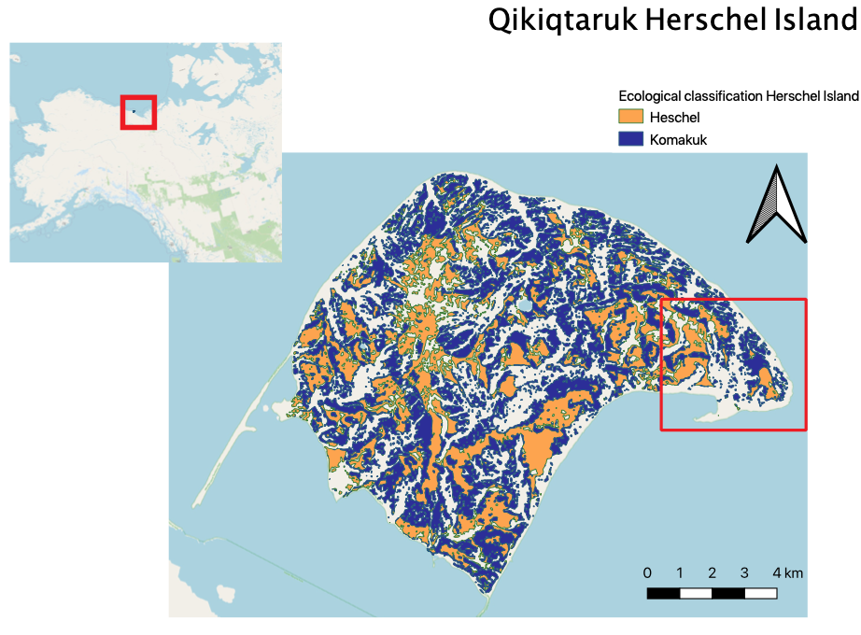

**Figure 2.1.** Extent of Herschel and Komakuk vegetation types across Qikiqtaruk-Herschel Island, with the inset map depicting the location within North America. The extent of the red square on QHI indicates the study site, Collison Head, and the location the long-term monitoring plots from where spectral measurements were taken (data source: vegetation classification (Obu et al., 2017))

QHI is floristically composed of predominantly lowland Arctic tundra plant communities, consisting of seven discrete vegetation types (Obu et al., 2017). Only the two dominant vegetation types, Herschel and Komakuk, were investigated in this study. Herschel vegetation type is characterized by relatively undisturbed moist acidic tussock tundra with an expanding willow canopy layer (Myers-Smith et al., 2011). Komakuk is composed of herbaceous and graminoid tundra, subjected to cryoturbation and surface disturbances (Myers-Smith, et al., 2011; Myers‐Smith et al., 2019). Each vegetation has 6 established 1 m 2 plots being monitored since 1999, according to ITEX methodology and are arranged randomly along 50m transects (Molau and Mølgaard, 1996).

* 1. **Data acquisition**

Figure 2.2 is a workflow diagram outlining key steps in data acquisition, manipulation, analysis, and visualization.

**2.2 workflow diagram** colors are coded as: data source (orange); data type (blue); data manipulation (green); analysis (red)

**2.3 Plot level point framing data**

At each of the long-term monitoring plots, vegetation compositional, structural, and phenological properties were collected using a point-framing vegetation surveying method (Molau and Mølgaard, 1996). Point framing involves partitioning each plot into 100 1cm2 cells and systematically recording species, tissue type, and statues (standing/dead). From point framing data, I calculated per plot, the biodiversity metrics richness and evenness using percentage cover of each species. Additional factors likely to influence spectral diversity were also calculated. These included bare ground, total vegetation cover, dead tissue, flowing tissue, as well as total graminoid and shrub cover. Only relevant observations of the top canopy layer were included, as sub-levels do not directly influence reflectance (Gholizadeh et al., 2018).

**2.4 Spectral data**

**2.4.1 Plot scale spectral data**

All analysis conducted relied on plot level spectral data collected over the 2018 and 2019 field season. Spectral data in both years were collected from 1x1m long-term monitoring plots that exist in Herschel and Komakuk vegetation types (6 plots each). To capture within plot spatial heterogenetic, long-term monitoring plots were partitioned into 9 subplots (3x3 m grid) from which replicate measurements were taken. In 2018, each subplot was reflectance and was measured at 9 distinct points, while in 2019, spectral measurements were only duplicated at each subplot. In 2019, additional spectral measurements were taken in areas exhibiting typical Herschel or Komakuk compositional features. These were grouped as mixed, as plots were alternatively sampled and could not be assigned to their original vegetation type. Point measurements were aggregated at plot level to represent the spectral signature of each community. Spectral measurements were taken during the end of the peak season phenological phase (04th August in 2018 and 30th & July in 2019). Solar radiance conditions at the time of spectral measurements varied between the years - 2018 being overcast and 2019 being sunny. Measurements were calibrated for downwelling radiance, using a white micasense plate. Spectral measurements were taken using two different spectrometers, with 2018 data having a higher spectral resolution. The obtained reflectance values were subset to 400–985 nm, filtering sensor noise present at the spectrometer’s limits of detection range.

**2.4.2. Airborne remotely-sensed spectral data**

Airborne Visible/InfraRed Imaging Spectrometer (AVIRIS) sensor data were taken by NASA during the 2019 field season. Airborne remotely-sensed hyperspectral data span across QHI and were taken on two different dates (2nd July 2019 & 27th July 2019) at spatial resolution of 5m per pixel. Using spatial extent data of vegetation types (Obu et al., 2016), 50 plots within each vegetation type could be assigned from which to extract spectral data. Due to navigation issues during data collection, airborne spectral data had unresolvable georectification issues. Therefore, I was not able to continue and finish my analysis for research Questions 5 and 6.

**2.5 Spectral diversity metric**

The Coefficient of Variation (CV) was used as the spectral diversity metric (Rocchini et al., 2010; (Wang, Gamon, Schweiger, et al., 2018) (Equation 1). CV is an expression of the spectral diversity of all the individual spectral measurements within a single plot.

**(1)**

*ρλ is the reflectance at wavelength λ.* σ*(ρλ) and μ(ρλ) are the standard deviation and mean value of reflectance at wavelength λ across all the pixels in one plot. (Wang., 2018a).*

**2.6 Spectral band selection**

**2.6.1 Manual band selection**

I conducted a manual band selection through identifying relevant spectral regions based on a literature review of other studies featuring spectral analysis of Arctic vegetation (table 2.4.1). I synthesized band sections of multiple sources and adapted them based on *a priori* assumption of the predicted biological significance spectral regions. Previous work indicates that regions in the blue, green peak, red, and middle of red-edge (680-725 nm) regions of the spectrum are particularly distinct between vegetation types. (Beamish et al., 2017; Bratsch et al., 2016; Buchhorn et al., 2013; Huemmrich et al., 2013).

*Table 2.6.1- The wavelengths included in supervised band selection and relevant biological significance.*

|  |  |  |
| --- | --- | --- |
| Wavelength | Spectral Region | Biological significance |
| 430-450 | Blue | Chlorophyll & carotenoid absorption |
| 545-555 | Green | Green reflectance peak |
| 660-680 | Red | Max absorption of chlorophyll |
| 700-725 | Red | Middle of red-edge transition |
| 745-755 | NIR | End of red-edge transition |
| 920-985 | IR | Vascular plant structures & water absorption |

**2.6.2 Automatic band selection**

An additional automatic band selection for dimensional reduction was conducted. While improving classification accuracy, manual band selections do not filter spectral noise and are susceptible to removing bands that contain important information for vegetation type discrimination (Gholizadeh et al., 2018). Therefore, I used Stabile Zone Unmixing (SZU) to automatically select a subset of bands. SZU, is a type of spectral mixture analysis that aims to provide robust and automated band selections to yield the optimal subset of bands for discriminating vegetation types. This is achieved through calculating the InStability Index (ISI) (Somers et al., 2010), a ratio index based on reflectance of each band across the entire measured spectrum and identifies bands (Equation 1). The ISI helps identify bands that are least sensitive to spectral variance, while maintaining comparably higher intertype differentiation.

**(1)**

*Rmean,1,i and Rmean,2,i are the mean reflectance values of each vegetation type and σmean,1,i and σmean,2,i are the standard deviations of the reflectance values (Somers et al., 2010).*

ISI values represent the intra-community spectral variance when compared to inter-community differences. A lower ISI indicates that a band is better at discriminating vegetation types (Beamish et al., 2017). Comparing ISI values across the entire spectrum, identifies the spectral regions best suited to discriminating Arctic vegetation types. Furthermore, specific wavelengths and the associated biophysical features can be identified (Beamish et al., 2017). This helps explain the origin spectral differences between vegetation types.

The computed ISI values were used as a selection criterion for the final band selection. A three-band moving window was used to identify and select local ISI minima. Local minima selection enables the automated and flexible selection of bands across the entire spectrum and does not exclude bands from variable spectral regions (Beamish et al., 2017). I conducted an additional post hoc automated band selection exclusively using 2019 measurements, as these had more distinct endmembers, cited to be essential to providing accurate and appropriate band selections (Somers et al., 2010; Song, 2005). This helped assess the robustness of the automated band selection. The theoretical optimum number of bands to discriminate bands was found by calculating DISI,  the amplitude at which estimated accuracy decreases with the inclusion of each additional bands (For full methods see Appendix 7.1)

**2.7 Statistical analysis**

I conducted my statistical analysis using R (v.3.6.2). No hierarchical structure existed, as mean reflectance and diversity are aggregated on a plot level. Therefore, I used a multiple linear regression model to conduct my statistical analysis.

Normality and homoscedasticity were assessed using Q-Q plots. To test how vegetation types influence spectral signatures, separate multiple linear regression models were used for mean reflectance and spectral diversity. The same models were used to evaluate H2c, with spectral diversity calculated using the subset of bands that were selected in manual and automatic band selections.

*Mean reflectance ~ vegetation type + year*

*Spectral diversity (CV) ~ vegetation type + year*

The following multiple linear regression model was used to quantify how species richness, evenness and bare ground affect spectral diversity. Interaction factors were included between vegetation type and each continuous variable. CV was calculated using the visible spectrum

*Spectral diversity (CV) ~ vegetation type + year +*

*(vegetation type *richness) +*

*(vegetation type *evenness) +*

*(vegetation type *bare ground)*

Variables in linear models where considered to be significant at p-value with an alpha level of 0.05 and if standard error around.

1. **Results**

**3.1 How do Arctic vegetation types discriminate based on the mean reflectance and spectral diversity of hyperspectral signatures?**

**3.1.1 Spectral signatures by vegetation type**

When comparing vegetation types, Herschel plots had lower mean reflectance and higher spectral diversity than Komakuk plots. Multiple linear regression predicted that Herschel vegetation had a lower mean reflectance than Komakuk (estimate HE=0.18; estimate Herschel=0.25; p-value=<0.0001; SE=0.03; n=21) (Appendix 7.2). Herschel type had a higher spectral diversity than Komakuk type (estimate HE=0.13; estimate KO=0.05; p=0.03; SE=0.02; n=21).

There is evidence that vegetation types can be identified based on their mean reflectance and spectral diversity, implying an acceptance of H1a. and H1b.. Vegetation had greater predicted differences based on their mean reflectance, implying a rejection of H1c.

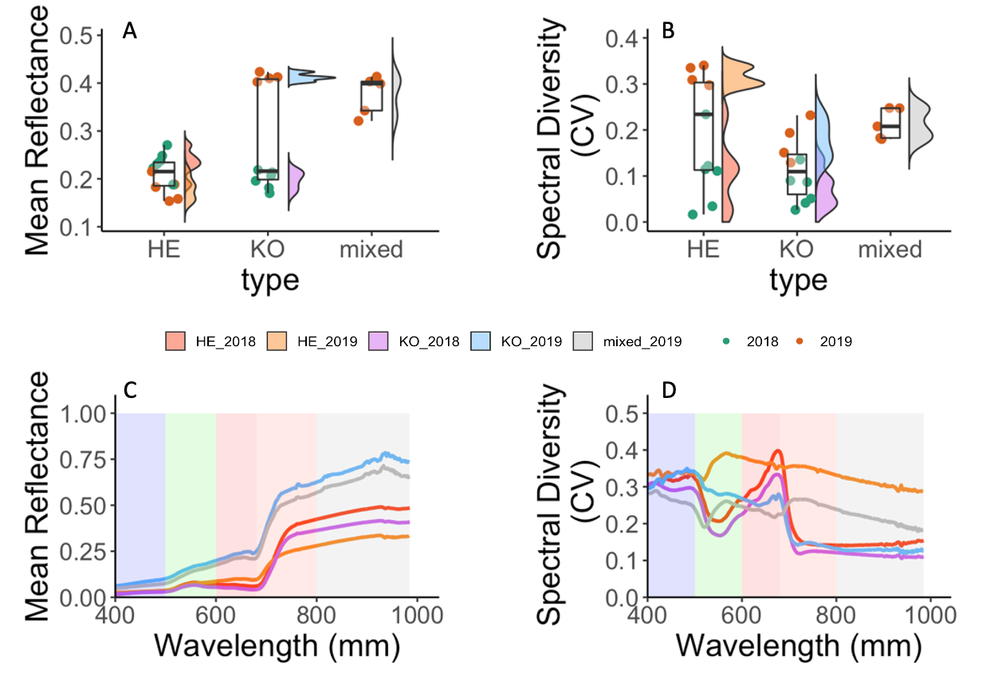

**Figure 3.1.1 Panel Plot Comparing Mean Reflectance and Spectral Diversity (CV).** Panel A and B: The mean reflectance and spectral diversity between different vegetation types. Red and Green points correspond with measurements from 2018 and 2019 respectively. C and D: Mean reflectance and spectral diversity across the spectrum of each vegetation type in each year. Background colors correspond to each region of the spectrum; blue 400-500 nm, green 500-600 nm, red 600-680 nm, near infra-red 680-800, infra-red 800-985.

**3.1.2 spectral signatures by year**

Predicted mean reflectance and spectral diversity values were greater in the 2019 measurements, mean reflectance (estimate=0.07; p=0.04; SE=0.03; n=21) spectral diversity (estimate=0.16; p<0.001; SE=0.3; n=21) (Appendix 7.3). When comparing between years, vegetation types had reversed trends in terms of mean reflectance, Herschel has a higher mean reflectance than Komakuk in 2018, and lower mean reflectance in 2019.

**3.1.3 When ordinated, do spectral signatures discriminate among vegetation type and year?**

The spectral discrimination of vegetations types in an ordination approach was only possible for the 2019 measurements. Here, Herschel and Komakuk had a sufficiently large distance in spectral feature space and greater inter-group differentiation than intra-group variation. When ordinated, spectral signatures clustered primarily by year (along the PC1 axis) with 2018 Heschel and Komakuk groups overlapping. Mixed vegetation spectral signatures did not discriminate into two groups corresponding with 2019 Herschel and Komakuk measurements, despite being selected based on exhibiting distinct compositional characteristics of either vegetation type.

**Figure 3.1.3 PCA of Spectral Signatures Grouped by Vegetation Type and Year** Spectral signatures of each plot were arranged in ordinal space according to mean reflectance and spectral diversity. Large points indicate the center of each group. PC1 eigenvalue=54.7%; PC2 eigenvalue=46.3%

Spectral signatures were also ordinated separately by year (Appendix 7.4). General trends remained relatively consistent, with 2019 measurements showing less differentiation.

**3.2: Does band selection influence correspondence between spectral diversity and vegetation types?**

**3.2.1 What regions of the spectrum best discriminate vegetation types?**

I identified the red region of the spectrum to best discriminate vegetation types, based on mean ISI (Table 3.2.1). This implies acceptance of H3a, where visible regions of the spectrum were predicted to have higher correspondence with vegetation type. Despite having a relatively small inter-type difference in mean reflectance, single bands that had green-red transition had the lowest ISI values and were the most informative for discriminating vegetation types (Figure 3.2.1). The two selected bands with the lowest ISI values, 573 and 599 nm correspond with anthocyanin absorption (Beamish et al., 2017; (Merzlyak et al., 2008). The red-edge transition (~690 - 740 nm) had a relative peak in ISI values at 718 nm, which corresponds with the point of transition from chlorophyll adsorption to canopy structure scattering (Asner and Heidebrecht, 2002; Daughtry, 2000). The NIR region exhibited a plateau with relatively low and consistently stable ISI values from 750-800 nm. The blue and IR regions respectively were the least discriminative, as well as the most variable, despite sensor noise at the limits of the spectrometer detection range being removed. The additional band selection using more spectrally distinct endmembers in the 2019 data (Appendix 7.5), had visual correspondence with the full band selection using 2018 and 2019 data.

**Table 3.2.1** Summary of ISI values by region, and breakdown bands selected. A lower ISI indicates that a band is better at discriminating vegetation types

|  |  |  |  |  |
| --- | --- | --- | --- | --- |
| Region | Total ISI | Mean ISI | Number of bands selected |  |
| Blue | 1161 | 19 | 5 |  |
| Green | 1044 | 17.1 | 2 |  |
| Red | 799 | 16 | 3 |  |
| NIR | 1326 | 17 | 3 |  |
| IR | 2218 | 18.2 | 11 |  |

**Figure 3.2.1 InStability Index (ISI) of bands across the spectrum.** ISI values indicate how well bands discriminate vegetation types, with low values being more discriminative. Clear dots along the plotted ISI and the corresponding rugs indicate bands selected, via local minima selection. Background colors correspond to each region of the spectrum; blue 400-500 nm, green 500-600 nm, red 600-680 nm, near infra-red 680-800, infra-red 800-985.

**3.2.2 What bands were selected following automated band selection?**

Automatic band selection yielded a dimensionally reduced, but spectrally diverse subset of bands, indicating an acceptance of H3b. Yet, there were proportionally high inclusions of bands in IR and blue regions. The applied three-wavelength moving window for minima selection yielded an unequal subset of bands, due to regional differences in ISI variability.

Plotting cumulative DISI, I values show the amplitude at which estimate accuracy decreases with the inclusion of each additional band (Figure 3.2.2). I found a global maximum at 3 selected bands, which indicates the theoretical optimum number of bands. Each further additional band included provides less information relative to introduced variability and reduces the spectral discrimination of vegetation types (Somers et al., 2010). The moving window minima selection selected 25 bands.

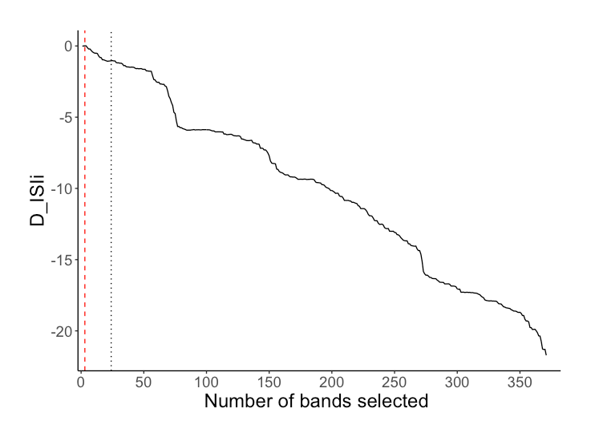

**Figure 3.2.2 DISI, I Accumulation by Number of Bands Selected.** DISI, I is the amplitude at which estimate accuracy decreases with the inclusion of each additional band. The red dashed line indicates the global maximum at selected bands. This is the theoretical optimum number of selected bands to best discriminate Herschel and Komakuk vegetation types based on their spectral signatures. The dotted black line at 25 indicates the number of bands selected using the three-band moving window minima selection.

**3.2.3 Does band selection result in greater discrimination between vegetation types based on spectral signatures?**

I found that band selection does not result in greater differentiation between vegetation types based on their spectral signatures, implying a rejection of H2a. Manual and automatic selection included 24 and 25 bands respectively.

**Figure 3.2.3 Comparison of predicted mean reflectance and spectral diversity.** The first row (A,B,C) is a visual representation of the subset of bands in each model. Each column corresponds with one set of bands, with (A,D) being the full spectrum, (B,E) manual band selection, and (C,F) automated band selection.

**3.3 How does spectral diversity relate to species richness, evenness, and bare ground?**

**3.3.1 How does spectral diversity relate to richness and evenness?**

Spectral diversity did not have a consistently significant positive correspondence with either species richness or species evenness implying a rejection of H3b andH3c (Figure 3.4.1, Appendix 7.6). Only species richness in Herschel vegetation had a significant relationship with spectral diversity (estimate=0.05, SE=0.02, p-value=0.02, n=11).

**3.3.2 How does bare ground relate to biodiversity?**

I did not find a relationship between spectral diversity bare ground in either vegetation types (Figure 3.4.1, Appendix 7.6). This implies a rejection of H3d and H3e which predicted a strong positive correspondence between bare ground and spectral diversity. Increased bare ground did tend to result in lower spectral diversity, but large errors were associated with predicted values.

**Figure 3.3.2 Multiple Linear Regression Models Predicting Spectral Diversity (CV).** Spectral diversity (A) increases with richness in Herschel vegetation, (B) does significantly correspond with evenness (C) tends to decrease at higher bare ground. Herschel vegetation types estimates are in yellow and Komakuk in blue, with ribbon representing the upper and lower bounds of the 95% confidence intervals. Plotted points represent computed spectral diversity estimates. Herschel type, n=11, Komakuk type, n=10)

**3.3.3 How is spectral diversity influenced by additional environmental factors?**

When spectral signatures were ordinated with additional environmental factors derived from point framing data, total cover had close positive correspondence with spectral diversity (CV). Total cover incorporates both canopy and sub-canopy vegetation layers and indicates greater vegetation density. Shrub cover, evenness and partial richness were also correlated. Aside from the previously tested factor bare ground, flowering tissue was directionally opposed to spectral diversity.

**Figure 3.3.3 PCA of Spectral Diversity (CV) and Environmental Factors** Groups were colored with red, indicating Herschel 2018, yellow Herschel 2019, purple Komakuk 2018, blue Komakuk 2019. Factors were colored by type, green being diversity indices, orange environmental factors, and lavender spectral properties. Dead, graminoid, shrub, and flowing tissue represent plot cover at canopy layer (visible when looking from above). Mean reflectance is denoted as Spec_mean; spectral diversity as CV. PC1 eigenvalue=39%; PC2 eigenvalue=27%.

**3.4 Are closer measurements more similar than more distant measurements?**

Spectral measurements exhibited of spatial autocorrelation between plots, indicating an acceptance of H4a. The distance to the sill indicated uncorrelation of measurements 20 meters (Figure 3.4). Plots in each vegetation type were arranged along a 50 transect, meaning some spatial degree of autocorrelation is always present. The nugget to sill ratio indicated that a maximum of 70% of variance between measurements can be attributed to distance.

**Figure 3.4 Variogram of Spectral Measurements.** Nugget at 0.00031; sill at 0.00043

**4. Discussion**

**4.1 Key Findings**

I found that dominant vegetation communities do have distinct spectral signatures, which they can be identified by. Mean reflectance had a larger correspondence with vegetation type than spectral diversity, suggesting an acceptance of H1a-H1b, and a rejection of H1c. Both mean reflectance and spectral diversity was greater in 2019 vegetation types. In an ordination approach, vegetation types discriminated by year and only partially by vegetation type, resulting in a rejection of H1d and acceptance of H1e. Spectral zone unmixing showed that overall bands from the green-red transition regions (570-670 nm) of the visible spectrum are the most distinct between vegetation types, resulting in an acceptance of H2a. Dimensional reduction, through automated band selection provided a small but spectrally diverse subset of bands, accepting H2b. Both manual and automatic band selections did not visually improve discriminating vegetation types based on their spectral signatures, resulting in a rejection of H3a. Spectral diversity did not have a consistent positive relationship with species richness, species evenness, and bare ground, and a rejection of H3b – H3e.

My results indicate Arctic tundra vegetation types can be successfully identified by their spectral signatures, yet large variance existed between years of measurement. The incongruence between my observed spectral-biodiversity relationships and previous literature highlights the challenges and of using hyperspectral data for biodiversity predictions.

**4.2 How do Arctic vegetation types discriminate based on the mean and variance of hyperspectral signatures?**

**4.2.1 Spectral signatures between vegetation types**

My results indicate vegetation types show greater discrimination based on their mean reflectance. I anticipated that spectral diversity would have larger correspondence with vegetation types, as spectral diversity can account for complexity of reflectance patterns across the spectrum (Wang et al., 2016a; Wang., 2018a) Herschel and Komakuk vegetation types did significantly differ in their spectral diversity, but mean reflectance had a stronger relationship with vegetation type. Greater mean reflectance in Komakuk vegetation is not explained by physiological features. Increased canopy complexity and vegetation density predominantly amplify reflectance in the NIR and IR regions of the spectrum, increasing mean reflectance ((Asner and Martin, 2009; Ollinger, 2011) Hershel vegetation characterized by canopy forming shrubs would be expected to have greater reflectance values. Yet, Komakuk vegetation dominated with graminoid species with less canopy complexity were found to have greater mean reflectance. When ordinated, I found that standing dead cover slightly correlated with increased mean reflectance. Yet, this is unlikely to account for the large increase in mean reflectance. It is possible that other factors not related to Komakuk vegetation physiology resulted in the observed high differences in spectral measurements.

Vegetation types may show greater discrimination by spectral diversity during senescence. At vegetation senescence, differences in chemical properties, such as photosynthetic pigmentation are most prominent (Beamish et al., 2017). Pigmentation influences reflectance across multiple spectral regions, resulting in vegetation types showing less differentiation based on their mean reflectance (Wang, et al., 2018a; 2018b). Spectral diversity accounts for variation across spectral regions and would be a better metric for distinguishing vegetation types (ibid). Quantifying how mean reflectance and spectral diversity vary between phenological phases, could provide insight into when vegetation types are most distinct in their spectral diversity.

**4.2.2 Spectral signatures between years**

Vegetation types showing less spectral differentiation in 2018 may be attributed cloudy cover during measurements. At Arctic sites, persistent cloud cover, variable solar irradiance, and short phenological phases impact measurement quality and the ability to replicate measurements between years (Beamish et al., 2017). Increased cloud cover during 2018 measurements likely confounded spectral data, resulting in less spectral differentiation between vegetation types (Hope et al., 1993). While measurements were calibrated for solar irradiance conditions, this only standardizes reflectance and does not compensate for altered patterns of reflectance at low irradiance. Cloud cover is likely to have resulted in 2018 measurements capturing less variation between vegetation types.

The onset of senescence during the 2018 measurements may have resulted in lower mean reflectance. Short growing seasons at high latitudes result in rapid shifts in phenology (Bjorkman et al., 2015). Measurements occurring 6 days earlier in 2019 could result in vegetation still exhibiting typical maximum canopy characteristics, while in 2018 vegetation would be beginning to senescence. Pigmentation concentration, and canopy density decrease during senescence, resulting in lower mean reflectance (Chavana-Bryant et al., 2017; Wang, Gamon, Montgomery, et al., 2016). Lower mean reflectance in 2018, may be attributed to measurements occurring during onset of senescence.

Exploratory analysis indicated that potential variations in wetness are unlikely to have influenced spectral signatures between years. Previous work has found that temporal variations in wetness influence measurements (Wang, et al., 2016b). Wetness increases absorbance in the red and NIR regions of the spectrum, resulting in a lower mean reflectance (Buchhorn et al., 2013; Liu et al., 2017). Using point framing data, I identified two plots, which had records of standing water, indicating higher wetness. When ordinated I observed no visual trend of wetness influencing spectral signatures, as wet plots in 2018 had both the highest and lowest mean reflectance. This indicates that seasonal weather variation influencing wetness is unlikely to explain the spectral difference in between years.

Lower levels of replication may have contributed to higher mean reflectance and spectral diversity in 2019. Reduced replication could have resulted in obtaining an unrepresentative sample including greater small-scale heterogeneous features. Factors such as dry soil, small stones, and lichens can increase mean reflectance (Asner, 1998; Chuvieco et al., 2002). Komakuk plots have increased bare ground visibility and an increased chance of including high reflectance heterogeneous features. Yet a post hoc linear regression model showed that bare ground has a non-significant slightly negative relationship with mean reflectance (Appendix 7.7). Therefore, Unrepresentative sampling of small-scale heterogeneous features are unlikely connected to variability in spectral signatures.

**4.2.3 Identifying vegetation by spectral signatures in ordination**

I found that when ordinating only spectral signatures from 2019, Herschel and Komakuk plots visually discriminated. The lack of inter-type differentiation between 2018 plots, and strong intra-type differences between 2018 and 2019 suggests uncertainty in how well spectral signatures can be used to identify vegetation types.

Using a PCA, mixed vegetation plots could not be discriminated. When ordinated, I expected that mixed plots would cluster into two groups, each corresponding with one vegetation type. Mixed plots were selected based on visually exhibiting characteristic Herschel or Komakuk features. I found that overlap between Komakuk plots occurred, but that mixed Herschel plots occupied their own region in ordinal space. This could be explained by mixed Herschel plots having regional heterogeneity in vegetation compositional structure or phenotypic appearance (Asner, 1998). Alternatively, environmental factors may have had greater influence on spectral signatures than vegetation type. This suggests that at regional scales additional sources of heterogeneity may reduce spectral signatures distinctness, making vegetation types more challenging to discriminate.

**4.3 Does band selection influence correspondence between spectral diversity and vegetation?**

**4.3.1 What regions of the spectrum best discriminate vegetation types?**

In the visible region of the spectrum vegetation types had the greatest difference in reflectance values. I found that bands in the green-red transition region (570-670 nm) were the most distinct between vegetation types. Reflectance values showed greater between type differences at 573 nm, which corresponds with the absorbance of anthocyanin (Merzlyak et al., 2008). Leaf anthocyanin accumulation occurs as a response to temperature and light stress or vegetation entering senescence (Landi et al., 2015; Ollinger, 2011). Yet, there is no indication of either of these events in Herschel vegetation, where anthocyanin absorbance was greater. The high distinctness in visible spectral regions can likely be attributed to baseline differences in pigmentation concentration between vegetation types.

**4.3.2 Does band selection improve differentiation vegetation types based on spectral signature?**

Band selections did not result in vegetation types showing greater visual discrimination based on spectral diversity. This suggests that bands from spectrally distinct regions do not correspond with greater between type differences in spectral diversity. Band selection was insensitive to the distantness of input spectral signatures. Song, 2005 and Somers et al., 2010 highlight the importance of using distinct endmember classes when calculating ISI to subset bands by. Therefore, I conducted an additional automatic band selection using only 2019 data, that contained greater spectral differentiation between vegetation types (Appendix 7.5). I found significant visual correspondence with the original band selection. This suggests that the most discriminative bands were consistent between years. Alternatively, ISI values were not sensitive to the additional noise of less distinct 2018 endmembers.

**4.4 How does spectral diversity relate to species richness, evenness, and bare ground?**

**4.4.1 How do species richness and evenness relate to spectral diversity?**

My results did not exhibit clear relationships between spectral diversity and biodiversity. This contradicts previous work that supports the existence of the spectral diversity hypothesis (Gholizadeh et al., 2018; Schmidtlein and Fassnacht, 2017; Schweiger et al., 2018). It has been shown that spectral to biodiversity relationships were stronger when using indexes that incorporate both richness and evenness, such as Shannon’s or Simpson’s diversity (Wang, et al., 2016a; 2018a). In post hoc exploratory analysis, I did not find that Shannon or Simpson evidence diversity indexes had stronger relationships to spectral diversity. My results did not show consistent spectral-biodiversity relationships and did not show evidence for the spectral diversity hypothesis.

My results not supporting the spectral diversity hypothesis is unlikely to be attributed to phenology. It has been identified that other spectral-biodiversity relationships (NDVI-richness) are variable over the growing season. Yet, Wang et al., 2016b showed spectral-biodiversity relationships are most pronounced during maximum canopy. Measurements occurring at maximum canopy can result in the reduced visibility of short-statured vegetation (Gholizadeh et al., 2018; Wang, et al., 2018a). Thus, increased diversity in understory vegetation would be not captured by increases in spectral diversity. My results do not show evidence of this as spectral diversity was found to increase with richness in Herschel vegetation, which has greater canopy complexity than Komakuk. Observed spectral-biodiversity relationships are unlikely to be influenced by measurements occurring at maximum canopy.

**4.4.2 How does bare ground relate to spectral diversity?**

My results did not show evidence of a significant relationship between bare ground spectral diversity. This does not correspond with previously cited literature that found bare ground to be an important predictor of spectral diversity (Gholizadeh et al., 2018; Wang, et al., 2018a). Soil reflectance is a spatially and temporally variable, being sensitive to moisture and roughness (Jacquemoud et al., 1992). There is the potential of general correspondence between the reflectance of high carbon soil (Jacquemoud et al., 1992; (Summers et al., 2011) and the spectral signatures of Herschel and Komakuk vegetation. Yet, standing litter, mosses, and lichen are also visible with bare ground. While standing litter has spectral signatures that resemble soil (van Leeuwen and Huete, 1996), moss and lichen which have distinct spectral signatures from Arctic tundra vascular plants, making this less likely (Hope et al., 1993). Despite being spectrally distinct, bare ground in did influence spectral diversity.

**4.4.3 Limitations**

**Add year stuff!!!**

The main limitation in my study was the inclusion of variability that could not be accounted for. The significant differences In spectral signatures between

Between years. Could isolate which year is better and attempt to deduce.

spatial model vs variogram

Manually sorting reflectance measurements resulted in the loss of subplot spatial information. Due to spectrometer storage issues, measurements in 2019 could only be confidently determined at a plot scale. By losing spatial coordinates, individual spectral measurements could not be linked with point framing data. This prevented characterizing the spectral properties of small-scale heterogeneous factors, such as standing litter, lichen, and moss, which would have helped explain the origin of variability between spectral signatures (van Leeuwen and Huete, 1996; Ollinger, 2011). Furthermore, with subplot spatial data, individual measurements could have been evaluated for spatial autocorrelation using the R packages such as INLA or spaMM. Incorporating subplot spatial information into analysis would have improved accounting for variability in spectral signatures.

Reduced subplot replication in 2019 prevented the use of linear mixed effects models. Including subplot spatial data into models would account for variation between spectral measurements. Reduced replication in 2019, resulted in reflectance data to be grouped at a plot level. If 2019 measurements had been replicated in a 9x9 grid at subplots, spectral diversity calculations could have been aggregated at subplot levels. This would have allowed the use of a linear mixed effects model, with plot as a random effect. Additionally, bare ground could have been recalculated at a subplot level, potentially resulting in the detection of spectral-biodiversity relationships. Increased replication enabling spectral diversity calculation on a subplot scale would allow the use of linear mixed effects models.

**4.4.4 Future work**

Airborne remotely-sensed data could provide insight into spatial temporal variation of spectral signatures. AVRIS hyperspectral were not used due to georectification issues, but these could be potentially resolved through manual correction. The influence of a phenological phase on spectral signatures can be determined using AVRIS data. Measurements were taken during the early and peak growing season and could be used to assess the temporal variability of spectral signatures. Through having increased sample size and covering greater spatial scale, remotely sensed data would also account for more spatial variability in spectral signatures. Using AVRIS would help quantifying sources of variability that could not be evaulutated using plot level data.

This does not correspond with the six-day difference in measurement date between the 2018 and 2019 data. AVRIS. AVRIS data can also be used as a baseline to evaluate between year variability plot level data. If one year of plot measurements show a stronger correspondence AVRIS data, this would help validate the accuracy of measurements in that year. AVRIS data can be used to assess phenological influences on spectral signatures, as well as between year variations of plot level data.

Though providing an independent set of measurements,

AVRIS data can potentially improve the interpretation of plot level data, yet direct comparison is complicated by differences in scale. Lower spatial resolution results in airborne spectral measurements capturing less intertype variance (cite). This is due to increased influence of canopy complexity, bare ground, and landscape features (Gholizadeh et al., 2018). My results indicated that bare ground has limited impact on spectral signatures. Yet these (bareground influences) increase with spatial scale, resulting in greater spectral deviation from plot level measurements (Gholizadeh et al., 2018). Furthermore atmospheric light interactions would add noise to spectral measurements (Ollinger, 2011). Scale influences on remotely-sensed spectral data limit the direct comparability of AVRIS and plot level data.

Taking measurements over multiple phenological phases would help identify when spectral signatures best discriminate vegetation types and predict biodiversity. Phenology influences Arctic vegetation spectral signatures and how well they can be spectrally discriminated (Beamish et al., 2017). Furthermore spectral-biodiversity relationships are variable across the growing season (Wang, et al., 2016b). Yet, to date there is no work assessing spectral diversity over time. Temporal changes in pigmentation, leaf structure, and vegetation density influence spectral signatures (Chavana-Bryant et al., 2017; Ollinger, 2011). Quantifying how mean reflectance and spectral diversity vary between phenological phases, could improve the spectral discrimination of vegetation types and detection of biodiversity.

The use of spectral mixture analysis may have improved differentiating vegetation types based on their spectral signatures. In spectral mixture analysis, vegetation type is predicted by comparing the proportional correspondence of plot level spectral signatures to endmember spectral signatures. Furthermore, spectral mixture analysis has been shown to benefit through dimensional reduction, based on ISI band selection (Somers et al., 2010). While my results indicated that vegetation types do have distinct spectral signatures, increased differentiation may be achieved through the use of spectral mixture analysis.

**5. Conclusion**

My study shows that dominant Arctic tundra vegetation types do have distinct spectral signatures, which they can be identified by. Significant between years, variability in spectral signatures highlight the importance of consistent environmental conditions and methodology when collecting spectral data. I identified that between vegetation type reflectance, values were most distinct in the green-red transition region, suggesting the important leaf pigmentation in characterizing spectral signatures. Additionally, the distinctness of reflectance in the NIR region demonstrations the additional information gained through using hyperspectral data. I found limited evidence to support the spectral diversity hypothesis. Increasing availability of remotely-sensed hyperspectral can be harnessed for identifying and mapping Arctic tundra vegetation types, yet my results imply future challenges for monitor spatial-temporal change in Arctic tundra biodiversity

**Last sentence should be on a personal finding note. Not big vs big, but mine vs big. Aka drop in my main keywords from my findings (don’t have a true statement that was true before)**

With more cross-site syntheses of the heterogeneous ways in which warming is altering the Arctic, we can better predict future ecosystem change.

Establishing the spectral differences among these vegetation communities, using field spectroscopy data, facilitates the potential for monitoring changes which are occurring in vegetation communities, as a result of increasing temperatures in the Arctic.

Biophysical relationships between spectral diversity and biodiversity must be better understood in order to monitor spatial-temporal change in Arctic tundra biodiversity

based on their hyperspectral signatures. Limited evidence of evident spectral-biodiversity relationships suggests limited potential in using remotely-sensed hyperspectral for monitoring spatial-temporal change in Arctic Tundra biodiversity.

Quantifying the influence of phenological phases on spectral-biodiversity could provide ????

**6. References**

Asner, G.P. (1998), “Biophysical and Biochemical Sources of Variability in Canopy Reflectance”, *Remote Sensing of Environment*, Vol. 64 No. 3, pp. 234–253.

Asner, G.P. and Heidebrecht, K.B. (2002), “Spectral unmixing of vegetation, soil and dry carbon cover in arid regions: Comparing multispectral and hyperspectral observations”, *International Journal of Remote Sensing*, Taylor & Francis, Vol. 23 No. 19, pp. 3939–3958.

Asner, G.P. and Martin, R.E. (2009), “Airborne spectranomics: mapping canopy chemical and taxonomic diversity in tropical forests”, *Frontiers in Ecology and the Environment*, Vol. 7 No. 5, pp. 269–276.

Assmann, J.J., Kerby, J.T., Cunliffe, A.M. and Myers-Smith, I.H. (2019), “Vegetation monitoring using multispectral sensors — best practices and lessons learned from high latitudes”, *Journal of Unmanned Vehicle Systems*, Vol. 7 No. 1, pp. 54–75.

Beamish, A.L., Coops, N., Chabrillat, S. and Heim, B. (2017), “A Phenological Approach to Spectral Differentiation of Low-Arctic Tundra Vegetation Communities, North Slope, Alaska”, *Remote Sensing*, Multidisciplinary Digital Publishing Institute, Vol. 9 No. 11, p. 1200.

Bjorkman, A.D., Elmendorf, S.C., Beamish, A.L., Vellend, M. and Henry, G.H.R. (2015), “Contrasting effects of warming and increased snowfall on Arctic tundra plant phenology over the past two decades”, *Global Change Biology*, Vol. 21 No. 12, pp. 4651–4661.

Bjorkman, A.D., Myers-Smith, I.H., Elmendorf, S.C., Normand, S., Rüger, N., Beck, P.S.A., Blach-Overgaard, A., et al. (2018), “Plant functional trait change across a warming tundra biome”, *Nature*, Vol. 562 No. 7725, pp. 57–62.

Bratsch, S.N., Epstein, H.E., Buchhorn, M. and Walker, D.A. (2016), “Differentiating among Four Arctic Tundra Plant Communities at Ivotuk, Alaska Using Field Spectroscopy”, *Remote Sensing*, Multidisciplinary Digital Publishing Institute, Vol. 8 No. 1, p. 51.

Buchhorn, M., Walker, D.A., Heim, B., Raynolds, M.K., Epstein, H.E. and Schwieder, M. (2013), “Ground-Based Hyperspectral Characterization of Alaska Tundra Vegetation along Environmental Gradients”, *Remote Sensing*, Multidisciplinary Digital Publishing Institute, Vol. 5 No. 8, pp. 3971–4005.

Cavender‐Bares, J., Gamon, J.A., Hobbie, S.E., Madritch, M.D., Meireles, J.E., Schweiger, A.K. and Townsend, P.A. (2017), “Harnessing plant spectra to integrate the biodiversity sciences across biological and spatial scales”, *American Journal of Botany*, Vol. 104 No. 7, pp. 966–969.

Chavana-Bryant, C., Malhi, Y., Wu, J., Asner, G.P., Anastasiou, A., Enquist, B.J., Cosio Caravasi, E.G., et al. (2017), “Leaf aging of Amazonian canopy trees as revealed by spectral and physiochemical measurements”, *New Phytologist*, Vol. 214 No. 3, pp. 1049–1063.

Chuvieco, E., Martín, M.P. and Palacios, A. (2002), “Assessment of different spectral indices in the red-near-infrared spectral domain for burned land discrimination”, *International Journal of Remote Sensing*, Vol. 23 No. 23, pp. 5103–5110.

Dahlin, K.M. (2016), “Spectral diversity area relationships for assessing biodiversity in a wildland–agriculture matrix”, *Ecological Applications*, Vol. 26 No. 8, pp. 2758–2768.

Daughtry, C. (2000), “Estimating Corn Leaf Chlorophyll Concentration from Leaf and Canopy Reflectance”, *Remote Sensing of Environment*, Vol. 74 No. 2, pp. 229–239.

Delalieux, S., van Aardt, J., Keulemans, W., Schrevens, E. and Coppin, P. (2007), “Detection of biotic stress (Venturia inaequalis) in apple trees using hyperspectral data: Non-parametric statistical approaches and physiological implications”, *European Journal of Agronomy*, Vol. 27 No. 1, pp. 130–143.

Gaston, K.J. (2000), “Global patterns in biodiversity”, *Nature*, Vol. 405 No. 6783, pp. 220–227.

Gholizadeh, H., Gamon, J.A., Zygielbaum, A.I., Wang, R., Schweiger, A.K. and Cavender-Bares, J. (2018), “Remote sensing of biodiversity: Soil correction and data dimension reduction methods improve assessment of α-diversity (species richness) in prairie ecosystems”, *Remote Sensing of Environment*, Vol. 206, pp. 240–253.

Heumann, B.W., Hackett, R.A. and Monfils, A.K. (2015), “Testing the spectral diversity hypothesis using spectroscopy data in a simulated wetland community”, *Ecological Informatics*, Vol. 25, pp. 29–34.

Hope, A.S., Kimball, J.S. and Stow, D.A. (1993), “The relationship between tussock tundra spectral reflectance properties and biomass and vegetation composition”, *International Journal of Remote Sensing*, Vol. 14 No. 10, pp. 1861–1874.

Huemmrich, K.F., Gamon, J.A., Tweedie, C.E., Campbell, P.K.E., Landis, D.R. and Middleton. (2013), “Arctic Tundra Vegetation Functional Types Based on Photosynthetic Physiology and Optical Properties”, *IEEE Journal of Selected Topics in Applied Earth Observations and Remote Sensing*, Vol. 6 No. 2, pp. 265–275.

Jacquemoud, S., Baret, F. and Hanocq, J.F. (1992), “Modeling spectral and bidirectional soil reflectance”, *Remote Sensing of Environment*, Vol. 41 No. 2–3, pp. 123–132.

IPCC, 2019: IPCC Special Report on the Ocean and Cryosphere in a Changing Climate [H.-O. Pörtner, D.C.

Roberts, V. Masson-Delmotte, P. Zhai, M. Tignor, E. Poloczanska, K. Mintenbeck, A. Alegría, M. Nicolai,

A. Okem, J. Petzold, B. Rama, N.M. Weyer (eds.)].

Jia, S., Ji, Z., Qian, Y. and Shen, L. (2012), “Unsupervised Band Selection for Hyperspectral Imagery Classification Without Manual Band Removal”, *IEEE Journal of Selected Topics in Applied Earth Observations and Remote Sensing*, presented at the IEEE Journal of Selected Topics in Applied Earth Observations and Remote Sensing, Vol. 5 No. 2, pp. 531–543.

Landi, M., Tattini, M. and Gould, K.S. (2015), “Multiple functional roles of anthocyanins in plant-environment interactions”, *Environmental and Experimental Botany*, Vol. 119, pp. 4–17.

Lausch, A., Bannehr, L., Beckmann, M., Boehm, C., Feilhauer, H., Hacker, J.M., Heurich, M., et al. (2016), “Linking Earth Observation and taxonomic, structural and functional biodiversity: Local to ecosystem perspectives”, *Ecological Indicators*, Vol. 70, pp. 317–339.

Lee, C.M., Cable, M.L., Hook, S.J., Green, R.O., Ustin, S.L., Mandl, D.J. and Middleton, E.M. (2015), “An introduction to the NASA Hyperspectral InfraRed Imager (HyspIRI) mission and preparatory activities”, *Remote Sensing of Environment*, Vol. 167, pp. 6–19.

van Leeuwen, W.J.D. and Huete, A.R. (1996), “Effects of standing litter on the biophysical interpretation of plant canopies with spectral indices”, *Remote Sensing of Environment*, Vol. 55 No. 2, pp. 123–138.

McGuire, A.D., Anderson, L.G., Christensen, T.R., Dallimore, S., Guo, L., Hayes, D.J., Heimann, M., et al. (2009), “Sensitivity of the carbon cycle in the Arctic to climate change”, *Ecological Monographs*, Vol. 79 No. 4, pp. 523–555.

Molau, U. and Mølgaard, P.E., 1996. ITEX Manual Danish Polar Center.

Merzlyak, M.N., Chivkunova, O.B., Solovchenko, A.E. and Naqvi, K.R. (2008), “Light absorption by anthocyanins in juvenile, stressed, and senescing leaves”, *Journal of Experimental Botany*, Vol. 59 No. 14, pp. 3903–3911.

Myers-Smith, I.H., Forbes, B.C., Wilmking, M., Hallinger, M., Lantz, T., Blok, D., Tape, K.D., et al. (2011), “Shrub expansion in tundra ecosystems: dynamics, impacts and research priorities”, *Environmental Research Letters*, IOP Publishing, Vol. 6 No. 4, p. 045509.

Myers‐Smith, I.H., Grabowski, M.M., Thomas, H.J.D., Angers‐Blondin, S., Daskalova, G.N., Bjorkman, A.D., Cunliffe, A.M., et al. (2019), “Eighteen years of ecological monitoring reveals multiple lines of evidence for tundra vegetation change”, *Ecological Monographs*, Vol. 89 No. 2, p. e01351.

Obu, J., Lantuit, H., Myers-Smith, I., Heim, B., Wolter, J. and Fritz, M. (2017), “Effect of Terrain Characteristics on Soil Organic Carbon and Total Nitrogen Stocks in Soils of Herschel Island, Western Canadian Arctic: Geomorphic Disturbance, SOC and TN”, *Permafrost and Periglacial Processes*, Vol. 28 No. 1, pp. 92–107.

Ollinger, S.V. (2011), “Sources of variability in canopy reflectance and the convergent properties of plants: Tansley review”, *New Phytologist*, Vol. 189 No. 2, pp. 375–394.

Pearson, R.G., Phillips, S.J., Loranty, M.M., Beck, P.S.A., Damoulas, T., Knight, S.J. and Goetz, S.J. (2013), “Shifts in Arctic vegetation and associated feedbacks under climate change”, *Nature Climate Change*, Vol. 3 No. 7, pp. 673–677.

Pettorelli, N., Wegmann, M., Skidmore, A., Mücher, S., Dawson, T.P., Fernandez, M., Lucas, R., et al. (2016), “Framing the concept of satellite remote sensing essential biodiversity variables: challenges and future directions”, edited by Boyd, D.*Remote Sensing in Ecology and Conservation*, Vol. 2 No. 3, pp. 122–131.

Post, E., Alley, R.B., Christensen, T.R., Macias-Fauria, M., Forbes, B.C., Gooseff, M.N., Iler, A., et al. (2019), “The polar regions in a 2°C warmer world”, *Science Advances*, Vol. 5 No. 12, p. eaaw9883.

Rocchini, D., Balkenhol, N., Carter, G.A., Foody, G.M., Gillespie, T.W., He, K.S., Kark, S., et al. (2010), “Remotely sensed spectral heterogeneity as a proxy of species diversity: Recent advances and open challenges”, *Ecological Informatics*, Vol. 5 No. 5, pp. 318–329.

Rocchini, D., McGlinn, D., Ricotta, C., Neteler, M. and Wohlgemuth, T. (2011), “Landscape complexity and spatial scale influence the relationship between remotely sensed spectral diversity and survey-based plant species richness: Rarefaction for spectral and species diversity”, *Journal of Vegetation Science*, Vol. 22 No. 4, pp. 688–698.

Schmidtlein, S. and Fassnacht, F.E. (2017), “The spectral variability hypothesis does not hold across landscapes”, *Remote Sensing of Environment*, Vol. 192, pp. 114–125.

Schuur, E.A.G., Bockheim, J., Canadell, J.G., Euskirchen, E., Field, C.B., Goryachkin, S.V., Hagemann, S., et al. (2008), “Vulnerability of Permafrost Carbon to Climate Change: Implications for the Global Carbon Cycle”, *BioScience*, Vol. 58 No. 8, pp. 701–714.

Schweiger, A.K., Cavender-Bares, J., Townsend, P.A., Hobbie, S.E., Madritch, M.D., Wang, R., Tilman, D., et al. (2018), “Plant spectral diversity integrates functional and phylogenetic components of biodiversity and predicts ecosystem function”, *Nature Ecology & Evolution*, Vol. 2 No. 6, pp. 976–982.

Somers, B., Delalieux, S., Verstraeten, W.W., van Aardt, J.A.N., Albrigo, G.L. and Coppin, P. (2010), “An automated waveband selection technique for optimized hyperspectral mixture analysis”, *International Journal of Remote Sensing*, Vol. 31 No. 20, pp. 5549–5568.

Song, C. (2005), “Spectral mixture analysis for subpixel vegetation fractions in the urban environment: How to incorporate endmember variability?”, *Remote Sensing of Environment*, Vol. 95 No. 2, pp. 248–263.

Summers, D., Lewis, M., Ostendorf, B. and Chittleborough, D. (2011), “Visible near-infrared reflectance spectroscopy as a predictive indicator of soil properties”, *Ecological Indicators*, Vol. 11 No. 1, pp. 123–131.

Wang, R., Gamon, J., Emmerton, C., Li, H., Nestola, E., Pastorello, G. and Menzer, O. (2016), “Integrated Analysis of Productivity and Biodiversity in a Southern Alberta Prairie”, *Remote Sensing*, Vol. 8 No. 3, p. 214.

Wang, R., Gamon, J., Montgomery, R., Townsend, P., Zygielbaum, A., Bitan, K., Tilman, D., et al. (2016), “Seasonal Variation in the NDVI–Species Richness Relationship in a Prairie Grassland Experiment (Cedar Creek)”, *Remote Sensing*, Vol. 8 No. 2, p. 128.

Wang, R. and Gamon, J.A. (2019), “Remote sensing of terrestrial plant biodiversity”, *Remote Sensing of Environment*, Vol. 231, p. 111218.

Wang, R., Gamon, J.A., Cavender-Bares, J., Townsend, P.A. and Zygielbaum, A.I. (2018), “The spatial sensitivity of the spectral diversity-biodiversity relationship: an experimental test in a prairie grassland”, *Ecological Applications*, Vol. 28 No. 2, pp. 541–556.

Wang, R., Gamon, J.A., Schweiger, A.K., Cavender-Bares, J., Townsend, P.A., Zygielbaum, A.I. and Kothari, S. (2018), “Influence of species richness, evenness, and composition on optical diversity: A simulation study”, *Remote Sensing of Environment*, Vol. 211, pp. 218–228.

**7. Appendices**

**7.1 Steps for Calculating D ISI, I**

1. Calculate ISI:
2. Order in terms of low to high ISI (decreasing stability)
3. Calculate relative change between ISI values (d IsI, i)
4. Calculate (D IsI,): the difference between d IsI, and q (trade-off value; 0.015 (Somers et al., 2010, 2010)
5. Calculate (D ISI, I ):the cumulative sum of (D IsI,)

**IZZY example for table heading**

**Abandoned and EAL cover decreased, and IAL cover increased directly following SUC.** With a low standard error and the highest marginal R2, abandoned LUC shows the strongest relationship with SUC (abandoned – N255; extensive – N = 247; intensive – N = 258).

**7.2 Mean Reflectance Between Vegetation Types and Years**

Komakuk vegetation shows greater mean reflectance (Type HE, n= 11; Type KO, n= 10)

|  |  |  |  |  |
| --- | --- | --- | --- | --- |
| Coefficient | Estimate | Std. error | t value | p-value |
| Type HE | 0.18 | 0.03 | 6.53 | <0.0001 |
| Type KO | 0.25 | 0.03 | 9.44 | <0.0001 |
| Year 2019 | 0.07 | 0.03 | 2.19 | 0.04 |

**7.3 Spectral diversity between vegetation types and years**

Herschel vegetation shows greater spectral diversity (Type HE, n= 11; Type KO, n= 10)

|  |  |  |  |  |
| --- | --- | --- | --- | --- |
| Coefficient | Estimate | Std. error | t value | p-value |
| Type HE | 0.13 | 0.02 | 6.10 | <0.0001 |
| Type KO | 0.05 | 0.02 | 2.34 | 0.03 |
| Year 2019 | 0.16 | 0.02 | 6.30 | <0.0001 |

**7.4 Ordination of only 2018 Measurements**

Herschel and vegetation do not discriminate based on their spectral signatures. PC1 eigenvalue 50.3%; PC2 eigenvalue 49.7%

**7.4.1 Ordination of only 2019 Measurements**

Herschel and Komakuk Vegetation discriminate but Show less differentiation in their spectral signatures. PC 1 eigenvalue=91%; PC2 eigenvalue=9%

**7.5 Post hoc alternate InStability Index (ISI) of bands across the spectrum, only using 2019 spectral signature, with more distinct endmembers**

**Figure 7.5.1 Post hoc alternate InStability Index (ISI) of bands across the spectrum.** ISI values indicate how well bands discriminating vegetation types, with low values being more discriminative. Clear dots along the plotted ISI and the corresponding rugs indicate bands selected, via local minima selection. Background colors correspond to each region of the spectrum; blue 400-500 nm, green 500-600 nm, red 600-680 nm, near infra-red 680-800, infra-red 800-985.

**Table 7.5.2** Summary of alternate band selection ISI values by region,

|  |  |  |  |  |
| --- | --- | --- | --- | --- |
| Region | ISI | Mean ISI | Number of bands selected | Selected band ISI |
| Blue | 1161 | 21 | 6 | 125 |
| Green | 1044 | 18.3 | 2 | 38 |
| Red | 799 | 18.2 | 1 | 19 |
| NIR | 1326 | 18.9 | 3 | 56 |
| IR | 2218 | 20.8 | 13 | 270 |

**7.6 Spectral diversity by Richness, evenness, and bare ground**

Year and vegetation were found to be significant and had large estimates with small standard error. Richness in Herschel vegetation was the only continuous variable to have a significant relationship with spectral diversity.

|  |  |  |  |  |
| --- | --- | --- | --- | --- |
| Coefficient | Estimate | Std. error | t value | p-value |
| Type HE | 0.09 | 0.03 | 3.67 | 0.003 |
| Type KO | 0.09 | 0.03 | 3.08 | 0.001 |
| Year 2019 | 0.19 | 0.03 | 6.76 | <0.001 |
| Richness: HE | 0.05 | 0.02 | 2.63 | 0.02 |
| Evenness: HE | 0.00 | 0.03 | -0.11 | 0.92 |
| Bare ground: HE | -0.03 | 0.04 | -0.71 | 0.49 |
| Richness: KO | -0.05 | 0.05 | -1.13 | 0.28 |
| Evenness: KO | 0.03 | 0.05 | 0.60 | 0.56 |
| Bare ground: KO | 0.01 | 0.05 | 0.18 | 0.86 |

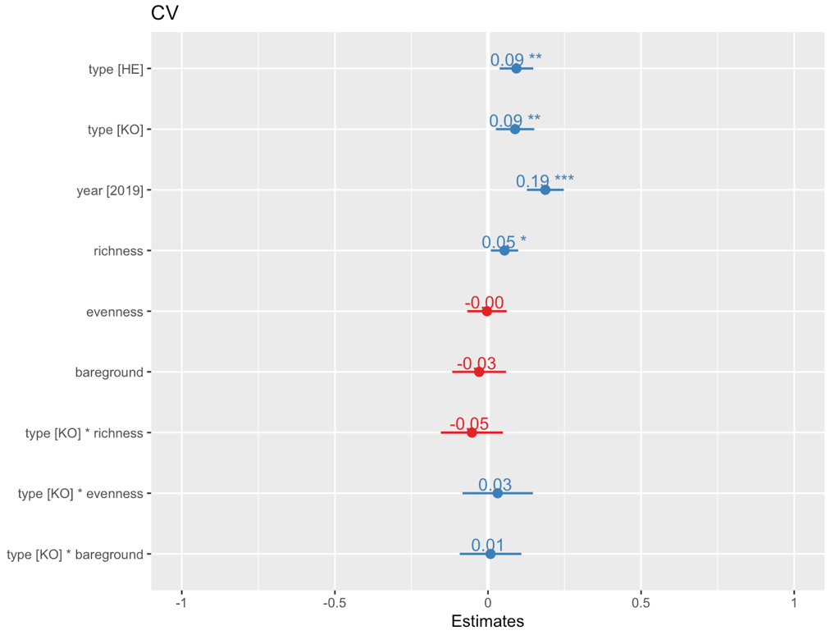

**7.6 Spectral diversity by Richness, evenness, and bare ground correlation matrix**

**7.7 Bare ground mean reflectance**

A negative trend was observed between bare ground and spectral, had no had a small effect size with large standard error

|  |  |  |  |  |
| --- | --- | --- | --- | --- |
| Coefficient | Estimate | Std. error | t value | p-value |
| Type HE | 0.04 | 0.01 | 3.02 | 0.01 |
| Type KO | 0.06 | 0.01 | 3.87 | 0.002 |
| Year 2019 | 0.06 | 0.02 | 4.30 | 0.001 |
| Richness: HE | -0.01 | 0.01 | -1.20 | 0.023 |
| Evenness: HE | 0.02 | 0.02 | 1.45 | 0.17 |
| Bare ground: HE | 0.04 | 0.02 | 1.94 | 0.07 |
| Richness: KO | 0.02 | 0.03 | 0.67 | 0.51 |
| Evenness: KO | -0.03 | 0.03 | -0.88 | 0.39 |
| Bare ground: KO | -0.05 | 0.02 | -2.01 | 0.06 |

**7.4 Spectral Signature by Type**

**7.7 Breakdown of Mean Reflectance by Region**

**7.7 Breakdown of spectral diversity by Region**

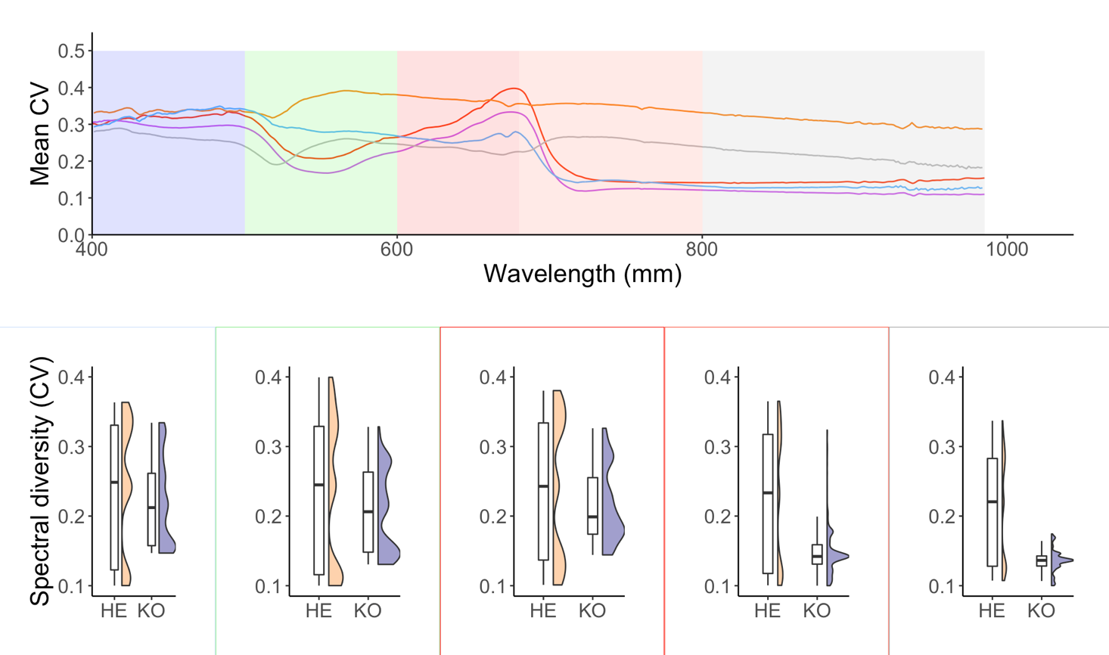

**7.17 Environmental factor biplot**

**7.16 PCA of spectral signatures and all environmental factors derived from point framing data and**

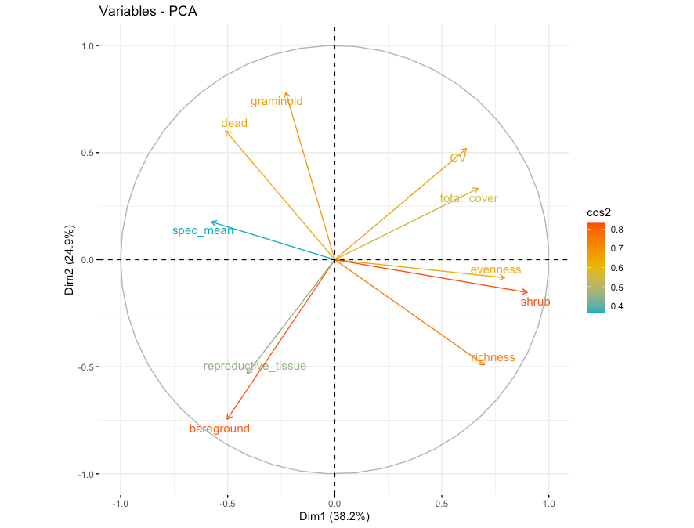

**7.15 Correlation plot between spectral signatures and all environmental factors derived from point framing data and**

**7.18 Environmental factor biplot by year**

**7.x Code for point framing**

**7.x Packages used for all code**

For full code visit: https://github.com/schneidereits/Dissertation

**References:**

IPCC, 2019: IPCC Special Report on the Ocean and Cryosphere in a Changing Climate [H.-O. Pörtner, D.C.

Roberts, V. Masson-Delmotte, P. Zhai, M. Tignor, E. Poloczanska, K. Mintenbeck, A. Alegría, M. Nicolai,

A. Okem, J. Petzold, B. Rama, N.M. Weyer (eds.)].

Molau, U. and Mølgaard, P.E., 1996. ITEX Manual Danish Polar Center.