Harnessing remote sensed hyper-spectral signatures as indicators of biodiversity in Arctic Tundra habitats

OR

Remotely sensed hyper-spectral signatures as indicators of biodiversity

The Hook

Fundamental to global ecological processes is the diversity and composition of plant communities. They are critical to providing a multitude of functions such as building the foundation of trophic food chains, supporting the existence all other organisms as well providing fundamental ecosystem services, such as maintaining fresh water supplies (Cavender-Bares et al., 2017). Concerningly, one in five plant species is currently categorized as threatened by extinction due to a number of stress factors such as land use change, global warming, overexploitation, invasive species, and pathogen introduction (Royal Botanic Gardens, 2016). Assessing changes in biodiversity and community composition is key to the efficient allocation of the limited resources, available to conservation efforts. Traditional methods of measuring biodiversity are costly and not sufficiently scalable, to adequately address the magnitude of change occurring. Remote sensing techniques present themselves as a cost-effective efficient technique to monitor real-time changes on an ecosystem or even global scale, combining remotely sensed earth observation data with local climactic and topographical condictiones.

The Knowledge Gap

Different vegetation types have distinct chemical, anatomical, and morphological traits resulting in distinct spectral signatures (Schweiger et al., 2018). The spectral variability hypothesis states that the spectral diversity of an area can be utilized as a proxy for spatial heterogeneity within an ecosystem. Thus, spectral diversity is an expression of the vegetation functional and biodiversity, an can be used as diversity metric (Wang and Gamon, 2019). While multiscale spectral data are becoming increasingly available, there is little known on transitioning from species specific signatures to ones representative of communities. Furthermore, for many habitat types, the direct relationship of vegetation spectral signatures to functional and biodiversity are unknown. How the results of airborne remote sensing methods compare to ground based sampling techniques also require further investigation, as the spectral diversity to biodiversity relationship may change at different grain sizes (pixel resolution) and across greater spatial scales.

Research Questions

1. Do Herschel and Komakuk vegetation types differ in their hyperspectral signatures?
2. How do hyperspectral signatures relate to species richness & evenness, canopy cover, and percent bare ground?
3. At what scale/resolution (Site, drone, Plane) can remote sensing data be applied before the stated hyperspectral relationships can no longer be observed? What is the variance in accuracy?
4. Can spectral diversity be scaled beyond individual vegetation communities? Can local or regional mappings be produced of ie. richness?

Methods

Described indices such as coefficient of variation (Wang et al., 2018) or spectral dissimilarity matrices (Schweiger et al., 2018) will be used to quantify spectral diversity.

1. The first question of whether Herschel and Komakuk vegetation types differ in their hyperspectral signatures can be answered using data obtained at a plot-scale or plane-scale. Overall plane-scale is currently the preferred means of analysis, as this could establish valuable precedence for further research. Here the variance in spectral diversity of Herschel and Komakuk vegetation will be compared, using an existing mapping of the vegetation types present on Qikiqtaruk (Obu et al., 2017).
2. How hyperspectral signatures relate to species, richness & evenness, canopy cover, and percent bare ground will be primarily answered with plot level data. Initially biodiversity indices will be as basic measurements of richness & evenness. Pointframing data can be used for the identification of species, aswell as canopy cover and percent bare ground. These are included as abiotic correlates, as they like have significant impact on the spectral signature of a plot, and therefor the derived biodiversity estimates (Asner and Martin, 2009), (Gholizadeh et al., 2018). Furthermore, principle component analysis can be conducted to see which variable explains the greatest variability within observed hyperspectral signatures.
3. Previous studies indicate a strong scale-dependence of the relationship between spectral diversity to biodiversity. Therefor this study will assess the relationship between hyperspectral variability and biodiversity at three spatial scales: i) plot-scale, ii) drone scale, and iii) plane-scale.

There for all spatial scale will be used to assess the impact of resolution on the observed hyperspectral relationships and if data saturation across scales occurs. This will also provide insight into the variance of accuracy between sensed spectral signatures and the biodiversity estimates at different spatial scales.

Canopy cover and structure may alter reflective properties of a plot, resulting in greater variance in spectral signatures and linked biodiversity estimates (Asner and Martin, 2009). Therefor canopy cover, from pointframing data, will be added as covariate for spectral diversity.

At the larger remotely sensed scales of observation, bare ground is likely to be a significant predictor of variance in spectral diversity (Gholizadeh et al., 2018). A potential approach to assess the significance of this variances to overlay plane hyperspectral raster data over the already mapped % bare ground obtained from previous years drone imagery.

At the plane scale , hyperspectral signature variance will be related to veg type, topography, wetness, (and possibly slope and aspect?). The topography Qikiqtaruk is available via the Arctic DEM dataset and wetness, slope and aspect can all be derived/interpolated from DEMs

1. Finally, a regional map of biodiversity will be produced using the remotely sensed hyperspectral data. Biodiversity will be calculated using question two’s model of hyperspectral density relationship biodiversity

Figures for Results

1. Average overlaid spectral profiles of Herschel and Komakuk vegetation types.

Example:

(here not the case…) Alison Beamish, Gergana Daskalova, Isla Myers-Smith3, Birgit Heim, Sabine Chabrillat et al. (in prep)

1. Simple linear plots of spectral diversity on y-axis vs factor (biodiversity, canopy cover, % bare ground on x-axis)

Example:

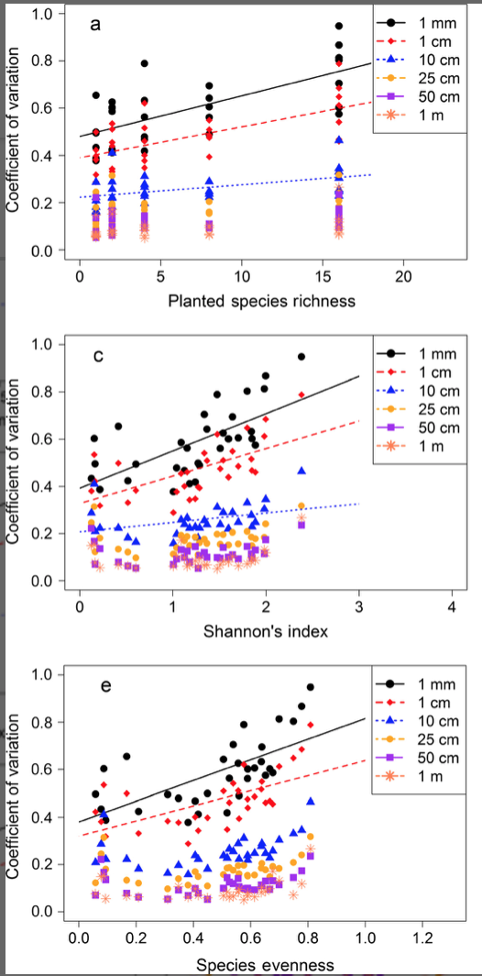

(Wang et al., 2018)

1. The above figure also can show the differences in between the scales of sensing. In wang 2018 lower pixel resolution of sensing resulted in smaller effect sizes.

Alternatively a segmented plot of the scaled variance of predicted vs measured values of biodiversity could be produced

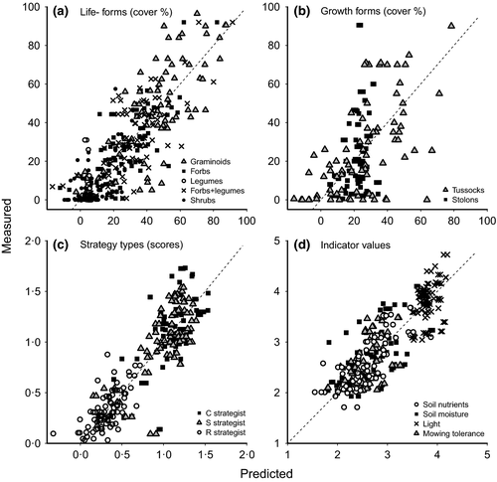

1. A local heat map of biodiversity based on observed spectral relationship.

Example

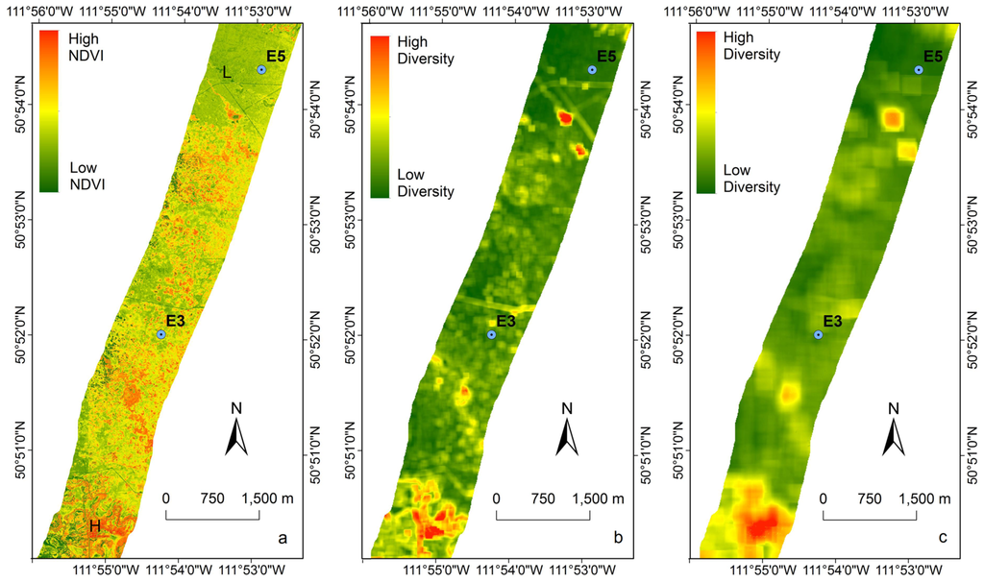

(Wang et al., 2016)

Take Home Message

Pairing field measurements with remotely sensed multispectral imagery presents itself to become a cost and time efficient way to assess biodiversity. Critically, it can provide a scalable method of environmental measurement, capable of sampling greater spatial areas than possible with conventional ground-based methods. The potential exists for remotely sensed spectral analysis to, through the use of improving satellite technology, to assess changes in biodiversity and ecosystem composition across time, on a global scale.

This study can be used to guide further effort of using remotely sensed data to assess biodiversity. (Hopefully) a model of how hyperspectral diversity relates to biodiversity, is presented and how abiotic factors impact spectral signatures and the associated biodiversity estimates. also aids in developing the methods and infrastructure required for the effective scaling assessing biodiversity remotely.

References:

Asner, G.P. and Martin, R.E. (2009), “Airborne spectranomics: mapping canopy chemical and taxonomic diversity in tropical forests”, *Frontiers in Ecology and the Environment*, Vol. 7 No. 5, pp. 269–276.

Cavender-Bares, J., Gamon, J.A., Hobbie, S.E., Madritch, M.D., Meireles, J.E., Schweiger, A.K. and Townsend, P.A. (2017), “Harnessing plant spectra to integrate the biodiversity sciences across biological and spatial scales”, *American Journal of Botany*, Vol. 104 No. 7, pp. 966–969.

Gholizadeh, H., Gamon, J.A., Zygielbaum, A.I., Wang, R., Schweiger, A.K. and Cavender-Bares, J. (2018), “Remote sensing of biodiversity: Soil correction and data dimension reduction methods improve assessment of α-diversity (species richness) in prairie ecosystems”, *Remote Sensing of Environment*, Vol. 206, pp. 240–253.

Obu, J., Lantuit, H., Myers-Smith, I., Heim, B., Wolter, J. and Fritz, M. (2017), “Effect of Terrain Characteristics on Soil Organic Carbon and Total Nitrogen Stocks in Soils of Herschel Island, Western Canadian Arctic: Geomorphic Disturbance, SOC and TN”, *Permafrost and Periglacial Processes*, Vol. 28 No. 1, pp. 92–107.

Royal Botanic Gardens, K. (2016), *State of the World’s Plants, 2016*.

Schweiger, A.K., Cavender-Bares, J., Townsend, P.A., Hobbie, S.E., Madritch, M.D., Wang, R., Tilman, D., et al. (2018), “Plant spectral diversity integrates functional and phylogenetic components of biodiversity and predicts ecosystem function”, *Nature Ecology & Evolution*, Vol. 2 No. 6, pp. 976–982.

Wang, R., Gamon, J., Emmerton, C., Li, H., Nestola, E., Pastorello, G. and Menzer, O. (2016), “Integrated Analysis of Productivity and Biodiversity in a Southern Alberta Prairie”, *Remote Sensing*, Vol. 8 No. 3, p. 214.

Wang, R. and Gamon, J.A. (2019), “Remote sensing of terrestrial plant biodiversity”, *Remote Sensing of Environment*, Vol. 231, p. 111218.

Wang, R., Gamon, J.A., Cavender-Bares, J., Townsend, P.A. and Zygielbaum, A.I. (2018), “The spatial sensitivity of the spectral diversity-biodiversity relationship: an experimental test in a prairie grassland”, *Ecological Applications*, Vol. 28 No. 2, pp. 541–556.