Harnessing Remote Sensed Hyper-Spectral Signatures as Indicators of

Arctic Tundra Vegetation Biodiversity

OR

Remotely Sensed Hyper-Spectral Signatures as Indicators of Biodiversity

The Hook

The diversity and composition of plant communities is fundamental to global ecological processes. They are critical to providing a multitude of functions, such as building the foundation of trophic food chains, supporting the existence of all other organisms, as well providing fundamental ecosystem services, including maintaining fresh water supplies (Cavender-Bares et al., 2017). One in five plant species is currently categorized as threatened by extinction due to stress factors such as land use change, global warming, overexploitation, invasive species, and pathogen introduction (Royal Botanic Gardens, 2016). Assessing changes in biodiversity and community composition is key to the efficient allocation of limited resources, available to conservation efforts. Traditional methods of measuring biodiversity are costly and not sufficiently scalable, to adequately address the magnitude of change occurring. Remote sensing techniques could be a cost-effective and standardized technique to monitor real-time changes on an ecosystem, or even global scale, by combining remotely sensed earth observation data with local climatic and topographical conditions.

Changes in plant communities are one of the most distinct signatures of climate change on the planet, yet we lack a fundamental understanding of plant richness and composition in the biome experiencing the highest rate of warming – the tundra.

Global climate change is altering the Earth’s ecosystems, among which the tundra is experiencing the highest rates of warming.

Among all of the Earth’s biomes, the tundra is experiencing the highest rates of climate warming and yet, its remoteness has obscured our understanding of biodiversity at northern latitudes.

Plants are among the first taxa to respond to environmental change, making them one of the most distinct signatures of the effects of climate change on biodiversity around the world.

The Knowledge Gap

Different vegetation types have distinct chemical, anatomical, and morphological traits resulting in distinct spectral signatures (Schweiger et al., 2018). The spectral variability hypothesis states that the spectral diversity of an area can be used as a proxy for spatial heterogeneity within an ecosystem. Thus, spectral diversity is an expression of the vegetation functional and biodiversity, and can be used as diversity metric (Wang and Gamon, 2019). While multiscale spectral data are becoming increasingly available, there is little known on transitioning from species specific signatures to ones representative of communities. Furthermore, for many habitat types, the direct relationship of vegetation spectral signatures to functional and biodiversity are unknown. How the results of airborne remote sensing methods compare to ground based sampling techniques also requires further investigation, as the spectral diversity to biodiversity relationship may change at different grain sizes (pixel resolution) and across greater spatial scales.

Research Questions and Predictions

1. Can tundra vegetation types be identified based on the variation in their hyperspectral signatures?
   * Given the press work by shrub et al. and wide number of other studies that have been able to correlate spectral with biological diversity, I think a simple difference in hyper-spectral signature is likely to be observable ([Feilhauer and Schmidtlein, 2009](https://www.sciencedirect.com/science/article/pii/S0034425717300482" \l "bb0040), [Foody and Cutler, 2003](https://www.sciencedirect.com/science/article/pii/S0034425717300482" \l "bb0050), [Foody and Cutler, 2006](https://www.sciencedirect.com/science/article/pii/S0034425717300482" \l "bb0055), [Rocchini, 2007](https://www.sciencedirect.com/science/article/pii/S0034425717300482" \l "bb0175))
   * There will be more variation in hyperspectral signatures among, rather than within, vegetation communities. (this is another, perhaps more specific way, of saying the above)
   * If spectral signatures are detected, these should also be observable at remotely sensed scales as other studies have done so at comparable resolutions.

As future steps, here below each question you can add a sketch of what you think the graph to answer this question will look like. Okay now I see you have some further down! So then next you can draw (either literally with pen and paper, or in powerpoint) what you think your figures specifically will be like),

1. How do hyperspectral signatures relate to species richness & evenness, canopy cover, and percent bare ground?

* There should exist at least a correlational relationship between spectral signatures and biodiversity. At increased observations scales, canopy cover and especially bare ground visibility will begin to have a significant impact on observed spectral diversity and the subsequent biodiversity predictions (Ollinger, 2011) (Gholizadeh et al., 2018).

1. At what scale/resolution (site, drone, plane) can remote sensing data be applied before the stated hyperspectral relationships can no longer be observed? What is the variance in accuracy?
   * This depends on the effect size of the relationship between spectral signature and biodiversity. If sufficiently large, even considering diminished resolution and the inclusion of increased environmental variation, the relationship could hold true.
2. Can spectral diversity be scaled beyond individual vegetation communities? Can local or regional mappings be produced of e.g. richness?

* If attempted the produced map will be more a test of feasibility and exploratory exercise. As much of the vegetative variation isn’t accounted for in the spectral diversity to biodiversity model and only 12 plots exist to validate the final output, a high variance between estimated and true biodiversity is to be expected.

Methods

The terms spectral diversity, spectral heterogeneity or spectral variability, synonymously refer to quantifying the spatial variation of spectral reflectance (Wang and Gamon 2019, Laliberté et al., 2019). The quantification of this relationship is what is required to determine the spectral signature of a vegetation community (Rocchini et al., 2010). The coefficient of variation (CV) of spectral reflectance (equation 1), will be used as the spectral diversity metric for this study (Wang et al., 2018). Here the average variation between all spectral bands is calculated in pixels within a plot (kernel size for remote sensing likely same).

(1)

urn:x-wiley:10510761:media:eap1669:eap1669-math-0003

*„where ρλ denotes the reflectance at wavelength λ and urn:x-wiley:10510761:media:eap1669:eap1669-math-0004 and μ(ρλ) indicate the standard deviation and mean value of reflectance at wavelength λ across all the pixels in one plot, respectively.“ (Wang et al., 2018)*

Spectral variance among pixel images could be calculated using metrics such as spectral dissimilarity matrices (Schweiger et al., 2018), or mean distance from spectral centroid (Rocchini et al., 2010) have been used for similar spectral diversity work. Yet, these metrics were proposed to incorporate phylogenetic and functional diversity components, which are extraneous to the scope of this paper.

Methods and Predictions for Individual Research Questions:

1. The first question of whether Quikiqtaruk vegetation types differ in their hyperspectral signatures can be answered using data obtained at a plot-scale or plane-scale. Overall plane-scale is currently the preferred means of analysis, as this could establish valuable precedence for further research. Here the variance in spectral diversity of Herschel and Komakuk vegetation will be compared, using an existing mapping of the vegetation types present on Qikiqtaruk (Obu et al., 2017).
2. How hyperspectral signatures relate to species, richness & evenness, canopy cover, and percent bare ground will be primarily answered with plot level data. Initially, biodiversity indices will be as basic measurements of richness & evenness. I will use...Point-framing data for the identification of species, as well as canopy cover and percent bare ground. These are included as abiotic correlates, as they like have significant impact on the spectral signature of a plot, and therefore the derived biodiversity estimates (Asner and Martin, 2009), (Ollinger, 2011) (Gholizadeh et al., 2018). Furthermore, principle component analysis can be conducted to see which variable explains the greatest variability within observed hyperspectral signatures.
3. Previous studies indicate a strong scale-dependence of the relationship between spectral diversity to biodiversity. Therefore, this study will assess the relationship between hyperspectral variability and biodiversity at three spatial scales: i) plot-scale, ii) drone scale, and iii) plane-scale.

Therefore, all spatial scale will be used to assess the impact of resolution on the observed hyperspectral relationships and if data saturation across scales occurs. This will also provide insight into the variance of accuracy between sensed spectral signatures and the biodiversity estimates at different spatial scales.

Canopy cover and structure may alter reflective properties of a plot, resulting in greater variance in spectral signatures and linked biodiversity estimates (Asner and Martin, 2009). Therefore, canopy cover, from point-framing data, will be added as covariate for spectral diversity.

At the larger remotely sensed scales of observation, bare ground is likely to be a significant predictor of variance in spectral diversity (Gholizadeh et al., 2018). A potential approach to assess the significance of this variances is to overlay plane hyperspectral raster data over the already mapped % bare ground obtained from previous years drone imagery.

At the plane scale, hyperspectral signature variance will be related to veg type, topography, wetness, (and possibly slope and aspect?). The topography Qikiqtaruk is available via the Arctic DEM dataset and wetness, slope and aspect can all be derived/interpolated from DEMs

1. Finally, a regional map of biodiversity will be produced using the remotely sensed hyperspectral data. Biodiversity will be calculated using question two’s model of hyperspectral density relationship biodiversity

Figures for Results

1. Average overlaid spectral profiles of Herschel and Komakuk vegetation types.

Example:

(here not the case…) Alison Beamish, Gergana Daskalova, Isla Myers-Smith3, Birgit Heim, Sabine Chabrillat et al. (in prep)

1. Simple linear plots of spectral diversity on Y-axis vs factor (biodiversity, canopy cover, % bare ground on X-axis)

Example:

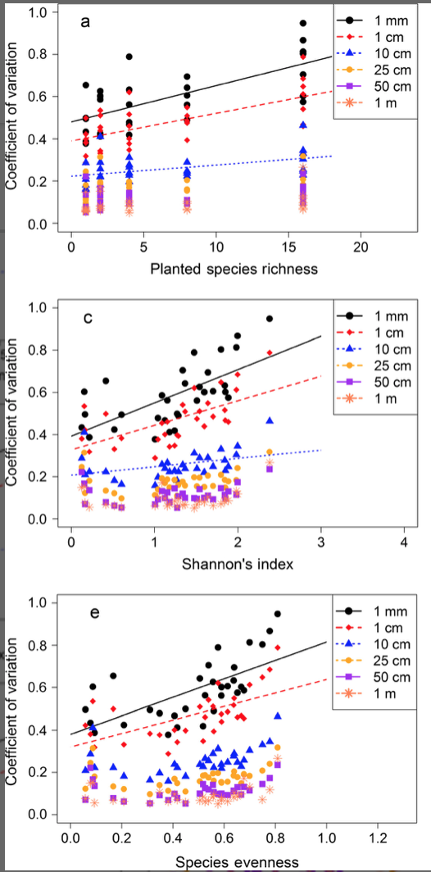

(Wang et al., 2018)

1. The above figure also can show the differences in between the scales of sensing. In Wang 2018 lower pixel resolution of sensing resulted in smaller effect sizes.

Alternatively, a segmented plot of the scaled variance of predicted vs. measured values of biodiversity could be produced.

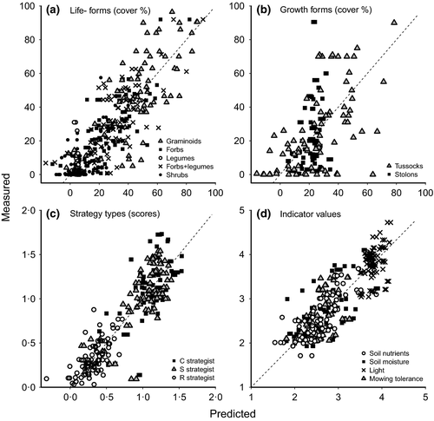

1. A local heat map of biodiversity based on observed spectral relationship.

Example

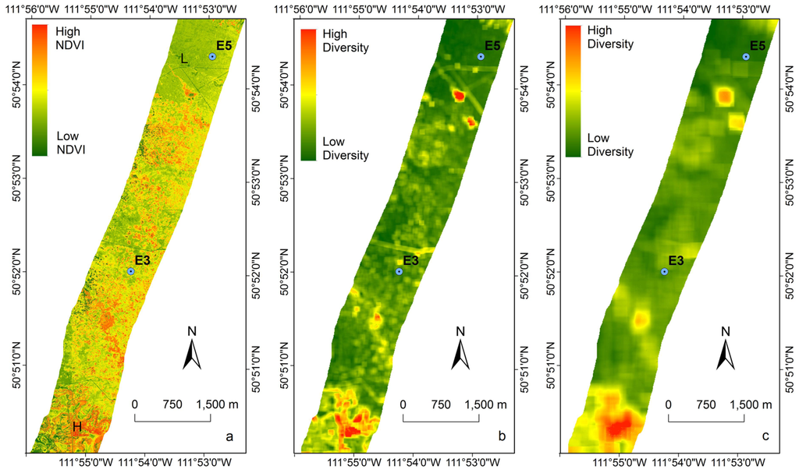

(Wang et al., 2016)

Take Home Message

Pairing field measurements with remotely sensed multispectral imagery could become a cost and time efficient way to assess biodiversity. Critically, it can provide a scalable method of environmental measurement, capable of sampling greater spatial areas than possible with conventional ground-based methods. Remotely sensed spectral analysis and contrinuously improving satellite technology could be used to assess changes in biodiversity and ecosystem composition across time, on a global scale.

This study can be used to guide further efforts of using remotely sensed data to assess biodiversity. (Hopefully) a model of how hyperspectral diversity relates to biodiversity, is presented and how abiotic factors impact spectral signatures and the associated biodiversity estimates. The presented results aim to aid the developing of the methods and infrastructure required for the effective scaling assessing biodiversity remotely.