**EO Project Overview: Hyperspectral Unmixing**

Group members: Philip Lier, Clemens Lang, Shawn Schneidereit, Janis Klug

**Title**: Exploring hyperspectral imagery for unmixing vegetation classes

**Abstract**: Terrestrial ecosystems are often highly complex, with interactions between topography, soil composition, and climate creating fine-scale mosaics of vegetation cover. This leads to mixed pixels as spatial resolutions common in satellite imagery, and therefore unmixing vegetation cover is needed to fully capture vegetation dynamics. Imaging spectroscopy provides enhanced spectral feature resolution, and may therefore be beneficial in distinguishing between relatively similar vegetation classes as compared to broad-band imagery. To this end, numerous narrowband indices have been developed to enhance the relationships with specific vegetation properties. In this project, you will explore the capabilities of hyperspectral imagery for mapping vegetation class fractions in California. You may explore the use of hyperspectral indices to enhance mapping efforts, and draw comparisons to Landsat-based analyses. You may further use the Landsat imagery to explore the effect of acquisition date on model performance.

**1) Specifying the scope of the project**

*a) Specify a research question or hypotheses, around which you can develop one or two main objectives (e.g., one related to methods, one related to LULC or global change processes). You may wish to refine the objectives presented to you with the topics*

1) How can hyperspectral imagery or derived narrowband indices be used to better map vegetation class fractions as compared to multispectral imagery?

2) Using multi-temporal multispectral imagery, explore how acquisition date can influence accuracy of the regression

b) *Search for relevant literature in your project context. Stick to recent publications in established journals, (e.g. Remote Sensing of Environment, Remote Sensing, Applied Earth Observation and Geoinformation, IEEE JSTARS).*

Cooper et al. (2020): Disentangling fractional vegetation cover: Regression-based unmixing of simulated spaceborne imaging spectroscopy data. Remote Sensing of Environment, 246. DOI: 10.1016/j.rse.2020.111856

Roberts et al. (2018): Hyperspectral vegetation indices. In: Hyperspectral indices and image classifications for agriculture and vegetation.

*Tbc*

c) *Evaluate the relevance of selected publications in more detail after you made a first selection and discuss this with your group. Go through the papers and identify aspects of the study which deserve further research. These should also guide you towards further relevant studies, or you may look at studies that cite a particular publication of interest.*

**2) Defining data requirements and methods**

*a) Specify the exact study area (location, extent) and time frame relevant for your analysis.*

Location:

North of Santa Rosa, California

Extend:

*EPSG:32610 - WGS 84 / UTM zone 10N - Projiziert*

*496664.7622136182617396,4261664.8695335863158107 : 568665.9213084551738575,4276665.0152994897216558*

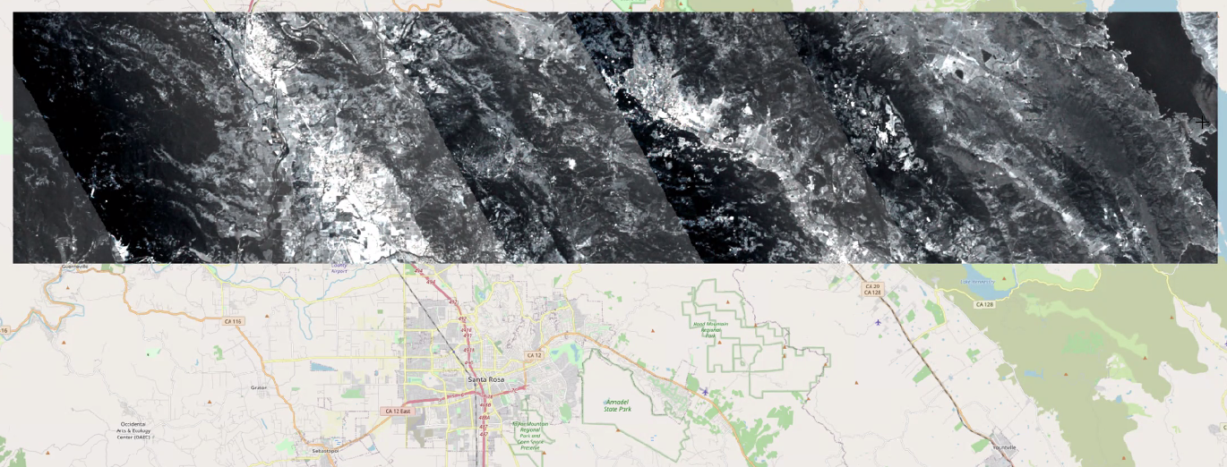

Time frame hyperspectral (EnMap):

2013-06-07

Time frame Landsat:

2013-06-07 (?)

*b) Define the sensor and data product of your choice (e.g. Landsat BOA, Sentinel-2 BOA).*

Landsat and simulated EnMap

*c) Develop a class catalogue including clear and precise class definitions. You may consider a hierarchical approach and aggregate thematically irrelevant classes wherever it appears useful.*

*Papers to be read first*

*d) Define the required temporal resolution (e.g. 5-yearly, annual, intra-annual).*

*?*

*e) Choose a suitable method (e.g. compositing, spectral-temporal metrics, time series analysis).*

*unmixing*

**3) Investigate study area and screen data:**

*a) Connect to the HU-Desktop using the instructions posted on Moodle. The data for your project will be found on the “O” drive: O:\SS21_EO. For now this includes shapefiles delineating your study region.*

*done*

*b) Look at your study site in Google Earth. Note the different vegetation types and patterns as well as how they change over time. You may also search online for other relevant data sources which may provide further context to your study, e.g. climate maps, fire frequency, or existing land cover maps.*

SWATH width 12km (lines 240km x 12km), light time lag (minutes) between 10:31 UTC and 15:21 UTC due to data acquisition method (flight)

Vegetation types: old-growth (cascade or coastal redwood?), forested highlands, cropping (e.g. vine, nuts?, avocado?, apple?, wheat?, rice?) -> **interesting for assignment**

Pattern: Dry season / drought (?), forest fires, growing season and harvest of crops

Others: Heterogeneous mix of land-cover types

*c) To screen all available image data, you may also visit the USGS EarthExplorer or any other data distribution service you might know. Browse through the available data for your study region and time frame. What is the image availability for your time period? How about cloudiness in the study region? Any other limiting factors?*

2013-06-02 good Landsat image in Google Earth (but not full extend of study area), how about USGS Earth Explorer?

Copernicus hub?